# SCons和ROSE编译系统介绍

## SCons编译系统

scons是一个Python写的自动化构建工具，从构建这个角度说，它跟GNU make是同一类的工具，是一种改进，并跨平台的gnu make替代工具，其集成功能类似于autoconf/automake。scons是一个更简便，更可靠，更高效的编译软件。

scons是一个Python写的自动化构建工具，从构建这个角度说，它跟GNU make是同一类的工具。它是一种改进，并跨平台的gnu make替代工具，其集成功能类似于autoconf/automake。scons是一个更简便，更可靠，更高效的编译软件。

Scons是一个开放源码、以Python语言编码的自动化构建工具，可用来替代make编写复杂的makefile。并且scons是跨平台的，只要scons脚本写的好，可以在Linux和Windows下随意编译。

SCons 的设计目标就是让开发人员更容易、更可靠和更快速的建造软件。

与传统的 make 工具比较，SCons 具有以下优点：

* 使用 Python 脚本做为配置文件；
* 对于C, C++ 和 Fortran, 内建支持可靠自动依赖分析，不用像 make 工具那样需要 执行"make depends"和"make clean"就可以获得所有的依赖关系。
* 内建支持 C, C++, D, Java, Fortran, Yacc, Lex, Qt，SWIG 以及 Tex/Latex。 用户还可以根据自己的需要进行扩展以获得对需要编程语言的支持。
* 支持 make -j 风格的并行建造。相比 make -j, SCons 可以同时运行 N 个工作，而 不用担心代码的层次结构。
* 使用 Autoconf 风格查找头文件，函数库，函数和类型定义。
* 良好的夸平台性。SCons 可以运行在 Linux, AIX, BSD, HP/UX, IRIX, Solaris, Windows, Mac OS X 和 OS/2 上。

## ROSE编译系统

<http://rosecompiler.org/>

ROSE is a robust, open source, compiler-based infrastructure for building program transformation and analysis tools, developed at Lawrence Livermore National Laboratory. ROSE Tools can process large C, C++, Fortran, OpenMP, and UPC source codes, as well as binary executables.

ROSE is particularly well suited for building custom tools for static analysis, program optimization, arbitrary program transformation, domain-specific optimizations, complex loop optimizations, performance analysis, and cyber-security analysis.

ROSE users include experienced compiler researchers as well as tool users and developers with minimal compiler experience.

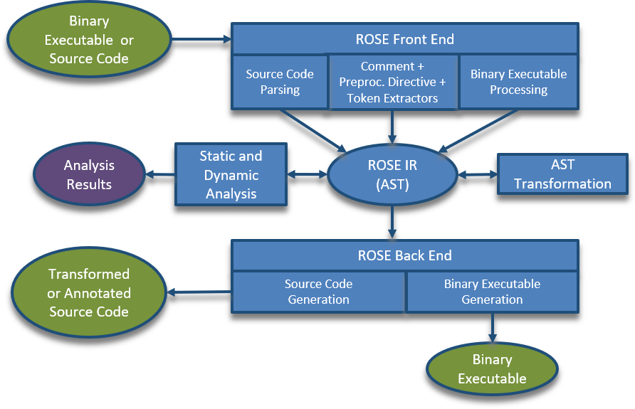

## Ubuntu系统下安装ROSE

<https://github.com/rose-compiler/rose/wiki/Installation-on-Ubuntu-From-Source>

使用apt-get安装

Use the commands below for the **experimental** installation of ROSE pre-built binaries packages using apt-get on Ubuntu:18.04. The rose-development archive is periodically updated based on the current development version while the rose-stable archive is updated upon release. These packages are configured to support c,c++, and binaries. The rose package includes the core rose libraries that are installed by a make install-core.The rose-tools package includes the tools installed by make install-tools and will also install the rose package dependency.

sudo apt-get install software-properties-common

sudo add-apt-repository ppa:rosecompiler/rose-development # Replace rose-development with rose-stable for release version

sudo apt-get install rose

sudo apt-get install rose-tools # Optional: Installs ROSE tools in addition to ROSE Core

GCC and Boost

This package uses the default system version of GCC and Boost which for Ubuntu 18.04 is GCC 7 and Boost 1_65_1.

查看安装了什么

You can get a list of installed ROSE tools by running the following command.

dpkg -L rose rose-tools | grep /usr/bin/

从源码编译和安装

The following code section shows all the command required to install ROSE, we will go into more detail in the following sections. If you are not running as root in a docker image do not forget to add sudo to the apt-get lines in order to install dependencies. Finally, you only need the last line if you interested into one of the ROSE's tool maintained internally.

## 参考文献

使用ROSE编译OP2:

Bertolli, C., Betts, A., Mudalige, G. R., Giles, M. B., and Kelly, P. H. J. Design and Performance of the OP2 Library for Unstructured Mesh Applications. Euro-Par 2011 Parallel Processing Workshops, Lecture Notes in Computer Science.