# How to Clone a CentOS Server with Rsync

Cloning is the practice of cloning an exact copy of an existing Live Linux server using the [rsync command-line tool](https://www.tecmint.com/rsync-local-remote-file-synchronization-commands/). Cloning requires 2 instances of servers – the server to be cloned and the destination server where the cloning process will occur. The rsync command-line tool [synchronizes all the files and directories](https://www.tecmint.com/sync-two-apache-websites-using-rsync/) from the server being cloned to the destination server.

In this guide, you will learn how to hot clone a CentOS server with Rsync file synchronization tool.

## 电脑配置

Here’s the lab setup that we are using for this guide.

* Source Server – CentOS 7 – 192.168.2.103
* Destination Server – CentOS 7 – 192.168.2.110

The source server is the one we are going to clone onto the destination server.

## 设置与要求

Before proceeding, ensure that you have met the prerequisites below:

* Both servers need to be running the same release of the operating system i.e **CentOS 7.x**, **CentOS 8.x**, etc.
* Additionally, the servers should have identical file systems and the same hard disk configuration i.e whether single-disks or in RAID configuration.

**NOTE**: Before hot cloning, ensure you disable all the services that involve shipping or writing data e.g databases, mail service, etc.

## Step 1: Installing the Rsync Tool in CentOS

For cloning to be successful the **rsync** command-line tool needs to be present on both servers. This will be used for mirroring the source server to the destination server and syncing all the differences between the two systems. Thankfully, modern systems come with **rsync** already pre-installed.

To check the version of **rsync** installed run:

$ rsync --version

If you want to view additional information about rsync, execute the following [rpm command](https://www.tecmint.com/20-practical-examples-of-rpm-commands-in-linux/):

$ rpm -qi rsync

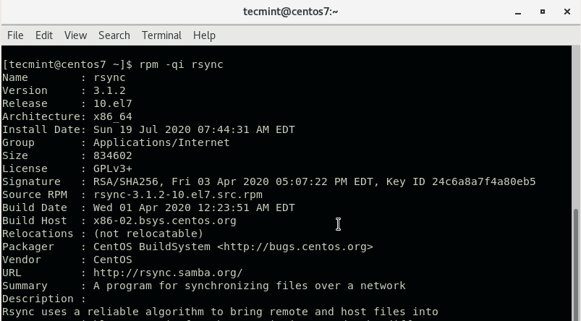

If **rsync** is missing, run the following command to install it in **RHEL** / **CentOS** / **Fedora** systems.

$ sudo yum install rsync

## Step 2: Configure the Source Server

There are directories and files that you may want to exclude from cloning because they are either already available in the destination server or are autogenerated. These include the /boot, /tmp and /dev directories.

Therefore, create an exclusion file /root/exclude-files.txt and add the following entries:

/boot

/dev

/tmp

/sys

/proc

/backup

/etc/fstab

/etc/mtab

/etc/mdadm.conf

/etc/sysconfig/network*

Save and exit the configuration file.

## Step 3: Clone the CentOS Server

With everything set, proceed and **rsync** your server to the remote or destination server using the command:

rsync -vPa -e 'ssh -o StrictHostKeyChecking=no' --exclude-from=/root/exclude-files.txt /REMOTE-IP:/

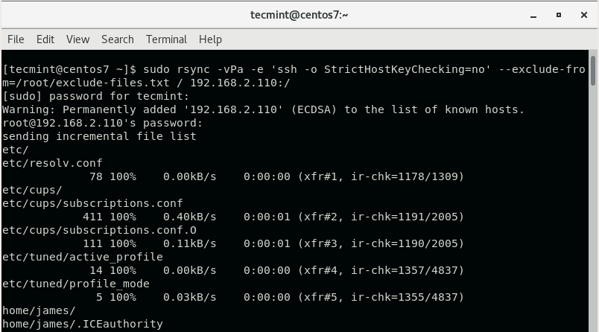

输入密码：read –p pswd

The command will rsync everything from the source server to the destination server while excluding the files and directories you defined earlier on. Be sure to replace the REMOTE-IP: option with your destination server’s IP address.

After the synching is done, **reboot** the destination system to reload the changes and thereafter, boot into the server using the source server’s credentials. Feel free to decommission the old server since you now have a mirror copy of it.