# ROSE编译系统

<http://rosecompiler.org/>

ROSE is a robust, open source, compiler-based infrastructure for building program transformation and analysis tools, developed at Lawrence Livermore National Laboratory. ROSE Tools can process large C, C++, Fortran, OpenMP, and UPC source codes, as well as binary executables.

ROSE is particularly well suited for building custom tools for static analysis, program optimization, arbitrary program transformation, domain-specific optimizations, complex loop optimizations, performance analysis, and cyber-security analysis.

ROSE users include experienced compiler researchers as well as tool users and developers with minimal compiler experience.

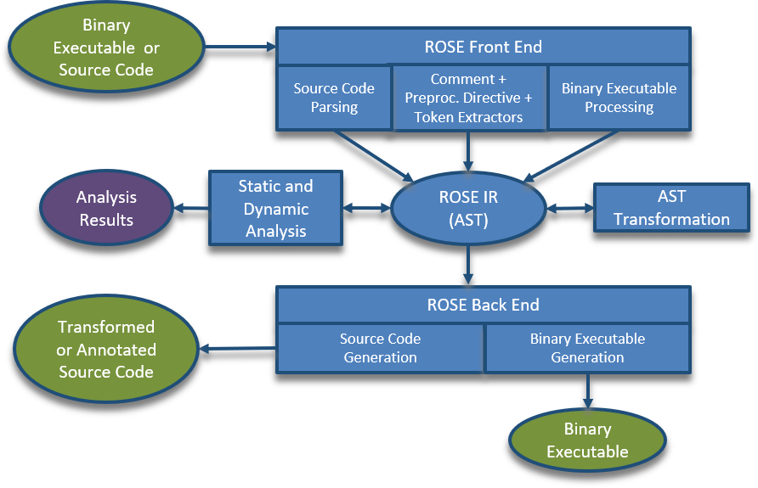

## Ubuntu系统下安装ROSE

<https://github.com/rose-compiler/rose/wiki/Installation-on-Ubuntu-From-Source>

使用apt-get安装

Use the commands below for the **experimental** installation of ROSE pre-built binaries packages using apt-get on Ubuntu:18.04. The rose-development archive is periodically updated based on the current development version while the rose-stable archive is updated upon release. These packages are configured to support c,c++, and binaries. The rose package includes the core rose libraries that are installed by a make install-core.The rose-tools package includes the tools installed by make install-tools and will also install the rose package dependency.

sudo apt-get install software-properties-common

sudo add-apt-repository ppa:rosecompiler/rose-development # Replace rose-development with rose-stable for release version

sudo apt-get install rose

sudo apt-get install rose-tools # Optional: Installs ROSE tools in addition to ROSE Core

GCC and Boost

This package uses the default system version of GCC and Boost which for Ubuntu 18.04 is GCC 7 and Boost 1_65_1.

查看安装了什么

You can get a list of installed ROSE tools by running the following command.

dpkg -L rose rose-tools | grep /usr/bin/

从源码编译和安装

The following code section shows all the command required to install ROSE, we will go into more detail in the following sections. If you are not running as root in a docker image do not forget to add sudo to the apt-get lines in order to install dependencies. Finally, you only need the last line if you interested into one of the ROSE's tool maintained internally.

## 参考文献

使用ROSE编译OP2:

Bertolli, C., Betts, A., Mudalige, G. R., Giles, M. B., and Kelly, P. H. J. Design and Performance of the OP2 Library for Unstructured Mesh Applications. Euro-Par 2011 Parallel Processing Workshops, Lecture Notes in Computer Science.