# SLIM1D and SLIM2D

SLIM2D is used in shallow-water environments where wind and tides are sufficient to keep the water column rather well mixed. It solves the depth-averaged shallow water equations for the surface elevation and the horizontal velocity. When the horizontal flow is mainly unidirectional such as for a well-mixed river, the shallow water equations can be averaged over the section leading to the 1D section-averaged shallow-water equations. SLIM1D consists of linear river segments where variable river width and cross-section are taken into account. River segments can be joined to model a river network with accurate computation of bifurcation by the means of a Riemann solver.

SLIM solves the model equations on an unstructured mesh with the Discontinuous Galerkin finite element method. This approach provides an optimal degree of flexibility both geometrically and functionally as it can accurately represent complex topographies and also model solutions with sharp gradients. Unlike more standard numerical methods, such as finite volumes, it introduces a minimal amount of numerical dissipation and thus preserves small-scale flow features such as recirculation eddies. The model equations can be forced by wind, tides, river discharges and large-scale currents from a global ocean model.

Most coastal areas are significantly influenced by tides. When approaching the coast, the tidal signal tends to amplify, especially in funnel-shaped embayments where the tidal range may reach considerable magnitudes. Combined with the fact that many estuaries and embayments also feature gradually sloping bathymetry, the total area submerged under water may vary significantly during the tidal cycle. To tackle this issues, SLIM2D is equipped with a wetting-drying algorithm that allows it to handle dry areas. The algorithm is based on an implicit time-stepping that combines computational efficiency with local mass conservation. The video below shows the water transport in the Columbia River estuary as modeled by SLIM2D. Dry tidal flats are clearly visible at low tide.

## To learn more…

Le, H.-A., Lambrechts, J., Ortleb, S., Gratiot, N., Deleersnijder, E., & Soares-Frazão, S. (2020). An implicit wetting–drying algorithm for the discontinuous Galerkin method: application to the Tonle Sap, Mekong River Basin. *Environmental Fluid Mechanics*. <https://doi.org/10.1007/s10652-019-09732-7>

Le, H.-A., Gratiot, N., Santini, W., Ribolzi, O., Tran, D., Meriaux, X., Soares-Frazão, S. (2020). Suspended sediment properties in the Lower Mekong River, from fluvial to estuarine environments. *Estuarine, Coastal and Shelf Science*, *233*, 106522. <https://doi.org/10.1016/j.ecss.2019.106522>

Vincent, D., Karatekin, Ö., Lambrechts, J., Lorenz, R. D., Dehant, V., & Deleersnijder, É. (2018). A numerical study of tides in Titan′s northern seas, Kraken and Ligeia Maria. *Icarus*, *310*, 105–126. <https://doi.org/10.1016/j.icarus.2017.12.018>

Delandmeter, P., Lambrechts, J., Marmorino, G. O., Legat, V., Wolanski, E., Remacle, J.-F., … Deleersnijder, E. (2017). Submesoscale tidal eddies in the wake of coral islands and reefs: satellite data and numerical modelling. *Ocean Dynamics*, *67*(7), 897–913. <https://doi.org/10.1007/s10236-017-1066-z>

Pham Van, C., de Brye, B., Deleersnijder, E., Hoitink, A. J. F., Sassi, M., Spinewine, B., Soares-Frazão, S. (2016). Simulations of the flow in the Mahakam river–lake–delta system, Indonesia. *Environmental Fluid Mechanics*, *16*(3), 603–633. <https://doi.org/10.1007/s10652-016-9445-4>

Vincent, D., Karatekin, Ö., Vallaeys, V., Hayes, A. G., Mastrogiuseppe, M., Notarnicola, C., … Deleersnijder, E. (2016). Numerical study of tides in Ontario Lacus, a hydrocarbon lake on the surface of the Saturnian moon Titan. *Ocean Dynamics*, *66*(4), 461–482. <https://doi.org/10.1007/s10236-016-0926-2>

Le Bars, Y., Vallaeys, V., Deleersnijder, É., Hanert, E., Carrere, L., & Channelière, C. (2016). Unstructured-mesh modeling of the Congo river-to-sea continuum. *Ocean Dynamics*, *66*(4), 589–603. <https://doi.org/10.1007/s10236-016-0939-x>

Thomas, C. J., Lambrechts, J., Wolanski, E., Traag, V. A., Blondel, V. D., Deleersnijder, E., & Hanert, E. (2014). Numerical modelling and graph theory tools to study ecological connectivity in the Great Barrier Reef. *Ecological Modelling*, *272*, 160–174. <https://doi.org/10.1016/j.ecolmodel.2013.10.002>

Kärnä, T., de Brye, B., Gourgue, O., Lambrechts, J., Comblen, R., Legat, V., & Deleersnijder, E. (2011). A fully implicit wetting–drying method for DG-FEM shallow water models, with an application to the Scheldt Estuary. *Computer Methods in Applied Mechanics and Engineering*, *200*(5–8), 509–524. <https://doi.org/10.1016/j.cma.2010.07.001>

de Brye, B., Schellen, S., Sassi, M., Vermeulen, B., Kärnä, T., Deleersnijder, E., & Hoitink, T. (2011). Preliminary results of a finite-element, multi-scale model of the Mahakam Delta (Indonesia). *Ocean Dynamics*, *61*(8), 1107–1120. <https://doi.org/10.1007/s10236-011-0410-y>

de Brye, B., de Brauwere, A., Gourgue, O., Kärnä, T., Lambrechts, J., Comblen, R., & Deleersnijder, E. (2010). A finite-element, multi-scale model of the Scheldt tributaries, river, estuary and ROFI. *Coastal Engineering*, *57*(9), 850–863. <https://doi.org/10.1016/j.coastaleng.2010.04.001>

Gourgue, O., Comblen, R., Lambrechts, J., Kärnä, T., Legat, V., & Deleersnijder, E. (2009). A flux-limiting wetting–drying method for finite-element shallow-water models, with application to the Scheldt Estuary. *Advances in Water Resources*, *32*(12), 1726–1739. <https://doi.org/10.1016/j.advwatres.2009.09.005>

Lambrechts, J., Hanert, E., Deleersnijder, E., Bernard, P.-E., Legat, V., Remacle, J.-F., & Wolanski, E. (2008). A multi-scale model of the hydrodynamics of the whole Great Barrier Reef. *Estuarine, Coastal and Shelf Science*, *79*(1), 143–151. <https://doi.org/10.1016/j.ecss.2008.03.016>

Hanert, E., Roux, D. Y. L., Legat, V., & Deleersnijder, E. (2005). An efficient Eulerian finite element method for the shallow water equations. *Ocean Modelling*, *10*(1–2), 115–136. <https://doi.org/10.1016/j.ocemod.2004.06.006>

# SLIM3D

SLIM3D solves the three-dimensional hydrostatic equations under the Boussinesq approximation. The model variables are the 3D velocity, the surface elevation, the salinity and the temperature. The density is obtained by means of an equation of state. SLIM3D uses a mesh composed of triangular prismatic elements that are formed by extruding the 2D unstructured mesh in the vertical direction. The model equations are solved by means of the Discontinuous Galerkin finite element method.

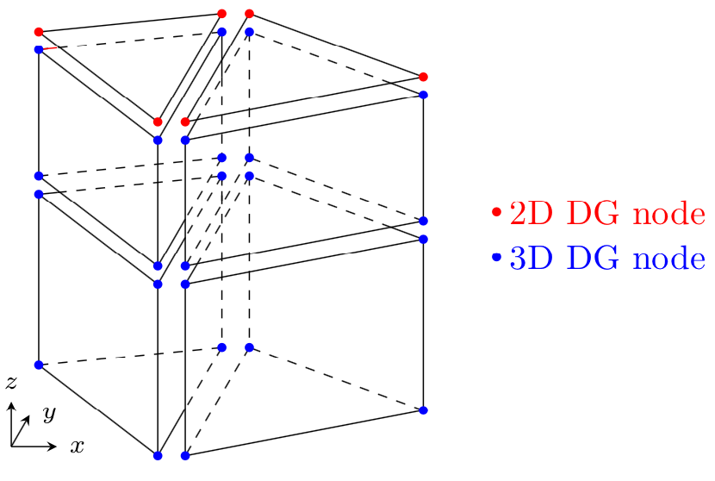

Sketch of the 3D mesh obtained by vertically extruding a 2D triangular mesh. All variables are piecewise linear and discontinuous between elements.

One key aspect in any 3D ocean model is the coupling between the external and internal modes. SLIM3D uses a mode-splitting formulation in which the fast propagating gravity waves are solved in an external 2D mode. That mode can either be discretised explicitly with a small time step or implicitly with a larger time step.

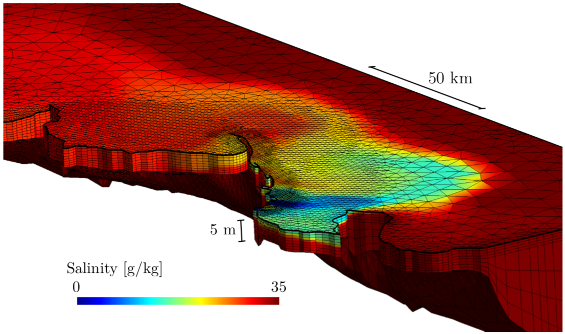

3D mesh used to simulate the sediment plume dynamics of the Burdekine River (Australia). The bathymetry being quite shallow and smooth, sigma layers are sufficient to provide an accurate solution.

In the vertical, SLIM3D allows a combination of z and sigma layers. For rather shallow environments with mild bathymetry gradients, sigma coordinates can be used over the entire water column. For deeper areas with sharp bathymetry gradients, sigma layers are generally used only near the surface while z layers are used in the rest of the domain. The number of z layers can be adapted to better approximate bathymetry gradients.

The accuracy of the mode coupling has been tested on a baroclinic test case described in Ilicak et al. (2012). The domain is a periodic (along the 500km-long boundaries) and closed (along the 160km-long boundaries) channel with a bathymetry of 1000m (exaggerated on the video). The large bottom drag coefficient and asymmetric initial condition trigger baroclinic instabilities in the channel. The 4km mesh resolution is similar to one of typical mesoscale eddy permitting models. SLIM3D is able to reproduce the development of baroclinic eddies, as illustrated by the evolution of the predicted temperature.

## To learn more…

Delandmeter, P., Lambrechts, J., Legat, V., Vallaeys, V., Naithani, J., Thiery, W., … Deleersnijder, E. (2018). A fully consistent and conservative vertically adaptive coordinate system for SLIM 3D v0.4 with an application to the thermocline oscillations of Lake Tanganyika. *Geoscientific Model Development*, *11*(3), 1161–1179. <https://doi.org/10.5194/gmd-11-1161-2018>

Vallaeys, V., Kärnä, T., Delandmeter, P., Lambrechts, J., Baptista, A. M., Deleersnijder, E., & Hanert, E. (2018). Discontinuous Galerkin modeling of the Columbia River’s coupled estuary-plume dynamics. *Ocean Modelling*, *124*, 111–124. <https://doi.org/10.1016/j.ocemod.2018.02.004>

Delandmeter, P., Lewis, S. E., Lambrechts, J., Deleersnijder, E., Legat, V., & Wolanski, E. (2015). The transport and fate of riverine fine sediment exported to a semi-open system. *Estuarine, Coastal and Shelf Science*, *167*, 336–346. <https://doi.org/10.1016/j.ecss.2015.10.011>

Kärnä, T., Legat, V., & Deleersnijder, E. (2013). A baroclinic discontinuous Galerkin finite element model for coastal flows. *Ocean Modelling*, *61*, 1–20. <https://doi.org/10.1016/j.ocemod.2012.09.009>

Kärnä, T., Legat, V., Deleersnijder, E., & Burchard, H. (2012). Coupling of a discontinuous Galerkin finite element marine model with a finite difference turbulence closure model. *Ocean Modelling*, *47*, 55–64. <https://doi.org/10.1016/j.ocemod.2012.01.001>

Comblen, R., Blaise, S., Legat, V., Remacle, J.-F., Deleersnijder, E., & Lambrechts, J. (2010). A discontinuous finite element baroclinic marine model on unstructured prismatic meshes: Part II: implicit/explicit time discretization. *Ocean Dynamics*, *60*(6), 1395–1414. <https://doi.org/10.1007/s10236-010-0357-4>

Blaise, S., Comblen, R., Legat, V., Remacle, J.-F., Deleersnijder, E., & Lambrechts, J. (2010). A discontinuous finite element baroclinic marine model on unstructured prismatic meshes: Part I: space discretization. *Ocean Dynamics*, *60*(6), 1371–1393. <https://doi.org/10.1007/s10236-010-0358-3>

White, L., Legat, V., & Deleersnijder, E. (2008). Tracer Conservation for Three-Dimensional, Finite-Element, Free-Surface, Ocean Modeling on Moving Prismatic Meshes. *Monthly Weather Review*, *136*(2), 420–442. <https://doi.org/10.1175/2007MWR2137.1>

White, L., Deleersnijder, E., & Legat, V. (2008). A three-dimensional unstructured mesh finite element shallow-water model, with application to the flows around an island and in a wind-driven, elongated basin. *Ocean Modelling*, *22*(1–2), 26–47. <https://doi.org/10.1016/j.ocemod.2008.01.001>

White, L., & Deleersnijder, E. (2007). Diagnoses of vertical transport in a three-dimensional finite element model of the tidal circulation around an island. *Estuarine, Coastal and Shelf Science*, *74*(4), 655–669. <https://doi.org/10.1016/j.ecss.2006.07.014>