# Instructions to finish the installation manually after a failure of the automatic installation

Important note: The following instructions are to check out the first tag (v7p2r2) of the v7p2 version. If you wish to work with a different version, edit all commands, paths, names and the configuration file with the version you wish to use.

## 1. Open the DOS prompt command

[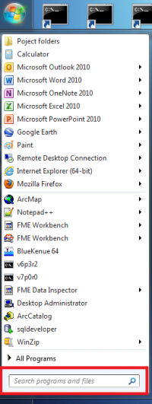](http://wiki.opentelemac.org/lib/exe/detail.php?id=instructions_to_finish_installing_the_telemac_system_manually_after_a_failure_of_the_automatic_installation&media=findind_dos_cmd.png)

If you do not know where the prompt command is, go to the Windows start menu and type “**cmd**” in the “Search programs and files” box. (see picture on the right)

## 2. Check out the TELEMAC source code

From the DOS prompt command, run the following command:

svn co http://svn.opentelemac.org/svn/opentelemac/tags/v7p2r2 "C:\opentelemac-mascaret\v7p2" --username ot-svn-public --password telemac1*

Note: The download could last more than 20 minutes depending on the quality of the internet connection.

Note: If the checkout crashed you do not have to start again just type svn update in the v7p2r2 folder to carry on the download.

## 3. Copy configuration file

Save the configuration file as ***systel_v7p2.cfg*** in C:\opentelemac-mascaret\v7p2\configs.

Here are the configuration files for v7p2: [configuration file v7p2](http://wiki.opentelemac.org/doku.php?id=configuration_file_v7p2)

for v7p0 : [configuration file](http://wiki.opentelemac.org/doku.php?id=configuration_file)

## 4. Create a shortcut of the DOS prompt command on your Desktop

[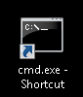](http://wiki.opentelemac.org/lib/exe/detail.php?id=instructions_to_finish_installing_the_telemac_system_manually_after_a_failure_of_the_automatic_installation&media=cmd.png)

## 5. Rename it “Telemac v7p2”

[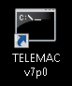](http://wiki.opentelemac.org/lib/exe/detail.php?id=instructions_to_finish_installing_the_telemac_system_manually_after_a_failure_of_the_automatic_installation&media=telemacv7p0.png)

## 6. Edit the properties of the new shortcut

[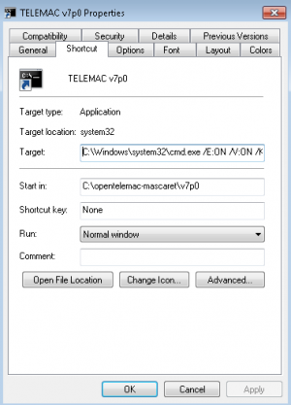](http://wiki.opentelemac.org/lib/exe/detail.php?id=instructions_to_finish_installing_the_telemac_system_manually_after_a_failure_of_the_automatic_installation&media=cmd_properties.png)

* Click right on the shortcut and edit the properties. The properties window should pop up (see picture on the right)
* In the **Target** box, copy/paste the following path next to what is already there, separated by a space.

下面的代码其实就是设置环境变量用的：

/E:ON /V:ON /K set SYSTELCFG=C:\opentelemac-mascaret\v7p2\configs\systel_v7p2.cfg && PATH=C:\opentelemac-mascaret\v7p2\scripts\python27;!PATH!

* In the **Start in** box, delete the path and replace it by C:\opentelemac-mascaret\v7p2
* Click OK

## 7. 编译TELEMAC系统

Double click on the Telemac v7p2 shortcut you created and run the following command:

compileTELEMAC.py

Note: The compilation can last more than 30 minutes depending on the characteristics of your computer

# 如何运行一个模拟项目?

After installing the TELEMAC system with the automatic installer, the software can be run through the shortcut created during the installation process.

## 运行一个算例

All test cases are in C:\opentelemac-mascaret\v7p0\examples

1. Double click on the TELEMAC v7p0 shortcut



Navigate to the test case folder. For example

C:\opentelemac-mascaret\v7p0\examples\telemac2d\bumpflu

cd examples\telemac2d\bumpflu

1. Run the following command:

telemac2d.py t2d_bumpflu.cas

[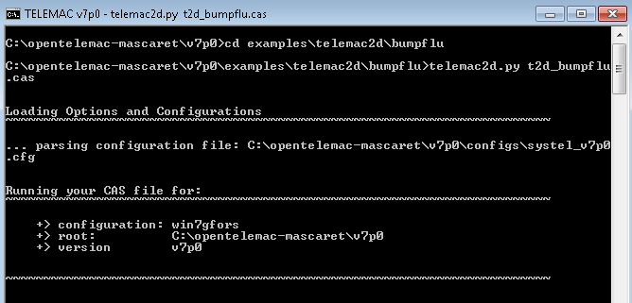](http://wiki.opentelemac.org/lib/exe/detail.php?id=how_to_run_a_simulation&media=runningtestcase.png)

## Deadlock on execution(运行时不动了？!)

If when you are testing a case the listing seems block just after displaying the header. It might be because your mpi installation is not registered to do that.

Do the following actions:

1. In an admnistrator shell type the following commands:
2. smpd -install
3. mpiexec -remove
4. mpiexec -register (With your windows login)

If you do not have administrator rights. A temporary solution that you will have to redo everytime you open a new shell. Is to go inside the temporary folder run the command that was displayed in the listing (the one with mpirun in it).

To check that it worked:

1. In an user shell type the following commands
2. mpiexec -validate (it should return SUCCESS on a user shell)
3. smpd -status (it should return 'smpd running on <hostname>')

# 编译TELEMAC-MASCARET V8.2

不能正确编译mascaret模型，其他一切正常。

必须在ifort CMD环境下，执行Python3脚本。

## 遇到的问题及解决

2.1

编译nestor时，#error: can't find include file: backfill_to_level.f

。。。。。。

要把nestor下的代码，拷贝到builds/../nestor下面去？！！！

2.2

UnicodeDecodeError: 'utf-8' codec can't decode byte 0xd3 in position 1086: invalid continuation byte

在parser_fortran.py的第1695行，

# encoding='utf-8'修改为encoding='ISO-8859-1'

修改代码为：

src_file = open(dif_file, 'r', encoding='ISO-8859-1')

2.3

mascaret静态链接库连接的问题:

xilib.exe /nologo /out:libmascaret.lib *.obj

再返回到D:\opentelemac\v8p2r0\scripts\python3

继续执行python compile_telemac.py

2.4 仍然无法连接生成mascaret,exe

注销了compil_tools.py的部分错误信息代码，在第507行。