# RAE2822 airfoil

This validation case examines the aerodynamic shape optimization of the RAE2822 airfoil. The flow conditions for the simulation are a Reynolds number of 6.5 million, Mach number of 0.729, and angle of attack of 2.31 degrees. Figure 1 displays the results of the simulation with a coarse mesh of 17,408 cells, a medium mesh of 60,672 cells, and a fine mesh of 108,675 cells along with the experimental data (Cook et al.,1979). The three simulations displayed in Figure 1 were run with the Spalart Allmaras turbulence model.

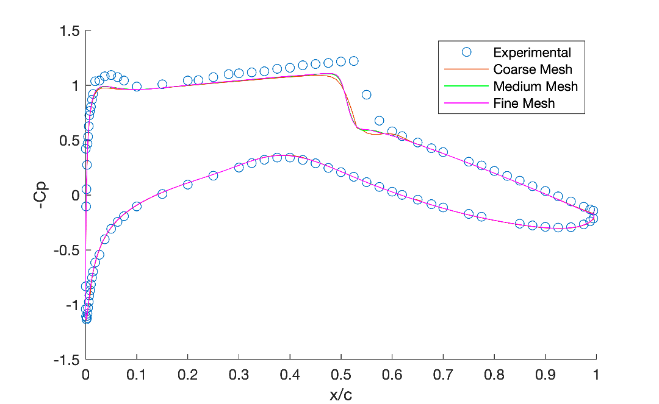

Fig. 1. The pressure distributions for simulations of various mesh cell numbers.

Figure 2 compares the experimental results (Cook et al.,1979) to simulations with the Spalart Allmaras and KOmegaSST turbulence models. Both of the simulations in Figure 2 have 60672 mesh cells

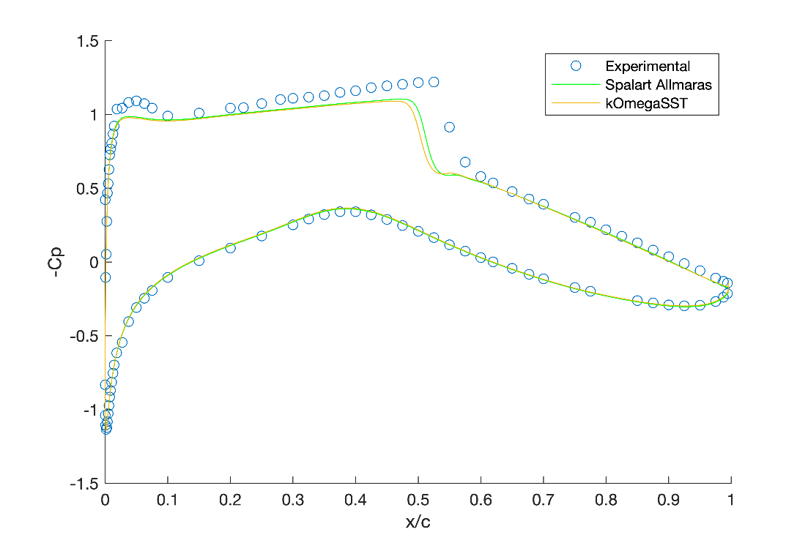

Fig. 2. The pressure distributions for simulations of various turbulence models.

References

Cook, P.H., M.A. McDonald, M.C.P. Firmin, “Aerofoil RAE 2822 - Pressure Distributions, and Boundary Layer and Wake Measurements,” *Experimental Data Base for Computer Program Assessment*, AGARD Report AR 138, 1979.

# NACA0012 airfoil

Under construction.

# Onera M6 wing

Under construction.

# Prowim wing propeller

Under construction.