# Index图形渲染库介绍

适用于 PARAVIEW 的 NVIDIA INDEX 插件

* 帮助更快获得科学发现的交互式立体可视化功能
* 以交互方式分析整个数据集。
* 更快地取得见解。

科学发现离不开将模拟结果迅速可视化。但是，现有的可视化工具无法供用户实时分析大型结构化和非结构化数据集。

NVIDIA IndeX? 是一种面向 HPC 的领先立体可视化工具，有助于解决这一难题。它将可视化工作负载分配到GPU加速的集群中，利用 GPU 的计算能力让用户实时地分析大型数据集。

现在，IndeX 已集成到HPC领域最热门的可视化工具之一ParaView 内。这意味着默认情况下，用户可以通过最新版的 ParaView 使用 IndeX 功能，以便与其现有的立体可视化工作流程进行实时交互。而且，IndeX 提供随数据扩展的可视化性能，以便科学家分析原始解决方案中的整个数据集，从而更快获得科学发现。

## 特性和优势

适用于ParaView的NVIDIA IndeX插件提供随数据扩展的交互式立体可视化功能，让科学家能分析整个数据集，从而更快获得科学发现。

结构化和非结构化立体数据的实时可视化

使用适用于 ParaView的IndeX插件，科学家通过以高帧速率渲染大规模数据，可以实时分析完整分辨率的模拟数据。通过将完整的数据可视化，科学家能快速锁定特别值得关注的数据并做进一步分析，从而更快获得科学发现。

无缝的工作流程

适用于ParaView的IndeX插件允许用户通过ParaView界面利用IndeX的强大功能。这样一来，用户无需学习新的工具、无需改变工作流程，并能专注于研究和更快获得科学发现。

快速分析大规模数据

现有的立体可视化工具无法让科学家以交互方式实时分析大规模数据。科学家必须等上数秒时间待每次交互加载完成，或使用迭代过程实施解决方案，以锁定特别值得关注的数据。适用于ParaView的IndeX插件将数据分散到GPU加速集群内的多个节点上，实时地分析大型数据集。

开源插件

开源软件的优势是用户可以根据自己的需求自定义应用程序。与ParaView相同，IndeX 插件也属于开源软件，可轻松适用于ParaView的定制版本。此插件可以像其他任何标准ParaView插件一样编译，无需使用任何特殊工具和编译器。

借助 BSC，我们生成了大型的人类心脏模型。要验证这些模型的准确性，我们必须对这个数据集进行可视化。并且，高互动性的可视化对于搜集有意义的研究发现而言至关重要。通过IndeX插件，我们可以实时地对我们的54M四面体细胞模型进行可视化。最棒的是，它能完全融入我们现有的ParaView工作流程。 -Mariano Vazquez， 巴塞罗那超级计算中心。

## 其他特性

* 允许以实时交互方式分析大型数据集
* 与 ParaView 基元混合的深度校正
* 动态流式传输和在 GPU 中缓存时变体数据
* 支持所有常见的 ParaView 数据格式
* 在单一节点上合成 ParaView 几何图形
* 针对 Windows 和 Linux 预先构建工作站版本
* 适用于工作站和 HPC 集群的

## PARAVIEW 插件

此插件有两个版本。如果在工作站或单服务器节点中使用，可免费获得此插件。如果想在 GPU 加速的多节点系统中快速分析大规模数据，学术用户可免费获得此插件的集群版本，商业用户则需购买该版本的许可证。

要了解更多信息以及与其他用户交流，请访问 IndeX 论坛页面。

# 使用Index编程

## 前言

## Purpose of this document

The NVIDIA IndeX® framework is intended for large-scale and high-quality volume data visualization. This document describes how to unbox NVIDIA IndeX and render a volumetric dataset.

Audience

This document is intended for scientists, engineers, and other professionals who require high-quality visualization of volumetric datasets of any size for interactive, real-time rendering, exploration, and analysis.

Prerequisites

Unpackaging the NVIDIA IndeX release and rendering a volumetric dataset requires no special skills. A description of the hardware and software prerequisites for running NVIDIA IndeX are included in this document.

Integrating NVIDIA IndeX into your visualization pipeline requires C++ programming skills. This task is covered in the developer documentation shipped with NVIDIA IndeX.

How this document is organized

This document is organized as follows:

* [Accelerating scientific discovery](https://raytracing-docs.nvidia.com/nvindex/getting_started/installing_sdk/index.html#intro#intro-to-ni) provides a brief introduction to NVIDIA IndeX.
* [System requirements](https://raytracing-docs.nvidia.com/nvindex/getting_started/installing_sdk/index.html#system_reqs#system-reqs) describes the hardware and software requirements for running NVIDIA IndeX.
* [Installing NVIDIA IndeX](https://raytracing-docs.nvidia.com/nvindex/getting_started/installing_sdk/index.html#installing_index#install-nv) guides you through download and installation of NVIDIA IndeX.
* [Testing your installation](https://raytracing-docs.nvidia.com/nvindex/getting_started/installing_sdk/index.html#testing_installation#test-install) describes how to load and render an example dataset.
* [Importing a dataset](https://raytracing-docs.nvidia.com/nvindex/getting_started/installing_sdk/index.html#importing_dataset#import-dataset) explains how to load and render your own data.
* [Next steps](https://raytracing-docs.nvidia.com/nvindex/getting_started/installing_sdk/index.html#next_steps#next-steps) offers suggestions for further exploration.
* [Frequently asked questions](https://raytracing-docs.nvidia.com/nvindex/getting_started/installing_sdk/index.html#faq#faq) provides immediate answers to commonly asked questions.
* [This appendix](https://raytracing-docs.nvidia.com/nvindex/getting_started/installing_sdk/index.html#svol_simple_prj#svol-simple-prj-scene-file) provides a listing of a simple scene that you can edit to load your own data.

1 Accelerating scientific discovery

The NVIDIA IndeX® framework sets a new standard for interactive and collaborative exploration and analysis of large-scale scientific visualizations. This document is intended to guide you through the steps for unboxing NVIDIA IndeX and start visualizing and exploring your scientific data.

For additional information about NVIDIA IndeX, see the:

* [NVIDIA IndeX 3D Volumetric Visualization Framework](https://developer.nvidia.com/nvidia-index) page, which provides a brief introduction to NVIDIA IndeX and how teams are using it to solve large-scale visualization challenges and advance scientific understanding.
* [NVIDIA Ray Tracing Documentation](https://raytracing-docs.nvidia.com/) page, where you can link to or download NVIDIA IndeX documentation.

**Note:** Setting up the development environment is not part of the scope of this document. For a description of the NVIDIA IndeX SDK and setting up the development environment, see the [Programmer's manual](https://raytracing-docs.nvidia.com/nvindex/manual/index.html).

2 System requirements

Following is a list of system requirements for NVIDIA IndeX:

GPU and driver

At least one CUDA-capable GPU and a driver that is compatible with the CUDA version required by NVIDIA IndeX. See the NVIDIA IndeX release notes for details.

Operating systems

NVIDIA IndeX runs under the following Linux and Windows systems:

* Red Hat Enterprise Linux (RHEL) or CentOS version 7 or newer. Typically, NVIDIA IndeX will run on other Linux distributions.
* Microsoft Windows 10.

3Installing NVIDIA IndeX

To install NVIDIA IndeX:

1. Fill in and submit the [IndeX contact](https://developer.nvidia.com/index-contact) form.

You will be given instructions for downloading NVIDIA IndeX.

1. After downloading NVIDIA IndeX, unzip the contents to the appropriate directory on your machine.

For a description of the directories, see the README (readme.md or readme.html).

4Testing your installation

The following procedure explains how to test your installation by running the rendering service included with your NVIDIA IndeX download. The rendering service initializes NVIDIA IndeX, loads the test dataset, and renders it. An HTTP server is automatically started and a viewing URL is specified in the log. Multiple people can view and explore the visualization from multiple browser instances using the same URL to enable a collaborative experience.

To test your installation:

1. Open a terminal session if you have not already done so.
2. From the machine where you installed NVIDIA IndeX, switch to the demo directory.

**Note:** You cannot run the demo from elsewhere because all child scripts and files have relative paths from the demo directory.

1. To start the demo, enter the following command at the prompt:
   * Windows: nvindex-viewer.cmd
   * Linux: ./nvindex-viewer.sh

When rendering is successfuly completed, a viewing URL is displayed in the log.

1. If the process fails, check the log for error messages. Ensure that all errors are fixed. If you are unable to resolve an error, contact NVIDIA for support at [nvidia-index@nvidia.com](mailto:nvidia-index@nvidia.com).
2. To display a successful rendering result, open a browser session and load the URL displayed in the log. As mentioned already, multiple people can interact with the visualization simultaneously by starting separate browser instances and loading the same URL.

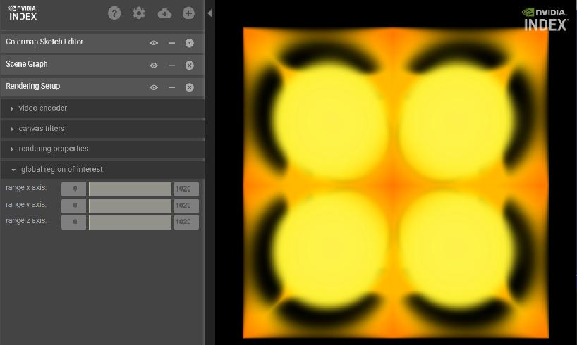

*Fig. 4.1 – Initial image rendered from demo dataset.*

1. To explore the visualization, manipulate it directly and use the supported functionality displayed to the left of the visualization. For example:
   * *Panning* — Hold down the Ctrl key while dragging the mouse
   * *Zooming* — Hold down the Shift key while dragging the mouse
   * *Rotating* — Drag the mouse

To add a panel, click the + button at the top of the window.

1. To close the visualization and release the memory, open the **[**Server**]** menu (top-left) and click **[**File ➤ Shutdown server**]**.

5 Importing a dataset

This chapter describes how to import your own data using a simple scene file and use the render service to visualize it. The scene file you create is used by the system at runtime to upload your data and override related settings in the default scene file.

To import and render your own data:

1. Create a simple scene file to import your data:
   1. Create an empty text file and name it svol-simple.prj.
   2. Copy the contents of the scene file listing in the [appendix](https://raytracing-docs.nvidia.com/nvindex/getting_started/installing_sdk/index.html#svol_simple_prj#svol-simple-prj-scene-file) into the empty text file.
2. Edit the following settings in svol-simple.prj as needed:
   1. A volume shader used for shading a volume dataset called svol_prog
   2. A color map applied to the volume dataset called svol_cmap
   3. Rendering properties applied to the dataset called svol_render_props
   4. The dataset with importer information called seismic_uint8 In particular, you need to specify the following information about the dataset:
      * Location
      * Size
      * Voxel type
3. Save the edited svol-simple.prj scene file to the [main_distribution_directory]/demo directory.
4. Open a command line session, if you have not already done so.
5. At the command prompt, enter:
6. ./nvindex-viewer.sh --add svol-simple.prj

The --add option enables you to specify the scene file that you want the system to use to override settings in the default scene file.

1. When rendering is successful, enter the viewing URL from the log into the location field of your browser to view the result.

6 Next steps

This chapter offers some suggestions to expand your hands-on exploration of NVIDIA IndeX capabilities.

6.1Running NVIDIA IndeX from a cloud service

NVIDIA IndeX is currently available as a cloud service from [AWS](https://github.com/NVIDIA/nvindex-cloud/blob/master/doc/aws.md) and [Google Cloud Marketplace](https://github.com/NVIDIA/nvindex-cloud/blob/master/doc/gke-app.md). Extensive documentation is provided to guide you through the process of setting up a cluster, uploading data , rendering, and viewing the result. Example datasets that you can use are available from the [Sample Dataset Information](https://github.com/NVIDIA/nvindex-cloud/blob/master/doc/datasets.md) page. Instructions are also provided for uploading and rendering your own datasets.

6.2Exploring the NVIDIA IndeX tutorials

Be sure to take a look at the tutorials, which explore some of the key capabilities of NVIDIA IndeX. You can start the tutorials from the [main_distribution_directory]/tutorial using the ./nvindex-tutorial.sh shell script. Be sure to take a look at the ../tutorial/README for additional detail before you start.

6.3Integrating NVIDIA IndeX into your application

For detailed information about integrating NVIDIA IndeX into your application or application pipeline, refer to the NVIDIA IndeX documentation accessible from the [NVIDIA Ray Tracing Documentation](https://raytracing-docs.nvidia.com/) page.

7Frequently asked questions

**Q:**Do I need to install the CUDA SDK or any other libraries to use the plugin?

**A:**The [CUDA SDK](https://developer.nvidia.com/cuda-zone) is required for building example programs or plugins that make use of CUDA. You also need to install the appropriate NVIDIA display driver for your GPU.

**Q:**Can I render multiple volumes?

**A:**Yes, the NVIDIA IndeX SDK supports multi-volume rendering.

Appendix A: Example scene file svol-simple.prj

The following listing is the simple scene file named svol-simple.prj. You can use this file to override the settings of the default scene file to load your own data. For more information, see [Importing a dataset](https://raytracing-docs.nvidia.com/nvindex/getting_started/installing_sdk/index.html#importing_dataset#import-dataset).

Words in italics should be replaced by the appropriate value for your installation.

#! index_app_project 0

# -*- mode: Conf; -*-

index::region_of_interest = 0 0 0 500 500 1500

app::scene::root::children = sparse_volume_data

app::scene::sparse_volume_data::type = static_scene_group

app::scene::sparse_volume_data::children = svol_render_props svol_cmap rtc_volume volume_dataset

app::scene::rtc_volume::type = rendering_kernel_program

app::scene::rtc_volume::target = volume_sample_program

app::scene::rtc_volume::enabled = true

app::scene::rtc_volume::source_file = sparse_volume_basic.cu

# Setup rendering properties

app::scene::svol_render_props::type = sparse_volume_rendering_properties

app::scene::svol_render_props::filter_mode = trilinear

app::scene::svol_render_props::sampling_distance = 0.5

# The map_type: either procedural or lookup_table

app::scene::svol_cmap::type = colormap

app::scene::svol_cmap::map_type = lookup_table

app::scene::svol_cmap::domain = 0.0 1.0

app::scene::svol_cmap::domain_boundary_mode = clamp_to_edge

# The volume type. A sparse volume is able to manage dense and sparse volume

# datasets as well as multi-resolution data.

app::scene::volume_dataset::type = sparse_volume

# This option selects a specific data importer. The importer reads raw voxel

# data in a given order (see below).

app::scene::volume_dataset::importer = nv::index::plugin::base_importer.Sparse_volume_importer_raw

# The voxel format. The present dataset's voxels are of type uint8. Valid types

# are: uint8, uint16, sint16, rgba8, float32.

app::scene::volume_dataset::voxel_format = uint8

# In some cases, volume data is stored in z-first/x-last order. In such cases,

# the option 'app::scene::volume_dataset::convert_zyx_to_xyz' needs to be set to

# 'true' because NVIDIA IndeX sores the volume data in x-first/z-last order in

# memory.

# The present dataset is assumed to be in x-first/z-last order, i.e., no

# conversion required: app::scene::volume_dataset::convert_zyx_to_xyz = false

# The size of the dataset in the datasets local space

app::scene::volume_dataset::size = 500 500 1500

# The bounding box defines the space within which the volume is defined

app::scene::volume_dataset::bbox = 0 0 0 500 500 1500

# Import directory

app::scene::volume_dataset::input_directory = *your-directory*

# Name of the file

app::scene::volume_dataset::input_file_base_name = *your-filename-without-extension*

# File extension (including the initial dot character)

app::scene::volume_dataset::input_file_extension = .*your-filename-extension*

# Cache data on disk for future accelerated data imports

app::scene::volume_dataset::cache = false

The value of app::scene::rtc_volume::source_file is the filename sparse_volume_basic.cu. This file contains a generic sparse volume CUDA program, displayed in Listing A.1:

*Listing A.1: CUDA file sparse_volume_basic.cu*

class Volume_sample_program

{

NV_IDX_VOLUME_SAMPLE_PROGRAM

const nv::index::xac::Colormap colormap = state.self.get_colormap();

public:

NV_IDX_DEVICE_INLINE_MEMBER

void initialize() {}

NV_IDX_DEVICE_INLINE_MEMBER

int execute(

const Sample_info_self& sample_info,

Sample_output& sample_output)

{

using namespace nv::index;

const auto& svol = state.self;

const auto svol_sampler =

svol.generate_sampler<float,xac::Volume_filter_mode::TRILINEAR>(

0u,

sample_info.sample_context);

const float v = svol_sampler.fetch_sample(

sample_info.sample_position_object_space);

sample_output.set_color(colormap.lookup(v));

return NV_IDX_PROG_OK;

}

};

## 1系统概览

<https://raytracing-docs.nvidia.com/nvindex/manual/index.html#system_overview#software-components>

1.1Software components

The NVIDIA IndeX release contains the following parts:

* Two shared library files for the Linux platform:
  + libdice, the Distributed Computing Environment (DiCE) layer
  + libnvindex, the IndeX library
* The set of C++ header files that declare the components of the IndeX API.
* The NVIDIA IndeX Programmer's Manual (this document)
* The [API documentation](https://raytracing-docs.nvidia.com/nvindex/reference/index.html) for IndeX and its support libraries
* [Installation instructions](https://raytracing-docs.nvidia.com/nvindex/getting_started/index.html)

In the documentation, the IndeX and DiCE software libraries are referenced together as the “IndeX library.” The application programming interface for these two libraries is called the “IndeX API.”

<https://raytracing-docs.nvidia.com/nvindex/getting_started/index.html>

[Unboxing](https://raytracing-docs.nvidia.com/nvindex/getting_started/installing_sdk/index.html)

[System settings](https://raytracing-docs.nvidia.com/nvindex/getting_started/system_settings/index.html)

[Options files](https://raytracing-docs.nvidia.com/nvindex/getting_started/scene_file_syntax/index.html)

[Structure and syntax](https://raytracing-docs.nvidia.com/nvindex/getting_started/scene_file_syntax/description/index.html)

[Options file: project.prj](https://raytracing-docs.nvidia.com/nvindex/getting_started/scene_file_syntax/project_options/index.html)

[Options file: scene.prj](https://raytracing-docs.nvidia.com/nvindex/getting_started/scene_file_syntax/scene_options/index.html)

The system settings explain how to tune your system so that NVIDIA IndeX runs effectively. Option files are used to define parameter settings for system operation and scene display and construction.

## 2基本编程概念

## 2Basic programming concepts

The follow sections describe the syntactic conventions, file system organization, and basic programming concepts of NVIDIA IndeX.

2.1Naming conventions

The IndeX library is written in C++. It use the namespace [nv::index](https://raytracing-docs.nvidia.com/nvindex/reference/nindex/namespacenv_1_1index.html) for identifiers, and the NVIDIA_INDEX_ prefix for macros.

Multiple words are concatenated with the underscore character (_) to form identifiers. Function names are all spelled in lowercase; type and class names start with one initial uppercase letter.

2.2Main C++ header files

The C++ header file [iindex.h](https://raytracing-docs.nvidia.com/nvindex/reference/nindex/iindex_8h.html) in the IndeX API directory nv/index contains the base functionality for initializing and accessing the IndeX library. More specific components of the library also have their respective header files in nv/index.

2.3Interfaces

The IndeX API follows current C++ library design principles for component software to achieve binary compatibility across shared library boundaries and future extensibility. The design provides access to the shared library through *interfaces*, abstract base classes with pure virtual member functions.

The global function [nv_index_factory](https://raytracing-docs.nvidia.com/nvindex/reference/nindex/group__nv__index.html#gab11a622fe7c01d97c7fc3f5741cda4af)() returns the main interface [IIndex](https://raytracing-docs.nvidia.com/nvindex/reference/nindex/classnv_1_1index_1_1IIndex.html) that allows access to the whole library. From this interface other interfaces of the library can be accessed with the [IIndex](https://raytracing-docs.nvidia.com/nvindex/reference/nindex/classnv_1_1index_1_1IIndex.html)::get_api_component member function.

2.4Reference counting

Interfaces are reference-counted dynamic resources that need to be released when no longer needed. Whenever a function returns a pointer to [mi::base::IInterface](https://raytracing-docs.nvidia.com/nvindex/reference/base/classmi_1_1base_1_1IInterface.html) or a class that uses it as a base class, the corresponding reference counter has already been increased by 1. That is, you can use the interface pointer without first determining if the pointer is still valid. Whenever you do not need an interface any longer, you have to release it by calling its release() method. Omitting such calls leads to memory leaks.

2.5Handle class

To assist in memory management of class instances, the IndeX API provides the handle class [mi::base::Handle](https://raytracing-docs.nvidia.com/nvindex/reference/base/classmi_1_1base_1_1Handle.html). This handle class maintains pointer semantics while supporting reference counting for interface pointers. For example, the operator acts on the underlying interface pointer. The destructor calls release() on the interface pointer; the copy constructor and assignment operator take care of retaining and releasing the interface pointer as necessary. Note that it is also possible to use other handle class implementations, for example, [std::tr1::shared_ptr<T>](http://en.cppreference.com/w/cpp/memory/shared_ptr) or [boost::shared_ptr](http://www.boost.org/doc/libs/1_58_0/libs/smart_ptr/shared_ptr.htm).

2.6Resources

As is typical in all resource-heavy applications, you should aim for minimal resource usage by releasing interface pointers as soon as you no longer need the resources to which they provide access. When a handle class instance goes out of scope, its destructor method releases its resources. By introducing a nested scope (surrounding statements in a { and } pair), resources acquired with the scope will automatically be released at its end.

2.7Strings

The interface [mi::IString](https://raytracing-docs.nvidia.com/nvindex/reference/dice/classmi_1_1IString.html) represents strings. However, some methods return constant strings as a pointer to const char for simplicity. These strings are managed by the IndeX library and you must not deallocate the memory pointed to by such a pointer. These pointers are valid as long as the interface from which the pointer was obtained is valid.

## 3 XAC -- Accelerated Compute Interface

The [IndeX Accelerated Compute (XAC) Interface](https://raytracing-docs.nvidia.com/nvindex/reference/nindex/group__xac.html) enables programmers to add real-time compiled sampling programs into the IndeX volume rendering pipeline. XAC programs are written in the CUDA programming language.

The data distribution, parallelization, and management is handled by IndeX while the XAC interface can directly modify the rendering output produced by Index.

3.1Sample program overview

IndeX performs a front-to-back ray casting procedure for each rendered frame of a scene. A user-defined sampling program can be executed at each step of a ray generated by the ray caster.

There are two types of sampling programs:

*Surface programs*

Based on class [ISurface_sample_program](https://raytracing-docs.nvidia.com/nvindex/reference/nindex/classnv_1_1index_1_1ISurface__sample__program.html)

*Volume programs*

Based on class [IVolume_sample_program](https://raytracing-docs.nvidia.com/nvindex/reference/nindex/classnv_1_1index_1_1IVolume__sample__program.html)

Volume sampling programs are called for each step traversing through a volume during the ray casting procedure. In contrast, surface programs are only executed when a surface-based scene element is hit.

[Listing 3.1](https://raytracing-docs.nvidia.com/nvindex/manual/index.html#listing_3.1) shows the basic structure of a volume sampling program.

*Listing 3.1*

using namespace [nv::index::xac](https://raytracing-docs.nvidia.com/nvindex/reference/nindex/namespacenv_1_1index_1_1xac.html);

class Volume_sample_program

{

[NV_IDX_VOLUME_SAMPLE_PROGRAM](https://raytracing-docs.nvidia.com/nvindex/reference/nindex/xac__interface__standard__lib__doc_8h.html#a8c9c2118abac6903df27e98dc2288aaf)

public:

[NV_IDX_DEVICE_INLINE_MEMBER](https://raytracing-docs.nvidia.com/nvindex/reference/nindex/xac__interface__standard__lib__doc_8h.html#a7e66f15f9e79913e3ef8d06094aa58d1)

void initialize()

{

...

Initialize the program

}

[NV_IDX_DEVICE_INLINE_MEMBER](https://raytracing-docs.nvidia.com/nvindex/reference/nindex/xac__interface__standard__lib__doc_8h.html#a7e66f15f9e79913e3ef8d06094aa58d1)

int execute(

const Sample_info_self& sample_info,

Sample_output& sample_output)

{

...

Perform computations

return [NV_IDX_PROG_OK](https://raytracing-docs.nvidia.com/nvindex/reference/nindex/group__xac__lib.html#gga88218f7155972573815d158e255a3524a374ca8497af1f5fb96a81ad99e9e2b54);

}

};

In [Figure 3.1](https://raytracing-docs.nvidia.com/nvindex/manual/index.html#xac#shader-evaluation), sampling is performed at various positions along the course of a rays traversal from the camera into the scene:

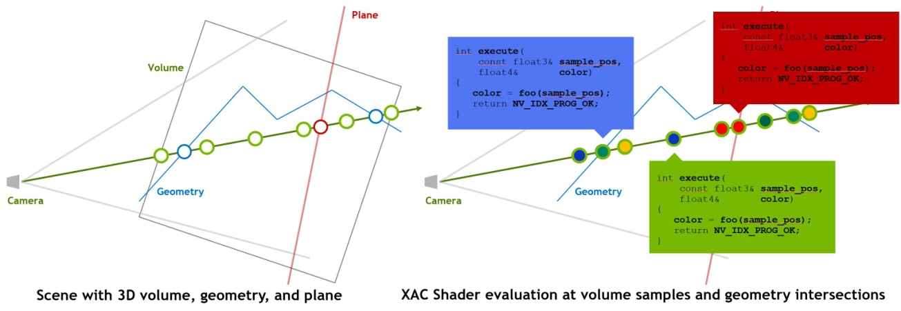

*Fig. 3.1 – XAC code execution in volume and surface programs occurs when sampling a volume along a ray or when a ray intersects a surface.*

[Figure 3.2](https://raytracing-docs.nvidia.com/nvindex/manual/index.html#xac#Cholla-Resample-Layout-xac-shape-v01a) shows a volume sample program in the code editor:

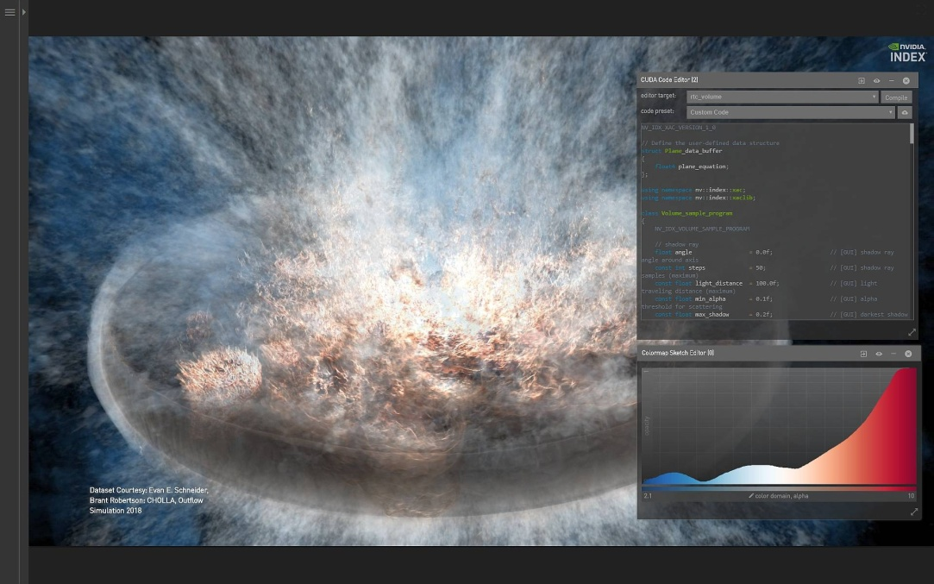

*Fig. 3.2 – Code editor and image display*

[Listing 3.2](https://raytracing-docs.nvidia.com/nvindex/manual/index.html#listing_3.2) shows the basic structure of a surface sampling program.

Listing 3.2

using namespace [nv::index::xac](https://raytracing-docs.nvidia.com/nvindex/reference/nindex/namespacenv_1_1index_1_1xac.html);

class Surface_sample_program

{

[NV_IDX_SURFACE_SAMPLE_PROGRAM](https://raytracing-docs.nvidia.com/nvindex/reference/nindex/xac__interface__standard__lib__doc_8h.html#a3e20492d1d6ce3a7e9885748e8922ef4)

public:

[NV_IDX_DEVICE_INLINE_MEMBER](https://raytracing-docs.nvidia.com/nvindex/reference/nindex/xac__interface__standard__lib__doc_8h.html#a7e66f15f9e79913e3ef8d06094aa58d1)

void initialize()

{

...

*Initialize the program*

}

[NV_IDX_DEVICE_INLINE_MEMBER](https://raytracing-docs.nvidia.com/nvindex/reference/nindex/xac__interface__standard__lib__doc_8h.html#a7e66f15f9e79913e3ef8d06094aa58d1)

int execute(

const Sample_info_self& sample_info,

*Read-only*

Sample_output& sample_output)

*Write-only*

{

...

*Perform computations*

return [NV_IDX_PROG_OK](https://raytracing-docs.nvidia.com/nvindex/reference/nindex/group__xac__lib.html#gga88218f7155972573815d158e255a3524a374ca8497af1f5fb96a81ad99e9e2b54);

}

};

The available information that is passed as input in the Sample_info_self depends on the associated scene element for which the program is executed.

See the [API documentation for structs used in sampling](https://raytracing-docs.nvidia.com/nvindex/reference/nindex/xac__interface__sample__info__doc_8h.html).

3.2Scene property access

[Listing 3.3](https://raytracing-docs.nvidia.com/nvindex/manual/index.html#listing_3.3) demonstrates how the state object provides access to the associated scene element for which a sample program has been called.

Listing 3.3

class Volume_sample_program

{

[NV_IDX_VOLUME_SAMPLE_PROGRAM](https://raytracing-docs.nvidia.com/nvindex/reference/nindex/xac__interface__standard__lib__doc_8h.html#a8c9c2118abac6903df27e98dc2288aaf)

const Regular_volume volume = state.self;

Retrieve the associated scene element reference

...

*Program using*volume

}

[Listing 3.4](https://raytracing-docs.nvidia.com/nvindex/manual/index.html#listing_3.4) demonstrates how scene elements that have been specified in the IndeX scene can be accessed in sample programs.

*Listing 3.4*

const Regular_volume volume =

state.scene.access<Regular_volume>(0);

*Example object retrieval from the scene*

Additionally, the scene provides access to a set of scene element handling and basic transformation functions.

See the [API documention for the XAC scene definition class](https://raytracing-docs.nvidia.com/nvindex/reference/nindex/xac__interface__scene__doc_8h.html).

3.3 Scene element overview

Predefinied elements that are part of the XAC interface can provide information about the current IndeX state, for example, rendering behavior and color mapping.

* [xac::Ray](https://raytracing-docs.nvidia.com/nvindex/reference/nindex/classnv_1_1index_1_1xac_1_1Ray.html)
* [xac::Camera](https://raytracing-docs.nvidia.com/nvindex/reference/nindex/classnv_1_1index_1_1xac_1_1Camera.html)
* [xac::Colormap](https://raytracing-docs.nvidia.com/nvindex/reference/nindex/classnv_1_1index_1_1xac_1_1Colormap.html)
* [xac::Light](https://raytracing-docs.nvidia.com/nvindex/reference/nindex/classnv_1_1index_1_1xac_1_1Light.html)
* [xac::Material_phong](https://raytracing-docs.nvidia.com/nvindex/reference/nindex/classnv_1_1index_1_1xac_1_1Material__phong.html)

XAC also provides a set of geometric scene elements that are used for the final visualization output:

* [xac](https://raytracing-docs.nvidia.com/nvindex/reference/nindex/namespacenv_1_1index_1_1xac.html)::Regular_volume
* [xac::Height_field](https://raytracing-docs.nvidia.com/nvindex/reference/nindex/classnv_1_1index_1_1xac_1_1Height__field.html)
* [xac::Triangle_mesh](https://raytracing-docs.nvidia.com/nvindex/reference/nindex/classnv_1_1index_1_1xac_1_1Triangle__mesh.html)
* [xac::Plane](https://raytracing-docs.nvidia.com/nvindex/reference/nindex/classnv_1_1index_1_1xac_1_1Plane.html)
* [xac::Cone](https://raytracing-docs.nvidia.com/nvindex/reference/nindex/classnv_1_1index_1_1xac_1_1Cone.html)
* [xac::Cylinder](https://raytracing-docs.nvidia.com/nvindex/reference/nindex/classnv_1_1index_1_1xac_1_1Cylinder.html)
* [xac::Ellipsoid](https://raytracing-docs.nvidia.com/nvindex/reference/nindex/classnv_1_1index_1_1xac_1_1Ellipsoid.html)

Compute texture objects can store additional information for surface scene elements.

* [xac::Compute_texture_tile](https://raytracing-docs.nvidia.com/nvindex/reference/nindex/classnv_1_1index_1_1xac_1_1Compute__texture__tile.html)

See the [API documention for XAC scene elements](https://raytracing-docs.nvidia.com/nvindex/reference/nindex/group__xac__obj.html).

3.4XAC library functionality

Standard CUDA math functionality is available within the sample programs. Additional headers can be provided by the scene and included within the sample program.

The XAC interface also provides a set of convenience macros and functions for printing debugging information, transformation handling, basic shading operations and generic gradient operators.

See also the [API documentation for XAC macros and functions](https://raytracing-docs.nvidia.com/nvindex/reference/nindex/xac__interface__standard__lib__doc_8h.html).

## 4 API用法

The IndeX software distribution includes an introduction to [programming with the IndeX API in this manual](https://raytracing-docs.nvidia.com/nvindex/manual/index.html#basic_programming_concepts#basic-programming-concepts) and [APIs, modules and source code](https://raytracing-docs.nvidia.com/nvindex/reference/examples/html/index.html) that showcase various features of using the library through its application programming interface (API). All the code examples can be run using the command line to test and illustrate individual functionalities of the library.

<https://raytracing-docs.nvidia.com/nvindex/manual/index.html#basic_programming_concepts#basic-programming-concepts>

The example source code is located under the src/index_examples/ directory. Running the make command in the src/ directory will build all the examples in the subdirectories containing a specific example. In order to run these examples, library paths need to be set. This can be done by executing the following command in the shell at the tape's root directory:

source src/setup.sh

Executing each example program with the -h option will show that example's usage options. Please note, this setup.sh script is for bash. If you need to use other type of shell, please adjust the setup script accordingly.