# HDF5的两个新概念VOL和VFD

介绍HDF5的两个新概念VOL和VFD，基于此，新开发了异步IO和GDS (GPUDirect Storage）的功能，对HPC I/O将有推动作用。

## VOL (Virtual Object Layer)

<https://portal.hdfgroup.org/display/HDF5/Virtual+Object+Layer>

下面介绍HDF5-1.12的VOL新特性。

介绍

The Virtual Object Layer (VOL) is an abstraction layer within the HDF5 library that enables different methods for accessing data and objects that conform to the HDF5 data model.

The VOL intercepts all HDF5 API calls that potentially modify data on disk and forwards those calls to a plugin "object driver". The data on disk can be a different format than the HDF5 format:

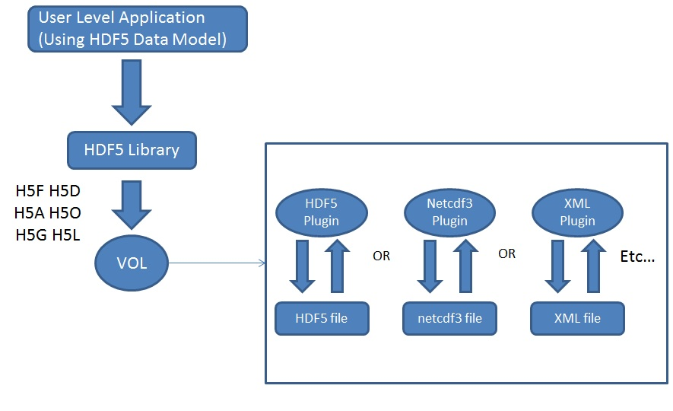

The plugins can actually store the objects in variety of ways. A plugin could, for example, have objects be distributed remotely over different platforms, provide a raw mapping of the model to the file system, or even store the data in other file formats (like native netCDF or HDF4 format). The user still gets the same data model where access is done to a single HDF5 “container”; however the plugin object driver translates from what the user sees to how the data is actually stored. Having this abstraction layer maintains the object model of HDF5 and allows better usage of new object storage file systems that are targeted for Exascale systems.

文档

* [HDF5 VOL User's Guide](https://portal.hdfgroup.org/display/HDF5/HDF5+VOL+User%27s+Guide)
* [HDF5 VOL Connector Author's Guide](https://portal.hdfgroup.org/display/HDF5/HDF5+VOL+Connector+Authors+Guide)
* [Virtual Object Layer (RFC)](https://portal.hdfgroup.org/display/HDF5/Virtual+Object+Layer+RFC)
* [VOL Feature flag/layers RFC](https://bitbucket.hdfgroup.org/projects/HDFFV/repos/hdf5doc/browse/RFCs/HDF5/VOL/2019-09-23-RFC_VOL_feature_flags.docx)
* [Berkeley DB VOL Connector](https://bitbucket.hdfgroup.org/projects/HDF5VOL/repos/berkeley-db/browse)

HDF5 Library APIs

Virtual Object Layer (H5VL) and VOL Property List APIs

New Virtual Object Layer (H5VL) APIs have been introduced for working with the VOL, as well as Property List APIs for working with the VOL:

| Function | Description |
| --- | --- |
| [H5P_GET_VOL_ID](https://portal.hdfgroup.org/display/HDF5/H5P_GET_VOL_ID) | Returns the identifier of the current VOL connector |
| [H5P_GET_VOL_INFO](https://portal.hdfgroup.org/display/HDF5/H5P_GET_VOL_INFO) | Returns a copy of the VOL information for a connector |
| [H5P_SET_VOL](https://portal.hdfgroup.org/display/HDF5/H5P_SET_VOL) | Set the file VOL connector for a file access property list |
| [H5VL_GET_CONNECTOR_NAME](https://portal.hdfgroup.org/display/HDF5/H5VL_GET_CONNECTOR_NAME) | Retrieves the connector name for the VOL associated with the object or file identifier |
| [H5VL_IS_CONNECTOR_REGISTERED_BY_NAME](https://portal.hdfgroup.org/display/HDF5/H5VL_IS_CONNECTOR_REGISTERED_BY_NAME) | Tests whether a VOL class has been registered or not |
| [H5VL_REGISTER_CONNECTOR](https://portal.hdfgroup.org/display/HDF5/H5VL_REGISTER_CONNECTOR) | Registers a new VOL connector |
| [H5VL_REGISTER_CONNECTOR_BY_NAME](https://portal.hdfgroup.org/display/HDF5/H5VL_REGISTER_CONNECTOR_BY_NAME) | Registers a new VOL connector by name |
| [H5VL_REGISTER_CONNECTOR_BY_VALUE](https://portal.hdfgroup.org/display/HDF5/H5VL_REGISTER_CONNECTOR_BY_VALUE) | Registers a new VOL connector by connector value |
| [H5VL_UNREGISTER_CONNECTOR](https://portal.hdfgroup.org/display/HDF5/H5VL_UNREGISTER_CONNECTOR) | Removes a VOL connector identifier from the library |

H5Fdelete and Changes to the Virtual File Layer (VFL) ([RFC](https://portal.hdfgroup.org/display/HDF5/H5Fdelete+RFC))

With the VOL, HDF5 "files" can map to arbitrary storage schemes such as object stores and relational database tables. The data created by these implementations may be inconvenient for a user to remove without a detailed knowledge of the storage scheme. The H5Fdelete() API was introduced to give VOL connector authors the ability to add connector-specific delete code to their connectors so that users can remove these "files" without detailed knowledge of the storage scheme.

| Function | Description |
| --- | --- |
| [H5F_DELETE](https://portal.hdfgroup.org/display/HDF5/H5F_DELETE) | Deletes an HDF5 file |

Since HDF5 storage can differ among the virtual file drivers, changes had to be made so that each Virtual File Driver (VFD) could have its own driver-specific cleanup code.

## VFD (Virtual File Driver)

What is a File Driver ?

In HDF5, a file driver is a mapping between the HDF5 format address space and storage. By default, HDF5 simply maps the format address space directly onto a single file.

However, users may want the ability to map the format address space onto different types of storage with various types of maps. With HDF5 we provide a small set of pre-defined file drivers, and users can implement their own mappings using the Virtual File Layer APIs. With HDF5-1.12 users can create Virtual Object Layer plugins to HDF5 to store objects with file drivers that they have created.

Detailed information on file drivers can be found under the Technical Notes documentation on the [Virtual File Layer](https://portal.hdfgroup.org/display/HDF5/Virtual+File+Layer)

https://portal.hdfgroup.org/display/HDF5/Virtual+File+Layer

File Drivers Defined in HDF5

Following are the file drivers that HDF5 provides.

* + - **H5FD_CORE:** This driver performs I/O directly to memory and can be used to create small temporary files that never exist on permanent storage.
    - **H5FD_FAMILY:**This driver partitions a large format address space into smaller chunks (separate storage of a user's choice).
    - [**HDF5_HDFS**](https://portal.hdfgroup.org/display/HDF5/Virtual+File+Drivers+-+S3+and+HDFS):This driver enables access to an HDF5 file with the Hadoop Distributed File System (HDFS). ***New***
    - **H5FD_MPIIO:** This driver is used with Parallel HDF5, and is only pre-defined if the library is compiled with parallel I/O support.
    - **H5FD_MULTI:**This driver enables different types of HDF5 data and metadata to be written to separate files. The H5FD_SPLIT driver is an example of what the H5FD_MULTI driver can do.
    - [**H5FD_ROS3**](https://portal.hdfgroup.org/display/HDF5/Virtual+File+Drivers+-+S3+and+HDFS):This driver enables access to an HDF5 file via the Amazon Simple Storage Service (Amazon S3).***New***
    - **H5FD_SEC2:**This is the default driver which uses Posix file-system functions like read and write to perform I/O to a single file.
    - **H5FD_SPLIT:**This driver splits the meta data and raw data into separate storage of a user's choice.
    - **H5FD_STDIO:**This driver uses functions from 'stdio.h' to perform buffered I/O to a single file.

Programming Model for Using a Pre-Defined File Driver

Create a copy or instance of the File Access property list:

***fapl*** = H5Pcreate (H5P_FILE_ACCESS);

Initialize the file driver. Each pre-defined file driver has it's own initialization function, whose name is H5Pset_fapl_ followed by the driver name and which takes a file access property list as the first argument, followed by additional driver-dependent arguments. For example:

size_t member_size = 100*1024*1024; /* 100 MB */

status = *H5Pset_fapl_family* (***fapl***, member_size, H5P_DEFAULT);

An alternative to using the driver initialization function is to set the driver directly using H5Pset_driver, which is not covered here.

Call H5Fcreate, passing in the identifier of the property list just modified.

file_id = H5Fcreate (HDF5FILE, H5F_ACC_TRUNC, H5P_DEFAULT, ***fapl***);

Close the File Access Property List:

status = H5Pclose (***fapl***);

Perform I/O on the file, if need be. To do so, a Data Access/Transfer property must be copied, modified, and passed in to H5Dread or H5Dwrite.

For example, the following sets the MPI-IO driver to use independent access for I/O operations:

dxpl = H5Pcreate (H5P_DATA_XFER);

status = H5Pset_dxpl_mpio (dxpl, H5FD_MPIO_INDEPENDENT);

status = H5Dread (dataset_id, type, mspace, fspace, buffer, dxpl);

User Designed File Drivers

These are out of the scope of this tutorial. Refer to the Technical Notes documentation on the [Virtual File Layer](https://portal.hdfgroup.org/display/HDF5/Virtual+File+Layer).

https://portal.hdfgroup.org/display/HDF5/Virtual+File+Layer

How Does a General Application Open an HDF5 File ?

A general application does not know what drivers were used to create a file. It would have to try different file drivers until it succeeds. An example of a general application is the h5dump tool that we provide with HDF5.

VFD SWMR(Single Writer Multiple Reader)

The SWMR (Single Writer Multiple Reader) feature enables a second process to read an HDF5 file while data is being written to it. However, the current implementation touches most parts of the HDF5 library, presenting significant maintenance issues, and furthermore, offers no guarantees on the maximum time from write to read, which is problematic for some applications.

The VFD SWMR is more modular, minimizing the maintenance issues. It has additional benefits  including allowing the HDF5 library to make guarantees for the maximum time from write to availability of data read and the possibility of extending SWMR to NFS and object stores. Please see the [RFC](https://portal.hdfgroup.org/display/HDF5/VFD+SWMR+-+RFC) for complete details.