# Introduction to ParaView Catalyst Live(2014)

<https://blog.kitware.com/introduction-to-paraview-catalyst-live/>

[ParaView Catalyst](http://catalyst.paraview.org/) is a library that adds ParaView analysis and visualization capabilities to a simulation program. For each time step, the simulation code generates data which is passed (using [Catalyst’s API](http://catalyst.paraview.org/)) to a ParaView pipeline. This pipeline generates images or processed data that can be saved to disk.

Furthermore, data can be exchanged with a remote ParaView server enabling easy inspection of simulation status and modification of analysis and visualization parameters. We call this connection ParaView Catalyst Live.

The goal of this post is to enable you to try out Catalyst Live and introduce its main features. First, we invite you to watch a video which introduces the example presented next.

[Introduction to Paraview Catalyst Live](https://vimeo.com/107165598) from [Kitware](https://vimeo.com/kitware) on [Vimeo](https://vimeo.com/).

To be able to run the example presented, you need to download a [repository version](http://www.paraview.org/Wiki/ParaView/Git) of ParaView, configure it with PARAVIEW_ENABLE_CATALYST and PARAVIEW_ENABLE_PYTHON and compile it (see the [ParaView Build and Install Wiki](http://www.paraview.org/Wiki/ParaView:Build_And_Install) for more information). Optionally, you can also enable PARAVIEW_USE_MPI if you want to run coprocessing or ParaView in parallel.

You also need two scripts: driver.py and coprocessing-pipeline.py which are attached to this blog post. driver.py plays the role of a simulation process which generates at each time step a wavelet with a different parameters (see ParaView’s Sources/Wavelet menu). coprocessing-pipeline.py processes this data by running a contour filter, saving both the wavelet and the contour as data files, saving an image showing the contour and enabling Catalyst Live communication. This second script was generated using the [Catalyst Script Generator Plugin](http://www.paraview.org/Wiki/images/4/48/CatalystUsersGuide.pdf) (for ParaView 4.1 and earlier it was called the CoProcessing Script Generator Plugin).

With these, you are ready to try out Catalyst Live. Note that all commands shown are relative to ParaView’s build directory. First download the two scripts in a directory (assume it is called Catalyst-test) and start the driver and the coprocessing pipeline:

bin/pvbatch ~/Catalyst-test/driver.py coprocessing-pipeline.py 1000

Here we run the driver for 1,000 time steps and we pass the coprocessing pipeline script as a parameter. Then, start ParaView and connect to Catallyst using Catalyst > Connect menu. The Pipeline Browser displays two servers, the builtin server and the catalyst server. Note that next to the catalyst server there is a ‘play’ icon showing that the simulation is running.

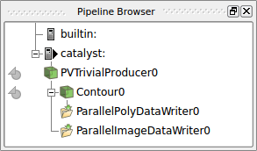

The two grayed out icons next to PVTrivialProducer0 and Contour0 allow you to extract data from Catalyst, transfer it, and visualize it on Catalyst Live. Care must be exercised when clicking on the extract icons as data you request to be transfered may be very big (for real simulations). When you click on the extract icon next the the Contour0 data is added as a source to the builtin server. This data can be visualized by clicking on the eye icon next to it.

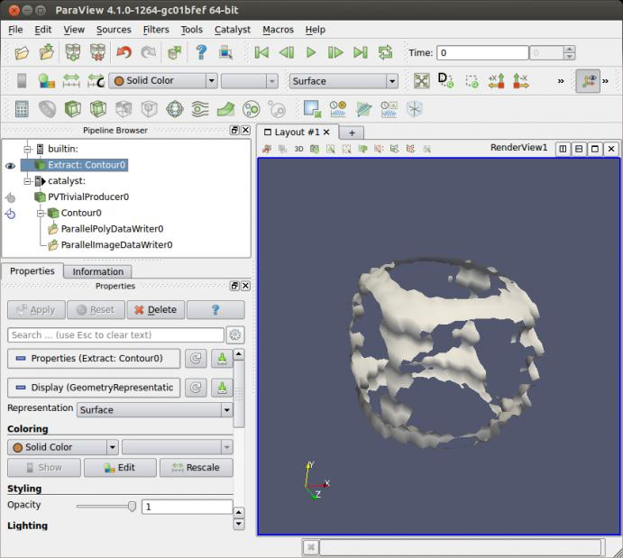

A user can do the following operations:

* Modify any visualization pipeline or writer parameters. Note that pipeline elements cannot be added or removed in the current version and we provide only generic writer parameters such as file name and writing frequency.
* Pause a simulation using Catalyst > Pause Simulation and continue it using Catalyst > Continue. If a simulation is paused, a ‘pause’ icon will be displayed next to the catalyst server.
* Pause the simulation at a certain time step in the future using Catalyst > Set Breakpoint or remove a previously set breakpoint using Catalyst > Remove Breakpoint. If a breakpoint is set, a red circle is displayed next to the catalyst server.

While a simulation is paused, the user can fully interact with simulation data by changing visualization pipeline parameters.

If you compiled ParaView with PARAVIEW_USE_MPI you can run both Catalyst and Paraview in parallel:

mpiexec -np 5 bin/pvbatch -sym ~/Catalyst-test/driver.py coprocessing-pipeline.py 1000

runs the driver and the coprocessing pipeline on 5 processors

mpiexec -np 2 bin/pvserver

runs ParaView server on 2 processors

bin/paraview -url=cs://your-computer-name:11111

runs the ParaView client and connects it to the ParaView server you just started. Everything else behaves the same as in the serial run.

With this, we end our introduction to ParaView Catalyst Live and invite you to try it out. It is part of the ParaView 4.2 release.

## Update 2017/11/03

The files in the post are now used for testing and are available in the ParaView source code.  Search the source code for the driver CatalystWaveletDriver.py and the coprocessing pipeline CatalystWaveletCoprocessing.py. You can use these files as described in the post or you can run the associated ParaView tests: ctest -R CatalystLive. Make sure you compile ParaView with BUILD_TESTING, PARAVIEW_USE_MPI and PARAVIEW_ENABLE_PYTHON.

# [How to try out Catalyst](https://discourse.paraview.org/t/how-to-try-out-catalyst/4213)

<https://discourse.paraview.org/t/how-to-try-out-catalyst/4213>

EDIT: since ParaView 5.9, Catalyst was refactored and the following may not be relevant anymore

Catalyst is the part of the ParaView framework dedicated to the in-situ analysis, i.e. the processing of data on the simulation side, at the time of the simulation.

Catalyst allows minimal modification on the simulation code (4 lines of codes are enough once linked to a Catalyst Adaptor !) and modifying the processing pipeline does not require any programmatic knowledge. Simulation code in python, C, C++ and fortran are supported (in fact, any language that can use a C interface)

# Architecture of a Catalyst Project

* at one side, your simulation code
* at the other side, the ParaView framework (see Catalyst Editions)
* between them, the Catalyst Adaptor : a thin interface to manage communication between simulation and paraview
* optionally, but very likely, a python script to configure the paraview pipeline.

# The Adaptor

Has two roles:

* it runs a ParaView pipeline, through a vtkCPProcessor object. The easiest way to initialize this pipeline is to use a python script exported from ParaView. During the update step, the adaptor should set a VTK Object as the pipeline input data.
* (optionally) it converts your simulation data to a VTK Object(s) (zero-copy most of the time).  
  This object will be the input of a ParaView processing pipeline

# Example : python simulation and Live Visualization

## Setup

Download ParaView 5.8 and the PythonFullExample [post release 5.8 29](https://gitlab.kitware.com/paraview/paraview/-/tree/48c0c9696efe0f948c6effe600377cb250ddb5fb/Examples/Catalyst/PythonFullExample)

* fedatastructure.py : simulation internal code: does not know about catalyst
* fedriver.py : simulation code, containing the main loop : call the adaptor
* coprocessor.py : the adaptor, called by the driver and initialized with a pipeline script.
* cpscript.py : a pipeline script, exported by ParaView.

To enable the LiveVisualization, modify cpscript.py (line 56) :

coprocessor.EnableLiveVisualization(True, 1)

## Run

Launch ParaView. Go to the Catalyst menu and click connect. A pop up raises, asking for a port connection. Validate with the default 22222 value. Another pop should say that ParaView is now waiting for a connection.

A new server appears in the pipeline browser, named ‘catalyst’.

(1)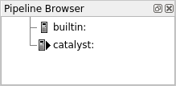

hint : check Catalyst/Pause Simulation. As the demo is quite short, it is useful to pause before the connection happens.

Now you are ready to launch the simulation !

$ ./bin/pvbatch ParaView-v5.8.0/Examples/Catalyst/PythonFullExample/fedriver.py ParaView-v5.7.0/Examples/Catalyst/PythonFullExample/cpscript.py

Now new sources has appeared in the pipeline browser (2). Note that to preserve your computer memory (and network) only metadata has been transferred.  
(2)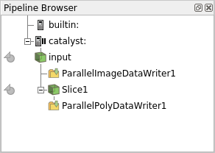 (3)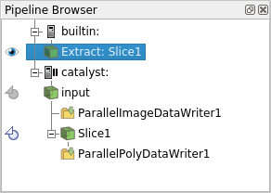

Click on the icon left to it in order to fetch the actual data (3), and be able to display it in ParaView (4)(don’t forget to click on the eye to set the visibility !)  
(4)

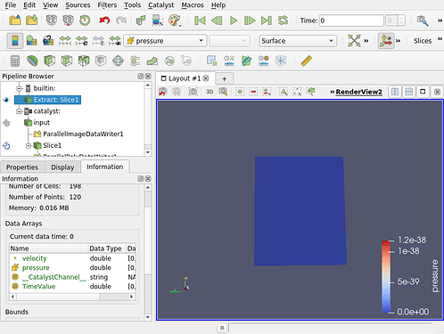

The simulation is still paused here.  
You can now unpause it via the same menu (Catalyst / run) and see your simulation data being updated on the screen ! (5)  
(5)   
hint : in this example, one time step is quite quick so maybe the visualization will jump and drop some of the timesteps … don’t hesitate to modify the code !

The simulation ends and stop the communication. A message box pops in ParaView and the catalyst part of the pipeline is removed. But the extracted data is still here !

## Configure the pipeline

You can try replacing the cpscript.py by your own exported from ParaView.  
First load a representative dataset, i.e. a dataset with the format (structured grid, polydata …) and data arrays named as in the simulation. In our example you can load the fullgrid_0.pvti created by the previous run. Then set up the pipeline you want. (6)  
(6) 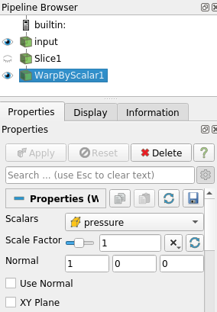

Click on the Catalyst/Define Export menu to open the Export Inspector. Here you can select a writer for your source, take screenshots and enable others live visualization (7a). Writers can be configured (7b).

(7a) 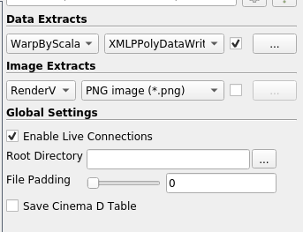 (7b) 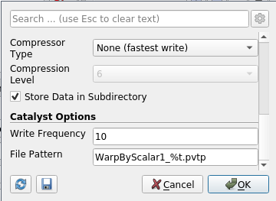  
Save the script with Catalyst/Export script.

You can re run the simulation with your new script !  
(8)

