VTK-数据结构
VTK User Guide 11th Edition的第483页。
Visualization ToolKit (VTK)有自己的文件格式，VTK提供了很多中数据格式。VTK有2种风格的格式：
legacy VTK和XML VTK
最简单的是legacy vtk，是一种串行格式，很容易编程读写。但legacy vtk没有XML格式灵活。
XML格式支持随机访问、并行化IO和可移植的数据压缩，要优于legacy vtk格式。

1简单的legacy格式

1.1ASCII格式
Legacy vtk文件格式由5个基本部分组成：
#vtkDataFile Version 2.0 | (1)
Really cool data | (2)
ASCII | BINARY | (3)
DATASET type  ... | (4)
POINT_DATA type  ...  CELL_DATA type  ... | (5)
第1部分：Header
第2部分：Title (256 characters maximum, terminated with newline \n character)
第3部分：Data type, either ASCII or BINARY
第4部分：Geometry/Topology. Type 包括：STRUCTURED_POINTS STRUCTURED_GRID UNSTRUCTURED_GRID POLYDATA STRUCTURED_POINTS RECTILINEAR_GRID FIELD
第5部分：Dataset attributes. The number of data items n of each type must match the number of points or cells in the dataset. (If type is FIELD, point and cell data should be omitted.
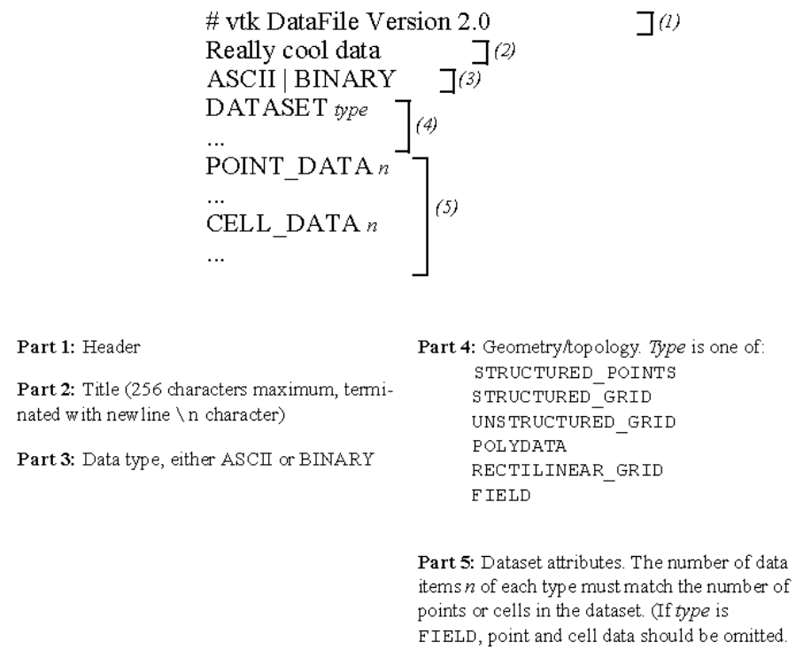
图1 VTK文件格式5个部分的概览图

1.2 二进制格式
不同计算机系统之间可移植，需要保证：（1）数据的字节顺序是对的；（2）保证各数据类型的长度是一致的。

1.3数据格式介绍
VTK支持5种不同数据结构，包括：Structured Points（vtkImageData）;结构网格、矩形网格、非结构网格和多边形数据。
(1) Structured Points
DATASET STRUCTURED_POINTS
DIMENSIONS nx ny nz
ORIGIN x y z
SPACING sx sy yz

(2) Structured Grid
DATASET STRUCTURED_GRID
DIMENSIONS nx ny nz
POINTS n dataType
p0x p0y p0z
p1x p1y p1z
...
p(n-1)x p(n-1)y p(n-1)z

(3) Rectilinear Grid

(4) Polygonal Data
DATASET POLYDATA
POINTS n dataType
p0x p0y p0z
p1x p1y p1z
...
p(n-1)x p(n-1)y p(n-1)z
VERTICES n size
numPoints0, i0, j0, k0, ...
numPoints1, i1, j1, k1, ...
...
numPointsn-1, in-1, jn-1, kn-1, ...
LINES n size
numPoints0, i0, j0, k0, ...
numPoints1, i1, j1, k1, ...
...
numPointsn-1, in-1, jn-1, kn-1, ...
POLYGONS n size
numPoints0, i0, j0, k0, ...
numPoints1, i1, j1, k1, ...
...
numPointsn-1, in-1, jn-1, kn-1, ...
TRIANGLE_STRIPS n size
numPoints0, i0, j0, k0, ...
numPoints1, i1, j1, k1, ...
...
numPointsn-1, in-1, jn-1, kn-1, ...

(5) Unstructured Grid
The unstructured grid dataset consists of arbitrary combinations of any possible cell type. Unstructured grids are defined by points, cells, and cell types. The CELLS keyword requires two parameters: the number of cells n and the size of the cell list size. The cell list size is the total number of integer values required to represent the list (i.e., sum of numPoints and connectivity indices over each cell). The CELL_TYPES keyword requires a single parameter: the number of cells n. This value should match the value specified by the CELLS keyword. The cell types data is a single integer value per cell that specified cell type (see vtkCell.h or 图2).
DATASET UNSTRUCTURED_GRID
POINTS n dataType
p0x p0y p0z
p1x p1y p1z
...
p(n-1)x p(n-1)y p(n-1)z
CELLS n size
numPoints0, i, j, k, l, ...
numPoints1, i, j, k, l, ...
numPoints2, i, j, k, l, ...
...
numPointsn-1, i, j, k, l, ...
CELL_TYPES n
type0
type1
type2
...
typen-1
Field（场）
Field data is a general format without topological and geometric structure, and without a particular dimensionality. Typically field data is associated with the points or cells of a dataset. However, if the FIELD type is specified as the dataset type (图1), then a general VTK data object is defined. Use the format described in the next section to define a field. Also see “Working With Field Data” on page 158 and the fourth example in this chapter “Examples” .
Dataset Attribute Format. The Visualization Toolkit supports the following dataset attributes: scalars (one to four components), vectors, normals, texture coordinates (1D, 2D, and 3D), tensors, and field data. In addition, a lookup table using the RGBA color specification, associated with the scalar data, can be defined as well. Dataset attributes are supported for both points and cells.
Each type of attribute data has a dataName associated with it. This is a character string (without embedded whitespace) used to identify a particular data. The dataName is used by the VTK readers to extract data. As a result, more than one attribute data of the same type can be included in a file. For example, two different scalar fields defined on the dataset points, pressure and temperature, can be contained in the same file. (If the appropriate dataName is not specified in the VTK reader, then the first data of that type is extracted from the file.)
Scalars（标量）
Scalar definition includes specification of a lookup table. The definition of a lookup table is optional. If not specified, the default VTK table will be used (and tableName should be “default”). Also note that the numComp variable is optional—by default the number of components is equal to one. (The parameter numComp must range between (1,4) inclusive; in versions of VTK prior to vtk2.3 this parameter was not supported.)
SCALARS dataName dataType numComp
LOOKUP_TABLE tableName
s0
s1
...
sn-1
The definition of color scalars (i.e., unsigned char values directly mapped to color) varies depending upon the number of values (nValues) per scalar. If the file format is ASCII, the color scalars are defined using nValues float values between (0,1). If the file format is BINARY, the stream of data consists of nValues unsigned char values per scalar value.
COLOR_SCALARS dataName nValues
c00 c01 ... c0(nValues-1)
c10 c11 ... c1(nValues-1)
...
c(n-1)0 c(n-1)1 ... c(n-1)(nValues-1)
Lookup Table
The tableName field is a character string (without imbedded white space) used to identify the lookup table. This label is used by the VTK reader to extract a specific table.
Each entry in the lookup table is a rgba[4] (red-green-blue-alpha) array (alpha is opacity where alpha=0 is transparent). If the file format is ASCII, the lookup table values must be float values between (0,1). If the file format is BINARY, the stream of data must be four unsigned char values per table entry.
LOOKUP_TABLE tableName size
r0 g0 b0 a0
r1 g1 b1 a1
...
rsize-1 gsize-1 bsize-1 asize-1
Vectors（矢量）
VECTORS dataName dataType
v0x v0y v0z
v1x v1y v1z
...
v(n-1)x v(n-1)y v(n-1)z
Field Data（场数据）
Field data is essentially an array of data arrays. Defining field data means giving a name to the field and specifying the number of arrays it contains. Then, for each array, the name of the array arrayName(i), the number of components of the array, numComponents, the number of tuples in the array, numTuples, and the data type, dataType, are defined.
FIELD dataName numArrays
arrayName0 numComponents numTuples dataType
f00 f01 ... f0(numComponents-1)
f10 f11 ... f1(numComponents-1)
...
f(numTuples-1)0 f(numTuples-1)1 ... f(numTuples-1)(numComponents-1)
arrayName1 numComponents numTuples dataType
f00 f01 ... f0(numComponents-1)
f10 f11 ... f1(numComponents-1)
...
f(numTuples-1)0 f(numTuples-1)1 ... f(numTuples-1)(numComponents-1)
...
arrayName(numArrays-1) numComponents numTuples dataType
f00 f01 ... f0(numComponents-1)
f10 f11 ... f1(numComponents-1)
...
f(numTuples-1)0 f(numTuples-1)1 ... f(numTuples-1)(numComponents-1)
VTK中的单元类型有：线性和非线性。
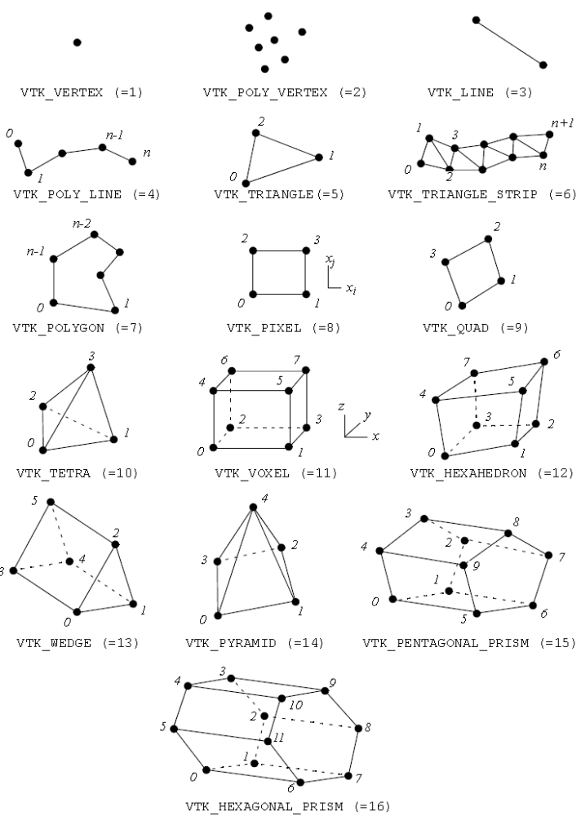
图2 VTK中已有的线性单元类型（使用头文件vtkCellType.h操作单元类型）
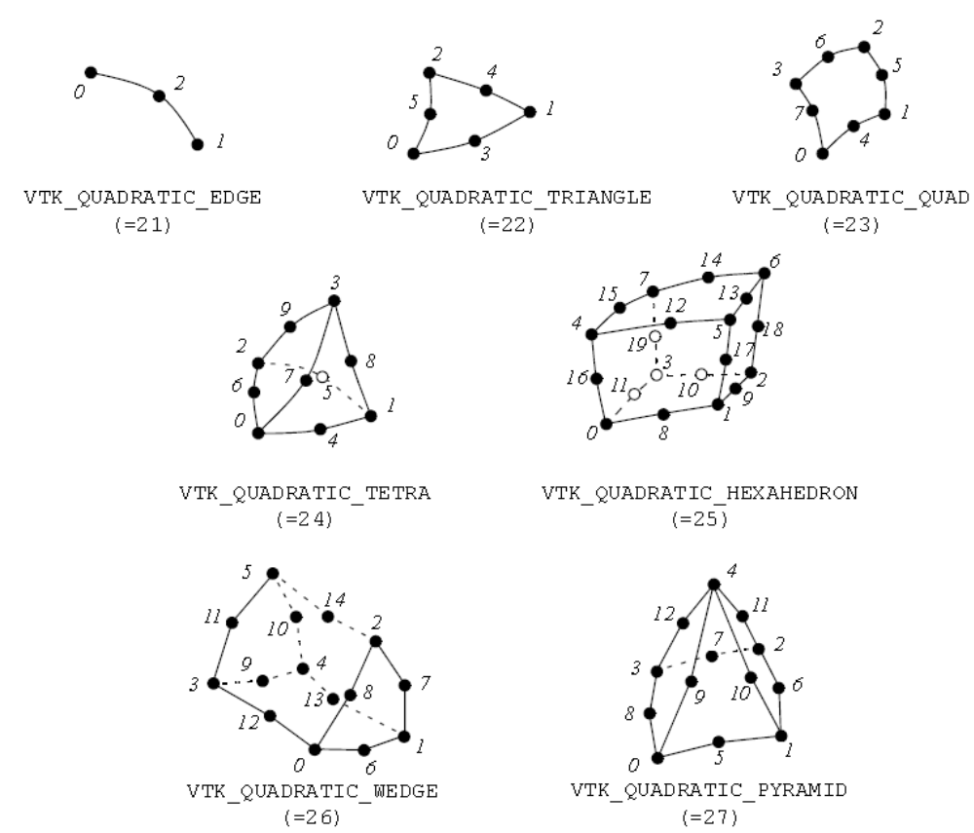
图3 VTK中已有的非线性单元类型

2 XML文件格式
VTK有另一种数据结构，使用XML语法。可支持压缩、可移植二进制编码、随机访问、大小端序的字节顺序。
VTK XML数据文件有2种：并行和串行。
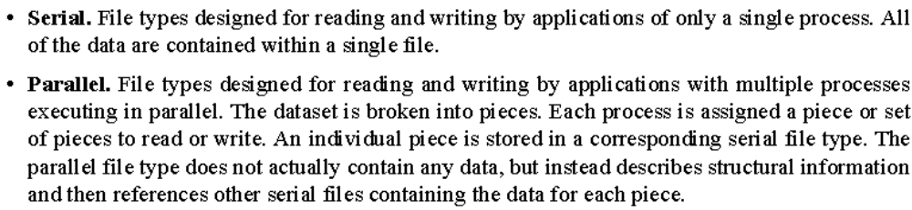
XML格式的VTK数据集可分为2类：结构和非结构
每种数据类型和文件类型都采用成对的文件后缀：
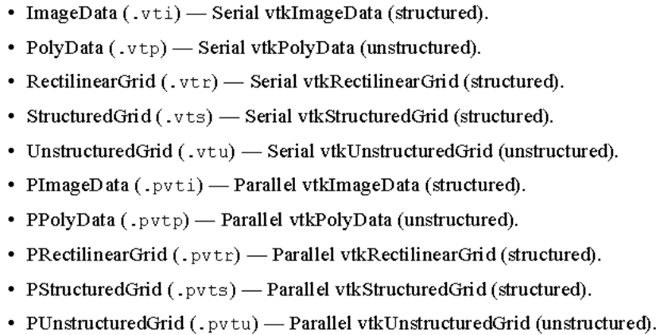
所有的VTK XML文件类型都是组织好的XML文档。文档层的单元是VTKFile:
单元的属性是：
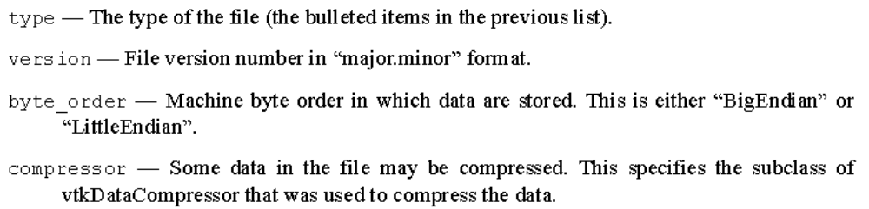
嵌套在VTKFile内部的单元名称对应数据格式的类型(type属性)，该单元描述数据集的拓扑，串行和并行格式是不一样的，介绍如下：

2.1Serial XML File Formats
ImageData, RectilinearGrid, StructuredGrid, PolyData, UnstructuredGrid
以StructuredGrid为例：
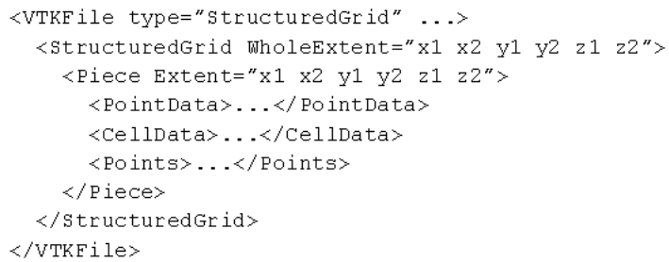

2.2Parallel XML File Formats
并行文件格式实际上不存储任何数据，只是将数据分解为很多部分，各部分以串行文件的格式存储。描述的关键词前面加个P
以PStructuredGrid为例：
