VTK-m库

VTK-m
VTK-m是适应新型处理器架构的科学可视化算法，支持细粒度的并发数据分析和可视化，提供抽象的数据模型驱动大规模计算，可应用于不同处理器架构的场景。
多年来，HPC可视化方法，例如ParaView, VisIT, EnSight等，都支持分布式内存计算系统上的并行处理，是一种同步并行模式，其中算法在相互独立的局部硬件上执行大部分的计算。伴随着硬件的发展，硬件架构出现不对称结构，多采用混合并行技术(MPI+OpenMP)，在不对称架构的机器上挖掘计算资源。这种方法的好处是使用已有的软件来管理消息传递的并行单元。
VTK-m框架就是发展节点间(intranode)并行化，节点间并行通常需要执行大量的线程和线程同步。VTK-m就是在新的HPC系统上（例如GPU系统），执行高度的并行化，可对1~10个数据单元执行线程操作，这是高度细粒度的并行化。VTK-m支持OpenMP, TBB, CUDA的线程并行。
VTK-m的前身是PISTON, Dax, EVAL。

传统的可视化技术存下的问题
- 荷载不均衡
- 动态内存分配
- 拓扑连接关系
- SIMD执行

数据并行原语(primitive)的计算效率可移植性
ParaView和VisIT包含400多个过滤器，升级这些功能模块是巨大的挑战。
VTK-m使用数据并行原语，实现计算效率的可移植性。VTK-m定义一个抽象设备模型，由数据并行原语操作（如map, scan, sort, reduce）组成，可并行化运行于设备上。移植到新的设备时，仅需要提供该种设备的并行原语，仅需要一次性将算法改写到VTK-m的抽象设备模型即可，这大大降低了针对各种架构的实施工作量，如图1。
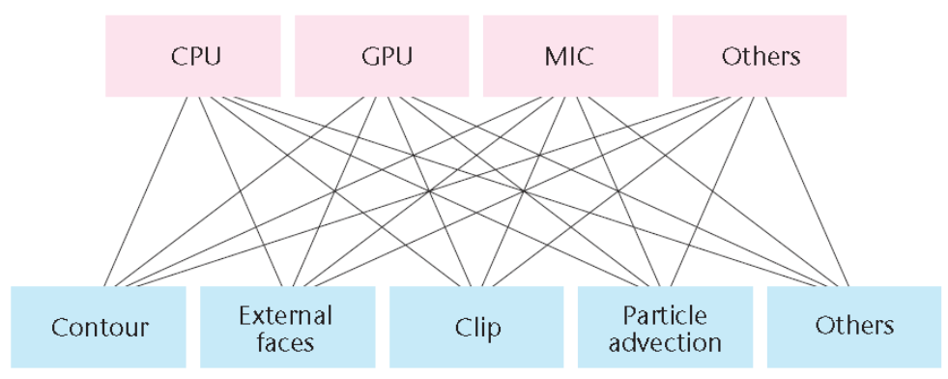
(a)对每种架构都要单独实施可视化算法，这导致不可管理的软件更新
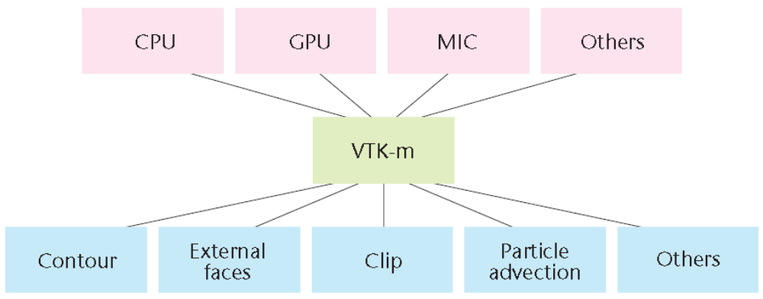
(b)通过使用VTK-m的基于数据并行原语的抽象设备模型，可以大大降低实施软件更新到可执行层的工作量
图1

VTK-m的数据模型
VTK-m数据模型非常灵活，适用于各种不同的数据布局，满足科学计算需要。另外，数据表征必须是空间存储效率高、可使用不同的硬件架构（CPU与GPU）访问数据。如图1，VTK-m数据集由3部分组成：cell sets, coordinate systems, fields。例如，结构化数据与非结构数据，都能统一为一种数据集，计算效率提高，适合于HPC应用。
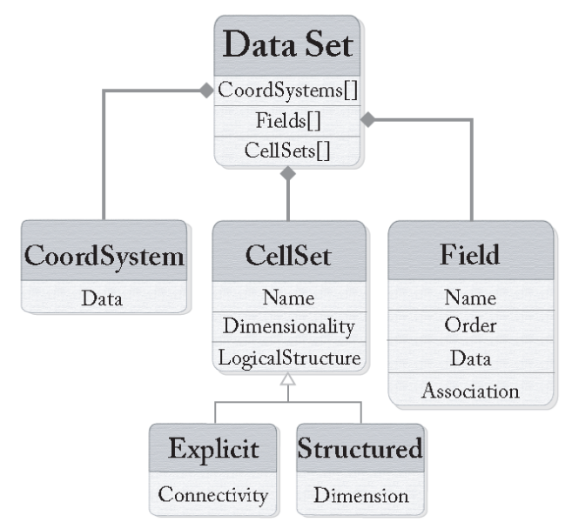
图1 VTK-m数据模型概览

数据集

坐标系统

单元集

VTK-m的优势
VTK-m允许有更多的精确数据表述（不同网格类型），即更多的数据部署；
有零拷贝(zero-copy)功能，这对在线可视化很重要，VTK-m可就地利用模型代码产生的数据数组，节省了时间和空间。
VTK-m开发为仅有头文件(header)的库，方便整合使用。

应用场景

光线追踪
Matthew Larsen，implemented Larsen’s ray-tracing algorithm in VTK-m and replicated many of the experimental runs in the Larsen paper.
all images are rendered with 1,080p resolution (1920 × 1080)
suggests that the integration of data models with the execution model, algorithms, and other features of VTK-m does not add overhead
M. Larsen et al., Ray Tracing within a Data Parallel Framework, Proc. IEEE Pacific Visualization Symp. (PacificVis), 2015: 279–286.

地震波传播的光线追踪渲染

直接体渲染
直接渲染在空间具有变化颜色和透明度的体，在科学可视化技术方面是常用且计算量集中的技术。
a supernova simulation dataset, consisting of a 432³ volume of voxels and rendered to a 1,024×1,024 window.
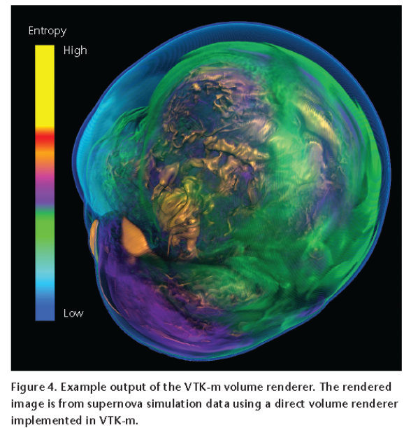

等值面
isosurface algorithm is adapted from PISTON. The new implementation integrates the algorithm with VTK-m’s data model and worklet execution mechanism.

表面简化

与HPC应用程序的整合
the supercomputer running the application using an in situ visualization paradigm
粒子模型
D. Pugmire et al., Towards Scalable Visualization Plugins for Data Staging Workflows, Proc. SC14 Workshop Big Data Analytics: Challenges and Opportunities (BDAC-14), 2014.

总结
过去20年发展了大量在HPC系统上应用的科学可视化工具，但传统方法不能很好地应用于大规模线程的环境。VTK-m填补了空白。
但是，VTK-m并不是取代VTK或其他现有的可视化工具，如ParaView和VisIT。VTK-m已与这些软件整合来提高其计算效率，应用于多线程开发的环境。

学习资源
• A high-level overview is given in the IEEE Vis talk "VTK-m: Accelerating the Visualization Toolkit for Massively Threaded Architectures."
• The VTK-m Users Guide provides extensive documentation. It is broken into multiple parts for learning and references at multiple different levels.
- "Part 1: Getting Started" provides the introductory instruction for building VTK-m and using its high-level features.
- "Part 2: Using VTK-m" covers the core fundamental components of VTK-m including data model, worklets, and filters.
- "Part 3: Developing with VTK-m" covers how to develop new worklets and filters.
- "Part 4: Advanced Development" covers topics such as new worklet types and custom device adapters.
• A practical VTK-m Tutorial based in what users want to accomplish with VTK-m:
- Building VTK-m and using existing VTK-m data structures and filters.
- Algorithm development with VTK-m.
- Writing new VTK-m filters.
• Community discussion takes place on the VTK-m users email list.
•Doxygen-generated nightly reference documentation is available online.

依赖库
VTK-m Requires:
- C++11 Compiler. VTK-m has been confirmed to work with the following
  - GCC 5.4+
  - Clang 5.0+
  - XCode 5.0+
  - MSVC 2015+
  - Intel 17.0.4+
- CMake
  - CMake 3.12+
  - CMake 3.13+ (for CUDA support)
Optional dependencies are:
- CUDA Device Adapter
  - Cuda Toolkit 9.2, >= 10.2
  - Note CUDA >= 10.2 is required on Windows
- TBB Device Adapter
  - TBB
- OpenMP Device Adapter
  - Requires a compiler that supports OpenMP >= 4.0.
- OpenGL Rendering
  - The rendering module contains multiple rendering implementations including standalone rendering code. The rendering module also includes (optionally built) OpenGL rendering classes.
  - The OpenGL rendering classes require that you have a extension binding library and one rendering library. A windowing library is not needed except for some optional tests.
- Extension Binding
  - GLEW
- On Screen Rendering
  - OpenGL Driver
  - Mesa Driver
- On Screen Rendering Tests
  - GLFW
  - GLUT
- Headless Rendering
  - OS Mesa
  - EGL Driver
VTK-m has been tested on the following configurations:
- On Linux
  - GCC 5.4.0, 5.4, 6.5, 7.4, 8.2, 9.2; Clang 5, 8; Intel 17.0.4; 19.0.0
  - CMake 3.12, 3.13, 3.16, 3.17
  - CUDA 9.2, 10.2, 11.0, 11.1
  - TBB 4.4 U2, 2017 U7
- On Windows
  - Visual Studio 2015, 2017
  - CMake 3.12, 3.17
  - CUDA 10.2
  - TBB 2017 U3, 2018 U2
- On MacOS
  - AppleClang 9.1
  - CMake 3.12
  - TBB 2018

编译VTK-m
VTK-m supports all majors platforms (Windows, Linux, OSX), and uses CMake to generate all the build rules for the project. The VTK-m source code is available from the VTK-m download page or by directly cloning the VTK-m git repository.
The basic procedure for building VTK-m is to unpack the source, create a build directory, run CMake in that build directory (pointing to the source) and then build. Here are some example linux commands for the process (individual commands may vary).
$ tar xvzf ~/Downloads/vtk-m-v1.4.0.tar.gz
$ mkdir vtkm-build
$ cd vtkm-build
$ cmake-gui ../vtk-m-v1.4.0
$ cmake --build -j . # Runs make (or other build program)
A more detailed description of building VTK-m is available in the VTK-m Users Guide.
常用的配置参数有：
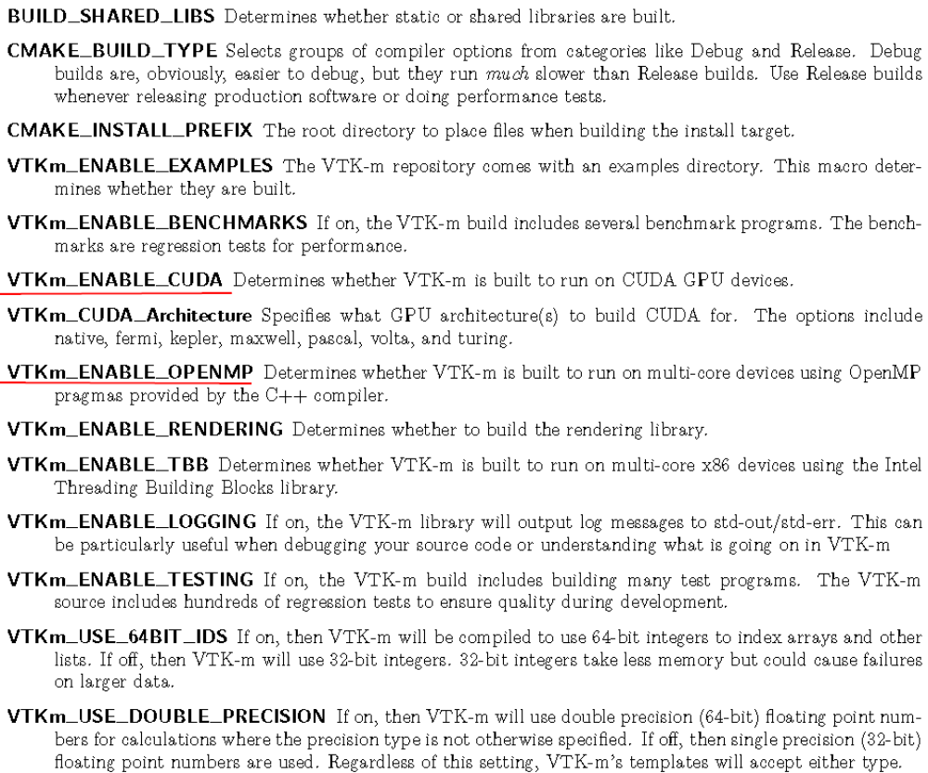
如果只是使用vtk-m，可以关闭编译tests, examples, benchmarks的开关，缩短编译时间。

连接到vtk-m
使用CMake的find_package函数：
例子：Loading VTK-m configuration from an external CMake project
find_package (VTKm REQUIRED)
设置CMAKE_PREFIX_PATH为vtk-m的安装路径；或设置VTKm_DIR为包含头文件和库文件的路径。
使用target_link_libraries命令，连接到vtk-m库：
例子：Linking VTK-m code into an external program
find_package (VTKm REQUIRED)
add_executable (myprog myprog.cxx)
target_link_libraries (myprog vtkm_filter)
提供若干个库目标，但大多数项目需要连接到一个或多个如下API：
vtkm_cont Contains the base objects used to control VTK-m. This library must always be linked in.
vtkm_filter Contains VTK-m’s pre-built filters including but not limited to CellAverage, CleanGrid, Contour, ExternalFaces, and PointAverage. Applications that are looking to use VTK-m filters will need to link to this library.
vtkm_io Contains VTK-m’s facilities for interacting with files. For example, reading and writing png,
NetBPM, and VTK files.
vtkm_rendering Contains VTK-m’s rendering components. This library is only available if VTKm ENABLE RENDERING is set to true.
vtkm_source Contains VTK-m’s pre-built dataset generators including but not limited to Wavelet, Tangle, and Oscillator. Most applications will not need to link to this library.
当完成find_package函数后，定义的所有CMake变量：
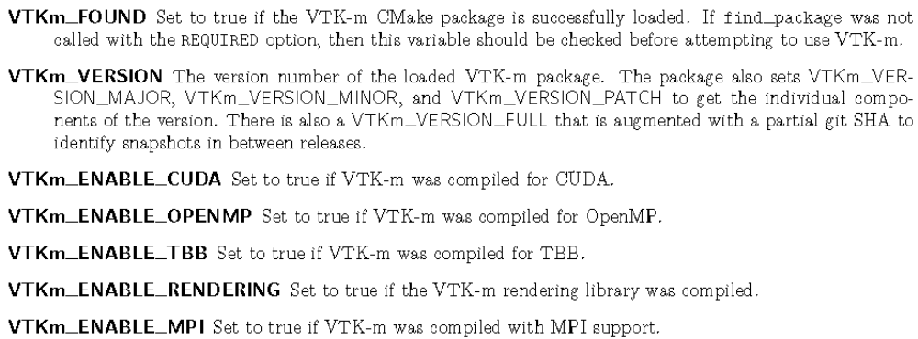
以上变量可用来查询是否支持合适的部件（在使用之前）。
例子：Using an optional component of VTK-m
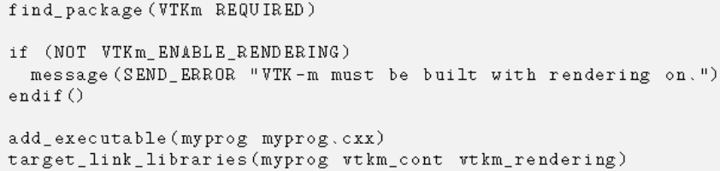

示例
The VTK-m source distribution includes a number of examples. The goal of the VTK-m examples is to illustrate specific VTK-m concepts in a consistent and simple format. However, these examples only cover a small part of the capabilities of VTK-m.
Below is a simple example of using VTK-m to load a VTK image file, run the Marching Cubes algorithm on it, and render the results to an image:

#include <vtkm/Bounds.h>
#include <vtkm/Range.h>
#include <vtkm/cont/ColorTable.h>
#include <vtkm/filter/Contour.h>

#include <vtkm/io/VTKDataSetReader.h>

#include <vtkm/rendering/Actor.h>
#include <vtkm/rendering/Camera.h>
#include <vtkm/rendering/CanvasRayTracer.h>
#include <vtkm/rendering/Color.h>
#include <vtkm/rendering/MapperRayTracer.h>
#include <vtkm/rendering/Scene.h>
#include <vtkm/rendering/View3D.h>

vtkm::io::VTKDataSetReader reader("path/to/vtk_image_file.vtk");
vtkm::cont::DataSet inputData = reader.ReadDataSet();
std::string fieldName = "scalars";

vtkm::Range range;
inputData.GetPointField(fieldName).GetRange(&range);
vtkm::Float64 isovalue = range.Center();

// Create an isosurface filter
vtkm::filter::Contour filter;
filter.SetIsoValue(0, isovalue);
filter.SetActiveField(fieldName);
vtkm::cont::DataSet outputData = filter.Execute(inputData);

// compute the bounds and extends of the input data
vtkm::Bounds coordsBounds = inputData.GetCoordinateSystem().GetBounds();

// setup a camera and point it to towards the center of the input data
vtkm::rendering::Camera camera;
camera.ResetToBounds(coordsBounds);
vtkm::cont::ColorTable colorTable("inferno");

// Create a mapper, canvas and view that will be used to render the scene
vtkm::rendering::Scene scene;
vtkm::rendering::MapperRayTracer mapper;
vtkm::rendering::CanvasRayTracer canvas(512, 512);
vtkm::rendering::Color bg(0.2f, 0.2f, 0.2f, 1.0f);

// Render an image of the output isosurface
scene.AddActor(vtkm::rendering::Actor(outputData.GetCellSet(),
outputData.GetCoordinateSystem(),
outputData.GetField(fieldName),
colorTable));
vtkm::rendering::View3D view(scene, mapper, canvas, camera, bg);
view.Paint();
view.SaveAs("demo_output.png");

A minimal CMakeLists.txt such as the following one can be used to build this example.

project(example)
set(VTKm_DIR "/somepath/lib/cmake/vtkm-XYZ")
find_package(VTKm REQUIRED)
add_executable(example example.cxx)
target_link_libraries(example vtkm_cont vtkm_rendering)

VTK-m论文发表
Moreland, K., Sewell, C., Usher, W., Lo, L.-T., Meredith, J., Pugmire, D., Kress, J., Schroots, H., Ma, K.-L., Childs, H., Larsen, M., Chen, C.-M., Maynard, R., & Geveci, B. (2016). VTK-m: Accelerating the Visualization Toolkit for Massively Threaded Architectures. IEEE Computer Graphics and Applications, 36(3), 48–58.
Moreland, K., Larsen, M., Childs, H. (2015). Visualization for Exascale: Portable Performance is Critical. Supercomputing Frontiers and Innovations, 2(3).
Schroots, H. A., Ma, K.-L. (2015). Volume rendering with data parallel visualization frameworks for emerging high performance computing architectures. SIGGRAPH Asia Visualization in High Performance Computing, 3:1–3:4
Maynard, R., Moreland, K., Ayachit, U., Geveci, B., Ma, K.-L. (2013). Optimizing Threshold for Extreme Scale Analysis. Visualization and Data Analysis 2013, Proceedings of SPIE-IS&T Electronic Imaging.
(Note: work initially performed in predecessor framework to VTK-m, and was subsequently ported to VTK-m.)

