METIS分区不连续的问题
编译运行并行的ELcirc和SELFE模型，需要采用Release格式的METIS和ParMETIS库文件，注意其中的GKfree函数，不能用指针！（调试心得！）
Why am I getting non-contiguous partitions with METIS?
The partitioning routines in METIS do not guarantee that the partitions are contiguous. In most cases, the partitions produced by METIS will be contiguous. However, depending on the underlying geometry and the size of the graph relative to the number of partitions, some of the partitions may not be contiguous. From version 5.0, Metis provides support for enforcing the partitions to be contiguous by using the -contig option.

metis3.0中
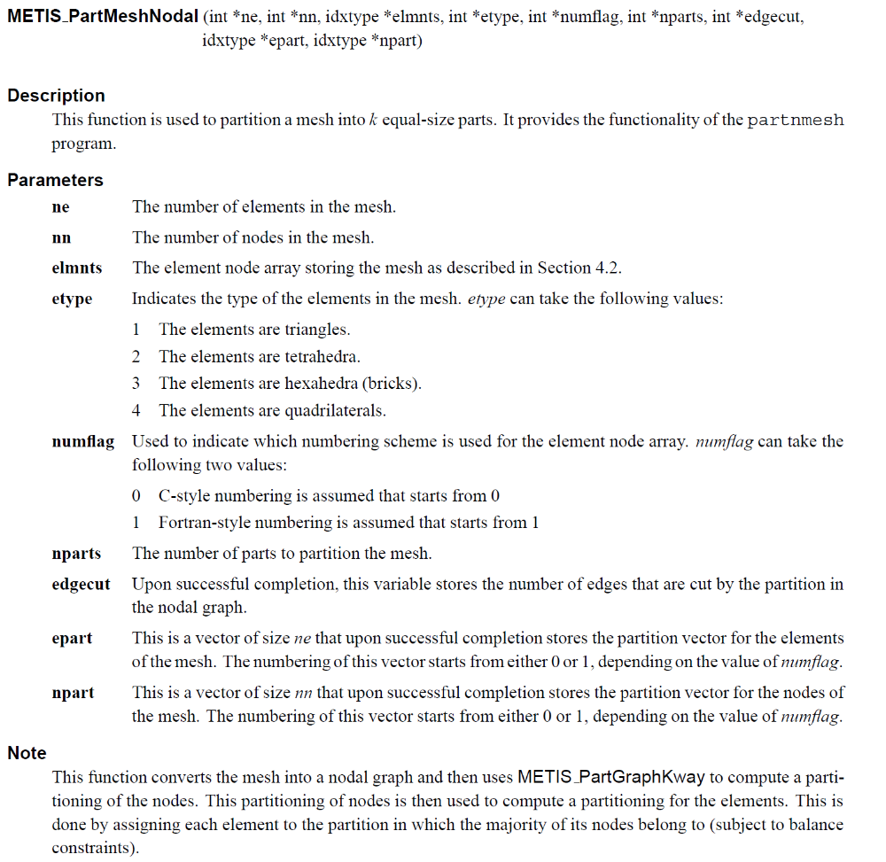
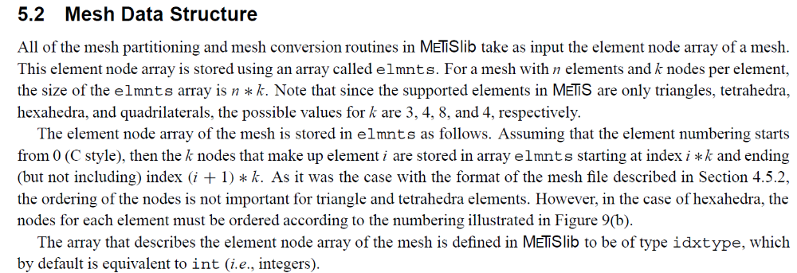

metis4.0中
metis5.0
由此可见，metis5.0较metis3.0和metis4.0的METIS_PartMeshNodal函数的形式参数有了很大改变。
相同的有: 待分区网格*ne *nn *nparts(分区个数) 存储分区后的网格*epart *npart

4.0: *elmnts --> 5.0: *eptr *eind
vwgt=>null() vsize=>null()
4.0: *numflag: 0 or 1 for C and FORTRAN, respectively
4.0 : edgecut --> 5.0: objval (存储分区成功后的网格边界处的ghost cell)
5.0： *tpwgts

metis5.0中：
