ParMETIS非结构网格分区程序介绍

ParMETIS介绍
ParMETIS4.0库基于METIS5.0编译，定义标量“整型”数据类型(idx_t)存储图的相邻结构。注意：图(graph)与网格(mesh)的区别。
PARMETIS是采用C语言编程，MPI用于处理器之间的通信。
由串行的METIS和并行的PARMETIS编译生成静态库文件，被Fortran调用。
技术支持：metis@cs.umn.edu
ParMETIS是采用C语言编程及MPI用于处理器之间通信进行非结构网格分区和稀疏矩阵计算的软件包，PARMETIS 提供以下功能：
- 对非结构图和网格进行分区处理；
- 对自适应网格变换的再分区；
- 多相和多物理过程模拟的图形分区处理；
- 改进当前分区网格的质量；
- 稀疏矩阵直接分解的填充归约排序计算；
- 构建网格的双重图形。

ParMETIS程序中的算法
共包括以下子程序：
ParMETIS_V3_PartGeomKway（SELFE使用）
ParMETIS_V3_PartGeom
ParMETIS_V3_PartKway
ParMETIS_V3_PartMeshKway
ParMETIS_V3_Mesh2Dual
ParMETIS_V3_AdaptiveRepart
ParMETIS_V3_RefineKway
ParMETIS_V3_NodeND

非结构图的分区
在最小化分区切割的边数下采用k路分区算法（其中k等于计算子区域数）进行非结构网格的分区，其算法是基于多层k路分区算法（multilevel k-way partitioning algorithm）和空间填充曲线法（space-filling curve method ）。ParMETIS包含有三种非结构网格分区的功能模块，如：ParMETIS V3 PartKway、ParMETIS V3 PartGeomKway、ParMETIS PartGeom，其中，三种网格分区方法均是基于串行的多层k路分区算法（G. Karypis，1998）和并行化（K. Schloegel，2000），该算法可快速生成高质量的分区网格，由三部分组成：网格粗化（garph coarsening）、初始分区（initial partitioning）和网格细化（uncoarsening/refinement）。如图，粗化阶段网格尺寸不断减小，初始分区阶段进行k路分区计算，在多层细化（或反粗化）阶段随着投影到较大的网格区域上分区逐渐细化。G₀为输入网格（最细），G_{i+1}为下一层较G_{i}粗的网格，G₄为最粗网格。但由于针对网格分区（Graph Partitioning）和网格分布（Graph Distribution）的计算方法和顺序的不同，三种方法的计算速度和分区后的网格质量也不同，其中，ParMETIS V3 PartKway计算速度最慢，但分区网格质量好，ParMETIS V3 PartGeomKway计算速度是ParMETIS V3 PartKway的2倍，可得到与ParMETIS V3 PartKway相同质量的分区网格，而ParMETIS PartGeom的计算速度通常是ParMETIS V3 PartGeomKway的5~10倍，但得到的分区网格质量较差，以上详细的介绍见文献。
本模型中采用的是ParMETIS V3 PartGeomKway的网格分区方法。
图2 多层k路网格分区的三个阶段

直接分区网格
ParMETIS也可以直接分区和再分区给定的网格（不是图）。
ParMETIS_V3_PartMeshKway将网格作为输入，计算网格单元的分区。程序内部，ParMETIS_V3_PartMeshKway使用网格到图的转换程序，然后调用相同核心分区子程序，被ParMETIS_V3_PartKway调用。

SELFE模型使用ParMETIS
!----------- Partition dual graph 非结构网格的并行计算分区子程序
call ParMETIS_V3_PartGeomKway(vtxdist,xadj,adjncy,vwgt,adjwgt,wgtflag, numflag,ndims,xyz,ncon,nproc,tpwgts,ubvec,options, edgecut,part,comm)

ParMETIS V3 PartGeomKway (idxtype *vtxdist, idxtype *xadj, idxtype *adjncy, idxtype *vwgt, idxtype *adjwgt,int *wgtflag, int *numflag, int *ndims, float *xyz, int *ncon, int *nparts,float *tpwgts, float *ubvec, int *options, int *edgecut, idxtype *part, MPI Comm *comm)
描述：
This routine is used to compute a k-way partitioning of a graph on p processors by combining the coordinate based and multi-constraint k-way partitioning schemes.
子程序ParMETIS V3 PartGeomKway用于计算p个处理器的k路图形分区。
参数
vtxdist This array describes how the vertices of the graph are distributed among the processors. (See discussion in Section 4.1). Its contents are identical for every processor.
数组，描述各处理器中的网格节点分布。每个处理器的内容相同。
xadj, adjncy
These store the (local) adjacency structure of the graph at each processor. (See discussion in Section
4.1).
数组，存储各处理器中的网格相邻结构。
vwgt, adjwgt
These store the weights of the vertices and edges. (See discussion in Section 4.1).
数组，存储网格节点和边的权重。
wgtflag This is used to indicate if the graph is weighted. wgtflag can take one of four values:
是否采用权重计算。取4个值：
0 无权重 (vwgt and adjwgt are both NULL).
1 仅边采用权重 (vwgt is NULL).
2 仅节点采用权重(adjwgt is NULL).
3 节点和边均采用权重
numflag This is used to indicate the numbering scheme that is used for the vtxdist, xadj, adjncy, and part
vtxdist, xadj, adjncy, part的编码格式标记：

arrays. numflag can take one of two values:
0 C-style numbering that starts from 0.
1 Fortran-style numbering that starts from 1.
ndims The number of dimensions of the space in which the graph is embedded.
xyz 节点坐标存储数组。 (described in Section 4.2).
ncon This is used to specify the number of weights that each vertex has. It is also the number of balance constraints that must be satisfied.
用于定义各网格节点的权重数，也是必须满足的平衡限制数。
nparts This is used to specify the number of sub-domains that are desired. Note that the number of subdomains is independent of the number of processors that call this routine.
用于定义用户需要设定的子计算域数。其中，本子程序中子计算域数与处理器数相独立。
tpwgts An array of size ncon× nparts that is used to specify the fraction of vertex weight that should be distributed to each sub-domain for each balance constraint. If all of the sub-domains are to be of the same size for every vertex weight, then each of the ncon x nparts elements should be set to a
value of 1/nparts. If ncon is greater than one, the target sub-domain weights for each sub-domain
are stored contiguously (similar to the vwgt array). Note that the sum of all of the tpwgts for a give vertex weight should be one.
ncon× nparts维的数组，用于定义节点权重分数，用于计算每个计算子区域的平衡限制。

ubvec An array of size ncon that is used to specify the imbalance tolerance for each vertex weight, with 1 being perfect balance and nparts being perfect imbalance. A value of 1.05 for each of the ncon weights is recommended.
Ncon维数组，用于定义各网格节点权重的不平衡残差，1为完全平衡（推荐值1.05）
options This is an array of integers that is used to pass parameters to the routine. Their meanings are identical to those of ParMETIS V3 PartKway.
整数数组，用于传递参数给本子程序。
edgecut Upon successful completion, the number of edges that are cut by the partitioning is written to this parameter.
如果程序成功计算，分区截取边数将写入本参数。
part This is an array of size equal to the number of locally-stored vertices. Upon successful completion the partition vector of the locally-stored vertices is written to this array. (See discussion in Section 4.4).
数组，维数等于局部存储节点数。如果程序成功计算，局部存储节点分区矢量将写入本数组。
comm This is a pointer to the MPI communicator of the processes that call PARMETIS. For most programs this will point to MPI COMM WORLD.
调用PARMETIS的MPI通信进程指针。大部分程序指向MPI COMM WORLD。

注意：
The quality of the partitionings computed by ParMETIS V3 PartGeomKway are comparable to those produced by ParMETIS V3 PartKway. However, the run time of the routine may be up to twice as fast.

Compile ParMetis-3.1.1 on windows

1. 编译METISLib:
1.1 create library project in IDE（Integrated Development Environment集成开发环境）;
1.2 add all the source file to the project.
1.3 添加 "#include <stdlib.h>" 到文件"metis.h". 这是因为visual c++ 不能找到常数变量"RAND_MAX";
1.4 编译工程即可。
(include "parmetis.h" to the additional include search folder.

2. 编译ParMETISLib:
2.1 create library project in IDE;
2.2 add all the source file to the project.
2.3 add the function declaration into the file "msetup.c"
MeshType *CreateMesh(void);
void InitMesh(MeshType *mesh);
2.4 compile the project will be ok.
(include "parmetis.h" to the additional include search folder.

METIS and ParMETIS
介绍
METIS is a library for partitioning and ordering matrices and graphs. It is used by Solver to reorder the original matrix to reduce fill-ins in the factored matrix.
ParMETIS is an MPI-based parallel library that implements a variety of algorithms for partitioning unstructured graphs and for computing fill-reducing orderings of sparse matrices.
The ParMETIS in MathKeisan is based on the original version 3.1 developed at University of Minnesota and Army HPC research center by George Karypis and Vipin Kumar.
User Interface
User interface information is available from several sources:
- The METIS Routine List and the ParMETIS Routine List contain one-line summaries for subprograms in METIS and ParMETIS.
- More user interface information is available in Karypis [1], [2].
- The Linking Chapter tells how to link with the METIS and ParMETIS libraries.
METIS Routine List
Name | Description
METIS_PartGraphRecursive | Partition mesh using multilevel recursive bisection.
METIS_PartGraphKway | Partition mesh using multilevel k-way partitioning to minimize edge cut.
METIS_PartGraphVKway | Partition mesh using multilevel k-way partitioning to minimize communication volume.
METIS_mCPartGraphRecursive | Partition mesh using multi-constraint multilevel recursive bisection to minimize edge cut.
METIS_mCPartGraphKway | Partition mesh using multi-constrained multilevel k-way partitioning algorithm to minimize edge-cut.
METIS_WPartGraphRecursive | PartGraphRecursive with prescribed partition weights.
METIS_WPartGraphKway | PartGraphKway with prescribed partition weights.
METIS_WPartGraphVKway | PartGraphVKway with prescribed partition weights.
METIS_PartMeshNodal | Converts mesh to nodal graph, then uses METIS_PartGraphKway.
METIS_PartMeshDual | Converts mesh to dual graph, then uses METIS_PartGraphKway.
METIS_EdgeND | Computes fill reducing ordering of sparse matrices using multilevel nested dissection algorithm. Use only for large matrices from 3-d finite elements.
METIS_NodeND | Computes fill reducing ordering of sparse matrices using multilevel nested dissection algorithm. Generally preferred over METIS_EdgeND.
METIS_NodeWND | Similar to METIS_NodeWND, but assumes compression performed prior to calling this routine.
METIS_MeshToNodal | Converts mesh to nodal graph.
METIS_MeshToDual | Converts mesh to dual graph.
METIS_EstimateMemory | Estimates amount of memory that will be used by Metis.

ParMETIS Routine List
Name | Description
ParMETIS_PartKway | Compute p-way partition of graph on p processors using multilevel k-way partitioning algorithm
ParMETIS_PartGeomKway | Compute p-way partition of graph on p processors combining coordinate-based partitioning and multilevel k-way partitioning algorithm.
ParMETIS_PartGeom | Compute p-way partition of graph on p processors using coordinate-based space-filling curves.
ParMETIS_RepartLDiffusion | Balance work load of graph corresponding to mesh that has been adaptively refined. Utilizes a diffusive scheme based on local load-imbalance information.
ParMETIS_RepartGDiffusion | Balance work load of graph corresponding to mesh that has been adaptively refined. Utilizes a diffusive scheme based on global load-imbalance information.
ParMETIS_RepartRemap | Balance work load of graph corresponding to mesh that has been adaptively refined. Based on new p-way partitioning and intelligently mapping it to the original partitioning so the migration cost is minimized.
ParMETIS_RepartMLRemap | Balance work load of graph corresponding to mesh that has been adaptively refined. Based on new p-way partitioning of coarsest graph, intelligently mapping it to original partitioning so migration cost is minimized, then refining using multilevel paradigm.
ParMETIS_RefineKway | Improve quality of existing p-way partition on p processors using multilevel p-way refinement algorithm.
ParMETIS_NodeND | Compute fill-reducing ordering of matrix using multilevel nested dissection.
Further Reading
- G. Karypis and V. Kumar. "METIS: A Software Package for Partitioning Unstructured Graphs, Partitioning Meshes, and Computing Fill-Reducing Orderings of Sparse Matrices." Univ. MN., 1998.
- G. Karypis, K. Schloegel and V. Kumar. ParMETIS: Parallel Graph Partitioning and Sparse Matrix Ordering Library." Univ MN., 2003.
- METIS Home Page

图形分区
ParMETIS V3 PartGeom (idxtype *vtxdist, int *ndims, float *xyz, idxtype *part, MPI Comm *comm)
Description
This routine is used to compute a p-way partitioning of a graph on p processors using a coordinate-based space-filling curves method.

ParMETIS V3 PartKway (idxtype *vtxdist, idxtype *xadj, idxtype *adjncy, idxtype *vwgt, idxtype *adjwgt, int *wgtflag, int *numflag, int *ncon, int *nparts, float *tpwgts, float *ubvec, int *options, int *edgecut, idxtype *part, MPI Comm *comm)
Description
This routine is used to compute a k-way partitioning of a graph on p processors using the multilevel k-way multi-constraint partitioning algorithm.

ParMETIS V3 PartGeomKway (idxtype *vtxdist, idxtype *xadj, idxtype *adjncy, idxtype *vwgt, idxtype *adjwgt,int *wgtflag, int *numflag, int *ndims, float *xyz, int *ncon, int *nparts,float *tpwgts, float *ubvec, int *options, int *edgecut, idxtype *part, MPI Comm *comm)
Description
This routine is used to compute a k-way partitioning of a graph on p processors by combining the coordinate based and multi-constraint k-way partitioning schemes.

ParMETIS V3 PartMeshKway (idxtype *elmdist, idxtype *eptr, idxtype *eind, idxtype *elmwgt, int *wgtflag, int *numflag, int *ncon, int *ncommonnodes, int *nparts, float *tpwgts, float *ubvec, int *options, int *edgecut, idxtype *part, MPI Comm *comm)
Description
This routine is used to compute a k-way partitioning of a mesh on p processors. The mesh can contain elements of different types.

图形再分区
Graph Repartitioning
ParMETIS V3 AdaptiveRepart (idxtype *vtxdist, idxtype *xadj, idxtype *adjncy, idxtype *vwgt, idxtype *vsize, idxtype *adjwgt, int *wgtflag, int *numflag, int *ncon, int *nparts, float *tpwgts, float *ubvec, float *itr, int *options, int *edgecut, idxtype *part, MPI Comm *comm)
Description
This routine is used to balance the work load of a graph that corresponds to an adaptively refined mesh.

分区再细化
Partitioning Refinement
ParMETIS V3 RefineKway (idxtype *vtxdist, idxtype *xadj, idxtype *adjncy, idxtype *vwgt, idxtype *adjwgt, int *wgtflag, int *numflag, int *ncon, int *nparts, float *tpwgts, float *ubvec, int *options, int *edgecut, idxtype *part, MPI Comm *comm)
Description
This routine is used to improve the quality of an existing a k-way partitioning on p processors using the multilevel k-way refinement algorithm.

使用非结构网格并行分区软件ParMETIS，需要在美国明尼苏达大学的Karypis实验室网站下载串行的METIS和并行的ParMETIS源代码（http://glaros.dtc.umn.edu/gkhome/views/metis）。
METIS和ParMETIS采用C语言编程，而ParMETIS中也采用了MPI的库函数，并且Fortran程序需要调用其中的函数ParMETIS_V3_PartGeomKway，需要首先进行Visual Studio6.0和MPICH2的配置，具体步骤参考有关文献。然后编译METIS和ParMETIS生成静态链接库文件libMETIS.lib和libParMETIS.lib，并添加到Intel Visual Fortran的相关目录下。最后，可以采用MPICH2和Intel Fortran配置好的编译器对并行的ELcirc模型进行编译即可生成执行文件ELcirc.EXE。
将并行ELcirc模型的输入参数文件和平面网格及垂向分层网格文件拷贝到上面生成的可执行程序文件夹下，通过MPICH2软件的执行窗口执行并行程序的计算工作，如图。

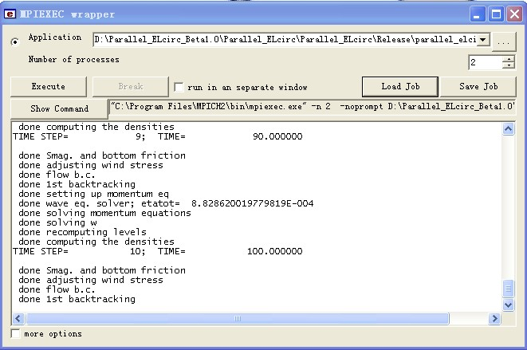

配置方法参考：
牛志伟，黄红女 Windows 平台下机群并行编译环境配置[J].计算机技术与发展，2007，7（8）：15-18
汤雷, 潘雪峰, 刘智珺 并行程序设计环境的研究[J].电脑知识与技术
Lingyun Wei, Riyu Wei, Tianbing Tang Design and implementation of a windows-based parallel computing environment for large scale optimization [J]. Advances in Engineering Software 35 (2004) 577–584

目前已有很多并行编程计算环境支持平台问世，如IBM公司的EUI、Intel公司的NX和橡树岭实验室开发的PVM等，这些平台均用于处理器间的通讯传递，但互不兼容，可移植性差。
1992年，由IBM、Intel公司等开发商联合一些研究机构和大学开发出了MPI软件并制定了一系列标准，共有2个版本：MPICH1（1994）和MPICH2（1997）。MPI现在已经是被应用最广泛的计算平台。
MPI（Message Passing Interface），消息传递编程接口，是用于处理器间的通信传递模型，由一组库函数组成，可以被C或Fortran语言程序调用并扩展。严格说来，MPI只是一组函数库，提供了程序开发的编程接口。本文模型采用的是MPICH2软件，可以下载安装程序及程序源代码（http://www.mcs.anl.gov/research/projects/mpich2/）。

在Windows平台上编译SELFE 模型
1. SELFE 需要2个 external library: ParMETISLib and METISLib. 这2个库文件的编译参考上一篇博客。
2. FOR SELFE compile, as the program need fpp compile instruction. The fpp function needed to be turn on in MSIDE. Two additional preprocessor definitions needed to be added:
USE_MPIMODULE;MPIVERSION=2.（为使用#define 、#if等宏命令，类似于C、 C++）
2.1 The compiler may report error on the max function in file "elfe_main.f90". An additional file is created to ower-write the max file as flowing:
MODULE funMaxModule
IMPLICIT NONE;
INTERFACE max
MODULE PROCEDURE max2i
END INTERFACE
CONTAINS
INTEGER FUNCTION max2i(x,y)
INTEGER ::x,y;
max2i= max(x,y);
END FUNCTION
END MODULE
Use the funMaxModule in the file may solve the problem.

2.2 slefe have problem in calling "netcdf " function. in file "sflux_9c.F90"
change
"integer time_dim" to "integer time_dim(2)"
and
"iret = nf_inq_dimlen(ncid, time_dim, num_file_times)" to
iret = nf_inq_dimlen(ncid, time_dim(1), num_file_times)
2.3 IF the MPICH2 library was used: It looks like the MPICH2 library don't support MPI_REAL8 data, need to change in file "elfe_msgp.F90" :
integer,public,save :: rtype = MPI_REAL8 to
integer,public,save :: rtype = MPI_DOUBLE_PRECISION
2.4 The SELFE can run in release model but will have problems in debug model. Because the SELEF will access the array(0) and will cause problem.
run MPICH2 in win7
running MPICH2 on win7 may have a problem "smpd -phrase behappy -install" to slove the problem

ParMETIS_V3_PartGeomKway
香溪的网格分区：
--------------------------------------------------------------------
Global Grid Size (ne,np,ns,nvrt): 19512 20683 40194 50
---------------------------------------------------------------------
**********Augmented Subdomain Sizes**********
rank nea ne neg npa np npg nsa ns nsg
0 2511 2369 142 2735 2588 147 5243 4954 289
1 2593 2473 120 2821 2695 126 5411 5165 246
2 2489 2393 96 2672 2573 99 5159 4964 195
3 2618 2510 108 2832 2719 113 5447 5226 221
4 2542 2461 81 2749 2666 83 5289 5125 164
5 2589 2481 108 2784 2677 107 5371 5156 215
6 2584 2414 170 2809 2632 177 5389 5042 347
7 2526 2411 115 2745 2625 120 5268 5033 235
---------------------------------------------------------------------

----------------------------------------------------------------
ParMETIS_V3_PartKway
Global Grid Size (ne,np,ns,nvrt): 19512 20683 40194 50
---------------------------------------------------------------------
**********Augmented Subdomain Sizes**********
rank nea ne neg npa np npg nsa ns nsg
0 2526 2420 106 2746 2632 114 5269 5049 220
1 2544 2445 99 2759 2655 104 5301 5098 203
2 2647 2560 87 2867 2775 92 5512 5333 179
3 2578 2497 81 2767 2684 83 5343 5179 164
4 2535 2390 145 2747 2597 150 5279 4984 295
5 2534 2425 109 2733 2617 116 5264 5039 225
6 2414 2269 145 2651 2499 152 5061 4764 297
7 2655 2506 149 2857 2703 154 5509 5206 303

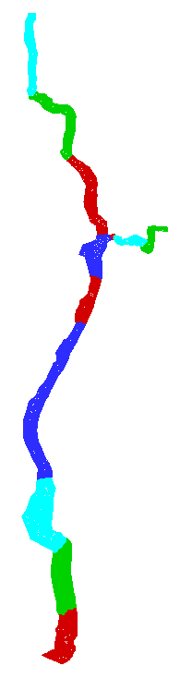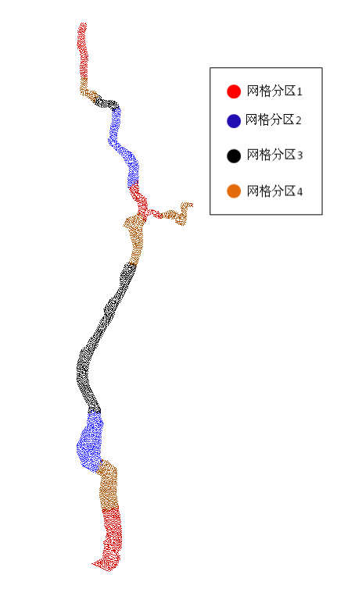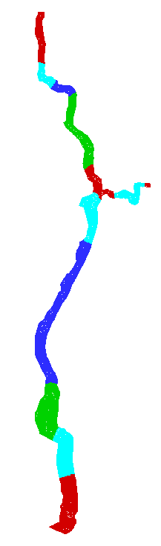
新的网格分区ParMETIS_V3_PartKway 旧的网格分区ParMETIS_V3_PartGeomKway 新的网格分区ParMETIS_V3_PartGeomKway

参考文献
George Karypis, Kirk Schloegel and Vipin Kumar PARMETIS : Parallel Graph Partitioning and Sparse Matrix Ordering Library, Version 3.1, 2003.
G. Karypis and V. Kumar. Multilevel k-way partitioning scheme for irregular graphs. Journal of Parallel and Distributed Computing, 48(1), 1998.
K. Schloegel, G. Karypis, and V. Kumar. Parallel multilevel algorithms for multi-constraint graph partitioning. In Proc. EuroPar-2000, 2000. Accepted as a Distinguished Paper.
汤继飞，李思 ，张理论等 面向并行负载平衡的数据剖分技术. 计算机应用研究，2010, 27(11): 4015-4019.
O.B. Fringer, M. Gerritsen, R.L. Street. An unstructured-grid, finite-volume, nonhydrostatic, parallel coastal ocean simulator Ocean Modelling 14 (2006) 139-173
非结构化网格模型的并行化的关键之处就是将非结构网格分区处理成分块网格分配到各个处理器中，因为ELcirc模型是采用平面非结构化网格，而垂向采用Z坐标分层网格，因此考虑对平面非结构网格分区处理以保证各处理器中垂向单元体（即水柱）的邻接性，这种垂向水柱的连续内存存储分配方式可提高计算效率。
在进行处理器间的网格分区时，需要尽可能地平均分区网格单元，否则会发生一些处理器工作负荷很重，而一些处理器参与计算任务过少，即网格分区的均衡性。而均衡化的网格分区确保计算任务在处理器间的均衡分配。非结构网格模型的并行计算效率很大程度上依赖于相邻处理器间的信息通讯，而处理器间的信息通讯量与处理器边界处的网格单元数成正比，因此，需要在尽可能地减少相邻处理器边界处的网格单元数的条件下做将网格单元平均分配到处理器中的优化分区。
满足以上条件的非结构网格分区的处理采用ParMETIS软件获得，ParMETIS可对二维平面非结构网格进行分区。如图，

