1. **Good visualization and bad visualizations**
2. **Good visualization 1** 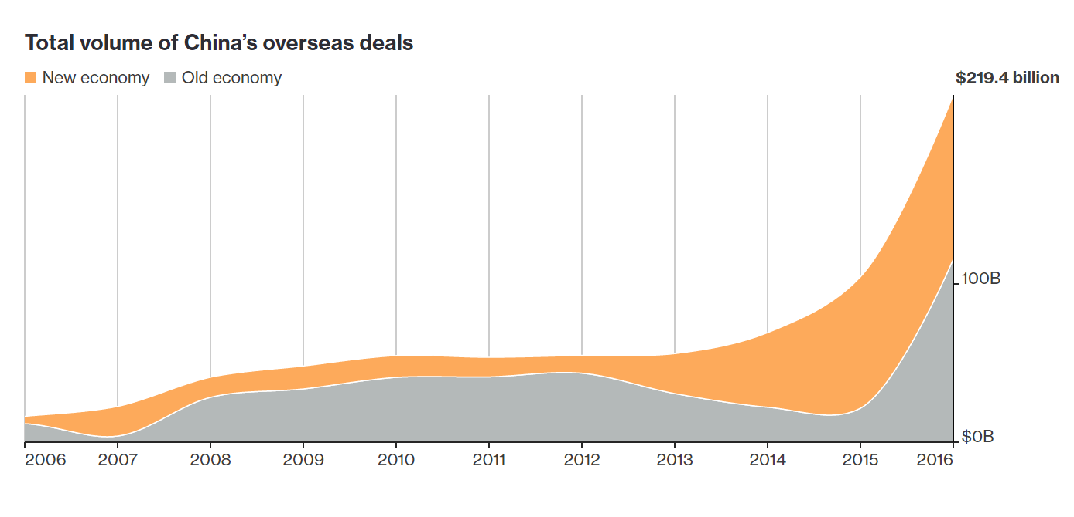

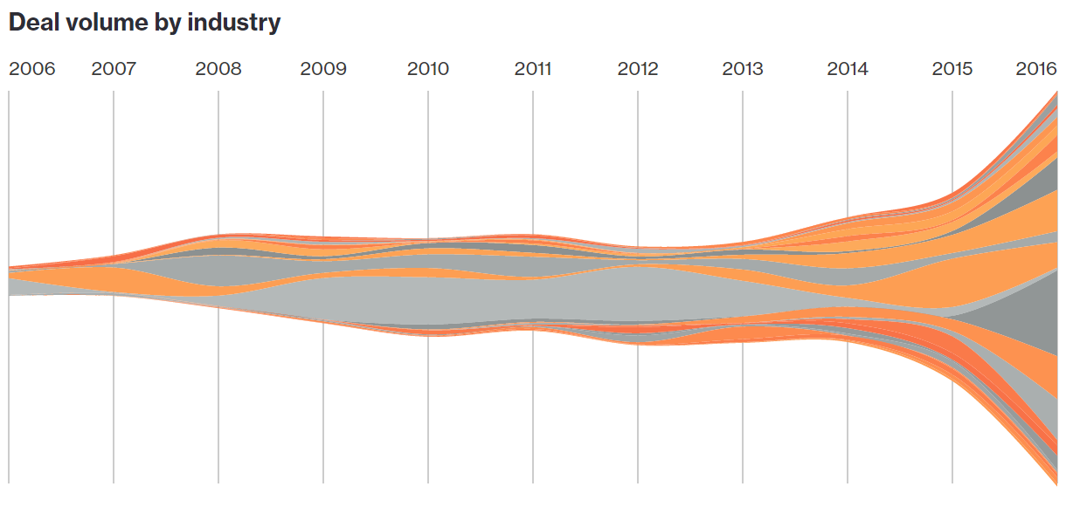

BloombergChinaDealVolume.png

<http://www.bloomberg.com/graphics/2016-china-deals/>

* 1. In what ways does the visual meet/fail to meet the principles of good visualization?

The chart is interactive and shows acquisitions in different industries over time. When a user hover over the each of the industries it will highlight that industry over time. The chart uses only two distinct group of colors. The shape and position utilize all available real estate well. The font is clear. The x-axis is labeled in years from 2006 to 2016. The y-axis is labeled in dollar amount. Both are in linear scale.

* 1. What story is the data telling or trying to tell?

I found this visualization when reading Bloomberg news stories on China’s overseas deal making. The chart very effectively told the story of a large increases of China’s overseas deals over the last two years. The purchases of businesses has more than doubled over the last two years. The components of deals changed from traditional industries to new economy industries. The black/grey colors for traditional industries like energy, mining, chemical, and the red/orange colors for new industries like internet, finance, entertainment. The story is China is buying a lot of companies from overseas, and they were buying more service oriented businesses over traditional businesses because their economy has changed.

* 1. What would you change to make the visual better or (for good ones) what do you hope to incorporate in future visuals of your own.

I think the flow chart is very cool. The flow chart is effective to show numeric measurement change over time. I remember seeing a similar flow chart in class. I would like to use it when visualize a dataset with numeric values.

* 1. In particular, focus on the elements in chapter 3 of Data Points, which elements of visualization does the chart use to create meaning?

I think the chart use all visualization components discussed by Data Point book very well. It use scale especially well. The components of deals from old economy industries to new economy industries are clearly visible. The visual cues are represented by area, volume which represent dollar amounts in deals. The choice of colors are very good. The time progression are linear from left to right.

1. **Good visualization 2** 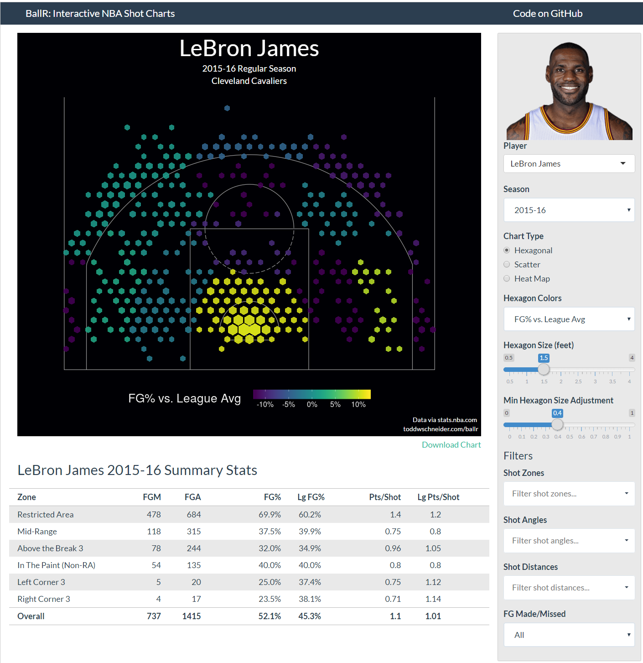

BallRNBAShortCharts.png

<http://toddwschneider.com/posts/ballr-interactive-nba-shot-charts-with-r-and-shiny/>

* 1. In what ways does the visual meet/fail to meet the principles of good visualization?

The chart uses different color to indicate player’s efficiency rating using Points/shot vs League average points/shot. The labels are clear. The use of basketball court lines also make it obvious it is a basketball chart and the position where players make or miss a shot. Fonts are easily readable.

* 1. What story is the data telling or trying to tell?

I found this on toddwschneider.com. This chart is created using R and Shiny. Shiny is powerful open source R library to create interactive graphs and website. I thought this is a really cool chart showing how each player’s FGP comparison to league average. This is to show if a player has a preference to certain area of the court.

* 1. What would you change to make the visual better or (for good ones) what do you hope to incorporate in future visuals of your own.

Instead of gradient color range we can use more distinctive step colors to indicate points/short vs league average points/shot. The hexagonal size seems to indicate size of data. We need some description or label to explain it better.

* 1. In particular, focus on the elements in chapter 3 of Data Points, which elements of visualization does the chart use to create meaning?

This chart use visual cue color, position very well. The color indicates the difference between current player and average points/shot. This indicates a player’s efficiency rating compare to league average. The size of dot indicates frequency of shots on the basketball court.

1. **Bad visualization 1**

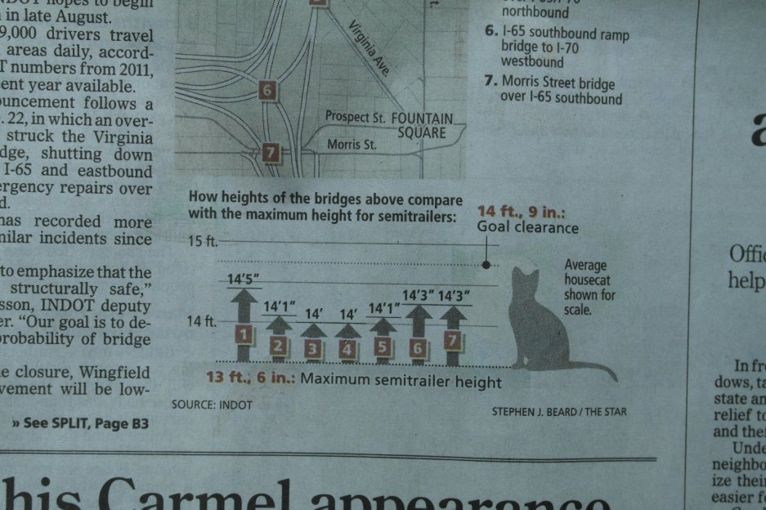

SemitrailerHeightBadVisual.jpg

<https://flowingdata.com/2013/07/15/open-thread-what-is-wrong-with-these-charts/>

* 1. In what ways does the visual meet/fail to meet the principles of good visualization?

This chart failed badly on principles of good visualization. It is confusing by adding a cat there. Cat is eye catching but distracting, and has nothing to do with the story. The y-axis starts with 13ft and 6 inches without good labels. The x-axis does not say what each of items from one to seven means. Without showing the full heights of the bridges and semitrailer it is difficult to see the actual comparisons. The bridge heights are truncated at maximum semitrailer height.

* 1. What story is the data telling or trying to tell?

This chart is very hard to understand at first. I did not understand what the story is at first. Then I realized it is trying to show the gap between bridges and maximum height of semitrailers. The gap is smaller than height of a cat.

* 1. What would you change to make the visual better or (for good ones) what do you hope to incorporate in future visuals of your own.

Since the actual story is the height of bridge and the height of semitrailers I would show draw all seven bridge and the average height of the semitrailers. This way is not as confusing as just showing the difference between the heights. I can use different colors to denote each of the seven bridges. The bridge heights should not be truncated.

* 1. In particular, focus on the elements in chapter 3 of Data Points, which elements of visualization does the chart use to create meaning?

Data Point talked about visual cues as visualization components. Here the length and scale are used as visual cues. However this chart was not effective when compare the height difference between bridges and semitrailer with a cat. It is confusing to the audience.

1. **Bad visualization 2**

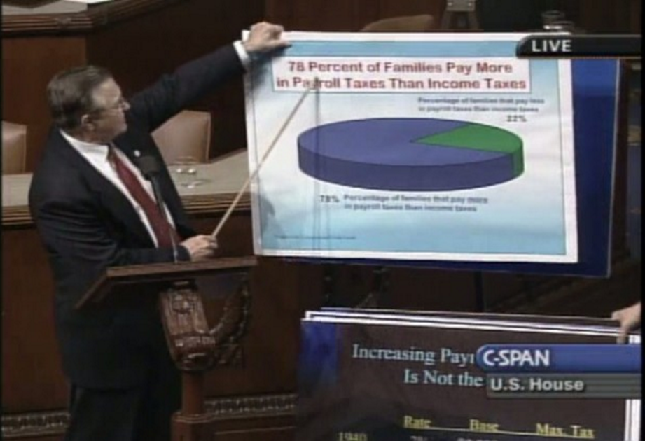

PayrollTaxes.png

<https://flowingdata.com/2012/11/20/ridiculous-but-real-charts-from-the-u-s-congress-floor/>

<http://www.scribblelive.com/blog/2014/05/12/data-visualization-charts-form-the-u-s-congress-floor-the-good-the-bad-and-the-ugly/>

* 1. In what ways does the visual meet/fail to meet the principles of good visualization?

There is no need to use a 3D pie chart here. Depends on audience perspective the ratio or proportion is different and difficult to access. The title is in bigger red font with white background. This is also not necessary. Both of these violates the “don’t add something does not need” principle.

* 1. What story is the data telling or trying to tell?

The actual story is more families pay more pay roll tax than income tax.

* 1. What would you change to make the visual better or (for good ones) what do you hope to incorporate in future visuals of your own.

The congressman could show a simple 2D pie chart with clearer labels and more distinctive colors.

* 1. In particular, focus on the elements in chapter 3 of Data Points, which elements of visualization does the chart use to create meaning?

Visual cues are color (blue and green), area and volume (size of pie). Coordinate system is polar.

1. **Tableau charts**
2. **Heat map 1**

Picture file name: 2015ImportHeatmap.png

Data set: comtrade.csv

<http://comtrade.un.org/data>

Description: I used filter function to only show countries that import at least 100 billion dollar of goods. The title and labels are clear. The length and size of bar represent size of importing dollars amount. The bar chart made the comparison between each countries very easy. I like it better than the second heat map which use size of dot to represent annual importing dollars amount.

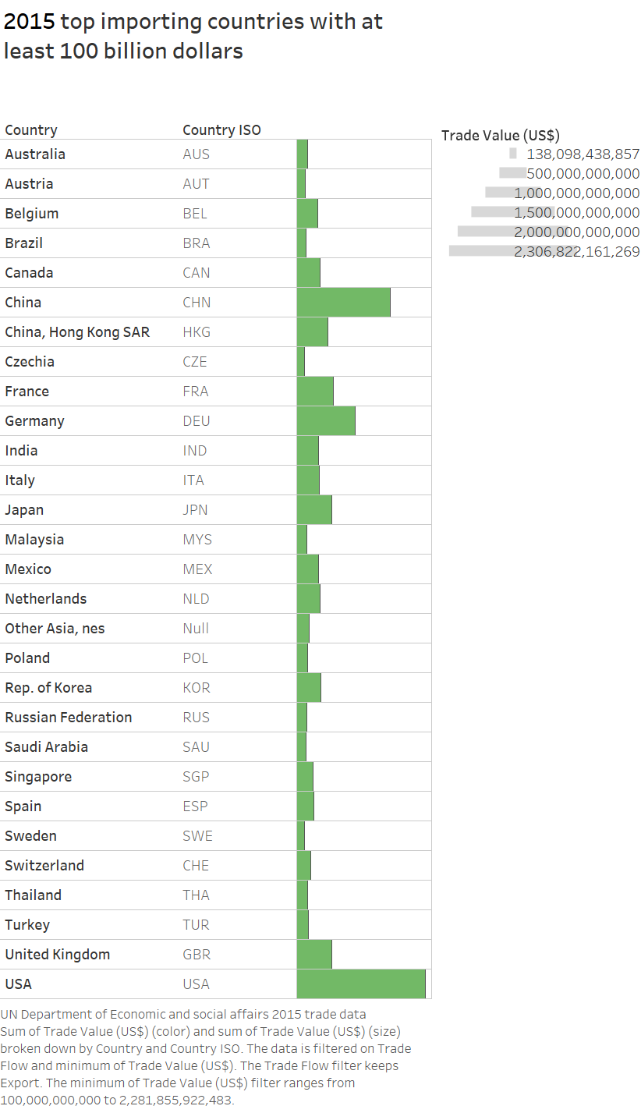

1. **Heat map 2**

Picture file name: 2015ExportHeatmap.png

Dataset: comtrade.csv

<http://comtrade.un.org/data>

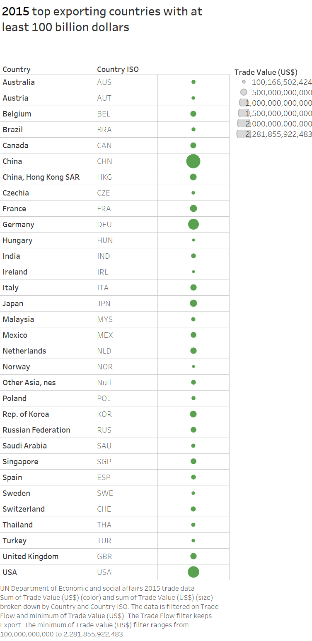

1. **Highlight table 1**

Picture file name: 2013NBAPlayerHighLight.png

Data set: 2013NBAPlayer.xlsx <https://www.statcrunch.com/app/index.php?dataid=1096769>

Description:

The heat map is created from 2013-2014 NBA player statics.

This heat map is my favorite. The use of colors made PPG comparisons between each players clear. The use of stepping colors gives better visual cues. The use of all color range is more confusing to the audience. The actual PPG numbers in the last column help audience understand the color difference. Title and labels are visible and use the same font. The next high light table shows PPG per team.

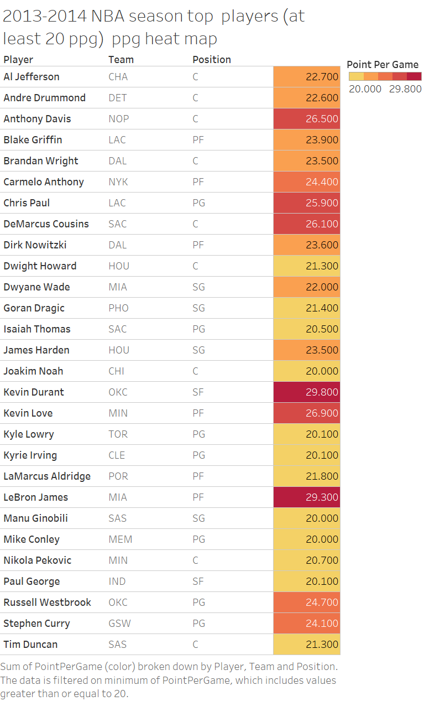

1. **Highlight table 2**

Picture file name:

Data set:

Description:

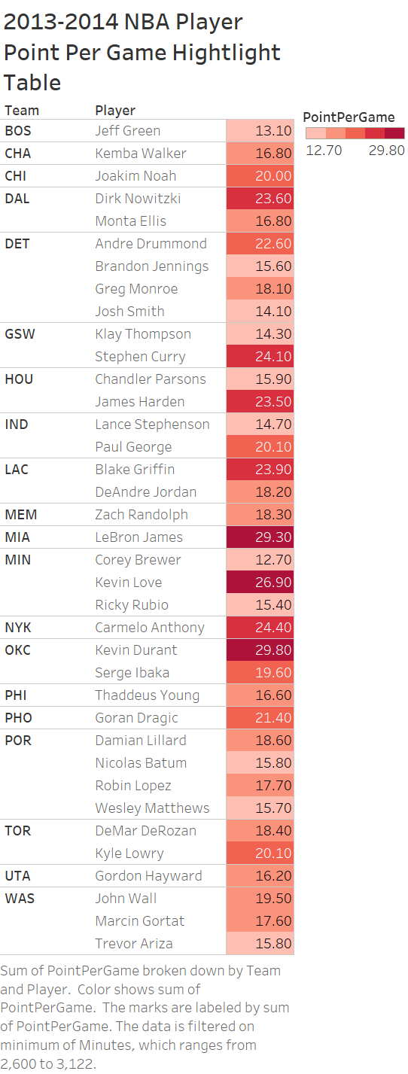

1. **Tree map 1**

Picture file name: StateTotalCrimeCost.png

Data set: JAG data.csv

Description: This is Tree map of state crime total dollars cost tree map. I changed the “Mark” to text it turns out to be a word cloud map. I like this one better than traditional tree map because the size and color of states are more distinctive than the next chart.

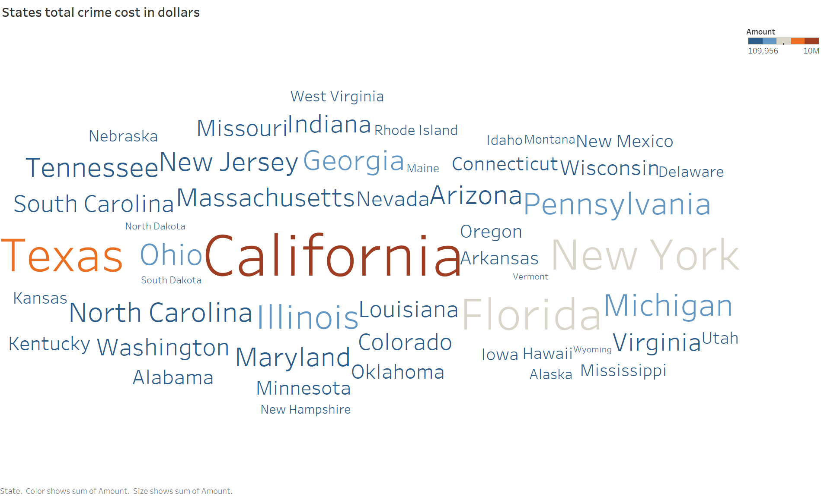

1. **Tree map 2**

Picture file name: StateCostPerCrime.png

Data set: JAG data.csv

