1. **Dashboard 1**

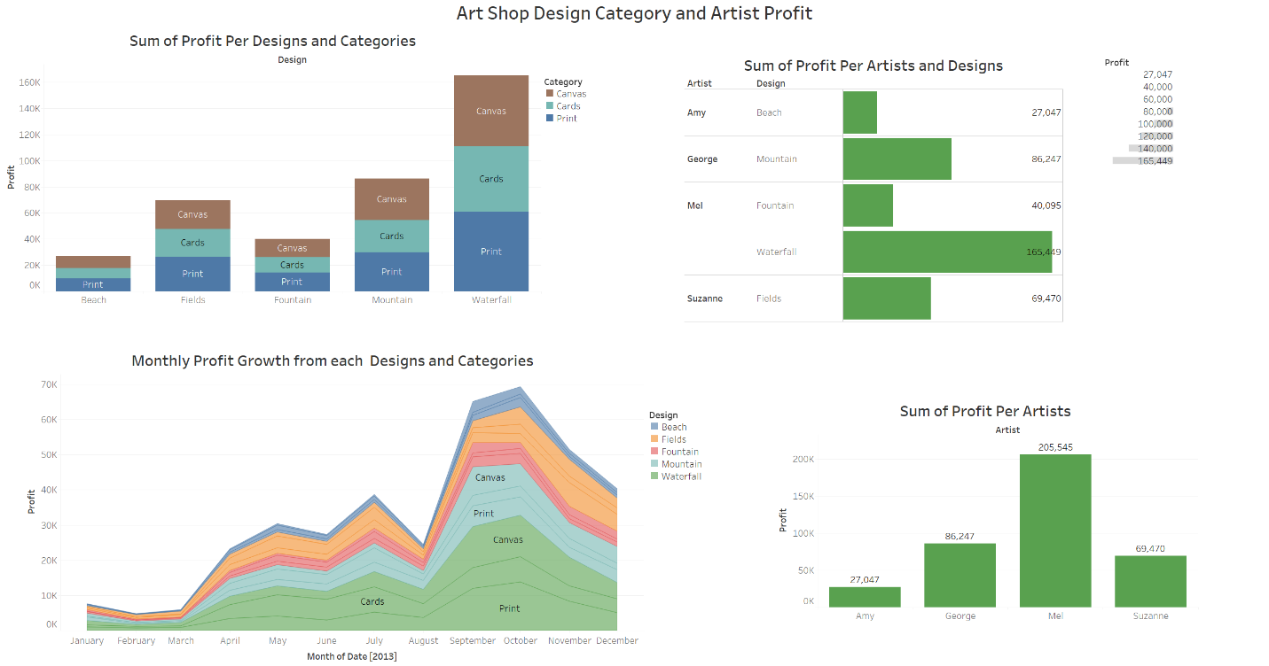

**Dashboard file name:** Art Shop Dashboard.png

**Description:** This dashboard includes four sheets. The dataset are inner join of Sales table and reference table. The first chart is a bar chart of different designs in y-axis and profit. Each designs was also separated into three categories: canvas, cards, and print. The result shows the waterfall design bough in most profit. The profit is a calculated field from sales amount subtract cost of goods and postages. The second chart and third chart are both bar charts that show sum of profit per designs or per artists. The fourth chart is a line chart of monthly profit changes from each designs and categories. The story of this dashboard shows Waterfall design from Mel was most profitable sales item in year of 2013. The profit grows from January to October and was highest in the October, the profit growth has slowed in the last two month of 2013. The use of bar chart is a good option to show difference between each designs. The colors are distinctive and not too many. Legends, arises, labels are clear and easy to see. Those meets principles of good visualizations.

1. **Dashboard 2**

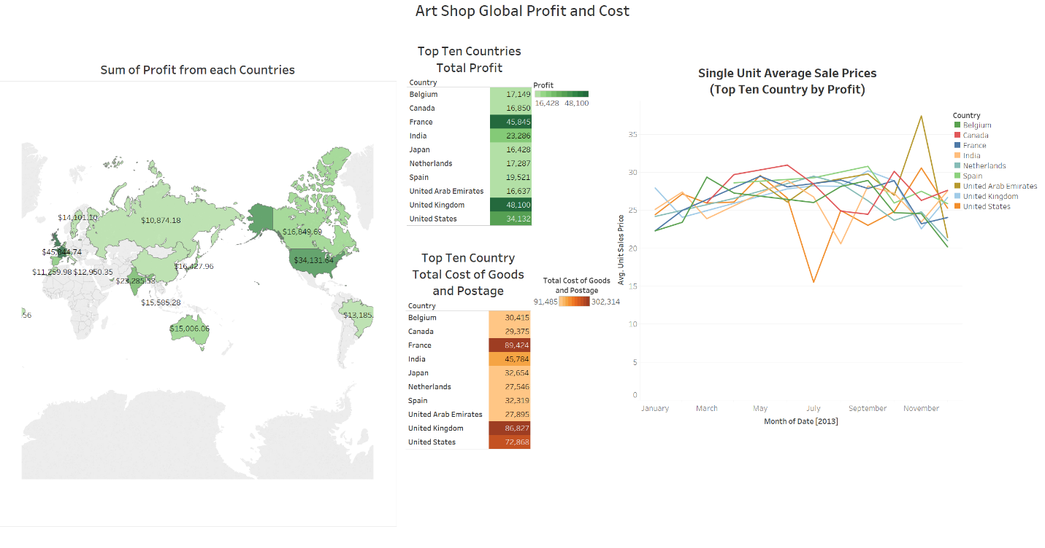

**Dashboard file name:** Art Shop Dashboard Global.png

**Description:** This dashboard shows where globally sales come from. The dashboard uses the same dataset from the first dashboard. There are also four charts in this dashboard. The first dashboard shows sum of profit from all countries. The dollar amount are a calculated field of profit with currency format. The second and third charts in the middle are highlight charts of profit and cost of goods and postage cost from top then countries (using filters). The fourth chart shows monthly profit changes for average unit item price. The monthly profit is a calculated field of profit divided by quantity of items (unit price) for each countries. This chart show average item price is steady from $25 to $30 dollars. Unit profit in US spiked in October then dropped to $20 per item in the last two month of the year. This is possible due to promotion in the Thanksgiving and Christmas sales. The world map use both color darkness and actual dollar amount and dollar sign to denote profit from each countries. The highlight chart uses stepped color with ten steps. Both line chart and highlight tables filter down to top ten countries with ten colors. Legends, arises, labels are clear and easy to see and in the same font. Those meets principles of good visualizations.

1. **Dashboard 3**

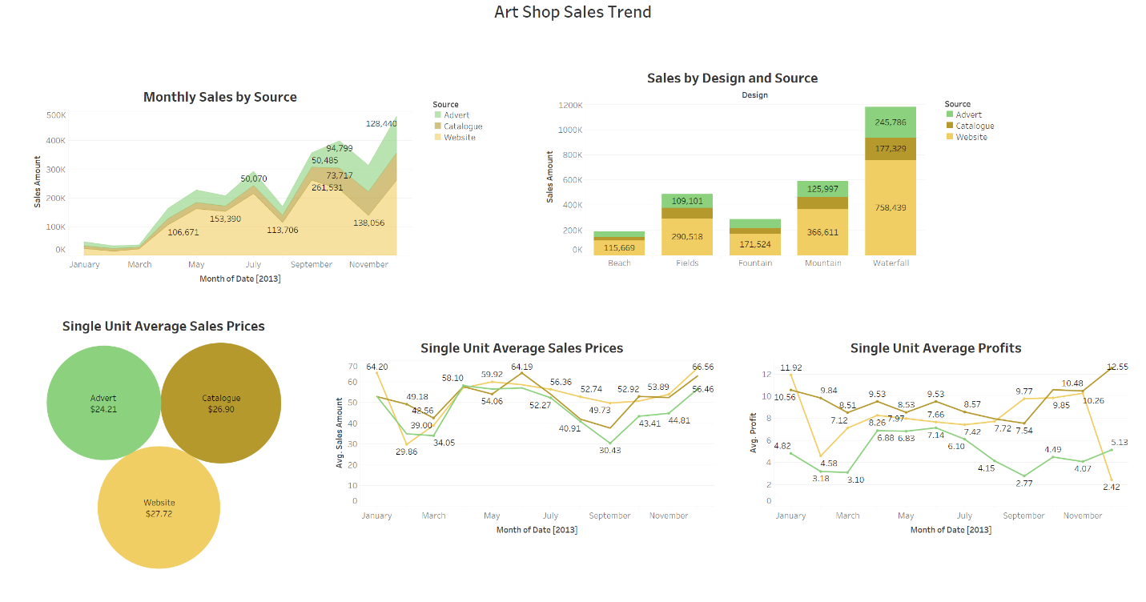

**Dashboard file name:** Art Shop Sales Trend.png

**Description:** This dashboard is my favorite. This dashboard shows sales trends. The dashboard contains five charts. The first chart shows monthly sales by source. It is clear website made most of sales. The second chart on the right top row shows sales by design and source. The waterfall design made most of sales on website. The second chart is a bubble chart shows single unit average sales prices from advertisement, catalogue, and website. The item on website made highest sales price. The fourth and fifth chart is single unit average sales price and single unit average profit during each month of year 2013. From the last two charts we see website unit sales price increased in the last two month of the year but unit profit dropped in the last two month from $10.48 to $2.42. This is likely due to heavy online promotions at the end of year. The item sold on Advertisement is not as profitable as website and catalogue. Art shop can increase profit by reduce sales on Advertisement and increase sales on website and catalogue. Art shop could also give more promotions on its website from January to October and reduce heavy promotion in the last two months of year. All five charts here use the same colors to denote three categories. The use of same three colors for each source is more consistent. The numbers are added to the charts to see actual difference. Legends, arises, labels are clear and easy to see and in the same font. Those meets principles of good visualizations.