1. **Dashboard 1**

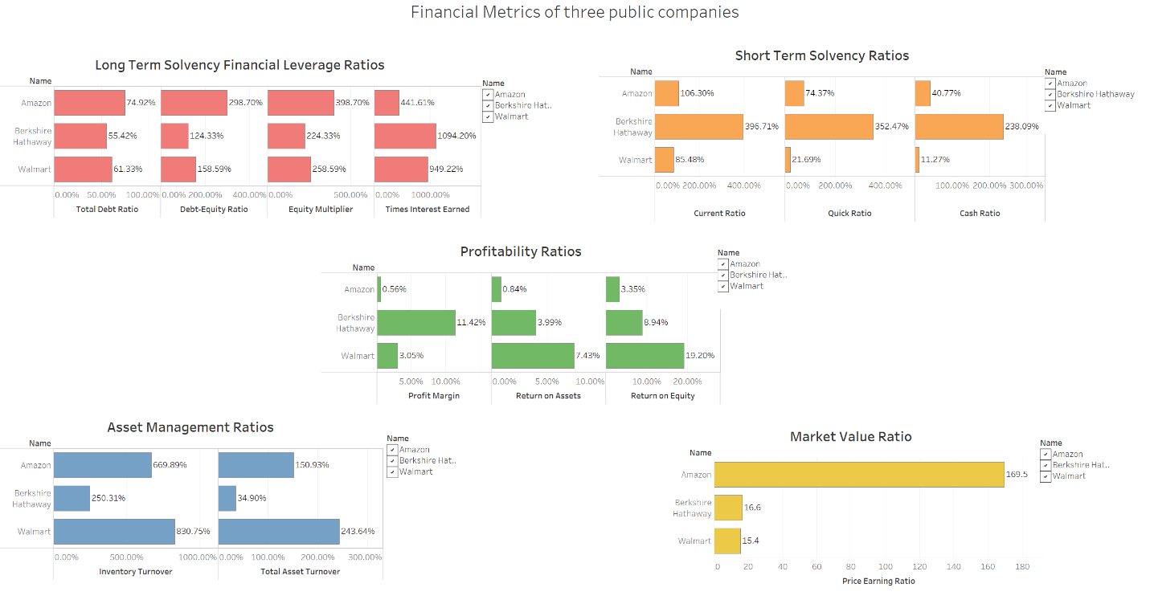

**Dashboard file name:** Art Shop Dashboard.png

**Description:** I picked three retail companies Amazon, Berkshire Hathaway, and Walmart. All retail companies has inventory dollar amounts on their quarterly balance sheets. The calculations of quick ratio and inventory turnover ratio are not null. The dashboard includes five bar charts. The first chart is a bar chart of long term solvency financial leverage ratios. The second chart is short term solvency ratios and third chart is profitability ratios. The fourth chart is asset management ratios. The five chart is market value ratios. The use of bar chart is a good option to show difference between each designs. The colors are distinctive and not too many. Legends, arises, labels are clear and easy to see. Those meets principles of good visualizations. The financial ratio.pdf has one error. The profit margin is net income divide by revenue. The return on assets is net income divides by total assets. As we can see the profit margin is and return on assets are different in the third chart.

The story of this dashboard shows differences between three retail companies. Of the three, Amazon has the lowest profitability ratio, highest market value. Berkshire Hathaway has a diversified businesses, therefore lowest inventory turnover ratio. Berkshire Hathaway has the best long term and short term solvency ratios from its huge cash reserve. Both Amazon and Walmart have higher Asset Management ratios because they sell more products than Berkshire Hathaway. This financial dashboard shows Amazon is not a traditional retail company it is not very profitable and a very expensive stock. However, Amazon sells a lot of products with less inventory than Berkshire Hathaway but not Walmart. Amazon also sells more products with less total asset than Walmart. Amazon is a very efficient company.

1. **Dashboard 2**

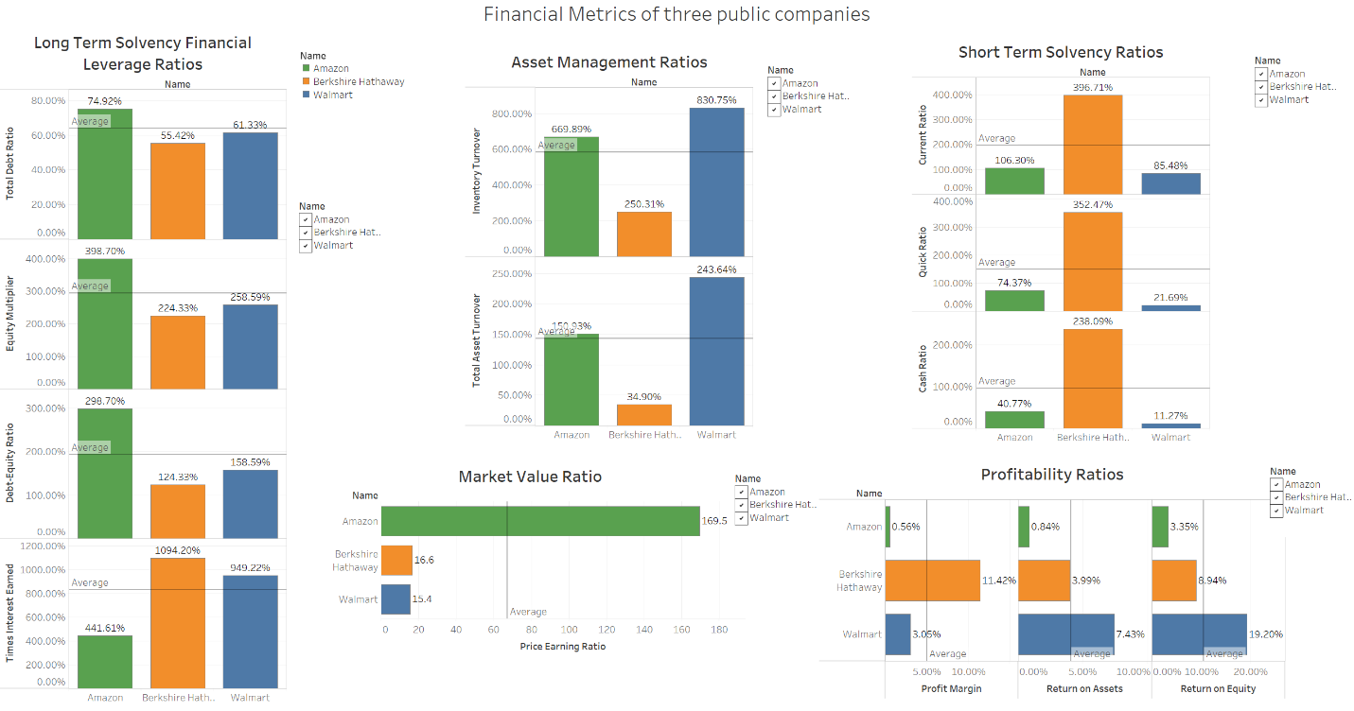

**Dashboard file name:** Art Shop Dashboard Global.png

**Description:**  The second dashboard includes five bar charts. The difference from the first dashboard is charts have the same thee consistent colors per companies. The colors are distinctive and not too many. I also added average reference line. The “Data Point” book talked about using annotations to help tell a story. With the average reference line it is easy to compare the ratios with the averages. The different bar chart styles (top-down or left to right) do a better job of utilize all real estate. Legends, arises, labels are clear and easy to see. Those meets principles of good visualizations. This dashboard is an improvement to the first dashboard.

1. **Dashboard 3**

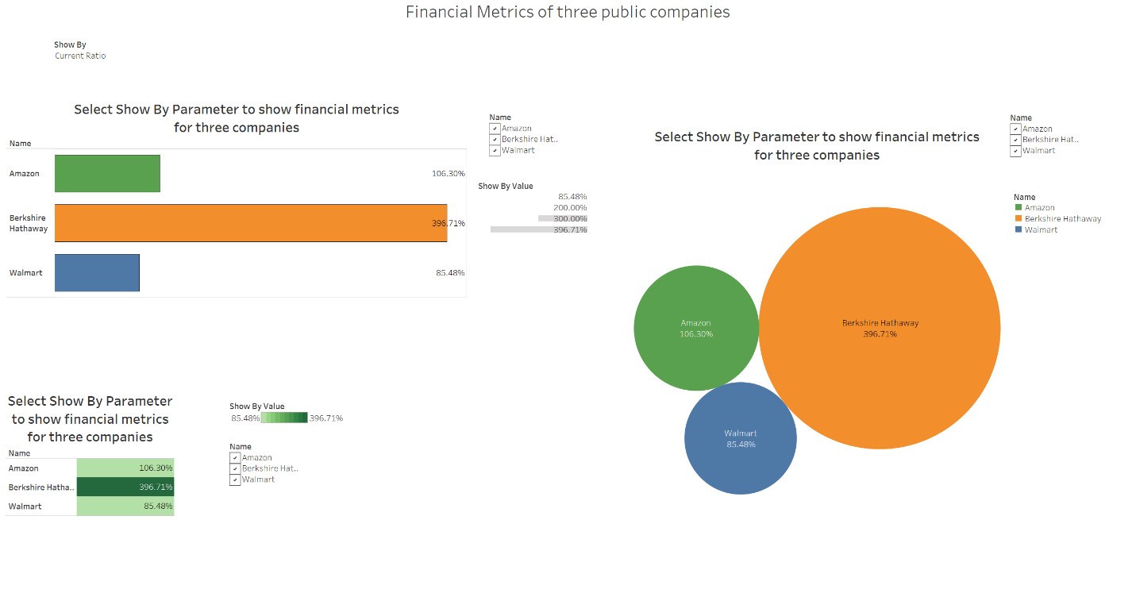

**Dashboard file name:** Art Shop Sales Trend.png

**Description:** This dashboard is my favorite. There are three charts on the dashboard. The three charts are a bar chart, a bubble chart and a highlight table. The dashboard uses a drop down list “Show By” to select financial metric to show. The three charts would update and show selected metrics. The drop down menu and filter checkbox only show selected ratios or company. The dashboard is very clean and less cluttered. This is the reason why this iteration is my favorite. All two charts here use the same colors to denote three categories. The highlight chart uses stepped color with ten steps. The use of same three colors for each companies is more consistent. Legends, arises, labels are clear and easy to see and in the same font. Those meets principles of good visualizations.