1. **Dashboard 1**

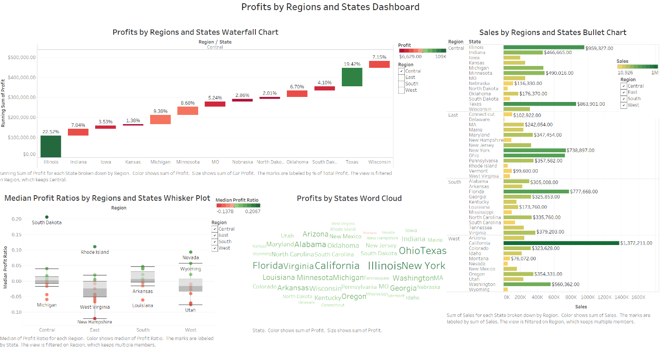

**Dashboard file name:** Profits by Region and State Dashboard.png

**Description:** The first dashboard includes four charts: a waterfall chart of car sale profit in regions and states, a sales by regions and states bullet chart, a whisker plot of average shipping cost per car, and a word cloud of profit by state. The minimum, maximum, average, and median sales dollars are shown on the bullet chart tooltips. The reason it does not label directly on each bar is to avoid overcrowding.

The story of this dashboard shows the differences in sales (bullet chart) or profits (waterfall chart) between regions and states. The region filters allow user to filter down to one or more regions. The word cloud shows those big states like California, Florida, Illinois, Ohio, New York, Texas made most profits. The whisker plot shows median profit ratios across region and state. The stepped colors are being used in all four charts. When there are both negative and positive numbers in the data it uses red to green diverging colors. If there are only positive numbers the chart uses green to gold sequential color. The “Data Points” book mentioned this is a good approach on selecting colors. The legends, labels, titles are clear and in the same font. The whisker plot dots are made slightly bigger so that it is easy to see. The whisker plot uses median number instead of average number because most of sales were not making profits, and only a few sales made big profits. Those meets principles of good visualizations.

1. **Dashboard 2**

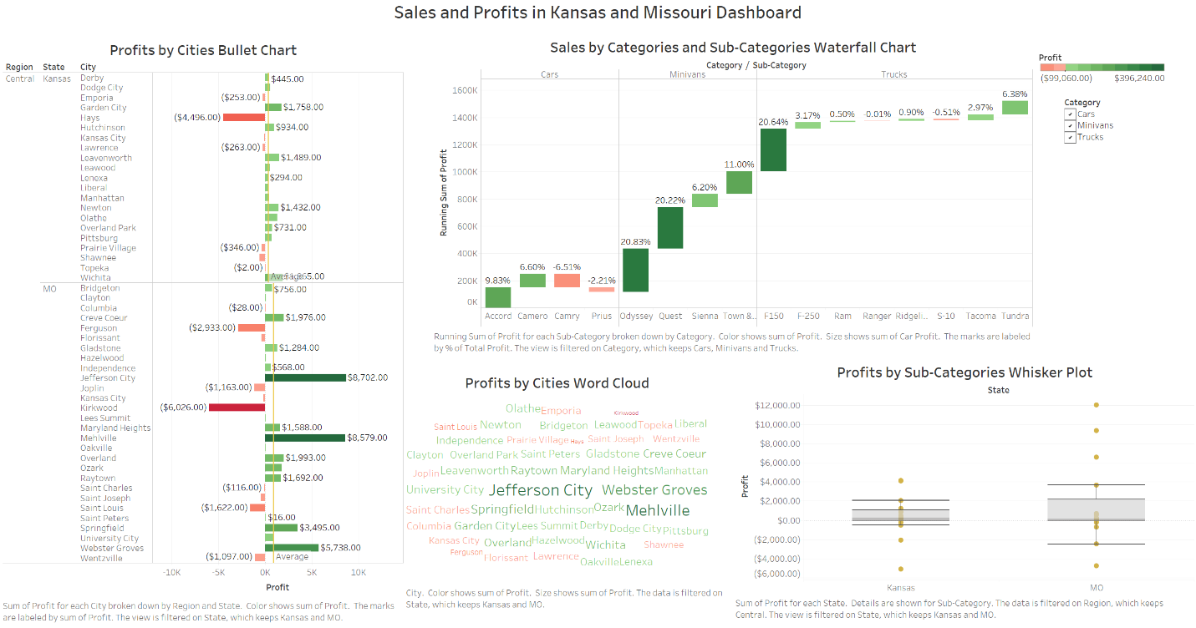

**Dashboard file name:** Sales and Profits in Kansas and Missouri Dashboard.png

**Description:**  This dashboard is an improvement to the first dashboard. The second dashboard has the same four chart types: a profit by Kansas and Missouri City bullet chart, a sales by vehicle category and sub-category waterfall chart, a profits by city word cloud, and profits by sub-category whisker plot. The average, median, maximum, minimum numbers are on the waterfall chart tooltips.

There were a lot of data on the first dashboard even with the optional regions filters. I made the second dashboard with only data from two states. The story of this dashboard is to show sales and profit in state of Kansas and Missouri. Which cities in state of Kansas and Missouri made more profits? Which vehicle made more sales or profits in cars, minivans, and truck?

Again I used same green to red step colors to show numbers with both negative and positive numbers. The colors are distinctive and not too many. I also added average reference line. The “Data Point” book talked about using annotations to help tell a story. I added the average reference line on the bullet chart so it is easy to compare the ratios with the averages. Legends, arises, labels are clear and easy to see. Those meets principles of good visualizations.

1. **Dashboard 3**

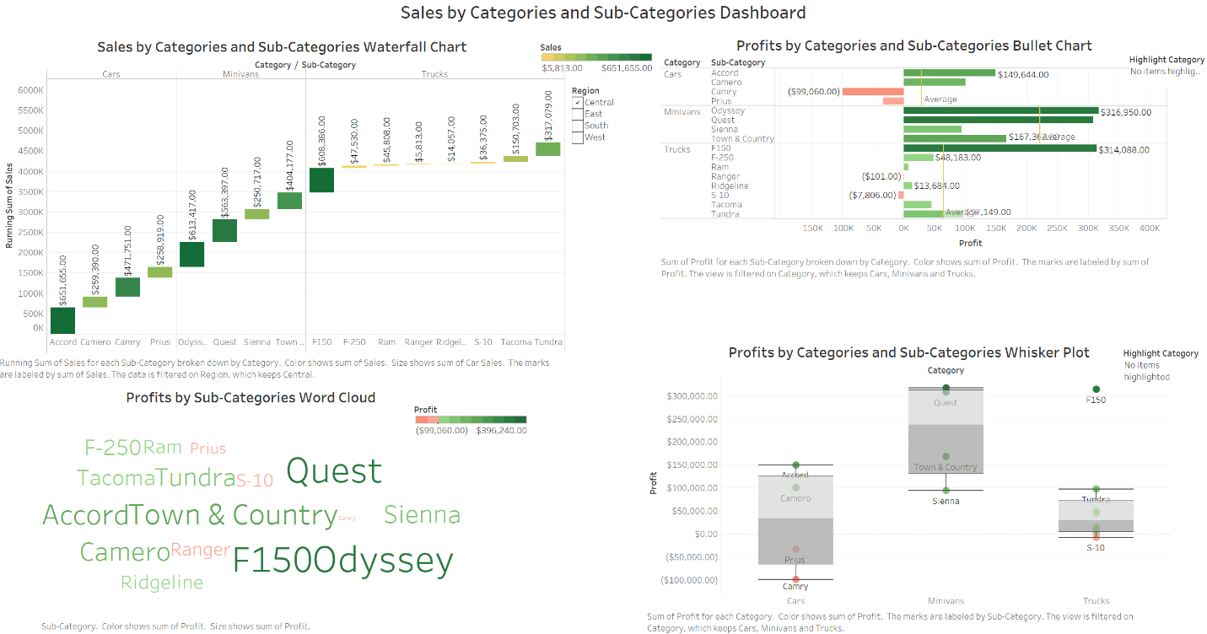

**Dashboard file name:** Sales by Category and Sub-Category Dashboard.png

**Description:** This dashboard is my favorite. It has the same four types of charts. The four charts are a sales by category and sub-category waterfall chart, a profits by category and sub-category bullet chart, a profits by car sub-category word cloud, and a profits by category and type whisker plot. The average, median, maximum, minimum numbers are on the bullet chart tooltips. This dashboard is my favorite because it focuses on the category and sub-category. The sales and profits differences between each category and sub-category are big. Is easy to see low gas mileage vehicles like F1500, Odyssey, and Quest made a lot of more profits than others. This tells a pretty interesting story of why car manufactures prefer to make gas guzzlers.

The dashboard is very clean and less cluttered. This is another reason why this iteration is my favorite. All four charts use the same stepped diverging colors to denote numbers with both negative and positive number. The sequential stepped colors are used for data with only positive number. The average reference line are added to the bullet chart to help distinguish difference in profits. The highlight and filter help to make the waterfall and bullet charts more interactive. Legends, titles, labels are clear and easy to see and in the same font. Those meets principles of good visualizations.