1. **Bank Balance and Default Balance**

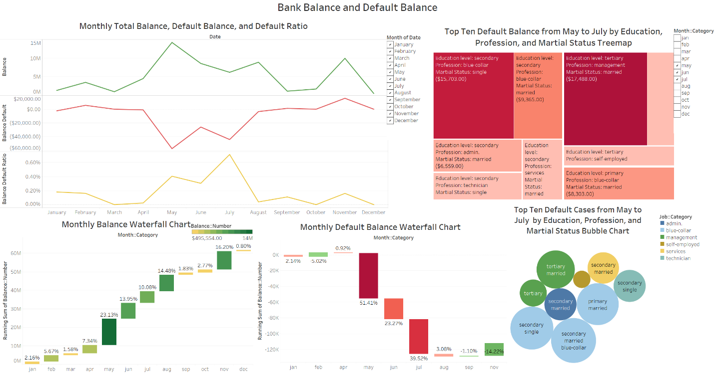

**Dashboard file name:** Profits by Region and State Dashboard.png

**Description:** The first dashboard includes five charts: a waterfall chart of monthly Bank Balance, a waterfall chart of monthly Default Bank Balance, a line chart including total balance, default balance, and default balance percentage, a tree map of top ten default by education, profession, and marital status, and a bubble chart of default balance by education, profession, and marital status.

The story of this dashboard shows customers’ balance in default vs overall balance. Marketing manager needs to watch marketing campaign during summer month from May to June because more default balances for customer profiles specified in the tree map chart. The tree map shows top ten categories of in total default balance. For the line chart a calculated field is used to calculate default ratio by dividing customers’ balance in default vs overall balance in each month. The ratio shows how capitalized bank balance is, or whether bank balance can cover default (a loss). We can see from the “Monthly Total Balance, Default Balance, and Default Ratio” chart something is pretty clear. That the months from May to July have the highest default ratio (0.4% - 0.71%). Monthly Default Balance Waterfall Chart shows us the highest default balance is in May. However, the bank’s total balance dropped in July and the total default balance is still pretty high that is why July is the highest default ratio. The month filter also allow user to filter down to specific month. The bubble chart shows the number of default cases for each of the top ten default categories and average default balances of each. The stepped colors are being used in all waterfall and tree map chart. The legends, labels, titles are clear and in the same font. Those meet the principles of good visualizations.