**EX NO:**

**DATE:**

**WEBPAGE CREATION USING CASCADING STYLE SHEETS**

**FIRSTemb-css.html:-**

<html>

<head>

<style type="text/css">

input.txt

{

background-color:teal;

color:orange;

font-size:16pt;

}

body

{

text-align:center;

background-image:url(snow.jpg);

color:maroon;

line-height:25pt;

font-size:30pt;

font-variant:small-caps;

}

h1

{

color:green;

font-size:20pt;

margin-left:150pt;

text-decoration:underline;

font-weight:bold;

}

form

{

position:absolute;

top:100pt;

left:400pt;

border-style:solid;

}

</style>

<h1>EXAMPLE OF EMBEDDED CSS</h1>

</head>

<body>

<form method="get" action="SECONDext-css.html">

UserName:<input class="txt" type="text" size="20"><br/>

PassWord:<input class="txt" type="password" size="15"><br/>

<input type="submit" value="SUBMIT"/>

<input type="reset" value="RESET"/>

</form>

</body>

</html>

**style1.css:-**

body

{

background-image:url(floral.jpg);

line-height:45pt;

color:maroon;

font-size:16pt;

}

table,td,th

{

border:solid blue;

font-size:20pt;

margin-left:100pt;

}

th

{

background-color:yellow;

color:blue;

font-size:30pt;

}

td

{

text-align:center;

}

h1

{

text-align:left;

font-sixe:16pt;

text-decoration:underline;

font-style:italic;

}

img

{

border-style:solid;

float:right;

margin:5px;

}

h1

{

color:green;

font-size:20pt;

text-align:center;

text-decoration:underline;

font-weight:bold;

}

a:visited

{

font-size:40pt;

color:orange;

}

a:link

{

color:red;

font-size:35pt;

}

a:hover

{

color:blue;

font-size:50pt;

}

a:active

{

color:gray;

font-size:20pt;

}

a

{

cursor:move;

}

**SECONDext-css.html:-**

<html>

<head>

<link rel="stylesheet" href="style1.css" type="text/css" />

<h1>EXAMPLE OF EXTERNAL CSS</h1>

</head>

<body>

The various courses available in our institution are given below:

<img src="comp.jpg" alt="Computer" width="30%" height="70%" /><br/>

<table>

<thead>

<tr>

<th>Course</th>

<th>Duration(in months)</th>

</tr>

</thead>

<tbody>

<tr>

<td>JAVA(Basic)</td>

<td>4</td>

</tr>

<tr>

<td>JAVA(Core)</td>

<td>8</td>

</tr>

<tr>

<td>C and C++</td>

<td>6</td>

</tr>

<tr>

<td>Visual Basic(VB)</td>

<td>2</td>

</tr>

<tr>

<td>Oracle DBA (10g)</td>

<td>18</td>

</tr>

<tr>

<td>Computer Assembling</td>

<td>3</td>

</tr>

</tbody>

</table>

<center><a href="THIRDinl-css.html">GOTO THE NEXT PAGE</a></center>

</body>

</html>

**THRIDinl-css.html:-**

<html>

<head>

<h1 style="color:green;font-size:20pt;text-align:center;text-decoration:underline;font-weight:bold;">EXAMPLE OF INLINE CSS</h1>

</head>

<body style="background-image:url(bckgd3.jpg);line-height:28pt;color:maroon;font-size:18pt;font-type:cooper black;font-weight:bolder">

For futher details contact us:

<pre>

Address:<h3 style="color:red;font-size:20pt;line-height:25pt">

104,Sahithya Towers,

1<sup>st</sup> Floor,

School Road,

Annanagar West Extn.,

Chennai-600 101.</h3>

Phone number:<h3 style="color:red;font-size:20pt;line-height:25pt">

Landline :(044)-26285642

Mobile :<i>+91 9940050011</i>

</h3>

</pre></body></html>

**OUTPUT:-**

**EMBEDDED CSS:-**

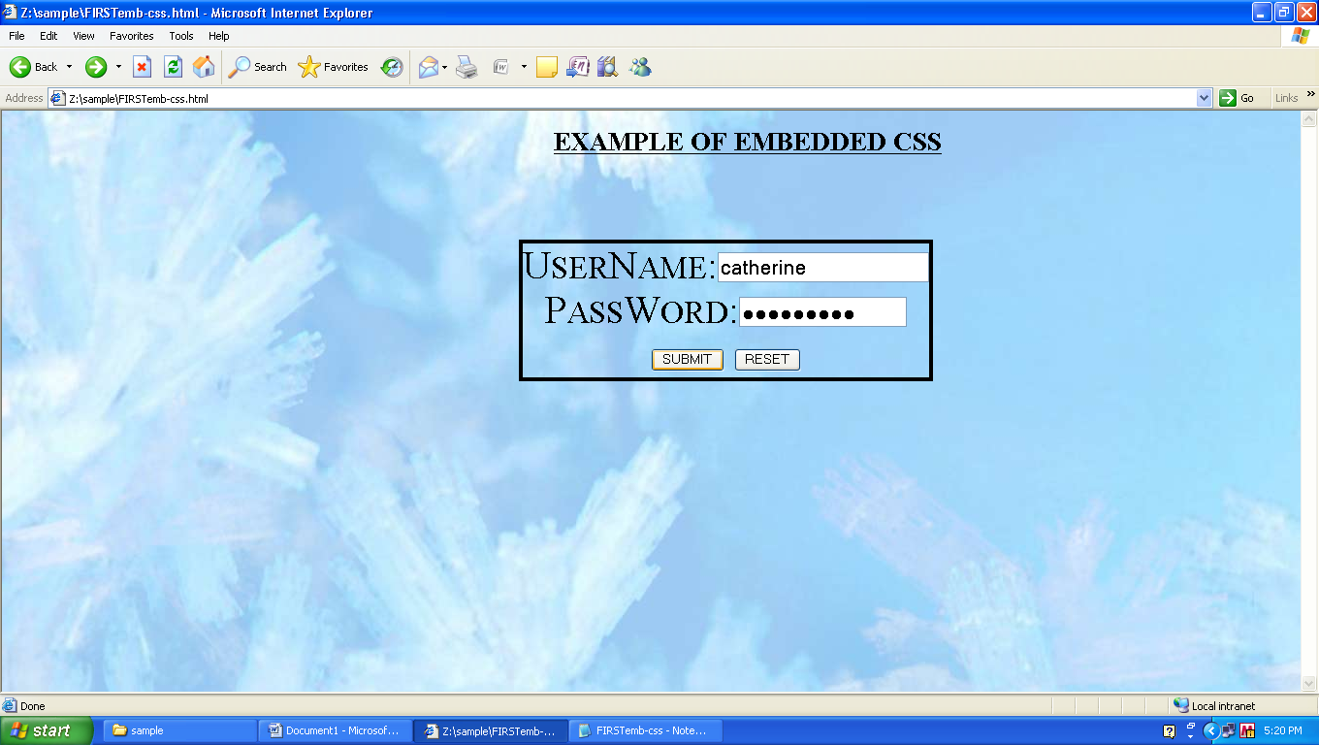

**EXTERNAL CSS:-**

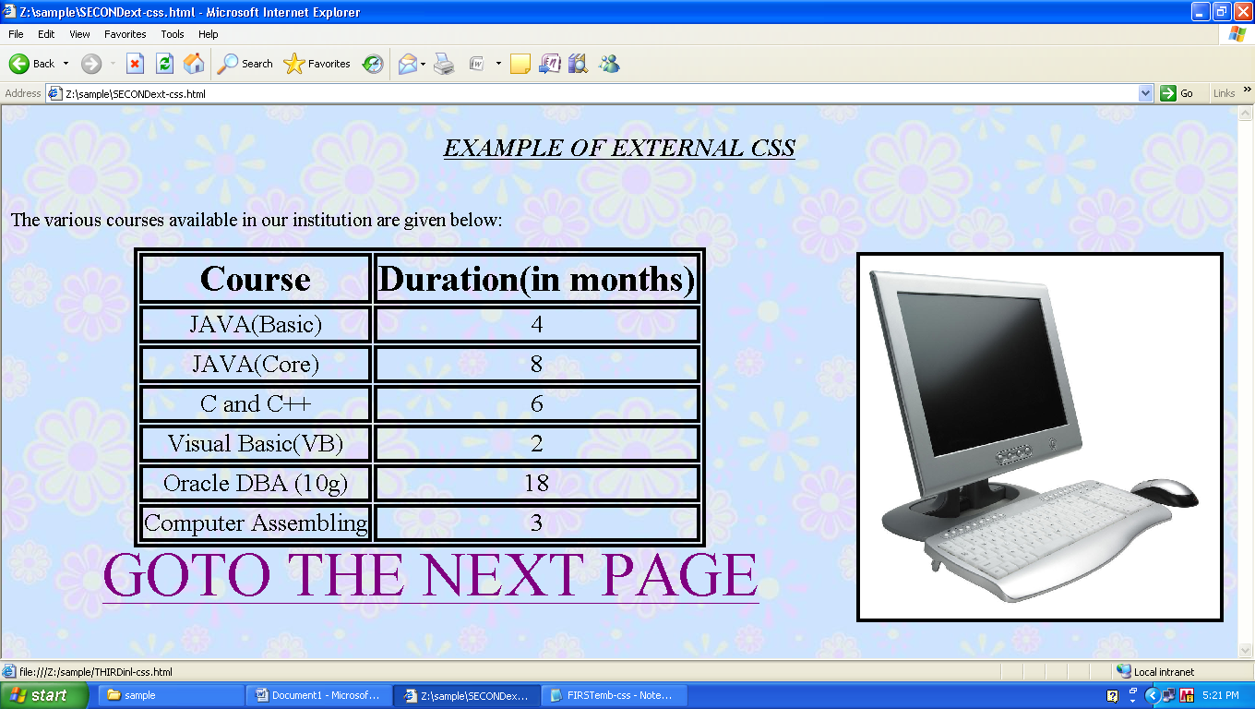

**INLINE CSS:-**

