Shallow Groundwater Causally Amplifies River Floods in Lowland Catchments
Jun, Julian, Liguang, …, Lars, Raphael
Target journal: GRL

Abstract (150 words)
River flood severity depends on storm characteristics and landscape properties, but also on antecedent catchment moisture (ACM). Recent precipitation, soil moisture, and baseflow are commonly used to represent ACM, but they may not fully capture the effects of shallow groundwater. Here, we combine event-scale rainfall-runoff data from Danish catchments with model-derived groundwater level anomalies to test whether shallow groundwater improves flood prediction and to estimate its causal effect on flood response. We find that groundwater rise from moderate to high levels increases flood peaks by 8%, raises flood occurrence probability from 16% to 19%, increases extreme flood volume by 4%, and prolongs flood duration by 3 days on average, after accounting for other ACM controls. Effects are strongest in low-gradient, stream-connected catchments, where shallow groundwater reduces available storage and sustains river discharge. These findings identify shallow groundwater preconditioning as a causal amplifier of river floods in lowland regions.
Plain Language Summary
River flood severity depends not only on rainfall, but also on how wet a catchment is before rain falls. In low-lying catchments, shallow groundwater can be closely connected to rivers, yet its role in amplifying floods under similar rainfall and soil moisture conditions remains poorly understood. Using causal machine learning and data from Danish catchments, we estimate how rising groundwater levels affects river floods. We find that higher groundwater levels increase flood peaks, raise the probability of flood occurrence, and extend flood duration. These findings show that shallow groundwater is an important preconditioning factor for floods and should be considered when assessing flood risk in low-lying regions such as Denmark.

- Introduction (460 words)
Flood severity is not determined by heavy rainfall alone. Antecedent catchment moisture (ACM) controls how efficiently rainfall converts to runoff, and therefore shapes flood peaks, volumes, and the likelihood that extreme discharge thresholds are exceeded. In large-sample flood studies, ACM is typically represented by recent precipitation (RR), soil moisture (SM), snowpack, or baseflow, with SM and baseflow both identified as strong predictors of flood peak magnitude (Ran et al., 2022; Berghuijs and Slater, 2023), and cause more extreme flood events. Both, however, are indirect proxies of ACM. SM reflects only the shallow unsaturated zone, and baseflow is itself extracted from the streamflow record, which is meant to help explain, making it sensitive to separation method and only weakly informative about how much subsurface storage remains available before a rainfall event.
Groundwater level (GWL) offers a more direct alternative. It is measured independently of the discharge record, and its depth directly controls riparian saturation and groundwater-stream connectivity, particularly in catchments where the GWL close to the surface. A shallow GWL leaves little storage capacity, expands saturated areas, and strengthens hydrological connectivity to the stream network, whereas a deeper GWL allows rainfall to infiltrate through a larger unsaturated zone before contributing to rapid runoff (Figure 1) - a distinction that SM alone cannot capture, since a shallow GWL can persist even when the soil layer above it is not saturated. Despite this direct mechanistic link, GWL is rarely evaluated as an antecedent flood control at large scales, largely because dense, long-term GWL monitoring networks remain uncommon.
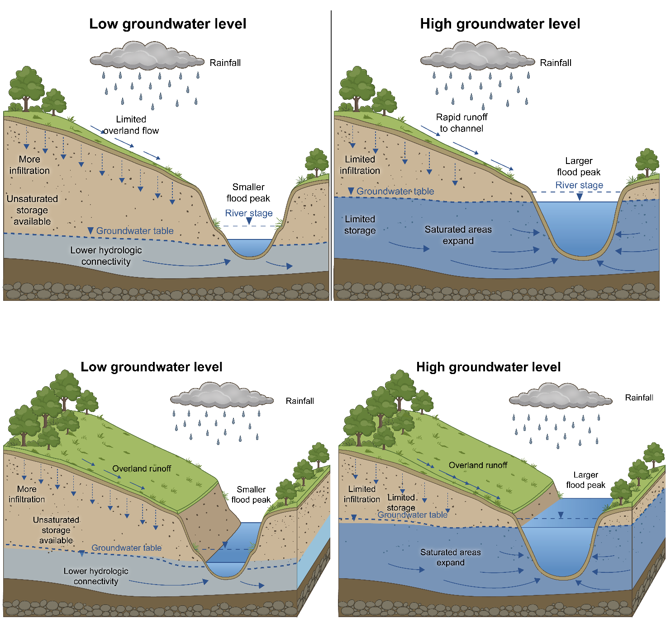
Figure 1. Conceptual role of shallow groundwater in flood generation under similar rainfall conditions. When groundwater levels are low, rainfall can infiltrate into a deeper unsaturated zone, leaving more subsurface storage available and weaker hydrological connectivity between hillslopes, riparian areas, and the stream. This reduces rapid runoff generation and results in lower flood peaks. When groundwater levels are high, available subsurface storage is limited, saturated areas expand, and hydrological connectivity to the stream increases. Under the same rainfall input, these conditions promote faster runoff generation, higher flood peaks, larger flood volumes, and longer flood duration.
Isolating groundwater's independent role is further complicated by confounding: shallow GWL tends to coincide with the same wet periods that also produce high SM and baseflow. Our previous study proved that predictive machine learning (ML) can establish whether GWL carries information useful for flood prediction, but cannot answer the counterfactual question central to hazard assessment - how flood response would differ if antecedent GWL were shallower under otherwise comparable ACM like RR and SM. Causal inference addresses this directly by explicitly adjusting for event, meteorological, and catchment confounders.
Here, we combine event-scale rainfall-runoff data from 299 Danish catchments with model-derived GWL and SM states to test, and then causally quantify, the role of antecedent GWL in flood response. Denmark's shallow GWL and strong groundwater-stream connectivity make it a natural lowland test bed, and a national hydrological model provides spatiotemporally consistent GWL and SM estimates. We compare groundwater indicators at catchment-wide, downstream, and stream-connected lowland scales, and apply causal ML to estimate how antecedent GWL state affects peak discharge, flood occurrence, volume, and duration, independent of concurrent RR and SM. We show that shallower GWL causally amplifies flood severity beyond what SM and RR alone explain, identifying groundwater preconditioning as an underused but directly measurable control on lowland flood hazard.

- Data and Methods

2.1 Study area and data
Denmark, located in northern Europe, is a low-lying country that relies heavily on groundwater, making it well suited for testing whether shallow GWL preconditions flood response. The national maximum elevation is approximately 170 m, while 99.28% of the land area lies below 100 m and 84.46% lies below 50 m (Figure 2a). Simulations from DK-model indicate widespread shallow GWL, with a median groundwater depth of 1.09 m below the land surface and 88.29% of the area having groundwater within 5 m below the surface (Figure 2b). These hydrogeomorphic conditions imply strong potential connectivity between antecedent GWL, near-surface saturation, and river response during rainfall events.

2.2 Identification of rainfall-runoff events
We used daily precipitation and discharge time series from CAMELS-DK dataset to pair rainfall-runoff events. For each catchment, rainfall events began when daily precipitation exceeded 3 mm/d and ended after 2 consecutive dry days. Events with total precipitation below 10 mm were excluded to remove weak rainfall events unlikely to generate a measurable runoff response. Because persistent wet spells may contain multiple rainfall pulses and overlapping runoff responses, rainfall events lasting longer than 14 days were not treated as single events. Instead, for these long events, we extracted the main rainfall pulse, defined as the rainfall sequence centered on the maximum daily precipitation and bounded by days falling below the 3 mm day⁻¹ threshold. This preserves hydrologically important long wet periods while maintaining a clearer temporal link between antecedent groundwater state and the subsequent discharge response.
For each retained rainfall event, the associated flood response window extended from rainfall starts to rainfall ends plus a catchment size dependent lag, T=3+log(A), where A is catchment area in square miles. If a subsequent rainfall event began before the end of this lagged response window, the response window was truncated on the day before the next rainfall event to avoid attributing discharge generated by the following rainfall event to the preceding event. Flood extremes were quantified using peak specific discharge and the number of days exceeding the catchment-specific 95th-percentile discharge threshold.
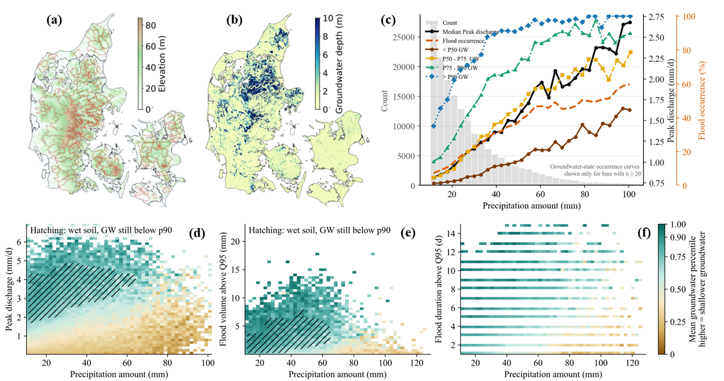
Figure 2. Maps of topography, mean groundwater depth, and statistics of the paired rainfall-runoff events in Denmark. (a) Location of the 299 Danish streamflow gauges and their catchment boundaries, with topography shown as background. (b) Mean groundwater depth across Denmark. (c) Distribution of rainfall-event amount, event peak discharge, and flood occurrence across antecedent groundwater states. (d–f) Relationships between event precipitation amount and (d) peak discharge, (e) flood volume above the 95th-percentile discharge threshold, and (f) flood duration above the 95th-percentile discharge threshold. Colors indicate the mean antecedent groundwater percentile within each rainfall-response bin, with higher values indicating shallower groundwater. Hatched areas identify bins where soil moisture is already high (75th percentile) while groundwater remains below the shallowest groundwater state (90th percentile), indicating conditions in which groundwater can still rise despite wet antecedent soils.

We identified 168,326 paired rainfall-runoff events, of these, 33,520 were classified as flood extremes that were quantified using peak specific discharge and the number of days (at least 1 day) exceeding the catchment-specific 95th-percentile discharge threshold (hereafter Q95, denoting the upper 5% of flows). The event catalogue spans a wide range of rainfall magnitudes, although most events had relatively small precipitation totals (Figure 2c). Figure 2c also shows the event peak discharge and flood occurrence increasing with the increase of precipitation amount. However, rainfall alone does not determine flood response. Higher groundwater states align with higher flood accordance (Figure 2c). For a given precipitation volume, events occurring under higher antecedent groundwater states generally produced larger peak discharge responses than events occurring under lower groundwater states (Figure 2d). Similarly, large precipitation amounts did not necessarily generate large flood volumes or long flood durations when groundwater was relatively low (Figures 2 e-f).

2.3 Antecedent states of groundwater and soil moisture
Daily GWD and soil moisture were obtained from calibrated DK-model simulations. GWD was used as a relative anomaly because absolute values are sensitive to local hydrogeological heterogeneity and model structural uncertainty, whereas temporal groundwater fluctuations are better constrained by model evaluation. Soil moisture was used in its absolute simulated form as an indicator of antecedent water storage in the unsaturated zone. For each rainfall-runoff event, both variables were extracted at the rainfall onset date, or at the main-pulse onset date. This allowed us to distinguish shallow groundwater preconditioning from antecedent soil wetness, two related but hydrologically distinct controls on runoff generation.
To examine how the spatial scale of groundwater storage influences flood response at gauged river sections, we aggregated daily GWD over three hydrologically relevant domains. The first domain was the full upstream catchment, representing basin-scale antecedent storage. The second was the near-station downstream sub-catchment, representing local groundwater conditions around the gauging reach and its contributing drainage area. The third was the riparian stream-connected zone, defined as a 500 m buffer around river channels, representing groundwater-river coupling and near-channel saturation. For each rainfall-runoff event, antecedent groundwater state was extracted on the rainfall onset date, or on the main-pulse onset date for compound events and expressed as a catchment-relative anomaly. Positive anomalies indicate shallower-than-normal groundwater conditions.

2.4 TabPFN model
We used TabPFN as an explainable predictive benchmark to test whether GWL contains information useful for event flood prediction. TabPFN is a transformer-based foundation model for tabular data that has been pretrained on many synthetic prediction tasks and can make accurate predictions with limited task-specific tuning. We trained TabPFN models to predict flood peaks and flood occurrence from event total precipitation, RR, SM, meteorological variables (temperature and potential evapotranspiration), and GWL anomalies. Model performance and feature-attribution analyses were then used to assess whether groundwater improves flood predictability and interacts predictively with other flood drivers. The extension version of TabPFN supports SHAP analysis and partial dependence display (PDP), making it easy to interpret feature impact on model outputs.

2.5 Causal Machine Learning
We used double ML with causal forests to estimate how antecedent GWL affect flood response under comparable event conditions, e.g., same RR and SM. The method first removes variation in both flood outcomes and treatment, i.e., GWL that can be explained by confounders. So two nuisance models are needed to estimate outcomes and treatment, suing the same confounders.

The remaining variation is then used to estimate the counterfactual effect of a groundwater rise on flood severity indicated by peaks, occurrence, volume and duration.

This framework provides average and specific catchment estimates of groundwater effects, allowing us to test whether GWL acts as a flood amplifier and where this amplification is strongest.

- Results
  - Groundwater adds predictive information beyond conventional ACM indicators
To test whether shallow GWL adds predictive information beyond conventional ACM predictors, we compared TabPFN models trained on progressively addictive predictos: rainfall and meteorology (RM); RM plus resent precipitation (RMaP); RMaP plus SM (RMaPS); and the full model additionally including relative GWL (RMaPDG). Predictive skill for peak discharge improved incrementally across this sequence, with the largest gain occurring when GWL was added (Figure 3a). Flood occurrence showed the same pattern, with ROC-AUC increasing consistently from the RM model to the full GWL-inclusive model (Figure 3b). The SHAP analysis also shows GWL is an important features (See supporting information). Because GWL improves prediction even after event total precipitation, RR, and SM are already accounted for, it captures catchment storage information that these conventional indicators do not.
The PDP surfaces show that this added skill reflects a physically consistent compounding mechanism. Predicted peak discharge and flood probability both increase with event precipitation and with shallower groundwater and are highest when large rainfall coincides with an already shallow GWL (Figure 3c, d). GWL and SM interact in a similar, complementary way: peak discharge and flood probability rise most sharply when both are elevated, indicating that near-saturated catchment storage amplifies flood response (Figure 3e, f). Notably, elevated SM alone is insufficient to raise predicted peaks or flood occurrence - the increase emerges only once groundwater is also shallower than normal, showing that groundwater carries storage information SM cannot substitute for even under wet conditions. Together, these results establish that shallow GWL conveys catchment storage information relevant to flood susceptibility beyond what RR and SM alone describe.
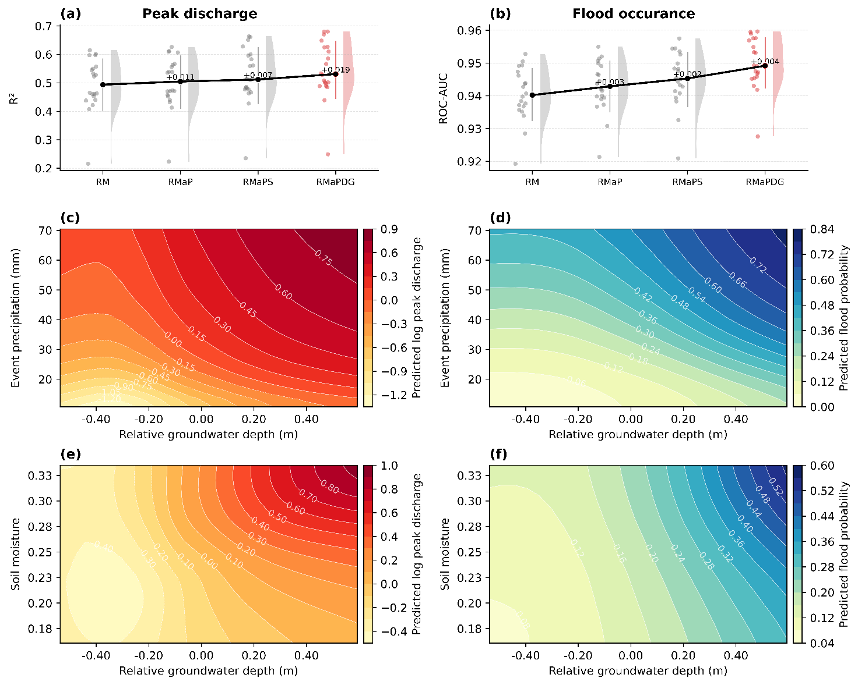
Figure 3. Predictive evidence for groundwater compounding of flood response. (a, b) Cross-validated predictive skill of TabPFN models for peak discharge and flood occurrence using progressively richer predictor sets: rainfall and meteorology (RM), rainfall, meteorology, and antecedent precipitation (RMaP), rainfall, meteorology, antecedent precipitation, and soil water content (RMaPS), and the full model including relative groundwater levels (RMaPDG). Points show fold-level scores, shaded distributions show fold variability, and black lines show mean performance. (c, d) Predicted peak discharge and flood probability as functions of groundwater anomaly and event precipitation. (e, f) Predicted peak discharge and flood probability as functions of groundwater anomaly and soil moisture. Positive groundwater anomaly indicates shallower-than-normal groundwater conditions.

  - Groundwater causally amplifies flood response
We estimated counterfactual effects of raising antecedent shallow groundwater levels using double machine learning with causal forests. Across all groundwater spatial definitions, a 10 cm groundwater rise from the observed event state produced positive effects on flood response (Figure 4, top row). On average, shallower groundwater increased peak discharge by approximately 7–8%, raised flood occurrence probability by about 1.3–1.6 percentage points, increased flood volume above Q95 by about 2–3%, and prolonged flood duration above Q95 by about 3–4%. These effects were consistently greater than zero across cross-validation folds, indicating that shallow groundwater acts as a systematic amplifier of rainfall-driven flood response rather than only a correlated wetness indicator.
The estimated effects became substantially stronger when groundwater was already high. Under very high antecedent groundwater states, a further 10 cm rise increased peak discharge by roughly 20%, flood occurrence probability by about 3–4 percentage points, flood volume by about 5–6%, and flood duration by about 7–9% (Figure 4, middle row). This nonlinear strengthening is consistent with a storage-threshold mechanism: when groundwater is close to the land surface, additional groundwater rise leaves less unsaturated storage available, increases hydrological connectivity to streams, and promotes faster runoff generation.
Groundwater amplification also varied systematically with antecedent groundwater state. Fold-level mean effects increased from low to very high groundwater conditions for flood occurrence, flood volume, and flood duration (Figure 4, bottom row). Peak-discharge effects were largest under low-to-moderate groundwater states and remained positive under high states, suggesting that peak magnitude and flood persistence respond differently to groundwater preconditioning. The three groundwater spatial definitions—catchment-wide, valley, and downstream groundwater—showed broadly similar effect directions, but downstream groundwater often produced stronger effects for flood occurrence, volume, and duration under high groundwater states. This pattern suggests that stream-connected groundwater conditions are particularly important for flood generation and persistence.
Together, these results provide causal evidence that shallow groundwater preconditioning amplifies river floods. While rainfall remains the immediate flood trigger, elevated groundwater increases catchment sensitivity to rainfall by reducing available storage and strengthening groundwater–stream connectivity. The results indicate that rising groundwater levels may intensify flood hazards in low-lying catchments, especially when high groundwater coincides with heavy rainfall.

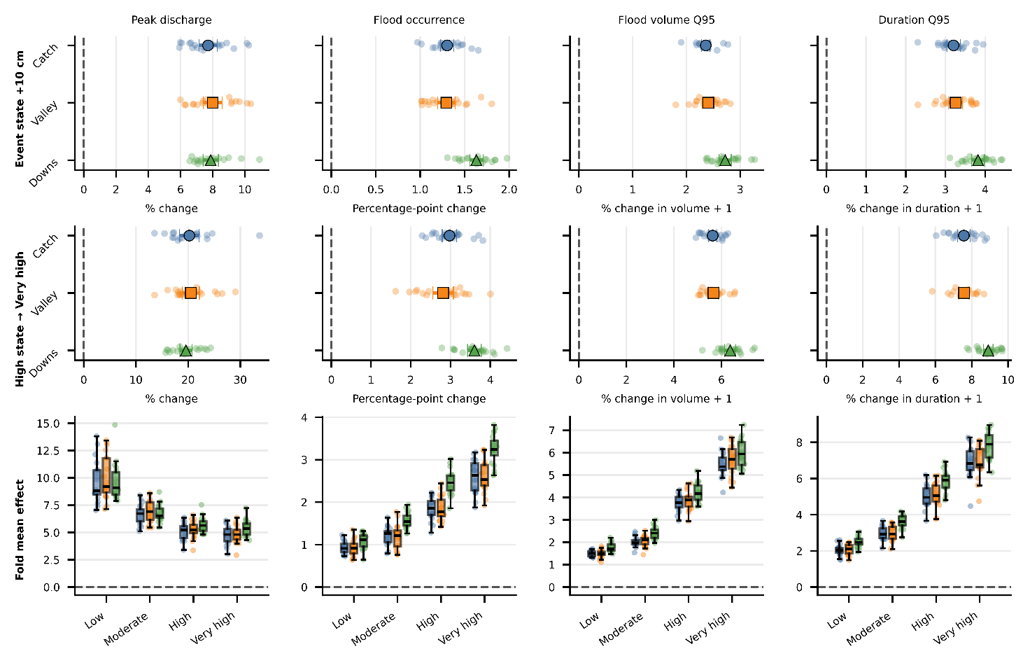
Figure 4. Consequences of raising groundwater levels on river floods. Estimated causal effects of antecedent groundwater rise on flood peak discharge, flood occurrence, flood volume above Q95, and flood duration above Q95. The top row shows the effect of GWL rise from moderate (50th percentile) to high (75th percentile) conditions and the middle rows show the effects of GWL rise from high to very high (90th percentile) conditions. Points show fold-level estimates for catchment-wide, valley, and downstream groundwater definitions; larger symbols indicate mean effects. The bottom row summarizes fold-mean effects across antecedent groundwater-state classes (Low: < 50th-percentile, Moderate: 50th – 75th percentile, High: 75th – 90th percentile, very high: > =90th percentile) from high to very high. Positive values indicate that shallower groundwater increases flood response.

  - Spatial variations of groundwater effects on river floods
The causal effects of groundwater rise were not spatially uniform across Denmark. Instead, both peak-discharge and flood-volume responses varied systematically with catchment setting, indicating that groundwater rise creates stronger flood amplification in some landscapes than others. Catchments at lower median elevation generally showed larger groundwater effects on both peak discharge and flood volume, whereas effects tended to decline with increasing elevation (Figure 5a). A similar pattern was found for baseflow index: groundwater effects were strongest in catchments with moderate to high baseflow contribution and weakened toward the highest baseflow-index values (Figure 5b). These relationships suggest that groundwater-driven flood amplification is most pronounced where shallow groundwater is close enough to influence runoff generation, but where additional groundwater rise can still meaningfully reduce available storage and increase stream connectivity.
The national maps further highlight clear spatial contrasts in groundwater sensitivity. The largest peak-discharge effects are concentrated in low-lying and groundwater-connected parts of Denmark, particularly across broad areas of Jutland and several coastal or lowland catchments (Figure 5c). Flood-volume effects show a broadly similar but not identical pattern, indicating that the controls on peak amplification and flood-volume amplification partly differ (Figure 5d). Some catchments show strong sensitivity in peak discharge but weaker sensitivity in volume, whereas others show the opposite. This distinction implies that groundwater rise can affect different aspects of flood hazard through different hydrological pathways, including rapid runoff generation, sustained discharge, and reduced catchment storage.
Combining peak and volume effects reveals spatially coherent zones of high groundwater-related flood vulnerability (Figure 5e). Catchments in the highest combined percentiles represent areas where groundwater rise is expected to amplify both flood magnitude and accumulated flood volume. The vulnerability-type classification further separates Denmark into catchments dominated by peak sensitivity, volume sensitivity, both high sensitivities, or mixed responses (Figure 5f). Mixed responses are the most common class, but substantial areas show either peak- or volume-dominated sensitivity, and a smaller set of catchments exhibits high sensitivity for both outcomes. These spatial differences indicate that groundwater rise should not be treated as a uniform flood-risk factor across Denmark. Instead, flood-risk assessments should account for where shallow groundwater is most likely to interact with river networks and reduce catchment storage before rainfall events.
Together, these results show that rising shallow groundwater levels create spatially variable flood vulnerability. Low-lying and stream-connected catchments are especially sensitive, but the dominant expression of this sensitivity differs among catchments: some respond mainly through larger flood peaks, others through greater flood volumes, and some through both. This spatial heterogeneity highlights the need to include groundwater preconditioning in regional flood-hazard assessments, particularly in low-gradient landscapes where groundwater and river systems are closely connected.
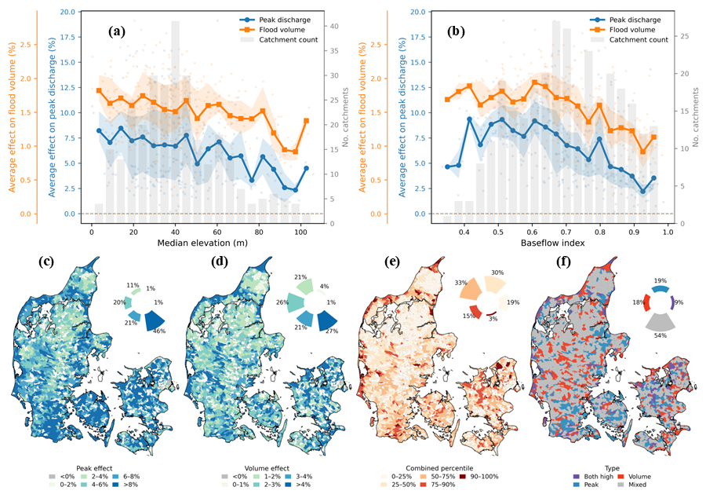
Figure 5. Spatial variability of flood sensitivity to groundwater rise across Denmark.(a, b) Average causal effects of groundwater rise on peak discharge and flood volume as a function of catchment median elevation and baseflow index. Lines show binned mean effects, shaded areas indicate variability, points represent individual catchments, and grey bars show the number of catchments per bin. (c, d) Spatial distribution of groundwater effects on peak discharge and flood volume. (e) Combined groundwater-sensitivity percentile based on peak and volume effects. (f) Vulnerability type classified according to whether each catchment shows high peak sensitivity, high volume sensitivity, both high sensitivities, or mixed response. Positive values indicate stronger flood amplification under shallower groundwater conditions.

- Discussion and Conclusion
The results show that GWL does more than correlate with flood severity: it exerts a causal amplifying effect on flood peaks, occurrence, volume, and duration, with the strength of this effect increasing nonlinearly as groundwater approaches the land surface (Figure 4). This threshold-like behavior, together with the generally stronger amplification observed for stream-connected groundwater relative to catchment-wide storage, points to a specific mechanism: as groundwater rises, it disproportionately erodes the buffering capacity of riparian and near-channel storage rather than uniformly reducing storage across the catchment. The spatial pattern of vulnerability reinforces this interpretation - amplification is concentrated in low-elevation, high baseflow index catchments where groundwater and stream networks are most tightly coupled (Figure 5), rather than distributed evenly across Denmark's lowland terrain.
These findings have implications beyond Denmark. Many lowland regions face rising groundwater tables under climate and land-use change, yet current flood-hazard frameworks - built primarily on precipitation and SM indicators, or on baseflow as an indirect proxy - are not designed to capture this preconditioning effect. Explicitly incorporating GWL state, particularly in the near-stream zone, could improve flood early-warning systems and hazard assessments in groundwater-dominated lowland catchments.
Our conclusions are subject to some limitations. Both GWL and SM are derived from the DK-model rather than direct observations; although the model is calibrated nationally, it may carry structural biases relative to sparse point observations, particularly where local hydrogeological heterogeneity is strong. Our causal estimates also rely on statistical adjustment for observed confounders, and unmeasured catchment or event characteristics could still bias the estimated effects, although consistent results across cross-validation folds and across three independent groundwater definitions support their robustness. Extending this causal framework to other lowland, groundwater-dominated regions would help establish how generalizable these amplification effects are beyond the Danish setting.
In conclusion, by combining large-sample event data with causal ML, we show that shallow groundwater is a causal amplifier of river floods in lowland catchments, acting through reduced antecedent storage and strengthened groundwater-stream connectivity. As GWL shifts under climate and land-use change, accounting for this preconditioning effect will be important for anticipating where, and how, flood hazard is changing in low-relief landscapes.

References
Halsnæs, K., Kaspersen, P. S., Mik-Meyer, V., and Sunding, T.: Økonomiske konsekvenser af oversvømmelser-Nationale skadesberegninger og vurdering af behov for klimatilpasning, Tech. Rep., DTU, Institut for Ledelse. https://www. dtu. dk/english/-/media …, 2024.
Merz, B., Blöschl, G., Vorogushyn, S., Dottori, F., Aerts, J. C. J. H., Bates, P., Bertola, M., Kemter, M., Kreibich, H., and Lall, U.: Causes, impacts and patterns of disastrous river floods, Nat. Rev. Earth Environ., 2, 592–609, 2021.
Rentschler, J., Avner, P., Marconcini, M., Su, R., Strano, E., Vousdoukas, M., and Hallegatte, S.: Global evidence of rapid urban growth in flood zones since 1985, Nature, 622, 87–92, https://doi.org/10.1038/s41586-023-06468-9, 2023.
Wu, C., Kim, W., Yang, S., Tsai, F. T. C., Nittrouer, J. A., Dong, T. Y., Keum, D., and Straub, K. M.: High variability in flood discharge and stage accelerates river mobility, 1–12, https://doi.org/10.1126/sciadv.adv7637, 2025.

