# **Talent Retention Study Codebook**

# Overview

Dataset info

|  |  |
| --- | --- |
| **Number of variables** | 37 |
| **Number of observations** | 1170 |
| **Total Missing (%)** | 0.0% |
| **Total size in memory** | 338.3 KiB |
| **Average record size in memory** | 296.1 B |

Variables types

|  |  |
| --- | --- |
| **Numeric** | 22 |
| **Categorical** | 8 |
| **Boolean** | 1 |
| **Date** | 0 |
| **Text (Unique)** | 0 |
| **Rejected** | 6 |
| **Unsupported** | 0 |

Six variables should be rejected. EmployerCount, Over18, and StandardHours have constant values. MonthlyIncome is highly correlated with JobLevel (ρ = 0.94864). ID and EmployeeNumber are unique for each employee for identification purpose.

# Variables

Age  
Numeric

|  |  |
| --- | --- |
| **Distinct count** | 43 |
| **Unique (%)** | 3.7% |
| **Missing (%)** | 0.0% |
| **Missing (n)** | 0 |
| **Infinite (%)** | 0.0% |
| **Infinite (n)** | 0 |

|  |  |
| --- | --- |
| **Mean** | 36.856 |
| **Minimum** | 18 |
| **Maximum** | 60 |
| **Zeros (%)** | 0.0% |

Quantile statistics

|  |  |
| --- | --- |
| **Minimum** | 18 |
| **5-th percentile** | 24 |
| **Q1** | 30 |
| **Median** | 35 |
| **Q3** | 42.75 |
| **95-th percentile** | 54 |
| **Maximum** | 60 |
| **Range** | 42 |
| **Interquartile range** | 12.75 |

Descriptive statistics

|  |  |
| --- | --- |
| **Standard deviation** | 9.0652 |
| **Coef of variation** | 0.24597 |
| **Kurtosis** | -0.38554 |
| **Mean** | 36.856 |
| **MAD** | 7.3619 |
| **Skewness** | 0.43576 |
| **Sum** | 43121 |
| **Variance** | 82.178 |
| **Memory size** | 9.2 KiB |

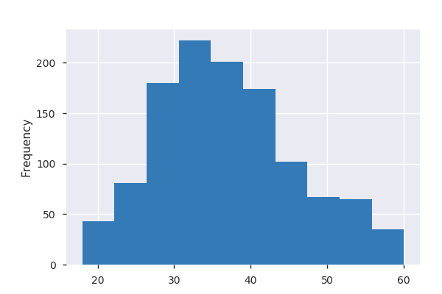

Attrition  
Categorical

|  |  |
| --- | --- |
| **Distinct count** | 2 |
| **Unique (%)** | 0.2% |
| **Missing (%)** | 0.0% |
| **Missing (n)** | 0 |

|  |  |
| --- | --- |
| **No** | 982 |
| **Yes** | 188 |

BusinessTravel  
Categorical

|  |  |
| --- | --- |
| **Distinct count** | 3 |
| **Unique (%)** | 0.3% |
| **Missing (%)** | 0.0% |
| **Missing (n)** | 0 |

|  |  |
| --- | --- |
| **Travel_Rarely** | 835 |
| **Travel_Frequently** | 225 |
| **Non-Travel** | 110 |

DailyRate  
Numeric

|  |  |
| --- | --- |
| **Distinct count** | 772 |
| **Unique (%)** | 66.0% |
| **Missing (%)** | 0.0% |
| **Missing (n)** | 0 |
| **Infinite (%)** | 0.0% |
| **Infinite (n)** | 0 |

|  |  |
| --- | --- |
| **Mean** | 810.41 |
| **Minimum** | 103 |
| **Maximum** | 1499 |
| **Zeros (%)** | 0.0% |

Quantile statistics

|  |  |
| --- | --- |
| **Minimum** | 103 |
| **5-th percentile** | 177.9 |
| **Q1** | 469.25 |
| **Median** | 809.5 |
| **Q3** | 1169 |
| **95-th percentile** | 1420.5 |
| **Maximum** | 1499 |
| **Range** | 1396 |
| **Interquartile range** | 699.75 |

Descriptive statistics

|  |  |
| --- | --- |
| **Standard deviation** | 402.22 |
| **Coef of variation** | 0.49632 |
| **Kurtosis** | -1.2086 |
| **Mean** | 810.41 |
| **MAD** | 349.05 |
| **Skewness** | -0.028297 |
| **Sum** | 948185 |
| **Variance** | 161780 |
| **Memory size** | 9.2 KiB |

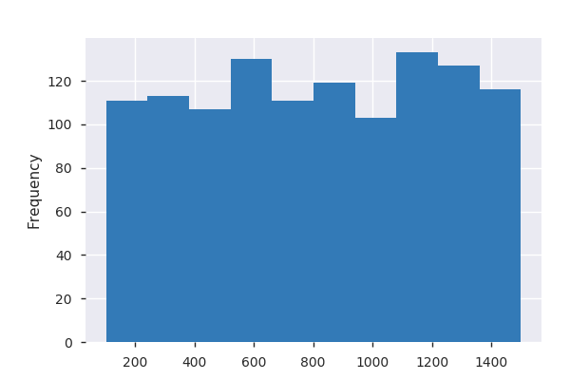

Department  
Categorical

|  |  |
| --- | --- |
| **Distinct count** | 3 |
| **Unique (%)** | 0.3% |
| **Missing (%)** | 0.0% |
| **Missing (n)** | 0 |

|  |  |
| --- | --- |
| **Research & Development** | 773 |
| **Sales** | 351 |
| **Human Resources** | 46 |

DistanceFromHome  
Numeric

|  |  |
| --- | --- |
| **Distinct count** | 29 |
| **Unique (%)** | 2.5% |
| **Missing (%)** | 0.0% |
| **Missing (n)** | 0 |
| **Infinite (%)** | 0.0% |
| **Infinite (n)** | 0 |

|  |  |
| --- | --- |
| **Mean** | 9.1778 |
| **Minimum** | 1 |
| **Maximum** | 29 |
| **Zeros (%)** | 0.0% |

Quantile statistics

|  |  |
| --- | --- |
| **Minimum** | 1 |
| **5-th percentile** | 1 |
| **Q1** | 2 |
| **Median** | 7 |
| **Q3** | 14 |
| **95-th percentile** | 26 |
| **Maximum** | 29 |
| **Range** | 28 |
| **Interquartile range** | 12 |

Descriptive statistics

|  |  |
| --- | --- |
| **Standard deviation** | 8.1506 |
| **Coef of variation** | 0.88808 |
| **Kurtosis** | -0.23309 |
| **Mean** | 9.1778 |
| **MAD** | 6.6214 |
| **Skewness** | 0.96001 |
| **Sum** | 10738 |
| **Variance** | 66.432 |
| **Memory size** | 9.2 KiB |

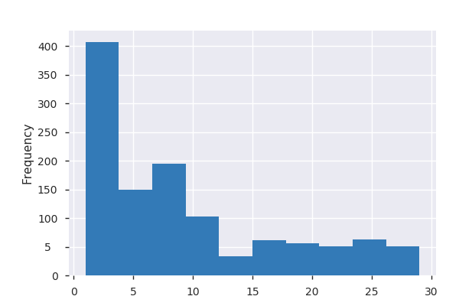

Education  
Numeric

|  |  |
| --- | --- |
| **Distinct count** | 5 |
| **Unique (%)** | 0.4% |
| **Missing (%)** | 0.0% |
| **Missing (n)** | 0 |
| **Infinite (%)** | 0.0% |
| **Infinite (n)** | 0 |

|  |  |
| --- | --- |
| **Mean** | 2.8915 |
| **Minimum** | 1 |
| **Maximum** | 5 |
| **Zeros (%)** | 0.0% |

Quantile statistics

|  |  |
| --- | --- |
| **Minimum** | 1 |
| **5-th percentile** | 1 |
| **Q1** | 2 |
| **Median** | 3 |
| **Q3** | 4 |
| **95-th percentile** | 4 |
| **Maximum** | 5 |
| **Range** | 4 |
| **Interquartile range** | 2 |

Descriptive statistics

|  |  |
| --- | --- |
| **Standard deviation** | 1.0271 |
| **Coef of variation** | 0.35522 |
| **Kurtosis** | -0.61522 |
| **Mean** | 2.8915 |
| **MAD** | 0.80753 |
| **Skewness** | -0.27515 |
| **Sum** | 3383 |
| **Variance** | 1.0549 |
| **Memory size** | 9.2 KiB |



EducationField  
Categorical

|  |  |
| --- | --- |
| **Distinct count** | 6 |
| **Unique (%)** | 0.5% |
| **Missing (%)** | 0.0% |
| **Missing (n)** | 0 |

|  |  |
| --- | --- |
| **Life Sciences** | 499 |
| **Medical** | 366 |
| **Marketing** | 121 |
| **Other values (3)** | 184 |

EmployeeNumber  
Numeric

|  |  |
| --- | --- |
| **Distinct count** | 1170 |
| **Unique (%)** | 100.0% |
| **Missing (%)** | 0.0% |
| **Missing (n)** | 0 |
| **Infinite (%)** | 0.0% |
| **Infinite (n)** | 0 |

|  |  |
| --- | --- |
| **Mean** | 1024.6 |
| **Minimum** | 1 |
| **Maximum** | 2065 |
| **Zeros (%)** | 0.0% |

Quantile statistics

|  |  |
| --- | --- |
| **Minimum** | 1 |
| **5-th percentile** | 90.7 |
| **Q1** | 487.25 |
| **Median** | 1025 |
| **Q3** | 1550.8 |
| **95-th percentile** | 1968.5 |
| **Maximum** | 2065 |
| **Range** | 2064 |
| **Interquartile range** | 1063.5 |

Descriptive statistics

|  |  |
| --- | --- |
| **Standard deviation** | 600.42 |
| **Coef of variation** | 0.586 |
| **Kurtosis** | -1.2164 |
| **Mean** | 1024.6 |
| **MAD** | 521.06 |
| **Skewness** | 0.0089767 |
| **Sum** | 1198789 |
| **Variance** | 360500 |
| **Memory size** | 9.2 KiB |

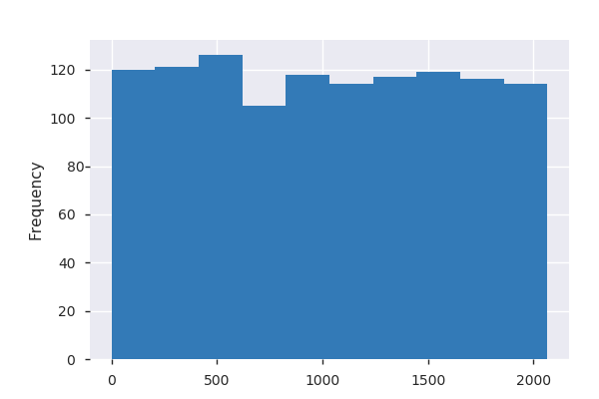

EnvironmentSatisfaction  
Numeric

|  |  |
| --- | --- |
| **Distinct count** | 4 |
| **Unique (%)** | 0.3% |
| **Missing (%)** | 0.0% |
| **Missing (n)** | 0 |
| **Infinite (%)** | 0.0% |
| **Infinite (n)** | 0 |

|  |  |
| --- | --- |
| **Mean** | 2.712 |
| **Minimum** | 1 |
| **Maximum** | 4 |
| **Zeros (%)** | 0.0% |

Quantile statistics

|  |  |
| --- | --- |
| **Minimum** | 1 |
| **5-th percentile** | 1 |
| **Q1** | 2 |
| **Median** | 3 |
| **Q3** | 4 |
| **95-th percentile** | 4 |
| **Maximum** | 4 |
| **Range** | 3 |
| **Interquartile range** | 2 |

Descriptive statistics

|  |  |
| --- | --- |
| **Standard deviation** | 1.0881 |
| **Coef of variation** | 0.4012 |
| **Kurtosis** | -1.1945 |
| **Mean** | 2.712 |
| **MAD** | 0.94251 |
| **Skewness** | -0.31212 |
| **Sum** | 3173 |
| **Variance** | 1.1839 |
| **Memory size** | 9.2 KiB |

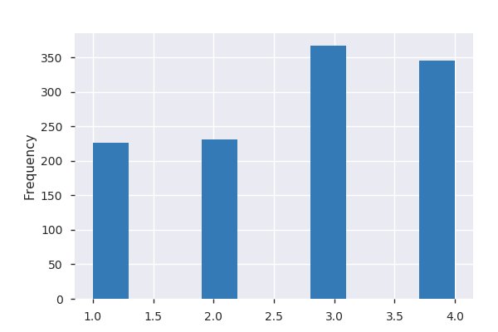

Gender  
Categorical

|  |  |
| --- | --- |
| **Distinct count** | 2 |
| **Unique (%)** | 0.2% |
| **Missing (%)** | 0.0% |
| **Missing (n)** | 0 |

|  |  |
| --- | --- |
| **Male** | 707 |
| **Female** | 463 |

HourlyRate  
Numeric

|  |  |
| --- | --- |
| **Distinct count** | 71 |
| **Unique (%)** | 6.1% |
| **Missing (%)** | 0.0% |
| **Missing (n)** | 0 |
| **Infinite (%)** | 0.0% |
| **Infinite (n)** | 0 |

|  |  |
| --- | --- |
| **Mean** | 65.92 |
| **Minimum** | 30 |
| **Maximum** | 100 |
| **Zeros (%)** | 0.0% |

Quantile statistics

|  |  |
| --- | --- |
| **Minimum** | 30 |
| **5-th percentile** | 34 |
| **Q1** | 48 |
| **Median** | 66 |
| **Q3** | 83 |
| **95-th percentile** | 97 |
| **Maximum** | 100 |
| **Range** | 70 |
| **Interquartile range** | 35 |

Descriptive statistics

|  |  |
| --- | --- |
| **Standard deviation** | 20.154 |
| **Coef of variation** | 0.30573 |
| **Kurtosis** | -1.1821 |
| **Mean** | 65.92 |
| **MAD** | 17.48 |
| **Skewness** | -0.019915 |
| **Sum** | 77126 |
| **Variance** | 406.18 |
| **Memory size** | 9.2 KiB |

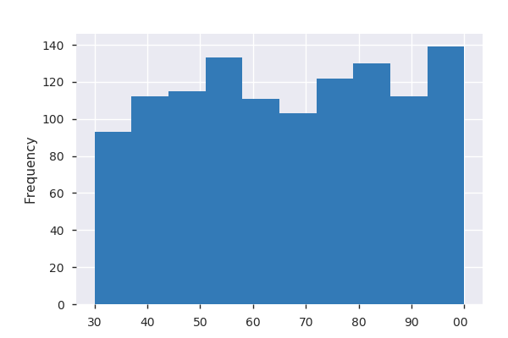

JobInvolvement  
Numeric

|  |  |
| --- | --- |
| **Distinct count** | 4 |
| **Unique (%)** | 0.3% |
| **Missing (%)** | 0.0% |
| **Missing (n)** | 0 |
| **Infinite (%)** | 0.0% |
| **Infinite (n)** | 0 |

|  |  |
| --- | --- |
| **Mean** | 2.7444 |
| **Minimum** | 1 |
| **Maximum** | 4 |
| **Zeros (%)** | 0.0% |

Quantile statistics

|  |  |
| --- | --- |
| **Minimum** | 1 |
| **5-th percentile** | 1 |
| **Q1** | 2 |
| **Median** | 3 |
| **Q3** | 3 |
| **95-th percentile** | 4 |
| **Maximum** | 4 |
| **Range** | 3 |
| **Interquartile range** | 1 |

Descriptive statistics

|  |  |
| --- | --- |
| **Standard deviation** | 0.71558 |
| **Coef of variation** | 0.26074 |
| **Kurtosis** | 0.27234 |
| **Mean** | 2.7444 |
| **MAD** | 0.56541 |
| **Skewness** | -0.4924 |
| **Sum** | 3211 |
| **Variance** | 0.51205 |
| **Memory size** | 9.2 KiB |

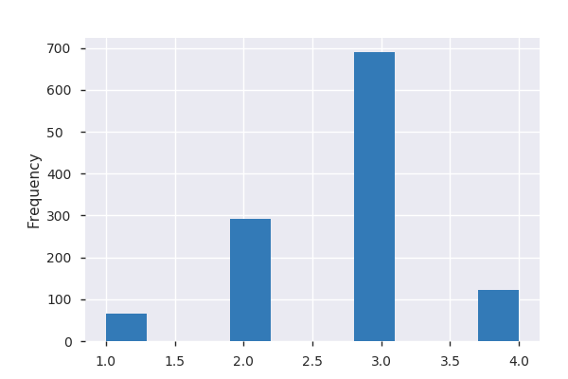

JobLevel  
Numeric

|  |  |
| --- | --- |
| **Distinct count** | 5 |
| **Unique (%)** | 0.4% |
| **Missing (%)** | 0.0% |
| **Missing (n)** | 0 |
| **Infinite (%)** | 0.0% |
| **Infinite (n)** | 0 |

|  |  |
| --- | --- |
| **Mean** | 2.0513 |
| **Minimum** | 1 |
| **Maximum** | 5 |
| **Zeros (%)** | 0.0% |

Quantile statistics

|  |  |
| --- | --- |
| **Minimum** | 1 |
| **5-th percentile** | 1 |
| **Q1** | 1 |
| **Median** | 2 |
| **Q3** | 3 |
| **95-th percentile** | 4 |
| **Maximum** | 5 |
| **Range** | 4 |
| **Interquartile range** | 2 |

Descriptive statistics

|  |  |
| --- | --- |
| **Standard deviation** | 1.0994 |
| **Coef of variation** | 0.53595 |
| **Kurtosis** | 0.39656 |
| **Mean** | 2.0513 |
| **MAD** | 0.82419 |
| **Skewness** | 1.0244 |
| **Sum** | 2400 |
| **Variance** | 1.2087 |
| **Memory size** | 9.2 KiB |



JobRole  
Categorical

|  |  |
| --- | --- |
| **Distinct count** | 9 |
| **Unique (%)** | 0.8% |
| **Missing (%)** | 0.0% |
| **Missing (n)** | 0 |

|  |  |
| --- | --- |
| **Sales Executive** | 258 |
| **Research Scientist** | 238 |
| **Laboratory Technician** | 213 |
| **Other values (6)** | 461 |

| Value | Count | Frequency (%) |  |
| --- | --- | --- | --- |
| Sales Executive | 258 | 22.1% |  |
| Research Scientist | 238 | 20.3% |  |
| Laboratory Technician | 213 | 18.2% |  |
| Manufacturing Director | 116 | 9.9% |  |
| Healthcare Representative | 101 | 8.6% |  |
| Manager | 78 | 6.7% |  |
| Sales Representative | 65 | 5.6% |  |
| Research Director | 64 | 5.5% |  |
| Human Resources | 37 | 3.2% |  |

JobSatisfaction  
Numeric

|  |  |
| --- | --- |
| **Distinct count** | 4 |
| **Unique (%)** | 0.3% |
| **Missing (%)** | 0.0% |
| **Missing (n)** | 0 |
| **Infinite (%)** | 0.0% |
| **Infinite (n)** | 0 |

|  |  |
| --- | --- |
| **Mean** | 2.7376 |
| **Minimum** | 1 |
| **Maximum** | 4 |
| **Zeros (%)** | 0.0% |

Quantile statistics

|  |  |
| --- | --- |
| **Minimum** | 1 |
| **5-th percentile** | 1 |
| **Q1** | 2 |
| **Median** | 3 |
| **Q3** | 4 |
| **95-th percentile** | 4 |
| **Maximum** | 4 |
| **Range** | 3 |
| **Interquartile range** | 2 |

Descriptive statistics

|  |  |
| --- | --- |
| **Standard deviation** | 1.1085 |
| **Coef of variation** | 0.40492 |
| **Kurtosis** | -1.2265 |
| **Mean** | 2.7376 |
| **MAD** | 0.96145 |
| **Skewness** | -0.34419 |
| **Sum** | 3203 |
| **Variance** | 1.2288 |
| **Memory size** | 9.2 KiB |

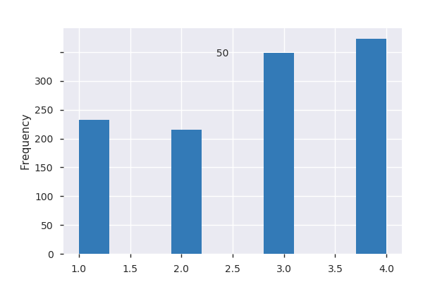

MaritalStatus  
Categorical

|  |  |
| --- | --- |
| **Distinct count** | 3 |
| **Unique (%)** | 0.3% |
| **Missing (%)** | 0.0% |
| **Missing (n)** | 0 |

|  |  |
| --- | --- |
| **Married** | 531 |
| **Single** | 375 |
| **Divorced** | 264 |

| Value | Count | Frequency (%) |  |
| --- | --- | --- | --- |
| Married | 531 | 45.4% |  |
| Single | 375 | 32.1% |  |
| Divorced | 264 | 22.6% |  |

MonthlyRate  
Numeric

|  |  |
| --- | --- |
| **Distinct count** | 1144 |
| **Unique (%)** | 97.8% |
| **Missing (%)** | 0.0% |
| **Missing (n)** | 0 |
| **Infinite (%)** | 0.0% |
| **Infinite (n)** | 0 |

|  |  |
| --- | --- |
| **Mean** | 14165 |
| **Minimum** | 2094 |
| **Maximum** | 26968 |
| **Zeros (%)** | 0.0% |

Quantile statistics

|  |  |
| --- | --- |
| **Minimum** | 2094 |
| **5-th percentile** | 3425.9 |
| **Q1** | 7797 |
| **Median** | 14095 |
| **Q3** | 20291 |
| **95-th percentile** | 25401 |
| **Maximum** | 26968 |
| **Range** | 24874 |
| **Interquartile range** | 12494 |

Descriptive statistics

|  |  |
| --- | --- |
| **Standard deviation** | 7085.9 |
| **Coef of variation** | 0.50024 |
| **Kurtosis** | -1.213 |
| **Mean** | 14165 |
| **MAD** | 6158.7 |
| **Skewness** | 0.042502 |
| **Sum** | 16573029 |
| **Variance** | 50210000 |
| **Memory size** | 9.2 KiB |

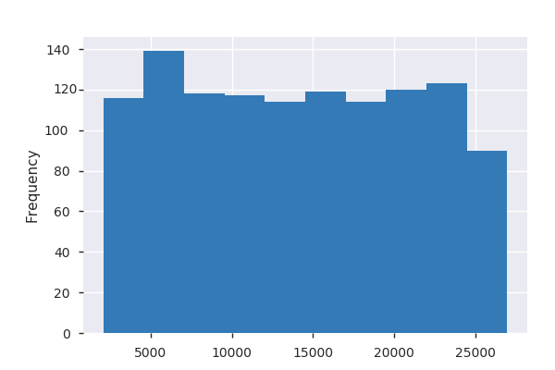

|  |  |  |  |
| --- | --- | --- | --- |
| 26968 | 1 | 0.1% |  |

NumCompaniesWorked  
Numeric

|  |  |
| --- | --- |
| **Distinct count** | 10 |
| **Unique (%)** | 0.9% |
| **Missing (%)** | 0.0% |
| **Missing (n)** | 0 |
| **Infinite (%)** | 0.0% |
| **Infinite (n)** | 0 |

|  |  |
| --- | --- |
| **Mean** | 2.7051 |
| **Minimum** | 0 |
| **Maximum** | 9 |
| **Zeros (%)** | 12.9% |

Quantile statistics

|  |  |
| --- | --- |
| **Minimum** | 0 |
| **5-th percentile** | 0 |
| **Q1** | 1 |
| **Median** | 2 |
| **Q3** | 4 |
| **95-th percentile** | 8 |
| **Maximum** | 9 |
| **Range** | 9 |
| **Interquartile range** | 3 |

Descriptive statistics

|  |  |
| --- | --- |
| **Standard deviation** | 2.5026 |
| **Coef of variation** | 0.92512 |
| **Kurtosis** | 0.0034389 |
| **Mean** | 2.7051 |
| **MAD** | 2.0599 |
| **Skewness** | 1.0297 |
| **Sum** | 3165 |
| **Variance** | 6.2628 |
| **Memory size** | 9.2 KiB |

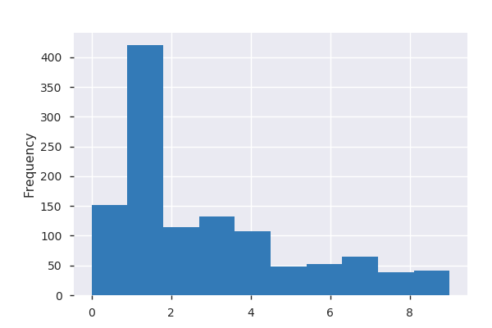

OverTime  
Categorical

|  |  |
| --- | --- |
| **Distinct count** | 2 |
| **Unique (%)** | 0.2% |
| **Missing (%)** | 0.0% |
| **Missing (n)** | 0 |

|  |  |
| --- | --- |
| **No** | 835 |
| **Yes** | 335 |

PercentSalaryHike  
Numeric

|  |  |
| --- | --- |
| **Distinct count** | 15 |
| **Unique (%)** | 1.3% |
| **Missing (%)** | 0.0% |
| **Missing (n)** | 0 |
| **Infinite (%)** | 0.0% |
| **Infinite (n)** | 0 |

|  |  |
| --- | --- |
| **Mean** | 15.185 |
| **Minimum** | 11 |
| **Maximum** | 25 |
| **Zeros (%)** | 0.0% |

Quantile statistics

|  |  |
| --- | --- |
| **Minimum** | 11 |
| **5-th percentile** | 11 |
| **Q1** | 12 |
| **Median** | 14 |
| **Q3** | 18 |
| **95-th percentile** | 22 |
| **Maximum** | 25 |
| **Range** | 14 |
| **Interquartile range** | 6 |

Descriptive statistics

|  |  |
| --- | --- |
| **Standard deviation** | 3.6477 |
| **Coef of variation** | 0.24021 |
| **Kurtosis** | -0.33687 |
| **Mean** | 15.185 |
| **MAD** | 3.0578 |
| **Skewness** | 0.81039 |
| **Sum** | 17767 |
| **Variance** | 13.306 |
| **Memory size** | 9.2 KiB |

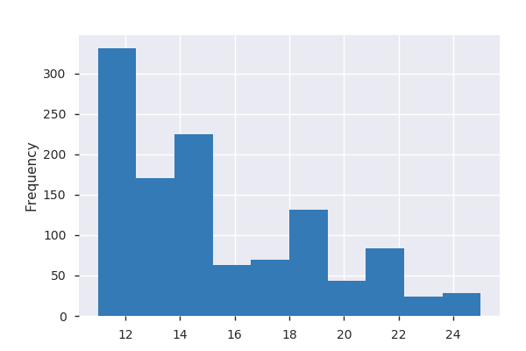

PerformanceRating  
Boolean

|  |  |
| --- | --- |
| **Distinct count** | 2 |
| **Unique (%)** | 0.2% |
| **Missing (%)** | 0.0% |
| **Missing (n)** | 0 |

|  |  |
| --- | --- |
| **Mean** | 3.153 |

|  |  |
| --- | --- |
| **3** | 991 |
| **4** | 179 |

Rand  
Numeric

|  |  |
| --- | --- |
| **Distinct count** | 1170 |
| **Unique (%)** | 100.0% |
| **Missing (%)** | 0.0% |
| **Missing (n)** | 0 |
| **Infinite (%)** | 0.0% |
| **Infinite (n)** | 0 |

|  |  |
| --- | --- |
| **Mean** | -0.023966 |
| **Minimum** | -3.0194 |
| **Maximum** | 3.1831 |
| **Zeros (%)** | 0.0% |

Quantile statistics

|  |  |
| --- | --- |
| **Minimum** | -3.0194 |
| **5-th percentile** | -1.6777 |
| **Q1** | -0.69572 |
| **Median** | 0.0050438 |
| **Q3** | 0.62231 |
| **95-th percentile** | 1.5673 |
| **Maximum** | 3.1831 |
| **Range** | 6.2025 |
| **Interquartile range** | 1.318 |

Descriptive statistics

|  |  |
| --- | --- |
| **Standard deviation** | 0.97802 |
| **Coef of variation** | -40.81 |
| **Kurtosis** | -0.0034777 |
| **Mean** | -0.023966 |
| **MAD** | 0.77521 |
| **Skewness** | -0.029599 |
| **Sum** | -28.04 |
| **Variance** | 0.95653 |
| **Memory size** | 9.2 KiB |

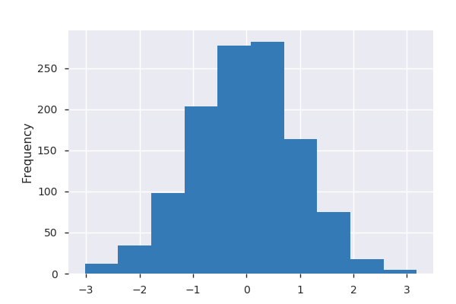

RelationshipSatisfaction  
Numeric

|  |  |
| --- | --- |
| **Distinct count** | 4 |
| **Unique (%)** | 0.3% |
| **Missing (%)** | 0.0% |
| **Missing (n)** | 0 |
| **Infinite (%)** | 0.0% |
| **Infinite (n)** | 0 |

|  |  |
| --- | --- |
| **Mean** | 2.7171 |
| **Minimum** | 1 |
| **Maximum** | 4 |
| **Zeros (%)** | 0.0% |

Quantile statistics

|  |  |
| --- | --- |
| **Minimum** | 1 |
| **5-th percentile** | 1 |
| **Q1** | 2 |
| **Median** | 3 |
| **Q3** | 4 |
| **95-th percentile** | 4 |
| **Maximum** | 4 |
| **Range** | 3 |
| **Interquartile range** | 2 |

Descriptive statistics

|  |  |
| --- | --- |
| **Standard deviation** | 1.0839 |
| **Coef of variation** | 0.39891 |
| **Kurtosis** | -1.1882 |
| **Mean** | 2.7171 |
| **MAD** | 0.93871 |
| **Skewness** | -0.30882 |
| **Sum** | 3179 |
| **Variance** | 1.1748 |
| **Memory size** | 9.2 KiB |

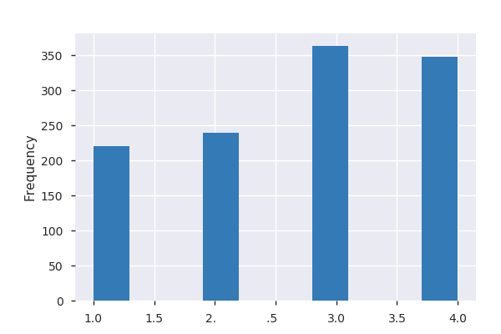

StockOptionLevel  
Numeric

|  |  |
| --- | --- |
| **Distinct count** | 4 |
| **Unique (%)** | 0.3% |
| **Missing (%)** | 0.0% |
| **Missing (n)** | 0 |
| **Infinite (%)** | 0.0% |
| **Infinite (n)** | 0 |

|  |  |
| --- | --- |
| **Mean** | 0.8 |
| **Minimum** | 0 |
| **Maximum** | 3 |
| **Zeros (%)** | 43.2% |

Quantile statistics

|  |  |
| --- | --- |
| **Minimum** | 0 |
| **5-th percentile** | 0 |
| **Q1** | 0 |
| **Median** | 1 |
| **Q3** | 1 |
| **95-th percentile** | 3 |
| **Maximum** | 3 |
| **Range** | 3 |
| **Interquartile range** | 1 |

Descriptive statistics

|  |  |
| --- | --- |
| **Standard deviation** | 0.86526 |
| **Coef of variation** | 1.0816 |
| **Kurtosis** | 0.33162 |
| **Mean** | 0.8 |
| **MAD** | 0.6906 |
| **Skewness** | 0.97685 |
| **Sum** | 936 |
| **Variance** | 0.74867 |
| **Memory size** | 9.2 KiB |

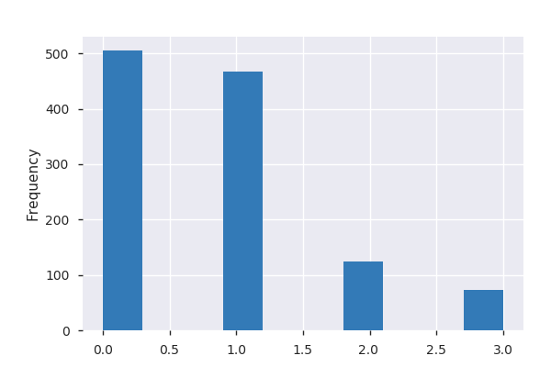

TotalWorkingYears  
Numeric

|  |  |
| --- | --- |
| **Distinct count** | 40 |
| **Unique (%)** | 3.4% |
| **Missing (%)** | 0.0% |
| **Missing (n)** | 0 |
| **Infinite (%)** | 0.0% |
| **Infinite (n)** | 0 |

|  |  |
| --- | --- |
| **Mean** | 11.186 |
| **Minimum** | 0 |
| **Maximum** | 40 |
| **Zeros (%)** | 0.7% |

Quantile statistics

|  |  |
| --- | --- |
| **Minimum** | 0 |
| **5-th percentile** | 1 |
| **Q1** | 6 |
| **Median** | 10 |
| **Q3** | 15 |
| **95-th percentile** | 28 |
| **Maximum** | 40 |
| **Range** | 40 |
| **Interquartile range** | 9 |

Descriptive statistics

|  |  |
| --- | --- |
| **Standard deviation** | 7.6641 |
| **Coef of variation** | 0.68513 |
| **Kurtosis** | 1.1017 |
| **Mean** | 11.186 |
| **MAD** | 5.8834 |
| **Skewness** | 1.1636 |
| **Sum** | 13088 |
| **Variance** | 58.739 |
| **Memory size** | 9.2 KiB |

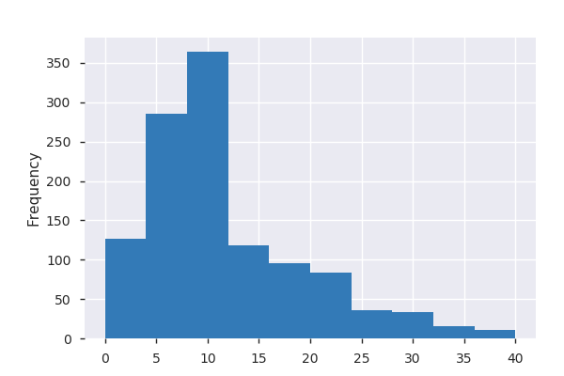

TrainingTimesLastYear  
Numeric

|  |  |
| --- | --- |
| **Distinct count** | 7 |
| **Unique (%)** | 0.6% |
| **Missing (%)** | 0.0% |
| **Missing (n)** | 0 |
| **Infinite (%)** | 0.0% |
| **Infinite (n)** | 0 |

|  |  |
| --- | --- |
| **Mean** | 2.7769 |
| **Minimum** | 0 |
| **Maximum** | 6 |
| **Zeros (%)** | 3.9% |

Quantile statistics

|  |  |
| --- | --- |
| **Minimum** | 0 |
| **5-th percentile** | 1 |
| **Q1** | 2 |
| **Median** | 3 |
| **Q3** | 3 |
| **95-th percentile** | 5 |
| **Maximum** | 6 |
| **Range** | 6 |
| **Interquartile range** | 1 |

Descriptive statistics

|  |  |
| --- | --- |
| **Standard deviation** | 1.2951 |
| **Coef of variation** | 0.46638 |
| **Kurtosis** | 0.4874 |
| **Mean** | 2.7769 |
| **MAD** | 0.98685 |
| **Skewness** | 0.54523 |
| **Sum** | 3249 |
| **Variance** | 1.6773 |
| **Memory size** | 9.2 KiB |

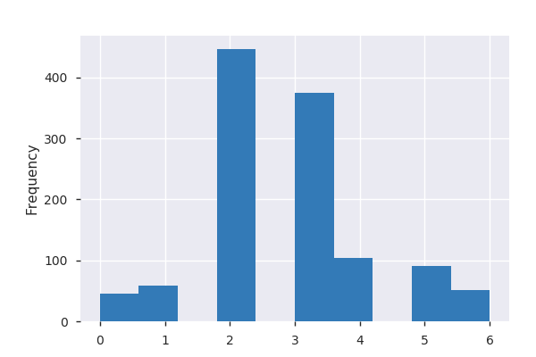

WorkLifeBalance  
Numeric

|  |  |
| --- | --- |
| **Distinct count** | 4 |
| **Unique (%)** | 0.3% |
| **Missing (%)** | 0.0% |
| **Missing (n)** | 0 |
| **Infinite (%)** | 0.0% |
| **Infinite (n)** | 0 |

|  |  |
| --- | --- |
| **Mean** | 2.7632 |
| **Minimum** | 1 |
| **Maximum** | 4 |
| **Zeros (%)** | 0.0% |

Quantile statistics

|  |  |
| --- | --- |
| **Minimum** | 1 |
| **5-th percentile** | 1 |
| **Q1** | 2 |
| **Median** | 3 |
| **Q3** | 3 |
| **95-th percentile** | 4 |
| **Maximum** | 4 |
| **Range** | 3 |
| **Interquartile range** | 1 |

Descriptive statistics

|  |  |
| --- | --- |
| **Standard deviation** | 0.71008 |
| **Coef of variation** | 0.25697 |
| **Kurtosis** | 0.3957 |
| **Mean** | 2.7632 |
| **MAD** | 0.55039 |
| **Skewness** | -0.5429 |
| **Sum** | 3233 |
| **Variance** | 0.50421 |
| **Memory size** | 9.2 KiB |

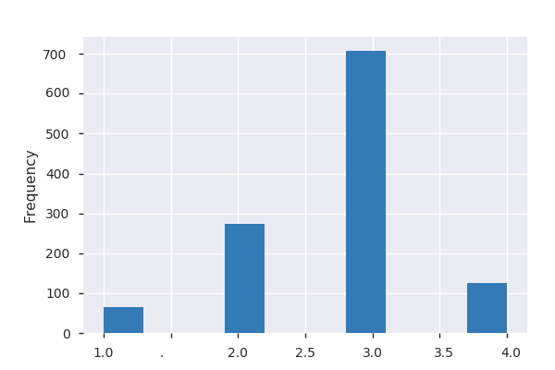

YearsAtCompany  
Numeric

|  |  |
| --- | --- |
| **Distinct count** | 36 |
| **Unique (%)** | 3.1% |
| **Missing (%)** | 0.0% |
| **Missing (n)** | 0 |
| **Infinite (%)** | 0.0% |
| **Infinite (n)** | 0 |

|  |  |
| --- | --- |
| **Mean** | 7.0205 |
| **Minimum** | 0 |
| **Maximum** | 40 |
| **Zeros (%)** | 3.1% |

Quantile statistics

|  |  |
| --- | --- |
| **Minimum** | 0 |
| **5-th percentile** | 1 |
| **Q1** | 3 |
| **Median** | 5 |
| **Q3** | 9 |
| **95-th percentile** | 20 |
| **Maximum** | 40 |
| **Range** | 40 |
| **Interquartile range** | 6 |

Descriptive statistics

|  |  |
| --- | --- |
| **Standard deviation** | 6.1131 |
| **Coef of variation** | 0.87075 |
| **Kurtosis** | 4.0937 |
| **Mean** | 7.0205 |
| **MAD** | 4.4552 |
| **Skewness** | 1.7711 |
| **Sum** | 8214 |
| **Variance** | 37.37 |
| **Memory size** | 9.2 KiB |

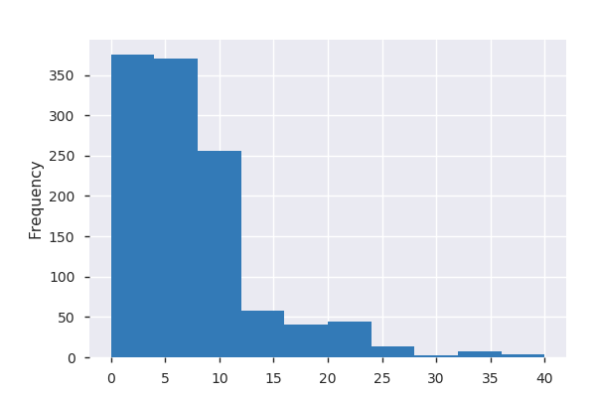

YearsInCurrentRole  
Numeric

|  |  |
| --- | --- |
| **Distinct count** | 19 |
| **Unique (%)** | 1.6% |
| **Missing (%)** | 0.0% |
| **Missing (n)** | 0 |
| **Infinite (%)** | 0.0% |
| **Infinite (n)** | 0 |

|  |  |
| --- | --- |
| **Mean** | 4.2761 |
| **Minimum** | 0 |
| **Maximum** | 18 |
| **Zeros (%)** | 16.3% |

Quantile statistics

|  |  |
| --- | --- |
| **Minimum** | 0 |
| **5-th percentile** | 0 |
| **Q1** | 2 |
| **Median** | 3 |
| **Q3** | 7 |
| **95-th percentile** | 11 |
| **Maximum** | 18 |
| **Range** | 18 |
| **Interquartile range** | 5 |

Descriptive statistics

|  |  |
| --- | --- |
| **Standard deviation** | 3.6507 |
| **Coef of variation** | 0.85375 |
| **Kurtosis** | 0.55834 |
| **Mean** | 4.2761 |
| **MAD** | 3.0703 |
| **Skewness** | 0.92169 |
| **Sum** | 5003 |
| **Variance** | 13.327 |
| **Memory size** | 9.2 KiB |

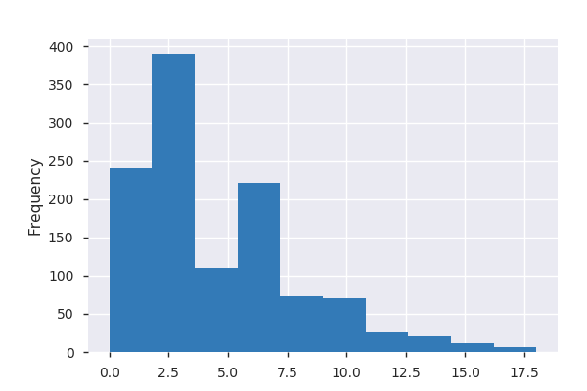

YearsSinceLastPromotion  
Numeric

|  |  |
| --- | --- |
| **Distinct count** | 16 |
| **Unique (%)** | 1.4% |
| **Missing (%)** | 0.0% |
| **Missing (n)** | 0 |
| **Infinite (%)** | 0.0% |
| **Infinite (n)** | 0 |

|  |  |
| --- | --- |
| **Mean** | 2.1487 |
| **Minimum** | 0 |
| **Maximum** | 15 |
| **Zeros (%)** | 39.5% |

Quantile statistics

|  |  |
| --- | --- |
| **Minimum** | 0 |
| **5-th percentile** | 0 |
| **Q1** | 0 |
| **Median** | 1 |
| **Q3** | 2.75 |
| **95-th percentile** | 9 |
| **Maximum** | 15 |
| **Range** | 15 |
| **Interquartile range** | 2.75 |

Descriptive statistics

|  |  |
| --- | --- |
| **Standard deviation** | 3.1419 |
| **Coef of variation** | 1.4622 |
| **Kurtosis** | 3.5849 |
| **Mean** | 2.1487 |
| **MAD** | 2.2896 |
| **Skewness** | 1.9683 |
| **Sum** | 2514 |
| **Variance** | 9.8718 |
| **Memory size** | 9.2 KiB |

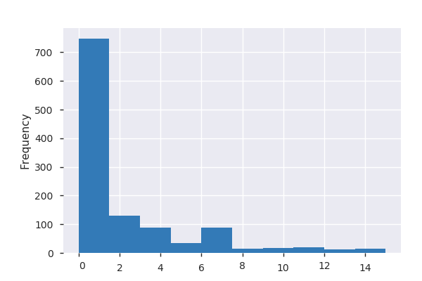

YearsWithCurrManager  
Numeric

|  |  |
| --- | --- |
| **Distinct count** | 18 |
| **Unique (%)** | 1.5% |
| **Missing (%)** | 0.0% |
| **Missing (n)** | 0 |
| **Infinite (%)** | 0.0% |
| **Infinite (n)** | 0 |

|  |  |
| --- | --- |
| **Mean** | 4.1598 |
| **Minimum** | 0 |
| **Maximum** | 17 |
| **Zeros (%)** | 17.9% |

Quantile statistics

|  |  |
| --- | --- |
| **Minimum** | 0 |
| **5-th percentile** | 0 |
| **Q1** | 2 |
| **Median** | 3 |
| **Q3** | 7 |
| **95-th percentile** | 10 |
| **Maximum** | 17 |
| **Range** | 17 |
| **Interquartile range** | 5 |

Descriptive statistics

|  |  |
| --- | --- |
| **Standard deviation** | 3.5803 |
| **Coef of variation** | 0.86069 |
| **Kurtosis** | 0.11935 |
| **Mean** | 4.1598 |
| **MAD** | 3.0562 |
| **Skewness** | 0.80868 |
| **Sum** | 4867 |
| **Variance** | 12.819 |
| **Memory size** | 9.2 KiB |



R version 3.5.1 (2018-07-02)

Platform: x86_64-w64-mingw32/x64 (64-bit)

Running under: Windows >= 8 x64 (build 9200)

Matrix products: default

locale:

[1] LC_COLLATE=English_United States.1252 LC_CTYPE=English_United States.1252 LC_MONETARY=English_United States.1252 LC_NUMERIC=C

[5] LC_TIME=English_United States.1252

attached base packages:

[1] stats graphics grDevices utils datasets methods base

loaded via a namespace (and not attached):

[1] compiler_3.5.1 tools_3.5.1 yaml_2.2.0