SHM-EM: A forecast-aware event management framework for heterogeneous engineering monitoring
Ji'an Liao^{a,b}, Zifa Wang^{a,b,*}, Dengke Zhao^{a,b}, Jianming Wang^{a,b}, Zhaoyan Li^{a,b}, Siran Yang^{a,b}
ª Key Laboratory of Earthquake Engineering and Engineering Vibration, Institute of Engineering Mechanics, China Earthquake Administration, Harbin 150080, China
^{b} Key Laboratory Earthquake Disaster Mitigation, Ministry of Emergency Management, Harbin 150080, China
* Corresponding author: Zifa Wang, Zifa@iem.ac.cn. Institute of Engineering Mechanics, China Earthquake Administration, No. 29 Xuefu Road, Harbin 150080, China.

Abstract
Engineering-monitoring software often separates observations, forecasting, and event response, leaving model inputs schema-bound and forecast decisions difficult to audit. SHM-EM is an open-source framework that treats persisted forecasts as contextualized inputs to engineering-event management. It contributes three mechanisms: a versioned engineering-semantic data-model contract; a synchronized Project Future State for multi-target forecasts; and a controlled forecast-to-event transition that separates audited Evaluate from gated Execute. Validation uses a de-identified excavation case, a synthetic bridge workflow fixture, a 15-case matrix comprising one positive control, 12 failure-path cases, and two input-availability controls, runtime measurements, and an event provenance trace. The reference workflow integrates six fixed-version point-forecast bundles, 124 targets, 40 future steps, and 4,960 prediction rows. Docker/Linux reproduced the logical workflow, but not the exact Windows output hash; no tolerance was applied. The contribution is an auditable software workflow, not a forecasting algorithm or a claim of predictive generalization.
Keywords: engineering monitoring; structural health monitoring; time-series forecasting; event management; provenance; reproducible research software

Metadata
Nr | Code metadata description | Metadata
C1 | Current code version | v1.0.1
C2 | Permanent link to code/repository used for this code version | https://github.com/lja666/SHM-EM/releases/tag/v1.0.1 (fixed commit: d7cba1419145e6c75fe69ad63172af5f5abe5028)
C3 | Legal code license | MIT License
C4 | Code versioning system | Git
C5 | Languages, tools, and services | Java 8; SQL; TypeScript; Python 3.10; Vue 3; Spring Boot 2.6.13; MyBatis 2.2.2; MySQL 8.4; PyTorch 2.11.0; Vite; ECharts; PowerShell 7; Docker Compose; OpenAPI
C6 | Compilation requirements, operating environments, and dependencies | Back end: Java 8 and Maven 3.8+; database: MySQL 8.0+; front end: Node.js 20+ and npm; forecasting runtime: Python 3.10 with locked dependencies. Windows 10/11 with PowerShell 7 is the exact-output reference. The exercised Docker Compose Linux path reproduces component checks and the logical six-model-to-provenance workflow, but not a bitwise-identical normalized prediction-output hash.
C7 | Developer documentation/manual | https://github.com/lja666/SHM-EM/tree/v1.0.1/docs (README, installation, reproduction, models, database, API, security, and data-availability documentation)
C8 | Support email | nlfdzlja@163.com

1. Motivation and significance
Engineering monitoring combines heterogeneous measurements [1-3] and increasingly uses machine learning [4-6], yet applications and model scripts often retain project-specific tables, units, identifiers, and implicit feature order. Standards such as OGC SensorThings organize sensor observations [7,8], while generic CEP provides stream and event patterns [9]. GMFAgent addresses ground-motion-field estimation [10], and Predictive-SHM provides ingestion, model registration, forecasting, visualization, and alerts [11]. SHM-EM instead formalizes the downstream boundary through which persisted forecasts enter auditable engineering-event workflows. It neither replaces these systems nor claims SensorThings conformance. Table 1 compares documented responsibilities; Not reported means only that the cited primary source does not explicitly document the capability.
Table 1. Source-grounded responsibility comparison.
Capability | OGC SensorThings | Generic CEP | Predictive-SHM | SHM-EM
Observation access and semantics | Yes | Partial | Yes | Yes
Model-specific ordered input contract | Not applicable | Not applicable | Partial | Yes
Pluggable forecasting/model adapter | Not applicable | Not applicable | Yes | Yes
Shared prediction origin and future timeline | Not applicable | Not applicable | Not reported | Yes
Project-level future-state aggregation | Not applicable | Not applicable | Not reported | Yes
Rule/event evaluation | Not applicable | Yes | Partial | Yes
Execution-time eligibility recheck | Not applicable | Not reported | Not reported | Yes
Formal event-to-prediction provenance link | Not applicable | Not reported | Not reported | Yes

Forecasting methods are reviewed elsewhere [12-19]; SHM-EM registers and governs fixed-version models rather than proposing one. Model cards, data documentation, FAIR software practice, citation, and provenance inform its evidence design [20-25]. Its contributions are limited to:
1. A versioned engineering-semantic data-model contract binding observations, ordered features, targets, units, transformations, model artifacts, temporal settings, and hashes.
2. A synchronized Project Future State summarizing target, station, and project forecast risk on one timeline while separating observed and forecast risk.
3. A controlled forecast-to-event transition in which Evaluate retains an audit run without formal business records, while Execute reloads forecasts and rechecks eligibility, integrity, and rule semantics before creating events and provenance.
Here, forecast-aware means that persisted forecasts are aligned, inspected, and conditionally admitted to a formal workflow rather than used only for visualization.
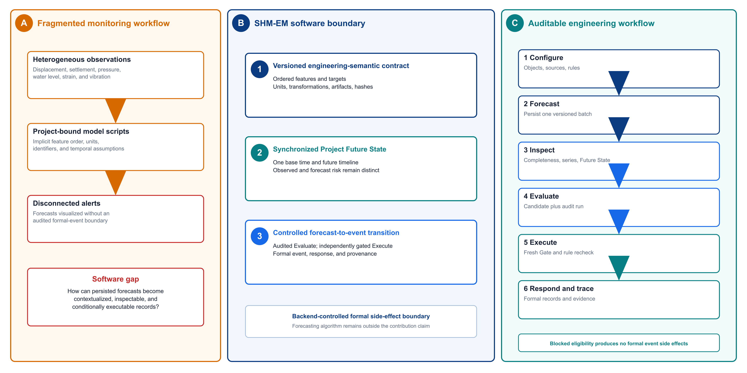
Fig. 1. Research gaps, the SHM-EM software boundary, and the forecast-aware user workflow.

1.1 Intended users and experimental setup
Researchers, analysts, and response personnel configure projects, stations, instruments, metrics, and approved observation mappings. PIT_PRE persists a prediction batch; users inspect its completeness, Project Future State, and joint series before Evaluate or Execute. Database scripts, APIs, tests, PowerShell, and Docker Compose reproduce the workflow; saved front-end state is not authoritative.

2. Software description

2.1 Software architecture
Fig. 2 shows four layers: Vue task views; Spring Boot services for observations, conversion, joint series, prediction Gate, Project Future State, rules, events, responses, and provenance; PIT_PRE for contract-driven Python inference; and MySQL persistence. This separates modelling dependencies from Java decision services, decouples inference from page access, and keeps event creation backend-controlled. MySQL is the validated implementation; registry and service interfaces define an extension boundary, but no alternative database adapter is validated.
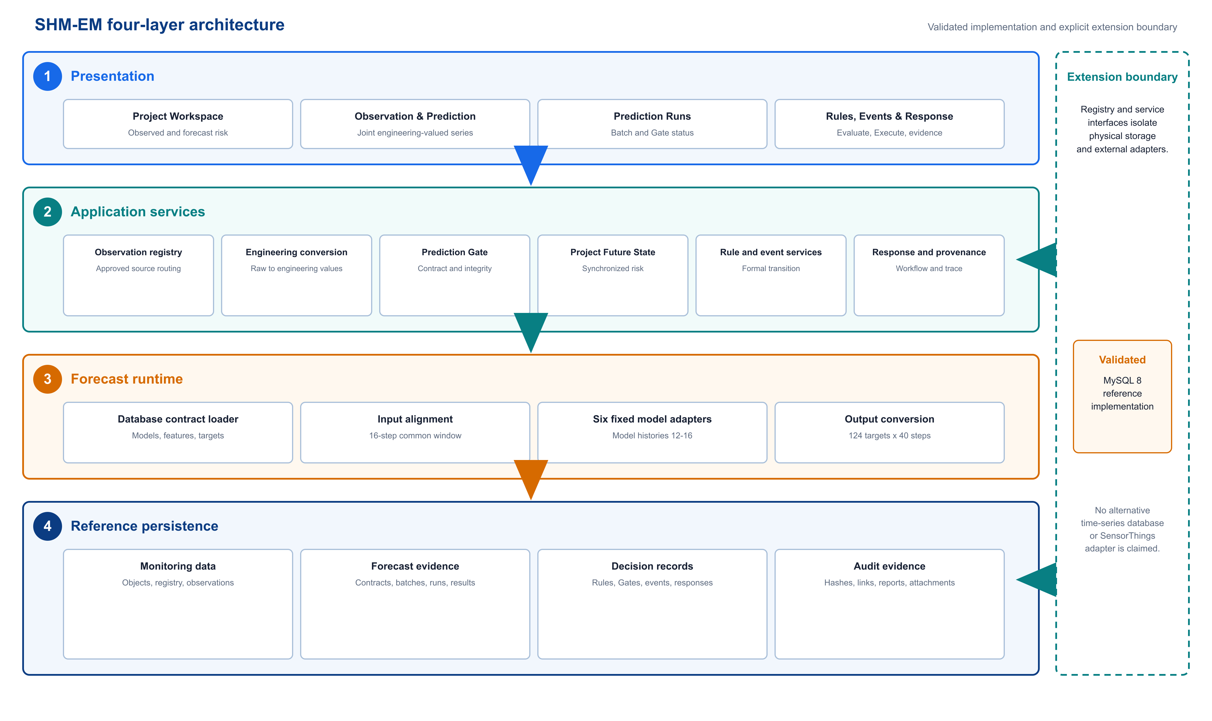
Fig. 2. Four-layer SHM-EM architecture. MySQL is the validated reference persistence implementation; the observation registry and service interfaces define the storage-adapter extension boundary.

2.1.1 Engineering monitoring object model and observation registry
A stable project-station-instrument-metric model links observations, forecasts, rules, and events:
project -> station -> instrument -> metric -> timestamped observation

Observations retain source, time, raw and engineering values, unit, quality, and conversion provenance. Clients request registry and metric codes, not table names. Four typed em_obs_* adapters and two registered acceleration partitions are supported; each source must satisfy allowlisted schema, time, unit, and conversion requirements.

2.1.2 Engineering-semantic data-model contract
The database-authoritative contract binds objects, ordered training features, targets, units, transformations, temporal settings, artifacts, preprocessors, scripts, runtime environment, and SHA-256 values. The public contract has 164 ordered source features and 124 targets. Frozen preprocessors select 114 columns for YD, XD, Strain, Pressure, and Water, and 164 for Settlement. A 16-step common window serves model-specific 12-16-step histories; Pressure declares 13 runner rows and consumes the final 12 (m=10, lag=2). Table 2 distinguishes aligned input widths from mapping and output counts.
Table 2. Verified model-bundle and tensor contract.
Model | Engineering target | Required history | Aligned input features | Output targets
YD | Deep horizontal displacement Y (mm) | 16 | 114 | 42
XD | Deep horizontal displacement X (mm) | 12 | 114 | 42
Strain | Earth-pressure strain (microstrain) | 13 | 114 | 14
Pressure | Earth pressure (MPa) | 13 | 114 | 14
Water | Groundwater elevation (m) | 13 | 114 | 2
Settlement | Surface settlement (mm) | 12 | 164 | 10

Full fields, mappings, hashes, and model parameters are repository evidence. Listing 1 shows the manuscript-facing schema subset.
Listing 1. Compact extract from the versioned contract.
{
"contractVersion": "pit_pre_contract_v1",
"timeline": {"steps": 40, "stepMinutes": 3, "sharedBaseTime": true},
"model": {"code": "settlement", "history": 12, "inputs": 164, "outputs": 10},
"feature": {"order": 115, "code": "dtu1_point1_settlement_value",
"rawUnit": "mm", "engineeringUnit": "mm", "required": true},
"inputSchemaSha256": "5c2f6f0f...672daa65f1"
}

The schema-validated example and database export are in docs/revision/examples/ and artifacts/revision/manuscript/.

Missing and asynchronous observations
Each required feature is matched backward-asof to a 3-min grid within one cadence; unresolved partial gaps use the declared linear interpolation and boundary-fill policy. Runs record signed source-time offsets, fill counts, ratios, and gap summaries. If an entire required feature is unavailable, or a required value remains unresolved, inference is rejected. Freshness is checked separately: OPERATIONAL uses wall-clock age, whereas REPLAY uses scenario time.

2.1.3 Multi-target rolling forecasts and Project Future State
A batch identifies its project, base time, cadence, horizon, and required models. Runs retain contract, input, artifact, alignment, and integrity metadata; results retain target, step, time, raw and engineering values, unit, conversion, and quality. Project Future State deterministically summarizes synchronized predictions and rule-bound risk without replacing formal rules or implying uncertainty estimation or multi-physics learning.
Algorithm 1. Policy-bound Project Future State aggregation.
INPUT project, batch, horizon, mode, reference time
1 Validate the active policy and its canonical hash.
2 Resolve a successful project-owned batch and positive horizon.
3 Inspect Gate eligibility for the requested temporal mode.
4 Load engineering-valued predictions and unit-compatible rule levels.
5 Evaluate each target by step with independent consecutive streaks.
6 Assign the highest activated severity and activation time.
7 Derive forecast risk; merge it with open observed-event risk.
8 Aggregate target, station, and future-timeline summaries.
9 Hash canonical state and return policy, Gate, risks, and summaries.

Inclusive operators and between include equality; strict operators do not. A nonmatch resets its streak, and severity governs risk ordering. Gate status is reported but does not alter the summary or become a hidden Execute prerequisite.

2.1.4 Controlled transition from forecasts to engineering events
MetricSeriesPoint exposes common object, metric, time, engineering value, unit, quality, source, and provenance fields; predictions add batch, run, model, step, conversion, and integrity context. Contract integrity, rule semantics, Evaluate, and Execute remain distinct. Evaluate inspects a REPLAY Gate, returns candidates, and persists one evaluation/audit run, but no formal event, Gate record, response, notification, report, evidence, or prediction link. Execute reloads the canonical series, persists a fresh Gate result, revalidates the rule, and only then creates formal records (Fig. 3).
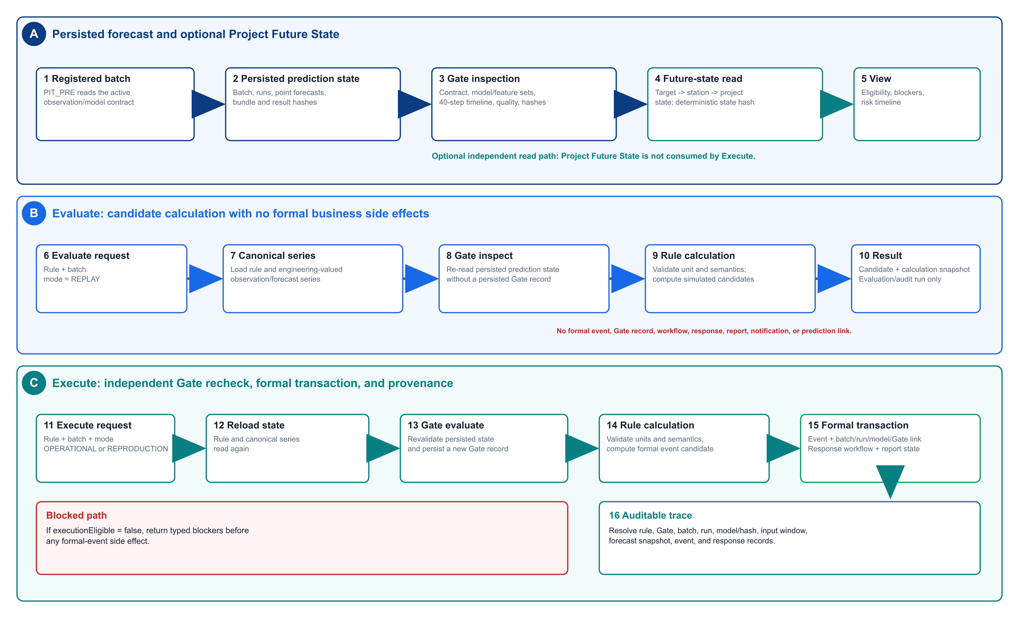
Fig. 3. Controlled sequence from persisted forecasts through optional Project Future State inspection, audited Evaluate, independently gated Execute, and formal provenance.

2.1.5 Response, provenance, and reproduction
Formal events may link responses, notifications, reports, generic media attachments, and audits; SHM-EM provides no camera control or capture subsystem. em_event_prediction_link records the batch/run, Gate, exceedance, lead time, peak, consecutive steps, snapshot, and result identity. Reproduction assets include the public window, fixed bundles, database scripts, locked dependencies, tests, entry points, and expected outputs [22-24,26-30].

2.2 Main functionalities
The interface supports project/observation registration, rolling predictions and Future State, Observation/Prediction rules with controlled execution, response/evidence management, and reproduction/audit. Fig. 4 combines the Project Workspace, joint series, and prediction-batch views; these panels are illustrative, not validation evidence.
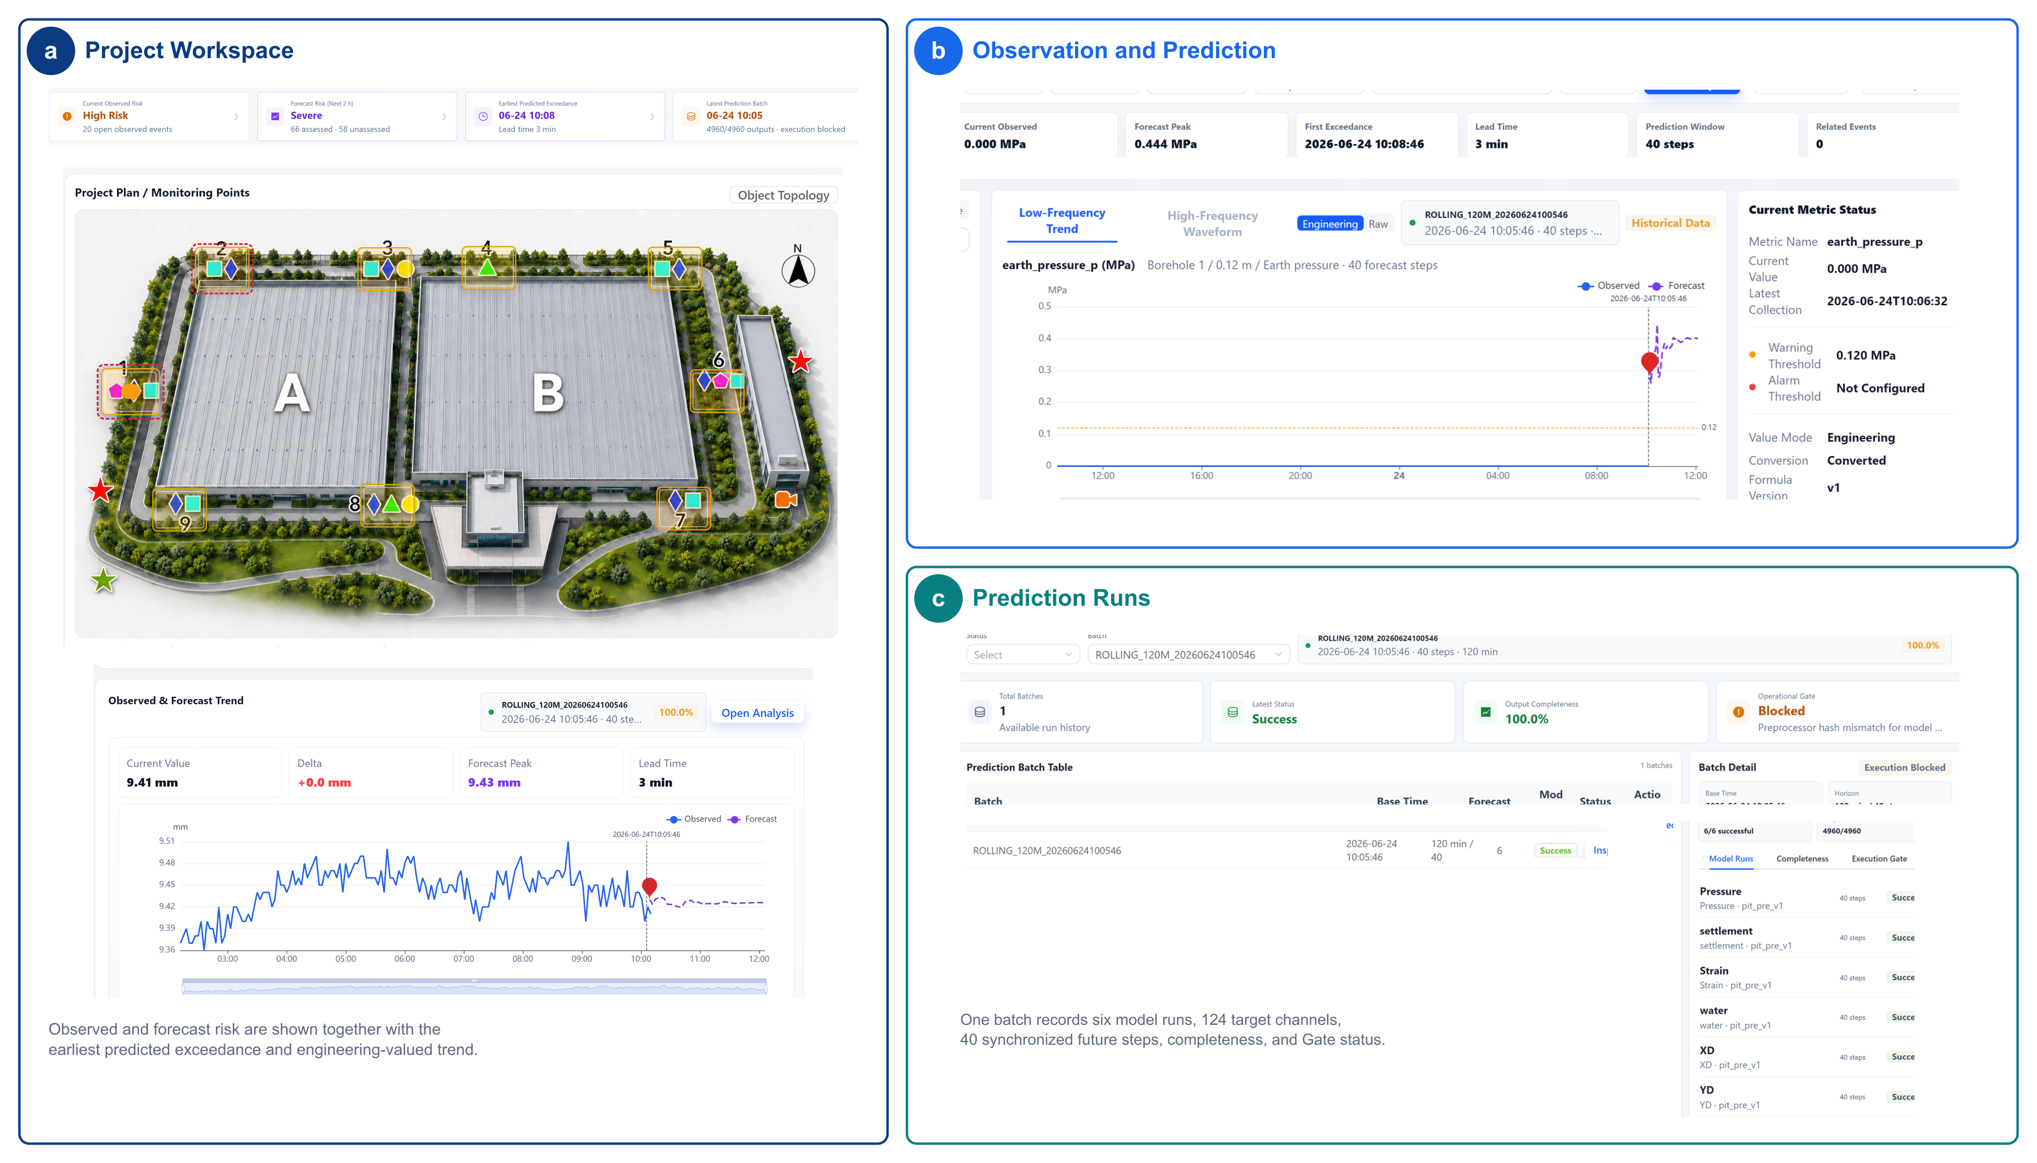
Fig. 4. Task-oriented interface views of SHM-EM: (a) project-level observed and forecast risk, (b) a joint engineering-valued observation/forecast series, and (c) prediction-batch completeness and execution eligibility. The interface is illustrative; quantitative validation is reported in the contract, failure-path, runtime, reuse, and provenance evidence.

2.3 Rule configuration and interfaces
Versioned rules define source (OBSERVATION or PREDICTION), metric, operator, threshold/unit, consecutive steps, severity, and temporal scope. The engine supports latest, extrema, mean, rate, absolute, interval, baseline-relative, and consecutive conditions for one metric. Cross-metric compound rules are outside v1.0.1. OpenAPI documents Future State, Evaluate, Execute, and provenance endpoints.

3. Software validation
Independent evidence families are reported separately because their behavior overlaps.
Table 3. Software testing evidence.
Test family | Cases/checks | Passed | Status
Backend unit/service/API tests | 55 | 55 | PASS
PIT_PRE contract/alignment/integrity tests | 13 | 13 | PASS
Validation matrix (P00, F01-F12, I01-I02) | 15 | 15 | PASS
Second-configuration end-to-end acceptance | 7 | 7 | PASS
Front-end typecheck and production build | 2 | 2 | PASS
Public reference end-to-end reproduction | 1 | 1 | PASS

No coverage percentage is claimed because no stable coverage instrument is included.

3.1 Public excavation-monitoring reference case
SHM_EM_PUBLIC_SAMPLE provides 2,464 de-identified, time-shifted observations from nine field points for displacement, pressure, groundwater, and hydrostatic level. Coordinates, operational identifiers, location, and events are removed. Sixteen 3-min steps support the 12-16-step model histories. The sample reproduces inference and software behavior, not independent accuracy or generalization. Its reference batch completed six models, 124 targets, 40 steps, and 4,960 rows through conversion, Gate, Future State, Evaluate, Execute, response, and provenance.
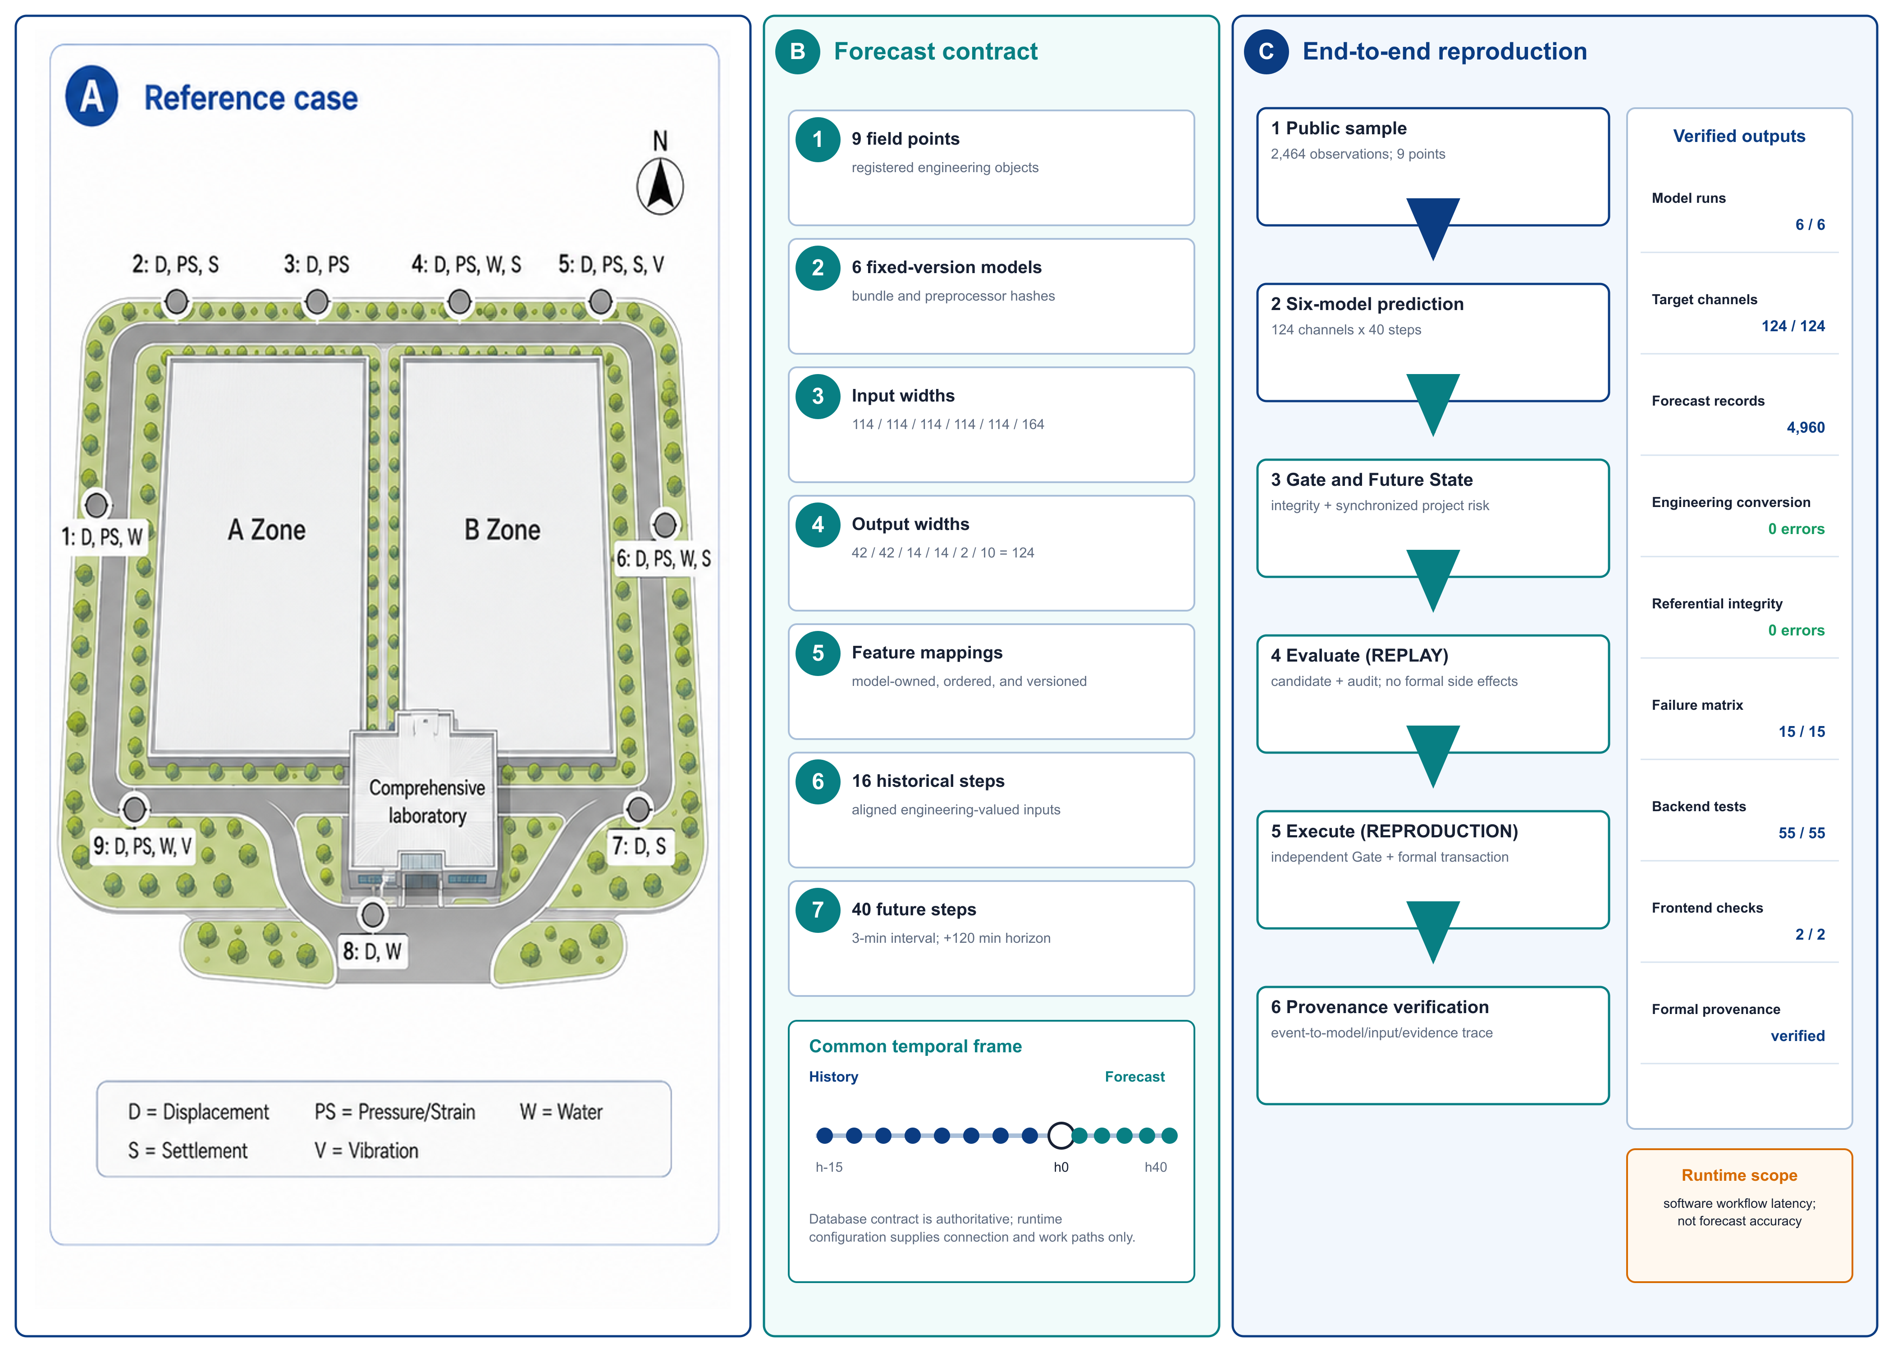
Fig. 5. Public reference case, verified six-model contract, common temporal frame, and end-to-end reproduction checks.

3.2 Cross-configuration reuse
One synthetic bridge configuration, used solely as a software-workflow fixture, tested registration and the end-to-end software boundary; it is not a bridge forecasting study.
Table 4. Synthetic bridge software-reuse fixture.
Registered or produced item | Count/result
Stations | 3
Instruments | 12
Compatible model bundles | 2
Persisted forecast rows | 1,120
End-to-end functional checks | 7/7 PASS
Frozen core/schema modifications | 0

The fixture produced 1,120 rows; integrity, Gate, Future State, Evaluate, Execute, response, provenance, API, and interface checks passed, while an unavailable mapping was rejected. Outputs are not interpreted as bridge-domain predictive validation or cross-domain accuracy. The result supports this tested configuration only.

3.3 Failure-path and execution-safety validation
A 15-case validation matrix comprising one positive control, 12 failure-path cases, and two input-availability controls ran in isolated databases. Blocked cases produced no formal event, response, report, evidence, or prediction link.
Table 5. Validation matrix and side-effect boundary.
Group | Cases | Condition | Expected/observed boundary
Positive control | P00 | Valid reference prediction and rule | Execute succeeds; one formal event is created
Contract/model/batch | F01, F03, F04, F06, F08, F11 | Incomplete steps; artifact hash mismatch; missing target; schema mismatch; failed run; failed batch | Execution Gate blocks
Timeline/quality/integrity | F02, F07, F09, F10 | Stale prediction; temporal misalignment; corrupted persisted values with stale hashes; invalid quality | Gate or persisted-result integrity blocks
Rule semantics | F05 | Incompatible engineering unit | Rule validation blocks
Evaluate-to-Execute mutation | F12 | Persisted state is changed after Evaluate | Execute reload/recheck blocks
Input availability | I01, I02 | Partial dropout; entire required feature unavailable | Declared alignment policy resolves the partial gap; unavailable required feature rejects input assembly

F09 motivated canonical-row integrity recomputation; F12 confirms that Execute reloads and rechecks state after Evaluate. This validates the tested fail-closed boundaries, not absolute safety.

3.4 Runtime and bounded scalability
Table 6 reports median/p95 Windows reference measurements from the fixed implementation. These are single-process reproduction workloads, not production-throughput tests.
Table 6. Selected runtime and bounded-scaling evidence (ms).
Operation | Workload | n | Median | p95
Full prediction batch | 6 models; 4,960 rows | 30 | 16,778.359 | 18,729.326
Execution Gate | 4,960 rows | 30 | 343.129 | 407.100
Project Future State | Reference batch | 30 | 472.342 | 574.761
Rule Evaluate | Reference batch | 30 | 269.465 | 313.340
Rule Execute | Reference batch | 10 | 317.238 | 336.361
Provenance trace | One event | 30 | 2.578 | 20.692
Gate S1 | 4,960 rows | 10 | 2,406.939 | 2,666.804
Gate S2 | 49,600 rows | 10 | 3,603.382 | 3,843.174

S1 and S2 are bounded endpoints, not evidence of linear scaling. The 50,000-row Gate cap is an application safeguard, not a MySQL capacity limit; no alternative time-series backend was measured.

3.5 Provenance and reproducibility
Table 7 summarizes one formal event trace; the complete 40-step chain is machine-readable in the repository.
Table 7. Concrete forecast-event provenance trace.
Trace element | Captured value
Formal event/rule | FEVT-4-f61b7667dcc01721aa2a; PRED_GROUND_SETTLEMENT_WARNING v2
Batch/run/model | Batch 40; run 236; settlement pit_pre_v1
Input/model integrity | Input-schema and model-artifact SHA-256 retained
Exceedance/Gate | 3-min lead; 9.43204345-mm peak; Gate 1 eligible
Formal records | Event, workflow, four steps, report, prediction link

Windows 10/11 with PowerShell 7 is the exact-output reference. Docker/Linux completed the logical six-model -> 4,960 results -> Gate -> Future State -> Evaluate -> Execute -> provenance path, with structural target/step and contract hashes matching. Its normalized output hash differed (exactPredictionReproduction=false); maximum absolute difference was 0.00285349, toleranceApplied=false, and the full row-wise comparison is retained. Native Ubuntu-host execution was not captured.

4. Impact

4.1 Reproducible and auditable forecast integration
The contract, deterministic public window, expected outputs, tests, failure matrix, runtime records, and provenance make a model run inspectable rather than an implicit script invocation. Evidence supports contract checking, workflow reproduction, and traceability for the tested configurations, not forecasting superiority, calibrated uncertainty, production throughput, or reliability improvement.

4.2 Cross-configuration reuse
The bridge fixture registered three stations, 12 instruments, and two compatible bundles, produced 1,120 rows, passed 7/7 checks, and required zero frozen-core or schema modifications. This supports reuse for one fixture, not bridge accuracy, model transfer, arbitrary tables, or universal no-code onboarding.

4.3 Controlled event transition and traceability
Evaluate and Execute share engineering-valued rule calculations but differ at the formal side-effect boundary. The failure matrix shows blocked execution without formal records; the successful trace resolves event, rule, batch, model, input, Gate, forecast, and response. SHA-256 detects accidental or uncoordinated mutation, not a privileged attacker changing both data and hashes.

4.4 Current deployment and scientific scope
The six bundles emit point forecasts; Gate status is data/artifact/timeline/quality/freshness eligibility, not uncertainty or probabilistic risk. MySQL 8 is the only validated backend, the 50,000-row cap is application-level, and no SensorThings adapter or conformance result exists. The bridge fixture is not field validation, and arbitrary tables or models may require adapter work. Docker/Linux demonstrated logical, not bitwise, portability.
SHM-EM is a research reference without application authentication. Production use requires TLS, external identity, role-based and separate Execute authorization, least-privilege database access, secret management, protected audit storage, network controls, rate limits, and tested backup/restore. Forecasts require engineering review and must not be the sole basis for automated safety decisions.

5. Conclusions
SHM-EM contributes a versioned engineering-semantic data-model contract, a synchronized Project Future State, and a controlled forecast-to-event transition. The public case, workflow fixture, failure matrix, runtime evidence, provenance trace, and bounded container result support auditable integration for tested configurations. They do not establish predictive generalization, calibrated uncertainty, production security, backend neutrality, or exact cross-platform numerical reproduction.

6. Data and software availability
SHM-EM v1.0.1 is archived at https://github.com/lja666/SHM-EM/releases/tag/v1.0.1, fixed release commit d7cba1419145e6c75fe69ad63172af5f5abe5028. SHM-EM-v1.0.1.zip has SHA-256 ea0973b7c82e06c3c8910ec36fcf2c3d47765a87d11552337a86c69de41a7cef. Code and six model bundles use MIT; the de-identified sample and conceptual plan use CC BY 4.0. The sample supports the reported workflow but not model generalization. Restricted historical field data, locations, operational identifiers, credentials, generated databases, and local state are excluded; the repository documents this boundary and provides tests and expected outputs.

Acknowledgements
The authors thank the members of the research group for their contributions to software development and manuscript preparation. This work was supported by the Scientific Research Fund of the Institute of Engineering Mechanics, China Earthquake Administration (No. 2025B07), the National Natural Science Foundation of China (Nos. 52378543 and 52378544), and the National Key Research and Development Program of China (No. 2023YFC3805203).

Declaration of generative AI and AI-assisted technologies in the manuscript preparation process
During preparation and revision, the authors used OpenAI ChatGPT and Codex for manuscript organization, language editing, software-code review, test and documentation preparation, and consistency checking. The authors reviewed, edited, and validated all AI-assisted outputs. AI-assisted code changes were human-reviewed and checked by the regression and reproduction procedures reported here. The authors take full responsibility for the publication's content.

References
[1] Farrar CR, Worden K. An introduction to structural health monitoring. Philos Trans A Math Phys Eng Sci. 2007;365(1851):303-315. https://doi.org/10.1098/rsta.2006.1928.
[2] Lynch JP, Loh KJ. A summary review of wireless sensors and sensor networks for structural health monitoring. Shock Vib Dig. 2006;38(2):91-128. https://doi.org/10.1177/0583102406061499.
[3] Hassani S, Dackermann U. A systematic review of advanced sensor technologies for non-destructive testing and structural health monitoring. Sensors. 2023;23(4):2204. https://doi.org/10.3390/s23042204.
[4] Bao Y, Li H. Machine learning paradigm for structural health monitoring. Struct Health Monit. 2021;20(4):1353-1372. https://doi.org/10.1177/1475921720972416.
[5] Azimi M, Eslamlou AD, Pekcan G. Data-driven structural health monitoring and damage detection through deep learning: state-of-the-art review. Sensors. 2020;20(10):2778. https://doi.org/10.3390/s20102778.
[6] Gomez-Cabrera A, Escamilla-Ambrosio PJ. Review of machine-learning techniques applied to structural health monitoring systems for building and bridge structures. Appl Sci. 2022;12(21):10754. https://doi.org/10.3390/app122110754.
[7] Broering A, Echterhoff J, Jirka S, Simonis I, Everding T, Stasch C, et al. New generation Sensor Web Enablement. Sensors. 2011;11(3):2652-2699. https://doi.org/10.3390/s110302652.
[8] Liang S, Khalafbeigi T, van der Schaaf H, editors. OGC SensorThings API Part 1: Sensing Version 1.1. OGC Implementation Standard 18-088. Open Geospatial Consortium; 2021. https://docs.ogc.org/is/18-088/18-088.html [accessed 1 September 2026].
[9] Cugola G, Margara A. Processing flows of information: from data stream to complex event processing. ACM Comput Surv. 2012;44(3):15. https://doi.org/10.1145/2187671.2187677.
[10] Zhao D, Wang Z, Wang J, Liao J, Li Z, Yang S. GMFAgent: domain knowledge-driven agent for ground motion field estimation. SoftwareX. 2026;34:102673. https://doi.org/10.1016/j.softx.2026.102673.
[11] Yang S, Li M, Liao J, Wang J, Zhao D, Li Z, et al. Predictive-SHM: an open-source, extensible software toolkit for multi-sensor structural health monitoring and time-series prediction. SoftwareX. 2026;35:102732. https://doi.org/10.1016/j.softx.2026.102732.
[12] Lim B, Zohren S. Time-series forecasting with deep learning: a survey. Philos Trans A Math Phys Eng Sci. 2021;379(2194):20200209. https://doi.org/10.1098/rsta.2020.0209.
[13] Kong X, Chen Z, Liu W, Ning K, Zhang L, Marier SM, et al. Deep learning for time series forecasting: a survey. Int J Mach Learn Cybern. 2025;16:5079-5112. https://doi.org/10.1007/s13042-025-02560-w.
[14] Vaswani A, Shazeer N, Parmar N, Uszkoreit J, Jones L, Gomez AN, et al. Attention is all you need. Adv Neural Inf Process Syst. 2017;30:5998-6008.
[15] Oreshkin BN, Carpov D, Chapados N, Bengio Y. N-BEATS: neural basis expansion analysis for interpretable time series forecasting. In: International Conference on Learning Representations; 2020.
[16] Lim B, Arik SO, Loeff N, Pfister T. Temporal Fusion Transformers for interpretable multi-horizon time series forecasting. Int J Forecast. 2021;37(4):1748-1764. https://doi.org/10.1016/j.ijforecast.2021.03.012.
[17] Zhou H, Zhang S, Peng J, Zhang S, Li J, Xiong H, et al. Informer: beyond efficient Transformer for long sequence time-series forecasting. Proc AAAI Conf Artif Intell. 2021;35(12):11106-11115. https://doi.org/10.1609/aaai.v35i12.17325.
[18] Wu H, Xu J, Wang J, Long M. Autoformer: decomposition transformers with auto-correlation for long-term series forecasting. Adv Neural Inf Process Syst. 2021;34:22419-22430.
[19] Nie Y, Nguyen NH, Sinthong P, Kalagnanam J. A time series is worth 64 words: long-term forecasting with Transformers. In: International Conference on Learning Representations; 2023.
[20] Mitchell M, Wu S, Zaldivar A, Barnes P, Vasserman L, Hutchinson B, et al. Model cards for model reporting. In: Proceedings of the Conference on Fairness, Accountability, and Transparency; 2019. p. 220-229. https://doi.org/10.1145/3287560.3287596.
[21] Gebru T, Morgenstern J, Vecchione B, Vaughan JW, Wallach H, Daume H III, et al. Datasheets for datasets. Commun ACM. 2021;64(12):86-92. https://doi.org/10.1145/3458723.
[22] Wilkinson MD, Dumontier M, Aalbersberg IJ, Appleton G, Axton M, Baak A, et al. The FAIR Guiding Principles for scientific data management and stewardship. Sci Data. 2016;3:160018. https://doi.org/10.1038/sdata.2016.18.
[23] Barker M, Chue Hong NP, Katz DS, Lamprecht AL, Martinez-Ortiz C, Psomopoulos F, et al. Introducing the FAIR Principles for research software. Sci Data. 2022;9:622. https://doi.org/10.1038/s41597-022-01710-x.
[24] Smith AM, Katz DS, Niemeyer KE; FORCE11 Software Citation Working Group. Software citation principles. PeerJ Comput Sci. 2016;2:e86. https://doi.org/10.7717/peerj-cs.86.
[25] Moreau L, Missier P, editors. PROV-DM: The PROV Data Model. W3C Recommendation. World Wide Web Consortium; 2013. https://www.w3.org/TR/2013/REC-prov-dm-20130430/ [accessed 25 July 2026].
[26] Wilson G, Aruliah DA, Brown CT, Chue Hong NP, Davis M, Guy RT, et al. Best practices for scientific computing. PLoS Biol. 2014;12(1):e1001745. https://doi.org/10.1371/journal.pbio.1001745.
[27] Sandve GK, Nekrutenko A, Taylor J, Hovig E. Ten simple rules for reproducible computational research. PLoS Comput Biol. 2013;9(10):e1003285. https://doi.org/10.1371/journal.pcbi.1003285.
[28] Pineau J, Vincent-Lamarre P, Sinha K, Lariviere V, Beygelzimer A, d'Alche-Buc F, et al. Improving reproducibility in machine learning research: a report from the NeurIPS 2019 reproducibility program. J Mach Learn Res. 2021;22(164):1-20.
[29] Lamprecht AL, Garcia L, Kuzak M, Martinez C, Arcila R, Martin Del Pico E, et al. Towards FAIR principles for research software. Data Sci. 2020;3(1):37-59. https://doi.org/10.3233/DS-190026.
[30] Stodden V, McNutt M, Bailey DH, Deelman E, Gil Y, Hanson B, et al. Enhancing reproducibility for computational methods. Science. 2016;354(6317):1240-1241. https://doi.org/10.1126/science.aah6168.

