Screenshot of incorrect input:

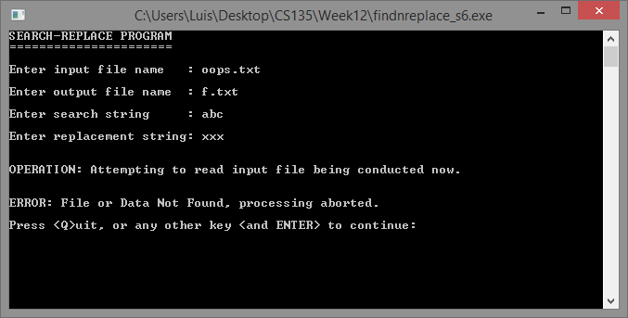

Screen shot of search string being replaced with longer string:

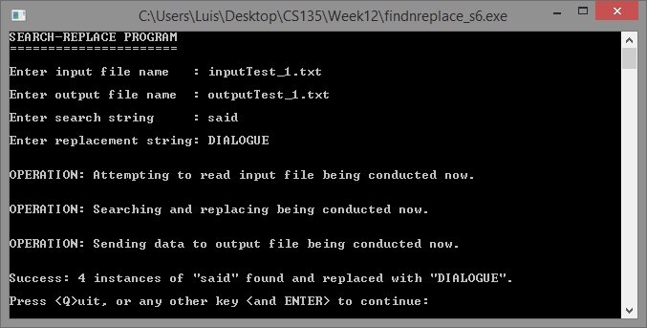

Screen shot of search string being replaced with shorter string:

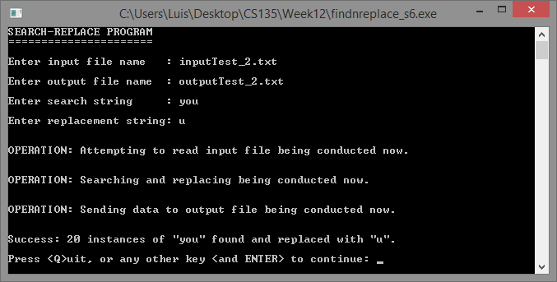

Screen shot of replacement with same amount of characters:

