1. Normal use with only one code entry.

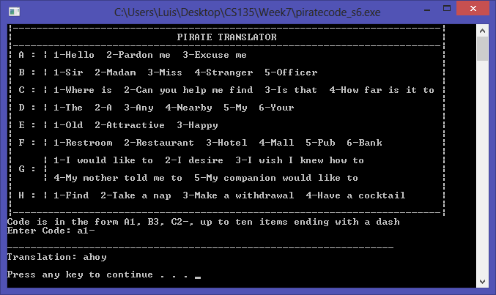

1. Normal use with three code entries.

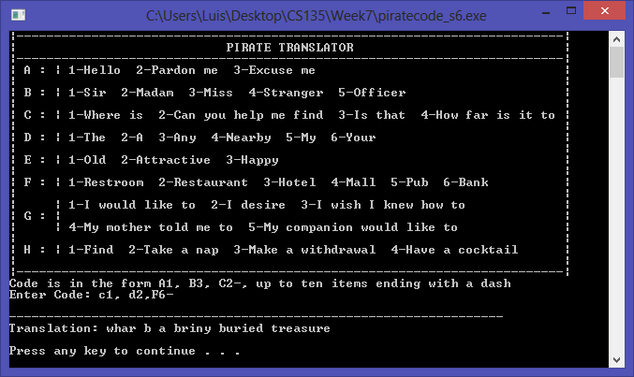

1. Normal use with five code entries.

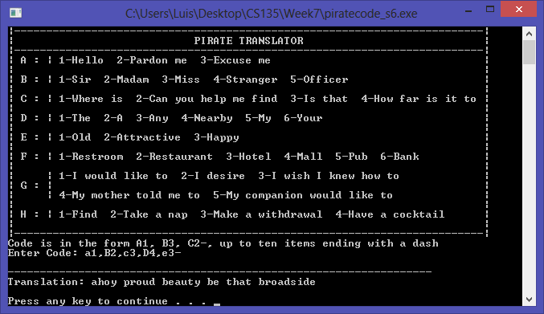

1. Normal use with 10 code entries. (added exaggerated spaces to show it still works)

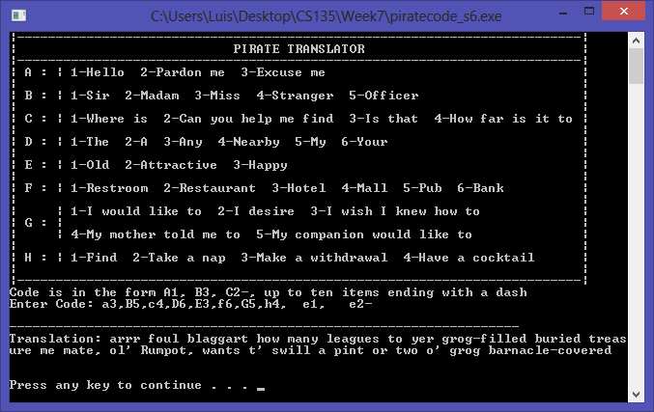

1. Incorrect Code Entry (Mm)

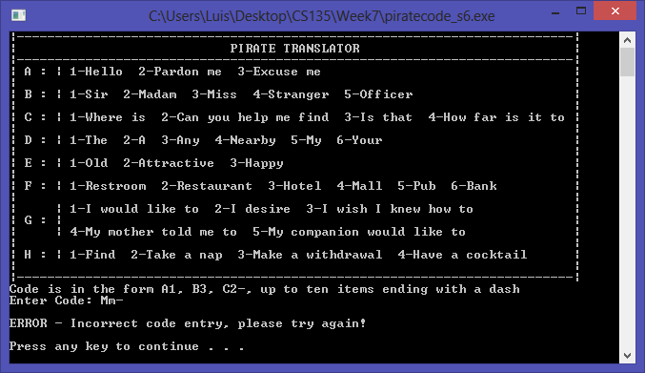

1. Code out of range (a5)

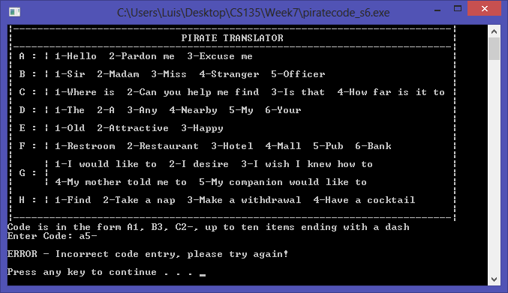

1. More than 10 codes entered

