Correctly Inserted File Name Screenshot:

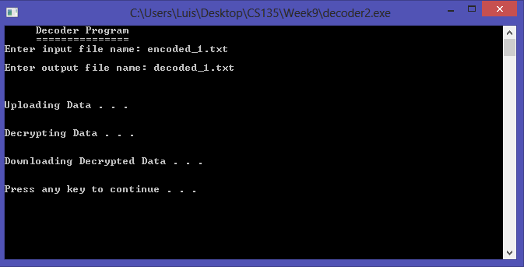

Incorrectly Inserted File Name Screenshot:

