Labyrinth User Manual

Gunnar Wambaugh, Daniel Lopez, Luis Almanzar
December 2015
CS480 – Graphics

Extra Credit
- - - - - - - - -
Top 10 Scoreboard

Main Menu
- - - - - - - -
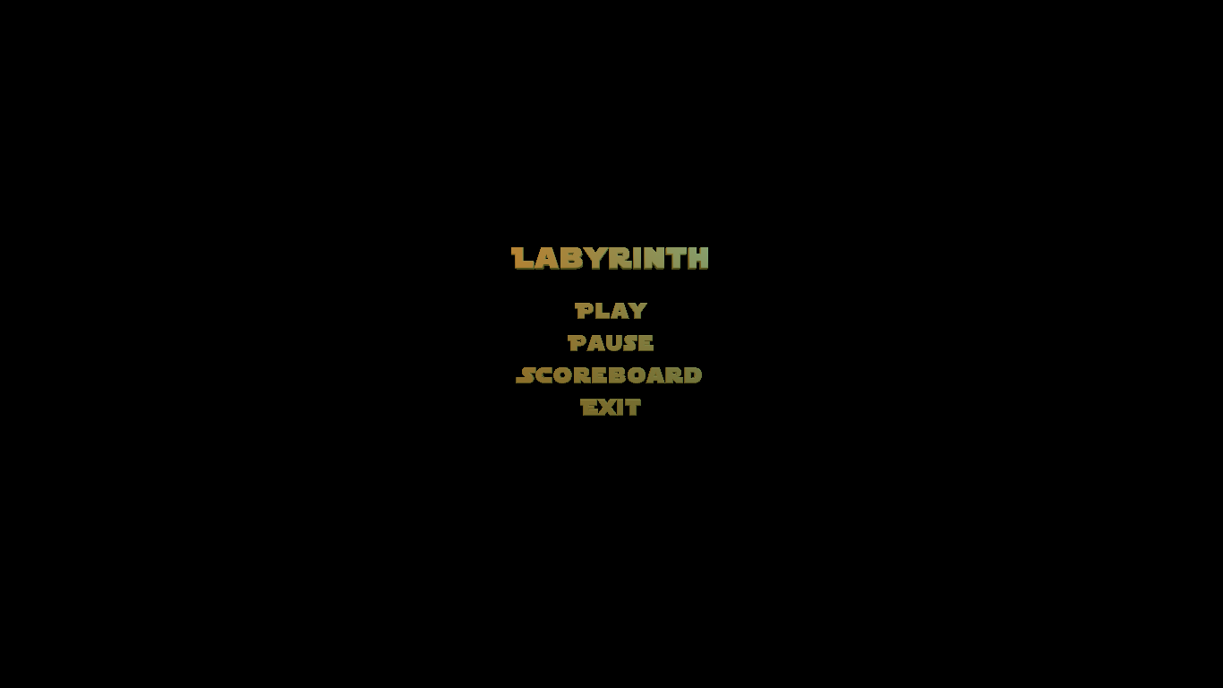
P: To play
S: To see top scores
Esc: To exit

Level Select
- - - - - - - - -
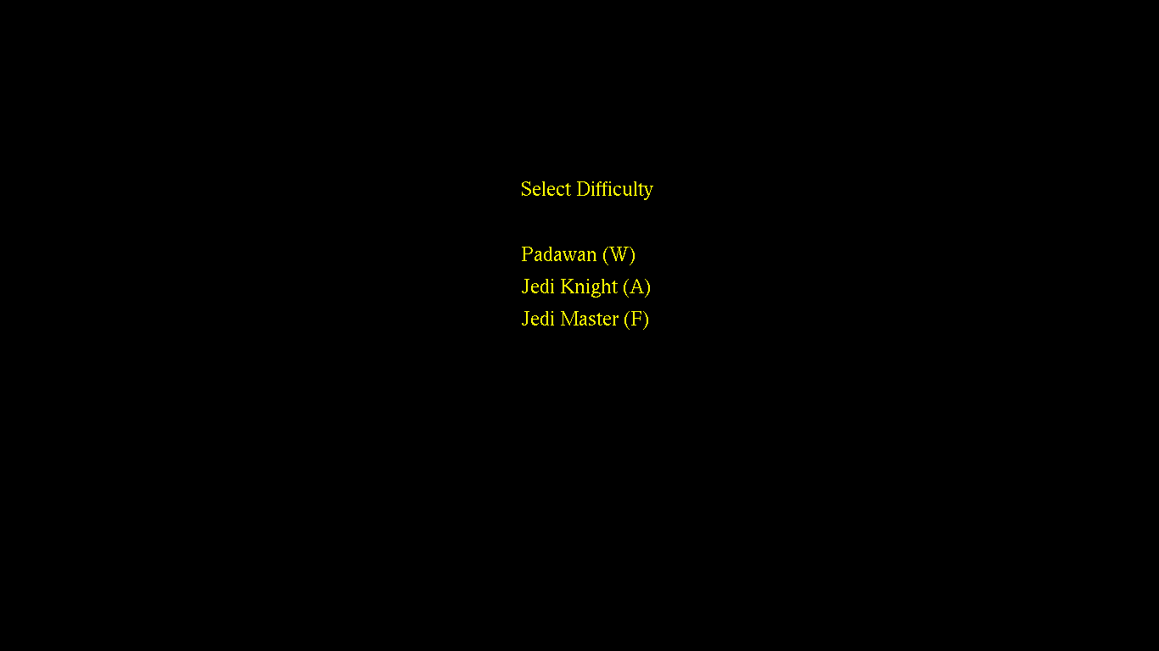
W: For easy
A: For medium
F: For hard
Gameplay
- - - - - - -
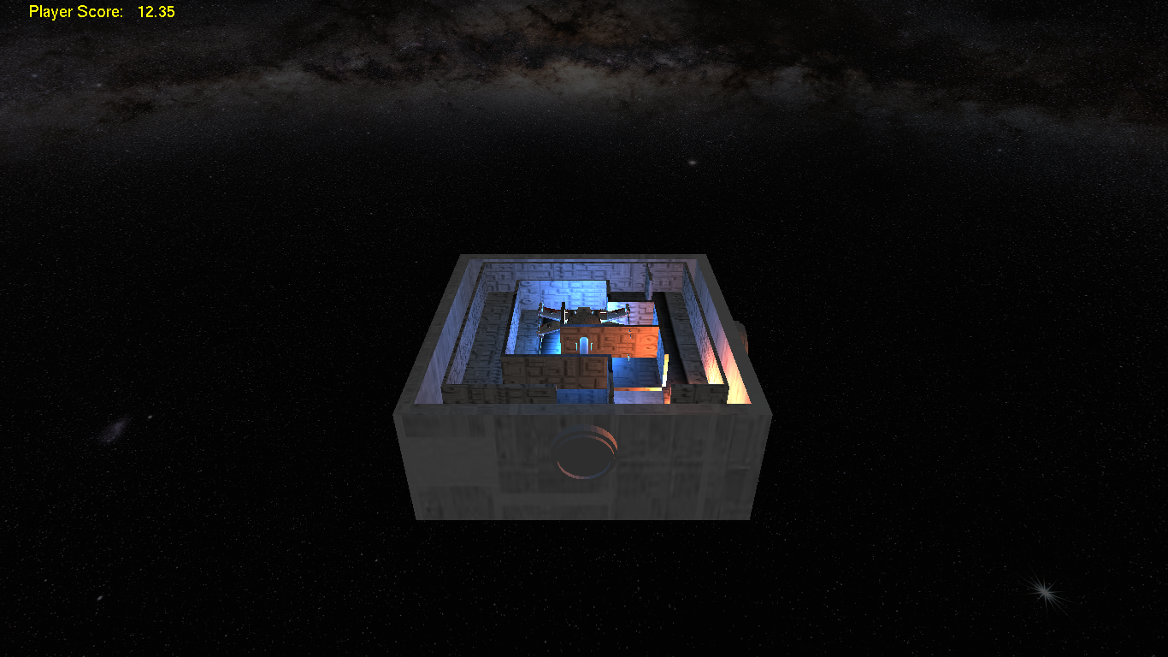
- Arrow keys for movement of table
P: Takes you to level select
Spacebar: Pause

Camera Controls
- Pivot camera up : 8
- Pivot camera down : 2
- Pivot camera left : 4
- Pivot camera up : 6

- Zoom in : +
- Zoom out : -

Scoreboard
- - - - - - - -
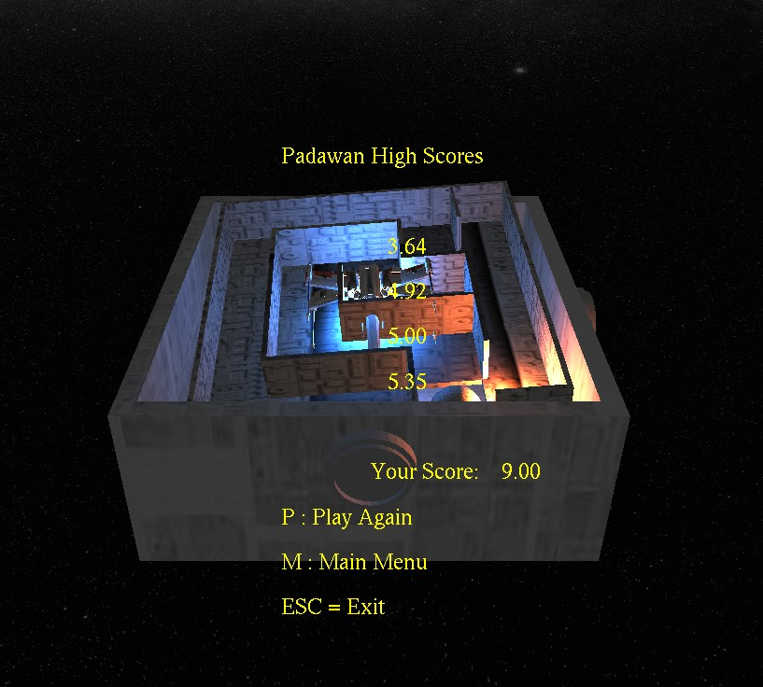
P: Play again
M: Return to main menu
Esc: Exit

Technical Stuff
- - - - - - - - - - -

Issues -
Pause: The way we implemented the timing of the game made it so we could not think of a way to easily pause the time when pausing the game which would making pausing unnecessary. We were comparing out current time with the time the game started but since the computer time is incrementing no matter what we were not able to stop the time mid-game.

Multiple Levels: We had 3 mazes ready for the game. We had one maze for each of the 3 levels implemented in the level select but were not able to switch between them. This would have made the game much more fun since the one level we have right now is very easy. Also, another problem we would have run into is that the mazes are more complex therefore smaller. Since they would have been smaller, our current ball would not have fit correctly in the maze. This could have been an easy fix but was not reached in time.

Would Do Differently -
View oriented controls: Our current controls are based of the default view and it would have been an added plus to be able to tilt and move the camera and still have the controls move the table relative to the view of the camera.

