EE366200 DSP Laboratory
Lab 1 Audio & Speech: MFCC
111061220 林進成
- Introduction
Mel-Frequency Cepstral Coefficients (MFCC) are one of the most widely used features in the fields of speech and audio processing. The key idea behind MFCCs is to extract a compact and informative representation of audio signals that reflects how humans perceive sound. Unlike a raw waveform or spectrum, MFCCs emphasize perceptually important information, making them particularly suitable for tasks such as speech recognition, speaker identification, and general audio classification. Their design is inspired by the human auditory system, especially the non-linear way in which our ears perceive frequencies.
The process of extracting MFCCs involves several key steps. First, the audio signal undergoes pre-emphasis, then divided into short, overlapping frames, and a windowing function (Hamming window is used in this lab) is applied. Next, each frame is transformed into the frequency domain using the Fast Fourier Transform (FFT), and the magnitude spectrum is calculated. This spectrum is passed through a series of triangular filters that are spaced on the mel scale, which maps frequency into a domain that more closely matches human perception of pitch. The energies of these mel-scale filter banks are then compressed using a logarithmic function to simulate human loudness perception. Finally, Discrete Cosine Transform (DCT) is applied to the log energies to produce the MFCCs.
- Objectives
In this lab, the focus is on understanding and implementing the full MFCC extraction pipeline. This includes applying pre-emphasis filtering to the audio signal, performing frame blocking and windowing, computing the short-time Fourier transform, and applying mel-scale filter banks to the resulting spectrum. The lab also emphasizes the importance of logarithmic compression and the role of DCT in obtaining compact cepstral coefficients. By working through each stage, the goal is to gain both theoretical understanding and practical experience with MFCCs, observing how different components of the pipeline contribute to the final feature representation of speech and audio signals
- Approach
The experiment was carried out strictly following the MFCC extraction flow chart. We began with the raw audio signal and first applied pre-emphasis in the time domain. After this operation, the signal was segmented into overlapping frames, each multiplied by a Hamming window to reduce boundary discontinuities. These steps prepared the data for spectral analysis through the Short-Time Fourier Transform (STFT), where each windowed frame was converted into its frequency representation by the Fast Fourier Transform (FFT).
The first checkpoint of the lab was to observe the spectrograms of both the original and the pre-emphasized signals. As shown in Figure 1, the spectrogram on the right (pre-emphasized) exhibits clearer representation of high-frequency components compared to the original signal on the left. This comparison allowed us to visually confirm the effect of pre-emphasis at this early stage of the pipeline.
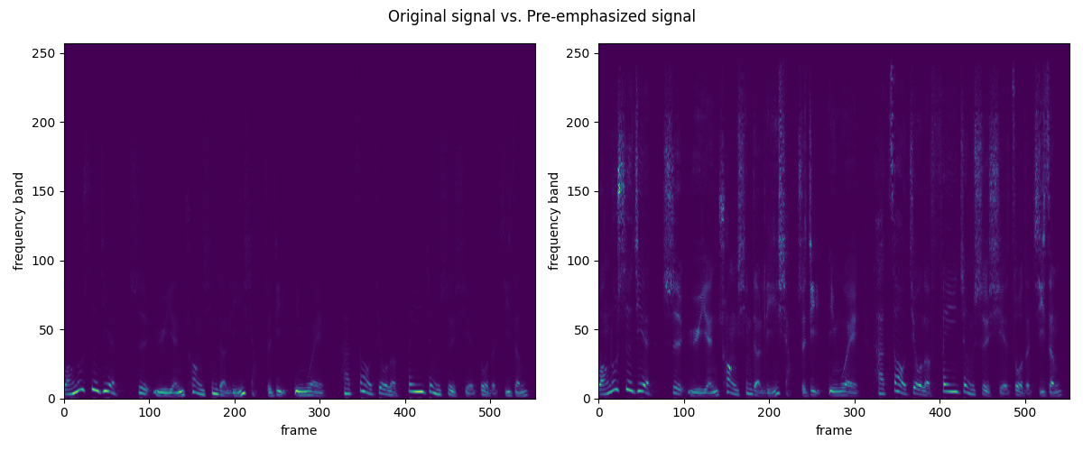
Figure 1. STFT of the original signal (left) and that of the pre-emphasized signal (right)
Once the spectra of each frame were obtained, they were passed through a bank of mel-scale triangular overlapping filters. These filters redistributed the energy into frequency bands that approximate human auditory perception. The outputs of the filter banks were then transformed using a logarithmic function, which compressed their dynamic range. Finally, Discrete Cosine Transform (DCT) was applied to the log-scaled energies, producing the MFCC feature vectors.
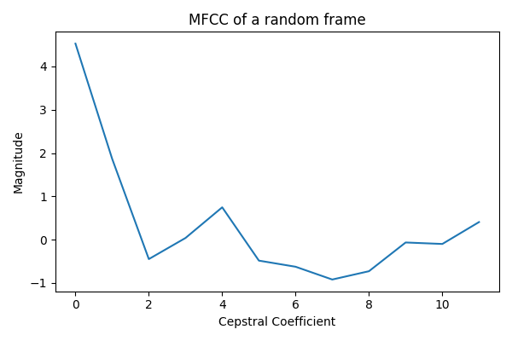
The second checkpoint was carried out after the full pipeline had been completed. At this stage, we selected one frame at random and extracted its MFCC coefficients for plotting. Figure 2 presents the resulting MFCC vector. The curve illustrates how the coefficients of this specific frame are distributed across indices, providing a clear numerical representation of the frame’s cepstral features.
Figure2. The MFCC of a random frame
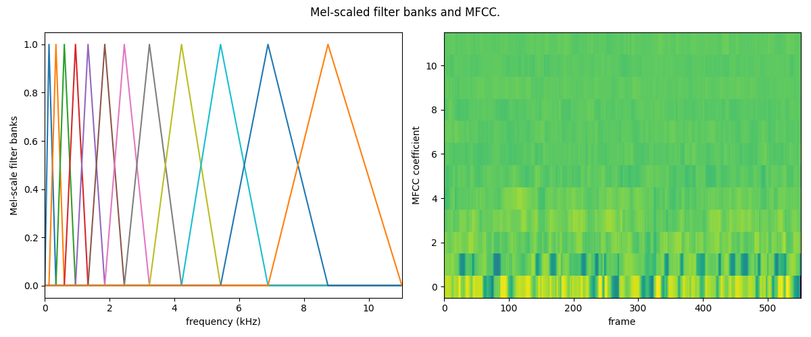
The third checkpoint extended the observation to both the filter design and the overall time sequence of coefficients. On the left side of Figure 3, the complete set of Mel-scaled triangular filters used in the experiment is plotted, showing their overlap and frequency distribution. On the right side of the same figure, the MFCC heatmap across all frames is presented. This heatmap reveals how the cepstral coefficients vary over time, offering a compact representation of the spectral dynamics of the entire audio signal.
Figure 3. The Mel-scaled filter banks and MFCC heat map
- Discussion
In this section, we provide reflections on the MFCC extraction pipeline by addressing the questions given. The following analysis connects the experimental results with both intuitive explanations and mathematical formulations.
Report Question 1:
From the intuitive perspective, we can start from the spectrogram comparison in Figure 1. The left panel shows the original signal, while the right panel shows the pre-emphasized signal. It can be observed that the high-frequency bands in the right panel appear brighter and more distinct, whereas in the original spectrogram they are much weaker. This direct observation suggests that pre-emphasis enhances the visibility of higher-frequency components, making them stand out more clearly in the spectral representation. Intuitively, this helps ensure that information carried in higher frequencies, such as fricatives in speech, is not overshadowed by the stronger low-frequency parts.
From the mathematical perspective, pre-emphasis is represented by a first-order FIR filter:
$$y\left[n\right]=x\left[n\right]-0.95x\left[n-1\right]$$
with frequency response:
$$H\left(z\right)=1-0.95z^{-1}, H\left(e^{jω}\right)=1-0.95e^{-jω}$$
The magnitude response increases with frequency, which aligns with the experimental observation that high-frequency content becomes more prominent after pre-emphasis.
Overall, this step is beneficial for audio analysis because it reduces the spectral imbalance and allows the subsequent FFT and mel-scale processing to capture both low- and high-frequency details more evenly.
Bonus Question 1:
The pre-emphasis filter is described by the transfer function:
$$H\left(z\right)=1-αz^{-1}, 0≤α<1$$
with frequency response:
$$H\left(e^{jω}\right)=1-αe^{-jω}, \left|H\left(e^{jω}\right)\right|=\sqrt{1+α^{2}-2α\cos\left(ω\right)}$$
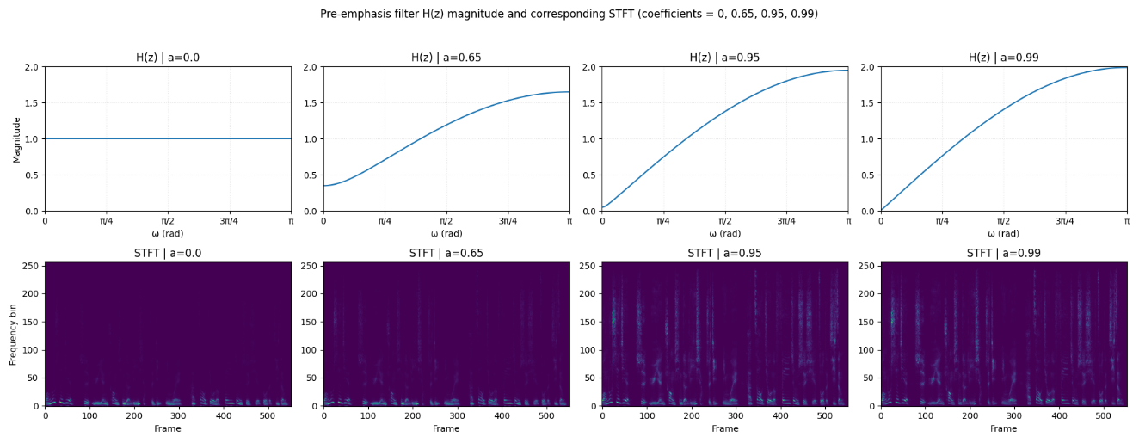
This relation indicates that the magnitude response grows with frequency, and the slope of this growth is determined by the coefficient $α$. In Figure 4, we compare the magnitude responses of $H(z)$ with $α=0,$ $0.65,$ $0.95,$ and$0.99$, alongside the corresponding STFTs.
Figure 4. The magnitude curve of $H(z)$ with different $α$ and their corresponding STFT
When $α=0$, the filter reduces to a flat response, and the spectrogram maintains its original form, with high-frequency regions relatively weak. When $α=0.65$, a mild upward slope appears in the magnitude curve, and the spectrogram shows a slight enhancement in the higher-frequency bands, though low-frequency energy remains dominant. Increasing $α$ to $0.95$ makes the slope steeper, and in the spectrogram, the high-frequency structures become much clearer and more balanced against the low-frequency components. Finally, when $α=0.99$, the filter provides the strongest high-frequency emphasis, and the spectrogram displays very prominent high-frequency activity, sometimes making the low-frequency portions appear comparatively suppressed.
From these observations, it is evident that the pre-emphasis coefficient directly determines the extent of high-frequency enhancement. A larger value of $α$ produces a sharper rise in the filter’s magnitude response, thereby emphasizing high-frequency details more strongly, while smaller values of $α$ result in a gentler boost and preserve more of the original spectral tilt.
Report Question 2:
The comparison of MFCC heatmaps under different numbers of banks and coefficients is illustrated in Figure 5.
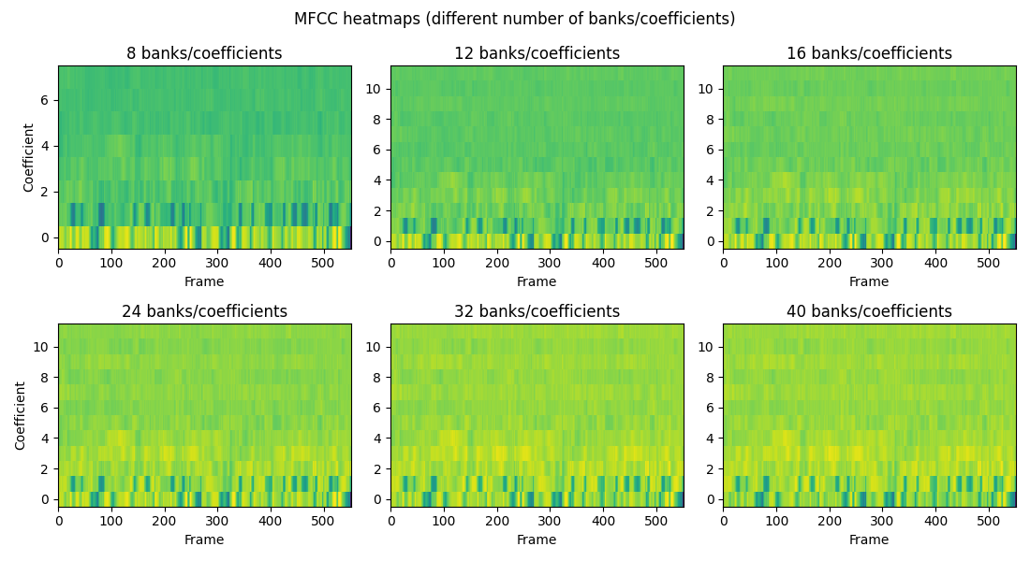
Figure 5. The MFCC heatmap under different numbers of banks/coefficients
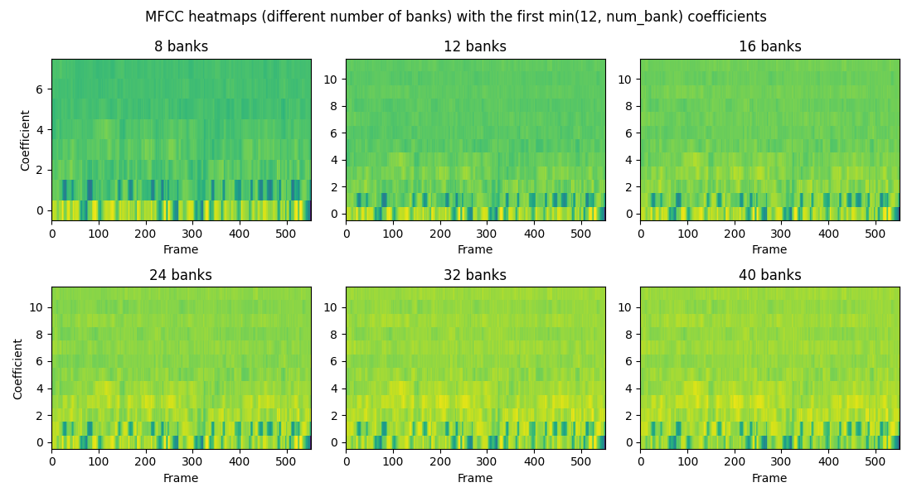
In Figure 5, both the number of mel filter banks and the number of MFCC coefficients increase together, so the heatmaps mix two effects at once: finer spectral sampling from more banks and a longer cepstral vector from more coefficients. As both grow, the maps look progressively “richer,” but much of the extra texture appears in higher-order coefficients and becomes visually jittery across frames.
Figure 6. The MFCC heatmap under different numbers of banks with the selected coefficients
In Figure 6, the comparison is controlled by fixing the number of coefficients to $min(12, num_banks)$. Concretely, when $num_banks=8$ the cepstrum uses $8$ coefficients, when $num_banks≥12$ it uses $12$ coefficients. Under this setting, raising the banks from $8→12→16$ clearly improves the temporal smoothness and makes the low-order bands more consistently expressed. Increasing further to $24$ still adds useful resolution without introducing obvious instability. Beyond $24$ (i.e.,$32→40$), the low-order structure changes little; the additional banks mainly contribute subtle, high-frequency variations that do not translate into meaningfully clearer patterns at the coefficient range we keep ($≤12$).
Therefore, more is not always better. With this audio, a reasonable operating point is 24 mel filter banks with 12 coefficients. This choice captures the salient, stable temporal patterns seen in Figure 6 while avoiding the redundancy and frame-to-frame fluctuations that appear when pushing banks/coefficients higher.
Bonus Question 2:
In the starter code, the spectrogram shows roughly half as many frequency channels as the configured FFT size because the STFT uses a one-sided real FFT (“rfft”). For real-valued time signals, the discrete Fourier transform is conjugate-symmetric, so only the bins from DC to the Nyquist frequency are unique. A real FFT therefore returns $\frac{N}{2}+1$ magnitude channels for an $N$-point FFT, which explains the “halved” frequency axis observed in the figure and matches the hint directing us to the STFT call in the helper file. When we replace the real FFT with a conventional (two-sided) FFT, the spectrogram contains the full set of $N$ bins. If we additionally apply an “fftshift” along the frequency axis, DC is centered and the plot reads from negative frequencies up to positive frequencies, producing a symmetric magnitude image for speech because the underlying signal remains real. The difference is thus representational rather than informational: the one-sided view discards only redundant mirror content, while the conventional view restores both halves for visualization consistency with the configured FFT size.
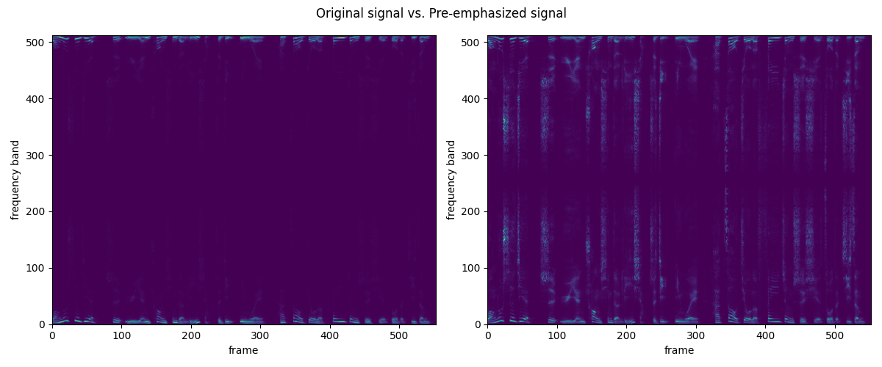
Figure 7. The STFT of the original and pre-emphasized signal using conventional FFT
- Conclusion
In this lab, we implemented the complete pipeline of Mel-Frequency Cepstral Coefficient (MFCC) extraction, from pre-emphasis through framing, Fourier analysis, mel-scale filtering, logarithmic compression, and the discrete cosine transform. By examining three checkpoints, we observed the effect of pre-emphasis on the spectrogram, extracted the MFCC vector of a single frame, and visualized the filter banks together with the MFCC heatmap across time. The discussion of report questions highlighted how pre-emphasis balances spectral energy, how the choice of filter banks and coefficients affects resolution and redundancy, and why the one-sided FFT leads to halved frequency channels compared to a conventional FFT. Through both theoretical reasoning and practical observation, we confirmed that MFCCs provide a compact and perceptually meaningful representation of speech signals, making them highly suitable for subsequent tasks in speech and audio analysis.
- Reference
[1] Department of Electrical Engineering, National Tsing Hua University, DSP_Lab_2025_Lab_1_lecture, 2025.
[2] Department of Electrical Engineering, National Tsing Hua University, DSP_Lab_2025_Lab_1_MFCC, 2025.

