ƒCSC

PART I. ORGANIZATIONAL PROFILE

A. CSC VISION/MISSION STATEMENT

A.1. Mandate
Legal Basis
The Civil Service Commission (CSC) was conferred the status of a department by Republic Act (RA) No. 2260, otherwise known as the Civil Service Law, and elevated to a constitutional body by the 1973 Constitution. Its role as the central personnel agency of government was redefined under Presidential Decree No. 807 (The Civil Service Decree of the Philippines). It was reorganized under Executive Order (EO) No. 181 dated November 21, 1986. After the promulgation of the 1987 Constitution, the Administrative Code of 1987 (EO 292) was issued to implement the Commission’s constitutional mandate to promote morale, efficiency, integrity, responsiveness, progressiveness, and courtesy in the Civil Service.
Functions
Under EO No. 292, the CSC shall perform the following functions:
- Administer and enforce the constitutional and statutory provisions on the merit system for all levels and ranks in the Civil Service;

PART I. ORGANIZATIONAL PROFILE
- Promulgate policies, standards and guidelines for the Civil Service and adopt plans and programs to promote economical, efficient and effective personnel administration in the government;
- Render opinion and rulings on all personnel and other Civil Service matters which shall be binding on all heads of departments, offices and agencies and which may be brought to the Supreme Court on certiorari;
- Appoint and discipline its officials and employees in accordance with law and exercise control and supervision over the activities of the Commission;
- Control, supervise and coordinate Civil Service examinations. Any entity or official in government may be called upon by the Commission to assist in the preparation and conduct of said examinations including security, use of buildings and facilities as well as personnel and transportation of examination materials which shall be exempt from inspection regulations;
- Prescribe all forms for Civil Service examinations, appointments, reports and such other forms as may be required by law, rules and regulations;
- Declare positions in the Civil Service as may properly be primarily confidential, highly technical or policy determining;

PART I. ORGANIZATIONAL PROFILE
- Formulate, administer and evaluate programs relative to the development and retention of qualified and competent work force in the public service;
- Hear and decide administrative cases instituted by or brought before it directly or on appeal, including contested appointments, and review decisions and action of its offices and of the agencies attached to it. Officials and employees who fail to comply with such decisions, orders, or rulings shall be liable for contempt of the Commission. Its decisions, orders or rulings shall be final and executory. Such decisions, orders, or rulings may be brought to Supreme Court on certiorari by the aggrieved party within thirty (30) days from receipt of the copy thereof;
- Issues subpoena and subpoena duces tecum for the production of documents and records pertinent to investigations and inquiries conducted by it in accordance with its authority conferred by the Constitution and pertinent laws;
- Advise the President on all matters involving personnel management in the government service and submit to the President an annual report on the personnel programs;
- Take appropriate actions on all appointments and other personnel matters in the Civil Service including extension of service beyond retirement age;

PART I. ORGANIZATIONAL PROFILE

- Inspect and audit the personnel actions and programs of the departments, agencies, bureaus, offices, local government including government-owned or -controlled corporations;
- Conduct periodic review of the decisions and actions of offices or officials to whom authority has been delegated by the Commission as well as the conduct of the officials and the employees in these offices and apply appropriate sanctions whenever necessary;
- Delegate authority for the performance of any functions to departments, agencies and offices where such functions may be effectively performed;
- Administer the retirement program of government officials and employees, and accredit government services and evaluate qualification for retirement;
- Keep and maintain personnel records of all officials and employees in the Civil Service; and
- Perform all functions properly belonging to a central personnel agency such as other functions as may be provided by law.

PART I. ORGANIZATIONAL PROFILE
General Functions of CSC Offices
- THE COMMISSION
- The executive offices, composed of the Office of the Chairperson (OCH) and two (2) Office of the Commissioner;
- The approving body;
- Performs overall management in implementing the CSC’s mandate; and
- Encompasses leadership, planning, organizing and controlling to achieve the CSC’s vision and mission and ensure smooth functioning of all the CSC Central and Regional offices;
- OFFICE OF THE ASST. COMMISSIONER FOR HUMAN RESOURCE GOVERNANCE (OAC-HRG)
- Performs functional supervision and oversight by integrating the perspectives, processes and practices of the CSC process owners involved in the regulation, management and implementation of HR functions, namely: Human Resource Process and Standards Office (HRPSO); and Public Assistance and Information Office (PAIO);
- Performs functional supervision and oversight by integrating the perspectives, processes and practices of the CSC Offices/Divisions involved in quality management matters;

PART I. ORGANIZATIONAL PROFILE

- Establishes common objectives; directions and programs by analyzing the complex and volatile environment of the bureaucracy and adopting appropriate strategies that will address identified present and future challenges;
- Supports and exhibits buy-in and full support for the Change Management Plans that carries out organization-wide changes and significant organizational effectiveness;
- Builds and leverages collaborative and inclusive partnerships among the concerned CSC process owners and other stakeholders to continually enhance the practice of Human Resource Management and Development in the bureaucracy. Performs data analytics in relation to the field of concern and manages the maintenance, upgrading and use of databases related to all HR concerns and quality management;
- Creates a performance-based culture by: leading the process owners by example; and, enabling them to achieve stretched performance standards through coaching and mentoring;
- Builds and cultivates a shared sense of commitment among the concerned process owners and other stakeholders despite differences and/or complexities of relationships. Leads the concerned process owners toward a learning culture committed to continuous improvements and talent development;

PART I. ORGANIZATIONAL PROFILE

- Supports process owners in the maintenance and continual improvements in the practice of ISO 9001:2015, and Investors in People (IiP); and
- Coordinates with other Assistant Commissioners through quarterly meetings to discuss matters across areas of concern.
- OFFICE OF THE ASST. COMMISSIONER FOR LEGAL (OAC-L)
- Performs functional supervision and oversight by integrating the perspectives, processes and practices of the CSC Offices/Divisions involved in the case adjudication and other legal matters, namely: Office of Legal Affairs and the Legal Services Division of the CSC Regional Offices;
- Monitors/ Utilizes Report Card Survey findings, in coordination with appropriate process owners, for purposive and integrated government-wide human resource systems and programs toward efficient delivery of government service as contemplated in RA 11032; and receive, review, hear, and decide on complaints on erring government employees and officials and non-compliance with the provisions of this Act;
- Establishes common objectives; directions and programs by analyzing the complex and volatile environment of the bureaucracy and adopting appropriate strategies that will address identified present and future challenges;

PART I. ORGANIZATIONAL PROFILE

- Supports and exhibits buy-in and full support for the Change Management Plans that carries out organization-wide changes and significant organizational effectiveness;
- Builds and leverages collaborative and inclusive partnerships among the concerned CSC Offices/Divisions and other stakeholders to continually enhance CSC laws, rules, regulations, the internal practice of case adjudication and review of contract;
- Performs data analytics in relation to the field of concern and manages the maintenance, upgrading and use of databases related to cases and other legal concerns;
- Creates a performance-based culture by: leading the process owners by example; and, enabling them to achieve stretched performance standards through coaching and mentoring;
- Builds and cultivates a shared sense of commitment among the concerned CSC Offices/Divisions and other stakeholders despite differences and/or complexities of relationships. Leads the concerned Offices/Divisions/Stakeholders toward a learning culture committed to continuous improvements and talent development;

PART I. ORGANIZATIONAL PROFILE

- Supports process owners in the maintenance and continual improvements in the practice of ISO 9001:2015, and Investors in People (IiP); and
- Coordinates with other Assistant Commissioners through quarterly meetings to discuss matters across areas of concern.
- OFFICE OF THE ASST. COMMISSIONER FOR PROFESSIONALIZATION AND COOPERATION (OAC-PAC)
- Performs functional supervision and oversight by integrating the perspectives, processes and practices of the CSC Offices/Divisions involved in professionalization and cooperation program, and global/external relations, namely: Examinations, Recruitment and Placement Office (ERPO); Civil Service Institute (CSI); Human Resource Relations Office (HRRO); Commission Secretariat and Liaison Office (CSLO); Public Assistance Information Office (PAIO);
- Represents the Civil Service Commission in international bodies with concerns related to the governance of civil service. Keeping abreast of emerging trends and best practices of said international bodies and adopting best practices that are applicable to the Commission;

PART I. ORGANIZATIONAL PROFILE

- Establishes common objectives; directions and programs by analyzing the complex and volatile environment of the bureaucracy and adopting appropriate strategies that will address identified present and future challenges;
- Supports and exhibits buy-in and full support for the Change Management Plans that carries out organization-wide changes and significant organizational effectiveness;
- Builds and leverages collaborative and inclusive partnerships among the concerned CSC Offices/Divisions and other stakeholders to continually enhance CSC laws, rules and regulations relative to civil service professionalization and external/global concerns;
- Performs data analytics in relation to the field of concern and manages the maintenance, upgrading and use of databases relative to civil service professionalization and external/global concerns;
- Creates a performance-based culture by: leading the process owners by example; and, enabling them to achieve stretched performance standards through coaching and mentoring;
- Builds and cultivates a shared sense of commitment among the concerned CSC Offices/Divisions and other stakeholders despite differences and/or complexities of relationships.

PART I. ORGANIZATIONAL PROFILE

- Leads the concerned Offices/Divisions/Stakeholders toward a learning culture committed to continuous improvements and talent development;
- Conducts research and formulates policies and standards to introduce improvements in regulations, procedures, processes, and practices based on empirical data;
- Support process owners in the maintenance and continual improvements in the practice of ISO 9001:2015, and Investors in People (IiP); and
- Coordinates with other Assistant Commissioners through quarterly meetings to discuss matters across areas of concern.
- OFFICE OF THE ASST. COMMISSIONER FOR SUPPORT AND ADMINISTRATIVE SERVICES (OAC-SAS)
- Performs functional supervision and oversight to CSC Central Offices supporting the overall CSC operations and administrative services such as Office for Strategy Management (OSM), Commission Secretariat and Liaison Office (CSLO), Office of Financial Assets and Management (OFAM), Office for Human Resource Management and Development (OHRMD), and Office for Integrated Records Management (IRMO), Internal Audit Services (IAS) and CSC Regional Offices;

PART I. ORGANIZATIONAL PROFILE

- Establishes common objectives; directions and programs by analyzing the complex and volatile environment of the bureaucracy and adopting appropriate strategies that will address identified present and future challenges in relation to regional concerns;
- Supports and exhibits buy-in and full support for the Change Management Plans that carries out organization-wide changes and significant organizational effectiveness;
- Builds and leverages collaborative and inclusive partnerships among the CSC Regional Offices and other stakeholders to continually enhance the practice of Human Resource Management and Development in the bureaucracy;
- Performs data analytics in relation to the field of concern and manages the maintenance, upgrading and use of databases related to regional concerns;
- Creates a performance-based culture by: leading the Regional Offices by example; and, enabling them to achieve stretched performance standards through coaching and mentoring;

PART I. ORGANIZATIONAL PROFILE

- Builds and cultivates a shared sense of commitment among the Regional Offices and other stakeholders despite differences and/or complexities of relationships. Leads the concerned process owners toward a learning culture committed to continuous improvements and talent development;
- Supports Regional Offices in the maintenance and continual improvements in the practice of ISO 9001:2015, and Investors in People (IiP);
- Coordinates with other Assistant Commissioners through quarterly meetings to discuss matters across areas of concern; and
- Reports directly to the Office of the Chairperson on matters requiring the approval of budget proposals and procurement concerns of the Central and Regional Offices.
- COMMISSION SECRETARIAT AND LIAISON OFFICE (CSLO)
- Programs and coordinates the regular and special meetings of the Commission Proper;
- Manages and maintains all decisions, policies, pronouncements, issuances, and records of the Commission Proper;
- Liaises with both Houses of Congress on legislative matters and those affecting the public personnel administration system and people working in government;

PART I. ORGANIZATIONAL PROFILE

- Assists legislators in facilitating their requests for technical help and advice, including those affecting their constituents; and
- Coordinates commitments of the CSC with the ASEAN and other international bodies.
- INTERNAL AUDIT SERVICE (IAS)
- Determines cost effectiveness, value for money, and benefits of major investments and expenditures of the Commission;
- Clarifies and enhances individual and unit accountabilities of established systems and procedures;
- Evaluates the efficiency of operations and determine whether CSC policies are being followed consistently in all offices of the Commission;
- Correct deficiencies in established internal control systems and procedures; and
- Recommend improvement/reengineering of internal control systems and procedures.
- OFFICE FOR STRATEGY MANAGEMENT (OSM)
- Oversees Strategy Implementation. The OSM shall track, review, and report the performance in the 1st and 2nd Level Scorecards and implementation of initiatives to internal and external stakeholders;

PART I. ORGANIZATIONAL PROFILE

- Develops a culture of performance management. The OSM shall secure the organizational alignment to budget, human resource, and communication and that strategy is lived in the daily operations of the organization; and
- Establishes system of monitoring and reporting. The OSM shall ensure that implementation and evaluation of strategies are linked to organizational performance.
- OFFICE FOR FINANCIAL AND ASSETS MANAGEMENT (OFAM)
- Provides the Commission with financial, logistics, adequate working facilities, transport and printing services, art works, and other basic support services needed
- OFFICE FOR HUMAN RESOURCE MANAGEMENT AND DEVELOPMENT (OHRMD)
- Develops and updates job description of positions by identifying duties, responsibilities, reporting relationships, working conditions and job requirements in terms of education, training, work experience, eligibility and required competencies;
- Develops, conducts or sources out Human Resource programs to enhance officials and employees’ competencies for better work performance;

PART I. ORGANIZATIONAL PROFILE

- Develops and implements a comprehensive Work-Life Program that aims to promote quality of life and ensure balance in work and enjoyment;
- Facilitates release of benefits, either regular or those provided pursuant to existing negotiations with the employee organization; and
- Promotes professionalism, commitment to service and observance of ethical standards and behavior required of an official/employee.
- OFFICE FOR LEGAL AFFAIRS (OLA)
- Conducts fact-finding investigation;
- Investigates cases affecting the functions of the Commission and represents the Commission in cases pending with the regular court or other tribunals;
- Prosecutes administrative disciplinary cases filed directly or instituted by the CSC;
- Renders counseling services and other assistance to the transacting public and to the other offices of the Commission;
- Disseminates opinions and rulings of the Commission in coordination with Regional and Field Offices;
- Evaluates and acts on administrative disciplinary cases brought on appeal to the Commission;
- Evaluates and acts on cases involving decisions of agency heads involving personnel actions;

PART I. ORGANIZATIONAL PROFILE

- Evaluate and act on cases brought on appeal involving disapproved appointments or any action/decision made by Civil Service Regional or Field Offices;
- Fast tracks resolution of cases that needs immediate action/decision from the Commission and investigates complaints against Commission officials and employees;
- Conducts research on legal issues brought before the Commission;
- Undertakes legal studies relevant to the Civil Service; and
- Conducts trainings/seminars/workshops to officials and employees of the Commission and of other agencies pertaining to legal matters.
- EXAMINATION, RECRUITMENT, AND PLACEMENT OFFICE (ERPO)
- Develops, enhances, controls, supervises, and coordinates pertinent schemes in the granting of civil service eligibility such as, but not limited to, administration of civil service examinations and conferment of civil service eligibilities through other modes/special laws; and
- Formulates policies programs, standards and guidelines in the conduct of examinations, grant of eligibilities under special laws and certification and placement of eligibles.

PART I. ORGANIZATIONAL PROFILE

- HUMAN RESOURCE POLICIES AND STANDARDS OFFICE (HRPSO)
- Formulates and periodically reviews policies on career systems and standards of the various closed and open career systems;
- Develops policies, strategic guidelines, and procedures relative to recruitment, qualification standards, appointment, leave benefits/privileges, incentives, performance evaluation, and promotion; and
- Develops policies and guidelines on position classification and compensation in collaboration with the Department of Budget and Management.
- CIVIL SERVICE INSTITUTE (CSI)
  - Provides direct training and personnel development interventions to all government officials and employees.
- HUMAN RESOURCE RELATIONS OFFICE (HRRO)
- Ensures the development of responsible public sector unionism and responsive management through an intensified education and information campaign;
- Evaluates applications for registration and accreditation to determine compliance with the requirements of EO No. 180 and its Implementing Rules;

PART I. ORGANIZATIONAL PROFILE

- Provides technical assistance towards an early conclusion of Collective Negotiation Agreement (CNA) between management and the union;
- Monitors the status of registered and accredited unions and compliance by management and accredited/recognized unions of CNA provision;
- Provides conciliation/mediation services at its own initiative or upon request of either management or employee union;
- Conducts research, evaluates existing policies to determine the need for amendments/enhancement and formulates new policies aimed at improving management-employee relations;
- Establishes linkages with agency members of the Public Sector Labor-Management Council (PSLMC), and other concerned agencies/institutions, i.e. the Department of the Interior and Local Governemtn, Human Resource Management Office (HRMO); and
- Serves as Secretariat and Hearing Officer of PSLMC.

PART I. ORGANIZATIONAL PROFILE

- INTEGRATED RECORDS MANAGEMENT OFFICE (IRMO)
- Formulates and implements policies, standards and rules pertaining to management of civil service records such as personnel and examination records, particularly on their development, maintenance, security and control, retention and disposition, transmission, preservation, and archive;
- Provides records storage and extension services that will ensure easy access to these records;
- Manages the flow of internal and external communication documents of the Commission; and
- Administers and maintains the library and museum services.

- PUBLIC ASSISTANCE AND INFORMATION OFFICE (PAIO)
  - Exercises overall supervision/administer the Commission’s Public Assistance/Client Relations Program;
  - Exercises overall supervision/administer the Honor Awards Program for the Civil Service; and
  - Develops, monitors, implements and evaluates activities, programs and policies relating to the Communication Plan.

18. INFORMATION AND COMMUNICATIONS TECHNOLOGY OFFICE (ICTO)
- Manages the day-to-day ICT operations and ensures the efficient delivery of ICTO’s mandated services and committed targets;
- Responsible for establishing, monitoring, and maintaining information technology systems and services;

PART I. ORGANIZATIONAL PROFILE

- Determines information technology requirements to enhance the efficiency of work processes and facilitate the delivery of services to internal and external clients despite challenging conditions;
- Identifies digital solutions (e.g. cloud-based data storage, digitization of records, data security, etc.) that will address identified requirements for work process enhancement;
- Undertakes maintenance of in-house systems, including and monitoring and evaluation of their performance; and
- Establishes and maintains linkages, development cooperation and partnership with local and international institutions engaged in ICT.

19. REGIONAL OFFICES (ROs)
- Enforce Civil Service law and rules, policies, standards on personnel management within their respective jurisdiction;
- Provide technical advice and assistance to government offices and agencies regarding personnel administration;
- Perform such other functions as may be delegated by the Commission. To date, the following are some of the delegated functions:
- Renders decision on protest cases involving appointments issued/acted/processed by agencies and local government units within its territorial jurisdiction;

PART I. ORGANIZATIONAL PROFILE

- Administers Civil Service examinations including the filing of formal charges, conduct of formal investigation, institution of corresponding criminal charge and other actions as may be necessary in the prosecution of cases attendant to Civil Service examination anomalies;
- Publishes bulletin of vacant positions;
- Processes applications for the grant of eligibility under special laws;
- Conducts regular inspection and audit in all government agencies and instrumentalities
- Reviews and approves personnel systems submitted by agencies for approval; conduct pre-accreditation audits in departments and agencies without field organizational units or at counterpart regional offices of departments and agencies as the case may be;
- Administers human resource development programs, render technical assistance on training needs assessment, develop appropriate training intervention and act as learning service provider;
- Renders opinions/rulings on queries relative to Civil Service law and rules;

PART I. ORGANIZATIONAL PROFILE

- Takes final action on appointments issued by regional offices of national government agencies, government-owned or controlled corporations pursuant to a sub delegation of functions by their department or agency heads and local chief executives;
- Maintains, secures control, and disposes personnel records of government personnel in the region; and
- Acts on complaints/administrative cases falling within the territorial jurisdiction of the regional offices.

A.2 CSC Organizational Vision

By 2030, the CSC shall be the leader in empowering people and organizations in human resource (HR) and organizational development (OD), and in serving the public through streamlined and digitalized services.

A.3 Mission Statement
Gawing Lingkod-Bayani ang Bawat Kawani

A.4 Major Final Outputs
With the Philippine Development Plan 2023-2028 as its foundation, the CSC espousing its revised Program Expenditure Classification (PREXC) structure shall pursue the following four (4) major programs and eight (8) sub-programs as indicated below:

PART I. ORGANIZATIONAL PROFILE

- Civil Service Human Resource Governance Program
1. Civil Service HR Policy and Information System Management Sub-Program
2. Public Assistance Sub-Program
- Civil Service Professionalization and Workplace Cooperation Program

1. Civil Service Professionalization Sub-Program
2. Civil Service Capability Building Sub-Program
3. Public Sector Unionism Sub-Program

- Administrative Justice Program
Efficient and effective administrative justice Sub-Program

- Support and Administrative Services Program
1. Support to Operations Sub-Program
2. General Administrative Support Services Sub-Program

PART I. ORGANIZATIONAL PROFILE
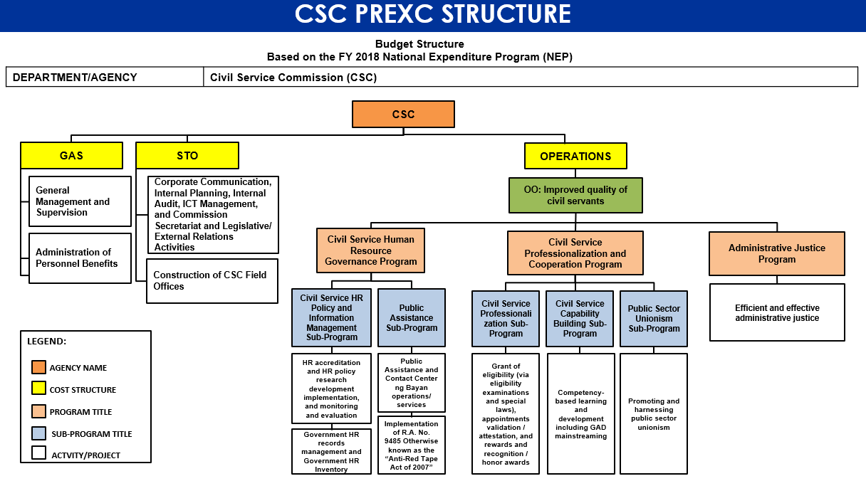

PART I. ORGANIZATIONAL PROFILE

B. DEPARTMENT/agency profile

B.1 Name of Designated IS Planner – SOLANE S. DUQUE-BASISTER
- Plantilla Position: Director IV
- Organizational Unit: Information and Communications Technology Office (ICTO)
- Email Address: icto@csc.gov.ph
- Contact Number/s: 02-8931-4178

B.2 Current Annual ICT Budget : 2024: PHP 137, 822, 588.00 GAA
2025: 720M - NEP
B.3 Organizational Structure

- Total Number of Plantilla Positions : 1,458
- Total Number of Warm Bodies : 1,230
- No. of Regional/Extension Offices : 16 Regional Offices
- No. of Provincial Offices : 109 Field Offices with 2 Satellite Offices

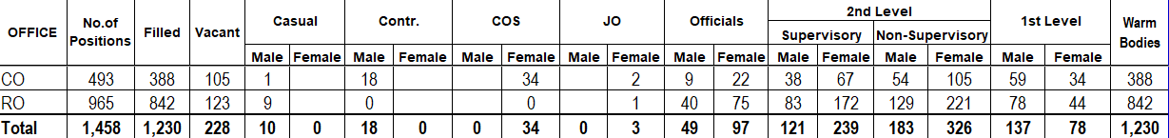
Data as of 31 January 2025

PART I. ORGANIZATIONAL PROFILE

B.4 Organizational Functional Chart
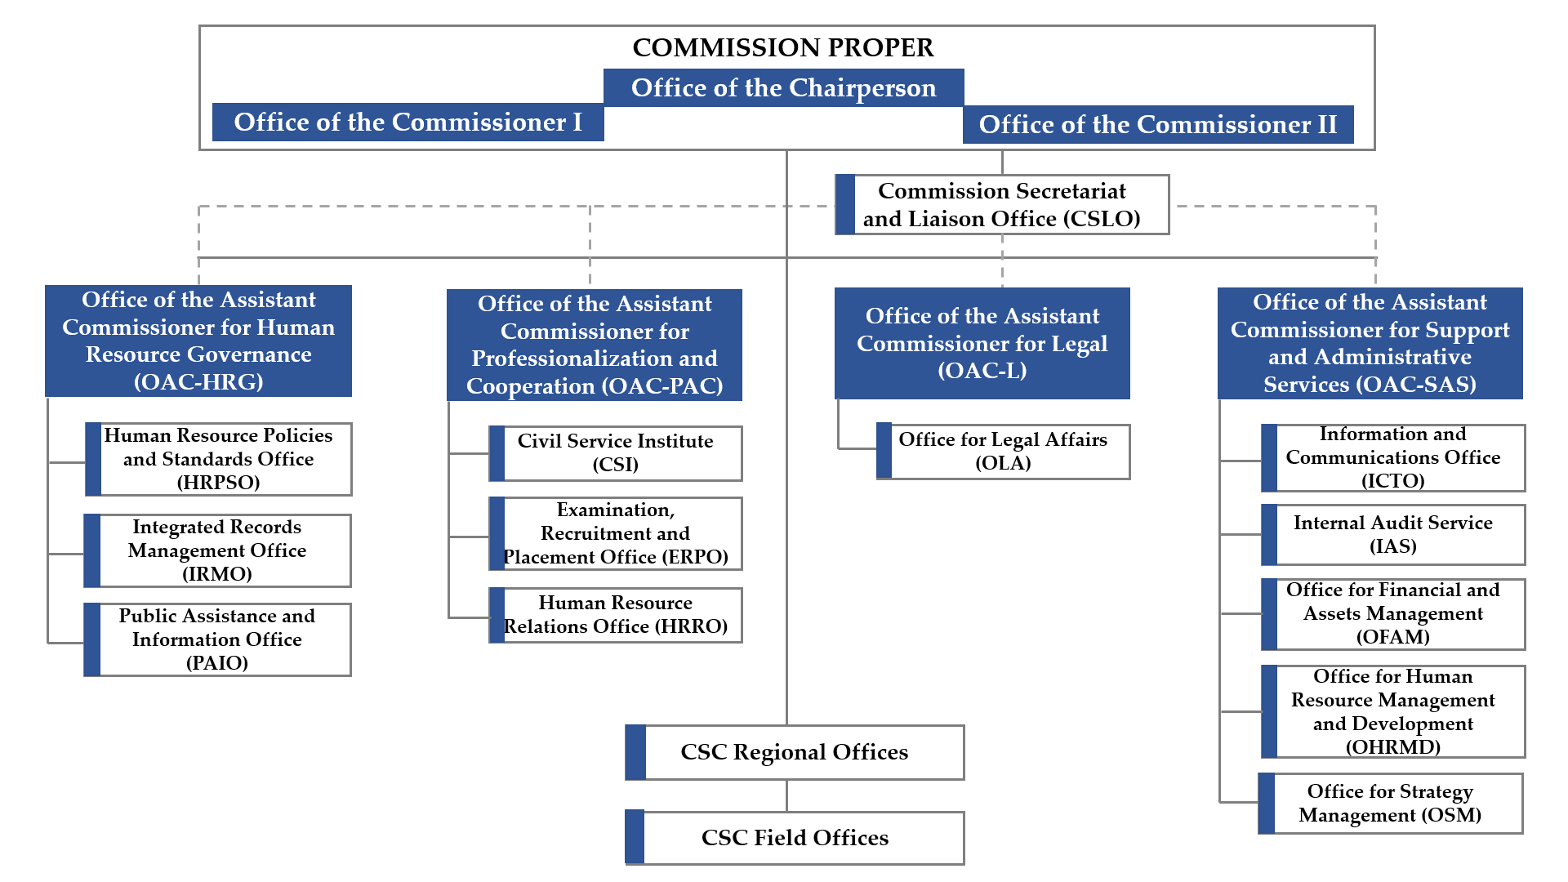

PART I. ORGANIZATIONAL PROFILE

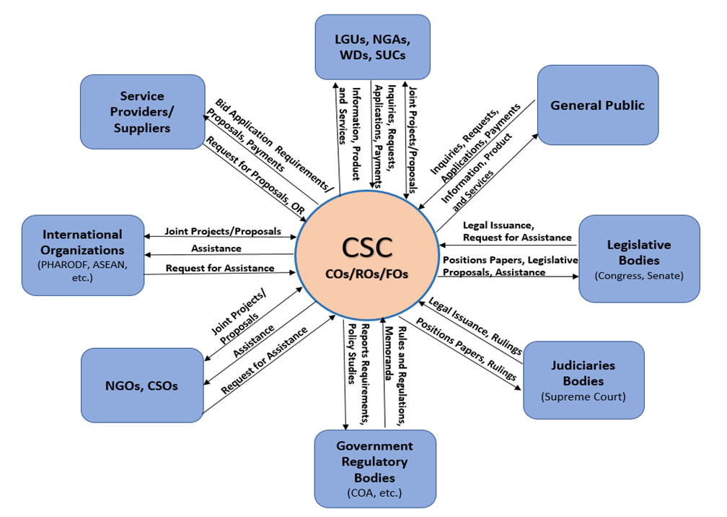
C. THE commission AND ITS ENVIRONMENT (FUNCTIONAL INTERFACE)
International
Organizations
(AAAEP-P, ADB, ASEAN, etc.)

PART I. ORGANIZATIONAL PROFILE

D. PRESENT ICT SITUATION (STRATEGIC CHALLENGES)
The CSC Information and Communications Technology Office (ICTO) is the one responsible in finding strategic ways on how to place digital technologies at the core of CSC’s operations, decision-making, customer interaction, and the like, in order to lead the path to digital transformation (DX). In pursuing DX in the CSC, the ICTO carefully assessed the CSC’s present environment and situation to lay down the appropriate strategies or roadmap in achieving the desired DX goals which also serve as guide for crafting this ISSP.
Below describes the present ICT situation of the CSC:
D.1. Inventory of ICT Equipment
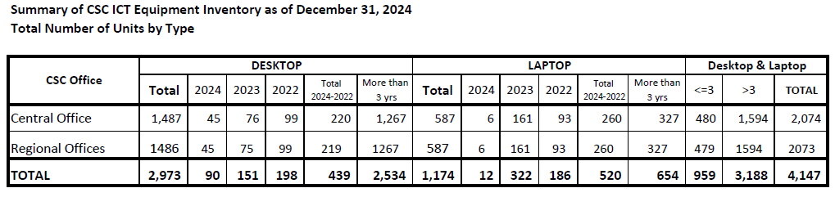
- There was a total of 4,147 computers (2,973 desktops and 1,174 laptops) but only 959 computer units (439 desktops and 520 laptops) are less than 3 years old, please refer to Figure 1 for the comparison. As of January 2025, an initial batch of 985 devices for both Central Office and Regional Office are under procurement.

PART I. ORGANIZATIONAL PROFILE
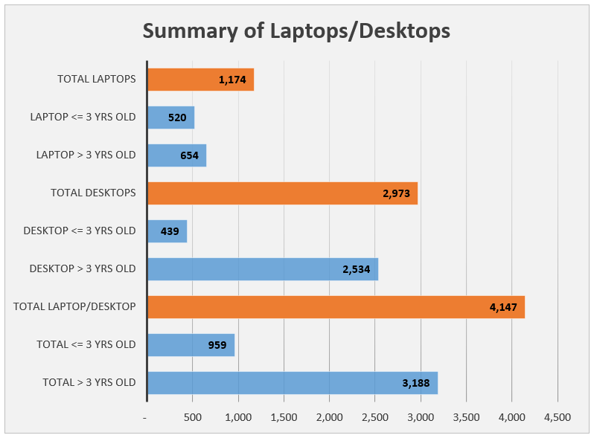

Figure 1: Summary of Laptops/Desktops

PART I. ORGANIZATIONAL PROFILE
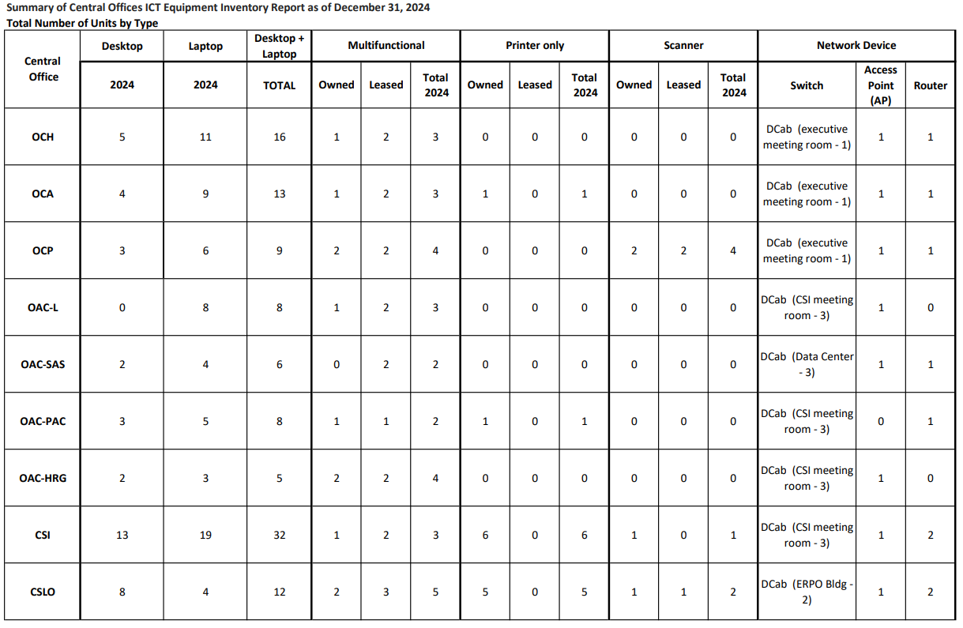

PART I. ORGANIZATIONAL PROFILE
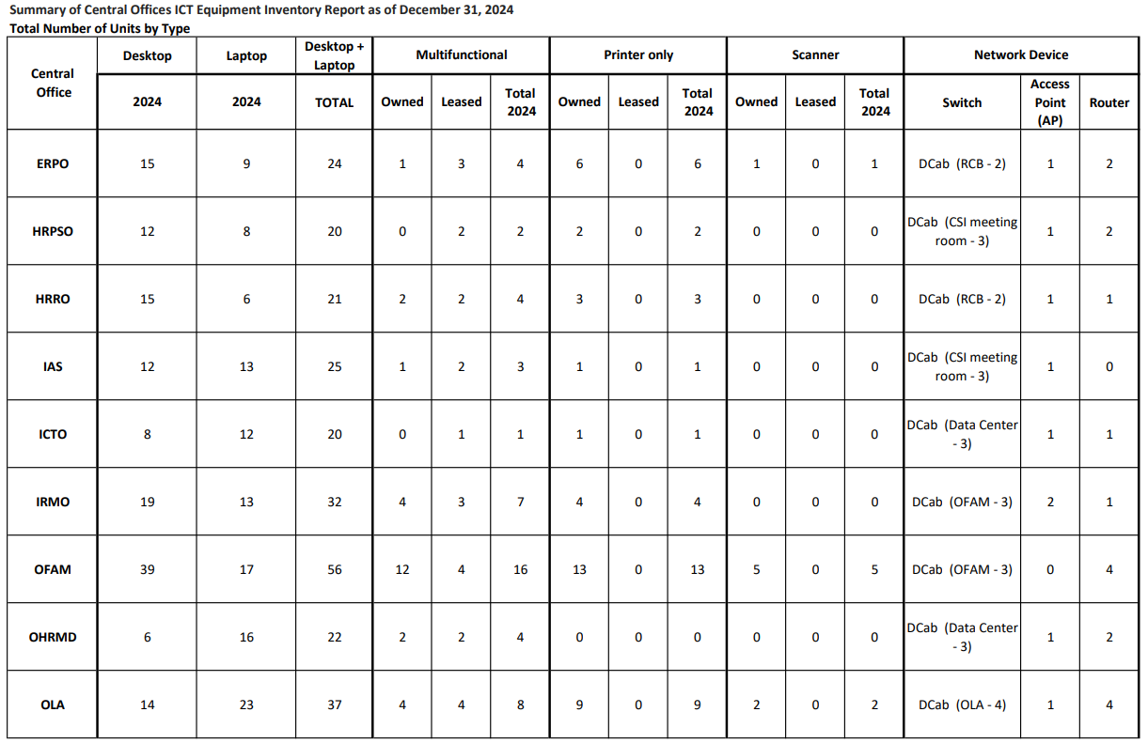

PART I. ORGANIZATIONAL PROFILE

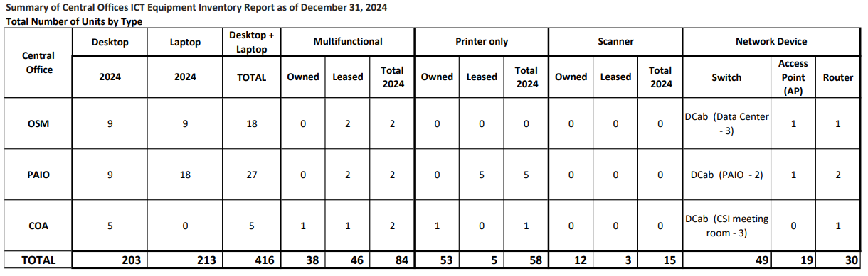

PART I. ORGANIZATIONAL PROFILE
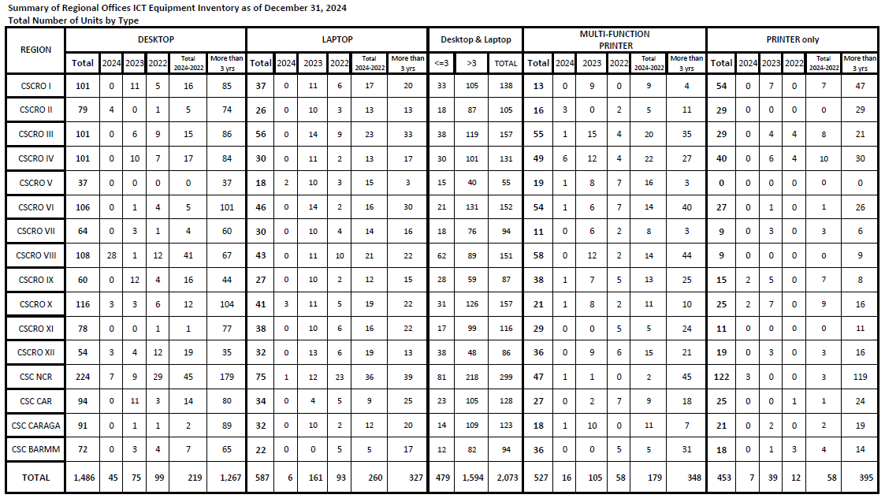

PART I. ORGANIZATIONAL PROFILE
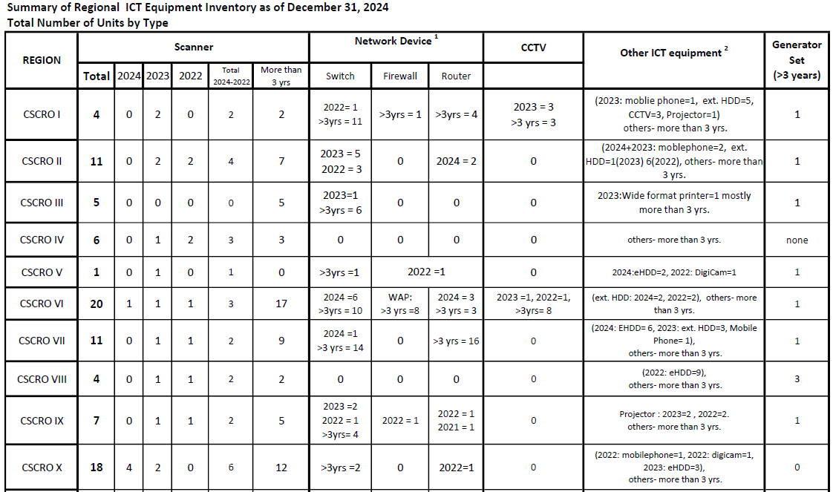

PART I. ORGANIZATIONAL PROFILE

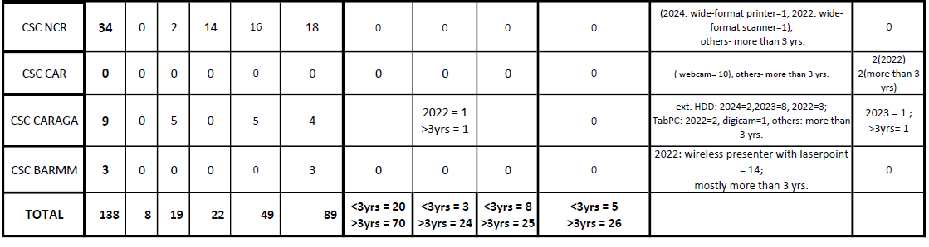

PART I. ORGANIZATIONAL PROFILE
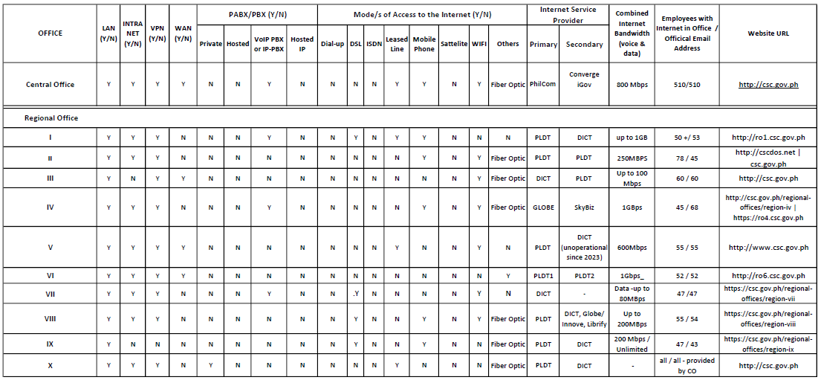
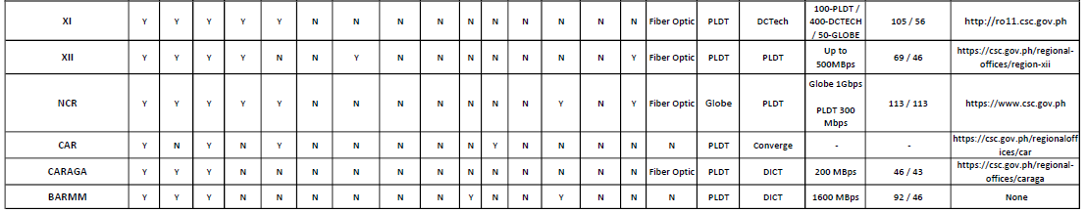

PART I. ORGANIZATIONAL PROFILE
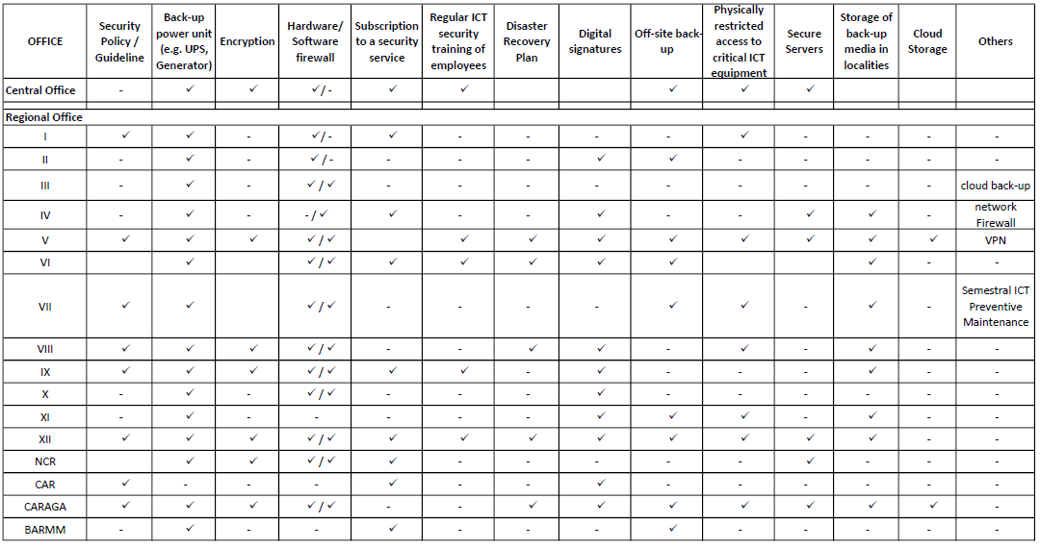

PART I. ORGANIZATIONAL PROFILE
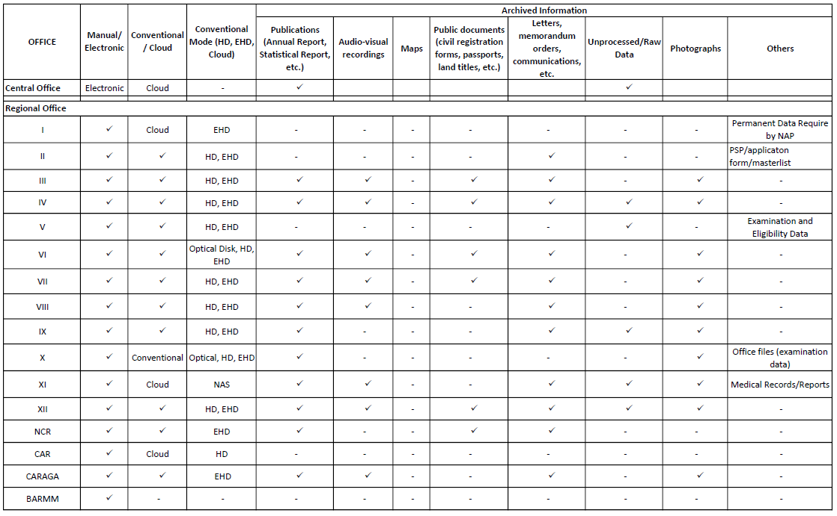

PART I. ORGANIZATIONAL PROFILE
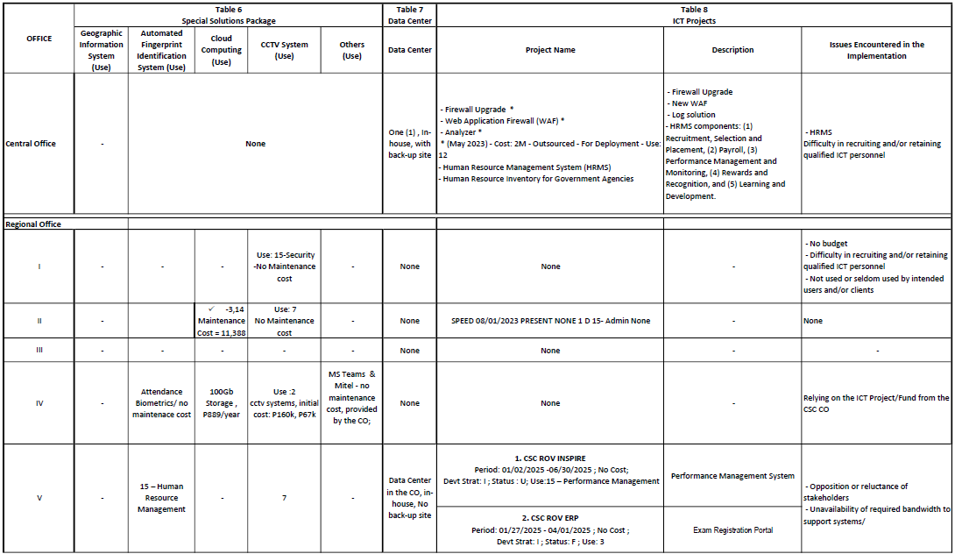

PART I. ORGANIZATIONAL PROFILE
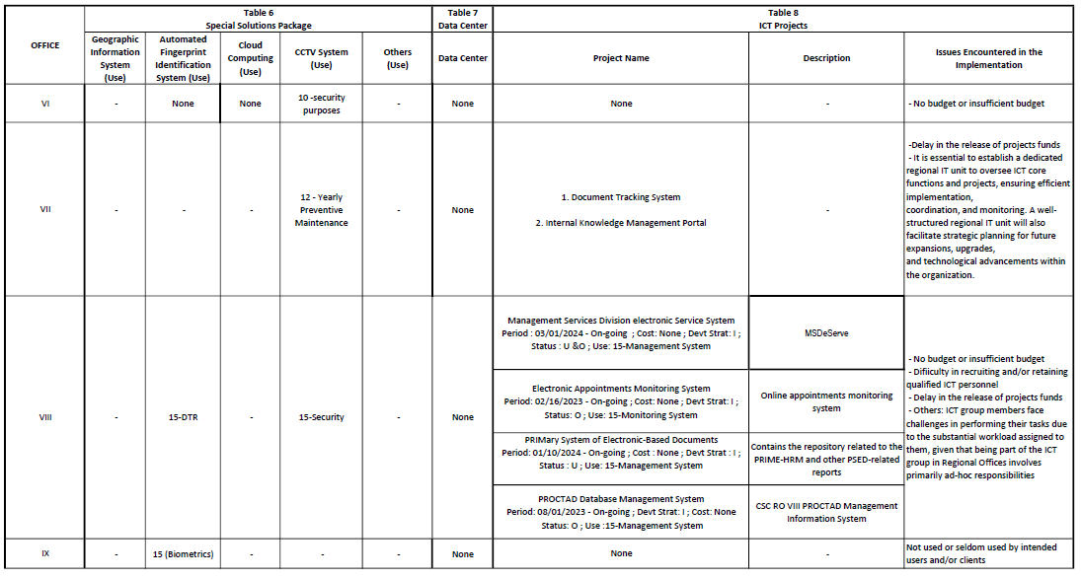

PART I. ORGANIZATIONAL PROFILE
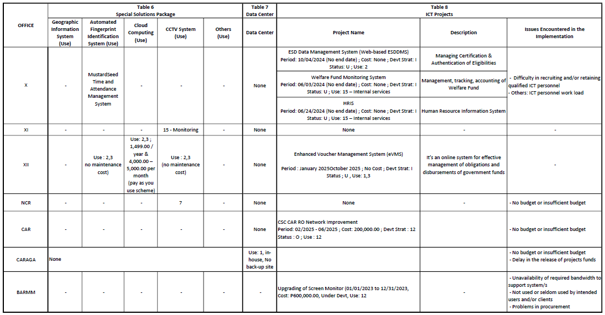

PART I. ORGANIZATIONAL PROFILE

D.2. On-going ICT Projects
Aside from the Office Productivity needs and Continuing Expenses for ICT maintenance of the CSC, the following ICT projects are on-going as of January 2025 and will be completed before the end of the 2024-2026 ISSP period.
D.2.1. Upgrading of ICT Equipment and Solutions
D.2.1.1. Data Center (DC)
- Enhancing and modernizing the infrastructure and technology to improve DC performance;
- Increasing the hosting capability in preparation for all systems/applications to be developed;
- Implementation of the 4-3-2 setup to secure data; and
- Implementation of disaster recovery response.
D.2.1.2. Server Security
- Enhancing the security of CSC servers from unauthorized access, data breaches and other security threats;
- Improving the accessibility and security of CSC systems and applications.
D.2.1.3. Network Rehabilitation
- Repairing/re-cabling of existing infrastructure to improve connectivity;
- Installation of managed Wireless Access Points;

PART I. ORGANIZATIONAL PROFILE

- Improving connectivity to the micro data center in Cebu; and
- Improving connectivity in the CSC Regional and Field Offices.
D.2.2. Smart Digital Workplace (Phase 1)
- Implementation of smart workplace facilities; and
- Improving the access of CSC employees to smart facilities.
D.2.3. Development of Various Information Systems
D.2.3.1. Human Resource and Payroll Management Information System (HRPMIS)
- Deployment of the HRPMIS Modules:
  - Recruitment, Selection and Placement (RSP);
  - Learning and Development (L&D);
  - Performance Monitoring (PM);
  - Rewards and Recognition (R&R); and
  - Payroll.

PART I. ORGANIZATIONAL PROFILE

D.2.3.2. Learning Management System (LMS)
- Integrating the CSI’s L&D process using a centralized platform which will systematize, simplify and shorten the performance of tasks involved in carrying out the L&D process.
D.2.3.3. Contact Center ng Bayan (CCB)
- Improving access to archive records and documents on the cloud;
- Improving the availability of data to the concerned office/agency/individual; and
- Incorporating chatbots for Frequently Asked Questions.
D.2.3.4. CSC Digital Examination (DEx)
- Implementation of an online mode of CSC examinations.
D.2.3.5. Quality Management System (QMS)
- Maintaining a repository of documented procedures and process management;
- Ensuring that an organization consistently meets customer requirements and enhance satisfaction.
D.2.3.6. Electronic Case Document Management System (eCDMS)
- Streamlining of case management in the CSC.
D.2.3.7. Financial and Assets Management System (FAMS)
- Streamlining the financial and assets management in the CSC; and

PART I. ORGANIZATIONAL PROFILE

- Includes the development of procurement management system and property inventory management system.
D.2.3.8. HRRO Digitalization and Automation
- Improving the administration, registration accreditation, and monitoring of Public Sector Employee Organizations (PSEO).
D.2.3.9. e-Qualification and Standards Management System (eQSMS)
- Streamlining the submission and evaluation of agency’s proposed position qualification standards to the HRPSO.
D.2.3.10. PRIME-HRM System
- A mechanism that assesses and accredits the maturity level of government agencies relative to HR management; and
- Automating the validation process of the PRIME-HRM to cater the HR needs of the Philippine bureaucracy.
D.2.3.11. Human Resource Inventory of Government Agencies (HRIGA)
- Generating the bureaucracy-wide inventory of human resources in the government.
D.2.3.12. Online Appointment Processing System (OAPS)
- Automating and reducing the processing time in attestation of appointment.

PART I. ORGANIZATIONAL PROFILE

D.3. Present Data Warehouse and Network Infrastructure
To increase productivity and to always make all applications available, the CSC implemented a High-Availability (HA) architecture for various systems and databases. A micro data center is being implemented as a co-location of database and system in one of the ROs of the CSC. This ensures that during calamity, data and system will still be accessible and operations will not be hampered.
The DC has been upgraded to Tier 1 compliant while network infrastructure has also been implemented to work office areas. The implementation of DC upgrade has catered the modest requirement of CSC to deliver the following upgrades:
- Firewall was installed for perimeter defense and IPsec VPN is established between CO and ROs while employee who work from home utilize VPN client to connect to network;
- Two tier network layouts for network design were implemented;
- Installed mixed of blade and monolithic servers;
- Wireless connectivity was installed and implemented; and
- VoIP Telephony System was also installed for central office and continuation of implementation with Regional Offices.

PART I. ORGANIZATIONAL PROFILE

D.4. CSC Website and Internet Connectivity
With regard to website hosting, the CO Data Center (DC) still hosts the CSC Website (www.csc.gov.ph) and the Regional Websites. The ICTO maintains the hosting of the website while the PAIO manages the content along with other Content Providers (focal personnel from various offices in the CO) to update the website. The RO ICT Focal Persons maintain and update the Regional Websites.
The CSC uses the DICT website template and hosted internally at the CSC DC. It is connected through a redundant connection consisting of two (2) direct internet access ISP in which provides 500Mbps and 300Mbps respectively along with supplemental bandwidth of 100Mbps provided by the Integrated Government Philippine Project (iGovPhil).

D.5. Employees’ ICT Literacy

The CSC has filled-up 1,230 of its 1,458 plantilla positions. Officials, employees holding technical, supervisory and non-supervisory positions, and employees performing clerical and administrative functions are all computer literate.

PART I. ORGANIZATIONAL PROFILE

To rapidly adopt and expand the use of hybrid work technology for remote operations and online collaborations, all CSC officials and employees participated in various orientations and trainings on collaborative/office productivity tools that were conducted by the ICTO. The CSC promotes continuous learning for its officials and employees to keep them updated with the latest ICT literacy. Among the trainings provided by the ICTO to CSC employees are:
- Cybersecurity Awareness; and
- Microsoft Office Applications (Word, Excel, PowerPoint, Outlook, PowerBi, Teams, Co-Pilot and Project).

The ICTO staff attended various specialized trainings like Linux operating system administration and security, Microsoft Office Applications (Word, Excel, PowerPoint, Outlook, PowerBi, Teams, Co-Pilot and Project), web programming, database administration, ethical hacking, Digital Transformation, cybersecurity awareness, cybersecurity fundamentals, cybersecurity proficiency, security operations center, defender strategies, generative AI, HR data analytics, Python Scikit-Learn, AWS Cloud operations, and CISSP security. Most of these trainings are external and some are scholarship grants under the Australia Awards and Alumni Engagement Program – Philippines (AAAEP-P) and the Unites States Agency for International Development (USAID).

PART I. ORGANIZATIONAL PROFILE

E. STRATEGIC CONCERNS FOR ICT USE
E.1 NARRATIVE DESCRIPTION
The CSC shall utilize ICT to strategically integrate and link its various systems ensuring streamlined operations and support CSC executive and management decisions. The development of a single sign-on platform integrating all applications through the “CSC eServe” facility shall make CSC’s services easily accessible to its clients.
The CSC has laid down various information systems (IS) towards its digital transformation (DX). Alongside with the development of IS is the need to upgrade its infrastructure and other ICT equipment in completion of all the DX efforts.

PART I. ORGANIZATIONAL PROFILE

E. STRATEGIC CONCERNS FOR ICT USE
MAJOR FINAL OUTPUT | CRITICAL MANAGEMENT/OPERATING/  BUSINESS SYSTEMS | PROBLEMS | INTENDED USE OF ICT
- Streamlined, digitized, digitalized, and integrated systems and services | - Informed decision-making  - Monitoring of the status of key projects, activities and programs | - Difficulty in monitoring the status of key projects, activities and programs  - No visual representation of data to easily make decisions | - Development of an Executive Monitoring and Management System;  - Dashboards, Scorecards and Data Analytics that shall facilitate reporting of key projects, activities and programs of the CSC.
- Efficient and effective administrative justice | • Take legal action on cases filed directly or on appeal or instituted by the CSC  • Deliberate and resolve cases affecting the Commission  • Issue clearance/certificate of no pending case | • Difficulty to track down cases in process  • Need to continuously digitize the cases received  • Misplaced records  • Unautomated issuance of clearance  • No data analytics | - Development of Harmonization of Administrative Justice System  - Enhancement of the Electronic Case Document Management System (eCDMS)  - Enhancement of the DIBAR  - Implementation of the e-Clearance  - Enhancement of the Cases Adjudication Reporting System (CARS) to automate the reporting of all the CSC legal units

PART I. ORGANIZATIONAL PROFILE

E. STRATEGIC CONCERNS FOR ICT USE

MAJOR FINAL OUTPUT | CRITICAL MANAGEMENT/OPERATING/  BUSINESS SYSTEMS | PROBLEMS | INTENDED USE OF ICT
- Empowered public sector employee organizations | - Processing of application for accreditation of employee organizations (EO) | - No enough storage to facilitate handling of documents submitted by the EOs  - Processing of application for accreditation is mostly manual, thus very tedious  - The old system (PEARS) needs an upgrade | - Development of the Public Sector  Employee Organization Management System  - Extended HRRO Digitalization and Automation project  - Continuous digitization and uploading of registration and accreditation certificate
- Streamlined, digitized, digitalized, and integrated systems and services | - Ensuring that an organization consistently meets customer requirements and enhances satisfaction  - Keeping CSC knowledge management (KM) products accessible and available online | - The current knowledge management portal needs to be upgraded | - Development of a Quality Management System (QMS) Portal which shall provide a repository of documented procedures, knowledge products and process management.

PART I. ORGANIZATIONAL PROFILE

E. STRATEGIC CONCERNS FOR ICT USE

MAJOR FINAL OUTPUT | CRITICAL MANAGEMENT/OPERATING/  BUSINESS SYSTEMS | PROBLEMS | INTENDED USE OF ICT
- Streamlined, digitized, digitalized, and integrated systems and services | - Facilitation of Pen-and-Paper Test (PPT) and Computer Examination (COMEX) | - Difficulty in retrieval of exam notice of school assignment and results by the clients  - Examination irregularity  - Long queues due to slow exam application processing  - No online application/registration  - DOS-based Examination Application Processing System (EAPS) is no longer responsive to the present business practice of the CSC | - Development of an Integrated Eligibility and Examination System

PART I. ORGANIZATIONAL PROFILE

E. STRATEGIC CONCERNS FOR ICT USE

MAJOR FINAL OUTPUT | CRITICAL MANAGEMENT/OPERATING/  BUSINESS SYSTEMS | PROBLEMS | INTENDED USE OF ICT
- Streamlined, digitized, digitalized, and integrated systems and services | - Keeping the bureaucracy-wide HR inventory | - The Inventory of Government Human Resource System (IGHRS) is no longer responsive to the current needs of the government (i.e., reports are limited, the platform needs to be upgraded, etc.) | - Enhancement of the Human Resource Inventory of Government Agencies (HRIGA) system to capture bureaucracy-wide statistical and analytical reports
- Streamlined, digitized, digitalized, and integrated systems and services | - Management of internal control and procedures  - Generation of summary of audit findings and monitoring of compliance | - Unautomated audit management  - Generation of comprehensive and insightful summary of findings is a challenge | - Development of an Internal Audit System  - Development of a Follow-up Audit Application with AI solution

PART I. ORGANIZATIONAL PROFILE

E. STRATEGIC CONCERNS FOR ICT USE

MAJOR FINAL OUTPUT | CRITICAL MANAGEMENT/OPERATING/  BUSINESS SYSTEMS | PROBLEMS | INTENDED USE OF ICT
- Streamlined, digitized, digitalized, and integrated systems and services  - Improved merit-based selection and talent development  - Professionalized and empowered HR in the civil service | - Recruitment, Selection and Placement (RSP)  - Performance Management (PM)  - Learning and Development (L&D)  - Rewards and Recognition (R&R)  - Payroll Management | - Difficulty in tracking, monitoring and processing of appointments  - Application has no link to the job portal for easy submission of application requirements/ packages  - No linkage between the Job Portal, Appointment Processing, and IGHRS  - No integration between the four HR areas (RSP, PM, L&D and R&R)  - Difficulty in retrieval of documents and monitoring of ageing HR documents  Difficulty in the administration of learning interventions | Enhancement of the Human Resource and Payroll Management System (HRPMIS) that shall facilitate:  - Automation of appointments processing;  - Integration of the Job Portal, Appointment Processing, and IGHRS  - Integration of the four HR areas  - Easy retrieval and monitoring of HR documents  - Deployment of a Self-service portal for requesting HR actions, printing pay slip and other reports  Implementation of web-based learning interventions, with online payment facility

PART I. ORGANIZATIONAL PROFILE

E. STRATEGIC CONCERNS FOR ICT USE
MAJOR FINAL OUTPUT | CRITICAL MANAGEMENT/OPERATING/  BUSINESS SYSTEMS | PROBLEMS | INTENDED USE OF ICT
- Improved mobilization and stewardship of resources | - Utilization of Information and Communications Technology Facilities | - Frequent breakdown of old and outdated ICT equipment  - Inaccessible Information Systems and databases due to slow and unreliable connections of CSC ROs  - Difficult to maintain and to secure CSC web services  - High charges on long distance communications.  - Need to update the competency of ICTO personnel | - Infrastructure upgrading  - procure high-end computers, modern equipment, and network devices  - upgrade hardware and software components  - upgrade Internet Service  - continuous maintenance services for network and computers  - Adoption of cloud services  - Rehabilitation and upgrade of network infrastructure of CSC ROs  - Upgrade and migration of CSC web services to cloud  - Training on how to utilize ICT facilities

PART I. ORGANIZATIONAL PROFILE

E. STRATEGIC CONCERNS FOR ICT USE

MAJOR FINAL OUTPUT | CRITICAL MANAGEMENT/OPERATING/  BUSINESS SYSTEMS | PROBLEMS | INTENDED USE OF ICT
- Improved mobilization and stewardship of resources | - Safeguarding all of the Information and Communications Technology resources  - Improving and securing workplace  - Adoption of emerging technologies | - ICT security and policies are not in place  - Challenge in cybersecurity monitoring and security incident response | - Establishment of a Next-Gen Security Operations Center (NSOC)  - Training on NSOC
 |  | - Challenge in adopting AI-driven technologies, IoT and machine learning | - Implementation of emerging technologies
 |  | - Challenge in protecting and authenticating digital communications | - Implementation of Internal Public Key Infrastructure
 |  | - No smart access control facility | - Implementation of a Smart Digital Workplace (Phase 2)
 |  | - Difficulty in controlling access for admin users and accounts | - Implementation of a Privilege Access Management  - Implementation of a Zero Trust Security Framework

