INTEGRATED SENIOR HIGH SCHOOL ATTENDANCE, ACTIVITY AND REQUIREMENT TRACKING, TEACHER LESSON PLANNING, AND LEARNING MATERIALS MANAGEMENT SYSTEM

A Capstone Project to the Faculty of the
College of Computing Studies
Laguna University

In Partial Fulfillment of the Requirements for the
Degree of Bachelor of Science in
Information Technology

Calica, Ljay H.
San Juan, John Rex G.

CHAPTER III
METHODOLOGY

3.1 Research Design
This study uses a Developmental and Descriptive-Evaluative Research Design. The developmental part focuses on designing and building CLASSREALM, an integrated web and mobile system for Eduardo Barreto Sr. High School combining RFID card attendance using an ESP32 USB Serial scanner device and a client-side Drift / SQLite offline sync engine (OfflineSyncService) with a manual attendance list, class schedule management, performance task, activity, quiz, and exam tracking, DepEd Order No. 015, s. 2026 grade computation, a lesson plan guide generator, a learning materials folder, and push notifications. The descriptive-evaluative part will measure system speed, accuracy, and acceptability using the ISO/IEC 25010:2023 software quality standard.
For the software development lifecycle (SDLC), the team used the Agile Scrum Methodology because it breaks the project into short weekly tasks and allows continuous feedback from the client teacher, Ma’am Karen P. Gonzaga. This connects directly to the Input-Process-Output (IPO) framework in Chapter II. Currently, the project is in Week 11 (Deployment Preparation), and classroom deployment is scheduled for November 3 to 6, 2026.

Figure 1
Agile Scrum Methodology Framework of CLASSREALM
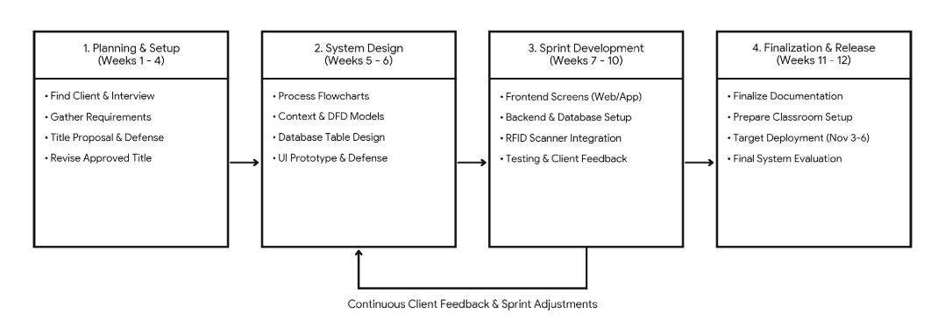
Figure 1 shows the four stages of the Agile Scrum workflow: Phase 1 (Weeks 1–4) covered client search, interview, and title defense (3 days after finding the client); Phase 2 (Weeks 5–6) covered flowcharts, database design, and UI prototype defense; Phase 3 (Weeks 7–10) covered frontend and backend coding, ESP32 USB Serial RFID integration with client-side Drift offline queue, and lab testing; and Phase 4 (Weeks 11–12) covers final documentation, classroom deployment (November 3–6, 2026), and final defense.

Table 1
Project Development Schedule and Weekly Deliverables
WEEK / DATES | TASK / ACTIVITY | PARTICIPANTS | OUTPUT / DELIVERABLE | STATUS
Week 1 (Aug 10–16, 2026) | Find a Client | Researchers, Client | Confirmed Ma’am Karen P. Gonzaga as client (Aug 15). | Completed
Week 2 (Aug 17–21, 2026) | Client Interview & Requirements | Researchers, Client Teacher | Interview notes, sample class records, DepEd DO 15 rules. | Completed
Week 3 (Aug 22–26, 2026) | Title & Proposal Preparation | Researchers, Subject Adviser | Drafted capstone title proposals and Chapter I outline. | Completed
Week 4 (Aug 27–Sep 2, 2026) | Title Defense & Revision | Researchers, Defense Panel | Approved CLASSREALM project title and scope. | Completed
Week 5 (Sep 3–9, 2026) | Flowchart & Process Design | Researchers, Subject Adviser | Approved Context Diagram, DFDs, and ERD. | Completed
Week 6 (Sep 10–18, 2026) | Prototyping & Prototype Defense | Researchers, Client, Panel | UI wireframes, initial prototype, passed Prototype Defense. | Completed
Week 7 (Sep 19–27, 2026) | Frontend System Development | Researchers (Frontend Lead) | Flutter web (Admin/Teacher) and mobile (Student/Parent) screens. | Completed
Week 8 (Sep 28–Oct 6, 2026) | Backend & Database Integration | Researchers (Backend Lead) | Supabase PostgreSQL tables, RLS rules, and Firebase login. | Completed
Week 9 (Oct 7–16, 2026) | Feature & Hardware Integration | Researchers | Connected ESP32 USB Serial RFID scanner, Drift/SQLite offline queue (OfflineSyncService), DO 15 grading, lesson guide, files. | Completed
Week 10 (Oct 17–24, 2026) | Testing, Debugging & Feedback | Researchers, Client Teacher | Benchmarked USB serial RFID speed, verified Drift offline queue syncing to Supabase, fixed bugs, and verified grade math. | Completed
Week 11 (Oct 25–Nov 2, 2026) | Finalization & Deployment Prep | Researchers, Adviser | Finalized Chapter III, encoded RFID cards, prepared USB driver and user guides. | In Progress
Week 12 (Nov 3–9, 2026) | Deployment, Survey & Defense | Researchers, All Evaluators | Classroom deployment (Nov 3–6), ISO survey, and Final Defense. | Planned
Table 1 details the 12-week schedule from August 10 to November 9, 2026, showing completed tasks (Weeks 1–10), ongoing preparation (Week 11), and planned deployment (Week 12).
3.2 Population of Study
The study will be conducted at Eduardo Barreto Sr. High School in Barangay Pansol, Calamba City, Laguna (verified August 18, 2026). Purposive sampling is used to select the single client teacher (Ma’am Karen P. Gonzaga), while the system supports multi-teacher scaling. Complete enumeration is used for all 65 Grade 11 students across her three handled Math sections. Purposive sampling is used to select 10 parents who own an Android smartphone and have internet access to test the Parent App, and 4 IT professionals to evaluate technical quality. Slovin's formula is not used because the student group is a complete census and the other groups use purposive criteria (Tejada & Punzalan, 2012).

Table 2
Target Population and Sample Distribution of CLASSREALM
PARTICIPANT CATEGORY | VERIFIED POPULATION (N) | PLANNED SAMPLE (N) | SELECTION METHOD AND JUSTIFICATION
Client Teacher (End User & Admin) | 1 | 1 | Purposive Sampling: Primary client teacher handling 3 Grade 11 Math sections.
Grade 11 Students (End Users) | 65 | 65 | Complete Enumeration: All enrolled Grade 11 students across the 3 sections (verified Aug 18, 2026).
Parents / Guardians (End Users) | 65 | 10 | Purposive Sampling: Selected parents with Android phones available to test the Parent App.
IT Professionals (Technical Evaluators) | 4 | 4 | Purposive Sampling: IT/CS graduates with >= 3 years experience in web, mobile, or IoT systems.
TOTAL | 136 | 81 | Combined evaluators for the planned November 3–6, 2026 deployment.
Table 2 shows the verified population (N = 136) and planned sample (n = 81). Paper forms will accompany Google Forms during the November 3–6, 2026 evaluation to prevent nonresponse.

3.3 Statistical Treatment of Data
This study separates technical test measurements from user survey ratings. Technical performance metrics—such as RFID tap response time over USB Serial (in seconds), client-side Drift / SQLite offline sync time to Supabase (in seconds), quiz and exam checking speed (in seconds), and DepEd grade math accuracy (percentage match)—will be analyzed using the arithmetic mean, minimum, maximum, and success percentage. These results will be compared directly against the target acceptance thresholds set in Chapter I.
User and expert evaluation ratings collected during the November 3 to 6, 2026 deployment will use a 5-point Likert agreement scale. All questionnaire items are positively phrased, so reverse coding is not needed. Missing answers or items marked Not Applicable (N/A) will be recorded separately and excluded from the valid total of respondents. Ratings from different questionnaires will be computed per group and per quality characteristic using the frequency-weighted mean formula:
Equation 1: WM = Σ(f × r) / Σf
In Equation 1, WM is the weighted mean, f is the frequency or number of respondents who selected a rating, r is the rating weight (1 to 5), and Σf is the total number of valid responses. The unrounded mean will be used to classify the verbal interpretation before rounding the final displayed score to two decimal places. Inferential tests such as t-tests or ANOVA are not used in this study because the objectives only require evaluating system performance and acceptability against fixed standards, rather than comparing experimental groups (NIST/SEMATECH, n.d.).

Table 3
Objective-to-Analysis Matrix of CLASSREALM
OBJECTIVE | VARIABLE & UNIT | DATA SOURCE & INSTRUMENT | PLANNED ANALYSIS | DECISION CRITERION
1. Dual-Path Attendance | Tap speed (s); Drift offline buffer (logs); sync (s). | ESP32 USB Serial & Flutter Drift logs; 50-tap timer log. | Mean, min, max time; % saved. | Tap < 2.0s; Drift queue retention; sync < 5.0s.
2. Schedule & Auto-Absent | Duplicate block (%); 11:59 PM job (%). | Attendance DB logs; schedule test script. | Percentage of correct marks. | 100% duplicate block; 100% auto-absent.
3. Task & Activity Tracking | Deadline check (s); alert speed (s). | Storage & Firebase logs; upload test log. | Mean time; upload success (%). | Deadline ±1.0s; push alert < 3.0s.
4. Quiz, Exam & Item Analysis | Scoring time (s); analysis time (s). | Quiz table logs; 20-item test script. | Mean processing time (s). | Score < 1.0s; item analysis < 2.0s.
5. DepEd DO 15 Grading | Grade delta vs. DepEd Excel (pts). | System vs. manual sheet (65 students). | Percentage match & delta. | 100% exact match (0.00 difference).
6. Lesson Plan Generator | Drafting time saved (%); output (s). | Teacher timing sheet. | Mean time saved (%). | >= 50% faster drafting; output < 5.0s.
7. Learning Materials | File download success rate (%). | Storage logs; download checklist. | Success percentage (%). | 100% download success (0 failures).
8. Role Portals & RLS | Blocked unauthorized queries (%). | Supabase RLS security test logs. | Pass/Fail percentage. | 100% data isolation across roles.
9. Restricted Admin Portal | Blocked admin grade access (%). | Admin security audit logs. | Pass/Fail percentage. | 0% admin access to class/grade data.
10. ISO 25010 Evaluation | Quality rating (1–5 scale). | Teacher, 65 Students, 10 Parents, 5 IT. | Weighted mean (WM) & %. | Weighted mean >= 4.20 (Strongly Agree).
Table 3 maps all ten specific objectives from Chapter I to their measured variables, instruments, statistical treatments, and acceptance thresholds.

3.4 Data Collection Procedure
Data collection follows four chronological stages: (1) Permission and Requirements Elicitation (Completed, Aug 15–21, 2026): Obtained school permission from the Principal and Ma’am Karen P. Gonzaga on August 15, 2026, and interviewed the client on August 18, 2026 while reviewing blank SF2 and DepEd DO 15 templates; (2) Instrument Review (Completed, Oct 17–24, 2026): Prepared role-specific ISO/IEC 25010:2023 survey forms reviewed by the adviser; (3) Laboratory Hardware & System Testing (Completed, Oct 17–24, 2026): Benchmarked the ESP32 USB Serial RFID scanner, client-side Drift / SQLite offline sync engine (OfflineSyncService), and web/mobile portals using sample records; and (4) Consent, Classroom Pilot, and Evaluation (Planned, Nov 3–6, 2026): Collect signed parental consent and student assent forms, deploy the system in the Grade 11 classroom, and administer the ISO survey to the teacher, 65 students, 10 parents, and 5 IT experts. Under RA 10173 (Data Privacy Act of 2012), student names and LRNs are coded (S-01 to S-65) and raw records are stored in an encrypted Drive folder for one year before deletion.

3.5 Requirement Analysis
The August 18, 2026 interview identified four classroom problems: slow paper roll calls (10–15 minutes per class), error-prone manual DepEd DO 15 grade calculations, time-consuming lesson plan drafting and file sorting, and delayed parent updates. To solve these, CLASSREALM defines four roles: (1) ADMIN (Web Portal) for creating teacher accounts and setting the school year, with zero access to class/grade data; (2) TEACHER (Responsive Web App) for creating student/parent accounts, managing sections/schedules, recording RFID/manual attendance, posting performance tasks, activities, quizzes, and exams, computing DO 15 grades, generating lesson guides, uploading handouts, and managing notifications; (3) STUDENT (Android App & RFID Card) for tapping RFID attendance, viewing attendance and schedules, uploading task/activity files, answering quizzes/exams, viewing grades, downloading handouts, and receiving notifications; and (4) PARENT (Android App) for linking their child's account, viewing attendance and schedules, receiving notifications (3+ absence alerts and task/activity/quiz/exam deadlines), and viewing quarterly grades.

Table 4
Validated Requirements Register of CLASSREALM (Functional & Non-Functional)
REQ ID | OWNER / SOURCE | ROLE | REQUIREMENT DESCRIPTION & BUSINESS RULE | PRIORITY | ACCEPTANCE CRITERION & STATUS
FR-01 | Client Teacher | Teacher, Student | Dual-path attendance: ESP32 USB Serial RFID card reader streaming to Flutter with client-side Drift / SQLite offline buffering (OfflineSyncService) and permanent manual attendance list fallback. | Critical | Tap < 2.0s; Drift queue synced < 5.0s; manual list editable (Approved/Built).
FR-02 | Client Teacher | Teacher, Student, Parent | Class schedule feature and schedule-based attendance status (Present/Late/Absent) with 11:59 PM auto-absent job; block duplicate taps. | High | 100% duplicate block; 11:59 PM job (Approved/Built).
FR-03 | Client Teacher | Teacher, Student, Parent | Performance task and activity tracking with file uploads, deadline checking, and push notifications. | High | Deadline ±1.0s; alert < 3.0s (Approved/Built).
FR-04 | Client Teacher | Teacher, Student | Online objective quiz and exam engine (MC, T/F, Identification) with auto-scoring and item analysis. | High | Score < 1.0s; analysis < 2.0s (Approved/Built).
FR-05 | Client / DO 15 | Teacher | DepEd DO 15, s. 2026 grade calculator (WW 20%, PT 50%, QA 30%) with 41-tier transmutation and Excel/PDF/CSV export. | High | 100% match with DepEd Excel (Approved/Built).
FR-06 | Client Teacher | Teacher | Lesson Plan Guide Generator creating editable Grade 11 Math lesson plan outlines. | Medium | Output < 5.0s; >= 50% faster (Approved/Built).
FR-07 | Client Teacher | Teacher, Student | Centralized Learning Materials folder for uploading and downloading class files by section. | Medium | 100% download success (Approved/Built).
FR-08 | Client Teacher | Teacher, Student, Parent | Teacher creation of Student/Parent accounts; mobile portals with schedule view, notifications, and 3+ absence alerts. | High | Alert < 3.0s; 100% RLS privacy (Approved/Built).
FR-09 | Client Teacher | Admin | Restricted Admin web portal for teacher account creation and school year rollover only. | High | 0% admin access to grades (Approved/Built).
NFR-01 | ISO 25010 | System | Performance Efficiency: Fast RFID card reading via USB Serial (< 2.0s) and rapid Drift/SQLite batch syncing to Supabase (< 5.0s). | High | Tap < 2.0s; sync < 5.0s (Approved/Built).
NFR-02 | ISO 25010 | System | Reliability: Client-side Drift / SQLite database (OfflineSyncService) safely queues offline attendance scans when internet connectivity is disconnected. | High | 0 data loss during network dropouts; automatic batch sync (Approved/Built).
NFR-03 | RA 10173 | System | Security: Firebase password encryption and Supabase Row-Level Security (RLS) rules. | High | 100% unauthorized queries blocked (Approved/Built).
NFR-04 | ISO 25010 | System | Compatibility & Maintainability: Runs smoothly on web browsers (Chrome/Edge) and Android 8.0+ phones. | High | Zero crash errors (Approved/Built).
Table 4 lists the approved functional (FR-01 to FR-09) and non-functional (NFR-01 to NFR-04) requirements, their business rules, and current status.

3.6 Research Instrument
This study uses three researcher-adapted instruments: (1) a Client Interview Guide, (2) a Technical Benchmark Sheet, and (3) an ISO/IEC 25010:2023 System Acceptability Questionnaire covering all nine characteristics (ISO, 2023). End users rate observable features (Students and Parents rate Functional Suitability, Performance Efficiency, Interaction Capability, and Security; the Teacher also rates Reliability, Flexibility, and Safety), while the 5 IT Professionals evaluate all nine characteristics including Compatibility and Maintainability.

Table 5
ISO/IEC 25010:2023 Instrument Blueprint and Draft Questionnaire Items
PART / CHARACTERISTIC | ITEM / QUESTION / METRIC STATEMENT | EVALUATORS | SCORING RULE
Part A: Interview Guide (Aug 18, 2026) | Q1. How do you record daily attendance and how long does it take? Q2. What challenges do you face in tracking tasks, activities, quizzes, and exams, and computing DepEd DO 15 grades? Q3. How do you prepare lesson plans and share handouts? Q4. How do you inform parents about absences or grades? | Client Teacher | Qualitative notes for Table 4.
Part B: Benchmark Sheet (Oct 17–24, 2026) | M1. USB Serial RFID Tap Time (50 trials; pass < 2.0s). M2. Drift Offline Sync Time to Supabase (50 logs; pass < 5.0s). M3. Quiz/Exam Auto-Score & Item Analysis Time (< 1.0s / < 2.0s). M4. DepEd DO 15 Grade Match vs. Excel (65 students; 100% match). M5. Push Alert Time (< 3.0s). | Researchers & IT | Timer values & Pass/Fail.
1. Functional Suitability (Obj 1–10) | 1. The system provides all features needed for my role (attendance, schedules, tasks/activities/quizzes/exams, grades, notifications, or lesson guides). 2. Computed grades and attendance logs are accurate. 3. The system completes tasks faster than paper recording. | Teacher, Students, Parents, IT | 1–5 Likert Scale (N/A excluded)
2. Performance Efficiency (Obj 1, 3, 4, 10) | 4. The RFID scanner and app screens respond quickly within 2 to 3 seconds. 5. The web or mobile app runs smoothly without freezing. | Teacher, Students, Parents, IT | 1–5 Likert Scale
3. Compatibility (Obj 10) | 6. The system works properly across web browsers (Chrome/Edge) and Android phones. 7. The ESP32 scanner, Flutter apps, and Supabase database exchange data without errors. | IT Only (N/A for end users) | 1–5 Likert Scale
4. Interaction Capability (Obj 8, 9, 10) | 8. Text, buttons, and menus are clear and easy to understand. 9. I can easily use the portal without long technical training. 10. The system shows clear warnings when invalid input is entered. | Teacher, Students, Parents, IT | 1–5 Likert Scale
5. Reliability (Obj 1, 2, 10) | 11. The Flutter application safely buffers RFID card taps in the local Drift / SQLite database when the internet is offline and synchronizes them to Supabase once reconnected. 12. The manual attendance list works reliably when a student forgets their card. | Teacher, IT Professionals | 1–5 Likert Scale
6. Security (Obj 8, 9, 10) | 13. The login screen requires a valid account and keeps my records private. 14. Database Row-Level Security (RLS) and Admin restrictions block unauthorized access to grades. | Item 13: All; Item 14: IT & Teacher | 1–5 Likert Scale
7. Maintainability (Obj 10) | 15. The Flutter code and database tables are organized clearly for future updates. 16. System logs make it easy to find and fix errors. | IT Only (N/A for end users) | 1–5 Likert Scale
8. Flexibility (Obj 10) | 17. The system allows adding new sections, subjects, and school years easily. 18. The screen layout adjusts properly to laptop and phone screens. | Teacher, IT Professionals | 1–5 Likert Scale
9. Safety (Obj 1, 10) | 19. The RFID scanner casing is safe to use at the classroom door. 20. The system asks for confirmation before deleting or changing grade records. | Teacher, IT Professionals | 1–5 Likert Scale
Table 5 presents the complete instrument blueprint, interview guide, benchmark metrics, evaluator assignments, and the 20-item ISO/IEC 25010:2023 survey.

3.7 Requirements Documentation
The requirements specification (Version 2.0, approved October 20, 2026) is maintained by the project researchers and reviewed by the client teacher and adviser. Every functional requirement (FR-01 to FR-09) is traced consistently across all models, prototype screens, and test cases.

Table 6
Requirements Traceability Matrix (RTM) of CLASSREALM
FR ID | DFD PROCESS | ERD TABLE | USE CASE | CLASS / MODULE | PROTOTYPE SCREEN | TEST ID | THRESHOLD & STATUS
FR-01 | 2.0 Manage Attendance | attendance_logs, students (synced from Drift) | UC-02: Tap RFID (USB Serial) / Drift Buffer / Manual List | AttendanceService, OfflineSyncService, UsbSerialService | SCR-03 Attendance & ESP32 Scanner | TC-01, TC-02 | Tap < 2.0s; Drift offline buffer; sync < 5.0s (v2.0).
FR-02 | 2.0 Manage Attendance | schedules, attendance_logs | UC-03: Set Schedule & Auto-Absent | ScheduleService | SCR-02 Class & Schedule | TC-03, TC-04 | 100% dup block; 11:59 PM (v2.0).
FR-03 | 3.0 Tasks & Assessments | activities, submissions | UC-04: Post Task/Activity & Upload | ActivityController | SCR-04 Task & Activity | TC-05 | Deadline ±1.0s; alert < 3.0s (v2.0).
FR-04 | 3.0 Tasks & Assessments | quizzes, quiz_responses | UC-05: Take Quiz/Exam & Analysis | QuizEngine | SCR-05 Quiz & Exam | TC-06 | Score < 1.0s; analysis < 2.0s (v2.0).
FR-05 | 4.0 Compute DO 15 Grades | grades, assessments | UC-06: Compute & Export Grades | GradingEngine | SCR-06 DepEd Gradebook | TC-07 | 100% DepEd Excel match (v2.0).
FR-06 | 5.0 Generate Lesson Guides | lesson_plans | UC-07: Generate Math Lesson Guide | LessonGenerator | SCR-07 Lesson Guide Tab | TC-08 | Output < 5.0s; DOCX/PDF (v2.0).
FR-07 | 6.0 Manage Materials | learning_materials | UC-08: Upload & Download Files | MaterialRepository | SCR-08 Materials Tab | TC-09 | 100% download success (v2.0).
FR-08 | 7.0 Accounts & Alerts | users, parent_student, notifications | UC-09: Student/Parent Accounts & Alerts | NotificationService | SCR-09 & SCR-10 Apps | TC-10 | Alert < 3.0s; 100% RLS (v2.0).
FR-09 | 1.0 Admin & School Year | users, academic_years | UC-01: Teacher Account & SY Setup | AdminController | SCR-01 Admin Portal | TC-11 | 0% admin grade access (v2.0).
Table 6 traces FR-01 to FR-09 across DFD processes, ERD tables, use cases, classes, prototype screens, and test cases.

3.8 Design of Software, Systems, Product and/or Processes
CLASSREALM uses a three-tier architecture: (1) the Classroom Hardware Layer using an ESP32 microcontroller and RC522 RFID reader operating as a dedicated USB Serial device streaming card UIDs directly to the teacher's host workstation; (2) the User Application Layer built in Flutter (Web and Mobile), featuring a local Drift / SQLite embedded database (OfflineSyncService) for client-side attendance buffering during network outages, alongside portals for Admin, Teacher, Student, and Parent; and (3) the Cloud Server Layer using Firebase Authentication and Supabase PostgreSQL with Row-Level Security (RLS) and a scheduled 11:59 PM auto-absent job.

Figure 2
System Architecture Diagram of CLASSREALM
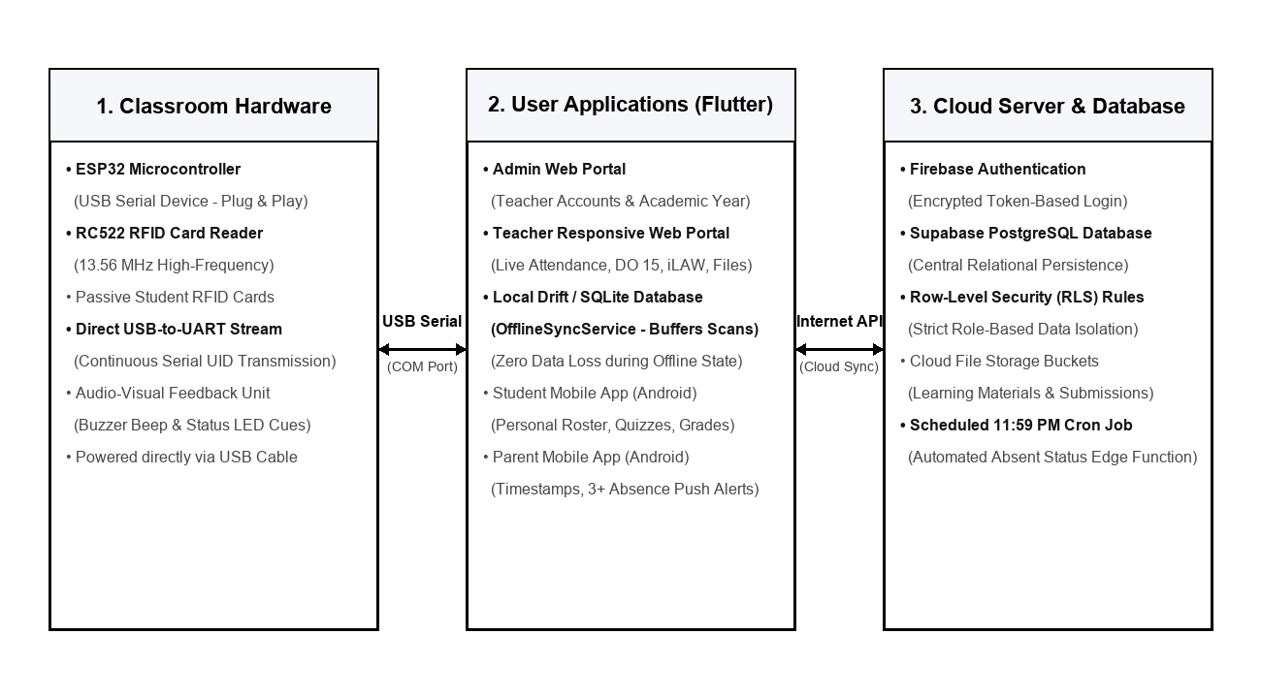
Figure 2 shows the hardware, application, and cloud layers of CLASSREALM, highlighting the USB Serial connection between the ESP32 scanner and the Flutter application, the local Drift / SQLite offline sync engine, and the secure Supabase / Firebase cloud connections.

Figure 3
Context Diagram (Level 0 DFD) of CLASSREALM
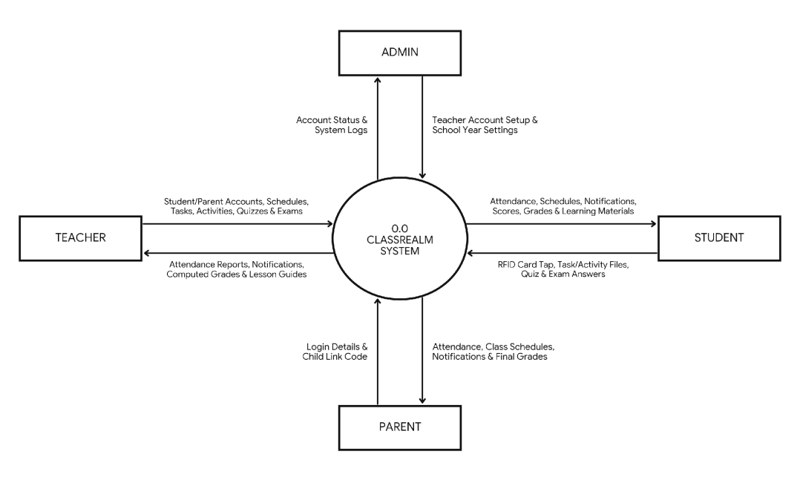
Figure 3 illustrates the Context Diagram (Level 0 DFD) of CLASSREALM with the central 0.0 CLASSREALM SYSTEM and the four user entities: ADMIN, TEACHER, STUDENT, and PARENT.

Table 7
Database Schema and Data Dictionary of CLASSREALM
TABLE NAME | PRIMARY & FOREIGN KEYS | MAIN FIELDS & DATA TYPES | PURPOSE & ACCESS RULE (RLS)
users | PK: id (UUID) | email, full_name, role (admin/teacher/student/parent), created_at | Stores login profiles across all 4 roles.
academic_years | PK: id | FK: created_by -> users.id | school_year (VARCHAR), is_active (BOOLEAN) | Admin sets active school year (2026-2027).
sections | PK: id | FK: teacher_id -> users.id | section_name, grade_level (INT), subject_name | Teacher manages own Grade 11 sections.
students | PK: id | FK: section_id, user_id | lrn (CHAR(12)), rfid_uid, first_name, last_name | Maps 12-digit LRN to student RFID card UID.
parent_student | PK: id | FK: parent_id, student_id | link_code (VARCHAR), verified (BOOLEAN) | Links parent account strictly to own child.
schedules | PK: id | FK: section_id -> sections.id | day_of_week, start_time, late_cutoff, end_time | Defines class hours and Present/Late cutoffs.
attendance_logs | PK: id | FK: student_id, section_id | scan_time, status, method (RFID/Manual) | Stores daily RFID or manual attendance marks.
activities | PK: id | FK: section_id -> sections.id | title, category (Task/Activity), due_date, max_score | Stores performance tasks, activities, and due dates.
submissions | PK: id | FK: activity_id, student_id | file_url, submitted_at, score (NUMERIC) | Stores student task/activity file uploads and scores.
quizzes | PK: id | FK: section_id -> sections.id | title, category (Quiz/Exam), total_items, is_open | Stores objective quizzes, exams, and answer keys.
quiz_responses | PK: id | FK: quiz_id, student_id | answers_json (JSONB), raw_score, tab_switches | Stores student quiz/exam answers and scores.
grades | PK: id | FK: student_id, section_id | quarter, ww_score, pt_score, qa_score, initial_grade, final_grade | Stores computed DepEd DO 15 quarterly grades.
lesson_plans | PK: id | FK: teacher_id -> users.id | topic, competencies, guide_content, file_url | Stores generated Grade 11 Math lesson guides.
learning_materials | PK: id | FK: section_id -> sections.id | title, file_url, file_type, uploaded_at | Stores downloadable handouts for enrolled students.
notifications | PK: id | FK: user_id -> users.id | title, message, is_read (BOOLEAN), created_at | Stores push alerts for Teacher, Student, and Parent.
Table 7 summarizes the 15 PostgreSQL database tables. Full Level 1 DFDs, ERD, and UML diagrams from earlier activities are reserved for the final compilation task.

3.9 Development and Testing
The system was built using Flutter 3.x (Dart), Drift / SQLite for client-side offline caching, Supabase PostgreSQL, Firebase Auth, Arduino C++ for the ESP32 USB Serial scanner, and Git/GitHub. Unit, integration, and system test cases (TC-01 to TC-11) were executed in the lab during Week 10 (October 17–24, 2026), while live classroom acceptance testing (TC-12) is scheduled for November 3–6, 2026.

Table 8
System Test Cases, Thresholds, and Verification Status
TEST ID & REQ | SCENARIO & INPUT STEPS | EXPECTED OUTPUT & PASS THRESHOLD | ACTUAL RESULT (IF RUN) | STATUS & DEFECT REF
TC-01 (FR-01, NFR-01) | RFID Tap Speed: Tap 50 registered RFID cards on ESP32 USB Serial scanner while online. | LED blinks, buzzer beeps, UID received via USB serial, tap saves in < 2.0s. | Avg scan time 0.22s (max 0.45s). | Pass (Oct 20, 2026)
TC-02 (FR-01, NFR-02) | Drift Offline Buffering: Disconnect internet connection, tap 50 cards (queued in local Drift/SQLite), reconnect internet. | 50 taps preserved in local Drift database and batch-synced to Supabase in < 5.0s. | 50/50 buffered in Drift; synced in 2.3s. | Pass (Oct 20; Fixed BUG-01)
TC-03 (FR-02) | Duplicate Tap Block: Tap same student card 3 times in one class. | First tap kept; repeat taps blocked. | 100% repeat taps blocked. | Pass (Oct 21, 2026)
TC-04 (FR-02) | Schedule, Manual List & 11:59 PM Auto-Absent Job. | Schedule shown; Excused kept; 4 unscanned marked Absent. | Schedule synced; 4 marked Absent. | Pass (Oct 21, 2026)
TC-05 (FR-03) | Task & Activity Upload: Upload PDF before and after due time. | Deadline checked ±1.0s; push alert < 3.0s. | Time within 0.3s; alert in 1.6s. | Pass (Oct 22, 2026)
TC-06 (FR-04) | Quiz & Exam Auto-Check: Submit 20-item quiz/exam and view analysis. | Scored in < 1.0s; item analysis in < 2.0s. | Scored in 0.35s; analysis in 1.1s. | Pass (Oct 22, 2026)
TC-07 (FR-05) | DepEd DO 15 Grade Math: Compute grades for 65 sample students. | Weights = 100%; 2-decimal round; 100% Excel match. | 100% exact match with DepEd Excel. | Pass (Oct 23; Fixed BUG-02)
TC-08 (FR-06) | Lesson Plan Guide: Enter Math topic and export to Word/PDF. | Editable lesson outline generated in < 5.0s. | Generated in 3.1s; exported cleanly. | Pass (Oct 23, 2026)
TC-09 (FR-07) | Learning Materials: Upload PDF handout and download on Student App. | 100% download success for enrolled students. | Downloaded with 0 errors. | Pass (Oct 23, 2026)
TC-10 (FR-08, NFR-03) | Student/Parent Accounts, 3+ Absence Alert & RLS Privacy. | Accounts login; alert < 3.0s; RLS blocks others. | Alert in 1.5s; RLS blocked others. | Pass (Oct 24, 2026)
TC-11 (FR-09, NFR-03) | Admin Restriction: Attempt to open class/grade pages as Admin. | 0% admin access to class or grade data. | 100% blocked from class/grade data. | Pass (Oct 24, 2026)
TC-12 (Obj 10) | Live Classroom Pilot & ISO Survey (Teacher, 65 Students, 10 Parents, 5 IT). | Overall weighted mean >= 4.20 across 9 ISO dimensions. | Scheduled for Nov 3–6, 2026 deployment. | Not yet run (Planned Nov 3–6)
Table 8 details all 12 test cases, including the two minor bugs (BUG-01 and BUG-02) fixed during Week 10 testing.

3.10 Description of Prototype
As of October 31, 2026, CLASSREALM is a working functional prototype (Build v1.0-RC1) across web browsers (Chrome/Edge), Android phones, and the ESP32 USB Serial RFID scanner: (1) Admin Web Portal (Working Build) for teacher account creation, school year setup, and system audit logs; (2) Teacher Web Portal (Working Build) with integrated USB Serial listener and local Drift / SQLite offline sync engine (OfflineSyncService), student and parent account creation, class and schedule setup, live RFID and manual attendance roster, performance task, activity, quiz, and exam management, DepEd DO 15 grade sheet and exporter, lesson plan guide generator, learning materials folder, and notification feature; (3) Student Mobile App (Working Build) for personal attendance view, class schedules, performance task and activity file upload, online quiz and exam answering, quarterly grade view, handout downloads, and notifications; and (4) Parent Mobile App (Working Build) for child link verification, daily attendance logs, class schedules, task/activity/quiz/exam due dates, quarterly grades, and notifications (including 3+ absence alerts).

Table 9
Prototype Screen and Module Inventory of CLASSREALM
SCREEN / MODULE ID | USER | LINKED FR | INPUT & OUTPUT | STATUS
SCR-01: Admin Account & School Year | ADMIN | FR-09 | In: Teacher email, SY. Out: Teacher account & active SY. | Working Build
SCR-02: Student/Parent Account & Schedule | TEACHER | FR-02, FR-08 | In: Student/Parent info, schedule. Out: Accounts & timetable. | Working Build
SCR-03: Live RFID & Manual Attendance | TEACHER | FR-01, FR-02 | In: USB Serial RFID taps / manual clicks. Out: Attendance sheet & Drift sync status. | Working Build
SCR-04: Performance Task & Activity Tab | TEACHER, STUDENT | FR-03 | In: Task details / file upload. Out: Submission logs & scores. | Working Build
SCR-05: Online Quiz, Exam & Analysis Tab | TEACHER, STUDENT | FR-04 | In: Quiz/Exam items & answers. Out: Auto-score & analysis. | Working Build
SCR-06: DepEd DO 15 Gradebook & Export | TEACHER | FR-05 | In: WW, PT, QA scores. Out: Transmutated grade & Excel/PDF. | Working Build
SCR-07: Lesson Plan Guide Generator | TEACHER | FR-06 | In: Math topic & competencies. Out: Editable DOCX/PDF guide. | Working Build
SCR-08: Learning Materials Folder | TEACHER, STUDENT | FR-07 | In: PDF/PPTX handouts. Out: Downloadable class files. | Working Build
SCR-09: Student App (Schedule, Tasks, Alerts) | STUDENT | FR-01–04, 07, 08 | In: Student login. Out: Attendance, schedule, tasks/quizzes, grades, alerts. | Working Build
SCR-10: Parent App (Schedule, Due Dates, Alerts) | PARENT | FR-02, FR-03, FR-08 | In: Parent login & code. Out: Child attendance, schedule, alerts, grades. | Working Build
HW-01: ESP32 RC522 RFID Scanner Unit | STUDENT, TEACHER | FR-01, NFR-01/02 | In: 13.56 MHz RFID tap. Out: USB Serial UID stream to Flutter app, LED/buzzer cues. | Working Hardware
Table 9 lists the prototype screens and hardware module, their users, linked FRs, inputs/outputs, and actual status.

3.11 Implementation Plan
The implementation plan covers preparation (Oct 25–Nov 2, 2026) and live classroom deployment, training, pilot use, and turnover (Nov 3–7, 2026) at Eduardo Barreto Sr. High School. If internet connectivity drops, the Flutter application automatically queues attendance scans in its local Drift / SQLite database (OfflineSyncService); if a student forgets their card or power fails, the teacher uses the permanent manual attendance list on her laptop or phone.
Table 10
Implementation and Deployment Plan Schedule of CLASSREALM
TASK / ACTIVITY | OWNER | DATES | PREREQUISITES & RESOURCES | OUTPUT / ACCEPTANCE EVIDENCE | STATUS
1. Cloud DB & Account Setup | Backend Lead | Oct 25–28, 2026 | Supabase/Firebase project; class rosters. | Configured tables, RLS, and teacher account. | Completed
2. RFID Card Encoding | Hardware Lead | Oct 29–Nov 2, 2026 | ESP32 scanner, 65 RFID cards, LRN list. | 65 encoded RFID cards matched to LRNs. | In Progress
3. Scanner & App Installation | Researchers & Client | Nov 3, 2026 | School permit, USB serial scanner mount, Android APK & Desktop build. | Scanner connected via USB; apps installed. | Planned
4. User Orientation & Training | Researchers | Nov 3, 2026 | User Guide, Teacher laptop, user phones. | Trained teacher, 65 students, and 10 parents. | Planned
5. Live Classroom Pilot Run | Teacher, Students, Parents | Nov 3–6, 2026 | Installed scanner, RFID cards, schedules. | Live attendance, quiz/exam, grade & alert logs. | Planned
6. ISO Survey & System Turnover | Researchers, Evaluators | Nov 6–7, 2026 | Survey forms, manual, turnover checklist. | Completed surveys (n = 81) & signed turnover. | Planned
Table 10 outlines the implementation tasks, owners, dates, resources, and status for the November 3–6, 2026 deployment.

3.12 References Cited in Chapter III
Department of Education. (2026). DepEd Order No. 015, s. 2026: Policy guidelines on the implementation of the Strengthened Senior High School (SSHS) curriculum and assessment. Department of Education.
International Organization for Standardization. (2023). Systems and software engineering — Systems and software Quality Requirements and Evaluation (SQuaRE) — Product quality model (ISO/IEC 25010:2023). https://www.iso.org/standard/78176.html
NIST/SEMATECH. (n.d.). e-Handbook of statistical methods. National Institute of Standards and Technology.
Https://www.itl.nist.gov/div898/handbook/
Pressman, R. S., & Maxim, B. R. (2020). Software engineering: A practitioner's approach (9th ed.). McGraw-Hill Education.
Republic Act No. 10173. (2012). An Act Protecting Individual Personal Information in Information and Communications Systems in the Government and the Private Sector, Creating for this Purpose a National Privacy Commission, and for Other Purposes (Data Privacy Act of 2012).
Schwaber, K., & Sutherland, J. (2020). The Scrum Guide: The definitive guide to Scrum: The rules of the game. Scrum.org.
Https://scrumguides.org/scrum-guide.html
Sommerville, I. (2021). Software engineering (10th ed.). Pearson Education.
Tejada, J. J., & Punzalan, J. R. B. (2012). On the misuse of Slovin's formula. The Philippine Statistician, 61(1), 129–136. https://www.psai.ph/docs/publications/tps/tps_2012_61_1_9.pdf

