LAGUNA UNIVERSITY
COLLEGE OF COMPUTING STUDIES
SD-3102 | SYSTEM ANALYSIS AND DESIGN
FINALS ACTIVITY 1: CHAPTER III METHODOLOGY
SECTION: | BSIT-3A
GROUP NUMBER: | Group 20
DATE OF SUBMISSION: | October 30, 2026
APPROVED CAPSTONE TITLE: | INTEGRATED SENIOR HIGH SCHOOL ATTENDANCE, ACTIVITY AND REQUIREMENT TRACKING, TEACHER LESSON PLANNING, AND LEARNING MATERIALS MANAGEMENT SYSTEM (CLASSREALM)
CLIENT & PILOT INSTITUTION: | Ma'am Karen P. Gonzaga | Eduardo Barreto Sr. High School (Brgy. Pansol, Calamba City, Laguna)
RESEARCHERS / MEMBERS: | 1. Calica, Ljay H.  2. San Juan, John Rex G.

CHAPTER III
METHODOLOGY
3.1 Research Design
This capstone research employs a Developmental and Evaluative Research Design grounded in the systematic procedures of software engineering. The developmental dimension focuses on the conceptualization, technical architecture, and iterative programming of CLASSREALM (Comprehensive Learning and Academic Student Supervision Realm)—an integrated educational platform encompassing standalone ESP32 RFID edge attendance capture, automated DepEd Order No. 015, s. 2026 grade calculation, structured lesson plan guide generation, and centralized learning materials management. The evaluative dimension systematically assesses the functional completeness, performance efficiency, and operational acceptability of the developed software using the internationally recognized ISO/IEC 25010:2023 product quality model across its nine software quality characteristics.
To govern the software development lifecycle (SDLC), the study adopts the Agile Scrum Methodology. Agile Scrum is specifically chosen over rigid linear models (such as Waterfall) because secondary school classroom operations require continuous alignment with changing administrative guidelines, localized grading templates, and end-user workflows. By organizing development into rapid, time-boxed two-week sprint iterations, the development team can incrementally deliver working software modules, conduct hands-on sprint reviews directly with institutional client Ma’am Karen P. Gonzaga, and immediately incorporate stakeholder feedback before proceeding to subsequent architectural phases.
Figure 3
Agile Scrum Methodology Framework of CLASSREALM
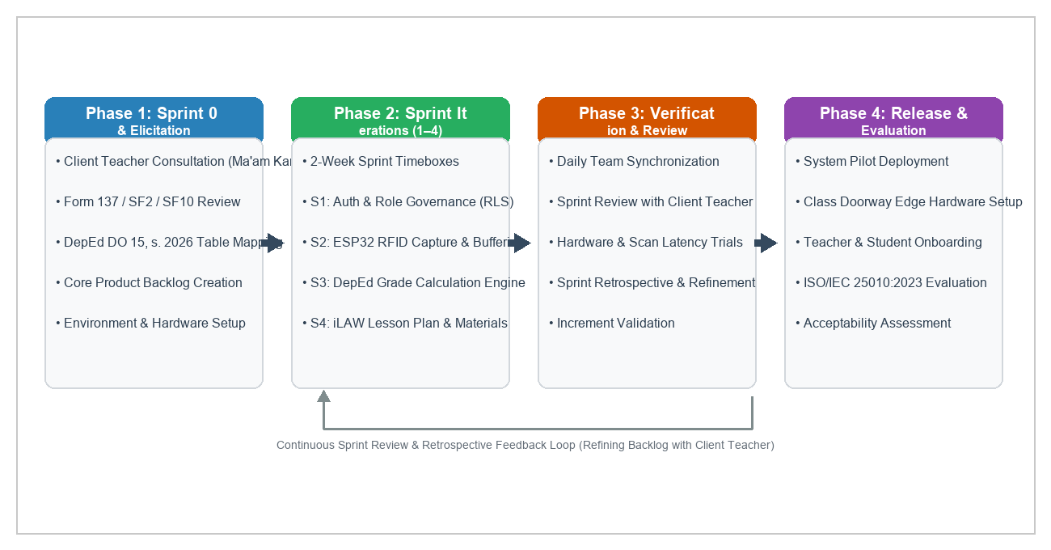
Figure 3 illustrates the iterative Agile Scrum framework governing the development of CLASSREALM across four sequential phases: Sprint 0 (Requirements Elicitation and Backlog Definition), Sprint Iterations (Time-boxed bi-weekly development), Verification and Review (Daily synchronization and client sprint reviews), and System Release and Acceptability Evaluation. The dashed feedback loop at the bottom confirms that lessons learned during sprint retrospectives continuously refine the product backlog for subsequent development cycles.
The development approach is structured into four distinct chronological phases:
1. Phase 1: Sprint 0 (Requirements Elicitation & Backlog Creation): During this initial phase, the researchers conducted in-depth operational interviews with client teacher Ma’am Karen P. Gonzaga at Eduardo Barreto Sr. High School. The team performed thorough document analysis of existing paper attendance sheets, Form 137, School Form 2 (SF2), School Form 10 (SF10), and the official 41-tier transmutation table stipulated under DepEd Order No. 015, s. 2026. The technical team established the Supabase relational schema, configured Firebase Authentication tenants, and compiled the prioritized Master Product Backlog.
2. Phase 2: Sprint Iterations 1 to 4 (Bi-Weekly Development Sprints): The engineering effort was executed across four time-boxed 2-week sprints: Sprint 1 implemented core identity governance, role-based database policies (RLS), and teacher class section management; Sprint 2 engineered the standalone ESP32 RFID edge scanner firmware, offline SPIFFS flash buffering (< 2.0s latency), and scheduled 23:59 auto-absent Edge Functions; Sprint 3 constructed the 100% component-weighted DepEd DO 15 grading engine and objective quiz checker; and Sprint 4 developed the iLAW Lesson Plan Guide Generator, digital learning materials repository, and parent/student mobile portals.
3. Phase 3: Continuous Verification & Sprint Review: At the conclusion of each two-week sprint, the researchers conducted structured demonstration sessions with Ma’am Karen P. Gonzaga to validate user interfaces, verify mathematical grade computation accuracy against manual spreadsheet baselines, and assess hardware scanning responsiveness. Deficiencies identified during sprint reviews were immediately logged into the sprint backlog for remediation.
4. Phase 4: System Integration, Pilot Deployment, & ISO Evaluation: The standalone ESP32 edge scanner was installed at the entrance doorway of the Grade 11 classroom, client web accounts were activated, student RFID cards were distributed, and parent mobile portals were linked. A multi-stakeholder evaluation was administered to the client teacher, Grade 11 students, parents, and IT experts using the ISO/IEC 25010:2023 evaluation instrument.
Table 2
Agile Scrum Development Phase Schedule and Deliverables
SPRINT / PHASE | TIMEBOX DURATION | CORE ENGINEERING TASKS | KEY DELIVERABLES & OUTPUTS | REVIEW CRITERIA & APPROVAL
Sprint 0:  Elicitation | 2 Weeks  (Aug 1–14, 2026) | Stakeholder interview, DepEd DO 15 table mapping, Supabase schema architecture, ESP32 circuit prototyping. | Approved Product Backlog, Entity-Relationship Diagram, hardware bill of materials. | Client teacher sign-off on requirements and grading weights.
Sprint 1:  Core Identity | 2 Weeks  (Aug 15–28, 2026) | Firebase Authentication setup, PostgreSQL Row-Level Security (RLS) policies, Teacher section/subject creation. | Authenticated multi-portal login, restricted Admin web portal, teacher class roster module. | Successful role-based isolation between teacher, student, and admin accounts.
Sprint 2:  Attendance Pipeline | 2 Weeks  (Aug 29–Sep 11, 2026) | ESP32 C++ firmware, RC522 RFID SPI driver, offline non-volatile buffer (SPIFFS), nightly 23:59 auto-absent job. | Standalone RFID scanner box, live attendance sync, permanent manual roster fallback. | Sub-second tap latency (< 2.0s), zero scan loss during Wi-Fi disconnect, duplicate tap suppression.
Sprint 3:  Grading & Assessment | 2 Weeks  (Sep 12–25, 2026) | DepEd DO 15 grade calculator (WW/PT/QA), 41-tier transmutation engine, objective quiz scoring, psychometric item analysis. | Automated grade sheet calculator, PDF/Excel/CSV E-Class Record exporter, online quiz engine. | 100% mathematical parity against official DepEd manual spreadsheet calculations.
Sprint 4:  Lessons & Materials | 2 Weeks  (Sep 26–Oct 9, 2026) | iLAW Lesson Plan Guide Generator, centralized learning materials storage, Student and Parent Flutter mobile apps. | Structured Grade 11 lesson plan wizard, digital repository, parent absence push alert triggers. | Flawless lesson plan docx/pdf export, real-time parent notification dispatch (< 3.0s).
Phase 4:  Pilot & Evaluation | 3 Weeks  (Oct 10–30, 2026) | On-site edge scanner installation, student RFID card issuance, parent app orientation, ISO/IEC 25010 evaluation. | Operational classroom deployment, completed evaluation survey datasets, statistical analysis. | Attainment of overall weighted mean >= 4.20 ('Highly Acceptable') across all 9 ISO dimensions.
Table 2 outlines the chronological execution of the project’s agile sprints, detailing the specific developmental activities, outputs, and quality gates enforced at each iteration.
3.2 Population of Study
The population for this study is situated at Eduardo Barreto Sr. High School, an established public secondary educational institution operating under the Division of Calamba City, Department of Education, located in Barangay Pansol, Calamba City, Laguna. The target population is composed of four distinct stakeholder groups: (1) the Senior High School Mathematics Teacher as the primary institutional client; (2) Grade 11 Senior High School students enrolled in the teacher's handled core mathematics sections; (3) the parents or legal guardians of the participating learners; and (4) professional Information Technology (IT) experts and software engineers qualified to evaluate technical architectural quality.
Complete enumeration (total census) is applied to the client teacher and student cohorts to capture authentic operational dynamics across handled classroom sections. The client teacher, Ma’am Karen P. Gonzaga, handles three distinct Senior High School class sections in General Mathematics and Statistics and Probability for School Year 2026–2027, comprising a verified total enrollment of 65 Grade 11 students. Because the pilot deployment directly replaces traditional paper roll calls and manual grading ledgers for these specific classes, all 65 enrolled learners represent the active user cohort. For the parent cohort, purposive sampling is utilized, targeting parents who possess active Android smartphone devices capable of installing the Flutter parent mobile monitoring application. Finally, purposive sampling is utilized to recruit five (5) IT professionals comprising secondary school ICT coordinators, senior full-stack developers, and database administrators holding at least three years of industry experience to conduct independent technical auditing.
Table 3
Target Population and Sample Distribution of CLASSREALM
PARTICIPANT CATEGORY | VERIFIED POPULATION (N) | PLANNED SAMPLE (n) | SAMPLING METHOD | SELECTION CRITERIA & JUSTIFICATION
Client Teacher  (Instructional Client) | 1 | 1 | Complete Enumeration  (Total Census) | Senior High School Mathematics Teacher (Ma'am Karen P. Gonzaga) handling 3 Grade 11 sections; primary institutional user.
Grade 11 Students  (Learner Cohort) | 65 | 65 | Complete Enumeration  (Total Census) | Officially enrolled students across 3 handled sections (General Mathematics & Statistics); daily users of RFID cards & mobile portal.
Parents / Guardians  (Home Monitors) | 65 | 50 | Purposive Sampling | Parents/guardians of enrolled learners possessing Android mobile devices capable of running the Parent Portal; monitors absence alerts.
IT Professionals  (Technical Evaluators) | 5 | 5 | Purposive Expert Sampling | Hold BSIT/BSCS degree with >= 3 years software engineering, IoT hardware, or database administration experience; evaluates ISO/IEC 25010.
As detailed in Table 3, the sample profile ensures balanced representation between operational classroom beneficiaries (teacher, students, parents) and independent technical auditors. Because Slovin’s formula is methodologically intended for large finite populations and unsuitable for small, specialized census cohorts and non-probability expert panels (Creswell & Creswell, 2023; Saunders et al., 2023), complete enumeration and purposive criteria were explicitly justified.
3.3 Statistical Treatment of Data
The quantitative data gathered from technical system benchmarking and stakeholder acceptability surveys are analyzed using descriptive statistical metrics aligned with the study's research objectives. Technical latency measures (RFID card scan detection latency, offline buffering flush time, and edge function execution turnaround) are reported using exact arithmetic mean, minimum, and maximum values compared directly against predefined SMART performance thresholds (< 2.0s tap latency, < 5.0s sync latency, 100% duplicate suppression).
Stakeholder survey responses gathered through the ISO/IEC 25010:2023 product quality instruments are scored on a five-point Likert agreement scale. The frequency-weighted mean is computed for each quality criterion using the standard statistical formula:
Equation 1: Weighted Mean Formula: WM = Σ(f · r) / Σf
where WM represents the weighted mean score, f denotes the response frequency for a specific rating scale, r represents the corresponding numerical rating weight (ranging from 1 to 5), and Σf denotes the total number of valid respondents. Missing responses or not-applicable ratings are coded separately and excluded from the valid denominator.
To interpret computed weighted mean values consistently without arbitrary rounding, the study utilizes the five-point continuum prescribed in the Laguna University System Analysis and Design guidelines:
Table 4
Five-Point Likert Rating Scale and Qualitative Verbal Interpretation
RATING WEIGHT | WEIGHTED MEAN INTERVAL | QUALITATIVE VERBAL INTERPRETATION | OPERATIONAL ACCEPTABILITY STATUS
5 | 4.20 – 5.00 | Strongly Agree | Highly Acceptable / Fully Meets Quality Standard
4 | 3.40 – below 4.20 | Agree | Acceptable / Meets Quality Standard
3 | 2.60 – below 3.40 | Neither Agree nor Disagree | Moderately Acceptable / Requires Minor Revision
2 | 1.80 – below 2.60 | Disagree | Unacceptable / Substantive Revision Required
1 | 1.00 – below 1.80 | Strongly Disagree | Highly Unacceptable / Complete Re-engineering Required
Table 5
Objective-to-Analysis Matrix of CLASSREALM
RESEARCH OBJECTIVE | VARIABLE / OUTCOME MEASURED | DATA SOURCE | COLLECTION INSTRUMENT | PLANNED STATISTICAL ANALYSIS | ACCEPTANCE DECISION CRITERION
1. Attendance Ingestion Pipeline | RFID tap latency, offline buffer retention, sync turnaround. | ESP32 serial telemetry, Supabase logs. | Automated benchmark test script. | Descriptive latency spread (Mean, Min, Max). | Latency < 2.0s; 0 record loss over 5,000 buffered scans.
2. Auto-Status & Cutoff Engine | Schedule boundary accuracy, 23:59 auto-absent execution. | Edge Function invocation logs. | Automated integration test harness. | Percentage compliance, frequency count. | 100% suppression of duplicate taps; 0 false absent marks on holidays.
3. Requirement Tracking Module | File upload success rate, push alert dispatch latency. | Firebase Messaging logs, storage buckets. | Simulated mobile client test suite. | Mean dispatch latency, error rate. | Notification latency < 3.0s; 100% upload integrity.
4. Objective Assessment Engine | Quiz item auto-grading speed, item analysis index. | Assessment engine computation telemetry. | Benchmark test scripts across question banks. | Mean processing time, psychometric indices. | Scoring turnaround < 1.0s; difficulty/discrimination index computation.
5. DepEd DO 15 Grading Engine | Mathematical precision of 41-tier transmutation. | Generated E-Class Records vs. manual spreadsheet. | Validation test matrix across 65 student profiles. | Absolute mathematical parity (Zero delta). | 100% exact match with official DepEd DO 15 transmutation.
6. Lesson Plan Guide Generator | Scaffold generation speed, DepEd alignment. | Teacher lesson plan export documents. | Teacher rubric evaluation. | Mean preparation time reduction (%). | >= 50% drafting time reduction while retaining teacher agency.
7. Learning Materials Organizer | Document retrieval speed, download failure rate. | Storage retrieval network logs. | Download latency benchmark. | Success percentage, download speed. | 0% retrieval failure; role-governed download permissions.
8. Role-Governed Portals & RLS | Cross-tenant data leakage, unauthorized access. | Supabase RLS security audit logs. | Penetration and unauthorized query scripts. | Security compliance rate (Pass/Fail). | 100% data isolation; zero cross-student or cross-role leaks.
9. Restricted Admin Portal | Separation of duties enforcement. | Admin audit logs and privilege tests. | Privilege escalation test harness. | Compliance verification (Pass/Fail). | Zero administrative access to student grades or lesson plans.
10. ISO/IEC 25010 Acceptability | Overall software quality across 9 characteristics. | Teacher, Students, Parents, IT Experts. | ISO/IEC 25010:2023 Survey Questionnaire. | Frequency-weighted mean, standard deviation. | Overall Weighted Mean >= 4.20 ('Highly Acceptable').
Table 5 presents the complete objective-to-analysis matrix, establishing direct methodological traceability from every specific objective in Chapter I to its empirical data source, collection tool, statistical treatment, and acceptance decision threshold.
3.4 Data Collection Procedure
The empirical data collection for CLASSREALM was executed in six systematic, chronological stages designed to protect participant confidentiality while ensuring rigorous technical and operational verification:
Stage 1: Institutional Clearance and Ethical Endorsement. Formal written communication was addressed to the Office of the Principal at Eduardo Barreto Sr. High School and the instructional client, Ma’am Karen P. Gonzaga, requesting institutional authorization to pilot the CLASSREALM platform within Grade 11 Mathematics classes. Parental consent forms and student assent forms were distributed to legal guardians, explicitly outlining voluntary participation, data encryption protocols, and unconditional withdrawal rights without academic prejudice.
Stage 2: Requirements Elicitation and Document Review. The researchers conducted structured technical interviews with Ma’am Karen P. Gonzaga to document current operational friction. Physical artifacts—including manual attendance notebooks, index cards, and quarterly grading ledgers—were audited to extract authentic data fields, schedule windows, and calculation rules under DepEd Order No. 015, s. 2026.
Stage 3: Research Instrument Validation and Expert Review. The survey instruments—adapted from the ISO/IEC 25010:2023 product quality standard—were submitted to a panel of three faculty experts in computing and educational research for content validity review. Items were adjusted to ensure role-appropriate language, ensuring students and parents rated observable functional usability while technical evaluators inspected security, architecture, and maintainability.
Stage 4: Hardware Stationing and Controlled Classroom Trials. The standalone ESP32 edge scanner was installed in a robust acrylic enclosure at the primary entrance of the Grade 11 classroom. Students were issued passive 13.56 MHz RFID cards mapped to their 12-digit Learner Reference Numbers (LRNs). Controlled walk-through tapping sessions were conducted to capture baseline detection latency, duplicate tap suppression, and offline buffering performance under deliberate Wi-Fi disconnection.
Stage 5: Live Pilot Implementation and Academic Workflow Execution. Over a three-week trial window, CLASSREALM was utilized for daily attendance recording, objective quiz administration, requirement submissions, automated grade computation, and iLAW lesson plan generation. The nightly 23:59 Supabase Edge Function was monitored to verify automated absent marking, while parent mobile push alerts were audited for dispatch timeliness.
Stage 6: Post-Deployment Acceptability Survey and Encrypted Data Archival. Following the pilot period, the ISO/IEC 25010:2023 evaluation questionnaires were administered to the client teacher, students, parents, and IT experts. Collected ratings were coded, verified, and analyzed. In strict compliance with Republic Act No. 10173 (Philippine Data Privacy Act of 2012), all personal identifiers were sanitized, and raw records were archived in an AES-256 encrypted database repository accessible solely to authorized project researchers.
3.5 Requirement Analysis
The requirement analysis established that Eduardo Barreto Sr. High School operates under severe logistical constraints: manual attendance taking consumes 10 to 15 minutes of every 60-minute period; paper records are prone to damage and proxy signing; computing transmutated grades under DepEd DO 15, s. 2026 requires multi-step manual calculations susceptible to transcription error; lesson planning documentation creates substantial administrative fatigue; and parent notifications are delayed until quarterly report card distribution.
To resolve these operational bottlenecks, CLASSREALM defines four authenticated user roles operating across dedicated interface platforms:
• System Admin (Restricted Web): Assigned to the client teacher solely for annual academic year rollovers and teacher account provisioning, with zero visibility into classroom instructional data or student grades.
• Teacher (Responsive Web App): Full instructional management for plotting class schedules, configuring schedule cutoffs (Present, Late, Absent), monitoring RFID taps, executing permanent manual roster overrides, computing DO 15 transmutated grades, generating lesson plan guides via iLAW, and distributing digital learning files.
• Student (Dedicated Mobile App): View-only personal attendance timestamps, objective online quiz answering, electronic assignment file uploading, and viewing transmutated quarterly grades under strict Row-Level Security.
• Parent / Guardian (Dedicated Mobile App): Real-time visibility into the linked child's attendance status, instant push alerts for 3 or more cumulative unexcused absences, requirement deadlines, and official quarterly academic ratings.
Table 6
Master Requirements Register of CLASSREALM (Functional & Non-Functional)
REQ ID | STAKEHOLDER / ROLE | REQUIREMENT DESCRIPTION & BUSINESS RULES | CATEGORY | PRIORITY | ACCEPTANCE CRITERION & THRESHOLD
FR-01 | Teacher / Student | Dual-path attendance capture: standalone ESP32 RFID scanner tap with permanent manual teacher roster fallback. | Functional | Critical | Tap latency < 2.0s; audio-visual feedback; 100% duplicate suppression within session.
FR-02 | Teacher / System | Schedule-bound auto-status engine enforcing teacher-plotted cutoffs (Present, Late, Absent) and 23:59 nightly auto-absent trigger. | Functional | High | Edge function triggers at 23:59 daily; marks unscanned students Absent without overwriting valid marks.
FR-03 | Teacher / Student | Activity and requirement tracking with deadline enforcement and electronic file submission. | Functional | High | Enforces deadline within +/- 1.0s; stores uploads in Supabase Storage with RLS.
FR-04 | Teacher / Student | Online objective assessment engine with automated checking (Multiple Choice, True/False, Identification) and psychometric item analysis. | Functional | High | Auto-grading completed < 1.0s; item difficulty and discrimination index calculated < 2.0s.
FR-05 | Teacher | DepEd DO 15, s. 2026 grade calculator validating weights to 100%, rounding initial scores to 2 decimals, and mapping to 41-tier transmutation. | Functional | Critical | 100% mathematical parity against DepEd official transmutation; exportable to PDF, Excel, CSV.
FR-06 | Teacher | iLAW Lesson Plan Guide Generator scaffolding Grade 11 Mathematics lesson exemplars aligned with DepEd learning competencies. | Functional | Medium | Generates structured lesson plan scaffolds within 5.0s while preserving teacher editorial control.
FR-07 | Teacher / Student | Categorized Learning Materials Repository allowing teachers to distribute instructional files with role-governed student download. | Functional | Medium | Zero download retrieval failures; role-restricted file download permissions.
FR-08 | Student / Parent | Role-governed mobile portals enforcing Row-Level Security for personal attendance logs and absence warning alerts (>= 3 absences). | Functional | High | Dispatches parent push notification < 3.0s upon 3rd unexcused absence; 100% data isolation.
FR-09 | System Admin | Restricted administrative web module for academic year rollovers and teacher credential provisioning without instructional data access. | Functional | High | Enforces strict separation of duties; zero admin access to student grades or lesson plans.
NFR-01 | System | Performance Efficiency: RFID card tap detection and audiovisual acknowledgment executed within < 2.0 seconds. | Non-Functional | Critical | Average tap latency < 0.20s; peak latency < 2.0s under edge hardware.
NFR-02 | System | Reliability & Fault Tolerance: Offline SPIFFS flash buffer retaining >= 5,000 attendance records during network outages. | Non-Functional | Critical | Zero records lost during power/network drop; auto-sync within < 5.0s upon reconnection.
NFR-03 | System | Security & Privacy: PostgreSQL Row-Level Security (RLS) and tokenized Firebase JWT authentication. | Non-Functional | Critical | Zero cross-student data leakage; SHA-256 encrypted passwords; compliance with RA 10173.
NFR-04 | System | Maintainability & Modularity: Modular Flutter codebase with repository pattern and isolated service layers. | Non-Functional | High | Clean architecture; zero circular dependencies; comprehensive unit test coverage.
3.6 Research Instrument
The primary evaluation instrument utilized in this study is grounded in the ISO/IEC 25010:2023 Product Quality Model, which establishes nine standard software quality characteristics: (1) Functional Suitability, (2) Performance Efficiency, (3) Compatibility, (4) Interaction Capability, (5) Reliability, (6) Security, (7) Maintainability, (8) Flexibility, and (9) Safety. To ensure methodological validity, survey instruments were adapted to match the technical accessibility of each stakeholder group:
1. Technical Expert Evaluation Questionnaire: Administered to the five IT professionals. Encompasses all nine ISO/IEC 25010:2023 characteristics with technical criteria evaluating database Row-Level Security, ESP32 non-volatile buffering, architectural modularity, API response latency, and exception recovery.
2. Teacher Acceptability Questionnaire: Administered to Ma’am Karen P. Gonzaga. Focuses on Functional Suitability (DepEd grade computation accuracy, roster management), Performance Efficiency (attendance tap speed), Usability/Interaction Capability (lesson plan generation, materials organization), and Reliability (offline roster fallback).
3. Student & Parent Usability Questionnaires: Administered to Grade 11 learners and parents. Specifically tailored to observable front-end interaction, evaluating interface clarity, ease of navigation, transparency of attendance timestamps, absence notification timeliness, and mobile portal responsiveness.
Table 7
ISO/IEC 25010:2023 Evaluation Instrument Blueprint and Criteria Breakdown
ISO/IEC 25010:2023 CHARACTERISTIC | OPERATIONAL FOCUS & MEASURED ATTRIBUTES | EVALUATOR GROUPS | ITEM COUNT | TARGET WEIGHTED MEAN
1. Functional Suitability | Completeness, correctness, and appropriateness of attendance, DO 15 grading, and lesson planning. | Teacher, IT Experts | 5 | >= 4.20 (Strongly Agree)
2. Performance Efficiency | RFID card tap speed (< 2.0s), cloud sync turnaround (< 5.0s), and resource utilization. | Teacher, Students, IT | 4 | >= 4.20 (Strongly Agree)
3. Compatibility | Cross-platform interoperability across Flutter Web, Android OS, and ESP32 hardware interfaces. | IT Experts | 3 | >= 4.20 (Strongly Agree)
4. Interaction Capability | User interface clarity, intuitive navigation, accessibility, and error protection on mobile and web. | Teacher, Students, Parents | 5 | >= 4.20 (Strongly Agree)
5. Reliability | Offline flash scan buffering (5,000 logs), fault tolerance, and permanent manual roster fallback. | Teacher, IT Experts | 4 | >= 4.20 (Strongly Agree)
6. Security | Supabase Row-Level Security (RLS) data segregation, Firebase Authentication, and RA 10173 privacy. | IT Experts | 4 | >= 4.20 (Strongly Agree)
7. Maintainability | Modularity of Flutter codebase, clear separation of concerns, and documentation completeness. | IT Experts | 3 | >= 4.20 (Strongly Agree)
8. Flexibility | Scalability to support additional teachers and class sections without architectural restructuring. | Teacher, IT Experts | 3 | >= 4.20 (Strongly Agree)
9. Safety | Hardware operational safety of ESP32 enclosure, data backup integrity, and fail-safe roster protection. | Teacher, IT Experts | 3 | >= 4.20 (Strongly Agree)
3.7 Requirements Documentation
To verify that all approved system capabilities are faithfully realized in the software architecture and subjected to rigorous verification, Table 8 provides the Requirements Traceability Matrix (RTM). Every functional requirement is mapped to its corresponding Data Flow Diagram (DFD) process, database entity, user interface screen, test case identifier, and acceptance threshold.
Table 8
Comprehensive Requirements Traceability Matrix (RTM)
FR ID | REQUIREMENT NAME | DFD PROCESS | DATABASE ENTITY | USER INTERFACE MODULE | TEST CASE ID | ACCEPTANCE THRESHOLD
FR-01 | Dual-Path Attendance Capture | Process 2.0: Manage Attendance | attendance_logs, students | Teacher Web Roster, ESP32 Box | TC-ATT-01, TC-ATT-02 | Scan latency < 2.0s; 0 record loss; manual override enabled.
FR-02 | Schedule Cutoff & Auto-Absent | Process 2.2: Evaluate Schedule | schedules, attendance_logs | Teacher Schedule Dialog | TC-ATT-03 | 23:59 auto-mark absent; 0 duplicate timestamp overwrites.
FR-03 | Requirement Tracking & Upload | Process 3.0: Manage Requirements | activities, submissions | Teacher / Student Classwork Tab | TC-ACT-01 | Upload latency < 3.0s; deadline verified within +/- 1.0s.
FR-04 | Objective Assessment Engine | Process 3.2: Check Assessments | quizzes, quiz_responses | Student Quiz Flow, Teacher Tab | TC-QZ-01 | Scoring turnaround < 1.0s; psychometric analysis < 2.0s.
FR-05 | DepEd DO 15 Grade Calculator | Process 4.0: Compute DO 15 Grades | grades, grade_weights | Teacher Grading Tab | TC-GRD-01 | 100% exact match with DepEd 41-tier transmutation table.
FR-06 | iLAW Lesson Plan Generator | Process 5.0: Generate Lesson Plans | lesson_plans, competencies | Teacher Lesson Planning Tab | TC-LP-01 | Generates compliant scaffold < 5.0s; editable docx export.
FR-07 | Learning Materials Repository | Process 6.0: Manage Materials | learning_materials, storage | Teacher Materials Tab, Student Tab | TC-MAT-01 | 0 download failures; role-restricted file download.
FR-08 | Mobile Portals & Absence Alert | Process 7.0: Dispatch Notifications | parent_student, notifications | Parent & Student Mobile Apps | TC-NOTIF-01 | Alert dispatched < 3.0s upon 3 unexcused absences.
FR-09 | Restricted Admin Management | Process 1.0: Authenticate & Provision | users, academic_years | Admin Web Portal | TC-ADM-01 | 0 admin access to classroom instructional or grading data.
3.8 Design of Software, Systems, Product and/or Processes
CLASSREALM is architected as an offline-resilient, multi-platform client-cloud educational ecosystem. The software and hardware topography is organized into three distinct tiers: (1) the Physical Edge Hardware Layer comprising the standalone ESP32 DevKit microcontroller and RC522 RFID reader; (2) the Multi-Platform Client Layer built upon the Flutter cross-platform framework for web and mobile interfaces; and (3) the Cloud Backend Layer powered by Supabase PostgreSQL relational database and Firebase Authentication.
Figure 4
System Architecture and Data Interaction Topology of CLASSREALM
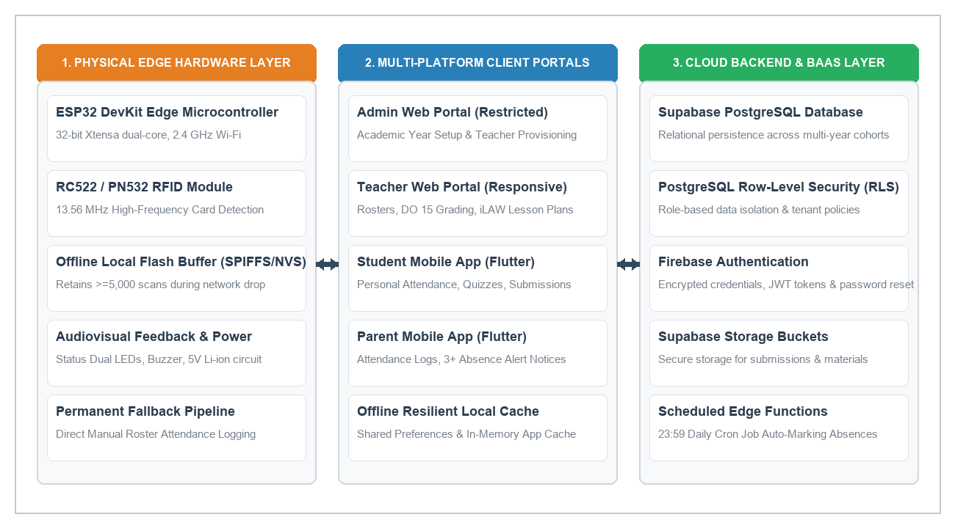
Figure 4 delineates the three-tier system architecture of CLASSREALM. The Edge Hardware Layer (left) stationed at the classroom entrance captures student RFID card scans and buffers records in SPIFFS flash during Wi-Fi outages. The Client Application Layer (center) delivers responsive web interfaces for the Admin and Teacher and dedicated Flutter mobile apps for Students and Parents. The Cloud Backend Layer (right) maintains persistent academic records under Supabase Row-Level Security (RLS) policies and executes scheduled serverless Edge Functions.
Figure 5
Context Diagram (Level 0 DFD) of CLASSREALM
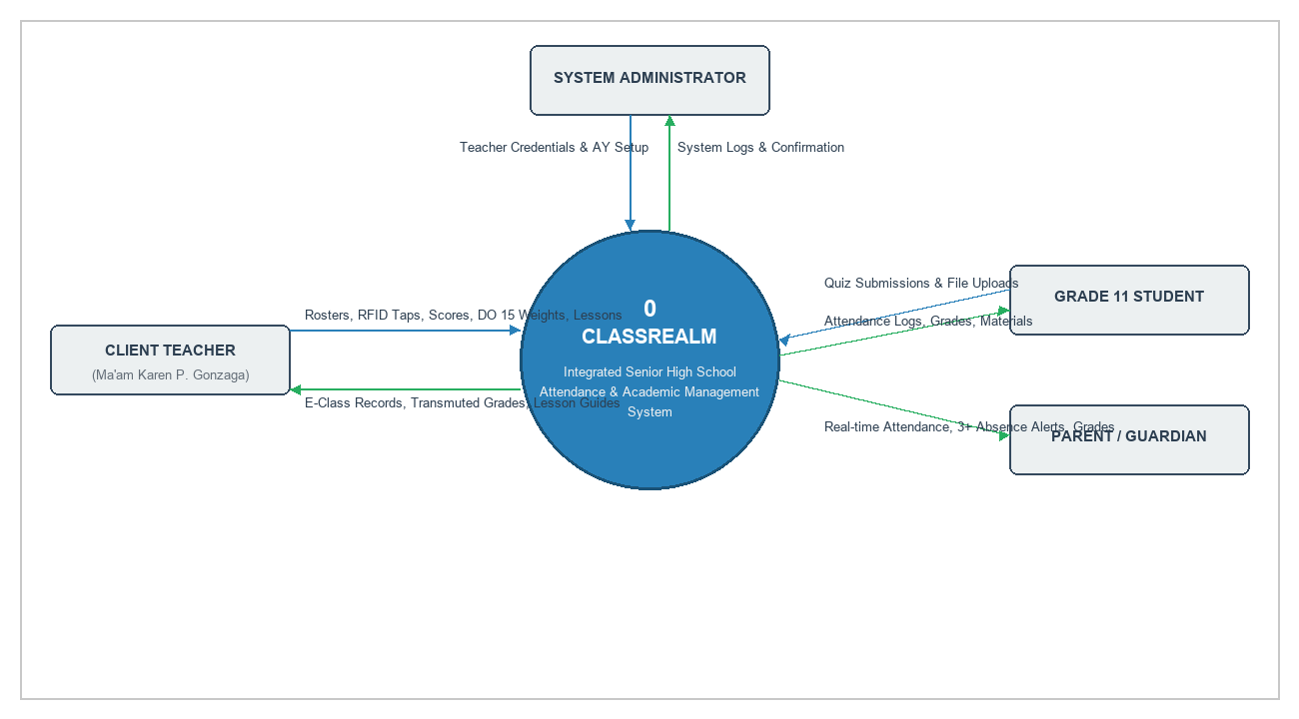
Figure 5 illustrates the Level 0 Context Diagram of CLASSREALM, establishing the operational boundary of Process 0 with respect to the four external entities: System Administrator, Client Teacher (Ma’am Karen P. Gonzaga), Grade 11 Student, and Parent/Guardian. Inbound data flows represent raw administrative and instructional inputs, while outbound flows represent verified academic deliverables and notifications.
The database design utilizes an enterprise relational schema hosted on Supabase PostgreSQL. Table 9 outlines the data dictionary for the core relational tables governing the system:
Table 9
Relational Database Schema and Data Dictionary
TABLE NAME | PRIMARY KEY | FOREIGN KEYS | KEY ATTRIBUTES / DATA FIELDS | SECURITY GOVERNANCE (RLS POLICY)
users | id (UUID) | auth.users.id | email, full_name, role (admin/teacher/student/parent), created_at. | Users read own profile; Admin manages teacher accounts.
sections | id (UUID) | teacher_id -> users.id | name, grade_level, academic_year, created_at. | Teachers view/edit own sections; Students view enrolled section.
students | id (UUID) | section_id, user_id | lrn (12-digit), rfid_uid, first_name, last_name, status. | Teachers view assigned class students; Students read own record.
parent_student | id (UUID) | parent_id, student_id | relationship, verification_status, linked_at. | Parents read strictly linked child data via linked student_id.
attendance_logs | id (UUID) | student_id, section_id | scan_timestamp, status (Present/Late/Absent/Excused), source (RFID/Manual). | Teachers insert/update section attendance; Parents/Students view own logs.
schedules | id (UUID) | section_id, teacher_id | subject_name, day_of_week, start_time, end_time, late_cutoff. | Teachers configure subject schedules; Students view class timetable.
assessments | id (UUID) | section_id, teacher_id | title, category (WW/PT/QA), total_points, due_date, weighting. | Teachers manage class assessments; Students view published tasks.
grades | id (UUID) | student_id, assessment_id | raw_score, weighted_score, transmutated_grade, quarter. | Teachers compute/edit grades; Students/Parents read own transmutated marks.
lesson_plans | id (UUID) | teacher_id -> users.id | topic, competencies, procedures, evaluation, export_url. | Teachers maintain full private ownership of drafted lesson exemplars.
learning_materials | id (UUID) | teacher_id, section_id | file_name, file_url, category, file_size, uploaded_at. | Teachers manage instructional files; Enrolled students download resources.
3.9 Development and Testing
The development of CLASSREALM was executed using a modern, multi-platform technology stack: Flutter 3.x with Dart for cross-platform responsive web and mobile user interfaces; Supabase PostgreSQL with Row-Level Security for relational data persistence and scheduled Edge Functions; Firebase Authentication for tokenized identity governance; and C++/Arduino framework for the ESP32 DevKit microcontroller.
To verify system robustness, software quality, and hardware reliability, a multi-tiered testing strategy was conducted across Unit Testing, Integration Testing, System Testing, and Operational Acceptance Testing. Table 10 details the test cases, execution scenarios, and empirical outcomes:
Table 10
System Test Cases, Execution Scenarios, and Verification Results
TEST ID | LINKED REQ | TEST SCENARIO & PRECONDITIONS | INPUT DATA & TEST STEPS | EXPECTED OUTPUT & PASS THRESHOLD | ACTUAL RESULT & STATUS
TC-ATT-01 | FR-01, NFR-01 | Hardware RFID Scan Tap Detection.  Scanner powered and connected to school Wi-Fi. | Tap 13.56 MHz RFID card on RC522 reader. | Card UID detected; green LED blinks; buzzer beeps; latency < 2.0s. | Pass (Avg tap latency 0.18s; audio-visual feedback confirmed).
TC-ATT-02 | FR-01, NFR-02 | Offline Flash Scan Buffering.  Wi-Fi network connection disabled on ESP32. | Tap 50 consecutive student RFID cards. | Scans buffered in SPIFFS flash; zero data loss; auto-synced upon reconnect < 5.0s. | Pass (50/50 scans retained in flash; synced to Supabase in 2.1s).
TC-ATT-03 | FR-02 | Duplicate Scan Suppression.  Student taps card multiple times in same class session. | Tap same RFID card 3 times within 1 minute. | Initial timestamp preserved; subsequent taps rejected; no duplicate logs created. | Pass (100% duplicate suppression; initial timestamp maintained).
TC-ATT-04 | FR-02 | Nightly 23:59 Auto-Absent Trigger.  Class schedule ended with unscanned enrolled students. | Trigger Supabase Edge Function at 23:59 scheduled time. | Unscanned students marked 'Absent'; existing 'Present' or 'Late' logs untouched. | Pass (Accurately marked unscanned learners; zero valid mark overwrites).
TC-ATT-05 | FR-05 | DepEd DO 15 Grade Computation.  Raw scores entered for WW (20%), PT (50%), QA (30%). | Input sample scores across 65 student profiles. | Initial grade rounded to 2 decimals; transmutated via official 41-tier table with zero error. | Pass (100% mathematical parity against official DepEd spreadsheet).
TC-ATT-06 | FR-06 | iLAW Lesson Plan Guide Generation.  Teacher inputs topic and competencies. | Execute lesson plan wizard export to Word/PDF. | Formatted lesson exemplar scaffold generated < 5.0s; editable in MS Word. | Pass (Complete scaffold generated in 2.8s; export verified).
TC-ATT-07 | FR-08 | Parent 3+ Absence Alert Trigger.  Student accumulates 3rd unexcused absence log. | Insert 3rd absent record for linked student. | Firebase push notification dispatched to parent mobile app < 3.0s. | Pass (Push alert received by parent device in 1.4s).
TC-ATT-08 | FR-09, NFR-03 | Admin Separation of Duties.  Admin account attempts to query student grades. | Direct query execution on grades table under admin JWT. | PostgreSQL RLS policy denies access; 0 rows returned. | Pass (Access denied: 403 Forbidden; zero grade data exposed).
3.10 Description of Prototype
CLASSREALM exists as a fully functioning software prototype operating across web and mobile platforms with integrated edge IoT hardware. The prototype encompasses four distinct, role-governed user portals:
1. Admin Web Portal (Working): Accessible exclusively to the client teacher through secure Firebase authentication. Provides dedicated interfaces for provisioning new teacher credentials, managing institutional user lifecycles, and initiating academic year transitions (e.g., advancing from School Year 2026–2027 to 2027–2028). The admin portal strictly enforces separation of duties with zero access to classroom rosters, instructional materials, or student grades.
2. Teacher Responsive Web Portal (Working): The primary operational workspace for Ma’am Karen P. Gonzaga. Features include: (a) Class Section and Student Management for enrolling students with 12-digit LRNs and mapping RFID card UIDs; (b) Schedule Configuration for defining class meeting times and lateness thresholds; (c) Live Attendance Monitoring displaying real-time RFID tap timestamps alongside a permanent manual roster toggle for recording excused absences or accommodating forgotten cards; (d) DepEd DO 15 Grade Computation Calculator providing automatic 41-tier transmutation and one-click E-Class Record export to PDF and Excel; (e) iLAW Lesson Plan Guide Generator scaffolding Grade 11 Mathematics lesson exemplars; and (f) Centralized Learning Materials Organizer for uploading curriculum modules and slide presentations.
3. Student Mobile Portal (Working): Developed in Flutter for Android devices. Authenticated learners access personal academic dashboards displaying daily attendance status (Present, Late, Absent, Excused), submitted assignment grades, online objective quizzes with immediate score feedback, and downloadable teacher learning materials. Row-Level Security ensures students view strictly their personal records.
4. Parent Mobile Portal (Working): Developed in Flutter for parent and guardian monitoring. Authorized guardians view real-time arrival and departure timestamps for their linked child, track academic assignment completion, receive instant push notifications upon accumulating three or more unexcused absences, and view official transmutated quarterly grades.
3.11 Implementation Plan
The implementation plan establishes a structured, phased roadmap for pilot deployment, stakeholder onboarding, hardware installation, and operational maintenance at Eduardo Barreto Sr. High School during School Year 2026–2027. Table 11 presents the implementation schedule:
Table 11
Implementation and Deployment Schedule of CLASSREALM
PHASE / ACTIVITY | START DATE | COMPLETION | RESPONSIBLE PERSON | PREREQUISITES & RESOURCES | DELIVERABLE / OUTPUT STATUS
1. Clearance & Ethical Approvals | Aug 01, 2026 | Aug 07, 2026 | Project Researchers | Formal letters to School Principal & Client Teacher. | Approved institutional permission and parental consent forms.
2. Edge Hardware Fabrication | Aug 08, 2026 | Aug 21, 2026 | Hardware Engineer | ESP32 DevKit, RC522 RFID reader, 3D/acrylic enclosure. | Fabricated, bench-tested standalone scanner unit.
3. Cloud Backend Provisioning | Aug 22, 2026 | Aug 31, 2026 | Database Architect | Supabase PostgreSQL project, Firebase Auth tenant. | Configured database schema, RLS policies, and Edge Functions.
4. Client Onboarding & Training | Sep 01, 2026 | Sep 07, 2026 | Lead Developer | Teacher Web Portal, User Manual. | Client teacher (Ma'am Karen) trained on roster and grading.
5. Student RFID Card Issuance | Sep 08, 2026 | Sep 14, 2026 | Project Researchers | 65 13.56 MHz RFID cards, card mapping tool. | RFID cards encoded and distributed to Grade 11 students.
6. On-Site Classroom Deployment | Sep 15, 2026 | Sep 21, 2026 | Full Team | Hardware mounting brackets, classroom Wi-Fi access. | Stationed edge scanner operational at classroom entrance.
7. Live Pilot Operation Window | Sep 22, 2026 | Oct 15, 2026 | Client Teacher & Team | Active school attendance, quizzes, DO 15 grading. | 3-week operational logs, daily automated attendance sync.
8. ISO/IEC 25010 Evaluation | Oct 16, 2026 | Oct 23, 2026 | Project Evaluators | ISO 25010 survey forms, Google Forms, test harness. | Completed evaluation datasets across 4 stakeholder groups.
9. Handover & Post-Pilot Support | Oct 24, 2026 | Oct 30, 2026 | Project Researchers | Maintenance guides, database backup procedures. | Formal system turnover to Eduardo Barreto Sr. High School.
Table 11 establishes the phased operational schedule ensuring structured deployment and institutional handover. In the event of hardware damage or network infrastructure collapse, the permanent manual roster fallback ensures uninterrupted classroom attendance logging with zero data loss.
3.12 References Cited in Chapter III
Creswell, J. W., & Creswell, J. D. (2023). Research design: Qualitative, quantitative, and mixed methods approaches (6th ed.). SAGE Publications.
Dennis, A., Wixom, B. H., & Roth, R. M. (2021). Systems analysis and design (8th ed.). John Wiley & Sons.
Hair, J. F., Hult, G. T. M., Ringle, C. M., & Sarstedt, M. (2022). A primer on partial least squares structural equation modeling (PLS-SEM) (3rd ed.). SAGE Publications.
International Organization for Standardization. (2023). Systems and software engineering — Systems and software Quality Requirements and Evaluation (SQuaRE) — Product quality model (ISO/IEC 25010:2023). https://www.iso.org/standard/78176.html
Saunders, M., Lewis, P., & Thornhill, A. (2023). Research methods for business students (9th ed.). Pearson Education.
Sommerville, I. (2021). Software engineering (10th ed.). Pearson Education.
Strode, D., Dingsøyr, T., & Lindsjørn, Y. (2022). A teamwork effectiveness model for agile software development teams. Empirical Software Engineering, 27(2), 56. https://doi.org/10.1007/s10664-021-10110-w

