RDC MARGIN
Top: 1.6
Left: 1.6
Bottom: 1.2
Right: 1.4
Note:
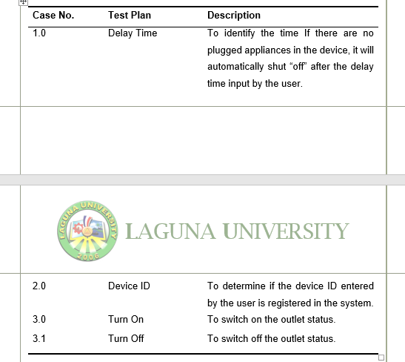
- Do not cut tables, unless it doesn’t fit the whole page.

- Do not cut Title and content.

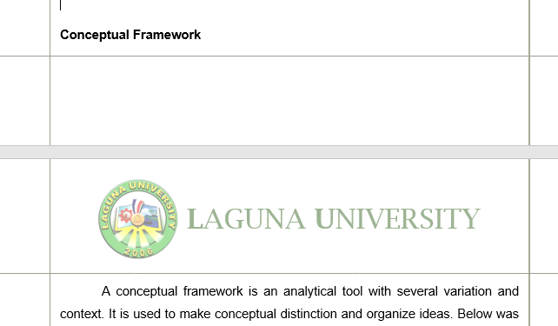

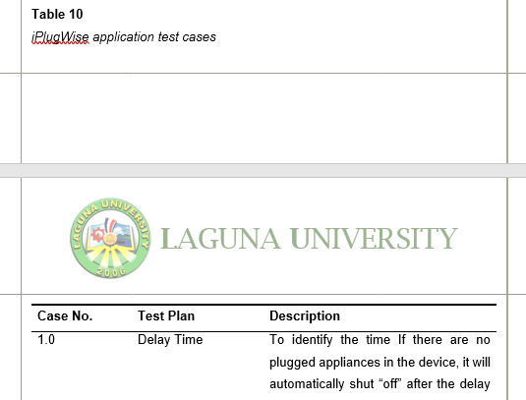

- Each figure and table should have a description.
- Each description must state what table # or figure # it describes.

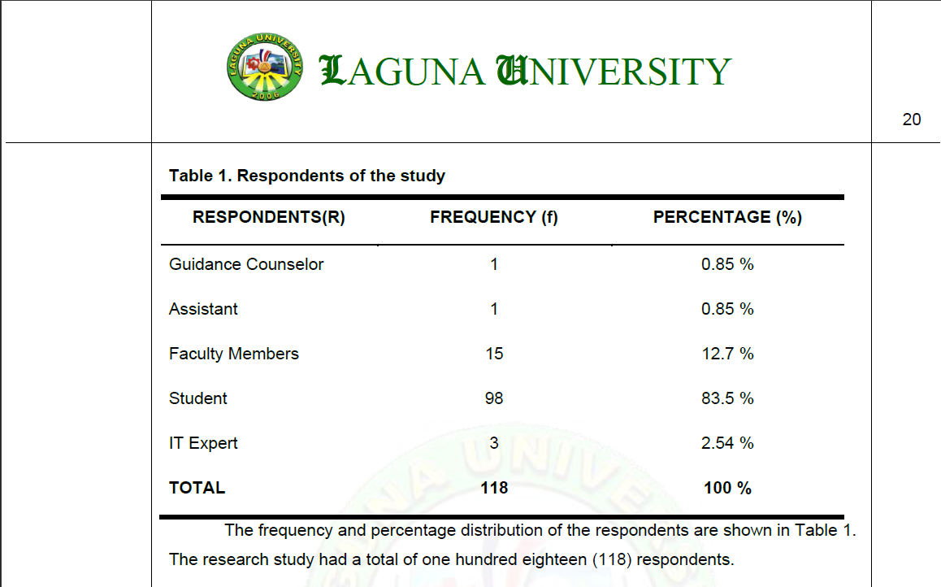


IT – Capstone Project
CS - Thesis

CAPSTONE

TITLE HERE

(5 spaces)

A Capstone Project to the Faculty of the
College of Computing Studies
Laguna University

(4 spaces)

In Partial Fulfillment of the Requirements for the
Degree of Bachelor of Science in
Information Technology

(4 spaces)

Lname, Fname, M.I.
Lname, Fname, M.I.
Lname, Fname, M.I.
Lname, Fname, M.I.
If Title (1 line only), 6 spaces between the Title and A Capstone/Thesis …

(6 spaces)

TABLE OF CONTENTS
1.15 spacing po ang table
FOR IT
Page
TITLE PAGE
TABLE OF CONTENTS
LIST OF TABLES
LIST OF FIGURES
LIST OF APPENDICES
CHAPTER I – INTRODUCTION
Project Context
Purpose and Description
Objectives of the Study
Scope and Limitations of the Research
Definition of Terms
CHAPTER II - REVIEW OF RELATED LITERATURE / SYSTEMS
Review of Related Literature / System
Synthesis
Theoretical Framework
Conceptual Framework
CHAPTER III - METHODOLOGY
Research Design
Population of Study
Statistical Treatment of Data
Data Collection Procedure
Requirement Analysis
Research Instrument
Requirements Documentation
Design of Software, Systems, Product and/or Processes
Development and Testing
Description of Prototype
Implementation Plan

TABLE OF CONTENTS
1.15 spacing po ang table for the OUTLINE
FOR COMPUTER SCIENCE
Page
TITLE PAGE
TABLE OF CONTENTS
LIST OF TABLES
LIST OF FIGURES
LIST OF APPENDICES
CHAPTER I – INTRODUCTION
Project Context
Research Problem and Objectives
Scope and Limitations of the Research
Definition of Terms

CHAPTER II - REVIEW OF RELATED LITERATURE / SYSTEMS
Review of Related Literature / System
Synthesis
Theoretical Framework
Conceptual Framework
CHAPTER III - METHODOLOGY
Research Design
Population of Study
Statistical Treatment of Data
Data Collection Procedure
Requirement Analysis
Research Instrument
Requirements Documentation
Design of Software, Systems, Product and/or Processes
Development and Testing
Description of Prototype
Implementation Plan
LIST OF TABLES
Note: Each List po ay bagong page

1.5 spacing po ditto sa mga List

Table | Description | Page
1 | Table Title
2 | Table Title
3 | Table Title
LIST OF FIGURES

Figure | Description | Page
1 | Figure Title
2 | Figure Title
3 | Figure Title
LIST OF APPENDICES
Table | Description | Page
A | Approval Letter of Technical Adviser
B  C  D  E | Approval Letter for Respondents  Approval Letter of Client  Deployment Letter  Software/System Evaluation
F | Proposal Template
G | Letter for Grammarian/Editor
H | Certificate of Experts
I | Curriculum Vitae of Experts
J | Curriculum Vitae of Student Researchers
K | Photo Documentary of System implementation
 | ( with Respondents and Experts)
L | LU:AA-FO-13 - Informed Consent Form
M  N | LU:AA-FO-127 - Approval Sheet  LU:AA-FO-135 - Student Research Software and User Manual Acknowledgement Form
CHAPTER I
Arial, 12pt.

INTRODUCTION

The absence of a strong online presence presents various challenges beyond mere visibility. Essentially, it hampers a company's ability to capitalize on the vast opportunities offered by the digital realm. Moreover, a lack of online presence can undermine a company's credibility and legitimacy in the eyes of consumers. In today's competitive landscape, a professionally designed website serves as a digital storefront, demonstrating trustworthiness and professionalism. Companies neglecting this aspect risk being perceived as outdated or unreliable, which weakens consumer confidence and inhibits their ability to attract and retain clients.
In between paragraph wala pong space
CONTENTS
Arial, 11pt.
The absence of a strong online presence presents various challenges beyond mere visibility. Essentially, it hampers a company's ability to capitalize on the vast opportunities offered by the digital realm. Moreover, a lack of online presence can undermine a company's credibility and legitimacy in the eyes of consumers. In today's competitive landscape, a professionally designed website serves as a digital storefront, demonstrating trustworthiness and professionalism. Companies neglecting this aspect risk being perceived as outdated or unreliable, which weakens consumer confidence and inhibits their ability to attract and retain clients.
Kapag bagong title, add po ng 1 space

Project Context
The absence of a strong online presence presents various challenges beyond mere visibility. Essentially, it hampers a company's ability to capitalize on the vast opportunities offered by the digital realm. Moreover, a lack of online presence can undermine a company's credibility and legitimacy in the eyes of consumers. In today's competitive landscape, a professionally designed website serves as a digital storefront, demonstrating trustworthiness and professionalism. Companies neglecting this aspect risk being perceived as outdated or unreliable, which weakens consumer confidence and inhibits their ability to attract and retain clients.
Proper indention
The absence of a strong online presence presents various challenges beyond mere visibility. Essentially, it hampers a company's ability to capitalize on the vast opportunities offered by the digital realm. Moreover, a lack of online presence can undermine a company's credibility and legitimacy in the eyes of consumers. In today's competitive landscape, a professionally designed website serves as a digital storefront, demonstrating trustworthiness and professionalism. Companies neglecting this aspect risk being perceived as outdated or unreliable, which weakens consumer confidence and inhibits their ability to attract and retain clients.

Table 1
Respondent of the study
UPPERCASE | UPPERCASE | UPPERCASE
Sample | Sample | Sample
Sample | Sample | Sample
Sample | Sample | Sample

Table description…

Theoretical Framework
The theoretical framework functioned as a guide for the researchers to methodically detect the rational problems and errors within the evolving system. The researchers used the input- process - storage - output diagram for the theoretical framework.

Figure 1
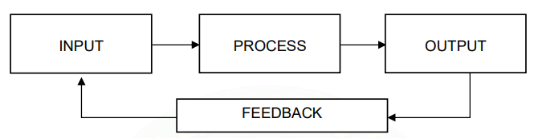
Input-Process-Output diagram (IPO)

Figure description…

