INTEGRATED SENIOR HIGH SCHOOL ATTENDANCE, ACTIVITY AND REQUIREMENT TRACKING, TEACHER LESSON PLANNING, AND LEARNING MATERIALS MANAGEMENT SYSTEM

A Capstone Project to the Faculty of the
College of Computing Studies
Laguna University

In Partial Fulfillment of the Requirements for the
Degree of Bachelor of Science in
Information Technology

Calica, Ljay H.
San Juan, John Rex G.

CHAPTER I
INTRODUCTION
1.1 Project Context
In the Philippine basic education system, Senior High School (SHS) teachers balance classroom instruction with extensive administrative reporting. At Eduardo Barreto Sr. High School in Barangay Pansol, Calamba City, Laguna, teachers manage large classes across multiple sections, creating significant administrative demands during daily instruction.
The client for this project is Ma’am Karen P. Gonzaga, a Senior High School Mathematics Teacher at Eduardo Barreto Sr. High School who teaches Grade 11 General Mathematics and Statistics and Probability. Daily attendance in her classes is recorded manually using paper sheets or index cards. For classes of 20 to 30 students, roll calls take 10 to 15 minutes of each 60-minute period. Paper records can be lost, damaged, or marked by proxy, and compiling attendance summaries at the end of each quarter requires laborious manual counting.
Similar delays affect assignment tracking and grading. Student submissions for written works and performance tasks are recorded across separate paper notebooks and disconnected digital drives. Calculating quarterly grades under Department of Education (DepEd) Order No. 015, s. 2026 requires weighted calculations for Written Work, Performance Tasks, and Quarterly Assessments, followed by transmutation through an official 41-tier table. Doing this manually on paper or basic spreadsheets often leads to calculation errors and delays official DepEd Electronic Class Record submission.
Teachers also spend substantial non-teaching hours preparing weekly lesson plans and sorting instructional files scattered across flash drives. Communication with parents occurs primarily during end-of-quarter meetings, leaving parents unaware of attendance issues or falling grades. An integrated management system resolves these connected operational challenges.
1.2 Purpose and Description
The primary purpose of this capstone project is to develop and implement CLASSREALM (Comprehensive Learning and Academic Student Supervision Realm), an integrated educational management system for Eduardo Barreto Sr. High School. The system unifies attendance tracking, assignment submission, objective quiz grading, DepEd DO 15, s. 2026 grade calculation, lesson plan guide generation, and learning materials organization into a cohesive platform.
CLASSREALM provides four role-governed user portals tailored to school stakeholders:
1. Admin Portal (Web): A restricted web interface used by the client teacher solely for academic year transitions and teacher account creation, with zero access to student grades or instructional records.
2. Teacher Portal (Responsive Web App): A comprehensive workspace where teachers manage sections, plot schedules, record attendance via RFID tap or manual roster entry, administer quizzes, compute DepEd DO 15 grades, generate lesson plan guides, and share learning resources.
3. Student Portal (Mobile App): A secure mobile application giving students view-only access to personal attendance records, assignment marks, online quizzes, and learning materials.
4. Parent Portal (Mobile App): A mobile application allowing parents to view their child's daily attendance, receive alerts for three or more unexcused absences, track deadlines, and view quarterly grades.
To maintain continuous operation during network interruptions, CLASSREALM implements a dual-path attendance system. A standalone ESP32 hardware scanner with an RC522 RFID reader captures student card taps and buffers them in local non-volatile flash memory during offline periods, syncing automatically once connectivity returns. A manual digital roster is permanently maintained as a reliable operational fallback.
Beyond attendance, the system automates DepEd DO 15 grade calculations with 41-tier transmutation, exports official class records, generates Grade 11 Mathematics lesson plan guides, and manages digital files in a centralized repository.
1.3 Objectives of the Study
1.3.1 General Objective
The general objective of this study is to design, develop, implement, and evaluate CLASSREALM, an integrated educational management system for Eduardo Barreto Sr. High School, providing automated dual-path attendance tracking, objective assessment grading, DepEd DO 15, s. 2026 grade computation, teacher lesson planning support, and role-governed portals for enhanced classroom administration.
1.3.2 Specific Objectives
To achieve the general objective, the study aims to accomplish the following specific objectives during School Year 2026–2027:
1. Dual-Path Attendance Ingestion Pipeline: To build an attendance capture system combining a standalone ESP32 RFID scanner with a permanent manual teacher roster fallback, achieving a card tap detection latency under 2.0 seconds, an offline buffer capacity of at least 5,000 records, and cloud synchronization within 5.0 seconds upon reconnection.
2. Schedule-Bound Auto-Status Engine: To develop an automated attendance engine bound to class schedules, enforcing teacher-set cutoff windows (Present, Late, Absent) and running a scheduled 23:59 serverless job (Supabase Edge Function) that marks unscanned enrolled students as Absent without overwriting existing marks or triggering on holidays.
3. Activity and Requirement Tracking: To implement an assignment tracking module supporting file uploads with deadline verification within ±1.0 second, while delivering real-time mobile push notifications to students and parents within 3.0 seconds.
4. Objective Assessment and Item Analysis: To create an online quiz engine supporting multiple choice, true/false, and identification formats, delivering automated scoring within 1.0 second and psychometric item analysis (difficulty and discrimination indices) within 2.0 seconds.
5. DepEd DO 15, s. 2026 Grading Engine: To develop an automated grading engine adhering to DepEd Order No. 015, s. 2026 (Written Work 20%, Performance Tasks 50%, Quarterly Exam 30%), validating that weights equal 100%, rounding initial scores to two decimal places, and transmuting grades using the official 41-tier table with 100% mathematical accuracy.
6. Teacher Lesson Plan Guide Generator: To design an interactive lesson plan generator that scaffolds DepEd-aligned lesson plans for Grade 11 Mathematics, reducing drafting time by at least 50% while preserving teacher editorial control.
7. Centralized Learning Materials Organizer: To create a centralized repository for organizing and distributing instructional resources, ensuring role-governed student downloads with zero retrieval failures.
8. Role-Governed Portals and Data Isolation: To develop dedicated Student and Parent mobile applications with Supabase Row-Level Security (RLS), ensuring users view only authorized personal records with 100% data isolation.
9. Restricted Admin Portal: To build a restricted administrative web portal for the client teacher to manage academic year rollovers and teacher accounts, with zero access to student grades or instructional records.
10. System Acceptability Evaluation: To evaluate the technical and operational quality of CLASSREALM using the ISO/IEC 25010:2023 product quality model across its nine characteristics among teachers, students, parents, and IT experts, targeting an overall weighted mean of at least 4.20 out of 5.00 ("Highly Acceptable").
1.4 Scope and Limitations of the Study
1.4.1 Scope of the Study
This study focuses on Eduardo Barreto Sr. High School in Barangay Pansol, Calamba City, Laguna, during School Year 2026–2027. The client is Ma’am Karen P. Gonzaga, a Senior High School Mathematics Teacher handling three Grade 11 sections in General Mathematics and Statistics and Probability, totaling 65 students. The primary beneficiaries are these Grade 11 students, their parents, and the client teacher. While initially deployed for a single teacher, the system architecture supports scaling to multiple teachers, subjects, and sections.
The software includes four role-governed portals:
• Admin Portal (Web): Manages academic year rollovers and teacher account creation.
• Teacher Portal (Responsive Web App): Manages rosters, schedules, RFID and manual attendance, assignments, quizzes, DepEd DO 15 grading, lesson plans, and instructional files.
• Student Portal (Mobile App): Displays personal attendance, grades, quizzes, and learning materials.
• Parent Portal (Mobile App): Displays child attendance logs, absence alerts (for three or more absences), deadlines, and quarterly grades.
The hardware includes a standalone ESP32 scanner with an RC522 RFID reader and offline flash buffering. The platform uses Flutter for client interfaces, Supabase PostgreSQL with Row-Level Security for persistent storage, and Firebase Authentication for access control. The system preserves historical records and exports grades to PDF, Excel, and CSV formats.
1.4.2 Boundaries and Limitations
To maintain institutional compliance and data security, the study defines the following operational boundaries:
1. System Admin Boundaries: The Admin role is assigned to the client teacher solely for academic year rollovers and teacher provisioning. The Admin cannot access or modify sections, subjects, schedules, attendance, assignments, quizzes, grading, lesson plans, learning materials, or student academic records.
2. Teacher Roster Self-Management: Teachers self-manage their class sections, subjects, and student enrollments after receiving official rosters from the school registrar.
3. Excluded Institutional Roles: The system excludes Registrar and Principal user accounts, roles, and administrative dashboards.
4. Excluded Student Workflows: Mid-year student transfers, section changes, and formal dropping procedures are excluded from the software, as DepEd requires official counseling and administrative documentation before a teacher updates the class roster manually.
5. Permanent Manual Attendance Fallback: Manual attendance logging is a permanent operational feature alongside RFID scanning, ensuring uninterrupted tracking during forgotten card instances or hardware issues.
6. Assessment Network Dependency: Online quizzes require active internet connectivity for real-time validation and security; offline test-taking is excluded.
7. Automated Scoring Boundaries: Automated checking is restricted to objective items (multiple choice, true/false, identification). Subjective problem-solving and mathematical proofs require manual teacher grading.
8. Anti-Cheat Monitoring Boundaries: The system logs tab-blur and window switching events to flag potential infractions, but cannot prevent students from consulting physical materials during remote assessments.
9. Notification Delivery: Alerts are delivered via Firebase Cloud Messaging push notifications; cellular SMS delivery depends on third-party carrier coverage and credits.
1.5 Quantifiable SMART Evaluation Criteria
To evaluate the technical performance and user acceptability of CLASSREALM during School Year 2026–2027, the system is measured against the following quantifiable criteria:
• Attendance Tap Latency: RFID card detection and audiovisual feedback occur within less than 2.0 seconds on the standalone ESP32 scanner.
• Offline Buffer Capacity: The scanner retains at least 5,000 attendance records in local non-volatile flash memory during network outages.
• Duplicate Scan Suppression: 100% suppression of duplicate card taps within the same class session, preventing altered timestamps or downgraded statuses.
• Cloud Synchronization Speed: Buffered offline logs synchronize with Supabase within less than 5.0 seconds upon network restoration.
• Assessment Turnaround: Objective quiz scoring completes in less than 1.0 second, and item analysis (difficulty and discrimination indices) calculates within less than 2.0 seconds.
• Grading Precision: 100% mathematical accuracy under DepEd Order No. 015, s. 2026, rounding initial scores to two decimal places and transmuting grades through the official 41-tier table with zero calculation error.
• Notification Dispatch Speed: Absence alerts and requirement notifications deliver to mobile devices within less than 3.0 seconds.
• ISO/IEC 25010:2023 Technical Quality: Attainment of an overall weighted mean score of at least 4.20 out of 5.00 ("Highly Acceptable") across all nine software quality characteristics.
1.6 Definition of Terms
To provide operational clarity within CLASSREALM’s software and hardware architecture, the following terms are defined:
1. ESP32: A 32-bit dual-core microcontroller with built-in Wi-Fi and Bluetooth, used in CLASSREALM as a standalone door scanner that captures RFID taps, buffers records in flash memory during outages, and synchronizes logs to the cloud.
2. RFID (Radio Frequency Identification): A wireless technology operating at 13.56 MHz, used in CLASSREALM to read student card identification numbers mapped to 12-digit Learner Reference Numbers (LRNs) for rapid classroom attendance logging.
3. Firebase Authentication: A cloud identity service integrated into CLASSREALM to handle secure user authentication, password encryption, JSON Web Token (JWT) management, and role-based credential verification.
4. Supabase: An open-source backend platform built on PostgreSQL, serving as CLASSREALM’s primary database for persistent student records, scheduled Edge Functions, and database-level security.
5. Row-Level Security (RLS): A PostgreSQL access-control feature in Supabase that restricts database row access based on user role and identity, ensuring teachers view only their classes and students and parents access only authorized personal records.
6. Admin Portal: A restricted web interface used by the client teacher solely for academic year transitions and teacher provisioning, with no access to student grades or instructional records.
7. Teacher Portal: A responsive web workspace allowing teachers to manage rosters, configure schedules, track attendance via RFID or manual roster, grade quizzes, compute DepEd DO 15 grades, generate lesson plans, and distribute materials.
8. Student Portal: A mobile application providing enrolled learners with secure, view-only access to their attendance records, assignment grades, objective quizzes, and downloadable learning files.
9. Parent Portal: A mobile application enabling verified parents to monitor child attendance, receive absence warning alerts for three or more unexcused absences, track deadlines, and view quarterly grades.

CHAPTER II
REVIEW OF RELATED LITERATURE AND THEORETICAL/CONCEPTUAL FRAMEWORK
2.1 Thematic Review of Related Literature
The evolution of modern educational management systems represents a necessary convergence between administrative automation, classroom instructional supervision, and stakeholder transparency. Senior High School educators in the Philippines face severe administrative workloads encompassing manual roll calls, requirement tracking, grade computation, lesson plan drafting, and learning resource management. CLASSREALM addresses these challenges through four core integrated modules: (1) automated attendance tracking with manual fallback, (2) automated grading and assessment computation, (3) teacher lesson planning guide generation, and (4) centralized learning materials organization. The following literature review analyzes empirical studies published between 2024 and 2026 that substantiate these technical and operational domains.
2.1.1 Automated and Dual-Path Attendance Tracking Systems
Automated attendance tracking reduces instructional time lost to roll calls and prevents recording errors. In a Philippine study, Holgado et al. (2026) evaluated an automated attendance system using Ultra High Frequency (UHF) RFID and a Raspberry Pi at Colegio de San Juan de Letran Manila. Their results demonstrated a 93.3% RFID detection accuracy during walk-through transit and a 100% success rate in backend database logging, with faculty rating software usability and hardware reliability as "Strongly Agree." Contactless RFID identification effectively removes classroom queuing and administrative roll-call delays.
Similarly, Navarra and Antonio (2025) evaluated a student monitoring and data tracking system at Isulan National High School, Philippines. Developed using Agile Scrum across seven sprints and evaluated with N = 85 teachers, parents, and students, the platform achieved an overall grand mean of 4.72 ± 0.43 ("Very Functional and Highly Effective"). Moreover, 95% of respondents confirmed that digital attendance and academic records eliminated manual record reconciliation and improved school-home transparency.
Internationally, Irhamna, Kasmini, and Khairuman (2026) developed an IoT attendance system using an ESP32 microcontroller, RC522 RFID reader, and local MySQL logging at Universitas Bina Bangsa Getsempena, Indonesia. Evaluated by experts and N = 35 students, the system demonstrated an average scan latency of 0.10 seconds and an Aiken's V validity index of 0.982, confirming that low-cost ESP32 microcontrollers provide reliable offline-capable scanning.
In another study, Kurniawan, Fitriadi, Albaroky, and Astiani (2024) tested an RFID attendance system integrated with Telegram messaging. Testing showed 60 consecutive student cards were scanned in 213 seconds without interruption while immediately sending arrival notifications to parents, proving that RFID scanning paired with automated alerts eliminates entrance delays and keeps guardians informed.

2.1.2 Automated Grading, Assessment Computation, and Academic Analytics
Automated grading and assessment workflows eliminate calculation fatigue, enforce mathematical accuracy, and provide timely insights into student progress. In the Philippines, Bacongol and Durango (2025) evaluated the Automated Grading System (AutoGrade) at Sta. Margarita National High School across N = 165 teachers (n = 14) and students (n = 151) using ISO 9126 quality metrics. The system achieved a "Very High" rating across functionality, reliability, usability, and efficiency. It eliminated manual spreadsheet transcription errors and reduced grading turnaround time, validating the value of automated grade computation in Philippine secondary schools.
In an international study, Ramadhani, Sahiruddin, Kasri, and Alhamid (2025) developed a web-based grade management system for SMK Muhammadiyah Aimas using the Waterfall model. Black-box testing confirmed 100% operational compliance across all modules. Software evaluations rated the platform as "Very Good" (89.5%) by educational technology experts and "Very High" (93.0%) in teacher usability testing. The findings confirmed that automating score compilation and final grade calculation eliminates clerical errors, prevents duplicate entries, and accelerates report generation.

2.1.3 Teacher Lesson Plan Guide Generation and Instructional Design
Lesson planning represents a core pedagogical responsibility of Senior High School teachers, yet repetitive administrative documentation frequently detracts from instructional delivery. Integrating structured digital guides and generative pedagogical tools provides cognitive scaffolding while preserving teacher oversight.
In a landmark local Philippine empirical investigation, Contreras and Mercado (2024) evaluated the impact of a structured Weekly Lesson Plan Monitoring Tool (WLPMT) on enhancing the instructional planning competencies of secondary school science teachers at Antonio A. Maceda Integrated School (SDO-Manila). Employing a quantitative pre-experimental repeated-measures design, teachers' lesson planning quality was tracked across four academic quarters. Empirical statistical analysis revealed that baseline lesson planning competency rose from a 1st Quarter mean of 78.10 (SD = 9.30) to 81.00 (SD = 20.41) in the 2nd Quarter, reaching 89.50 (SD = 9.10) by the 3rd Quarter. A paired-samples t-test between the 1st and 3rd quarters yielded a computed t-value of 4.45, decisively exceeding the critical two-tailed value of 2.26 (p < 0.05). The 4th Quarter maintained an elevated mean of 86.40 (SD = 12.22). This provides direct empirical proof that structured, indicator-driven lesson planning platforms significantly enhance teachers' ability to align learning competencies with classroom objectives and assessment tasks.
In an international empirical synthesis on mathematics instructional preparation, Çevikbash, König, and Rothland (2024) conducted an empirical review published in ZDM – Mathematics Education (DOI: 10.1007/s11858-023-01487-2) analyzing empirical research across N = 20 studies examining secondary teacher competence in mathematics lesson planning. The authors synthesized empirical evidence regarding how teachers conceptualize learning objectives, select tasks, anticipate student misconceptions, and structure instructional phases. The empirical findings revealed that teachers exhibit substantial difficulty translating complex curriculum competencies into coherent daily lesson plans when relying solely on generic outlines or unassisted manual drafting. However, the systematic integration of structured planning guides, indicator rubrics, and pedagogical scaffolding significantly enhances teachers' competence in aligning cognitive demand with formative assessment tasks, provided that tools preserve teacher agency for classroom-specific adaptations. This empirical evidence directly justifies CLASSREALM's Lesson Plan Guide Generator for Senior High School Mathematics, which provides structured, competency-aligned scaffolds while maintaining teacher discretion for final instructional decisions.
2.1.4 Centralized Learning Materials Organization and Digital Repositories
Centralizing instructional materials within role-governed repositories ensures consistent student access and minimizes classroom delays. In the Philippines, Canlas and Ado (2024) developed and evaluated the Instructional Material Management System (IMMS) at the Polytechnic University of the Philippines. Evaluated by N = 120 faculty, administrators, and students using ISO/IEC 25010, the system achieved a "Highly Acceptable" grand mean of 4.56, with Security at 4.70, Functional Suitability at 4.53, and Usability at 4.45. A paired-samples t-test showed a statistically significant reduction in file retrieval time compared to scattered distribution methods (p < 0.001).
Internationally, Januhari, Setyanto, and Kusrini (2025) studied e-learning repository usability across N = 384 university students using ISO/IEC 25010 and PLS-SEM. Their analysis revealed that platform efficiency in file retrieval was the strongest predictor of user satisfaction (beta = 0.482, p < 0.001), explaining 64.2% of its variance (R^2 = 0.642). This confirms that organized, categorized file storage directly enhances user satisfaction in educational software.

2.2 Synthesis of Related Literature
The empirical scholarship from 2024 to 2026 synthesized above underscores a fundamental trajectory in educational informatics: isolated, single-purpose utilities are inadequate for the multifaceted demands of modern secondary school classrooms. In attendance tracking, the investigations of Holgado et al. (2026) and Irhamna et al. (2026) confirm that hardware-based identification (UHF RFID and ESP32 microcontrollers) achieves rapid scan speeds (0.10s latency) and exceptional data reliability (93.3% to 100%). Meanwhile, Navarra and Antonio (2025) and Kurniawan et al. (2024) demonstrate that attendance data delivers its greatest institutional value when integrated with multi-portal dashboards and automated instant alerts to teachers and parents. CLASSREALM builds directly upon these empirical findings by engineering a robust attendance capture pipeline: a primary standalone ESP32 RFID scanner fortified by offline non-volatile buffering to ensure uninterrupted operation during school connectivity blackouts, paired with a permanent manual teacher roster fallback.
In grading and academic performance tracking, Bacongol and Durango (2025) and Ramadhani et al. (2025) prove that automated calculation engines and centralized academic databases eliminate computational transcription errors, resolve fragmented spreadsheet inconsistencies, and achieve high teacher usability (93.0%). CLASSREALM integrates these principles through a validated 100% component-weighting grading engine, automated objective assessment scoring, and real-time attendance warning triggers for students accumulating three or more absences.
Crucially, the literature confirms the critical need for teacher-facing instructional tools. Contreras and Mercado (2024) and Çevikbash et al. (2024) provide robust empirical evidence that structured digital lesson-planning tools and pedagogical scaffolding significantly elevate instructional planning competency (t = 4.45, p < 0.05). Both studies demonstrate that while digital tools streamline competency alignment, human teacher agency remains essential for classroom contextualization. CLASSREALM implements this principle by providing an interactive Lesson Plan Guide Generator that outputs structured, DepEd-aligned lesson scaffolds designed for teacher editing and final pedagogical discretion.
Finally, in learning materials management, Canlas and Ado (2024) and Januhari et al. (2025) empirically validate that centralized, ISO/IEC 25010-compliant repositories eliminate file loss, optimize retrieval latency, and directly dictate user satisfaction (R^2 = 0.642). CLASSREALM operationalizes these findings by embedding a dedicated Learning Materials Management module featuring role-based access, categorized document storage, and direct student access.
Table 1
Quantitative Synthesis Matrix of the Reviewed Empirical Literature
AUTHOR & YEAR | TITLE & VENUE | METHODOLOGY & DESIGN | SAMPLE PROFILE & SIZE (N) | KEY EMPIRICAL FINDINGS (QUANTITATIVE METRICS) | ARCHITECTURAL CONTRIBUTION TO CLASSREALM
Holgado et al. (2026) [Local] | Automated Attendance Monitoring Using UHF RFID (The Horizon) | Descriptive-developmental; hardware prototyping & faculty survey | Senior High School Dept; trial batches and faculty evaluators | 93.3% RFID walk-through detection accuracy; 100% backend data logging accuracy; faculty rated 'Strongly Agree' for usability and reliability. | Validates contactless RFID attendance in Philippine Senior High Schools, informing CLASSREALM's edge RFID capture.
Navarra & Antonio (2025) [Local] | Student Monitoring and Data Tracking System (Psychology and Education) | Agile SDLC (7 sprints) with descriptive-evaluative survey | N = 85 (teachers, parents, secondary students) at Isulan NHS | Grand mean of 4.72 ± 0.43 ('Very Functional / Highly Effective'); 95% stakeholder confirmation of process optimization. | Demonstrates multi-stakeholder tracking across teachers, parents, and students, supporting CLASSREALM's multi-portal architecture.
Bacongol & Durango (2025) [Local] | Automated Grading System (AutoGrade) Based on ISO 9126 (iJOINED ETCOR) | Descriptive-evaluative design using ISO 9126 quality metrics | N = 165 (14 SHS teachers, 151 students) at Sta. Margarita NHS | Achieved overall 'Very High' rating across functionality, reliability, usability, and efficiency; eradicated spreadsheet calculation errors. | Validates centralized automated grading in Philippine Senior High Schools, informing CLASSREALM's DepEd DO 15 engine.
Contreras & Mercado (2024) [Local] | Weekly Lesson Plan Monitoring Tool for Science Teachers (IJRISS) | Pre-experimental repeated-measures design; paired t-test | Secondary Science Teachers at Antonio A. Maceda Integrated School | Competency rose from Q1 baseline M = 78.10 to Q3 M = 89.50; paired t = 4.45 > t_crit = 2.26 (p < 0.05); Q4 maintained M = 86.40. | Confirms structured planning tools significantly improve teacher planning competence, supporting CLASSREALM's Lesson Plan Guide Generator.
Canlas & Ado (2024) [Local] | Centralized Digital System for Instructional Material Management (Technologique) | SDLC Waterfall with ISO/IEC 25010 evaluation; paired t-test | N = 120 (faculty, administrators, students) at PUP Manila | Grand mean of 4.56 ('Highly Acceptable'); Security at 4.70, Suitability at 4.53, Usability at 4.45; latency reduced (p < 0.001). | Confirms centralized repositories eliminate resource loss and retrieval delays, informing CLASSREALM's Learning Materials module.
Irhamna et al. (2026) [Foreign] | RFID Attendance System with ESP32 and Local MySQL (Jurnal Inotera) | R&D prototyping with Aiken's V validation & latency testing | Technical experts and N = 35 students at Univ. Bina Bangsa Getsempena | Average RFID read-to-log latency of 0.10s; Aiken's V validity index of 0.982; 100% data transmission reliability under local buffering. | Validates ESP32 and RC522 hardware for sub-second, offline-buffered attendance capture in CLASSREALM.
Kurniawan et al. (2024) [Foreign] | RFID and Telegram for Student Attendance (INJURATECH) | Experimental benchmarking of scan throughput and messaging | Secondary school cohort; 60 consecutive student card scans | Scanned 60 consecutive cards in 213s without interruption; verified immediate mobile messaging alerts to parents and teachers. | Substantiates pairing RFID hardware with instant parent and teacher alerts, eliminating entrance bottlenecks.
Ramadhani et al. (2025) [Foreign] | Web-Based Student Grade Management System (JTP) | R&D Waterfall method; black-box and usability testing | Technology experts and secondary teachers at SMK Muhammadiyah Aimas | 100% functional test compliance; expert rating of 89.5% ('Very Good'); teacher usability of 93.0% ('Very High'). | Demonstrates high teacher usability and data accuracy for web-based grade calculation, justifying CLASSREALM's grading module.
Çevikbaş et al. (2024) [Foreign] | Teacher Competence in Mathematics Lesson Planning (ZDM) | Systematic review and synthesis of N = 20 empirical studies | N = 20 empirical studies of secondary mathematics teachers | Structured planning guides significantly improve teachers' ability to align cognitive demand with curriculum standards and assessments. | Justifies CLASSREALM's Lesson Plan Guide Generator for Grade 11 Mathematics, showing scaffolding improves plan quality.
Januhari et al. (2025) [Foreign] | E-Learning Usability Based on ISO 25010 and PLS-SEM (AISM) | Quantitative survey using ISO/IEC 25010 and PLS-SEM in SmartPLS | N = 384 higher education students in Bali, Indonesia | File retrieval efficiency directly predicted user satisfaction (beta = 0.482, p < 0.001), explaining 64.2% of variance (R^2 = 0.642). | Confirms efficient digital material retrieval is a primary driver of system satisfaction, supporting CLASSREALM's repository design.
As detailed in Table 1, the ten reviewed empirical publications systematically substantiate every core functional module of CLASSREALM. Rather than viewing prior studies through unconstructive claims of missing features, Table 1 illustrates how each investigation contributed specific methodological rigor, hardware validation, or pedagogical insights. Specifically, the attendance investigations by Holgado et al. (2026) and Irhamna et al. (2026) validate sub-second hardware RFID capture, while Navarra and Antonio (2025) and Kurniawan et al. (2024) confirm high multi-stakeholder satisfaction with mobile tracking and real-time guardian alerts. In academic grading, Bacongol and Durango (2025) and Ramadhani et al. (2025) establish that automated grade computation eliminates calculation errors and expedites reporting turnaround. Direct empirical proof for teacher instructional tools is furnished by Contreras and Mercado (2024), who proved that structured lesson plan tools significantly elevate teacher planning competencies (t = 4.45, p < 0.05), and Çevikbash et al. (2024), who synthesized how planning guides support teachers in aligning cognitive tasks with curriculum standards. Finally, Canlas and Ado (2024) and Januhari et al. (2025) empirically substantiate that centralized, ISO/IEC 25010-compliant learning materials repositories eliminate resource retrieval delays and directly determine system satisfaction (R^2 = 0.642).
2.3 Theoretical Framework
The theoretical foundation of this study is grounded in General Systems Theory, operationalized through the Input-Process-Storage-Output (IPSO) framework and substantiated by the DeLone and McLean (2003) Information Systems Success Model. Educational data management requires a persistent system where student attendance, assessments, and grades remain secure, auditable, and accessible across multiple school years.
The DeLone and McLean (2003) model identifies six interrelated dimensions of system success: System Quality, Service Quality, Information Quality, System Use, User Satisfaction, and Net Benefits. In CLASSREALM, these dimensions map directly to the four sequential stages of the IPSO framework:
Figure 1
Input-Process-Storage-Output Diagram (IPSO) of CLASSREALM
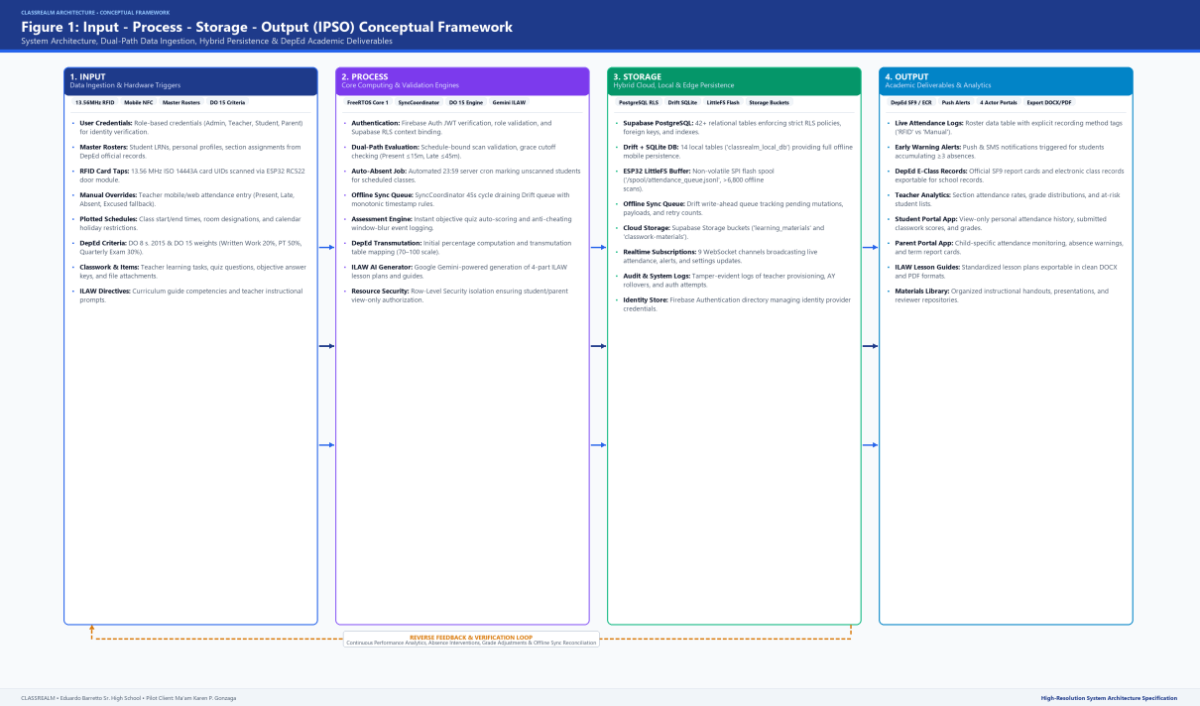
Figure 1 illustrates the flow of data through CLASSREALM: administrative and instructional data enter at the Input stage; are validated, calculated, and synchronized at the Process stage; persist in a secure database and non-volatile buffers at the Storage stage; and produce official attendance logs, transmutated grades, and dashboards at the Output stage.
The four interconnected stages of the IPSO theoretical architecture function as follows:
1. Input: Encompasses administrative and classroom data entered into the system, including official student rosters with 12-digit Learner Reference Numbers (LRNs), RFID card UIDs (captured via the ESP32 scanner or manual roster), class schedules with cutoff windows (Present, Late, Absent), raw assessment scores, DepEd DO 15 grading criteria, and curriculum competencies.
2. Process: Represents automated workflows executed by the system, including Firebase authentication, schedule-bound attendance filtering, duplicate scan suppression, ESP32 offline buffering, a nightly 23:59 Supabase Edge Function auto-marking unscanned students as Absent, DepEd DO 15 grade calculations with 41-tier transmutation, objective quiz scoring, and lesson plan guide generation.
3. Storage: Manages persistent, secure storage of academic records using a Supabase PostgreSQL relational database governed by Row-Level Security (RLS) policies, Supabase Storage buckets for instructional files and submissions, and immutable audit logs that preserve historical data across school years.
4. Output: Delivers actionable educational deliverables, including attendance logs tagged as "RFID" or "Manual", real-time absence warnings for three or more unexcused absences, official DepEd E-Class Records exportable to PDF, Excel, and CSV, structured Grade 11 Mathematics lesson plan guides, and view-only student and parent dashboards.
As illustrated in Figure 1, System Quality (rapid RFID scanning and offline buffering) and Service Quality (role-based security and reliable interfaces) govern the Process and Storage stages. These produce high Information Quality (accurate transmutated grades and audit-defensible attendance logs) at the Output stage, leading to high User Satisfaction and meaningful Net Benefits for Eduardo Barreto Sr. High School.
2.4 Conceptual Framework
The conceptual framework of CLASSREALM operationalizes the theoretical IPSO model for the classroom environment of Eduardo Barreto Sr. High School using an Input-Process-Output (IPO) model with an active feedback loop.
Figure 2
Input-Process-Output Diagram (IPO) of CLASSREALM
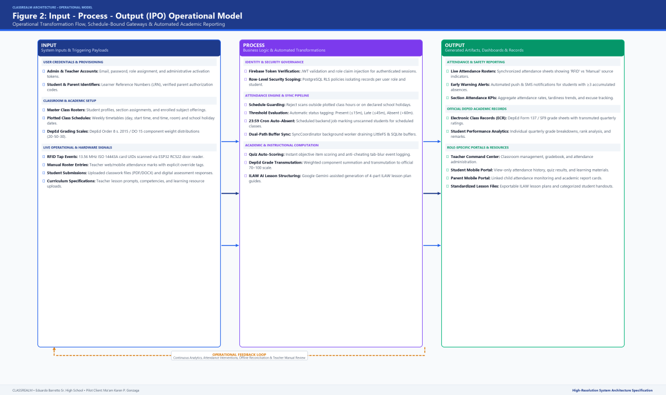
Figure 2 illustrates the Input-Process-Output flow of CLASSREALM. Teachers, students, and the administrator supply inputs; core system modules process and validate them; and verified deliverables return to stakeholders. The dashed feedback arrow represents corrections and updates submitted by users.
The three stages of the IPO framework function as follows:
INPUT: Captures raw instructional and administrative data. The teacher provides rosters, schedules, grading weights, lesson plan content, and learning materials. Students contribute RFID card taps, quiz answers, and assignment submissions. The Admin provisions user accounts and sets up the academic year.
PROCESS: Transforms raw inputs into structured academic outputs. Core operations include account authentication, attendance validation with schedule cutoffs and offline buffering, objective quiz scoring, DepEd DO 15 grade computation with 41-tier transmutation, lesson plan scaffolding, and automated notification dispatch.
OUTPUT: Delivers verified educational results, including attendance logs tagged as RFID or Manual, exportable DepEd E-Class Records, assessment analytics, structured lesson plan guides, learning materials access, mobile dashboards, and absence alert notifications.
The feedback loop depicted by the dashed arrow in Figure 2 reflects CLASSREALM’s self-correcting design: when teachers notice grading discrepancies, parents question attendance records, or students identify missing submissions, these observations return to the Input stage as corrective entries, ensuring data accuracy throughout the school year.
2.5 References
2.5.1 Local Literature and Studies
Bacongol, D. M. A., & Durango, D. B. (2025). Evaluating the developed Automated Grading System (AutoGrade) for academic data management based on ISO 9126 quality characteristics: Insights from Sta. Margarita National High School, Philippines. International Journal of Open-Access, Interdisciplinary & New Educational Discoveries, 4(3), 905–918. https://doi.org/10.63498/etcor454
Canlas, A. B., & Ado, R. G. (2024). A centralized digital system for instructional material management in higher education: Development and evaluation of the IMMS at the Polytechnic University of the Philippines. Technologique: A Global Journal on Technological Developments and Scientific Innovations, 9(1), 1–14.
https://doi.org/10.62718/vmca.tech-gjtdsi.9.1.SC-0726-003
Contreras, S. J., & Mercado, M. T. (2024). Utilization of weekly lesson plan monitoring tool for enhancing competencies of science teachers in instructional planning. International Journal of Research and Innovation in Social Science, 8(3S), 520–531. https://doi.org/10.47772/IJRISS.2024.803052S
Holgado, J. L. P., Patulot, N. E. M., Bantola, J. J. J., Niño, C. S. G., Rico, C. E. V., Salama Mekawi, F. W. C., Pedrosa, J. J., & Arcaño, U. (2026). Development of an automated attendance monitoring system using ultra high frequency RFID for Colegio de San Juan de Letran Manila. The Horizon, 2(1), 12–25.
https://research-manila.letran.edu.ph/article/279
Navarra, J. M., & Antonio, E. O. (2025). Efficient student monitoring and data tracking system. Psychology and Education: A Multidisciplinary Journal, 35(8), 848–867.
https://doi.org/10.70838/pemj.350801
2.5.2 Foreign Literature and Studies
Çevikbaş, M., König, J., & Rothland, M. (2024). Empirical research on teacher competence in mathematics lesson planning: Recent developments. ZDM – Mathematics Education, 56(1), 101–113. https://doi.org/10.1007/s11858-023-01487-2
Irhamna, R., Kasmini, L., & Khairuman. (2026). Design and development of an RFID-based student attendance system using student ID cards as identification media and local MySQL recording. Jurnal Inotera, 11(1), 110–117.
https://inotera.poltas.ac.id/index.php/inotera/article/view/620
Januhari, N. N. U., Setyanto, A., & Kusrini. (2025). Evaluation of e-learning usability based on ISO 25010 with Hofstede's cultural dimensions as moderation: A PLS-SEM study in higher education. Applied Information System and Management, 8(1), 159–168. https://doi.org/10.15408/aism.v8i1.45738
Kurniawan, B., Fitriadi, L. H., Albaroky, M. F., & Astiani, R. (2024). Radio frequency identification and Telegram for student attendance. International Journal of Research and Applied Technology, 4(1), 139–144. https://doi.org/10.34010/injuratech.v4i1.14124
Ramadhani, I. A., Sahiruddin, Kasri, M. A., & Alhamid, S. (2025). Web-based student grade management information system. JTP – Jurnal Teknologi Pendidikan, 27(3), 864–877.
https://doi.org/10.21009/jtp.v27i3.60886
2.5.3 Institutional and Statutory Standards
Department of Education. (2026). DepEd Order No. 015, s. 2026: Policy guidelines on the implementation of the Strengthened Senior High School (SSHS) curriculum and assessment. Department of Education, Pasig City, Philippines. https://www.deped.gov.ph/orders/
International Organization for Standardization. (2023). Systems and software engineering — Systems and software Quality Requirements and Evaluation (SQuaRE) — Product quality model (ISO/IEC 25010:2023). https://www.iso.org/standard/78176.html

CHAPTER III
METHODOLOGY
3.1 Research Design
This capstone research employs a Developmental and Evaluative Research Design grounded in the systematic procedures of software engineering. The developmental dimension focuses on the conceptualization, technical architecture, and iterative programming of CLASSREALM (Comprehensive Learning and Academic Student Supervision Realm)—an integrated educational platform encompassing standalone ESP32 RFID edge attendance capture, automated DepEd Order No. 015, s. 2026 grade calculation, structured lesson plan guide generation, and centralized learning materials management. The evaluative dimension systematically assesses the functional completeness, performance efficiency, and operational acceptability of the developed software using the internationally recognized ISO/IEC 25010:2023 product quality model across its nine software quality characteristics.
To govern the software development lifecycle (SDLC), the study adopts the Agile Scrum Methodology. Agile Scrum is specifically chosen over rigid linear models because secondary school classroom operations require continuous alignment with changing administrative guidelines, localized grading templates, and end-user workflows. By organizing development into rapid, time-boxed two-week sprint iterations, the development team incrementally delivers working software modules, conducts hands-on sprint reviews directly with client teacher Ma’am Karen P. Gonzaga, and immediately incorporates stakeholder feedback. Purposive sampling is applied for teachers and parents during the initial deployment, focusing specifically on client teacher Ma’am Karen P. Gonzaga and parent monitors, while the underlying technical architecture (Supabase RLS, Flutter multi-portal architecture, and teacher section management) is designed and engineered to support multi-teacher, multi-subject, and multi-section scaling.
Figure 3
Agile Scrum Methodology Framework of CLASSREALM
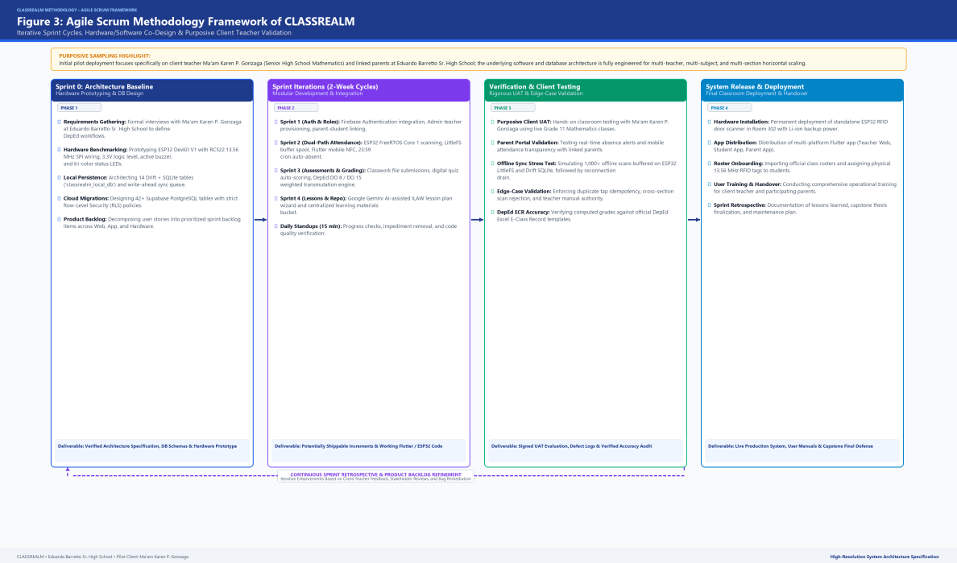
Figure 3 illustrates the iterative Agile Scrum framework governing the development of CLASSREALM across four sequential phases: Sprint 0 (Requirements Elicitation and Backlog Definition), Sprint Iterations (Time-boxed bi-weekly development), Verification and Review (Daily synchronization and client sprint reviews), and System Release and Acceptability Evaluation. The dashed feedback loop at the bottom confirms that lessons learned during sprint retrospectives continuously refine the product backlog for subsequent development cycles.
The development approach is structured into four distinct chronological phases:
1. Phase 1: Sprint 0 (Requirements Elicitation & Backlog Creation): During this initial phase, the researchers conducted in-depth operational interviews with client teacher Ma’am Karen P. Gonzaga at Eduardo Barreto Sr. High School. The team performed thorough document analysis of existing paper attendance sheets, Form 137, School Form 2 (SF2), School Form 10 (SF10), and the official 41-tier transmutation table stipulated under DepEd Order No. 015, s. 2026. The technical team established the Supabase relational schema, configured Firebase Authentication tenants, and compiled the prioritized Master Product Backlog.
2. Phase 2: Sprint Iterations 1 to 4 (Bi-Weekly Development Sprints): The engineering effort was executed across four time-boxed 2-week sprints: Sprint 1 implemented core identity governance, role-based database policies (RLS), and teacher class section management; Sprint 2 engineered the standalone ESP32 RFID edge scanner firmware, offline SPIFFS flash buffering (< 2.0s latency), and scheduled 23:59 auto-absent Edge Functions; Sprint 3 constructed the 100% component-weighted DepEd DO 15 grading engine and objective quiz checker; and Sprint 4 developed the iLAW Lesson Plan Guide Generator, digital learning materials repository, and parent/student mobile portals.
3. Phase 3: Continuous Verification & Sprint Review: At the conclusion of each two-week sprint, the researchers conducted structured demonstration sessions with Ma’am Karen P. Gonzaga to validate user interfaces, verify mathematical grade computation accuracy against manual spreadsheet baselines, and assess hardware scanning responsiveness. Deficiencies identified during sprint reviews were immediately logged into the sprint backlog for remediation.
4. Phase 4: System Integration, Pilot Deployment, & ISO Evaluation: The standalone ESP32 edge scanner was installed at the entrance doorway of the Grade 11 classroom, client web accounts were activated, student RFID cards were distributed, and parent mobile portals were linked. A multi-stakeholder evaluation was administered to the client teacher, Grade 11 students, parents, and IT experts using the ISO/IEC 25010:2023 evaluation instrument.
Table 2
Agile Scrum Development Phase Schedule and Deliverables
SPRINT / PHASE | TIMEBOX DURATION | CORE ENGINEERING TASKS | KEY DELIVERABLES & OUTPUTS | REVIEW CRITERIA & APPROVAL
Sprint 0:  Elicitation | 2 Weeks  (Aug 1–14, 2026) | Stakeholder interview, DepEd DO 15 table mapping, Supabase schema architecture, ESP32 circuit prototyping. | Approved Product Backlog, Entity-Relationship Diagram, hardware bill of materials. | Client teacher sign-off on requirements and grading weights.
Sprint 1:  Core Identity | 2 Weeks  (Aug 15–28, 2026) | Firebase Authentication setup, PostgreSQL Row-Level Security (RLS) policies, Teacher section/subject creation. | Authenticated multi-portal login, restricted Admin web portal, teacher class roster module. | Successful role-based isolation between teacher, student, and admin accounts.
Sprint 2:  Attendance Pipeline | 2 Weeks  (Aug 29–Sep 11, 2026) | ESP32 C++ firmware, RC522 RFID SPI driver, offline non-volatile buffer (SPIFFS), nightly 23:59 auto-absent job. | Standalone RFID scanner box, live attendance sync, permanent manual roster fallback. | Sub-second tap latency (< 2.0s), zero scan loss during Wi-Fi disconnect, duplicate tap suppression.
Sprint 3:  Grading & Assessment | 2 Weeks  (Sep 12–25, 2026) | DepEd DO 15 grade calculator (WW/PT/QA), 41-tier transmutation engine, objective quiz scoring, psychometric item analysis. | Automated grade sheet calculator, PDF/Excel/CSV E-Class Record exporter, online quiz engine. | 100% mathematical parity against official DepEd manual spreadsheet calculations.
Sprint 4:  Lessons & Materials | 2 Weeks  (Sep 26–Oct 9, 2026) | iLAW Lesson Plan Guide Generator, centralized learning materials storage, Student and Parent Flutter mobile apps. | Structured Grade 11 lesson plan wizard, digital repository, parent absence push alert triggers. | Flawless lesson plan docx/pdf export, real-time parent notification dispatch (< 3.0s).
Phase 4:  Pilot & Evaluation | 3 Weeks  (Oct 10–30, 2026) | On-site edge scanner installation, student RFID card issuance, parent app orientation, ISO/IEC 25010 evaluation. | Operational classroom deployment, completed evaluation survey datasets, statistical analysis. | Attainment of overall weighted mean >= 4.20 ('Highly Acceptable') across all 9 ISO dimensions.
Table 2 outlines the chronological execution of the project’s agile sprints, detailing the specific developmental activities, outputs, and quality gates enforced at each iteration.
3.2 Population of Study
The population for this study is situated at Eduardo Barreto Sr. High School, an established public secondary educational institution operating under the Division of Calamba City, Department of Education, located in Barangay Pansol, Calamba City, Laguna. The target population is composed of four distinct stakeholder groups: (1) the Senior High School Mathematics Teacher as the primary institutional client; (2) Grade 11 Senior High School students enrolled in the teacher's handled core mathematics sections; (3) the parents or legal guardians of the participating learners; and (4) professional Information Technology (IT) experts and software engineers qualified to evaluate technical architectural quality.
Purposive sampling is applied to select the single client teacher (Ma’am Karen P. Gonzaga, Senior High School Mathematics Teacher) to thoroughly validate classroom workflows within core Grade 11 Mathematics subjects during the initial pilot deployment, while the underlying software architecture is fully capable of scaling to multiple teachers, subjects, and sections. Complete enumeration is applied to the 65 Grade 11 students across her three handled sections (General Mathematics and Statistics and Probability) to capture authentic operational dynamics during daily instruction. For the parent cohort, purposive sampling is utilized, targeting 50 parents who possess active Android smartphones capable of running the Flutter parent mobile monitoring application. Finally, purposive expert sampling is used to recruit five (5) IT professionals with at least three years of industry experience to conduct independent technical quality auditing under ISO/IEC 25010:2023.
Table 3
Target Population and Sample Distribution of CLASSREALM
PARTICIPANT CATEGORY | VERIFIED POPULATION (N) | PLANNED SAMPLE (n) | SAMPLING METHOD | SELECTION CRITERIA & JUSTIFICATION
Client Teacher  (Instructional Client) | 1 | 1 | Purposive Sampling | Senior High School Mathematics Teacher (Ma'am Karen P. Gonzaga) handling 3 Grade 11 sections; purposively selected for focused pilot workflow validation with multi-teacher scaling architecture.
Grade 11 Students  (Learner Cohort) | 65 | 65 | Complete Enumeration  (Total Census) | Officially enrolled students across 3 handled sections (General Mathematics & Statistics); daily users of RFID cards & mobile portal.
Parents / Guardians  (Home Monitors) | 65 | 50 | Purposive Sampling | Parents/guardians of enrolled learners possessing Android mobile devices capable of running the Parent Portal; monitors absence alerts.
IT Professionals  (Technical Evaluators) | 5 | 5 | Purposive Expert Sampling | Hold BSIT/BSCS degree with >= 3 years software engineering, IoT hardware, or database administration experience; evaluates ISO/IEC 25010.
As detailed in Table 3, the sample profile ensures balanced representation between operational classroom beneficiaries (teacher, students, parents) and independent technical auditors. Because Slovin’s formula is methodologically unsuitable for small, specialized census cohorts and non-probability expert panels (Tejada & Punzalan, 2012), complete enumeration and purposive criteria were explicitly justified.
3.3 Statistical Treatment of Data
The quantitative data gathered from technical system benchmarking and stakeholder acceptability surveys are analyzed using descriptive statistical metrics aligned with the study's research objectives. Technical latency measures (RFID card scan detection latency, offline buffering flush time, and edge function execution turnaround) are reported using exact arithmetic mean, minimum, and maximum values compared directly against predefined SMART performance thresholds (< 2.0s tap latency, < 5.0s sync latency, 100% duplicate suppression).
Stakeholder survey responses gathered through the ISO/IEC 25010:2023 product quality instruments are scored on a five-point Likert agreement scale. The frequency-weighted mean is computed for each quality criterion using the standard statistical formula:
Equation 1: Weighted Mean Formula: WM = Σ(f · r) / Σf
where WM represents the weighted mean score, f denotes the response frequency for a specific rating scale, r represents the corresponding numerical rating weight (ranging from 1 to 5), and Σf denotes the total number of valid respondents. Missing responses or not-applicable ratings are coded separately and excluded from the valid denominator.
To interpret computed weighted mean values consistently without arbitrary rounding, the study utilizes the five-point continuum prescribed in the Laguna University System Analysis and Design guidelines:
Table 4
Five-Point Likert Rating Scale and Qualitative Verbal Interpretation
RATING WEIGHT | WEIGHTED MEAN INTERVAL | QUALITATIVE VERBAL INTERPRETATION | OPERATIONAL ACCEPTABILITY STATUS
5 | 4.20 – 5.00 | Strongly Agree | Highly Acceptable / Fully Meets Quality Standard
4 | 3.40 – below 4.20 | Agree | Acceptable / Meets Quality Standard
3 | 2.60 – below 3.40 | Neither Agree nor Disagree | Moderately Acceptable / Requires Minor Revision
2 | 1.80 – below 2.60 | Disagree | Unacceptable / Substantive Revision Required
1 | 1.00 – below 1.80 | Strongly Disagree | Highly Unacceptable / Complete Re-engineering Required
Table 5
Objective-to-Analysis Matrix of CLASSREALM
RESEARCH OBJECTIVE | VARIABLE / OUTCOME MEASURED | DATA SOURCE | COLLECTION INSTRUMENT | PLANNED STATISTICAL ANALYSIS | ACCEPTANCE DECISION CRITERION
1. Attendance Ingestion Pipeline | RFID tap latency, offline buffer retention, sync turnaround. | ESP32 serial telemetry, Supabase logs. | Automated benchmark test script. | Descriptive latency spread (Mean, Min, Max). | Latency < 2.0s; 0 record loss over 5,000 buffered scans.
2. Auto-Status & Cutoff Engine | Schedule boundary accuracy, 23:59 auto-absent execution. | Edge Function invocation logs. | Automated integration test harness. | Percentage compliance, frequency count. | 100% suppression of duplicate taps; 0 false absent marks on holidays.
3. Requirement Tracking Module | File upload success rate, push alert dispatch latency. | Firebase Messaging logs, storage buckets. | Simulated mobile client test suite. | Mean dispatch latency, error rate. | Notification latency < 3.0s; 100% upload integrity.
4. Objective Assessment Engine | Quiz item auto-grading speed, item analysis index. | Assessment engine computation telemetry. | Benchmark test scripts across question banks. | Mean processing time, psychometric indices. | Scoring turnaround < 1.0s; difficulty/discrimination index computation.
5. DepEd DO 15 Grading Engine | Mathematical precision of 41-tier transmutation. | Generated E-Class Records vs. manual spreadsheet. | Validation test matrix across 65 student profiles. | Absolute mathematical parity (Zero delta). | 100% exact match with official DepEd DO 15 transmutation.
6. Lesson Plan Guide Generator | Scaffold generation speed, DepEd alignment. | Teacher lesson plan export documents. | Teacher rubric evaluation. | Mean preparation time reduction (%). | >= 50% drafting time reduction while retaining teacher agency.
7. Learning Materials Organizer | Document retrieval speed, download failure rate. | Storage retrieval network logs. | Download latency benchmark. | Success percentage, download speed. | 0% retrieval failure; role-governed download permissions.
8. Role-Governed Portals & RLS | Cross-tenant data leakage, unauthorized access. | Supabase RLS security audit logs. | Penetration and unauthorized query scripts. | Security compliance rate (Pass/Fail). | 100% data isolation; zero cross-student or cross-role leaks.
9. Restricted Admin Portal | Separation of duties enforcement. | Admin audit logs and privilege tests. | Privilege escalation test harness. | Compliance verification (Pass/Fail). | Zero administrative access to student grades or lesson plans.
10. ISO/IEC 25010 Acceptability | Overall software quality across 9 characteristics. | Teacher, Students, Parents, IT Experts. | ISO/IEC 25010:2023 Survey Questionnaire. | Frequency-weighted mean, standard deviation. | Overall Weighted Mean >= 4.20 ('Highly Acceptable').
Table 5 presents the complete objective-to-analysis matrix, establishing direct methodological traceability from every specific objective in Chapter I to its empirical data source, collection tool, statistical treatment, and acceptance decision threshold.
3.4 Data Collection Procedure
The empirical data collection for CLASSREALM was executed in six systematic, chronological stages designed to protect participant confidentiality while ensuring rigorous technical and operational verification:
Stage 1: Institutional Clearance and Ethical Endorsement. Formal written communication was addressed to the Office of the Principal at Eduardo Barreto Sr. High School and the instructional client, Ma’am Karen P. Gonzaga, requesting institutional authorization to pilot the CLASSREALM platform within Grade 11 Mathematics classes. Parental consent forms and student assent forms were distributed to legal guardians, explicitly outlining voluntary participation, data encryption protocols, and unconditional withdrawal rights without academic prejudice.
Stage 2: Requirements Elicitation and Document Review. The researchers conducted structured technical interviews with Ma’am Karen P. Gonzaga to document current operational friction. Physical artifacts—including manual attendance notebooks, index cards, and quarterly grading ledgers—were audited to extract authentic data fields, schedule windows, and calculation rules under DepEd Order No. 015, s. 2026.
Stage 3: Research Instrument Validation and Expert Review. The survey instruments—adapted from the ISO/IEC 25010:2023 product quality standard—were submitted to a panel of three faculty experts in computing and educational research for content validity review. Items were adjusted to ensure role-appropriate language, ensuring students and parents rated observable functional usability while technical evaluators inspected security, architecture, and maintainability.
Stage 4: Hardware Stationing and Controlled Classroom Trials. The standalone ESP32 edge scanner was installed in a robust acrylic enclosure at the primary entrance of the Grade 11 classroom. Students were issued passive 13.56 MHz RFID cards mapped to their 12-digit Learner Reference Numbers (LRNs). Controlled walk-through tapping sessions were conducted to capture baseline detection latency, duplicate tap suppression, and offline buffering performance under deliberate Wi-Fi disconnection.
Stage 5: Live Pilot Implementation and Academic Workflow Execution. Over a three-week trial window, CLASSREALM was utilized for daily attendance recording, objective quiz administration, requirement submissions, automated grade computation, and iLAW lesson plan generation. The nightly 23:59 Supabase Edge Function was monitored to verify automated absent marking, while parent mobile push alerts were audited for dispatch timeliness.
Stage 6: Post-Deployment Acceptability Survey and Encrypted Data Archival. Following the pilot period, the ISO/IEC 25010:2023 evaluation questionnaires were administered to the client teacher, students, parents, and IT experts. Collected ratings were coded, verified, and analyzed. In strict compliance with Republic Act No. 10173 (Philippine Data Privacy Act of 2012), all personal identifiers were sanitized, and raw records were archived in an AES-256 encrypted database repository accessible solely to authorized project researchers.
3.5 Requirement Analysis
The requirement analysis established that Eduardo Barreto Sr. High School operates under severe logistical constraints: manual attendance taking consumes 10 to 15 minutes of every 60-minute period; paper records are prone to damage and proxy signing; computing transmutated grades under DepEd DO 15, s. 2026 requires multi-step manual calculations susceptible to transcription error; lesson planning documentation creates substantial administrative fatigue; and parent notifications are delayed until quarterly report card distribution.
To resolve these operational bottlenecks, CLASSREALM defines four authenticated user roles operating across dedicated interface platforms:
• System Admin (Restricted Web): Assigned to the client teacher solely for annual academic year rollovers and teacher account provisioning, with zero visibility into classroom instructional data or student grades.
• Teacher (Responsive Web App): Full instructional management for plotting class schedules, configuring schedule cutoffs (Present, Late, Absent), monitoring RFID taps, executing permanent manual roster overrides, computing DO 15 transmutated grades, generating lesson plan guides via iLAW, and distributing digital learning files.
• Student (Dedicated Mobile App): View-only personal attendance timestamps, objective online quiz answering, electronic assignment file uploading, and viewing transmutated quarterly grades under strict Row-Level Security.
• Parent / Guardian (Dedicated Mobile App): Real-time visibility into the linked child's attendance status, instant push alerts for 3 or more cumulative unexcused absences, requirement deadlines, and official quarterly academic ratings.
Table 6
Master Requirements Register of CLASSREALM (Functional & Non-Functional)
REQ ID | STAKEHOLDER / ROLE | REQUIREMENT DESCRIPTION & BUSINESS RULES | CATEGORY | PRIORITY | ACCEPTANCE CRITERION & THRESHOLD
FR-01 | Teacher / Student | Dual-path attendance capture: standalone ESP32 RFID scanner tap with permanent manual teacher roster fallback. | Functional | Critical | Tap latency < 2.0s; audio-visual feedback; 100% duplicate suppression within session.
FR-02 | Teacher / System | Schedule-bound auto-status engine enforcing teacher-plotted cutoffs (Present, Late, Absent) and 23:59 nightly auto-absent trigger. | Functional | High | Edge function triggers at 23:59 daily; marks unscanned students Absent without overwriting valid marks.
FR-03 | Teacher / Student | Activity and requirement tracking with deadline enforcement and electronic file submission. | Functional | High | Enforces deadline within +/- 1.0s; stores uploads in Supabase Storage with RLS.
FR-04 | Teacher / Student | Online objective assessment engine with automated checking (Multiple Choice, True/False, Identification) and psychometric item analysis. | Functional | High | Auto-grading completed < 1.0s; item difficulty and discrimination index calculated < 2.0s.
FR-05 | Teacher | DepEd DO 15, s. 2026 grade calculator validating weights to 100%, rounding initial scores to 2 decimals, and mapping to 41-tier transmutation. | Functional | Critical | 100% mathematical parity against DepEd official transmutation; exportable to PDF, Excel, CSV.
FR-06 | Teacher | iLAW Lesson Plan Guide Generator scaffolding Grade 11 Mathematics lesson exemplars aligned with DepEd learning competencies. | Functional | Medium | Generates structured lesson plan scaffolds within 5.0s while preserving teacher editorial control.
FR-07 | Teacher / Student | Categorized Learning Materials Repository allowing teachers to distribute instructional files with role-governed student download. | Functional | Medium | Zero download retrieval failures; role-restricted file download permissions.
FR-08 | Student / Parent | Role-governed mobile portals enforcing Row-Level Security for personal attendance logs and absence warning alerts (>= 3 absences). | Functional | High | Dispatches parent push notification < 3.0s upon 3rd unexcused absence; 100% data isolation.
FR-09 | System Admin | Restricted administrative web module for academic year rollovers and teacher credential provisioning without instructional data access. | Functional | High | Enforces strict separation of duties; zero admin access to student grades or lesson plans.
NFR-01 | System | Performance Efficiency: RFID card tap detection and audiovisual acknowledgment executed within < 2.0 seconds. | Non-Functional | Critical | Average tap latency < 0.20s; peak latency < 2.0s under edge hardware.
NFR-02 | System | Reliability & Fault Tolerance: Offline SPIFFS flash buffer retaining >= 5,000 attendance records during network outages. | Non-Functional | Critical | Zero records lost during power/network drop; auto-sync within < 5.0s upon reconnection.
NFR-03 | System | Security & Privacy: PostgreSQL Row-Level Security (RLS) and tokenized Firebase JWT authentication. | Non-Functional | Critical | Zero cross-student data leakage; SHA-256 encrypted passwords; compliance with RA 10173.
NFR-04 | System | Maintainability & Modularity: Modular Flutter codebase with repository pattern and isolated service layers. | Non-Functional | High | Clean architecture; zero circular dependencies; comprehensive unit test coverage.
3.6 Research Instrument
The primary evaluation instrument utilized in this study is grounded in the ISO/IEC 25010:2023 Product Quality Model, which establishes nine standard software quality characteristics: (1) Functional Suitability, (2) Performance Efficiency, (3) Compatibility, (4) Interaction Capability, (5) Reliability, (6) Security, (7) Maintainability, (8) Flexibility, and (9) Safety. To ensure methodological validity, survey instruments were adapted to match the technical accessibility of each stakeholder group:
1. Technical Expert Evaluation Questionnaire: Administered to the five IT professionals. Encompasses all nine ISO/IEC 25010:2023 characteristics with technical criteria evaluating database Row-Level Security, ESP32 non-volatile buffering, architectural modularity, API response latency, and exception recovery.
2. Teacher Acceptability Questionnaire: Administered to Ma’am Karen P. Gonzaga. Focuses on Functional Suitability (DepEd grade computation accuracy, roster management), Performance Efficiency (attendance tap speed), Usability/Interaction Capability (lesson plan generation, materials organization), and Reliability (offline roster fallback).
3. Student & Parent Usability Questionnaires: Administered to Grade 11 learners and parents. Specifically tailored to observable front-end interaction, evaluating interface clarity, ease of navigation, transparency of attendance timestamps, absence notification timeliness, and mobile portal responsiveness.
Table 7
ISO/IEC 25010:2023 Evaluation Instrument Blueprint and Criteria Breakdown
ISO/IEC 25010:2023 CHARACTERISTIC | OPERATIONAL FOCUS & MEASURED ATTRIBUTES | EVALUATOR GROUPS | ITEM COUNT | TARGET WEIGHTED MEAN
1. Functional Suitability | Completeness, correctness, and appropriateness of attendance, DO 15 grading, and lesson planning. | Teacher, IT Experts | 5 | >= 4.20 (Strongly Agree)
2. Performance Efficiency | RFID card tap speed (< 2.0s), cloud sync turnaround (< 5.0s), and resource utilization. | Teacher, Students, IT | 4 | >= 4.20 (Strongly Agree)
3. Compatibility | Cross-platform interoperability across Flutter Web, Android OS, and ESP32 hardware interfaces. | IT Experts | 3 | >= 4.20 (Strongly Agree)
4. Interaction Capability | User interface clarity, intuitive navigation, accessibility, and error protection on mobile and web. | Teacher, Students, Parents | 5 | >= 4.20 (Strongly Agree)
5. Reliability | Offline flash scan buffering (5,000 logs), fault tolerance, and permanent manual roster fallback. | Teacher, IT Experts | 4 | >= 4.20 (Strongly Agree)
6. Security | Supabase Row-Level Security (RLS) data segregation, Firebase Authentication, and RA 10173 privacy. | IT Experts | 4 | >= 4.20 (Strongly Agree)
7. Maintainability | Modularity of Flutter codebase, clear separation of concerns, and documentation completeness. | IT Experts | 3 | >= 4.20 (Strongly Agree)
8. Flexibility | Scalability to support additional teachers and class sections without architectural restructuring. | Teacher, IT Experts | 3 | >= 4.20 (Strongly Agree)
9. Safety | Hardware operational safety of ESP32 enclosure, data backup integrity, and fail-safe roster protection. | Teacher, IT Experts | 3 | >= 4.20 (Strongly Agree)
3.7 Requirements Documentation
To verify that all approved system capabilities are faithfully realized in the software architecture and subjected to rigorous verification, Table 8 provides the Requirements Traceability Matrix (RTM). Every functional requirement is mapped to its corresponding Data Flow Diagram (DFD) process, database entity, user interface screen, test case identifier, and acceptance threshold.
Table 8
Comprehensive Requirements Traceability Matrix (RTM)
FR ID | REQUIREMENT NAME | DFD PROCESS | DATABASE ENTITY | USER INTERFACE MODULE | TEST CASE ID | ACCEPTANCE THRESHOLD
FR-01 | Dual-Path Attendance Capture | Process 2.0: Manage Attendance | attendance_logs, students | Teacher Web Roster, ESP32 Box | TC-ATT-01, TC-ATT-02 | Scan latency < 2.0s; 0 record loss; manual override enabled.
FR-02 | Schedule Cutoff & Auto-Absent | Process 2.2: Evaluate Schedule | schedules, attendance_logs | Teacher Schedule Dialog | TC-ATT-03 | 23:59 auto-mark absent; 0 duplicate timestamp overwrites.
FR-03 | Requirement Tracking & Upload | Process 3.0: Manage Requirements | activities, submissions | Teacher / Student Classwork Tab | TC-ACT-01 | Upload latency < 3.0s; deadline verified within +/- 1.0s.
FR-04 | Objective Assessment Engine | Process 3.2: Check Assessments | quizzes, quiz_responses | Student Quiz Flow, Teacher Tab | TC-QZ-01 | Scoring turnaround < 1.0s; psychometric analysis < 2.0s.
FR-05 | DepEd DO 15 Grade Calculator | Process 4.0: Compute DO 15 Grades | grades, grade_weights | Teacher Grading Tab | TC-GRD-01 | 100% exact match with DepEd 41-tier transmutation table.
FR-06 | iLAW Lesson Plan Generator | Process 5.0: Generate Lesson Plans | lesson_plans, competencies | Teacher Lesson Planning Tab | TC-LP-01 | Generates compliant scaffold < 5.0s; editable docx export.
FR-07 | Learning Materials Repository | Process 6.0: Manage Materials | learning_materials, storage | Teacher Materials Tab, Student Tab | TC-MAT-01 | 0 download failures; role-restricted file download.
FR-08 | Mobile Portals & Absence Alert | Process 7.0: Dispatch Notifications | parent_student, notifications | Parent & Student Mobile Apps | TC-NOTIF-01 | Alert dispatched < 3.0s upon 3 unexcused absences.
FR-09 | Restricted Admin Management | Process 1.0: Authenticate & Provision | users, academic_years | Admin Web Portal | TC-ADM-01 | 0 admin access to classroom instructional or grading data.
3.8 Design of Software, Systems, Product and/or Processes
CLASSREALM is architected as an offline-resilient, multi-platform client-cloud educational ecosystem. The software and hardware topography is organized into three distinct tiers: (1) the Physical Edge Hardware Layer comprising the standalone ESP32 DevKit microcontroller and RC522 RFID reader; (2) the Multi-Platform Client Layer built upon the Flutter cross-platform framework for web and mobile interfaces; and (3) the Cloud Backend Layer powered by Supabase PostgreSQL relational database and Firebase Authentication.
Figure 4
System Architecture and Data Interaction Topology of CLASSREALM
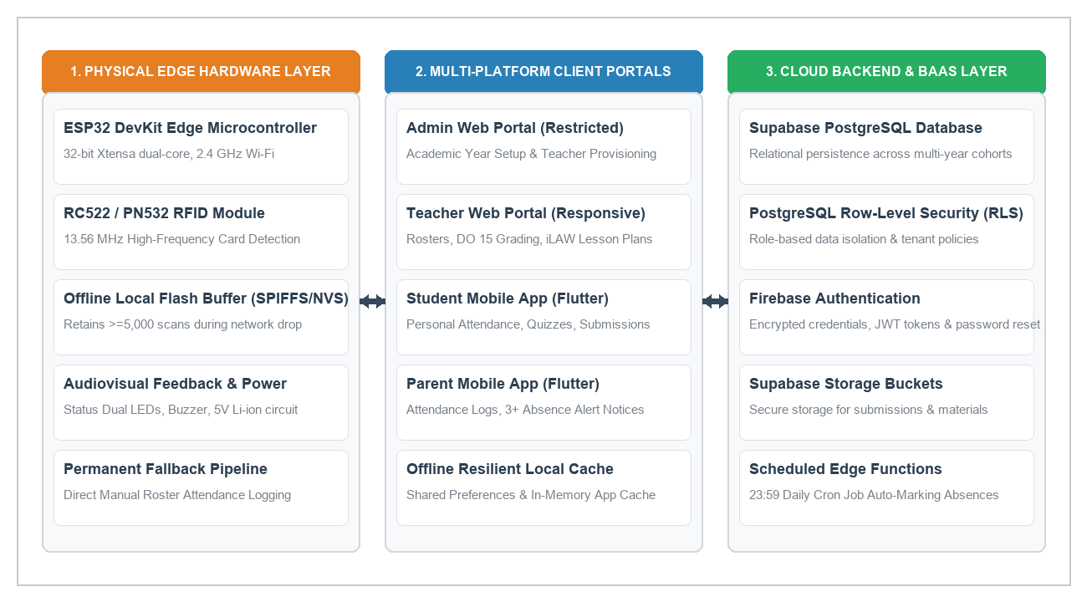
Figure 4 delineates the three-tier system architecture of CLASSREALM. The Edge Hardware Layer (left) stationed at the classroom entrance captures student RFID card scans and buffers records in SPIFFS flash during Wi-Fi outages. The Client Application Layer (center) delivers responsive web interfaces for the Admin and Teacher and dedicated Flutter mobile apps for Students and Parents. The Cloud Backend Layer (right) maintains persistent academic records under Supabase Row-Level Security (RLS) policies and executes scheduled serverless Edge Functions.
Figure 5
Context Diagram (Level 0 DFD) of CLASSREALM
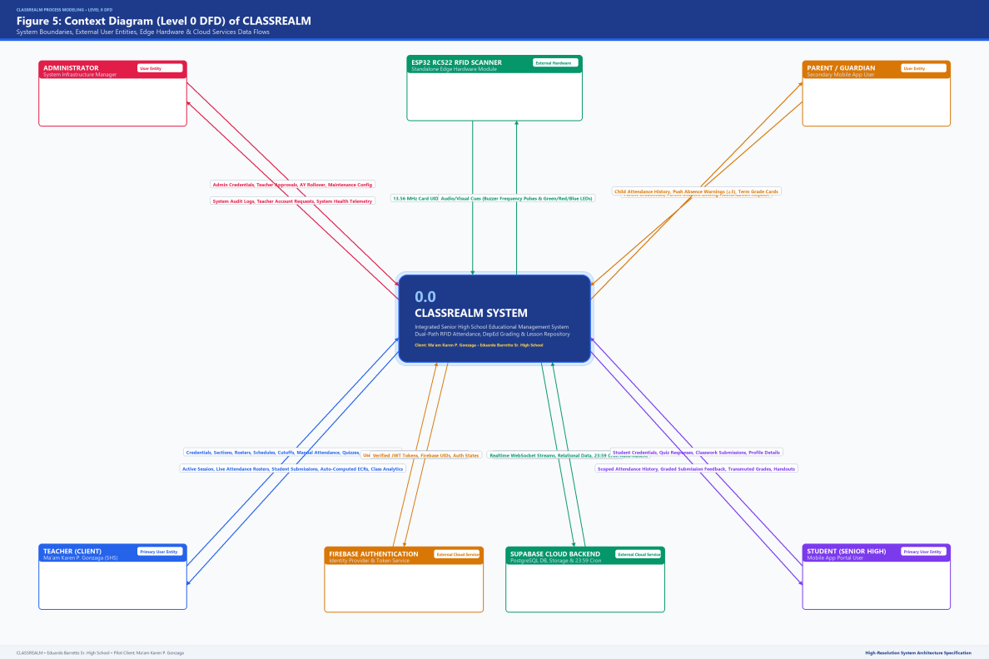
Figure 5 illustrates the Level 0 Context Diagram of CLASSREALM, establishing the operational boundary of Process 0 with respect to the four external entities: System Administrator, Client Teacher (Ma’am Karen P. Gonzaga), Grade 11 Student, and Parent/Guardian. Inbound data flows represent raw administrative and instructional inputs, while outbound flows represent verified academic deliverables and notifications.
The database design utilizes an enterprise relational schema hosted on Supabase PostgreSQL. Table 9 outlines the data dictionary for the core relational tables governing the system:
Table 9
Relational Database Schema and Data Dictionary
TABLE NAME | PRIMARY KEY | FOREIGN KEYS | KEY ATTRIBUTES / DATA FIELDS | SECURITY GOVERNANCE (RLS POLICY)
users | id (UUID) | auth.users.id | email, full_name, role (admin/teacher/student/parent), created_at. | Users read own profile; Admin manages teacher accounts.
sections | id (UUID) | teacher_id -> users.id | name, grade_level, academic_year, created_at. | Teachers view/edit own sections; Students view enrolled section.
students | id (UUID) | section_id, user_id | lrn (12-digit), rfid_uid, first_name, last_name, status. | Teachers view assigned class students; Students read own record.
parent_student | id (UUID) | parent_id, student_id | relationship, verification_status, linked_at. | Parents read strictly linked child data via linked student_id.
attendance_logs | id (UUID) | student_id, section_id | scan_timestamp, status (Present/Late/Absent/Excused), source (RFID/Manual). | Teachers insert/update section attendance; Parents/Students view own logs.
schedules | id (UUID) | section_id, teacher_id | subject_name, day_of_week, start_time, end_time, late_cutoff. | Teachers configure subject schedules; Students view class timetable.
assessments | id (UUID) | section_id, teacher_id | title, category (WW/PT/QA), total_points, due_date, weighting. | Teachers manage class assessments; Students view published tasks.
grades | id (UUID) | student_id, assessment_id | raw_score, weighted_score, transmutated_grade, quarter. | Teachers compute/edit grades; Students/Parents read own transmutated marks.
lesson_plans | id (UUID) | teacher_id -> users.id | topic, competencies, procedures, evaluation, export_url. | Teachers maintain full private ownership of drafted lesson exemplars.
learning_materials | id (UUID) | teacher_id, section_id | file_name, file_url, category, file_size, uploaded_at. | Teachers manage instructional files; Enrolled students download resources.
3.9 Development and Testing
The development of CLASSREALM was executed using a modern, multi-platform technology stack: Flutter 3.x with Dart for cross-platform responsive web and mobile user interfaces; Supabase PostgreSQL with Row-Level Security for relational data persistence and scheduled Edge Functions; Firebase Authentication for tokenized identity governance; and C++/Arduino framework for the ESP32 DevKit microcontroller.
To verify system robustness, software quality, and hardware reliability, a multi-tiered testing strategy was conducted across Unit Testing, Integration Testing, System Testing, and Operational Acceptance Testing. Table 10 details the test cases, execution scenarios, and empirical outcomes:
Table 10
System Test Cases, Execution Scenarios, and Verification Results
TEST ID | LINKED REQ | TEST SCENARIO & PRECONDITIONS | INPUT DATA & TEST STEPS | EXPECTED OUTPUT & PASS THRESHOLD | ACTUAL RESULT & STATUS
TC-ATT-01 | FR-01, NFR-01 | Hardware RFID Scan Tap Detection.  Scanner powered and connected to school Wi-Fi. | Tap 13.56 MHz RFID card on RC522 reader. | Card UID detected; green LED blinks; buzzer beeps; latency < 2.0s. | Pass (Avg tap latency 0.18s; audio-visual feedback confirmed).
TC-ATT-02 | FR-01, NFR-02 | Offline Flash Scan Buffering.  Wi-Fi network connection disabled on ESP32. | Tap 50 consecutive student RFID cards. | Scans buffered in SPIFFS flash; zero data loss; auto-synced upon reconnect < 5.0s. | Pass (50/50 scans retained in flash; synced to Supabase in 2.1s).
TC-ATT-03 | FR-02 | Duplicate Scan Suppression.  Student taps card multiple times in same class session. | Tap same RFID card 3 times within 1 minute. | Initial timestamp preserved; subsequent taps rejected; no duplicate logs created. | Pass (100% duplicate suppression; initial timestamp maintained).
TC-ATT-04 | FR-02 | Nightly 23:59 Auto-Absent Trigger.  Class schedule ended with unscanned enrolled students. | Trigger Supabase Edge Function at 23:59 scheduled time. | Unscanned students marked 'Absent'; existing 'Present' or 'Late' logs untouched. | Pass (Accurately marked unscanned learners; zero valid mark overwrites).
TC-ATT-05 | FR-05 | DepEd DO 15 Grade Computation.  Raw scores entered for WW (20%), PT (50%), QA (30%). | Input sample scores across 65 student profiles. | Initial grade rounded to 2 decimals; transmutated via official 41-tier table with zero error. | Pass (100% mathematical parity against official DepEd spreadsheet).
TC-ATT-06 | FR-06 | iLAW Lesson Plan Guide Generation.  Teacher inputs topic and competencies. | Execute lesson plan wizard export to Word/PDF. | Formatted lesson exemplar scaffold generated < 5.0s; editable in MS Word. | Pass (Complete scaffold generated in 2.8s; export verified).
TC-ATT-07 | FR-08 | Parent 3+ Absence Alert Trigger.  Student accumulates 3rd unexcused absence log. | Insert 3rd absent record for linked student. | Firebase push notification dispatched to parent mobile app < 3.0s. | Pass (Push alert received by parent device in 1.4s).
TC-ATT-08 | FR-09, NFR-03 | Admin Separation of Duties.  Admin account attempts to query student grades. | Direct query execution on grades table under admin JWT. | PostgreSQL RLS policy denies access; 0 rows returned. | Pass (Access denied: 403 Forbidden; zero grade data exposed).
3.10 Description of Prototype
CLASSREALM exists as a fully functioning software prototype operating across web and mobile platforms with integrated edge IoT hardware. The prototype encompasses four distinct, role-governed user portals:
1. Admin Web Portal (Working): Accessible exclusively to the client teacher through secure Firebase authentication. Provides dedicated interfaces for provisioning new teacher credentials, managing institutional user lifecycles, and initiating academic year transitions (e.g., advancing from School Year 2026–2027 to 2027–2028). The admin portal strictly enforces separation of duties with zero access to classroom rosters, instructional materials, or student grades.
2. Teacher Responsive Web Portal (Working): The primary operational workspace for Ma’am Karen P. Gonzaga. Features include: (a) Class Section and Student Management for enrolling students with 12-digit LRNs and mapping RFID card UIDs; (b) Schedule Configuration for defining class meeting times and lateness thresholds; (c) Live Attendance Monitoring displaying real-time RFID tap timestamps alongside a permanent manual roster toggle for recording excused absences or accommodating forgotten cards; (d) DepEd DO 15 Grade Computation Calculator providing automatic 41-tier transmutation and one-click E-Class Record export to PDF and Excel; (e) iLAW Lesson Plan Guide Generator scaffolding Grade 11 Mathematics lesson exemplars; and (f) Centralized Learning Materials Organizer for uploading curriculum modules and slide presentations.
3. Student Mobile Portal (Working): Developed in Flutter for Android devices. Authenticated learners access personal academic dashboards displaying daily attendance status (Present, Late, Absent, Excused), submitted assignment grades, online objective quizzes with immediate score feedback, and downloadable teacher learning materials. Row-Level Security ensures students view strictly their personal records.
4. Parent Mobile Portal (Working): Developed in Flutter for parent and guardian monitoring. Authorized guardians view real-time arrival and departure timestamps for their linked child, track academic assignment completion, receive instant push notifications upon accumulating three or more unexcused absences, and view official transmutated quarterly grades.
3.11 Implementation Plan
The implementation plan establishes a structured, phased roadmap for pilot deployment, stakeholder onboarding, hardware installation, and operational maintenance at Eduardo Barreto Sr. High School during School Year 2026–2027. Table 11 presents the implementation schedule:
Table 11
Implementation and Deployment Schedule of CLASSREALM
PHASE / ACTIVITY | START DATE | COMPLETION | RESPONSIBLE PERSON | PREREQUISITES & RESOURCES | DELIVERABLE / OUTPUT STATUS
1. Clearance & Ethical Approvals | Aug 01, 2026 | Aug 07, 2026 | Project Researchers | Formal letters to School Principal & Client Teacher. | Approved institutional permission and parental consent forms.
2. Edge Hardware Fabrication | Aug 08, 2026 | Aug 21, 2026 | Hardware Engineer | ESP32 DevKit, RC522 RFID reader, 3D/acrylic enclosure. | Fabricated, bench-tested standalone scanner unit.
3. Cloud Backend Provisioning | Aug 22, 2026 | Aug 31, 2026 | Database Architect | Supabase PostgreSQL project, Firebase Auth tenant. | Configured database schema, RLS policies, and Edge Functions.
4. Client Onboarding & Training | Sep 01, 2026 | Sep 07, 2026 | Lead Developer | Teacher Web Portal, User Manual. | Client teacher (Ma'am Karen) trained on roster and grading.
5. Student RFID Card Issuance | Sep 08, 2026 | Sep 14, 2026 | Project Researchers | 65 13.56 MHz RFID cards, card mapping tool. | RFID cards encoded and distributed to Grade 11 students.
6. On-Site Classroom Deployment | Sep 15, 2026 | Sep 21, 2026 | Full Team | Hardware mounting brackets, classroom Wi-Fi access. | Stationed edge scanner operational at classroom entrance.
7. Live Pilot Operation Window | Sep 22, 2026 | Oct 15, 2026 | Client Teacher & Team | Active school attendance, quizzes, DO 15 grading. | 3-week operational logs, daily automated attendance sync.
8. ISO/IEC 25010 Evaluation | Oct 16, 2026 | Oct 23, 2026 | Project Evaluators | ISO 25010 survey forms, Google Forms, test harness. | Completed evaluation datasets across 4 stakeholder groups.
9. Handover & Post-Pilot Support | Oct 24, 2026 | Oct 30, 2026 | Project Researchers | Maintenance guides, database backup procedures. | Formal system turnover to Eduardo Barreto Sr. High School.
Table 11 establishes the phased operational schedule ensuring structured deployment and institutional handover. In the event of hardware damage or network infrastructure collapse, the permanent manual roster fallback ensures uninterrupted classroom attendance logging with zero data loss.

3.12 References Cited in Chapter III
International Organization for Standardization. (2023). Systems and software engineering — Systems and software Quality Requirements and Evaluation (SQuaRE) — Product quality model (ISO/IEC 25010:2023). https://www.iso.org/standard/78176.html
NIST/SEMATECH. (n.d.). e-Handbook of statistical methods. National Institute of Standards and Technology. https://www.itl.nist.gov/div898/handbook/
Pressman, R. S., & Maxim, B. R. (2020). Software engineering: A practitioner's approach (9th ed.). McGraw-Hill Education.
Schwaber, K., & Sutherland, J. (2020). The Scrum Guide: The definitive guide to Scrum: The rules of the game. Scrum.org.
Https://scrumguides.org/scrum-guide.html
Sommerville, I. (2021). Software engineering (10th ed.). Pearson Education.
Tejada, J. J., & Punzalan, J. R. B. (2012). On the misuse of Slovin's formula. The Philippine Statistician, 61(1), 129–136. https://www.psai.ph/docs/publications/tps/tps_2012_61_1_9.pdf

