**003 Report (Group Work)**

|  |  |
| --- | --- |
| **Module Name:** | CPT208 Human-Centric Computing |
| **Group ID and topic:** | Group C4 Fitness and Sport – Assistive Fitness Patch System Based on Electronic Biotechnology |
| **Group members:** | Jingcheng Li (2034306)  Ziyang He (2035557)  Xi Kong (2037023)  Xinyuan Zhang (2036932)  Yifei Shen (2034340)  Tianxing He (2033875) |
| **Submission deadline:** | **9:00 a.m. Monday April 3, Week 8** |

## Introduction

Exercise and fitness are increasingly becoming a part of contemporary life. To meet this trend, more and more smart devices and systems related to them are coming into the public eye in the context of the digital age. From the earliest sensor devices, to mobile phones and advanced wearable devices, and more recently to VR, the diversity of devices and systems continues to give users a more user-friendly and advanced experience. This includes more complete functionality, an optimised interface, lower barriers to use, etc.

However, in the process of pushing the boundaries of design, there are inevitably many products that have unreasonable and unfriendly designs. The aim of this report is to select some of the unfriendly product designs on the market, evaluate them in several aspects, including functionality, design principles etc., and propose solutions.

For the selected cases, we expect to select two different aspects of products or systems related to sports and fitness, which are hardware devices and software apps. Likewise, we have tended to select products that are being widely used and have a large group of users, making their unfriendly design more valuable for analysis. Eventually, selected cases are as followed, software systems include Keep, hardware devices include the wearable Fitbit Charge, Apple Watch, as well as the fitness aid shirt Hexoskin Smart Shirt and the fitness device Peloton Bike.

## Case 1 – Peloton Bike

|  |  |
| --- | --- |
| Led by | Ziyang He & Tianxing He |
| Participants | Jingcheng Li, Xi Kong |

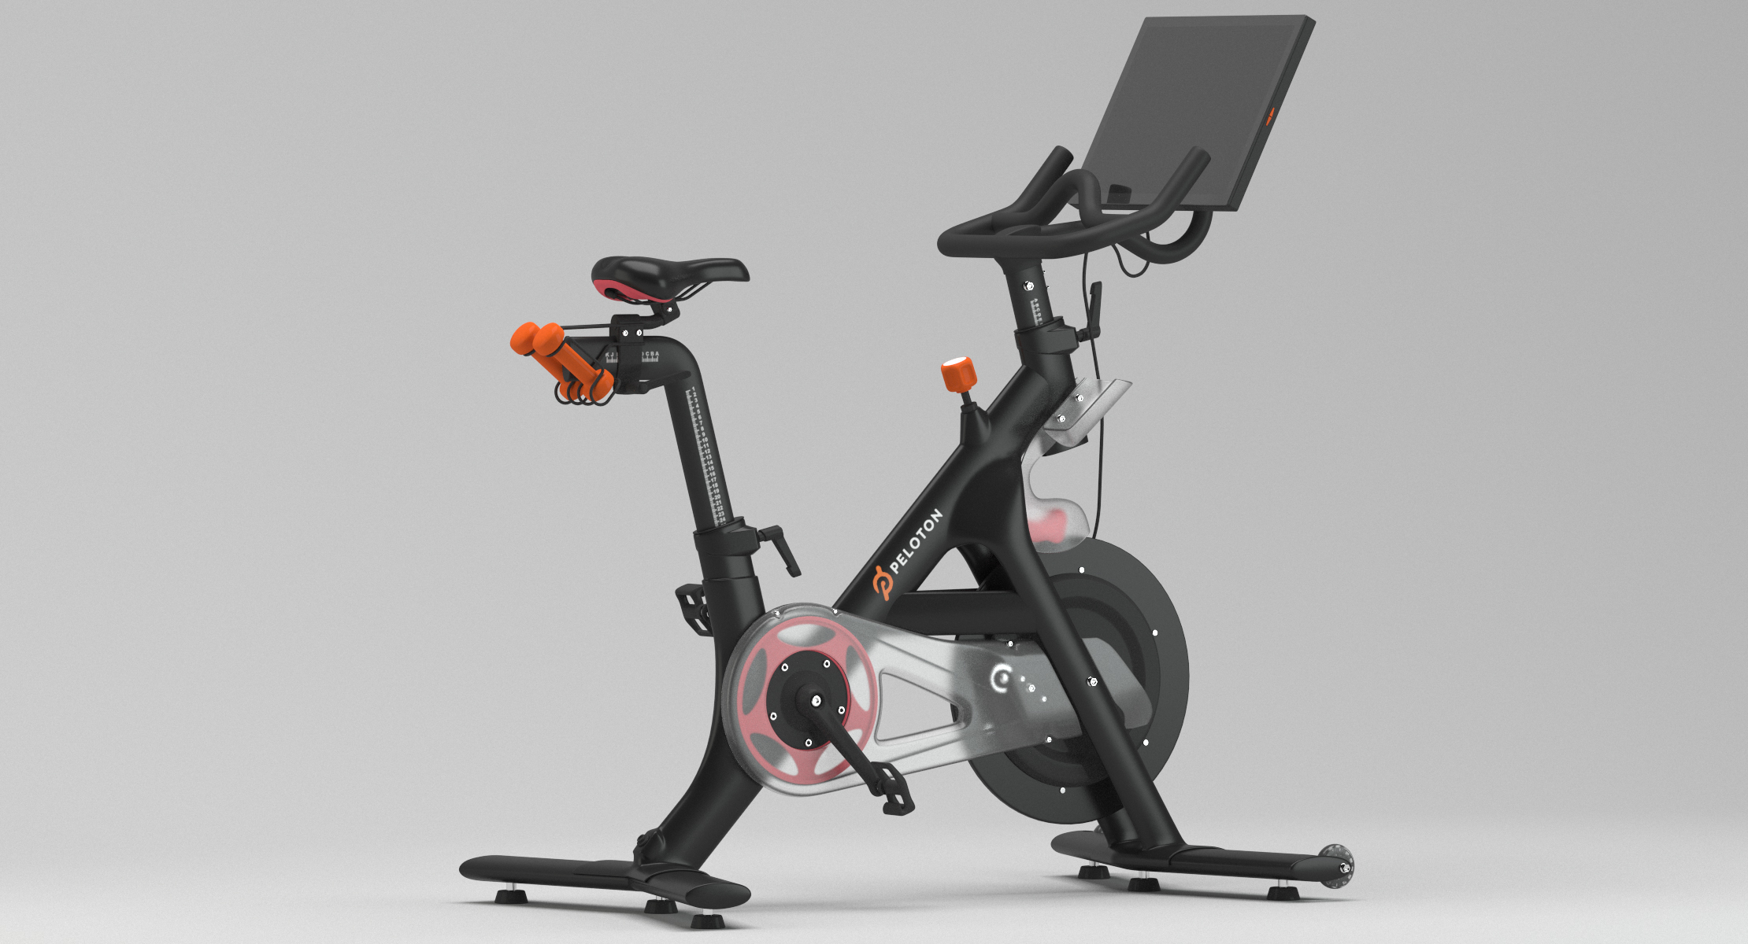

Figure 1. Peloton Bike

I found a fitness product called Peloton bike, which is a kind of single bike model fitness machine. It has the structure of a traditional bicycle, a triangular bracket to stabilize the entire machine, and a liquid crystal display equipped with an Apple or Android system. The majority of users of this product are young fitness enthusiasts, mostly aged between 17 and 30, with fewer users in other age groups. This product can be used to simulate cycling for fitness purposes, and can be placed in a gym or user's home. The product itself is not particularly heavy, so moving its location is more convenient than other fitness machines. It also has internal exercise teaching courses that can guide new users how to use this kind of machine.

However, this product has many inconveniences. Firstly, due to the need to connect power to the product, there are significant restrictions on the placement of the product, most of which can only be placed next to the wall. Secondly, the display interfaces are quite complex, and new users need a long time to remember the method of using this machine, which violates the principle of learnability. Moreover, the icons of the interface are small, making it difficult to use while riding. Thirdly, there are too many parts for this fitness equipment and it requires manual assembly, for beginners, it takes a lot of time to assemble. Even with packaged transportation services, greater damage probability and additional costs can also lead to a decline in the user's experience. Fourth, the product does not have a voice function, and when users complete their exercise goals, the product cannot provide timely reminders. Fifth, the product, such as the grip, does not have waterproof or absorbent measures in the areas that come into contact with the skin, and cannot respond well to the sweat generated after prolonged exercise. Finally, the seat position cannot be adjusted, resulting in significant differences in the user experience of users with different body types, and making the distance between the display screen and the user can’t use such screen conveniently, resulting in many negative comments about this product.

I have collected feedbacks on this fitness product from users of different body types online: The people which is smaller compared to this fitness product believe that this fitness device cannot adjust the height of the seat, making it too far away from the display screen to use the functions of the system while riding; Tall people think they need to bend over for a long time to use the system, which makes their waist ache. The most feedback is that the riding posture of this product is different from the user's posture when using a bicycle on daily life, which makes the user too tired.

Regarding how to solve these problems, I think it is necessary to simplify the interface and add more guidance to enable users to quickly get started with the use of this fitness system, and in the future, there is no need to learn again. Increase the icon size and reduce useless screen blank of the system. Also, reduce the number of parts for easy assembly and necessary waterproof measures. The most important thing is to change the seat to an adjustable seat, and then add more adjustable joints on the machine, then users can change the seat position and height according to their own habits.

## Case 2 – Hexoskin Smart Shirt

|  |  |
| --- | --- |
| Led by | Jingcheng Li & Tianxing He |
| Participants | Xinyuan Zhang, Yifei Shen |



Figure 2. Hexoskin Smart Shirt.

The Hexoskin Smart Shirt is a smart fitness shirt that records the user's health data in real time and transfers it to a mobile phone or computer app to generate a data report of the user's workout. While this technology can offer many benefits to people's fitness and health, the Hexoskin Smart Shirt still suffers from some unfriendly design issues from a human-computer interaction point of view.

Firstly, the Hexoskin Smart Shirt requires the product to be held close to the user's body to collect data. However, this may be an unreasonable and uncomfortable design for some users. This tends to restrict the user's movement during fitness and exercise, leading to substandard movements and even some injuries.

Secondly, the Hexoskin Smart Shirt is not intuitive to use compared to other wearable fitness devices. Users need to download the corresponding app and pair it with the device, a complicated process that may be a challenge for users who are not familiar with the technology. In addition, the Hexoskin Smart Shirt can be worn differently than a typical shirt, which may also be a deterrent for users.

Thirdly, the Hexoskin Smart Shirt's data reporting can be confusing for users. Although it can provide detailed information about health and exercise data, this information may not be understood or needed by all users. This results in the user taking some time to understand the data reports.

In response to its unfriendly design, we have also discussed some suggested solutions to change the user experience of interacting with it as follows. Firstly, the shirt should offer more adaptable options, such as adjustable straps or waistbands, to suit different body types and needs, thus allowing users to wear the Hexoskin Smart Shirt more comfortably for exercise and fitness.

Secondly, manufacturers could offer a simpler pairing and set-up process and provide easier-to-understand data analysis and reporting features to help users better understand and utilise the data. Alternatively, manufacturers could provide some detailed instructions as well as live video demonstrations, which would help users better understand and use the product.

Finally, the Hexoskin Smart Shirt could be integrated with other devices, such as smart watches or smartphones, with some real-time reporting such as voice broadcasting to provide more data reporting and a more user-friendly experience. To do this, manufacturers can work with other device manufacturers to achieve better integration.

Since smart wearable devices are not indispensable in the process of fitness, it is still difficult to make them stand out from other means such as buying fitness classes and using fitness software. Hexoskin Smart Shirt is just one specific example of a wearable device, but there are still many potential drawbacks that have not been fully revealed in short-term use

## Case 3 – Keep

|  |  |
| --- | --- |
| Led by | Xi Kong |
| Participants | Tianxing He, Ziyang He |

(*<http://www.gotokeep.com>)* Keep is a comprehensive fitness app that provides users with a range of workout options, personalized meal plans, and a supportive community to help them reach their health and fitness goals. With its user-friendly interface and easy-to-follow routines, Keep is an excellent choice for anyone looking to establish a healthier lifestyle.

|  |
| --- |
|  |
|  |  |

Figure4. The purpose of using Keep

Keep performs very well in the design of UI interface, most of the colours are white and purple, the fonts are the same, all buttons are informative feedback and their functions are clear, and the layout is neat and refreshing. Each interface is very instructive and reversible, users can control their own page.

However, there are still some defects in the functional design of the product. In our survey of Keep users, it was revealed that a mere 14% of individuals employ the application for muscle hypertrophy, with the remaining majority opting for yoga or cardiovascular routines. Following the interrogation of several muscle hypertrophy users, we gleaned that Keep is of limited benefit to them. They would rather expend more resources on hiring a personal trainer, as it proves more efficacious. Keep merely furnishes users with a training regimen, whilst assisting them in devising their repetitions and exercise duration. However, it does not possess the capability to gauge the user's actual exertion or movement quality, and any deviation from standard execution can considerably diminish the training effect. Moreover, for user convenience, Keep has forgone the incorporation of any supplementary monitoring devices. As such, we propose the development of an adjunctive fitness patch, which is capable of detecting muscular contraction. When affixed to the region undergoing exercise, the system can ascertain whether the user's movements and force are within normative ranges. In instances where deviations arise, voice prompts can advise users on the necessary adjustments to be made, effectively supervising and optimizing their training experience. After the workout is complete, the system will use the data returned by the patch to calculate when the user is exhausted and what weight is appropriate for the area at this stage. The next training and more accurate scientific plan. This not only makes the user more efficient in training, but also saves the money of the expensive personal trainer.

All in all, Keep is a user-friendly fitness app that offers personalized meal plans, a supportive community, and various workout options. However, it has limited benefits for users seeking muscle hypertrophy. To enhance the user experience, a fitness patch that can detect muscular contraction should be developed, helping to supervise and optimize the training experience.

## Case 4 – Fitbit Charge 2

|  |  |
| --- | --- |
| Led by | Xinyuan Zhang |
| Participants | Yifei Shen, Xi Kong |

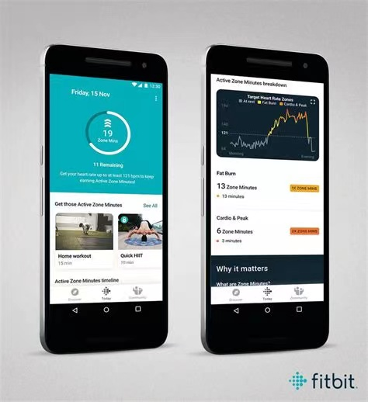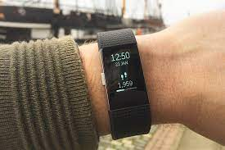

Figure 4. Fitbit Charge 2

Fitbit Charge 2 is a multifunctional fitness wristband. It monitors the user's fitness level through personalized cardio scores and tracks exercise throughout the day. To compensate for the small display on the wristband, it also has a corresponding mobile APP to synchronize various data in real-time and to better visualize the data. In addition to its powerful functions, its outstanding design is also loved by trendsetters. It can be said that this product has captured the desire of white-collar people who are keen on physical activity.

However, this product can still be improved in terms of interaction design according to Heuristic evaluation.

The most important issue is the poor visibility of system status. Firstly, the study found that users could not tell if the device was in "off" or "tracking" mode and that the device did not provide feedback to the user on its status, which led to doubts about the accuracy of the system[3]. New users may be confused when exploring the use of the wristband. Besides, this is detrimental to establishing the user's reliability of the data displayed by the product because users cannot be sure whether their workout is being recorded. Therefore, one available solution is to give the user feedback through vibrations so that they know whether their workout is being tracked or not. Secondly, due to the slow synchronization of wristband and mobile app, the app often has a long blank screen when opened. However, there is no message such as "Data is being synchronized, please be patient". The long blank screen may cause suspicion to users. We interviewed 10 people about their suspicion of a blank screen, and more than half of them thought the network was broken which does not correspond to the actual situation. By observing the interviewees' expressions, all of them showed varying degrees of annoyance and confusion about the blank screen. One interviewee even complained that this phenomenon is very harmful to a brand that goes upscale. Therefore, it is essential to provide users with timely feedback on the status of the system.

Another principle it violates is “user control and freedom”. The wristband is missing a pause function that allows the user to pause for a short period of time during movement. According to a two-hour observation of nearly 50 people who ran at night in the school playground, close to eighty percent of the observed people stopped during the run. They either tied their shoes, or drank water, or relieved their fatigue by walking during the run. From the observations, it is clear that users need a tap-to-pause option which is not available for Fitbit charge 2.

All in all, Fitbit Charge 2 is a fitness-assisted wristband with a minimalist design and takes the light luxury route. It is a product that will please most users and help them stay fit. But at the same time, it needs to be improved in terms of visibility of system status and user control and freedom.

## Case 5 – Name

|  |  |
| --- | --- |
| Led by | Yifei Shen |
| Participants | Ziyang He, Jingcheng Li |

The Apple Watch 8 has been positioned as a premium fitness and health tracking

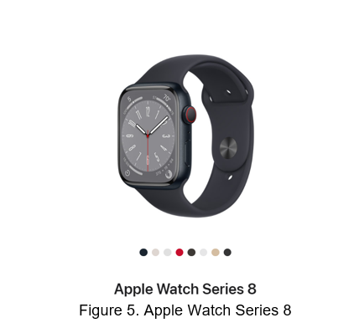device that is designed to provide accurate sports tracking and feedback to its users. It boasts of advanced sensors such as heart rate monitoring, sports trackers, accelerometers, and gyroscopes, which enable it to offer users comprehensive sports data analysis and feedback. Compared to other fitness trackers like the Mi Band, the Apple Watch 8 places a greater emphasis on fashion and high-end design, offering users an intelligent sports monitoring experience.

However, despite its many advanced features, the Apple Watch 8 falls short in meeting the needs of its target fitness audience in some ways. According to user feedback, there are some design issues that need to be addressed, such as poor system status visibility and the inability to monitor a user's exercise posture and provide targeted improvement suggestions. These problems can be particularly frustrating for fitness enthusiasts who rely on their devices for accurate and comprehensive tracking of their physical activity.

One of the most significant design problems with the Apple Watch 8 is its poor system status visibility. Users have reported difficulty in accurately knowing the status of their exercise, such as whether the synchronization was successful or if the exercise has started. To address this problem, Apple can consider improving the visibility of system status by using larger fonts, providing easy-to-find adjustment options, using high-contrast colors or animations to draw user attention.

Another problem that the Apple Watch 8 faces is its inability to monitor the user's exercise posture and provide corresponding improvement suggestions. This makes it challenging for users to get effective guidance and help when exercising. One way to solve this problem is by interconnecting the Apple Watch 8 with other wearable devices to monitor the user's exercise posture. An alarm can be issued when necessary to remind the user to adjust their posture, enabling them to maintain proper form during their workout sessions.

To further enhance the user experience, the Apple Watch 8 needs to simplify its function design and provide more personalized sports data analysis and improvement suggestions. This will help users avoid getting lost in the many functions of the device and provide them with more targeted feedback. For example, the device could provide users with personalized recommendations for workouts based on their fitness goals, current fitness level, and activity history.

Finally, Apple needs to pay attention to the matching degree of the device with the real world in its design. Providing more accurate, comprehensive, and personalized sports data analysis and feedback will help users better achieve their fitness goals. The device can offer users suggestions on how to adjust their workouts to fit their schedule, helping them to stay on track with their fitness goals.

In conclusion, the Apple Watch 8 is an advanced fitness and health tracking device that has the potential to meet the needs of fitness enthusiasts. However, to truly meet the needs of its target audience, Apple must address the device's design problems, improve system status visibility, simplify function design, and provide more personalized feedback. By doing so, the Apple Watch 8 can become an even more valuable tool for users looking to improve their fitness and overall health.

## Conclusion

After the process above, we have analysed the various products for their poor design and made suggestions for improvement. Through a cross-sectional comparison of the hardware devices, we identified some common shortcomings: inaccurate data recording, a complex interface design and lacking reminder for users. These unfriendly designs have given us a list of problems that need to be avoided in our hardware design. We need to further develop a user-centred, user-friendly interface and interaction for our fitness assistance system. Similarly, the unfriendly design of Keep, which is lacking of customization and personalized guidance also reminds us of the need to focus on different target users and to adapt the software's functionality to respond to different user needs.

Therefore, for our project, in order to design a system that combines hardware monitoring and software interaction, we need to take into account the advantages of the above-mentioned products, because they are widely accepted in the market, but also to avoid their unfriendly design, in order to achieve better integration and compatibility.

## References

[1] Ben Shneiderman. (n.d.). Eight Golden Rules of Interface Design. Retrieved from <https://www.cs.umd.edu/users/ben/goldenrules.html>

[2] Morris, S. (2019, April 26). Don't spend money to be fit: Here's how to exercise on a budget. CNET. Retrieved from https://www.cnet.com/health/fitness/dont-spend-money-to-be-fit-heres-how-to-exercise-on-a-budget/

[3] Irwin, C., & Gary, R. (2022). Systematic Review of Fitbit Charge 2 Validation Studies for Exercise Tracking. *Translational Journal of the American College of Sports Medicine, 7*(4), 1-7. doi:10.1249/tjx.0000000000000215