**Main code:**

import perfect

n = int(input("Enter number: "))

d = {1:perfect.GenerateFactors(n), 2:perfect.isPrimeNo(n), 3:perfect.isPerfectNo(n)}

try:

choice = int(input("Choose 1 to see factors of number:\nChoose 2 to check if number is prime:\nChoose 3 to check if number is perfect:\n"))

except: **output**

print("Invalid choice!")

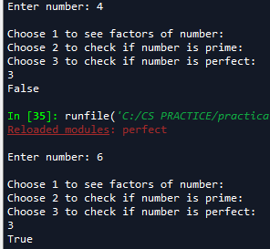

print(d[choice])

**perfect.py**

def GenerateFactors(n):

factors = []

for i in range(1, (n//2) + 1):

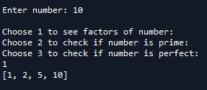 if n % i == 0:

factors.append(i)

factors.append(n)

return factors

def isPrimeNo(n):

return (len(GenerateFactors(n)) == 2)

def isPerfectNo(n):

return (sum(GenerateFactors(n)) == n * 2)