App foundation

1. Let’s structure our app by creating the following folders:

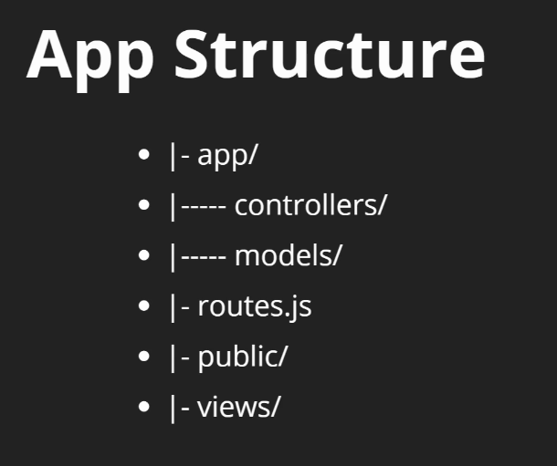

This is what our Folder App structure looks like:

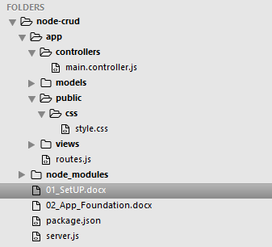

1. Back in our ‘server.js’ file, we don’t want to set our routes in that file, but in ‘route.js’ file instead. So in our code we will require it with the following line of code.

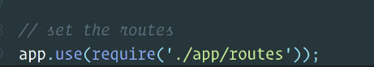

And that code will bring all the routes from that special file

1. Then in the ‘route.js’ file we’ll create a brand new express router, and that’s good practice to keep all of our routing separate from our ‘server.js’ file.
2. Next we export it, that way we can require it over in the ‘server.js’ file
3. Then we can define routes, with the same code that we first used to get a response in our browser.

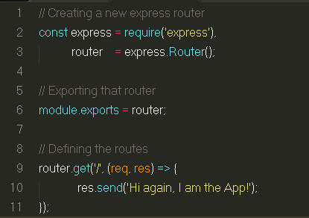

1. We are going to go a little bit more modular, when we look at our router above, we can see that we have functionality here.
2. The ‘route.js’ file is only supposed to route our application and not the actuall working of our application with requests and responses.
3. So we’ll take that functionality of router.get and move it to ‘main.controller.js’ file instead.
4. In ‘main.controller.js’ file we’ll export an object, and create a new function called ‘showHome’ with the request and response parameters, and their functionalities.

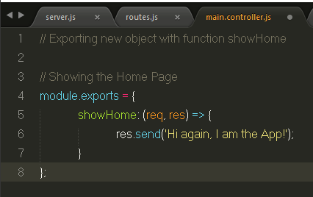

10.Now we can import this controller inside our ‘routes.js’ file, and we will call it ‘mainController’.

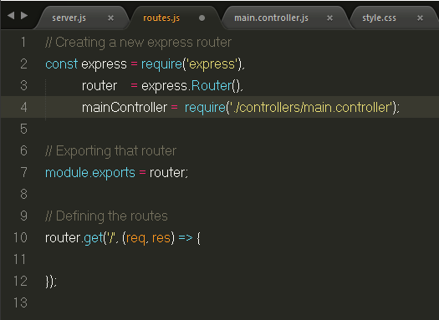

11.Now instead of doing the functions (req,res) => above,

We’ll do a mainController.showHome

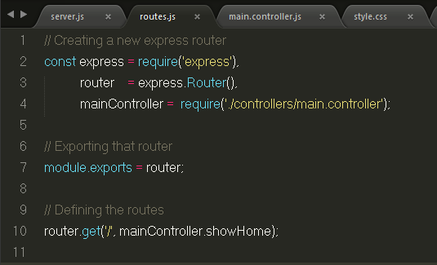

Now our ‘routes.js’ is strictly concerned with just routing,

Our functionalities have been moved to ‘main.controller.js’ file, and our ‘server.js’ file is mainly concerned with the setup of our application.

We have defined ways to structure our application:

* Functionalities go to => main.controllers
* Routing goes to => routes.js
* Server is pretty much for => configuration & loading