**LESTER JOHN P. GUMOGDA** 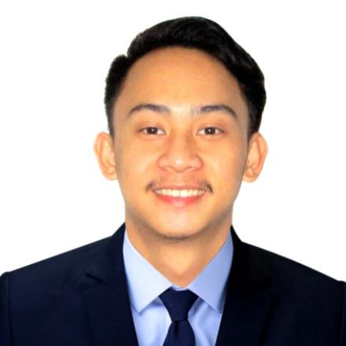

Address: 439-I San Rafael St, San Miguel Manila

Email:lj.gumogda11@gmail.com

Contact #:09564332682

**CAREER OBJECTIVE:**

To acquire valuable knowledge and skills to complement those I have learned from school in an actual job environment. I offer my services and determination to be part of your company throughout the duration of my training period

.

**EDUCATIONAL ATTAINMENT:**

GRADUATED :

**CENTRO ESCOLAR UNIVERSITY**

**BACHELOR OF SCIENCE IN INFORMATION TECHNOLOGY**

1001 San Rafael St. San Miguel,Manila, 1001 Metro Manila(2015-2019).

SECONDARY :

**DIVINE WORD COLLEGE OF VIGAN**

Burgos Street,Vigan City (2011-2015)

PRIMARY :

**SAN JULIAN ELEMENTARY SCHOOL**

San Julian Sur , Vigan City (2005-2011)

**SEMINARS ATTENDED:**

* **JPCS I.T. Workshop in Adobe Photoshop CS6; August 12, 2015**

**ISC, Centro Escolar University – Manila**

* **JPCS I.T. Workshop in VB.net; August 22, 2016**

**ISC, Centro Escolar University – Manila**

* **Introduction to Mobile Development using IOS; November 9, 2017**

**ISC Mezzanine, Centro Escolar University – Manila**

* **Game Design Journey: A Walkthrough of Experiences; November 9, 2017**

**ISC Mezzanine, Centro Escolar University – Manila**

* **Latest Trends in Technology (Data Science and Analytics); November 9, 2017**

**ISC Mezzanine, Centro Escolar University – Manila**

* **Mineski Infinity Level Up: Responsible Gaming and Careers in E-Sports; November 9, 2017**

**ISC Mezzanine, Centro Escolar University – Manila**

* **Autodesk Fusion 360; May 28 – 29, 2018**

**ISC, Centro Escolar University – Manila**

**Work Experience**

* **On the Job Training - SPICRM Global-Manila Inc.**
* **Technical Support**

**SKILLS SUMMARY**

* Work well with other people.
* Communication ability.
* Perform every task may be assign.
* Motivate to create high-quality work.
* Proficient in computer handling; experience in MS Office application(Word, Excel, PowerPoint)
* Work smoothly and handles work gracefully even under pressure.
* Technical Support - Hardware and Software
* Programming - Java , C++
* Web Development - PHP , HTML , JAVAScript

**CHARACTER REFERENCES**

ASHLEY TYRA T. BONAYON

Recruitment Assistant

ADDRESS: San Miguel , Manila

CONTACT NO. 09750148824

*I hereby certified that the mentioned above are true to the best knowledge and belief.*

_______________________

LESTER JOHN P. GUMOGDA

Applicant