INF2009 Image analysis lab
Student name: Lai Jun Hong Sakda
Student ID: 2302678

Experiments and Results
### 1. Basic Color Segmentation
- This experiment demonstrates RGB color segmentation
- The code captures video from webcam and segments it into red, green, and blue components
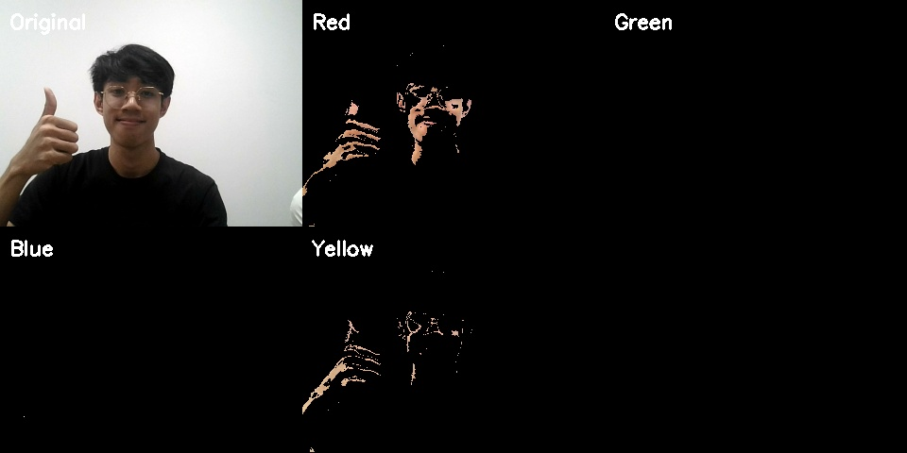

- RGB colour segmentation demonstration
- Shows original image and the different colour components

### 2. HOG Feature Extraction
- This experiment demonstrates Histogram of Oriented Gradients (HOG)
- HOG is used for edge detection and feature extraction

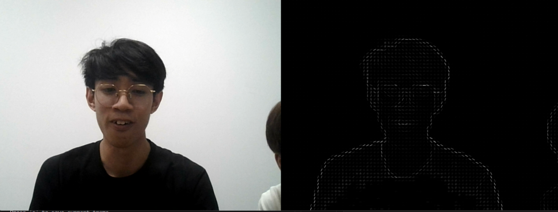
- Left: Original image,
- Right: HOG visualization
- Shows edge detection and feature patterns

### 3. Face Detection

- This experiment shows real-time face detection using MediaPipe
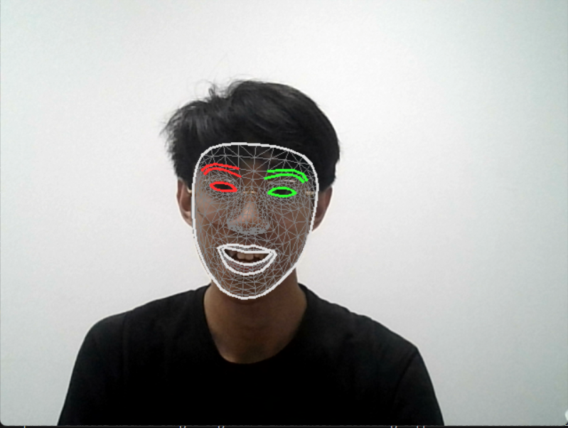
It shows basic face detection capabilities and also the differentiation between left eye and right eye as well as the different nodes to different points on the face.

### 4. Facial Landmarks Detection

- This experiment demonstrates detailed facial landmark detection
- Uses MediaPipe's Face Mesh for precise facial feature tracking
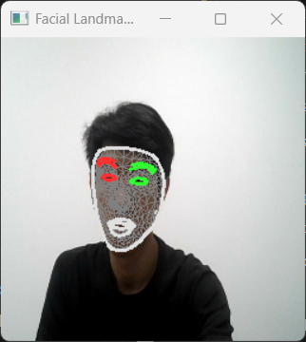
- Shows detailed facial mesh and contours
- Tracks 468 facial landmarks in real-time
5. Face position using HOG features, HOG features extracted at different resolutions to return the position of the face relative to the camera (left, centre, right)
