MSE NCC NMI

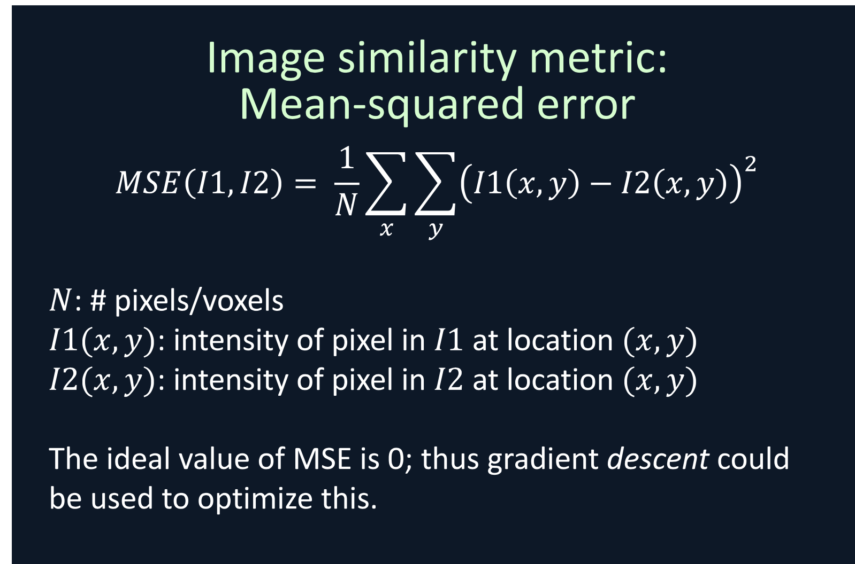 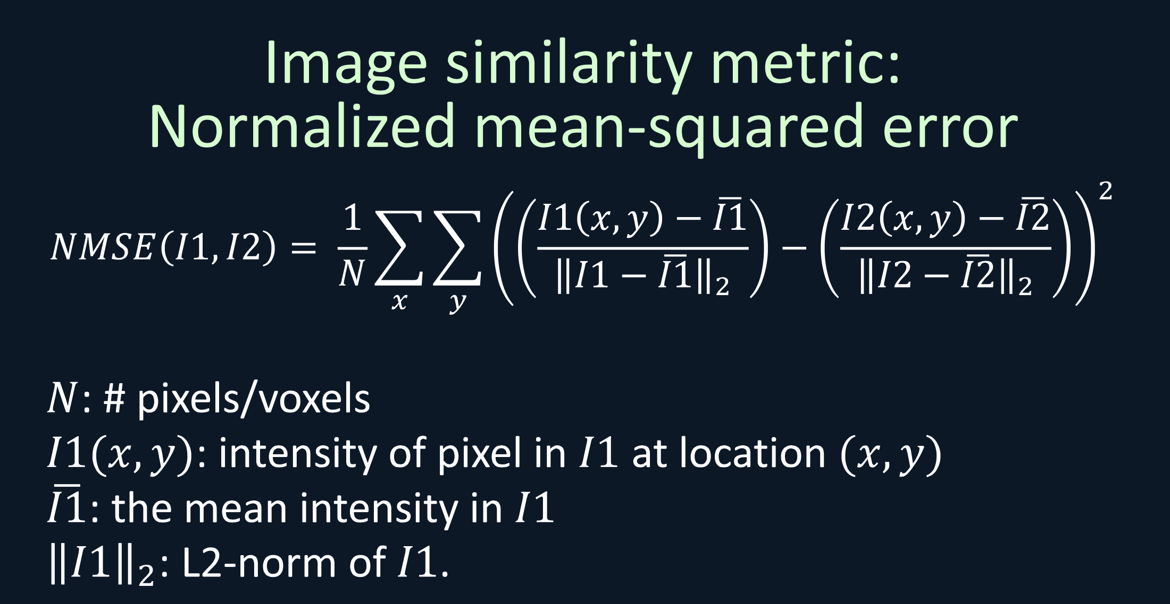

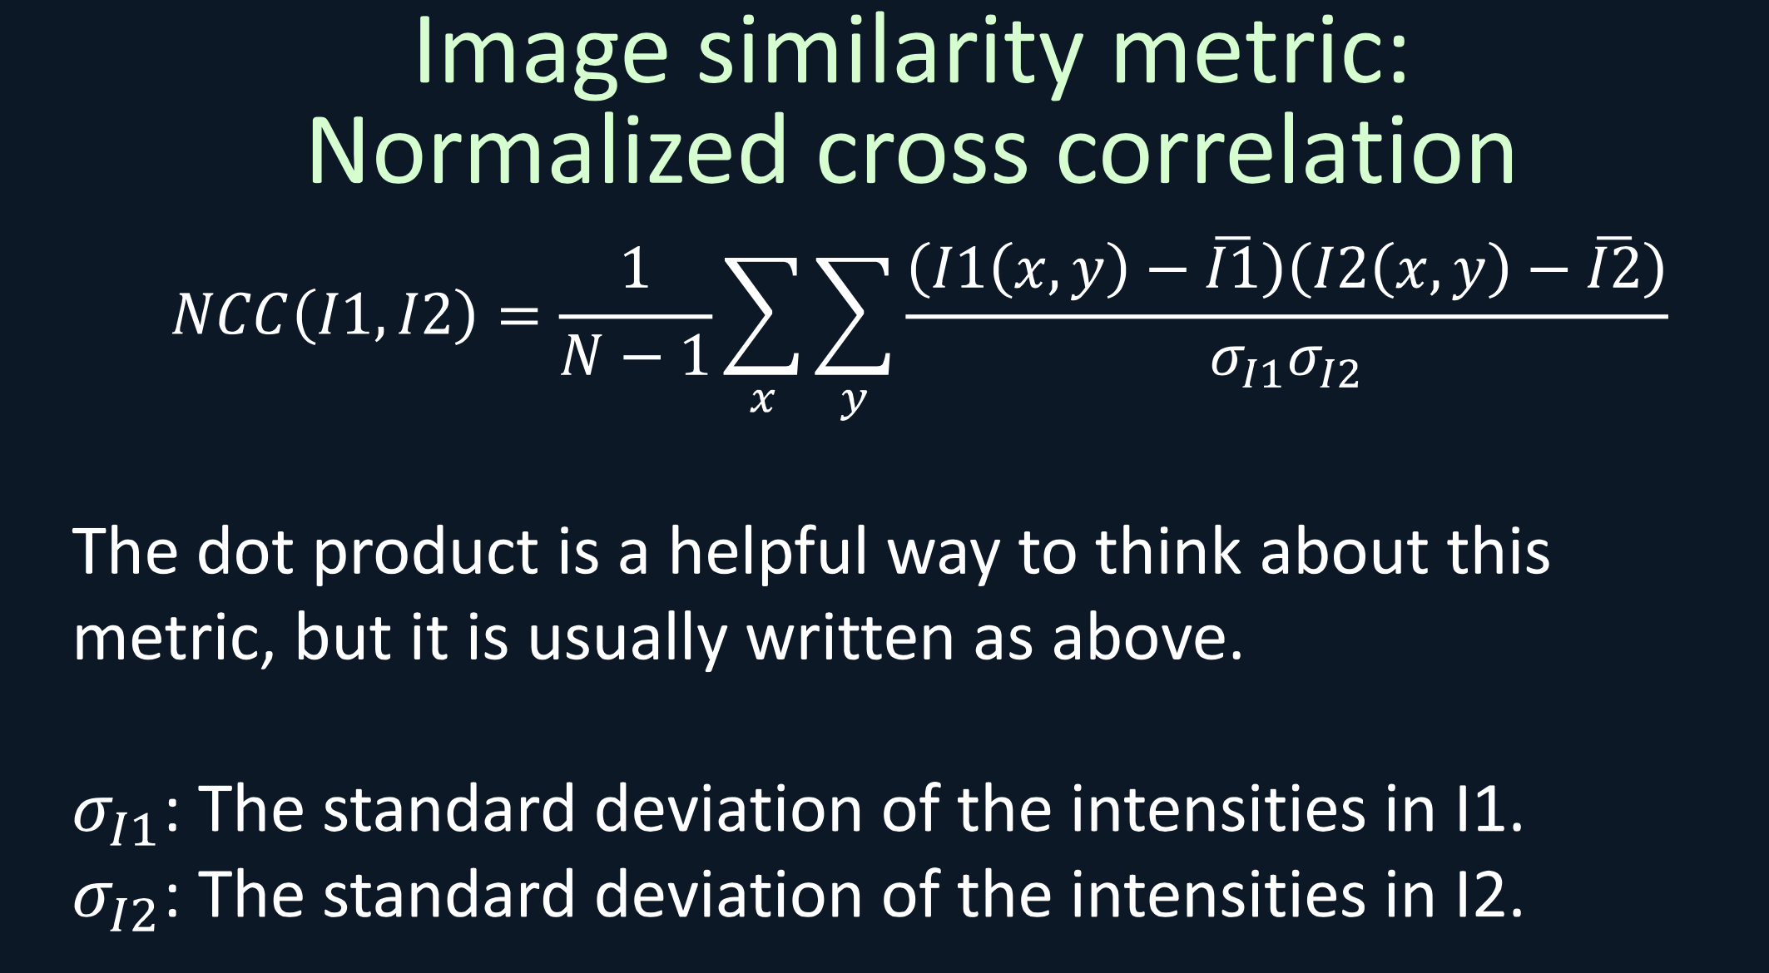

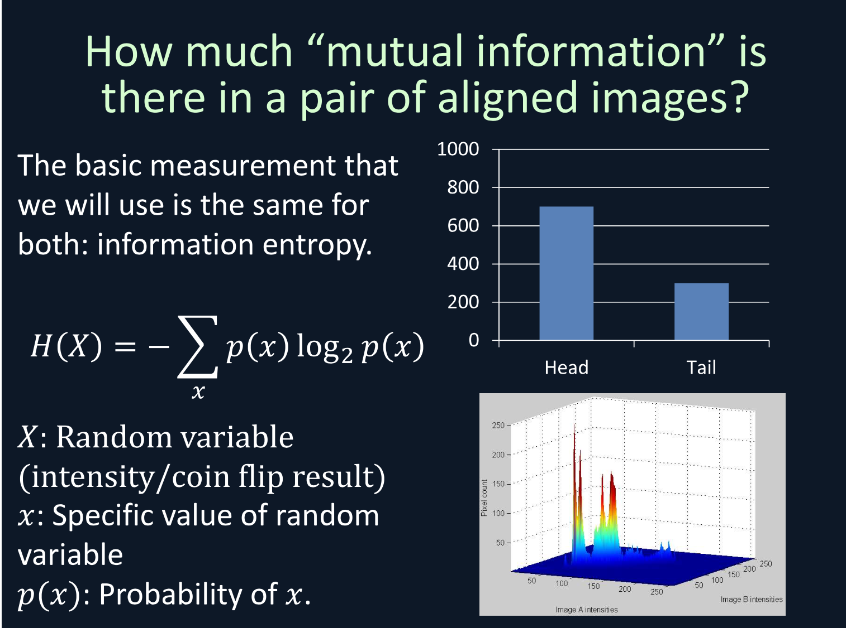 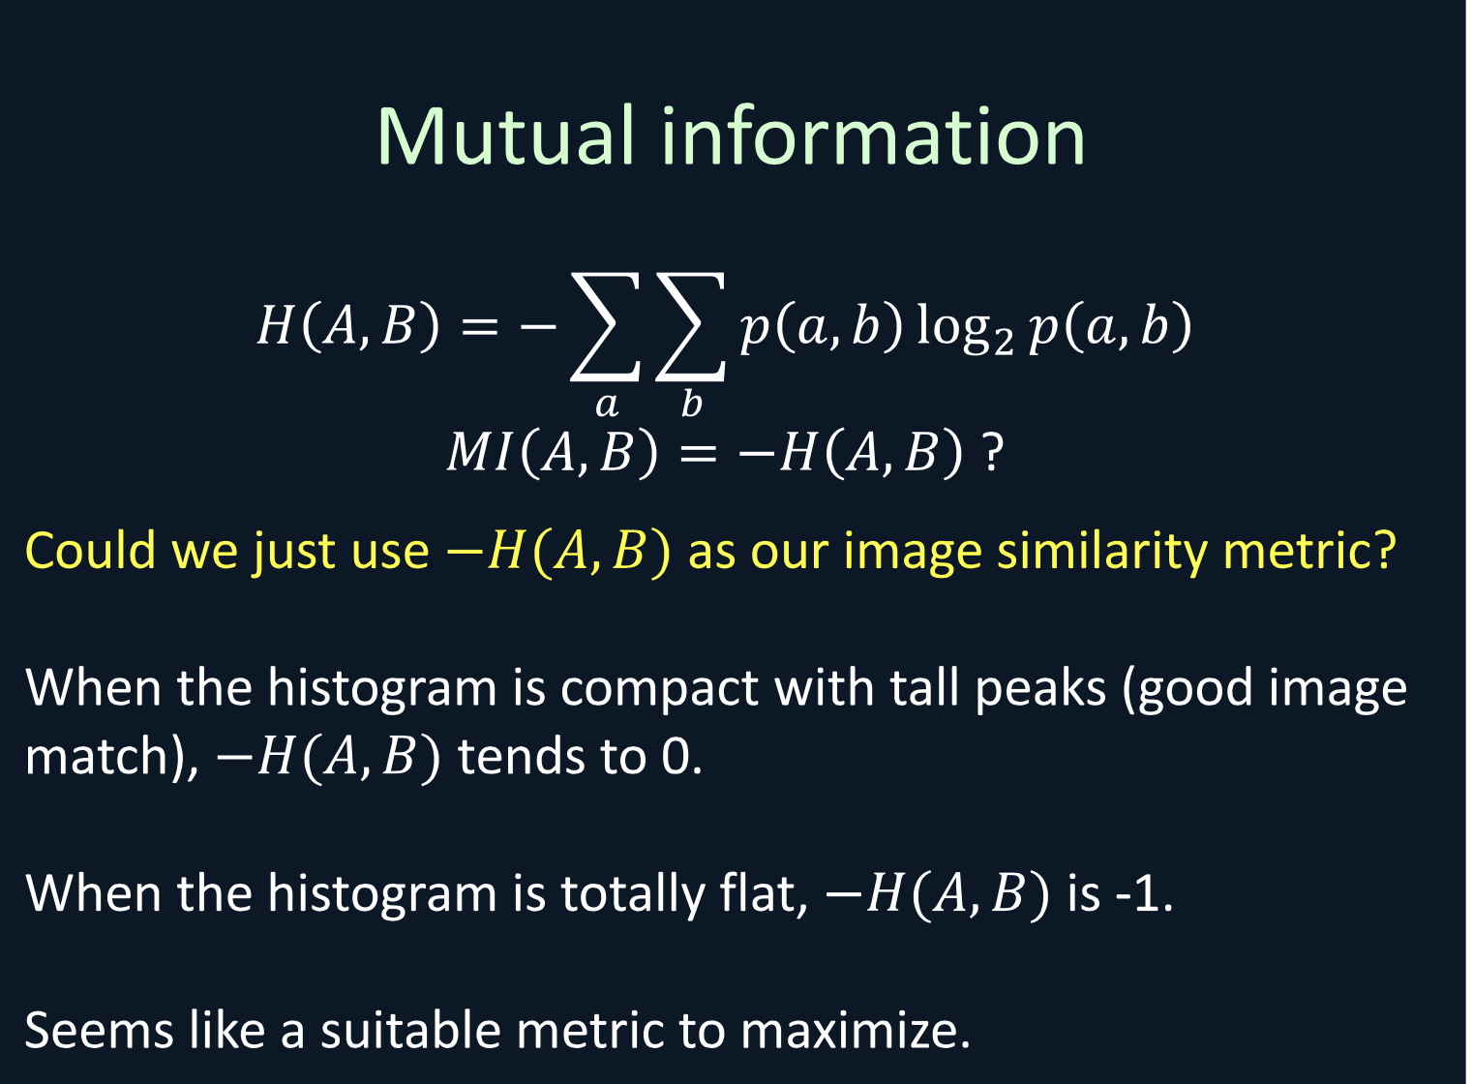

NMI: big is better. Flat is 1, bad and tail peak compact is better,0 , like the coin

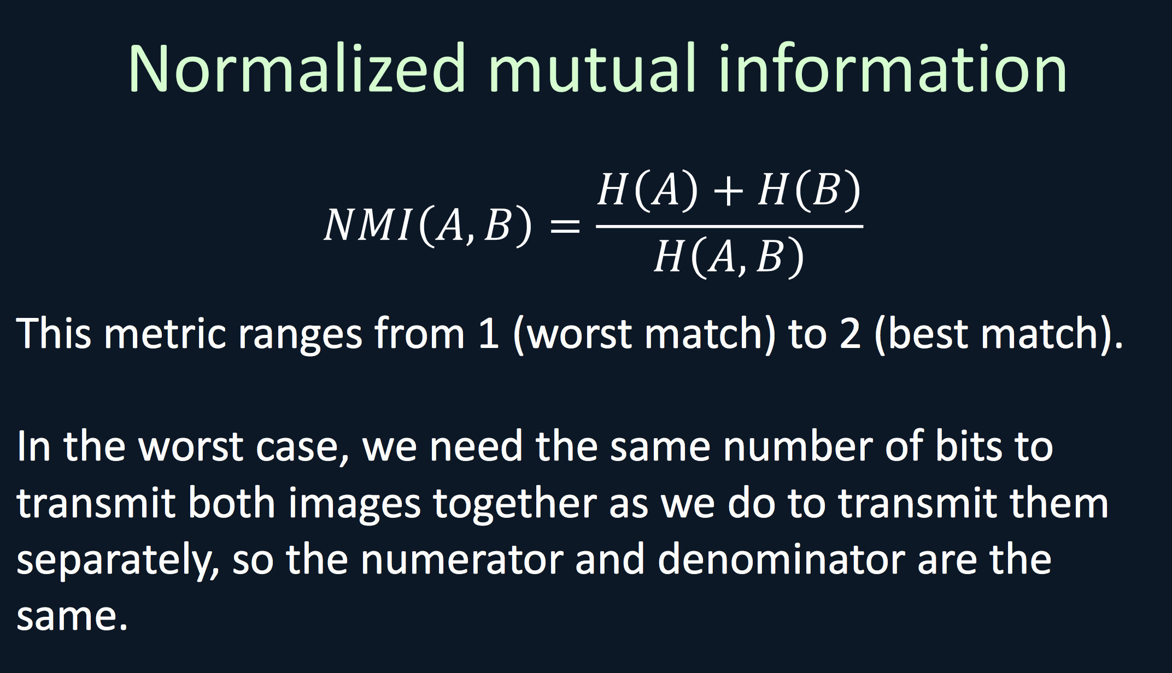 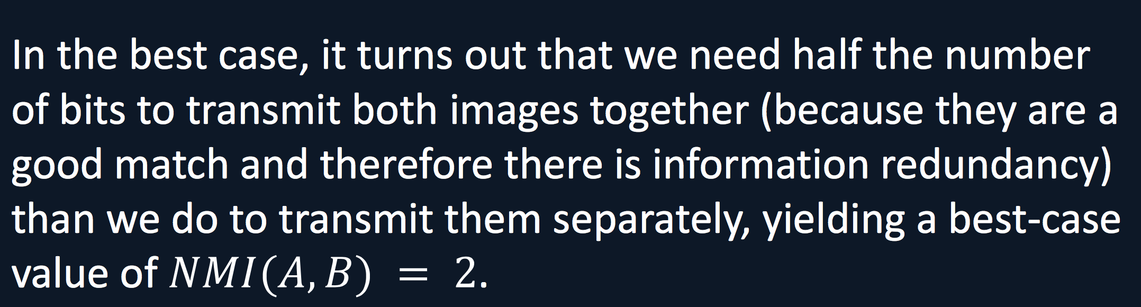

NMI bigger is better.

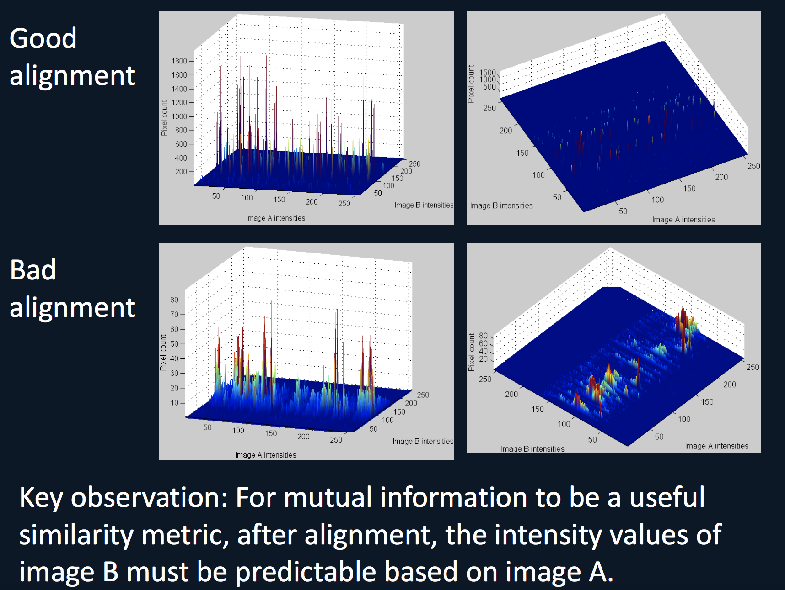 NMI may be suitable if the intensities in the fixed image can be predicted based on the intensities in the correctly aligned moving image.

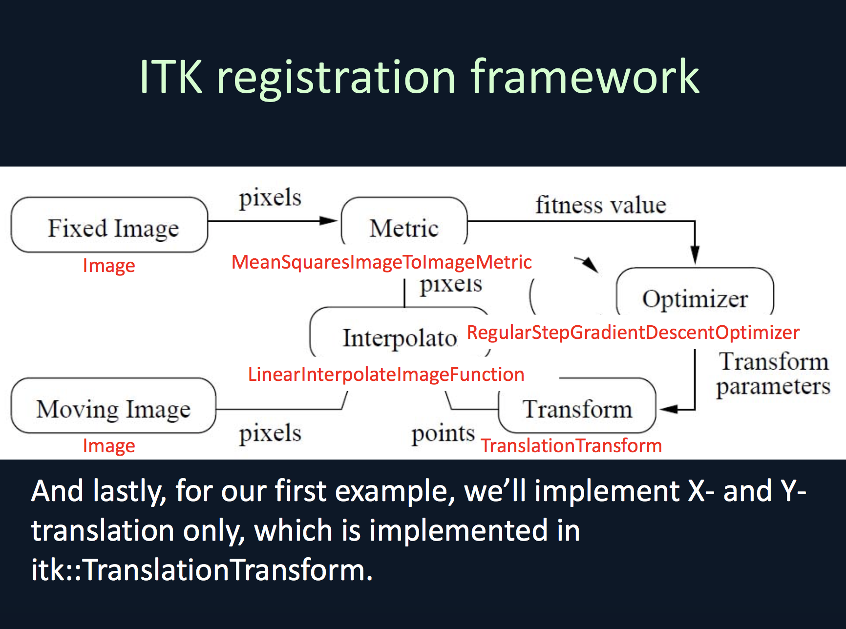 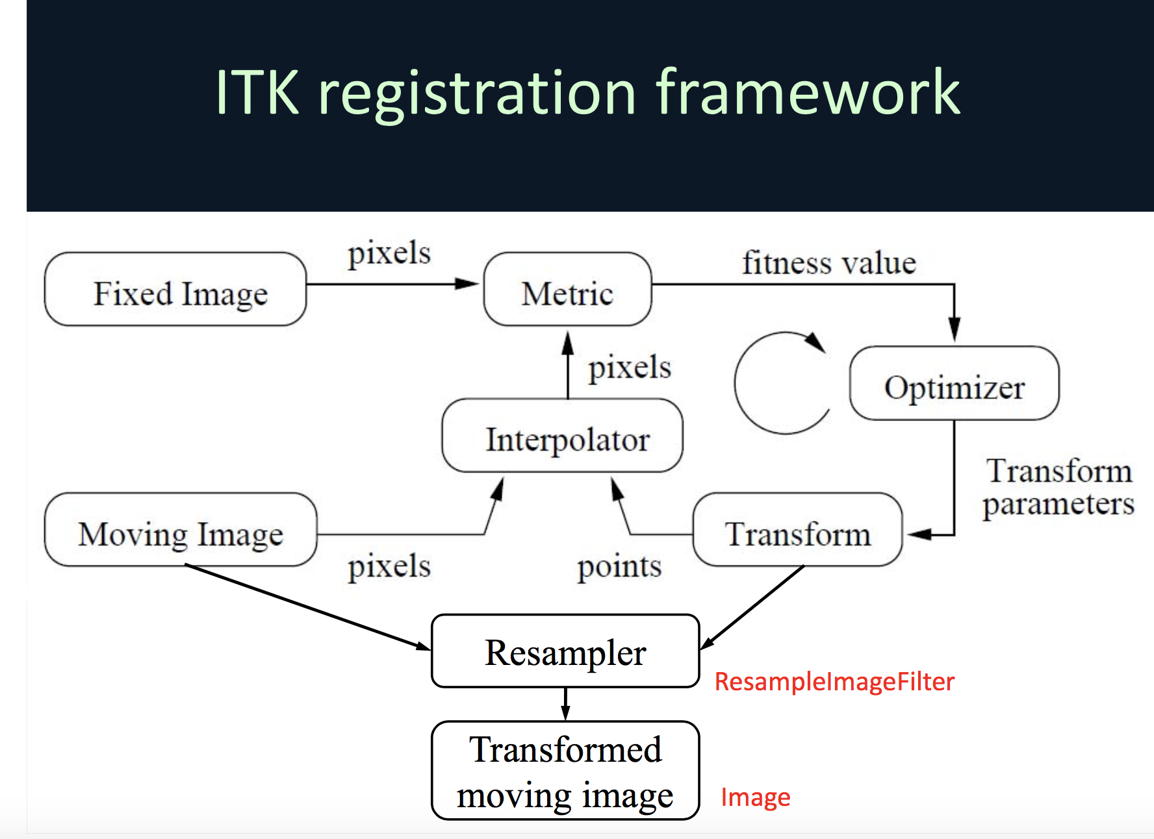

结束之后

13:

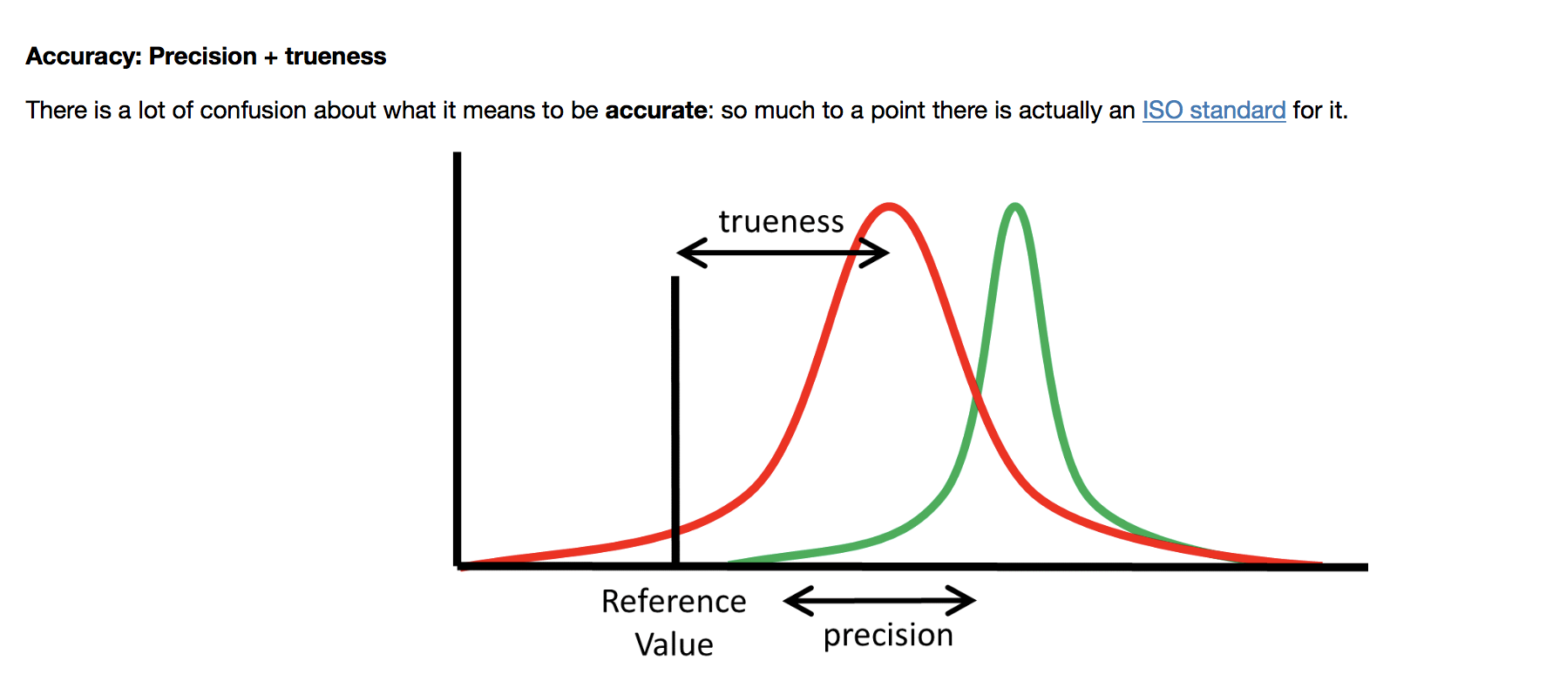 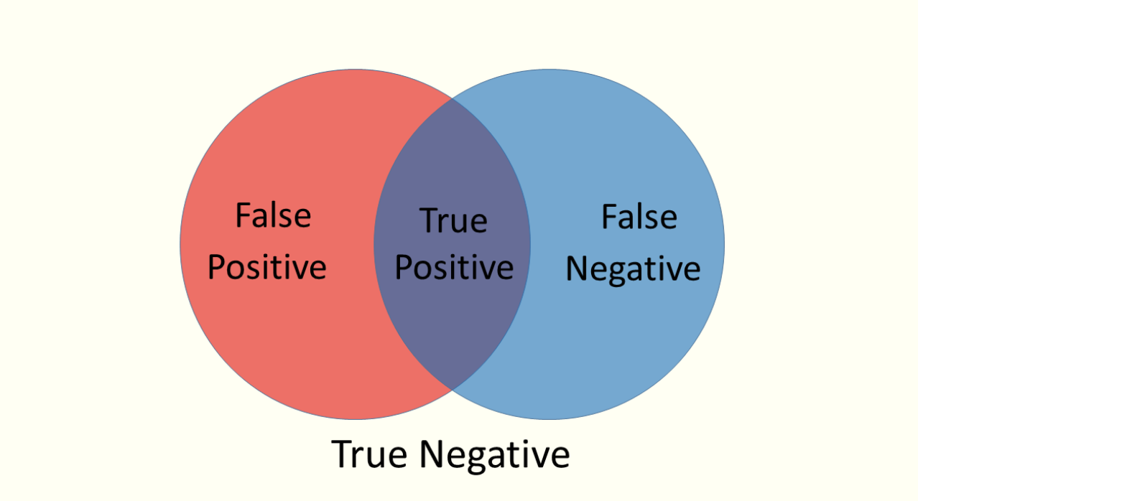

Thus, **Sensitivity**, or True Positive Rate, is the extent to which true foreground pixels are correctly identified (so false negatives are few).  **If the segmentation is sensitive, then it is good at identifying the foreground pixels.**

Specificity, True Negative on the other hand, relates to how good a segmentation at identify the background pixels. It is the proportion of known background pixtures (True Negative) to those evaluated to be background.