软件学院2023-2024学年度第一学期
《软件设计综合实践》实验报告

班级： | 软件2201班
学号： | U202217182
姓名： | 李俊辉

目录
1. 实验内容和要求 7
2. 斐波拉契数代码 7
3. 词法分析程序 7
3.1 主要设计和实现思路 7
3.2 词法分析程序代码 7
3.3 实验演示 7
4. Lex文件 7
4.1 Lex输入文件代码 7
4.2 实验演示 8
5. BNF描述 8
6. 语法分析程序 8
6.1 主要设计和实现思路 8
6.2 递归下降语法分析程序代码 8
6.3 实验演示 8
7. 语义分析程序 8
7.1 主要设计和实现思路 8
7.2 类型检查语义分析程序代码 8
7.3 实验演示 9
8. 实验总结 9

实验内容和要求
- 用C--语言写一个函数计算第n（从标准输入获得）个斐波那契数，并将计算结果输出到屏幕；
- 用C语言设计和实现C--语言的词法分析器，并对输入的C--代码输出词法分析扫描结果;
- 书写C--语言的Lex输入文件，并用Lex生成C--语言的词法分析器；
- 参照实验参考书中附录A中给出的C Minus语言的BNF语法，给出C--语言的BNF语法描述；
- 用C语言设计和实现C--语言的递归下降语法分析器，并对输入的C--代码输出语法树。
- 用C语言设计和实现对C--语言进行符号表构造和类型检查的语义分析程序。

斐波拉契数代码
int fibonacci(int n) {
int m=n,num1,num2,num,i;
num1=1,num2=1;
if(m==1)return num1;
else if(m==2)return num2;
else if(m>2){
for(i=2;i<m;i++){
num=num1+num2;
num1=num2;
num2=num;
}
return num;
}
}
int main(){
int i,num;
i=intput();
num=fibonacci(i);
output(num);
}

词法分析程序

主要设计和实现思路
首先设置3个变量：
- token用来存放构成单词符号的字符串；
- sum用来整型单词；
- syn用来存放单词符号的种别码。
- 关键字符做特殊处理，将其放入二维数组中
char *reserveword[6] = {"int", "if", "else", "while", "void", "return"};
用getchar（）函数读入下一个字符
用Retract（）函数回溯到上一个字符
用GetBC（）函数将所有的字符读入到chSTeam[]中
Solve函数判断类别首先用Isletter函数判断第一个是否为字母，若是则可能是关键字或者标识符，再将字符串与所保存的关键字对比判断是否为关键字；否则继续用IsDigit判断第一个字母是否为数字，若是则为标识符；否则则为运算符或界符，对于不同符号给出相应的syn值。
最后在main函数中做输出

词法分析程序代码
#include <stdio.h>
#include <string.h>
#define MaxSize 1000
char *reserveword[6] = {"int", "if", "else", "while", "void", "return"}; // 关键字表
char ch;
char chStream[MaxSize]; // 缓存输入的字符流
char strToken[MaxSize]; // 字符数组，存放构成单词符号的字符串
int p, syn, sum; // 搜索指针 种别码和整型常数
// 子程序过程，把下一个字符读入ch中
char GetChar(int *p)
{ return chStream[(*p)++];}
// 跳过空白符，直至读入一个非空字符
char GetBC(int *p)
{
while(chStream[*p] == ' '){
(*p)++;
}
return chStream[(*p)++];
}
// 判断是否为字母
int IsLetter(char c)
{
if((c >= 'a' && c <= 'z') || (c >= 'A' && c <= 'Z')){
return 1;
}
return 0;
}
// 判断是否为数字
int IsDigit(char c)
{
if(c >= '0' && c <= '9'){
return 1;
}
return 0;
}
// 搜索指针回调一个字符位置
void Retract(int *p)
{
(*p)--;
}
// 运算符和界符的判断
void solve(int *p)
{
memset(strToken, 0, sizeof(strToken));
ch = GetBC(p); // 跳过空白符，直至读入一个非空字符
if(IsLetter(ch)){ // 第一个是字母，则可能是关键字也可能是标识符
int idx = 0;
while(IsLetter(ch) || IsDigit(ch)){
strToken[idx++] = ch;
ch = GetChar(p);
}
// strToken[idx] = '\0';
Retract(p); // 搜索指针回调一个字符位置
syn = 10; // 先默认是标识符，接下来再判断是否为关键字
for(int i = 0; i < 6; i++){
if(strcmp(strToken, reserveword[i]) == 0){ // 与关键字相比较
syn = i+1; // 获取对应关键字的种别
break;
}
}
}
else if(IsDigit(ch)){ // 第一个是数字
sum = 0;
while(IsDigit(ch)){
sum = sum * 10 + (ch - '0');
ch = GetChar(p);
}
Retract(p);
syn = 11;
}
else{
switch(ch){
case '+': syn = 13; strToken[0] = ch; break;
case '-': syn = 14; strToken[0] = ch; break;
case '*': syn = 15; strToken[0] = ch; break;
case '/': syn = 16; strToken[0] = ch; break;
case ':':
syn = 17;
strToken[0] = ch;
ch = GetChar(p); // 超前搜索一个字符
if(ch == '='){
strToken[1] = ch;
syn = 18;
}
else{
// 如果超前搜索到的字符不能与当前字符相结合，则需要回退
Retract(p);
} break;
case '<':
syn = 20;
strToken[0] = ch;
ch = GetChar(p);
if(ch == '>'){
strToken[1] = ch;
syn = 21;
}
else if(ch == '='){
strToken[1] = ch;
syn = 22;
}
else{
Retract(p);
}
break;
case '>':
syn = 23;
strToken[0] = ch;
ch = GetChar(p);
if(ch == '='){
strToken[1] = ch;
syn = 24;
}
else{
Retract(p);
}
break;
case '=': syn = 25; strToken[0] = ch; break;
case ';': syn = 26; strToken[0] = ch; break;
case '(': syn = 27; strToken[0] = ch; break;
case ')': syn = 28; strToken[0] = ch; break;
case '#': syn = 0 ; strToken[0] = ch; break;
default : syn = -1; break;
}
}
}
int main()
{
int idx = 0;
do{
ch = getchar();
chStream[idx++] = ch;
}while(ch != '#');
chStream[idx] = '\0'; // 标记字符串结束
p = 0;
do{
solve(&p);
switch(syn){
case -1: printf("error!\n"); break;
case 11: printf("<%d, %d>\n", syn, sum); break;
default:
printf("<%d, %s>\n", syn, strToken);
break;
}
}while(p < idx && syn != 0);
return 0;
}

实验演示
代码示例1：求三个输入整数中的最大值：
Token结果如图
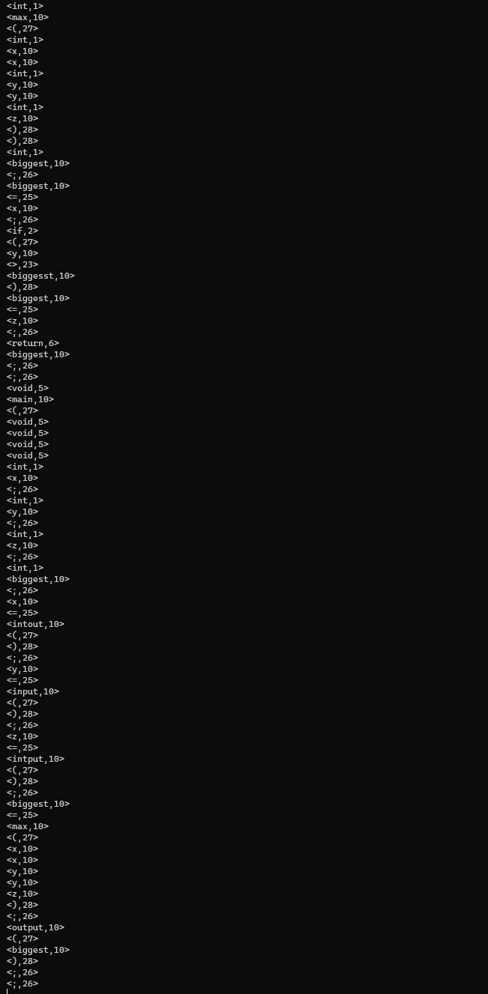
代码示例2：给定N，求1到N之和：
结果如图所示
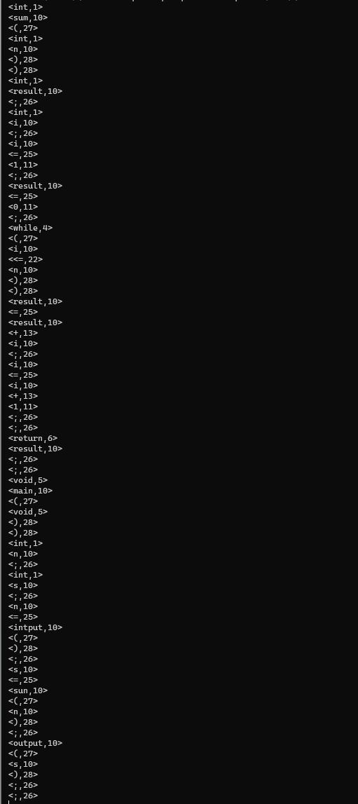
斐波那契数代码
结果如图所示
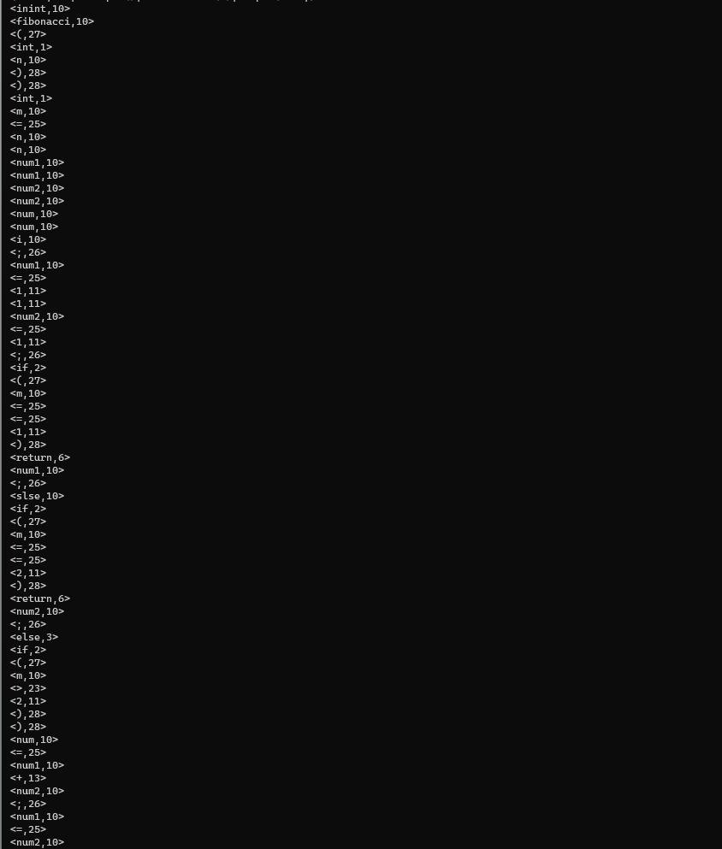
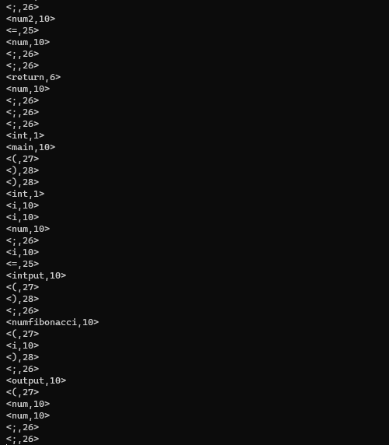

Lex文件

Lex输入文件代码
%{
/* lexeme of identifier or reserved word */
char tokenString[MAXTOKENLEN+1];
void printToken( TokenType token, const char* tokenString );
%}
digit [0-9]
number {digit}+
letter [a-zA-Z]
identifier {letter}+
newline \n
whitespace [ \t]+
%%
"if" {return IF;}
"while" {return WHILE;}
"else" {return ELSE;}
"return" {return RETURN;}
"int" {return INT;}
"void" {return VOID;}
"=" {return ASSIGN;}
"==" {return EQ;}
"<" {return LT;}
"<=" {return LTE;}
">" {return GT;}
">=" {return GTE;}
"!=" {return NE;}
"+" {return PLUS;}
"-" {return MINUS;}
"*" {return TIMES;}
"/" {return DIVIDE;}
"(" {return LPAREN;}
")" {return RPAREN;}
";" {return SEMI;}
"{" {return LBRACE;}
"}" {return LBRACE;}
{number} {return NUM;}
{identifier} {return ID;}
{newline} {lineno++;}
{whitespace} {/* skip whitespace */}
"/*" {
char c;
int flag = 1;
do
{ c = input();
if (c == EOF) break;
if (c == '\n') lineno++;
if (c == '*')
{
c = input();
if (c == '/') flag = 0;
}
} while (flag);
}
. {return ERROR;}
%%
TokenType getToken(void)
{
static int firstTime = TRUE;
TokenType currentToken;
if (firstTime)
{ firstTime = FALSE;
lineno++;
yyin = source;
yyout = listing;
}
currentToken = yylex();
strncpy(tokenString,yytext,MAXTOKENLEN);
if (TraceScan) {
fprintf(listing,"\t%d: ",lineno);
printToken(currentToken,tokenString);
}
return currentToken;
}
int yywrap()
{
return 1;
}

实验演示
三个数求最大值
<int,1>
<max,10>
<(,27>
<int,1>
<x,10>
<x,10>
<int,1>
<y,10>
<y,10>
<int,1>
<z,10>
<),28>
<),28>
<int,1>
<biggest,10>
<;,26>
<biggest,10>
<=,25>
<x,10>
<;,26>
<if,2>
<(,27>
<y,10>
<>,23>
<biggest,10>
<),28>
</,16>
<*,15>
<comment,10>
<example,10>
<*,15>
</,16>
<biggest,10>
<=,25>
<y,10>
<;,26>
<if,2>
<(,27>
<z,10>
<>,23>
<biggest,10>
<),28>
<biggest,10>
<=,25>
<z,10>
<;,26>
<return,6>
<biggest,10>
<;,26>
<;,26>
<void,5>
<main,10>
<(,27>
<void,5>
<),28>
<),28>
<int,1>
<x,10>
<;,26>
<int,1>
<y,10>
<;,26>
<int,1>
<z,10>
<;,26>
<int,1>
<biggest,10>
<;,26>
<x,10>
<=,25>
<intput,10>
<(,27>
<),28>
<;,26>
<y,10>
<=,25>
<input,10>
<(,27>
<),28>
<;,26>
<z,10>
<=,25>
<intput,10>
<(,27>
<),28>
<;,26>
<biggest,10>
<=,25>
<max,10>
<(,27>
<x,10>
<x,10>
<y,10>
<y,10>
<z,10>
<),28>
<;,26>
<output,10>
<(,27>
<biggest,10>
<),28>
<;,26>
求和
<int,1>
<fibonacci,10>
<(,27>
<int,1>
<n,10>
<),28>
<),28>
<int,1>
<m,10>
<=,25>
<n,10>
<n,10>
<num1,10>
<num1,10>
<num2,10>
<num2,10>
<num,10>
<num,10>
<i,10>
<;,26>
<num1,10>
<=,25>
<1,11>
<1,11>
<num2,10>
<=,25>
<1,11>
<;,26>
<if,2>
<(,27>
<m,10>
<=,25>
<=,25>
<1,11>
<),28>
<return,6>
<num1,10>
<;,26>
<else,3>
<if,2>
<(,27>
<m,10>
<=,25>
<=,25>
<2,11>
<),28>
<return,6>
<num2,10>
<;,26>
<else,3>
<if,2>
<(,27>
<m,10>
<>,23>
<2,11>
<),28>
<),28>
<for,10>
<(,27>
<i,10>
<=,25>
<2,11>
<;,26>
<i,10>
<<,20>
<m,10>
<;,26>
<i,10>
<+,13>
<+,13>
<),28>
<),28>
<num,10>
<=,25>
<num1,10>
<+,13>
<num2,10>
<;,26>
<num1,10>
<=,25>
<num2,10>
<;,26>
<num2,10>
<=,25>
<num,10>
<;,26>
<;,26>
<return,6>
<num,10>
<;,26>
<;,26>
<;,26>
int main(){
<int,1>
<main,10>
<(,27>
<),28>
<),28>
<int,1>
<i,10>
<i,10>
<num,10>
<i,10>
<=,25>
<intput,10>
<(,27>
<),28>
<;,26>
<num,10>
<=,25>
<fibonacci,10>
<(,27>
<i,10>
<),28>
<;,26>
<output,10>
<(,27>
<num,10>
<),28>
<;,26>
Fibonacci数列
<int,1>
<fibonacci,10>
<(,27>
<int,1>
<n,10>
<),28>
<),28>
<int,1>
<m,10>
<=,25>
<n,10>
<n,10>
<num1,10>
<num1,10>
<num2,10>
<num2,10>
<num,10>
<num,10>
<i,10>
<;,26>
<num1,10>
<=,25>
<1,11>
<1,11>
<num2,10>
<=,25>
<1,11>
<;,26>
<if,2>
<(,27>
<m,10>
<=,25>
<=,25>
<1,11>
<),28>
<return,6>
<num1,10>
<;,26>
<else,3>
<if,2>
<(,27>
<m,10>
<=,25>
<=,25>
<2,11>
<),28>
<return,6>
<num2,10>
<;,26>
<else,3>
<if,2>
<(,27>
<m,10>
<>,23>
<2,11>
<),28>
<),28>
<for,10>
<(,27>
<i,10>
<=,25>
<2,11>
<;,26>
<i,10>
<<,20>
<m,10>
<;,26>
<i,10>
<+,13>
<+,13>
<),28>
<),28>
<num,10>
<=,25>
<num1,10>
<+,13>
<num2,10>
<;,26>
<num1,10>
<=,25>
<num2,10>
<;,26>
<num2,10>
<=,25>
<num,10>
<;,26>
<;,26>
<return,6>
<num,10>
<;,26>
<;,26>
<;,26>
<int,1>
<main,10>
<(,27>
<),28>
<),28>
<int,1>
<i,10>
<i,10>
<num,10>
<;,26>
<i,10>
<=,25>
<intput,10>
<(,27>
<),28>
<;,26>
<num,10>
<=,25>
<fibonacci,10>
<(,27>
<i,10>
<),28>
<;,26>
<output,10>
<(,27>
<num,10>
<),28>
<;,26>

BNF描述
program → declaration-list
declaration-list → declaration-list declaration | declaration
declaration → var-declaration | fun-declaration
Var-declaration → type-specifier ID;
type-specifier → int | void
fun-declaration → type-specifierID(params) | compound-stmt
params → params-list | void
param-list → param-list , param | param
param → type-specifierID
compound-stmt → {local-declarationsstatement-list}
local-declarations → local-declarationsvar-declaration | empty
statement-list → statement-liststatement | empty
statement → expression-stmt
| compound-stmt
| selection-stmt
| it eration-stmt
| return-stmt
expression-stmt → expression; | ;
selection-stmt → if(expression)statement
| if (expression)statement else statement
iteration-stmt → while(expression)statement
return-stmt → return; | return expression;
expression → var = expression | simple-expression
var → ID
simple-expression → additive-expression relop additive-expression
| additive-expression
relop → <= | < | > | >= | == | !=
additive-expression → additive-expression addop term | term
addop → + | -
term → term mulop factor | factor
mulop → * | /
factor → (expression) | var | call | NUM
call → ID(args)
args → arg-list | empty
arg-list → arg-list, expression | expression

语法分析程序

主要设计和实现思路
定义结点类型：
typedef enum { StmtK, ExpK, DecK } NodeKind;
typedef enum { IfK, WhileK, ReturnK, CallK, CompoundK } StmtKind;
typedef enum { OpK, IdK, ConstK, AssignK } ExpKind;
typedef enum { ScalarDecK, FuncDecK } DecKind;
typedef enum { Void, Integer, Function } ExpType;
定义数据结构
typedef struct treeNode
{
struct treeNode * child[MAXCHILDREN];
struct treeNode * sibling;
int lineno;
NodeKind nodekind;
union
{
StmtKind stmt;
ExpKind exp;
DecKind dec;
} kind；
TokenType op;
int val;
char *name；
ExpType functionReturnType;
ExpType variableDataType;
ExpType expressionType；
int isParameter;
struct treeNode *declaration;
} TreeNode;
在下降过程中，如果后一语句不为空，则前一语句为后一语句的树根

递归下降语法分析程序代码
#include "globals.h"
#include "util.h"
#include "scan.h"
#include "parse.h"
static TokenType token; // current token
static TreeNode *declaration_list(void);
static TreeNode *declaration(void);
static TreeNode *var_declaration(void);
static TreeNode *param(void);
static TreeNode *param_list(void);
static TreeNode *compound_statement(void);
static TreeNode *local_declarations(void);
static TreeNode *statement_list(void);
static TreeNode *statement(void);
static TreeNode *expression_statement(void);
static TreeNode *if_statement(void);
static TreeNode *while_statement(void);
static TreeNode *return_statement(void);
static TreeNode *expression(void);
static TreeNode *simple_expression(TreeNode *passdown);
static TreeNode *additive_expression(TreeNode *passdown);
static TreeNode *term(TreeNode *passdown);
static TreeNode *factor(TreeNode *passdown);
static TreeNode *args(void);
static TreeNode *arg_list(void);
static TreeNode *identifier_statement(void);
static void syntaxError(char *message)
{
fprintf(listing, ">>> Syntax error at line %d: %s", lineno, message);
}
static void match(TokenType expected)
{
if (token == expected)
token = getToken();
else
{
syntaxError("unexpected token ");
printToken(token, tokenString);
fprintf(listing, "\n");
}
}
static ExpType matchType()
{
ExpType t_type = Void;
switch (token)
{
case INT:
t_type = Integer;
token = getToken();
break;
case VOID:
t_type = Void;
token = getToken();
break;
default:
{
syntaxError("expected a type identifier but got a ");
printToken(token, tokenString);
fprintf(listing, "\n");
break;
}
}
return t_type;
}
static int isAType(TokenType tok)
{
if ((tok == INT) || (tok == VOID))
return TRUE;
else
return FALSE;
}
static TreeNode * declaration_list(void)
{
TreeNode * tree;
TreeNode * ptr;
tree = declaration();
ptr = tree;
while (token != ENDOFFILE)
{
TreeNode *tmp;
tmp = declaration();
if ((tmp != NULL) && (ptr != NULL))
{
ptr->sibling = tmp;
ptr = tmp;
}
}
return tree;
}
static TreeNode *declaration(void)
{
TreeNode *tree = NULL;
ExpType declaration_type;
char *identifier;
declaration_type = matchType();
identifier = copyString(tokenString);
match(ID);
switch (token)
{
case SEMI: /* variable declaration */
tree = newDecNode(ScalarDecK);
if (tree != NULL)
{
tree->variableDataType = declaration_type;
tree->name = identifier;
}
match(SEMI);
break;
case LPAREN: /* function declaration */
tree = newDecNode(FuncDecK);
if (tree != NULL)
{
tree->functionReturnType = declaration_type;
tree->name = identifier;
}
match(LPAREN);
if (tree != NULL)
tree->child[0] = param_list();
match(RPAREN);
if (tree != NULL)
tree->child[1] = compound_statement();
break;
default:
syntaxError("unexpected token ");
printToken(token, tokenString);
fprintf(listing, "\n");
token = getToken();
break;
}
return tree;
}
static TreeNode *var_declaration(void)
{
TreeNode *tree = NULL;
ExpType declaration_type;
char *identifier;
declaration_type = matchType();
identifier = copyString(tokenString);
match(ID);
if(token == SEMI)
{
tree = newDecNode(ScalarDecK); /* variable declaration */
if (tree != NULL)
{
tree->variableDataType = declaration_type;
tree->name = identifier;
}
match(SEMI);
}
else
{
syntaxError("unexpected token ");
printToken(token, tokenString);
fprintf(listing, "\n");
token = getToken();
}
return tree;
}
static TreeNode *param(void)
{
TreeNode *tree;
ExpType parmType;
char *identifier;
parmType = matchType(); /* get type of formal parameter */
identifier = copyString(tokenString);
match(ID);
tree = newDecNode(ScalarDecK);
if (tree != NULL)
{
tree->name = identifier;
tree->val = 0;
tree->variableDataType = parmType;
tree->isParameter = TRUE;
}
return tree;
}
static TreeNode *param_list(void)
{
TreeNode *tree;
TreeNode *ptr;
TreeNode *newNode;
if (token == VOID) /* void param */
{
match(VOID);
return NULL;
}
tree = param();
ptr = tree;
while ((tree != NULL) && (token == COMMA)) /* mutiple params */
{
match(COMMA);
newNode = param();
if (newNode != NULL)
{
ptr->sibling = newNode;
ptr = newNode;
}
}
return tree;
}
static TreeNode *compound_statement(void)
{
TreeNode *tree = NULL;
match(LBRACE);
if ((token != RBRACE) && (tree = newStmtNode(CompoundK)))
{
if (isAType(token))
tree->child[0] = local_declarations();
if (token != RBRACE)
tree->child[1] = statement_list();
}
match(RBRACE);
return tree;
}
static TreeNode *local_declarations(void)
{
TreeNode *tree;
TreeNode *ptr;
TreeNode *newNode;
/* find first variable declaration, if it exists */
if (isAType(token))
tree = var_declaration();
/* subsetmpuent variable declarations */
if (tree != NULL)
{
ptr = tree;
while (isAType(token))
{
newNode = var_declaration();
if (newNode != NULL)
{
ptr->sibling = newNode;
ptr = newNode;
}
}
}
return tree;
}
static TreeNode *statement_list(void)
{
TreeNode *tree = NULL;
TreeNode *ptr;
TreeNode *newNode;
if (token != RBRACE)
{
tree = statement();
ptr = tree;
while (token != RBRACE)
{
newNode = statement();
if ((ptr != NULL) && (newNode != NULL))
{
ptr->sibling = newNode;
ptr = newNode;
}
}
}
return tree;
}
static TreeNode *statement(void)
{
TreeNode *tree = NULL;
switch (token)
{
case IF:
tree = if_statement();
break;
case WHILE:
tree = while_statement();
break;
case RETURN:
tree = return_statement();
break;
case LBRACE:
tree = compound_statement();
break;
case ID:
case SEMI:
case LPAREN:
case NUM:
tree = expression_statement();
break;
default:
syntaxError("unexpected token ");
printToken(token, tokenString);
fprintf(listing, "\n");
token = getToken();
break;
}
return tree;
}
static TreeNode *expression_statement(void)
{
TreeNode *tree = NULL;
if (token == SEMI)
match(SEMI);
else if (token != RBRACE)
{
tree = expression();
match(SEMI);
}
return tree;
}
static TreeNode *if_statement(void)
{
TreeNode *tree;
TreeNode *expr;
TreeNode *ifStmt;
TreeNode *elseStmt = NULL;
match(IF);
match(LPAREN);
expr = expression();
match(RPAREN);
ifStmt = statement();
if (token == ELSE)
{
match(ELSE);
elseStmt = statement();
}
tree = newStmtNode(IfK);
if (tree != NULL)
{
tree->child[0] = expr;
tree->child[1] = ifStmt;
tree->child[2] = elseStmt;
}
return tree;
}
static TreeNode *while_statement(void)
{
TreeNode *tree;
TreeNode *expr;
TreeNode *stmt;
match(WHILE);
match(LPAREN);
expr = expression();
match(RPAREN);
stmt = statement();
tree = newStmtNode(WhileK);
if (tree != NULL)
{
tree->child[0] = expr;
tree->child[1] = stmt;
}
return tree;
}
static TreeNode *return_statement(void)
{
TreeNode *tree;
TreeNode *expr = NULL;
match(RETURN);
tree = newStmtNode(ReturnK);
if (token != SEMI)
expr = expression();
if (tree != NULL)
tree->child[0] = expr;
match(SEMI);
return tree;
}
static TreeNode *expression(void)
{
TreeNode *tree = NULL;
TreeNode *lvalue = NULL;
TreeNode *rvalue = NULL;
int gotLvalue = FALSE;
if (token == ID)
{
lvalue = identifier_statement();
gotLvalue = TRUE;
}
/* assign */
if ((gotLvalue == TRUE) && (token == ASSIGN))
{
if ((lvalue != NULL) && (lvalue->nodekind == ExpK) &&
(lvalue->kind.exp == IdK))
{
match(ASSIGN);
rvalue = expression();
tree = newExpNode(AssignK);
if (tree != NULL)
{
tree->child[0] = lvalue; /* left value */
tree->child[1] = rvalue; /* right value*/
}
}
else
{
syntaxError("attempt to assign to something not an lvalue\n");
token = getToken();
}
}
else
tree = simple_expression(lvalue);
return tree;
}
static TreeNode *simple_expression(TreeNode *passdown)
{
TreeNode *tree;
TreeNode *lExpr = NULL;
TreeNode *rExpr = NULL;
TokenType operator;
lExpr = additive_expression(passdown);
if ((token == LTE) || (token == GTE) || (token == GT) ||
(token == LT) || (token == EQ) || (token == NE))
{
operator = token;
match(token);
rExpr = additive_expression(NULL);
tree = newExpNode(OpK);
if (tree != NULL)
{
tree->child[0] = lExpr;
tree->child[1] = rExpr;
tree->op = operator;
}
}
else
tree = lExpr;
return tree;
}
static TreeNode *additive_expression(TreeNode *passdown)
{
TreeNode *tree;
TreeNode *newNode;
tree = term(passdown);
while ((token == PLUS) || (token == MINUS))
{
newNode = newExpNode(OpK);
if (newNode != NULL)
{
newNode->child[0] = tree;
newNode->op = token;
tree = newNode;
match(token);
tree->child[1] = term(NULL);
}
}
return tree;
}
static TreeNode *term(TreeNode *passdown)
{
TreeNode *tree;
TreeNode *newNode;
tree = factor(passdown);
while ((token == TIMES) || (token == DIVIDE))
{
newNode = newExpNode(OpK);
if (newNode != NULL)
{
newNode->child[0] = tree;
newNode->op = token;
tree = newNode;
match(token);
newNode->child[1] = factor(NULL);
}
}
return tree;
}
static TreeNode *factor(TreeNode *passdown)
{
TreeNode *tree = NULL;
/* If the subtree in "passdown" is a Factor, pass it back. */
if (passdown != NULL) return passdown;
if (token == ID)
{
tree = identifier_statement();
}
else if (token == LPAREN)
{
match(LPAREN);
tree = expression();
match(RPAREN);
}
else if (token == NUM)
{
tree = newExpNode(ConstK);
if (tree != NULL)
{
tree->val = atoi(tokenString);
tree->variableDataType = Integer;
}
match(NUM);
}
else
{
syntaxError("unexpected token ");
printToken(token, tokenString);
fprintf(listing, "\n");
token = getToken();
}
return tree;
}
static TreeNode *identifier_statement(void)
{
TreeNode *tree;
TreeNode *expr = NULL;
TreeNode *arguments = NULL;
char *identifier;
if (token == ID)
identifier = copyString(tokenString);
match(ID);
if (token == LPAREN)
{
match(LPAREN);
arguments = args();
match(RPAREN);
tree = newStmtNode(CallK);
if (tree != NULL)
{
tree->child[0] = arguments;
tree->name = identifier;
}
}
else
{
tree = newExpNode(IdK);
if (tree != NULL)
{
tree->child[0] = expr;
tree->name = identifier;
}
}
return tree;
}
static TreeNode *args(void)
{
TreeNode *tree = NULL;
if (token != RPAREN)
tree = arg_list();
return tree;
}
static TreeNode *arg_list(void)
{
TreeNode *tree;
TreeNode *ptr;
TreeNode *newNode;
tree = expression();
ptr = tree;
while (token == COMMA)
{
match(COMMA);
newNode = expression();
if ((ptr != NULL) && (tree != NULL))
{
ptr->sibling = newNode;
ptr = newNode;
}
}
return tree;
}
TreeNode *Parse(void)
{
TreeNode *t;
token = getToken();
t = declaration_list();
if (token != ENDOFFILE)
syntaxError("Unexpected symbol at end of file\n");
/* t points to the fully-constructed syntax tree */
return t;
}

实验演示
求三个整数最大值
[Function declaration "max()" of return type "integer"]
[Scalar declaration "x" of type "integer"]
[Scalar declaration "y" of type "integer"]
[Scalar declaration "z" of type "integer"]
[Compound statement]
[Scalar declaration "biggest" of type "integer"]
[Assignment]
[Identifier "biggest"]
[Identifier "x"]
[IF statement]
[Operator ">"]
[Identifier "y"]
[Identifier "biggest"]
[Assignment]
[Identifier "biggest"]
[Identifier "y"]
[IF statement]
[Operator ">"]
[Identifier "z]"]
[Identifier "biggest"]
[Assignment]
[Identifier "biggest"]
[Identifier "z"]
[RETURN statement]
[Identifier "biggest"]
[Function declaration "main()" of return type "void"]
[Compound statement]
[Scalar declaration "x" of type "integer"]
[Scalar declaration "y" of type "integer"]
[Scalar declaration "z" of type "integer"]
[Scalar declaration "biggest" of type "integer"]
[Assignment]
[Identifier "x"]
[Call to function "input()"]
[Assignment]
[Identifier "y"]
[Call to function "input()"]
[Assignment]
[Identifier "z"]
[Call to function "input()"]
[Assignment]
[Identifier "biggest"]
[Call to function "max()"]
[Identifier "x"]
[Identifier "y"]
[Identifier "z"]
[Call to function "output()"]
[Identifier "biggest"]
求和
[Function declaration "sum()" of return type "integer"]
[Scalar declaration "n" of type "integer"]
[Compound statement]
[Scalar declaration "result" of type "integer"]
[Scalar declaration "i" of type "integer"]
[Assignment]
[Identifier "i"]
[Literal constant "1"]
[Assignment]
[Identifier "result"]
[Literal constant "0"]
[WHILE statement]
[Operator "<="]
[Identifier "i"]
[Identifier "n"]
[Compound statement]
[Assignment]
[Identifier "result"]
[Operator "+"]
[Identifier "result"]
[Identifier "i"]
[Assignment]
[Identifier "i"]
[Operator "+"]
[Identifier "i"]
[Literal constant "1"]
[RETURN statement]
[Identifier "result"]
[Function declaration "main()" of return type "void"]
[Compound statement]
[Scalar declaration "n" of type "integer"]
[Scalar declaration "s" of type "integer"]
[Assignment]
[Identifier "n"]
[Call to function "intput()"]
[Assignment]
[Identifier "s"]
[Call to function "sum()"]
[Identifier "n"]
[Call to function "output()"]
[Identifier "s"]
Fibonacci
[Function declaration "sum()" of return type "integer"]
[Scalar declaration "n" of type "integer"]
[Compound statement]
[Scalar declaration "result" of type "integer"]
[Scalar declaration "i" of type "integer"]
[Assignment]
[Identifier "i"]
[Literal constant "1"]
[Assignment]
[Identifier "result"]
[Literal constant "0"]
[WHILE statement]
[Operator "<="]
[Identifier "i"]
[Identifier "n"]
[Compound statement]
[Assignment]
[Identifier "result"]
[Operator "+"]
[Identifier "result"]
[Identifier "i"]
[Assignment]
[Identifier "i"]
[Operator "+"]
[Identifier "i"]
[Literal constant "1"]
[RETURN statement]
[Identifier "result"]
[Function declaration "main()" of return type "void"]
[Compound statement]
[Scalar declaration "n" of type "integer"]
[Scalar declaration "s" of type "integer"]
[Assignment]
[Identifier "n"]
[Call to function "intput()"]
[Assignment]
[Identifier "s"]
[Call to function "sum()"]
[Identifier "n"]
[Call to function "output()"]
[Identifier "s"]

语义分析程序

主要设计和实现思路
7.1.1 符号表构造
首先通过 void buildSymbolTable(TreeNode *syntaxTree) 函数进行符号表构造
static void drawRuler(FILE *output, char *string) 函数，用于确定符号表的格式，打印分割线
static void declarePredefines(void) 函数，用来将 C— 语言内置的 input() 和 output() 函数添加进符号表
static void startBuildSymbolTable(TreeNode *syntaxTree) 函数开始构造符号表：
该函数的参数为语法树根结点，通过遍历整个语法树，来寻找结点类型为 DECK（声明结点）的结点，并将他们插入到符号表中，插入的过程中将进行检测。
声明也分为两种：变量的声明与函数的声明：变量的声明可直接插入到符号表；而函数的声明中可能有变量声明，此时，将会调用之前提到过的 drawruler() 函数，增加一张符号表，用于处理该函数内部的变量声明。
对于非声明类结点，只需进行错误检测，即在既有的符号表中查询其是否进行过声明。
7.1.2 类型检查
首先通过 traverse(syntaxTree, nullProc, checkNode) 函数，检查相邻语法树结点的词法属性来判断是否出错。
static void nullProc(TreeNode *syntaxTree) 函数直接返回（即遇到叶子结点），不进行其他操作
static void checkNode(TreeNode *syntaxTree) 函数通过遍历语法树，遍历到当前的一个结点之后，检查该结点的相邻结点是否符合语法规则，如果不符合就报错，如果符合就可以继续遍历。

类型检查语义分析程序代码
#include <stdlib.h>
#include <string.h>
#include <strings.h>
#include <stdio.h>
#include <stdlib.h>
#include "Globals.h"
#include "SymTab.h"
#include "Util.h"
#define MAXTABLESIZE 233
#define HIGHWATERMARK "__invalid__"
/* The hash table itself */
static HashNodePtr hashtable[MAXTABLESIZE];
/* The "temporary list", used to track scopes. */
static HashNodePtr tempList;
extern int TraceAnalyse;
int scopeDepth;
static HashNodePtr allocateSymbolNode(char *name,
TreeNode *declaration,
int lineDefined);
/* hashfunction(): takes a string and generates a hash value. */
static int hashFunction(char *key);
/* error reporting */
static void flagError(char *message);
/* used in symbol table scope dump */
static char *formatSymbolType(TreeNode *node);
/* the guts of dumpCurrentScope() */
static void startDumpCurrentScope(HashNodePtr cursor);
void initSymbolTable(void)
{
memset(hashtable, 0, sizeof(HashNodePtr) * MAXTABLESIZE);
tempList = NULL;
}
void insertSymbol(char *name, TreeNode *symbolDefNode, int lineDefined)
{
char errorString[80];
HashNodePtr newHashNode, temp;
int hashBucket;
/* If the symbol already exists, flag an error */
if (symbolAlreadyDeclared(name))
{
sprintf(errorString, "duplicate identifier \"%s\"\n", name);
flagError(errorString);
}
else
{
/* Locate bucket we're using */
hashBucket = hashFunction(name);
/* Allocate and insert record on front of bucket */
newHashNode = allocateSymbolNode(name, symbolDefNode, lineDefined);
if (newHashNode != NULL)
{
temp = hashtable[hashBucket];
hashtable[hashBucket] = newHashNode;
newHashNode->next = temp;
}
/* Stick node on front of "tempList" */
newHashNode = allocateSymbolNode(name, symbolDefNode, lineDefined);
if (newHashNode != NULL)
{
temp = tempList;
tempList = newHashNode;
tempList->next = temp;
}
}
}
/* Check to see if the symbol given by "name" is already declared in thecurrent scope. */
int symbolAlreadyDeclared(char *name)
{
int symbolFound = FALSE;
HashNodePtr cursor;
/* Scan "tempList" within _current_ scope for duplicate definition */
cursor = tempList;
while ((cursor != NULL) && (!symbolFound) && ((strcmp(cursor->name, HIGHWATERMARK) != 0)))
{
if (strcmp(name, cursor->name) == 0)
symbolFound = TRUE;
else
cursor = cursor->next;
}
return (symbolFound);
}
HashNodePtr lookupSymbol(char *name)
{
HashNodePtr cursor;
int hashBucket; /* hash bucket on which to conduct our search */
int found = FALSE;
hashBucket = hashFunction(name);
cursor = hashtable[hashBucket];
while (cursor != NULL)
{
if (strcmp(name, cursor->name) == 0)
{
found = TRUE;
break;
}
cursor = cursor->next;
}
if (found == TRUE)
return cursor;
else
return NULL;
}
/*
* Use recursion to dump symbols out in "reverse-reverse" order.. i.e the
* right way around...
*/
void dumpCurrentScope()
{
HashNodePtr cursor;
cursor = tempList;
/* if the current scope isn't empty, dump it out */
if ((cursor != NULL) && (strcmp(HIGHWATERMARK, cursor->name)))
startDumpCurrentScope(cursor);
}
#define IDENT_LEN 12
static void startDumpCurrentScope(HashNodePtr cursor)
{
char paddedIdentifier[IDENT_LEN + 1];
char *typeInformation; /* used to catch result of formatSymbolType */
if ((cursor->next != NULL) && (strcmp(cursor->next->name, HIGHWATERMARK) != 0))
startDumpCurrentScope(cursor->next);
/* pad identifier name */
memset(paddedIdentifier, ' ', IDENT_LEN);
memmove(paddedIdentifier, cursor->name, strlen(cursor->name));
paddedIdentifier[IDENT_LEN] = '\0';
/* output symbol table entry */
typeInformation = formatSymbolType(cursor->declaration);
fprintf(listing, "%3d %s %7d %c %s\n",
scopeDepth,
paddedIdentifier,
cursor->lineFirstReferenced,
cursor->declaration->isParameter ? 'Y' : 'N',
typeInformation);
/* Prevent a memory leak */
free(typeInformation);
}
void newScope()
{
HashNodePtr newNode, temp;
/*
* This function is short and sweet: we just append a "high water mark"
* on "tempList".
*/
newNode = allocateSymbolNode(HIGHWATERMARK, NULL, 0);
if (newNode != NULL)
{
temp = tempList;
tempList = newNode;
tempList->next = temp;
}
}
void endScope()
{
/*
* endScope()'s job is to delete all symbols in the current scope. It
* works by scanning "tempList" from the front and for each record
* before the high-water mark, it deletes each symbol's occurrence in
* the hash table. This is done until the high-water mark is consumed.
*/
HashNodePtr hashPtr;
HashNodePtr temp; /* used in freeing HashNodes */
int hashBucket;
while ((tempList != NULL) && (strcmp(HIGHWATERMARK, tempList->name)) != 0)
{
/* locate this node in the hash table, delete it */
hashBucket = hashFunction(tempList->name);
hashPtr = hashtable[hashBucket];
/*
* INVARIANT: since symbols were inserted into the hash table _and_
* tempList in the same order, the name of the symbol on the
* front of the hash bucket _must_ be the same as the one under
* tempListPtr.
*/
assert((tempList != NULL) && (hashtable[hashBucket] != NULL));
assert(strcmp(tempList->name, hashPtr->name) == 0);
/* delete from hash table */
temp = hashtable[hashBucket]->next;
free(hashtable[hashBucket]);
hashtable[hashBucket] = temp;
/* ... and from second list */
temp = tempList->next;
free(tempList);
tempList = temp;
}
/* delete high water mark */
assert(strcmp(tempList->name, HIGHWATERMARK) == 0);
temp = tempList->next;
free(tempList);
tempList = temp;
}
static HashNodePtr allocateSymbolNode(char *name,
TreeNode *declaration,
int lineDefined)
{
HashNode *temp;
temp = (HashNode *)malloc(sizeof(HashNode));
if (temp == NULL)
{
Error = TRUE;
fprintf(listing,
"*** Out of memory allocating memory for symbol table\n");
}
else
{
temp->name = copyString(name);
temp->declaration = declaration;
temp->lineFirstReferenced = lineDefined;
temp->next = NULL;
}
return temp;
}
/* Power-of-two multiplier in hash function */
#define SHIFT 4
/* Code borrowed from Louden p.522 */
static int hashFunction(char *key)
{
int temp = 0;
int i = 0;
while (key[i] != '\0')
{
temp = ((temp << SHIFT) + key[i]) % MAXTABLESIZE;
++i;
}
return temp;
}
static void flagError(char *message)
{
fprintf(listing, ">>> Semantic error (symbol table): %s", message);
Error = TRUE; /* global variable to inhibit subseq. passes on error */
}
static char *formatSymbolType(TreeNode *node)
{
char stringBuffer[100];
if ((node == NULL) || (node->nodekind != DecK))
strcpy(stringBuffer, "<<ERROR>>");
else
{
/* node is a declaration */
switch (node->kind.dec)
{
case ScalarDecK:
sprintf(stringBuffer, "Scalar of type %s",
typeName(node->variableDataType));
break;
case ArrayDecK:
sprintf(stringBuffer, "Array of type %s with %d elements",
typeName(node->variableDataType), node->val);
break;
case FuncDecK:
sprintf(stringBuffer, "Function with return type %s",
typeName(node->functionReturnType));
break;
default:
strcpy(stringBuffer, "<<UNKNOWN>>");
break;
}
}
return copyString(stringBuffer);
}

实验演示
Scope Identifier Line Is a Symbol type
depth Decl. parm?
--- fibonacci ----------------------------------
2 cnt 3 N Scalar of type integer
2 firstFib 4 N Scalar of type integer
2 secondFib 5 N Scalar of type integer
2 fib 6 N Scalar of type integer
1 n 1 Y Scalar of type integer
--- main ---------------------------------------
2 n 31 N Scalar of type integer
--- GLOBALS ------------------------------------
0 input 0 N Function with return type integer
0 output 0 N Function with return type void
0 fibonacci 1 N Function with return type integer
0 main 29 N Function with return type void
------------------------------------------------

实验总结
在本次软件设计综合实践中，我学到了如何使用lex相关工具设计一个语言词法分析器，在这个过程中配置了相关环境等等，从一开始的无从下手到后来的轻车熟路，在这过程中学到了很多知识。关于其中令人遗憾的地方就是这段时间由于考试周而导致时间过于仓促而未能将语义分析器写完以及自己所写的代码可读性与效率低，在以后空闲时可能会思考改进。

