**Uncle Grandpa and cake cutting**

**Note:** This problem will be graded for 1%. Your coding style will contribute 30% toward your grade for the lab

It’s Uncle Grandpa’s birthday. As a gift for his birthday, Pizza Steve (a friend of our dear Grandpa) will buy him a “super special very big gigantic chilly” birthday cake. The cake consists of $n$ mini-cake columns, each columns has a height of $a_{i}$ (i.e, consist of $a_{i}$ pieces of mini-cake of size $1*1$). Now, our dear Grandpa wants to cut out a perfect rectangular-shape piece of cake from the original cake, so that the cut-out piece can have the maximum area. Please help him!

## Input

The first line contains a single integer $n,$ $1≤n≤{10}^{5}$– the number of columns of the birthday cake

The second line contains $n$ integers $a_{i}$ $(1≤a_{i}≤{10}^{9})$– the height of each column of the birthday cake

## Output

A single integer – the answer of the problem

## Examples

|  |  |
| --- | --- |
| Input (cake1.in) | Output (cake1.out) |
| 4  4 5 4 2 | 12 |

|  |  |
| --- | --- |
| Input (cake2.in) | Output (cake2.out) |
| 4  2 3 2 4 | 8 |

## Explanation:

For the 1st example, we have some of the following possible way to cut:

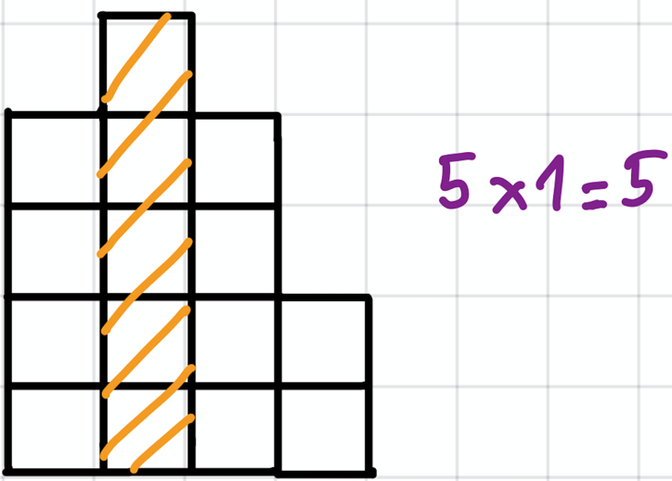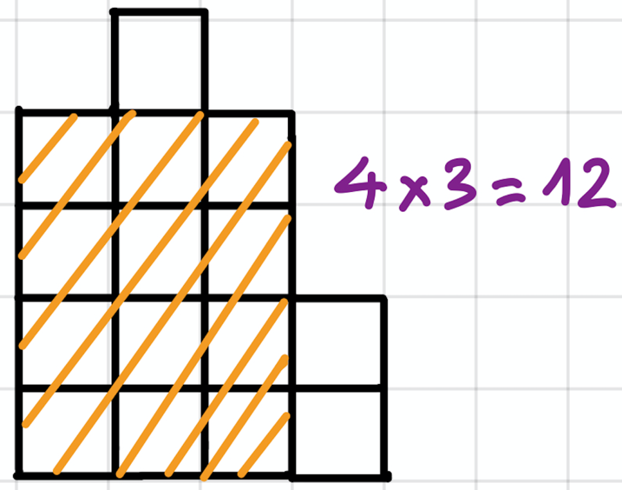

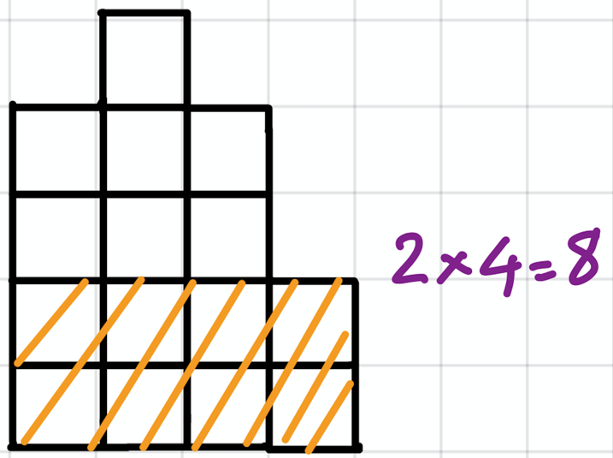

Out of all possible way to cut, the best way will have an area of 12.

## Note:

1. A skeleton file has been given to help you. You should not create a new file or rename the file provided. You should develop your program using this skeleton file.
2. You are free to define your own helper methods and classes (or remove existing ones) if it is suitable but you must put all the new classes, if any, in the same skeleton file provided

## Skeleton File

You are given the skeleton file Cake.java. You should see the following contents when you open the file:

|  |
| --- |
| /**  * Name :  * Matric. No :  */  import java.util.*;  public class Cake {  private void run() {  }  public static void main(String args[]) {  Cake cake = new Cake();  cake.run();  }  } |