 Joystick Jitter White Paper

DATE: | 10/02/97
SUBJECT: | Joystick jitter problem, investigation and suggested solution
AUTHOR: | WMH, Wessam Hassanein
AUTHOR FILE: | 0000.doc

Summary :
Several firmware solutions for joystick jitter have been investigated and the best results were obtained when using the interrupt 6 bit precision technique. This technique approximates 4 hex which removes 2 bits of precision of the original 8 bit precision technique. Jitter was still seen on the host using both the Polling and the Finite Impulse Response techniques, while it was only eliminated to the eye using the 6 bit precision technique.

Introduction :
The joystick implementation is done using an interrupt 8 bit precision technique where the movement of the joystick is calculated using GPIO interrupts. The hardware implementation is done using 1800pF capacitors and 2Kohm resistors. When the capacitors that are connected to the port pins charge to the threshold level this causes a GPIO interrupt. The time taken to charge the capacitor is then used to calculate the movement of the joystick which is then sent to the host. The One_msec interrupt subroutine is used to start the charge cycle of the capacitors and the GPIO interrupt subroutine is used to end it. In this technique each of the capacitors ( x, y, z and throttle) is allowed to charge every 4 msecs. Although the z direction is implemented in firmware it is not part of the hardware implementation and therefore is not used.

Problem :
Joystick jitter is a problem where the joystick appears to move around the center position when the user is not actually moving the joystick.

Solutions :
The following solutions were implemented to study the best solution for the jitter problem. In all solutions, all interrupts were disabled during the charge up time of the capacitors connected to the port pins. This was done to eliminate any interrupt latency due to interrupts that might occur during that charge cycle.

1- Interrupt 6 bit precision technique
In this solution the current value of the joystick position is compared to the previous value and if the difference between them is less than four hex the previous position is sent to the host. This means that two bits of precision of the joystick movement

are lost. Each port pin is sampled every 4 msec. and the data is sent to the host every 10msec. ( when the host sends an “IN” packet to the device). This means that the data is sampled 2.5 times for every packet value sent to the host. Therefore 60% of sampled data values are discarded and each data value has 2 bits of precision lost. In this method GPIO interrupts are used to implement the movement of the joystick in the same way the interrupt 8 bit precision technique does.

x(n) = current value
x(n-1) = previous value

Algorithm :

if |x(n) - x(n-1)| < 4h then
send x(n-1)
else
send x(n)
x(n-1) = x(n)

2- Polling 8 bit precision Technique
In this solution the port pins are constantly being polled in the main routine to determine the movement and throttle of the joystick. If the value of the pin is below the threshold voltage then it is interpreted as ‘0’ otherwise it is a ‘1’. When the value of the pin is a ‘1’ then the charge time of the capacitors are used to calculate the movement of the joystick. This means that the GPIO interrupts are not used.

3- Digital Filter (Finite Impulse Response) Technique
In this solution a Finite Impulse Response Filter is implemented. The filter is a two bit filter and it simply implements the average function. This is done by saving the previous value of the movement and throttle of the joystick and using that value with the current value to calculate an average. That average is then sent to the host as the position of the joystick. This solution uses the GPIO interrupts in the same way as the interrupt 6 or 8 bit precision techniques.

x(n) = current value
x(n-1) = previous value
a₀ = 1/2
a₁ = 1/2
y(n) = filter output

y(n) = a₀. x(n) + a₁. x(n-1)

Results :
Using the oscilloscope to observe the jitter of the x, y and throttle pins the following results were obtained using a sample size of 1200.

The charge cycle is approx. = 80 microsec.
Max X jitter approx. = 4.6 microsec.
Max Y jitter approx. = 2.4 microsec.
Max Throttle jitter approx. = 7.2 microsec.

Using the CATC analyzer to observe the jitter in the packets that are being sent to the host. Two joysticks were used with all the three solution techniques as well as without any of the three solutions. Fifty samples of data of each of the x, y and throttle were studied with each technique and joystick. All centers and numbers are given in decimal representation. The following equations were used in the calculations :

Mean(x) = (1/n) Σ_{i} x for i=1 to n
Variance (x) = {{ ∑(x - Mean(x))² }/(n-1)}^{1/2}

1- Interrupt with 8 bit precision technique :

Joystick #1:

value | X | Y | Throttle
-1 | 1 | 2 | 1
center | 16 | 48 | 8
+1 | 33 | 0 | 41

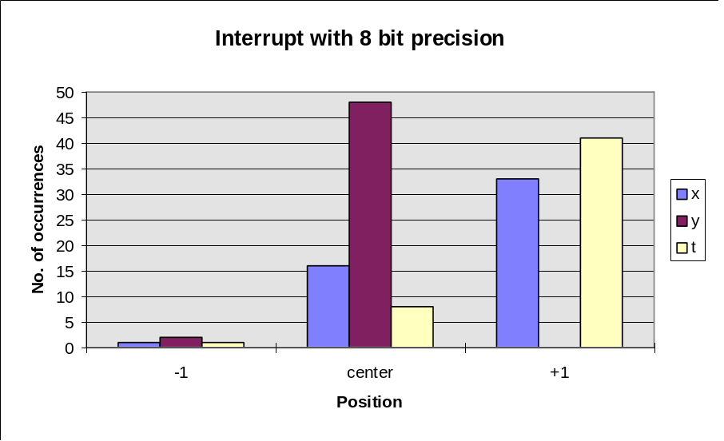

Center(X) = 81 Center(Y) = 101 Center(T)= 92

Joystick #2 :

value | X | Y | Throttle
-3 | 0 | 5 | 0
-2 | 11 | 13 | 0
-1 | 12 | 16 | 11
center | 27 | 16 | 15
+1 | 0 | 0 | 11
+2 | 0 | 0 | 12
+3 | 0 | 0 | 1

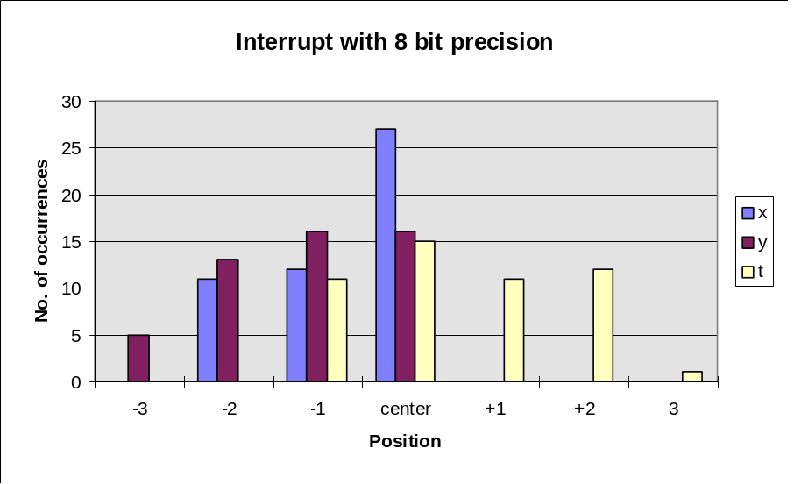

Center(X) = 79 Center(Y) = 102 Center(T)= 145

 | X1 | Y1 | T1 | X2 | Y2 | T2
Mean | 81.64 | 100.96 | 92.8 | 78.32 | 100.86 | 145.54
Variance | 0.525 | 0.198 | 0.452 | 0.819 | 0.99 | 1.147

2- Interrupt with 6 bit precision technique :

The values of x, y and t did not change from the center positions in this experiment in both joysticks with a sample of 50 values. Therefore the sample was increased to 250 values. In this sample range the values of x, y and t also did not change. Therefore observing for jitter on the host screen another sample of 110 values around a seen throttle jitter was taken. In this sample the x and y did not change while the t changed as shown below :

value | Throttle
-4 | 6
-3 | 0
-2 | 0
-1 | 0
center | 104

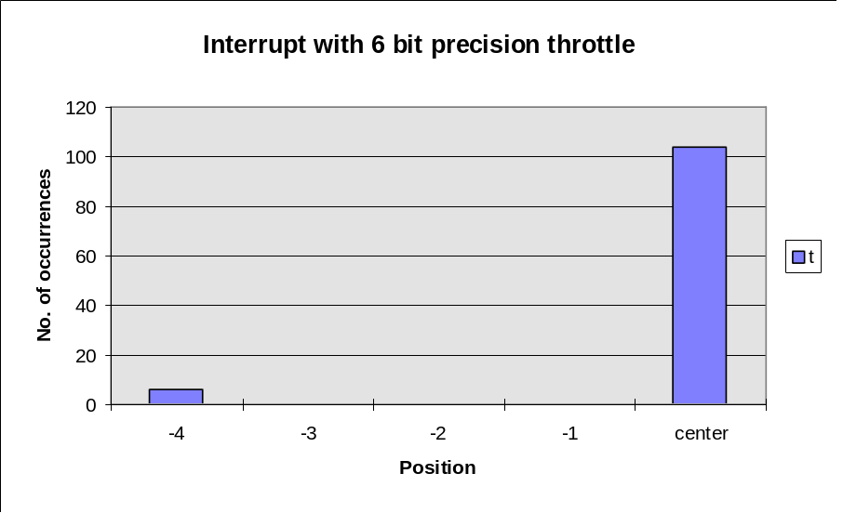

Center(T) = 150
Mean(T) = 149.78 Variance(T) = 0.913

3- Polling with 8 bit precision technique :

Joystick #1:

value | X | Y | Throttle
-2 | 0 | 0 | 1
-1 | 10 | 0 | 37
center | 40 | 19 | 12
+1 | 0 | 31 | 0

Center(X) = 82 Center(Y) = 81 Center(T)= 128

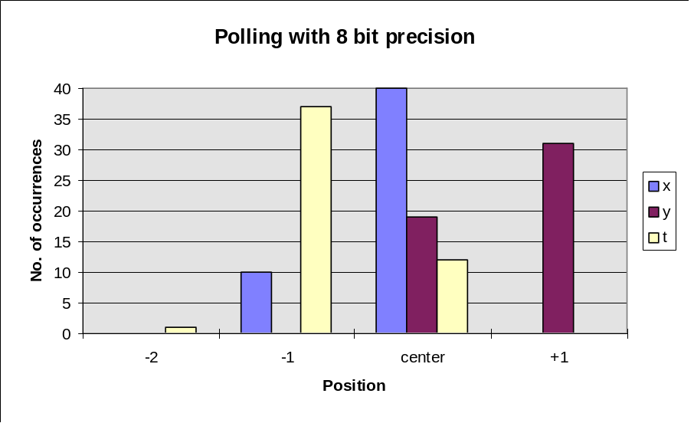

Joystick #2:

value | X | Y | Throttle
-1 | 7 | 1 | 3
center | 36 | 34 | 40
+1 | 7 | 15 | 7

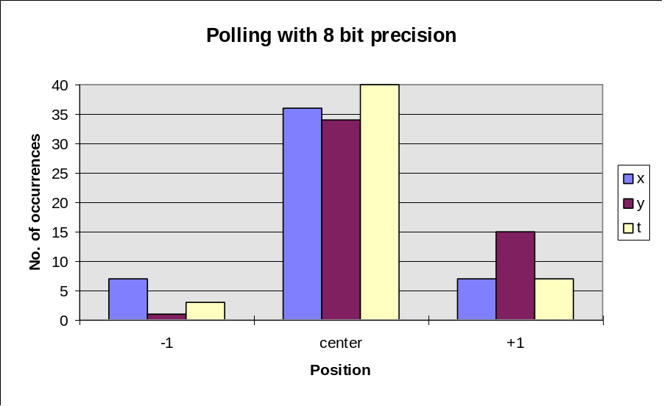

Center(X) = 78 Center(Y) = 82 Center(T)= 60

 | X1 | Y1 | T1 | X2 | Y2 | T2
Mean | 81.8 | 81.62 | 127.22 | 78 | 82.28 | 60.08
Variance | 0.404 | 0.49 | 0.465 | 0.535 | 0.497 | 0.444

4- Finite Impulse Response Filter :

Joystick #1:

value | X | Y | Throttle
-1 | 5 | 5 | 0
center | 43 | 42 | 15
+1 | 2 | 3 | 31
+2 | 0 | 0 | 4

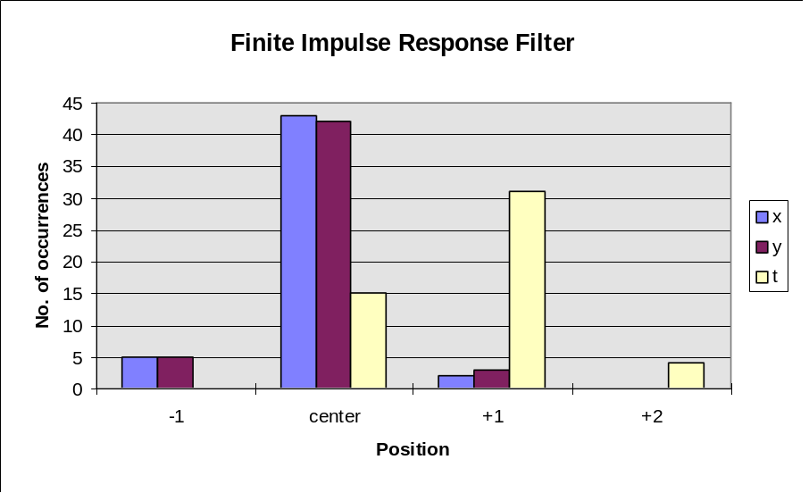

Center(X) = 77 Center(Y) = 80 Center(T)= 126

Joystick #2:

value | X | Y | Throttle
-2 | 8 | 0 | 0
-1 | 26 | 8 | 26
center | 16 | 24 | 24
+1 | 0 | 18 | 0

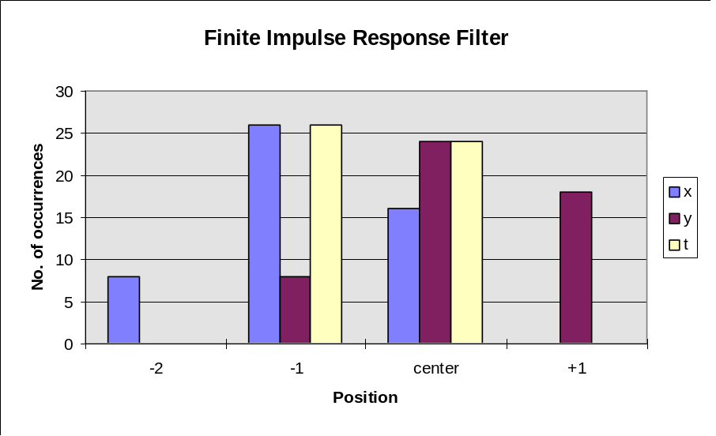

Center(X) = 80 Center(Y) = 100 Center(T)= 33

 | X1 | Y1 | T1 | X2 | Y2 | T2
Mean | 76.94 | 79.96 | 126.78 | 79.16 | 100.2 | 50.48
Variance | 0.373 | 0.402 | 0.582 | 0.681 | 0.7 | 0.505

Conclusion :

The interrupt with 6 bit precision method that gave the best results and was the only method that eliminates most of the jitter problem. Therefore it is the suggested method to use to solve the joystick jitter problem.

