
LJHoliday 7001 Seaview Ave NW Seattle WA 98117 https://ljholiday.com +1 206 778 7065

Business Plan

LJHoliday | Classic Style, High Performance 2
Summary 2
We Believe 2
Mission 2
Vision 2
Why 3
What We Do 3
Where We Do It 3
How We Do It 4
What We Don't Do 4
Roadmap 4
Current Status 4
Who We Do It For 6
Customer Culture 6
Company Culture 6
How We Stand Out 7
The Team 7
Financials 8

Executive Summary

Summary
- An overview of your business idea (one or two sentences).
- A description of your product and/or service. What problems are you solving for your target customers?
- Your goals for the business. Where do you expect the business to be in one year, three years, five years?
- Your proposed target market. Who are your ideal customers?
- Your competition and what differentiates your business. Who are you up against, and what unique selling proposition will help you succeed?
- Your management team and their prior experience. What do they bring to the table that will give your business a competitive edge?
- Financial outlook for the business. If you’re using the business plan for financing purposes, explain exactly how much money you want, how you will use it, and how that will make your business more profitable.
LJHoliday's outfits are patterned to present classic silhouettes and constructed of modern high performance fabrics.
Our market demographic is people who shop at REI because they understand the fabrics. It is the fabrics and the features that define and differentiate LJHoliday.
We are on track to put a product in the online store for Fall Season 2021.
Our growth model is to use revenue to add products every season.
Our exit strategy is to retain ownership of our fun business until we die or sell the company for ten million in three years. I'm not sure which. It's my name. Do I really want to sell it? Maybe I can sell the Classic Style Line and retain the name for all the other businesses?

Company Description

We Believe
- Life Is Better Well Dressed.
- It shouldn't be a pain to take care of your clothes.
- You should be able to look good no matter what you are doing.
- Simplicity is at the heart of good living.
- LJHoliday strives for elegance and luxury. Not economy and frugality.

Mission
LJHoliday's mission is to dominate the global sportswear market.
LJHoliday's mission is to provide high performance clothing of enduring style with no regard for fleeting fashion.

Vision
LJHoliday revolutionized the sportswear sector of the apparel market by completely changing the way people think about sportswear. LJHoliday clothing became the standard for any occasion from a meeting in the boardroom, a grueling afternoon on the slopes or an evening on the dance floor.
LJHoliday Clothiers customers have come to expect the highest standards of service, materials and construction. With a tradition rooted in classic style we deliver finely crafted clothing manufactured from the highest quality modern performance materials available to meet the rigorous demands of our active clientele. For a hard day at work, a grueling afternoon on the slopes or an evening on the dance floor, our customers are confident and comfortable in our clothing

Why
Pretty much everybody seems to agree good quality clothing makes for a better day. weather resistance comfort breathability all add up to better. It seems though, the price people are paying for this is ugly clothing. Why do people accept ugly clothing? We want to make high quality, weather resistant, breathable, and comfortable clothing that looks good too.

What We Do
We are a full service family clothing company.
Our flagship products are classic style silhouettes using modern manufacturing practices and materials, specifically referencing the current sportswear industry.

Where We Do It
We sell clothes in an online store and drop ship them to our customers from overseas.
We have an online store stocked with everything a person needs to get dressed from Jackets to socks.

The Business Model
LJHoliday LLC is a family clothing store focused on classic style apparel made from modern high performance materials. We are currently an LLC registered in the State of Washington. We operate in the Apparel Sector.
Recently the good factories in China have embraced dropshipping. This means we can have individual jackets made and shipped to customers when they order from our website. Like how my t-shirts work now. This is good news.
This means we can have a jacket in the store ready to ship to customers for only the cost of the tech pack and pattern, development samples, and factory samples. There is no longer any need to purchase a large order of garments in advance and store them in a warehouse until they are sold or discarded.
I believe this puts us on track to have a very popular product in the store in time for Fall 2021.

How We Do It
From drawings by Lonn Holiday, designers in eastern asia create patterns and tech packs used by our manufacturing partners to create each order for our customers.

What We Don't Do
We do not carry hats or shoes at this time. Our vision is to develop a machine washable classic fedora as soon as financially possible. Our weblog will include several articles about shoes, and why old school handmade shoes and boots are absolutely the best. Ideally we will be able to create relationships with shoemakers like Crockett and Jones, Allen Edmonds, and Alden and represent their lines in our store.

Operational Plan

Roadmap

Tech Pack | Source Product | Samples | Store Setup | Marketing | Sales
Our designer delivers a factory ready tech pack, graded pattern, and sewn sample. | With the help of out designer, we source appropriate fabric and a suitable factory. | Our factory submits samples for inspection. | We create product images, descriptions, and pages in our online store. | We run FaceBook, Google, and email ad campaigns. | We make sales in our store, get paid through our payment gateway, and our factory dropships items to our customers.

Products and Services

Current Status
We currently have a design drawing of a belted back jacket ready to create a tech pack and graded pattern. This jacket will be our flagship product and initial source of revenue.
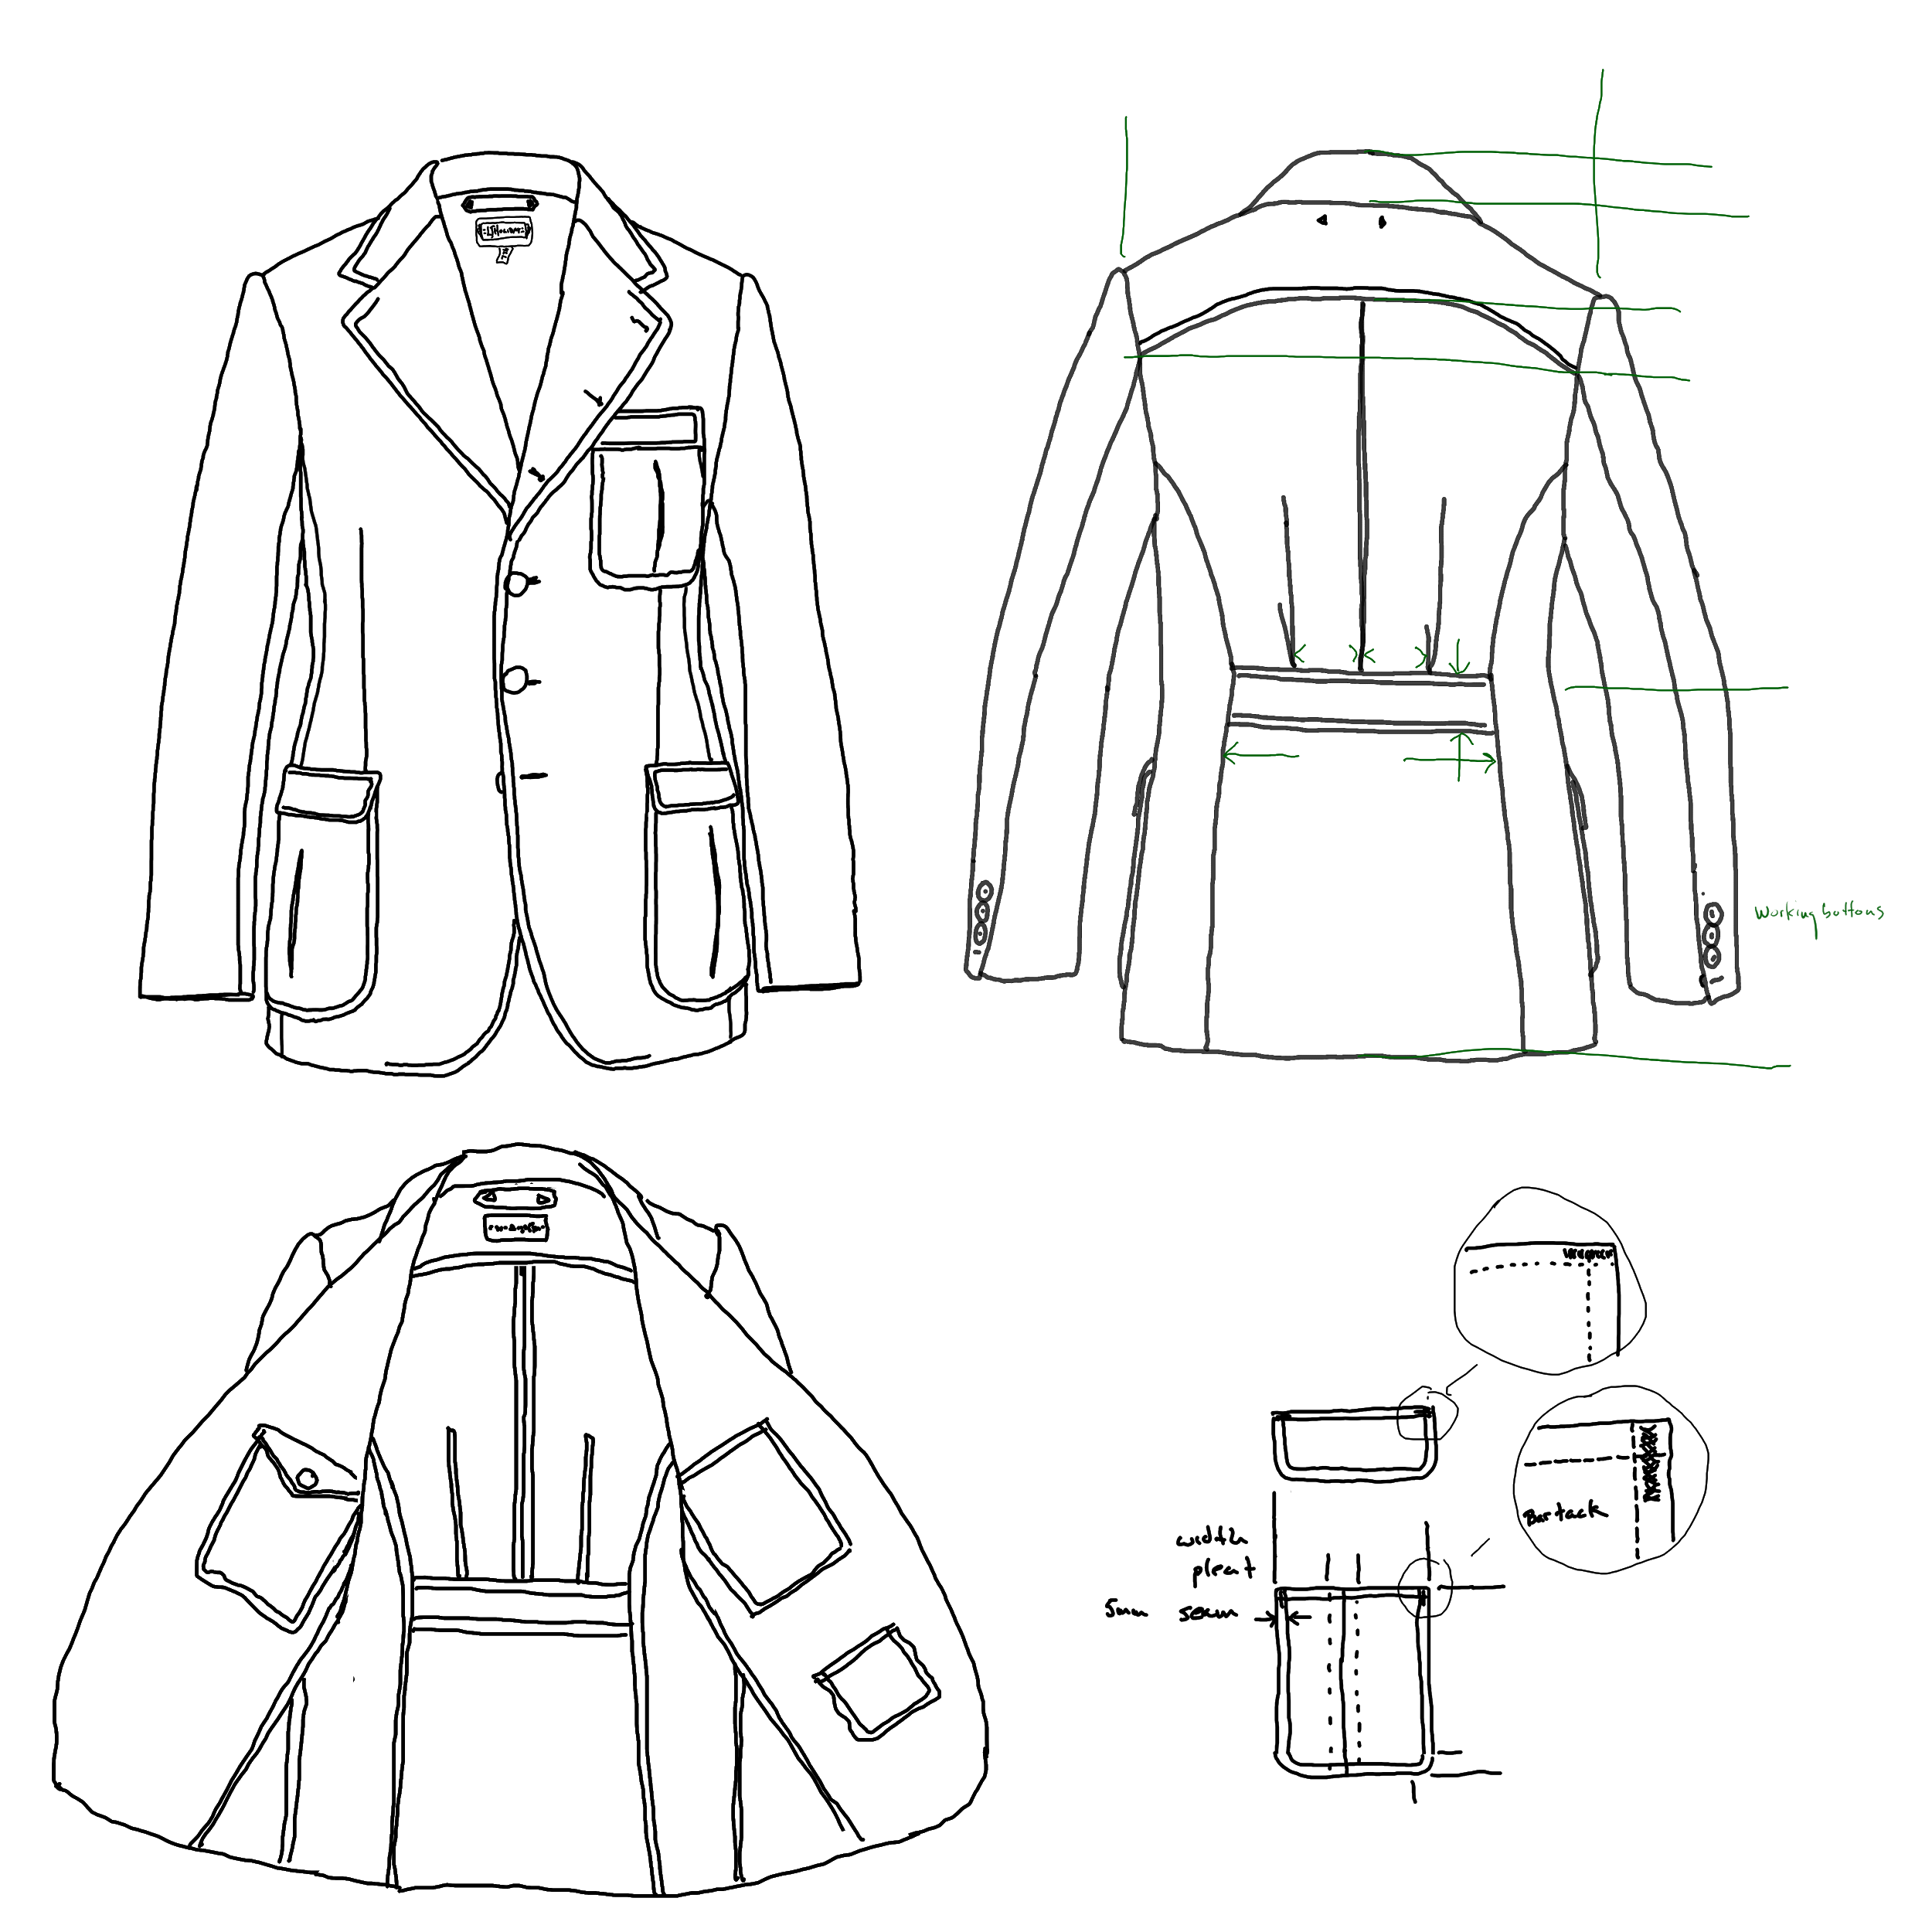

We also have a trench coat in prototype stage. This trenchcoat will be one of our flagship products in the Fall 2021 season.
We have an online store built with WooCommerce on WordPress currently offering t-shirts featuring Lonn Holiday's original artwork.
We have a social network at the name Elonara we can transition into a support and brand loyalty network.

Marketing Plan

Who We Do It For
We are targeting people that shop at REI because they understand the fabrics. Many people that shop and REI, Northface, Patagonia, etc, do so because they demand high performance from their clothing. They hike, ski, boat, or just enjoy walking around in Seattle. They are accustomed to spending $80 to $400 for a good quality jacket built like a cardboard box. For a really good looking jacket our pricepoint of $300 to $350 for this jacket will seem quite reasonable and should generate substantial sales. Indeed we already have commitments for several and garnered $7,000 in Kickstarter commitments at $500 each for our first prototype.
A quick google search for fashion sportswear quickly reveals the dire need for our products.

Customer Culture
Our market segment is people that shop at REI because they understand the fabrics. Our customers are people that appreciate fine things, simple living, adventure, and good food.
LJHoliday's principles include a commitment to simple living. We believe life is better when lived with few unnecessary distractions. We are not committed to austerity, yay, we promote and pursue prosperity. We believe these principles are not at odds. As an example, we believe it is better to own one pair of well made shoes which demand a higher price than several lower cost pairs. More costly clothing is generally higher quality clothing which lasts longer and provides a better return on investment. Our customers understand this.
Our public presence reflects our principles. Customers will find articles in our weblog discussing streamlined travel kits, simplified time management, characteristics of quality clothing, and aspects of style.
Our company social network is gently moderated to encourage discussion among our customers and loyal fans about places they have travelled, methods they have used to simplify their wardrobe, and stories about their interactions in the world while well dressed.

Company Culture
We believe our company culture is reflected in our customer culture, that is, we believe our people reflect our customers. How we live affects who we attract.

How We Stand Out
Our commitment to established good looks is our hallmark. The modern products we use to make our clothing separates us from all others who offer those classic looks. Our products are better for everyday life. Our products are beautiful, classic, and hassle free.

Management and Organization

The Team

 |  | 
David Eberhardt | Lonn Holiday | Al Parisi
Business Direction. CFO, Keeps us alive. | Founder. CEO. Artist, entrepreneur, geek. The perfect mix of creativity, technical savvy, and business acumen to get this done. | Operations. COO, Gets stuff done.
Lonn James Holiday | Founder. CEO.
He is a Cornish BFA graduate and a long time member of the Seattle and Fremont arts community
He has established a successful IT career, worked in the Real Estate business as a photographer and house painter, served in the restaurant industry and driven City buses
He completed Entrepreneur and Project Management certifications at North Seattle College.
He has lived in the greater Seattle area most of his life in various houses, motorhomes, and a sailboat.
David Eberhardt | CFO. Business consultant. Investor.
Al Parisi | COO.
Marcus Whiting | CMO
CIO

Startup Expenses and Capitalization

Financials
Sales for Fall Season 2021 would begin around August. eight months from now. To get there, we need an additional $25,000.
The funding is necessary to pay for:
- Development of a factory ready tech pack and graded pattern including three rounds of sewn samples. It is standard to have the first few samples made from muslin and the final sample sewn in a fabric comparable to the final product. I expect this phase to cost under $2,000.
- Factory samples. It usually takes three rounds for a factory to adjust the pattern and workflow to their facilities and personnel. Samples and materials will be shipped back and forth at a cost of under $3,000.
- Initial marketing. I can reach half a million people a month for around $300 a month. Three months of marketing for about $1,000.
- One person will need to work full time overseeing the development process, setting up the online store, creating marketing campaigns, etc. I will populate the store with all the products a clothing store needs. Trousers, shirts, socks, and pocket squares. Belts and maybe even shoes though I don't know about competing on shoes yet. These will be products available for dropship from India, Viet Nam, Bangladesh and China. The fashion sportswear will be our market differentiator and this first jacket will be our flagship product. I can live on under $2,000 a month for eight months if I do the work from Mexico. Something I would be happy to do. $16,000.
- Hosting is already paid for and the online store is in place including systems to integrate dropship products.
Total cost for the project is estimated to be around $22,000 so plan on $25,000.

Phase One | Expenses | Income
Phase One | Startup. | $25,000
Phase Two | Establish. | $100,000
Phase Three | Grow/First Year | $250,000 | $1,000,000
Three Year |  | Annual Profit $1,000,000
Five Year |  | Annual Profit 2,000,000
Exit |  | $10,000,000

Phase One. Startup. This is where we are now. We are developing a flagship product to draw traffic to our online store. We are populating our inventory of products.
Phase Two. Establish. We will use profits to develop additional flagship products and gain loyal customers.
Phase Three. Grow. We may add one or two products during this phase but our emphasis will be getting the word out and building a strong customer community.
Exit. Sell or IPO or….?

Phase One | Expenses
Tech Pack | $1,000
Sewn Samples | $1,000
Factory Samples | $2,000
Management | $16,000
Surprises | $2,000
Total Expenses Phase One | $25,000

Tech Pack. We are contacting tech pack designers soliciting bids. We are looking for an established professional we can develop a long term relationship with. Lonn Holiday has a preference for a designer from Bangladesh but business concerns may override him. Our tech pack designer will deliver a complete, factory ready tech pack including graded patterns we can submit to factories for bids.
Sewn Samples. In addition to design fees we expect to order several sewn samples to fine tune our design. It is common to make a few initial samples out of an inexpensive fabric like muslin and a final sample in a fabric similar to the intended production fabric. Our designer will deliver a prototype in a comparable fabric we can use for runway shows and product literature photography.
Factory Samples. We will contact a list of potential factories requesting bids. From the first round of bids we will select a few factories to purchase samples from. We will likely need to purchase more than one sample from the factory we eventually select for this project. Ideally this will lead to a long term relationship.
Management. We will need to pay for store development, time spent communicating with designers and factories, and general administration.
Surprises. There are always surprises.
This process will complete phase one resulting in an online store offering a full line of clothing with a flagship product demonstrating a new concept in the marketplace. This will put us in a position to realize revenue and begin to grow.

Financial Plan
Cost per unit
Acquisition cost per customer
Monthly expenses
Annual recurring expenses

Appendices

>>

