**ACADEMIC VITAE**

**(January, 2013)**

**CHIH-HSIANG HO**

Department of Mathematical Sciences

University of Nevada, Las Vegas

Las Vegas, NV 89154 - 4020

Tel: (702) 895-0396

Fax: (702) 895-4343

E-mail: chho@unlv.nevada.edu

**EDUCATION**

Ph.D. (Statistics), University of Minnesota, Minnesota, 1986 (Advisor: Donald A. Berry)

M.S. (Statistics), University of Minnesota, Minnesota, 1984

M.S. (Mathematics), New Mexico Highlands University, Las Vegas, New Mexico, 1981

B.S. (Mathematics), National Central University, Taiwan, 1975

**RESEARCH INTERESTS**

Statistical modeling and analysis for interdisciplinary research which concerns with human and social betterment

**PROFESSIONAL SOCIETIES**

American Statistical Association

International Chinese Statistical Association

**EMPLOYMENT HISTORY**

**1986 – Present Department of Mathematical Sciences, University of Nevada, Las Vegas**

Department Chair (July 2006 – June 2009)

Director, Center of Applied Mathematics and Statistics (2 years, began S 2003)

Co-Associate Chair/College Executive Committee (1 year, began F 2000)

Assistant (August 1986)/Associate (July 1991)/Full Professor (July 1996)

**1992 – 1993 Institute and Department of Applied Mathematics**

**National Chung-Hsing University, Taichung, Taiwan**

(Sabbatical Leave) Visiting Associate Professor

**SCHOLARLY ACTIVITY**

**Research Grants and Contracts Completed**

Co-PI (with Jeffery Q. Shen and Roy Ogawa) for the project “Development of an Interdisciplinary Bioinformatics Research/Education Program at UNLV,” funded by the UNLV 2004-05 Planning Initiative Awards, August 2004 – December 2005, $30,000.

Principal Investigator for the project “Statistical Analysis of Episodic Patterns of Volcanism: Implications for Volcanic Hazard Assessment at Yucca Mountain, Nevada,” funded by a contract from the Agency for Nuclear Projects, State of Nevada, July 2003 – June 2004, $40,000.

Principal Investigator for the project “Statistical Analysis of Episodic Patterns of Volcanism: Implications for Volcanic Hazard Assessment at Yucca Mountain, Nevada,” funded by a contract from the Agency for Nuclear Projects, State of Nevada, July 2002 – June 2003, $34,000.

Principal Investigator for the project “Statistical Analysis of Episodic Patterns of Volcanism: Implications for Volcanic Hazard Assessment at Yucca Mountain, Nevada,” funded by a contract from the Agency for Nuclear Projects, State of Nevada, January 2002 – June 2002, $17,000.

Statistical Consultant for the project “The Effects of Substance Abuse on Child Welfare Families

and Children” and “Levels of Intervention with Positive Toxicology Newborns and Related Family Outcomes" funded by State of Nevada Division of Children and Family Services, July 2000 – June 2001, $50,000. (PI: An-Pyng Sun)

Principal Investigator for the project “A Report Summarizes the Statistical Modeling of Nuclear Waste Repository Site,” funded by a grant from the Nuclear Waste Project Office, State of Nevada, February 1996 – December 1996, $15,000.

Principal Investigator for the project “Sensitivity Analysis on Smith’s AMRV Model,” funded by a grant from the Nuclear Waste Project Office, State of Nevada, October 1994 – September 1995, $35,000.

Principal Investigator for the project “A Compound Power-Law Model for Volcanic Eruptions: Implications for Risk Assessment of Volcanism at Proposed Nuclear Waste Repository at Yucca Mountain, Nevada,” funded by a grant from the Nuclear Waste Project Office, State of Nevada, October 1993 – September 1994, $35,000.

Principal Investigator for the project “Sensitivity in Risk Assessment for the Yucca Mountain High-Level Nuclear Waste Repository Site: The Model and the Data,” funded by a grant from the Nuclear Waste Project Office, State of Nevada, October 1992 – September 1993, $30,000.

Principal Investigator for the project “Risk Assessment for the Yucca Mountain High-Level Nuclear Waste Repository Site,” funded by a grant from the Nuclear Waste Project Office, State of Nevada, October 1991 – September 1992, $30,000.

Principal Investigator for the project “Time Trend Analysis of Basaltic Volcanism near the Yucca Mountain Site,” funded by a grant from the Nuclear Waste Project Office, State of Nevada, October 1991 – September 1992, $25,000.

Principal Investigator for the project “The Mathematical Model of Volcanism at Yucca Mountain,” funded by a grant from the Nuclear Waste Project Office, State of Nevada, October 1989 – September 1990, $20,000.

## Research Grants and Contracts Unfunded

Co-PI for the project “Infrastructure Development for a Bioinformatics Program,” submitted (November 2007) to UNLV for $99,890.

Co-PI (with S. Qian, Y. Jiang, J. Q. Shen, and M. Yang at UNLV, and H. M. Gash, B. Freeman, and Y. Ma at NVCI) for the project “BBSI – Nevada Bioengineering and Bioinformatics Summer Institute” submitted (November 29, 2005) to NSF for $431,749, January 1, 2006 – December 31, 2008.

Principal Investigator for the project “Fingerprinting International Decade Volcanoes,” submitted

to NASA, 03/01/04 – 02/28/05, $16,000.

Principal Investigator for the project “Fingerprinting and Time-Series Models for International Decade Volcanoes,” submitted to NSF EPSCoR, 01/01/04 – 12/31/04, $20,000.

## Principal Investigator for the project “3-D Poisson Process for Volcanic Hazard Assessment,” submitted to NSF, 01/01/96 – 12/31/97, $79,512.

## Principal Investigator for the project “Studies Determining the Usefulness of a Compound Weibull Process Model in Volcanology,” submitted to NSF, 07/01/95 – 06/30/98, $55,905.

**Articles in Referred Journals/Books**

Sun, A.P., Ho, C.-H., and Ashley, L., 2012. Addiction and substance abuse among Nevada youths. In "The Social Science of Nevada," edited by D. N. Shalin, UNLV Center for Democratic Culture.

Amei, A., Fu, W., and Ho, C.-H., 2012. Time series analysis for predicting the occurrences of large scale earthquakes, International Journal of Applied Science and Technology, 2(7): 64-75.

Leyngold, M.M., Stutman, R.L., Khiabani, K.T., Shah, H., Fong, E., Ho, C.-H, and Zamboni, W.A., 2012. Contributing variables to post mastectomy tissue expander infection, The Breast Journal, 18(4): 351-356.

Ho, C.-H, 2010. **Hazard area and recurrence rate time series for determining the probability of volcanic disruption of the proposed high-level radioactive waste repository at Yucca Mountain, Nevada, USA**, Bulletin of Volcanology, 72: 205-219.

Ho, C.-H., 2008. Empirical recurrence rate time series for volcanism: Application to Avachinsky volcano, Russia, Journal of Volcanology and Geothermal Research, 173: 15-25.

Ho, C.-H., Smith, E.I., and Keenan, D. 2006. Hazard area and probability of volcanic disruption of the proposed high-level radioactive waste repository at Yucca Mountain, Nevada, USA, Bulletin of Volcanology, 69: 117-123.

Sun, A.P., Maurer, A., and Ho, C.-H., 2003. Predictors of College Students’ Binge Drinking: Experience of an Urban University in the Southwest,Alcoholism Treatment Quarterly, 21 (4): 17-36.

Chen, L., Cha, J., and Ho, C.–H., 2002. A Three-Point-Translation Technique for Root Coverage: With Four–Year Follow-Up, Dentistry Today, 21(10):112-115.

Murray, K.D., Ho, C.-H., Hsia, J.Y.J., and Little, A.G., 2002. The Influence of Pulmonary Staple Line Reinforcement on Air Leaks, Chest, 122:2146-2149.

Li, X., Ho, C.-H., and Chen, C.S., 2002. Computational Test of Approximation of Functions and Their Derivatives by Radial Basis Functions**,**  Neural, Parallel, and Scientific Computation, 10:25-46.

Li, X., Ho, C.-H., and Chen, C.S., 2001. Construction of Radial Basis Functions for Approximation, Advances in Computational Engineering & Sciences, Eds: Atluri, S.N., Nishioka, T., and Kikuchi, M. Paper #76.

Karch, S.B., Stephens, B., and Ho, C.-H., 1999. Methamphetamine Related Deaths in San Francisco: Demographic, Pathologic, and Toxicology Profiles, Journal of Forensic Sciences, 44:359-368.

Ho, C.-H. 1998. Repeated Significance Tests on Accumulating Data of Repairable Systems, Communications in Statistics - Theory and Methods, 27:1181-1200.

Ho, C.-H., and Smith, E.I. 1998. A Spatial-Temporal/3-D Model for Volcanic Hazard Assessment: Application to the Yucca Mountain Region, Nevada, Mathematical Geology, 30:497-510.

Karch, S.B., Stephens, B., and Ho, C.-H., 1998. Relating Cocaine Blood Concentrations to Toxicity - an Autopsy Study of 99 Cases, Journal of Forensic Sciences, 43:41-45.

Karch, S. B., Graff, J., Young, S., and Ho, C.-H., 1998. Response Times and Outcomes for Cardiac Arrests in Las Vegas Casinos, American Journal of Emergency Medicine, 16:249-253.

Ho, C.-H., and Smith, E.I. 1997. Volcanic Hazard Assessment Incorporating Expert Knowledge: Application to the Yucca Mountain Region, Nevada, U.S.A., Mathematical Geology, 29:615-627.

Ho, C.-H. 1996. Volcanic Time Trend Analysis, Journal of Volcanology and Geothermal Research, 74: 171-177.

Karch, S.B., Lewis, T., Young, S., Hales, D., and Ho, C.-H. 1996. Field Incubation of Trauma Patients: Complications, Indications, and Outcomes, American Journal of Emergency Medicine, 14: 617-619.

Ho, C.-H. 1995. A Simulation Study of a Change-Point Poisson Process Based on Two Well-known Test Statistics, in Niederreiter H. and P.J.-S. Shiue (editors), Monte Carlo and Quasi-Monte Carlo Method in Scientific Computing, Springer, Lecture Notes in Statistics, 106: 228-238.

Karch, S.B., Lewis, T., Young, S., and Ho, C.-H. 1995. Surgical Delays and Outcomes in patients Treated with Pneumatic Anti-Shock Garments: A Population-Based Study, American Journal of Emergency Medicine, 13:401-404.

Ho, C.-H. 1995. Sensitivity in Volcanic Hazard Assessment for the Yucca Mountain High-Level Nuclear Waste Repository Site: The Model and the Data, Mathematical Geology, 27:239-258.

Ho, C.-H. 1993. Forward and Backward Tests for an Abrupt Change in the Intensity of a Poisson Process, Journal of Statistical Computation and Simulation, 48:245-252.

Tate, J.S., and Ho, C.-H. 1993. The Use of the Inspiratory Pause "Hold" in Increasing Oxygenation in Post Surgical Patients, Journal of the National Medical Association, 85:598-600.

Ho, C.-H. 1992. Statistical Control Chart for Regime Identification in Volcanic Time Series, Mathematical Geology, 24:775-787.

Ho, C.-H. 1992. Risk Assessment for the Yucca Mountain High-Level Nuclear Waste Repository Site: Estimation of Volcanic Disruption, Mathematical Geology, 24: 347-364.

Ho, C.-H. 1992. Predictions of Volcanic Eruptions at Mt. Vesuvius, Italy, Journal of Geodynamics, 15: 13-18.

Ho, C.-H. 1991. Stopping Rules for Clinical Trials Implicitly Incorporating Safety Information, Biometrical Journal, 33:817-827.

Tippie, D., Deacon, J.E., and Ho, C.-H. 1991. Effects of Convict Cichlids on Growth and Recruitment of White River Springfish, Great Basin Naturalist, 51:256-260.

Ho, C.-H. 1991. Some Frequentist Properties of a Bayesian Method in Clinical Trials, Biometrical Journal, 33:735-740.

Ho, C.-H. 1991. Time Trend Analysis of Basaltic Volcanism near the Yucca Mountain Site, Journal of Volcanology and Geothermal Research, 46:61-72.

Ho, C.-H., Smith, E.I., Feuerbach, D.L., and Naumann, T.R. 1991. Eruptive Probability Calculation for the Yucca Mountain Site, U.S.A.: Statistical Estimation of Recurrence Rates, Bulletin of Volcanology, 54:50-56.

Ho, C.-H. 1991. Nonhomogeneous Poisson Model for Volcanic Eruptions, Mathematical Geology, 23: 167-173.

Little, A.G., Wu, H.-S., Ferguson, M.K., Ho, C.-H., Bowers, V.D., Segalin, A., and Staszek, V.M. 1990. Preoperative Blood Transfusion Adversely Affects Prognosis of Patients with Stage I Non-Small-Cell Lung Cancer, American Journal of Surgery, 160:630-633.

Gentilello, L.M., Cortes, V., Mougaes, S., Viamonte, M., Malinin, T.L., Ho, C.-H., and Gomez, G.A. 1990. Continuous Arteriovenous Rewarming: Experimental Results and Thermodynamic Model Simulation of Treatment for Hypothermia, Journal of Trauma, 30:1436-1449.

Ho, C.-H. 1990. Bayesian Analysis of Volcanic Eruptions, Journal of Volcanology and Geothermal Research, 43:91-98.

Berry, D.A. and Ho, C.-H. 1988. One-Sided Sequential Stopping Boundaries for Clinical Trials: A Decision-Theoretic Approach, Biometrics, 44:219-227.

**Sponsored Research Reports**

“Hazard area and probability of volcanic disruption of the proposed high-level radioactive waste repository at Yucca Mountain,” annual report to the Agency for Nuclear Projects, State of Nevada (September 2004).

“Statistical Analysis of Episodic Patterns of Volcanism: Implications for Volcanic Hazard Assessment at Yucca Mountain, Nevada,” annual report to the Agency for Nuclear Projects, State of Nevada (August 2003).

“Statistical Analysis of Episodic Patterns of Volcanism: Implications for Volcanic Hazard Assessment at Yucca Mountain, Nevada,” annual report to the Agency for Nuclear Projects, State of Nevada (June 2002).

“A Report Summarizes the Statistical Modeling of Volcanic Risk Studies at the Yucca Mountain Nuclear Waste Repository Site,” three quarterly progress reports to the Nuclear Waste Project Office, State of Nevada (1996).

“Sensitivity Analysis on Smith's AMRV Model," three quarterly progress reports and a final report to the Nuclear Waste Project Office, State of Nevada (1995).

"A Compound Power-Law Model for Volcanic Eruptions: Implication for Risk Assessment of Volcanism at the Proposed Nuclear Waste Repository at Yucca Mountain, Nevada," three quarterly progress reports and a final report to the Nuclear Waste Project Office, State of Nevada (1994).

"Sensitivity in Risk Assessment for the Yucca Mountain High-Level Nuclear Waste Repository Site: The Model and the Data," three quarterly progress reports and a final report to the Nuclear Waste Project Office, State of Nevada (1993).

"Risk Assessment for the Yucca Mountain High-Level Nuclear Waste Repository Site,” three quarterly progress reports and a final report to the Nuclear Waste Project Office, State of Nevada (1992).

"Time Trend Analysis of Basaltic Volcanism near the Yucca Mountain Site," three quarterly progress reports and a final report to the Nuclear Waste Project Office, State of Nevada (1991).

"The Mathematical Model for Volcanism at Yucca Mountain," three quarterly progress reports and a final report to the Nuclear Waste Project Office, State of Nevada (1990).

## Professional Papers Presented

“A Smoothing Technique for Point Process,” presented at the 8th ICSA International Conference, held in Guangzhou, China, December 19 - 22, 2010.

“A Nonparametric Approach to Forecast a System of Poisson Type in Geosciences,” presented at the 33rd International Geological Congress, held in Oslo, Norway, August 6-14, 2008.

“A method for estimating intensity of a Poisson process,” poster presentation (joint with S. Gunti and H.

–W. Cheng) at 2007 Joint Statistical Meetings, held in Salt Lake City, Utah, July 29 - August 2, 2007.

“ARIMA models for forecasting Poisson process observations: reliability and quality control,” presented at the 2007 Taipei International Statistical Symposium and ICSA International Conference, held in Taipei, Taiwan, June 25-27, 2007.

“Empirical recurrence rate time series and hazard area for probability of volcanic disruption of the proposed high-level radioactive waste repository at Yucca Mountain, Nevada, USA,” invited talk at Nanjing University of Technology, Nanjing, China, May 28, 2007.

“An ARIMA-model-based approach with hazard area for the probability of volcanic disruption of the proposed high-level radioactive waste repository at Yucca Mountain, Nevada, USA,” presented at the the 15th International Conference of Forum for interdisciplinary mathematics on interdisciplinary mathematical & statistical techniques, held in Shanghai, China, May 20-23, 2007.

“Hazard area and probability of volcanic disruption of the proposed high-level radioactive waste repository at Yucca Mountain, Nevada, USA,” invited presentation at the NV-ASA Fall Symposium, held at UNLV, November 19, 2005.

“Volcanism at Yucca Mountain,” presented at State of Nevada Yucca Mountain Project Expert Conference, held in Washington D.C., December 10-12, 2003.

“A Decision-Theoretic Approach for the Performance Assessment of the Yucca Mountain Nuclear Waste Repository Site, U.S.A.,” presented at the International Conference on Information Technology and Disaster Management, held in London, England, September 21 - 24, 1998.

“Forward & Backward Control Chart for Repairable Systems,” presented at the 4th ICSA Statistical Conference, held at Yunnan University, Kunming, China, August 19 - 21, 1998.

“Statistical Methods for Volcanic Time-Trend,” invited presentation at Colima Volcano: 6th International Meeting held in Colima, Mexico, January 26 - 31, 1998.

“A Spatial-Temporal/3-D Model for Volcanic Hazard Assessment,” presented at the 97th International Association of Volcanology and Chemistry of the Earth’s Interior Congress held in Puerta Vallarta, Mexico, January 19 - 24, 1997.

“Volcanic Hazard Assessment Incorporating Multiple-Expert Knowledge (Ho, C.-H., Smith, E.I., and G. Yogodzinski),” presented at the 30th International Geological Congress, held in Beijing, China, August 8 - 14, 1996.

“A 3-D Volcanic Hazard/Risk Assessment Model: Application to the Yucca Mountain Region, Nevada, U.S.A. (Ho, C.-H., and Smith, E.I.),” presented at the 30th International Geological Congress, held in Beijing, China, August 4 - 14, 1996.

“Volcanic Hazard Analysis at the Yucca Mountain Nuclear Waste Repository Site,” invited presentation at the DOE/Geomatrix workshop on Alternative Hazard Models for the Probabilistic Volcanic Hazard Analysis (PVHA) project held on March 30 - 31, 1995 at Las Vegas, NV.

"Repeated Significance Tests on Accumulating Data of Repairable Systems," presented at the 1994 Joint Statistical Meetings held in Toronto, Canada, August 13 - 18, 1994.

"A Simulation Study of a Change-Point Poisson Process Based on Two Well-known Test Statistics," presented at the conference on Monte Carlo and Quasi-Monte Carlo Methods in Scientific Computing, held at the University of Nevada, Las Vegas, June 23 - 25, 1994.

"The Role of the Bayesian Prior in Volcanic Risk Calculations at the Yucca Mountain Nuclear Waste Repository Site, U.S.A.," presented at the 2nd Annual Meeting of the International Society for Bayesian Analysis held in Alicante, Spain, June 10 - 11, 1994.

"Volcanism at the Yucca Mountain Nuclear Waste Repository Site, U.S.A.: A Decision Analysis Perspective," presented at the 5th Valencia International Meeting on Bayesian Statistics held in Alicante, Spain, June 5 - 9, 1994.

“Alternative Geologic Models: Their Significance with Respect to Calculation of Volcanic Hazard at Yucca Mountain,” Invited presentation (with E.I. Smith) in the meeting of the United States Nuclear Waste Technical Review Board’s Panel on structural geology and geo-engineering, held on March 8 - 9, 1994 at San Francisco.

“Sensitivity in Risk Assessment for the Yucca Mountain High-Level Nuclear Waste Repository Site: The Model and the Data,” invited speaker at the Fourth International Meeting and A Decade Volcano Workshop held in Colima, Mexico, January 24 - 28, 1994.

“Sensitivity in Risk Assessment for the Yucca Mountain High-Level Nuclear Waste Repository Site,” presented, as an invited discussant, in the meeting of the National Academy of Sciences’ Committee on the Technical Bases for Yucca Mountain Standards, held on November 9 - 10, 1993 in Las Vegas, NV.

“Comments on the Preliminary Draft of Los Alamos National Laboratory on the Status of Volcanic Hazard Studies for the Yucca Mountain Site Characterization Project,” presented at the meeting of DOE-NRC Technical Exchange on Volcanism Studies held in Las Vegas on June 9, 1993.

"Risk Assessment for the Yucca Mountain High-Level Nuclear Waste Repository Site: Estimation of Volcanic Disruption," presented at the U.S. Technical Review Board's Panel on Structural Geology and Geo-engineering in Las Vegas on September 14 - 15, 1992.

"Volcanic Risk Assessment for the Yucca Mountain High-Level Nuclear Waste Repository Site," presented at the 29th Geological Congress, held in Kyoto, Japan, August 25 - September 4, 1992.

"Application of Bayesian Concepts to Clinical Research," invited speaker for Hoechst-Roussel Pharmaceuticals Inc., April 16, 1992.

"Prediction of Explosive Eruptions at Volcan de Colima, Mexico," invited speaker at the 2nd International Reunion on Volcanology held in Colima, Mexico, January 20 - 24, 1992.

"Prediction of Volcanic Eruptions: An Application to the Yucca Mountain Site, U.S.A.," presented at the International Conference on Active Volcanoes and Risk Mitigation, held in Napoli, Italy, August 27 - September 1, 1991.

"Statistical Analysis of Basaltic Volcanism Near the Yucca Mountain Site," presented to the United States Nuclear Waste Technical Review Board at the March 1, 1991 meeting on volcanism in Tucson.

"Volcanic Risk Assessment Studies for the Proposed High-Level Radioactive Waste Repository at Yucca Mountain, Nevada, USA (Smith, E.I., Feuerbach, D.L., Naumann, T.R., and Ho, C.-H.),” poster presentation at the International Conference on Active Volcanoes and Risk Mitigation, held in Napoli, Italy, August 27 - September 1, 1991.

"Group Sequential Clinical Trials Based on the Posterior Probabilities: The Role of the Bayesian Prior," at the Annual Meeting of American Statistical Association, held in New Orleans, LA, August 21 - 25, 1988.

"An Asymmetric Testing Procedure for Clinical Trials," presented at 1986 International Statistical Symposium, held in Taipei, Republic of China.

**TEACHING ACTIVITIES**

**Student Support via My Research Grants**

Graduate: David Lerman, Andy Tsang, Heng Wei Cheng

Undergraduate: Andy Tsang, Elizabeth Freeman, Scott MacDonald

**Thesis Advising Completed**

Master: Hui Wang, Jenny Liu, Sandhya Gunti, Heng Wei Cheng, Wandong Fu, Qing Chen, Siqi Tan, Fangjin Cui, Annabelle Starks, Blessed Quansah, and Guancun Zhong

**Courses Taught at the Department of Mathematical Sciences, UNLV**

**Statistics:** Introductory Statistics, Statistical Methods I & II, Statistics for Scientists I & II, Applied Statistics for Engineers, Probability Theory, Advanced Mathematical Statistics, Regression Analysis I & II, Nonparametric Statistics, Experimental Design, Multivariate Statistical Methods, Decision Theory, Analysis of Variance, Multivariate Analysis, Techniques of Statistical Consultation, Statistical Modeling & Computation, Point Process - Modeling & Application, Bayesian Data Analysis and Computing

**Mathematics:** Algebra, Trigonometry, Finite Mathematics, Calculus

**SERVICE ACTIVITIES**

**Significant Professional Services**

Principal investigator for the Yucca Mountain project, funded by the Agency for Nuclear Projects, State of Nevada, October 1989 - June 2004. (In the belief that a decision based on up-to-date information and modern analytical techniques are preferable to one based on less sophisticated analysis. The challenge is to better address the question: Does the possibility of a volcanic eruption pose a great enough risk to the public to disqualify Yucca Mountain as a nuclear waste repository?) I pursue this work with the conviction that I can actually make a contribution in the site characterization study whose solution is vital to the welfare of the State of Nevada and the nation.

Reviewed (October 18, 1996) DOE Probabilistic Volcanic Hazard Analysis Report.

I testified (August 1, 1995) in the district court as witness (for statistical analysis) on behalf of the State of Nevada in a criminal action prosecuted by the state.

I was invited to participate in the meeting (held on November 9 - 10, 1993) of the National Academy of Sciences' Committee on the Technical Bases for Yucca Mountain Standards. I offered scientific opinions on some important elements that might form the technical bases for a site-specific standard to protect public health and safety.

Conducted a four-day workshop of Statistical Analysis System (SAS) at the National Chung-Hsing University, Taiwan (April 23, 28, 30, and May 3, 1993).

I was invited to participate in the 2nd International Meeting and the 4th International Meeting on Volcanology held on January 20 - 24, 1992 and on January 24 - 28, 1994 respectively. Both meetings were held at Colima, Mexico. I was motivated by the potential value of my work to people who live under threat from the world's restless volcanoes. My contribution to the volcanic research program and risk mitigation plans was acknowledged in a certificate of recognition awarded by the Chief Committee Organizer.

I was invited to present the idea and application of Bayesian concepts to clinical research by Hoechst-Roussel Pharmaceuticals Inc. (April 16, 1992). They were interested in the methodologies that I demonstrated in several of my published papers in the area of clinical trials.

Participated in the cancer and biomedical joint research with faculty of the University of Nevada School of Medicine to produce advanced medical procedures (Murry Brown was saved by the revolutionary blood-warming technique developed by my coauthors, L. Gentilello et al., and supported by my statistical analysis). It demonstrates that my research and publication show a scholarship concerned with human and social betterment.

Reviewed Los Alamos National Laboratory Study Plan 8.3.1.8.1.1, Probability of Magmatic Disruption of the Repository.

Referee for NSF, Biometrics, Journal of American Statistical Association, International Journal of Earth Sciences, and Journal of Volcanology and Geothermal Research.

**Institutional Committee**

# University

Science and Engineering Facility Programming Committee (2000 - 2001)

Chairman of the Faculty Senate Appeals Committee (1 year, began Fall 1996)

University Research Grants and Fellowships Committee (3 years, began Fall 1996)

Faculty Senate Appeals Committee (began Fall 1994, member for 2 years, chair for 1 year and wrote new Committee Bylaws)

Faculty Senate Special Hearing Committee (1 year, began Fall 1994)

Graduate College Faculty Representative/member of several MS/Ph.D. Examination Committees.

**College**

Executive Committee (member, August 2000 - June 2001; July 2006 - June 2009)

Peer Review Committee (3 years, began Fall 1998)

**Department**

Department Chair (July 2006 - June 2009)

Executive Committee (member, May 2005 - June 2009)

Director, Center for Applied Statistics and statistical Advising (2 years, began Spring 2003)

Ph.D. Proposal Committee (Fall 2002)

Co-Associate Chairman (August 2000 - June 2001)

Graduate (2 years, began Fall 1998)

Personnel/Promotion and Tenure (Fall 1989 – Spring 1998 and Fall 2002 - Spring 2004)

Merit (Fall 1993, Spring 1994, Spring 1997, and Spring 2009 - Spring 2011)

Advising (2 years, began Spring 1987)

Search Committee, Applied Statistics/Applied Analysis

(Chair, in 1996, 1998, 2004, and 2005; Member, 2003 & 2011)

Proposed (with R. Dalpatadu) and successfully obtained a minor in actuarial science.

Developed a minor in statistics for the Math Department.

Restructured the statistical program (MAT 461, 462; STA 411, 412, 467, 491, 492).

Developed four new statistics graduate courses (STA 693, 695, 713, and 715) in 1986, and initiated the courses in 1989.

**STATISTICAL CONSULTANT**

I have acted as an in-house statistical consultant to different departments at UNLV, UN School of Medicine, and various organizations in Las Vegas since 1986.

**A Simple Note: Statistical Consulting in a University**

"Late on Friday afternoon (after 2:30 p.m.), I was working in my room struggling with a tricky optimization problem, namely how to position my chair and an open drawer of my desk to achieve the most comfortable position in which to rest while scanning The Annals of Statistics. A knock on my door disturbed my intense concentration (this is not a euphemism for it woke me up!), and into the room entered a person whom I had never met before, but who proceeded to inform me that he had a "small problem" with which he needed some statistical help. Ever eager to please I asked him to explain his problem, and was almost at once bombarded with words and phrases such as "visual cortex", "arrays of implanted electrodes," "phosphenes," "ghosts," etc., etc. I eventually managed to stop the flow and reminded my client that I was a statistician not a physiologist and that he would need to explain his problems using language I could understand. Clearly this came as a surprise, as if the fact that a phosphene is a spot of light seen by a blind person with an array of electrodes implanted onto the visual cortex, when these electrodes are stimulated by radio waves across the skull, was self evident! Nevertheless, I persevered and eventually began to understand what appeared to be a very interesting problem, and we began to discuss possible approaches to its solution. All of these involved a considerable amount of work on my part and I estimated that it would take me at least 3 months before I would have any answers. "Oh that's no use" was the reply, "I need the results in the next 2 weeks so that I can finish writing up my M.D. thesis!" (I later discovered that the data had taken 5 years to collect and yes, the visit to me was the first to a statistician!)"

The quoted story was published by E.S. Everitt in Statistical Science, 1987, vol. 2, No. 2, p 107-134. It shows that successful consulting generally requires both statistical skills and interpersonal skills. The statistician's contribution goes beyond just cranking out numbers. Statistical consulting is defined as the collaboration of a statistician with another professional for the purpose of devising solutions to research problems. Statisticians in a university often have a heavy consulting load and a strenuous teaching schedule. Clients come to a first consultation with varied expectations about what statistical consultants do. The most common roles that consultants are expected to assume are those of helper, leader, data-blesser, collaborator, and teacher. These roles and others present several challenges.

This anecdote emphasizes the significant service I provide to helping each project through to its completion. Each of my clients (or collaborators) and I pool our talents and expertise to produce research better than that which would have occurred in the absence of statistical consultation. My involvement with several projects in cooperation with UNLV's biology department, geology department, and UN School of Medicine characterizes my consultant role at UNLV as unique in scope, important, and valuable.

**Another note: A Chinese essay written for my high school students quite a long time ago**

Below is a Chinese essay that I wrote that elaborates my teaching philosophy. It was published in the school bulletin of a senior high school where I taught mathematics for three years, before I headed to the USA for advanced degrees.

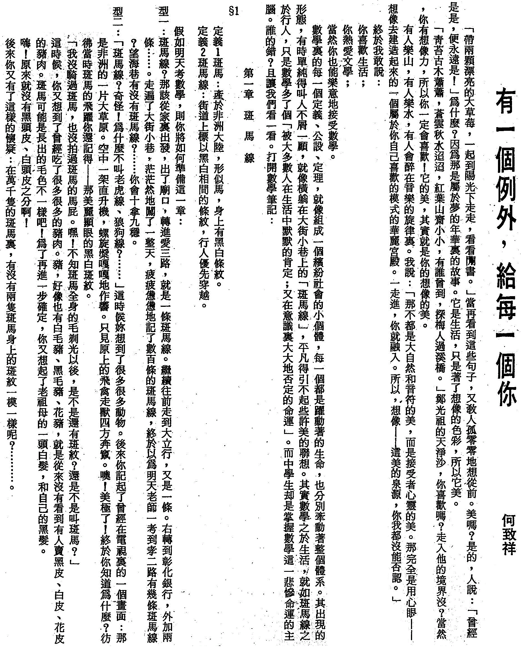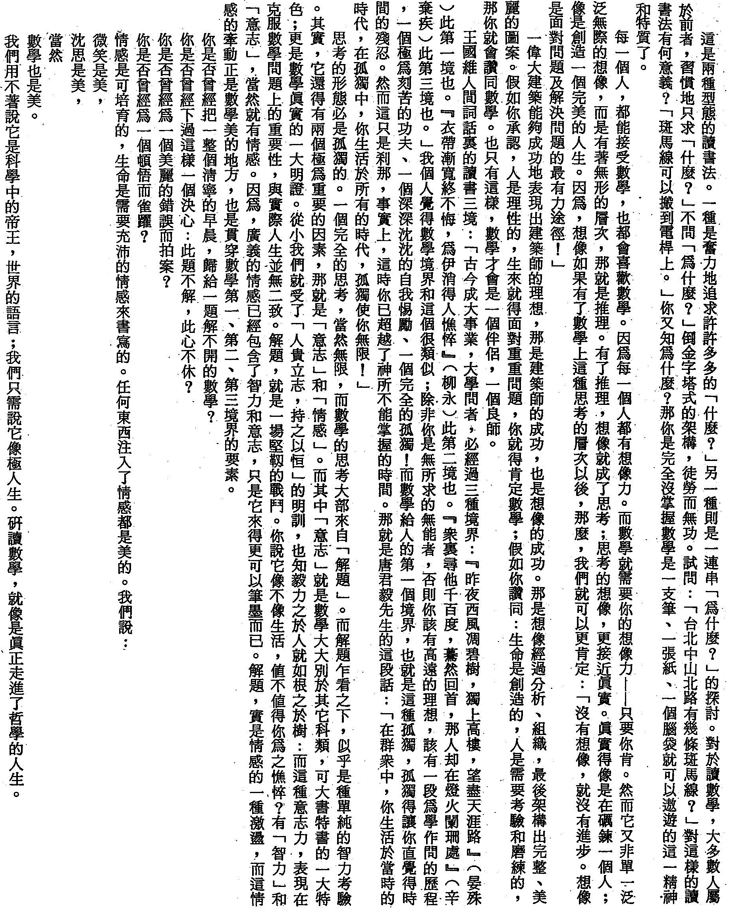**Another note: A Chinese essay written for my high school students quite a long time ago (cont.)**