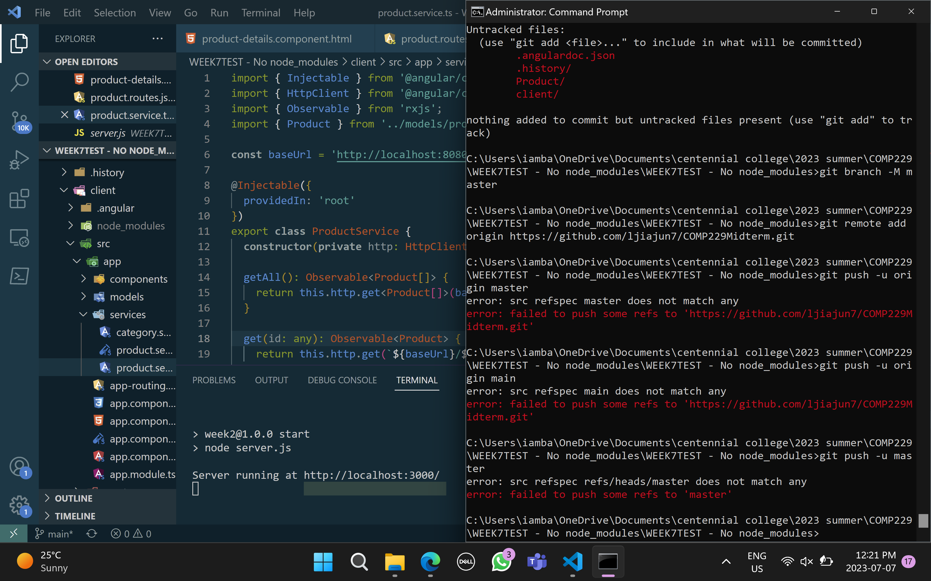

Cannot push it to my repo,

Link is here: [ljiajun7/COMP229Midterm (github.com)](https://github.com/ljiajun7/COMP229Midterm)

