INFORMATIX DE COLOMBIA
RapidPay

SPRINT II DELIVERY DOCUMENT

BUCARAMANGA - COLOMBIA
JUNIO - 2013
CONTENT

INTRODUCTIÓN 3
CHANGES ON IPAYONLINE 4
System login 4
Manage Credit Cars 4
Approve the credit card validation (New) 5
ACH Processor 6
APIRAPIDPAY PROJECT (NEW) 7
System Login 7
System components 7
Transaction 7
Transaction Type 7
Error messages 8
Frequency 9
Responses 9
Input fields 10
Geographic location 10
Terminal 11
Acquirer Account 12
System management 12

INTRODUCTIÓN
This document contains an abstract of the executed functionalities for the RapidPay Sprint II delivery, in which were developed the payments and credit card validation through the ACH Processor requirements, also, the apiRapidPay project was created, which communicates with ELAVON and contains its components’ management.

CHANGES ON IPAYONLINE

System login
SuperAdministrator Role
- User: admin.iPayOnline
- Password: Administrator1

The functionalities modified to accomplish the demanded requirements are as follows:

Manage Credit Cars
On this functionality the icon “Validate” was added, which allows to perform the approbation for the credit card validation through ELAVON.
The column Validated Credit Card was also added, this column allows informing if the card is already validated.

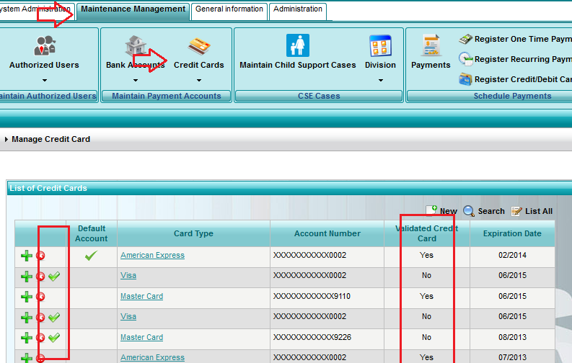

Approve the credit card validation (New)
It was created the interface in which the credit card is validated by accepting the ELAVON terms and conditions, in which the amount of 1 dollar is sent.
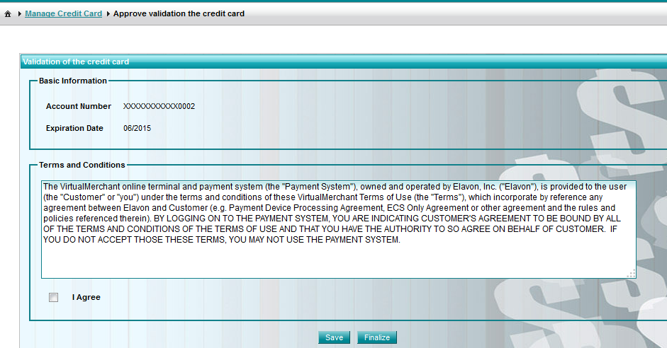

ACH Processor
On this functionality it was developed the scheduling for making the payments by credit card through ELAVON, for both one time payments and recurring payments.

APIRAPIDPAY PROJECT (NEW)
From this Project is performed the communication with iPayOnline through WebServices and with ELAVON through the HTTP transfer protocol. It also contains the management of the required components to perform such communication.

System Login
Super administrator Role
- User: admin.apiRapidPay
- Password: 123456

System components

Transaction
It contains the information about the transactions performed through ELAVON.
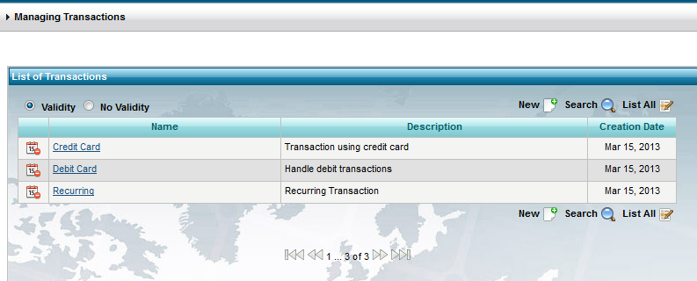

Transaction Type
It contains the information about the transaction types that are made on a transaction.

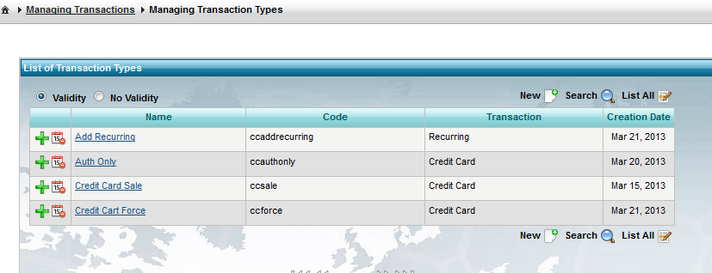

Error messages
It contains the information about the error messages that may come up in a transaction, taking into account the information in English or Spanish.

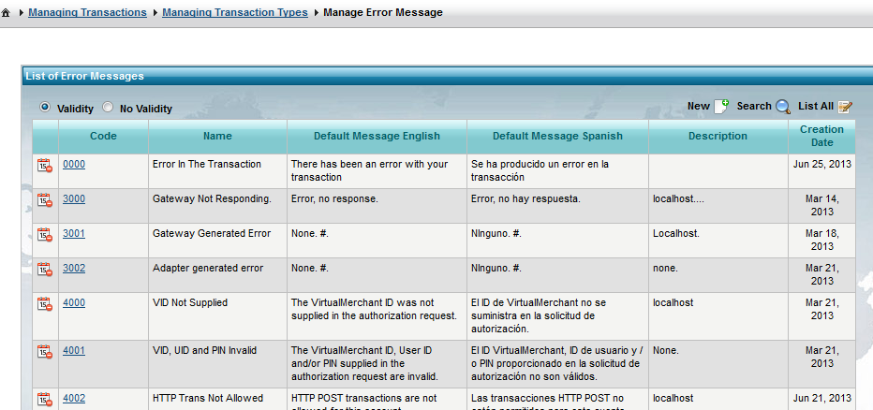

Frequency
It contains the information about the frequencies on which the recurring payments can be made.
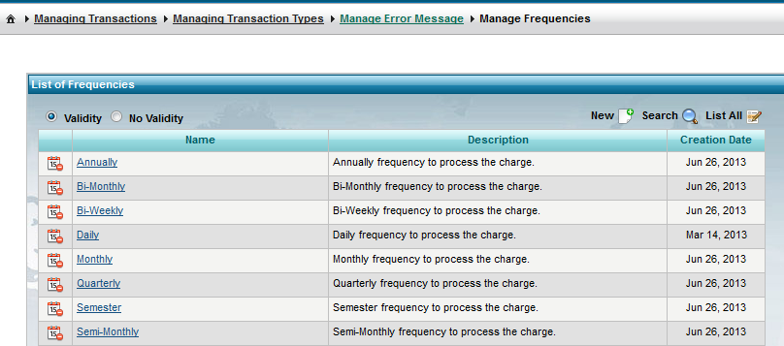

Responses
It contains the information about the responses that may come up in a transaction.
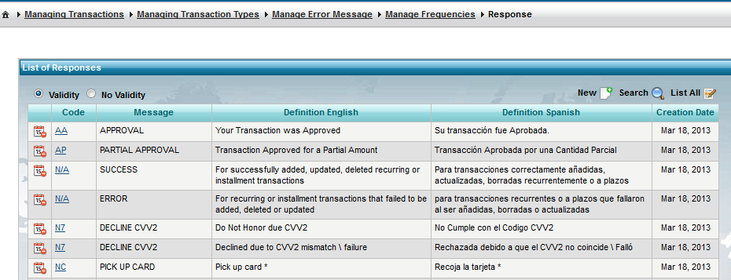

Input fields
It contains the information about the fields that are sent to ELAVON with the information of the transaction.
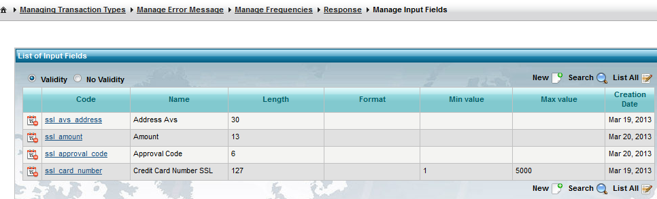

Geographic location

It contains the information about the countries, states and cities of the system.
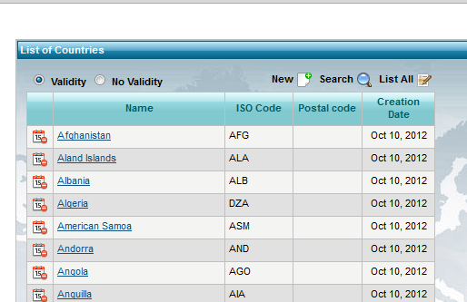

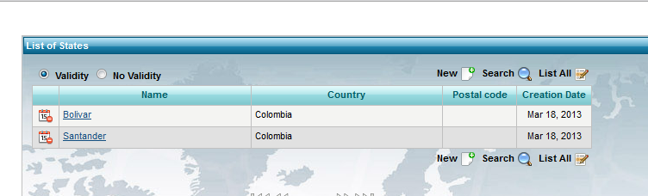

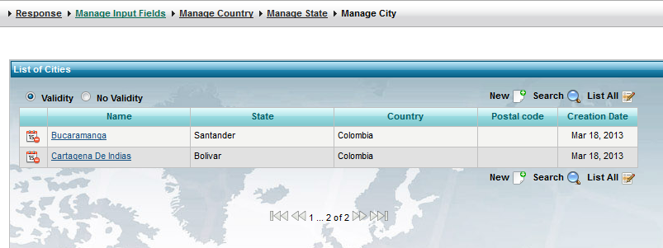

Terminal
It contains the information about the terminals that the system may have.
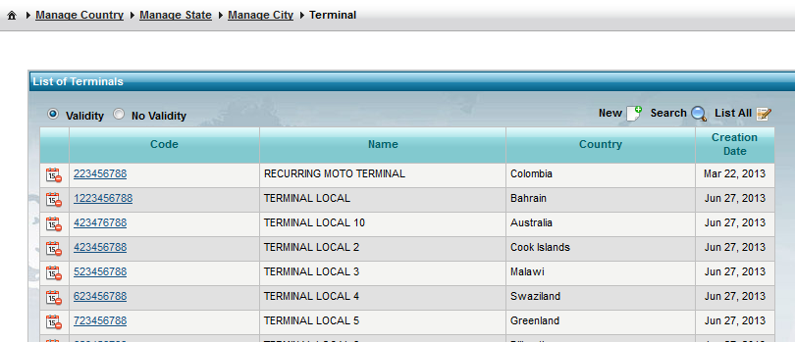

Acquirer Account
It contains the information about the acquirer which communicates with the banks to perform the transaction.
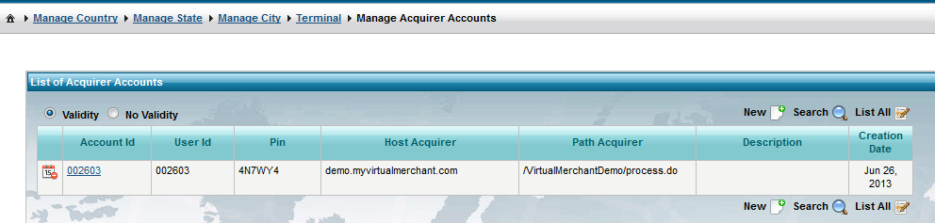

System management
It contains the functionalities for the system management:
- Icons: Menu icons, option for developers.
- Menu: System menus, option for developers.
- Method: System authorizations for methods, option for developers.
- Change Password: Allows the logged in user to change his pawwsord.
- Person: People registered on the system.
- Role: Roles that exist on the system.
- User: System users.

