Run and Test:

run command: node server.js， 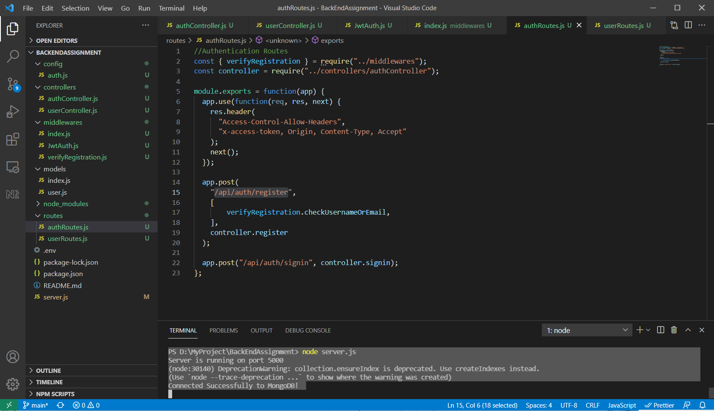

then use postman to test：

Register an account, POST: localhost:5000/api/auth/register

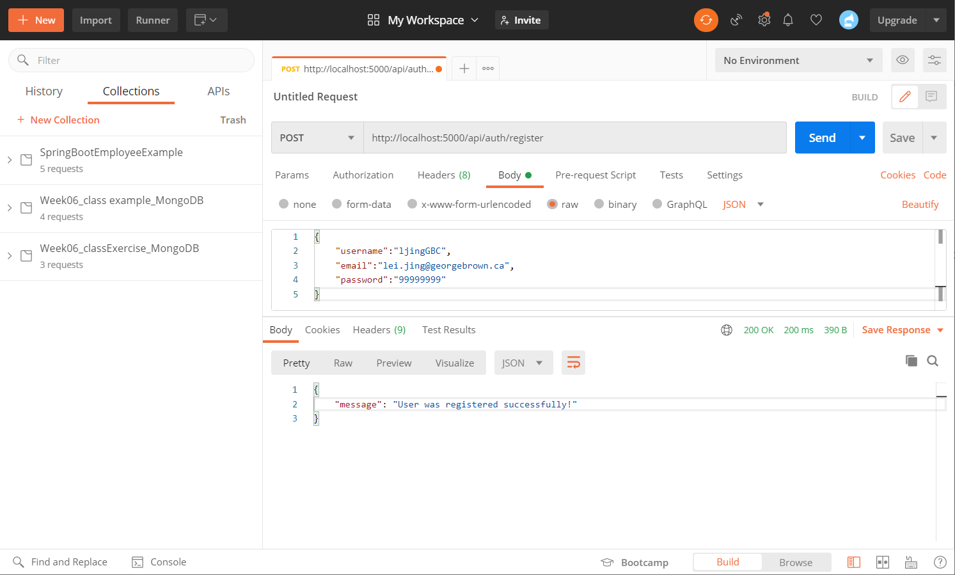

MongoDB

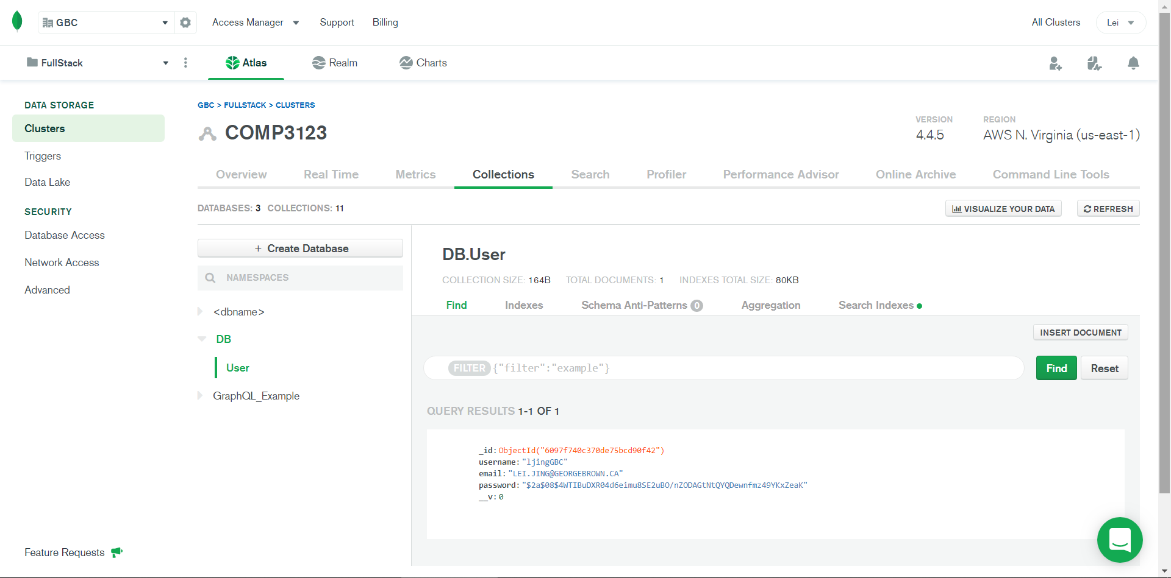

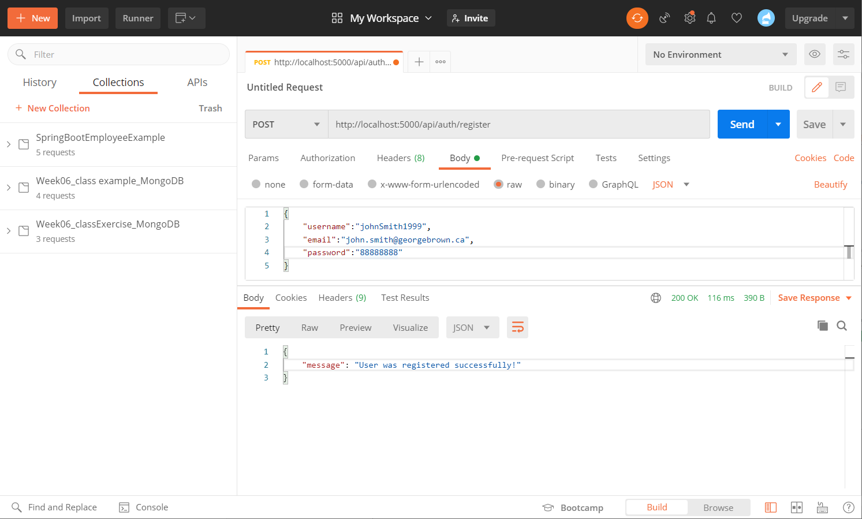

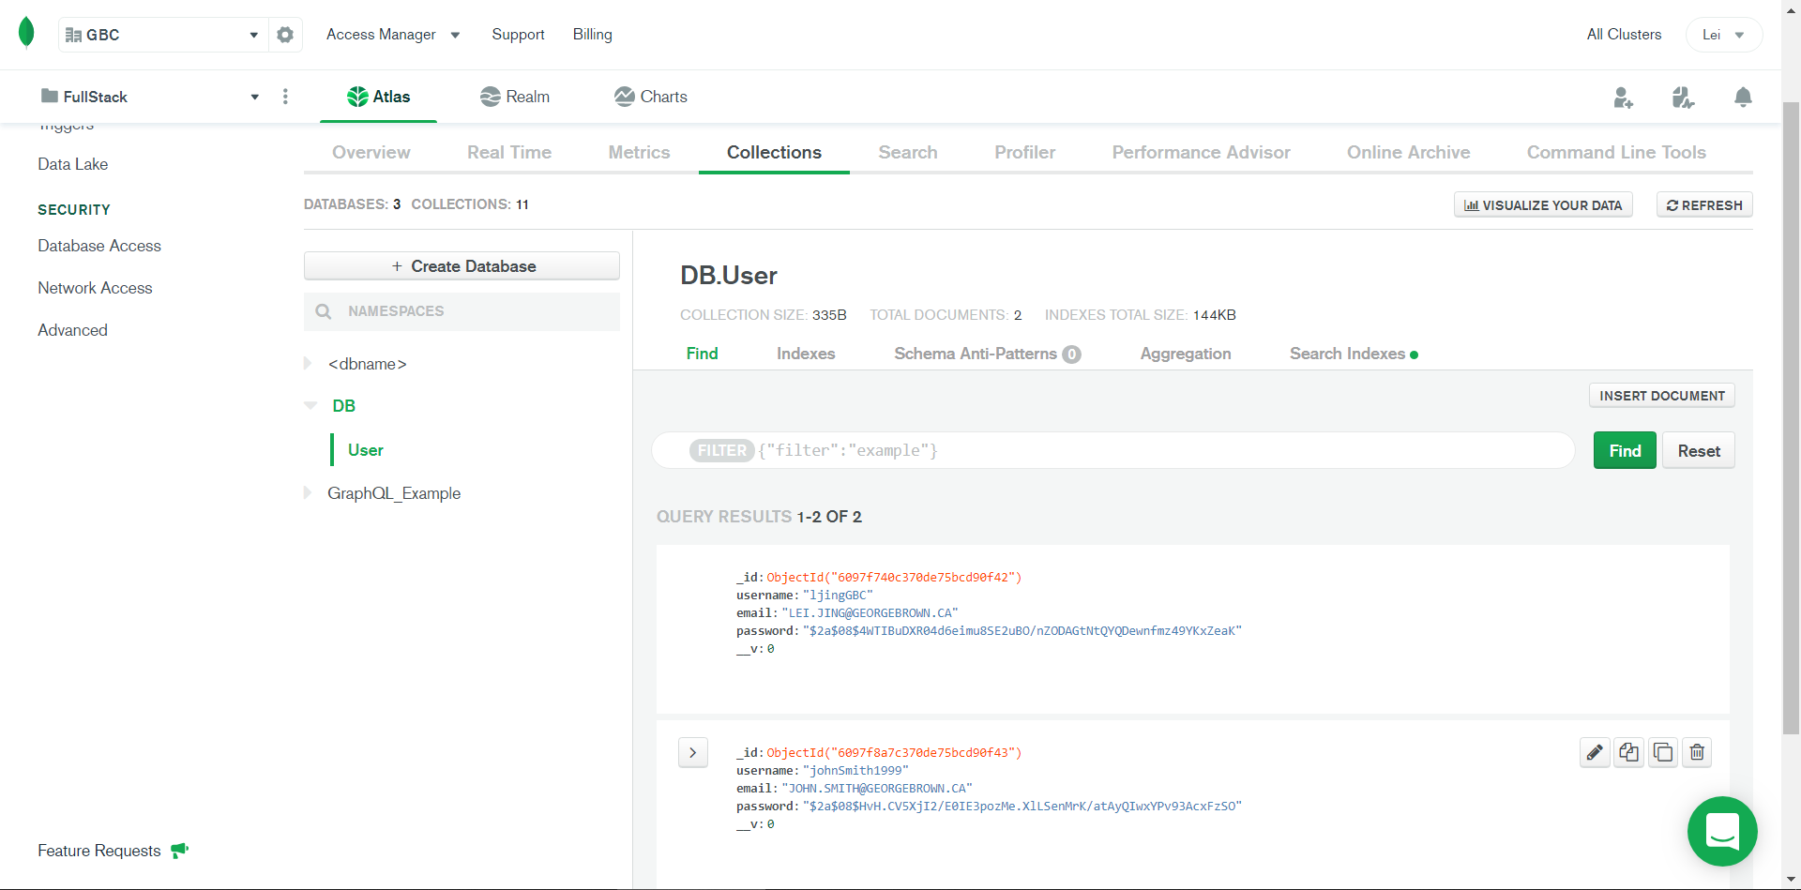

**Sign in with wrong password:** POST: localhost:5000/api/auth/signin

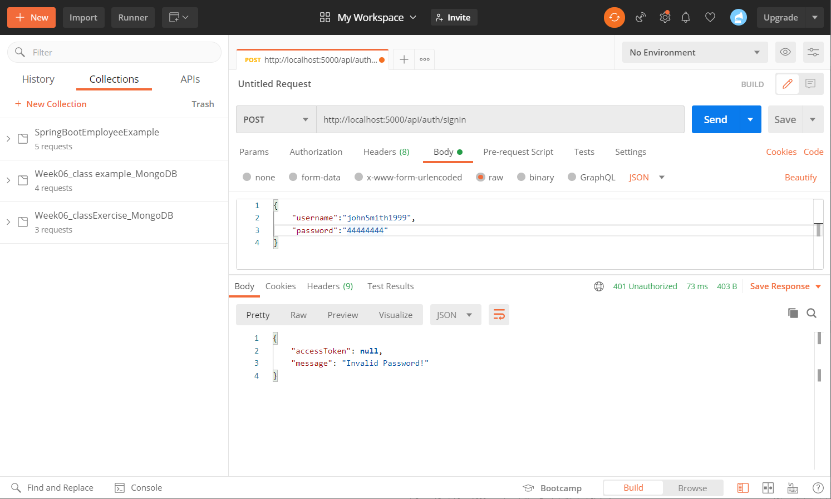

**Sign in using an account which doesn’t exist:** POST: localhost:5000/api/auth/signin

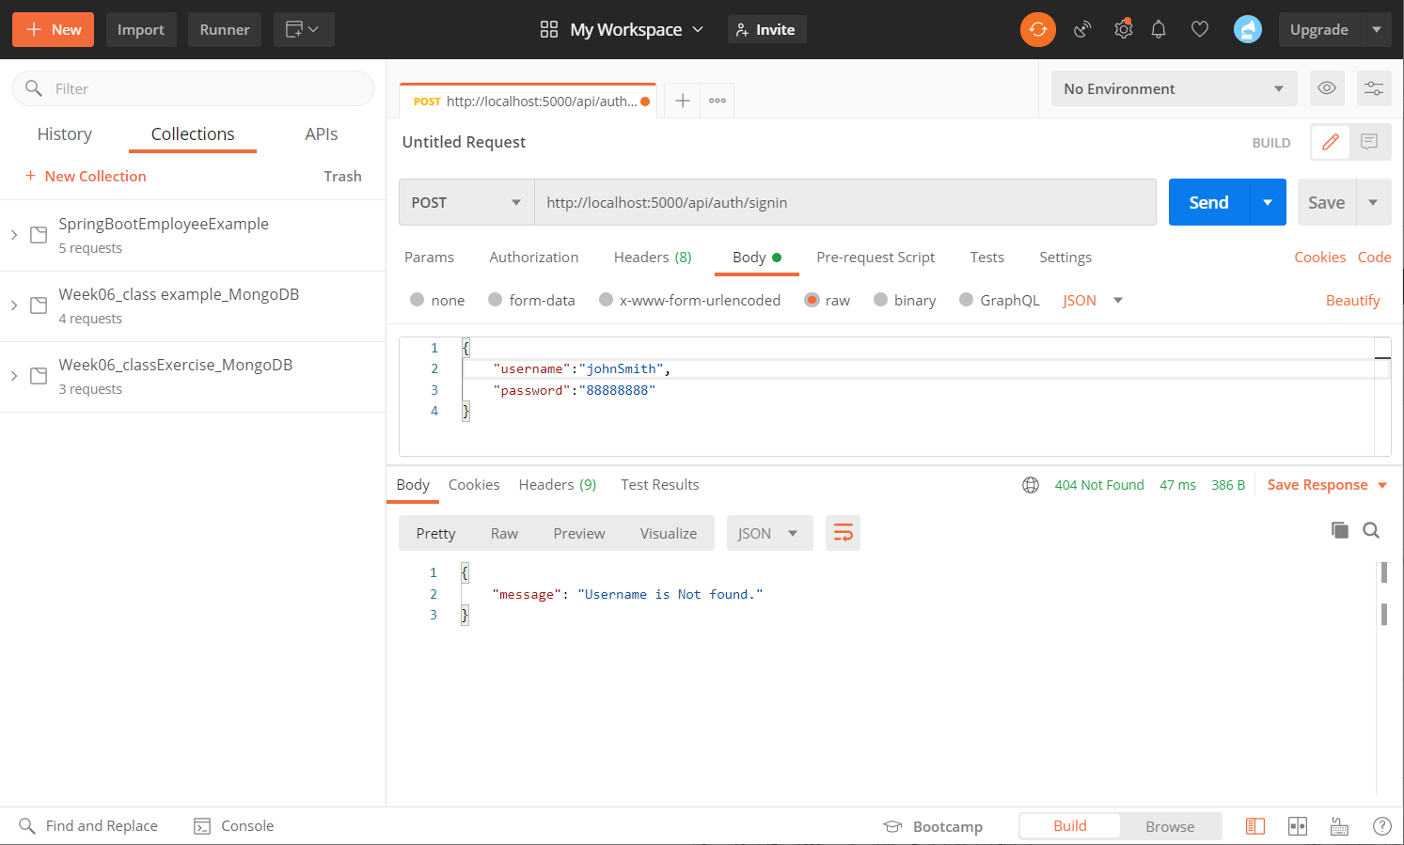

**Sign in with right username and password:** POST: localhost:5000/api/auth/signin

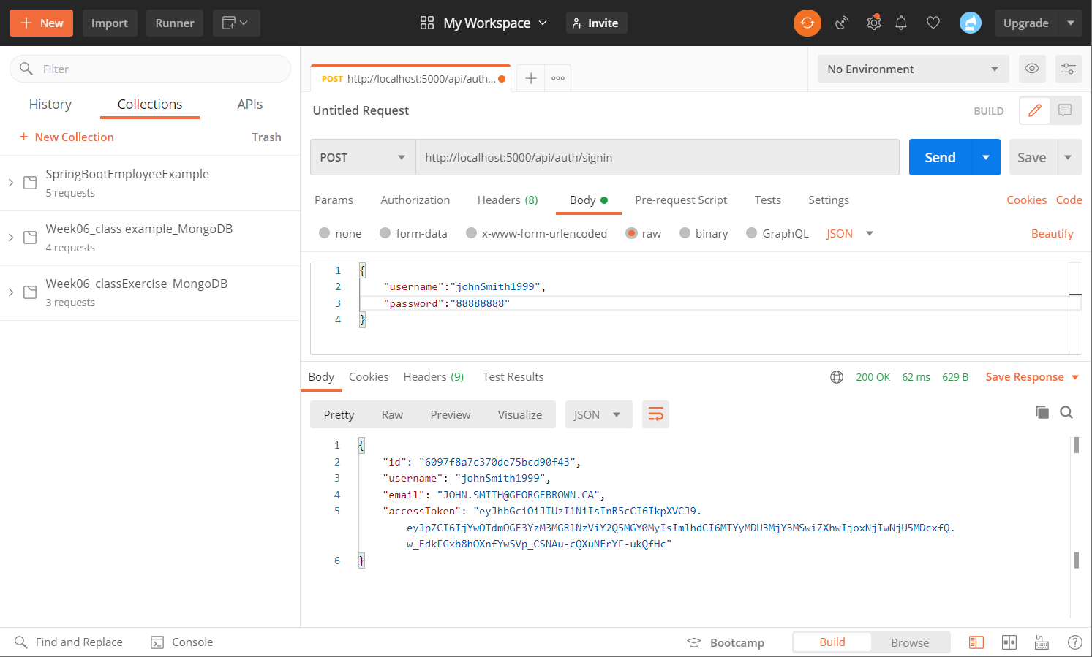

**Access public resource:** GET: localhost:5000/api/test/public

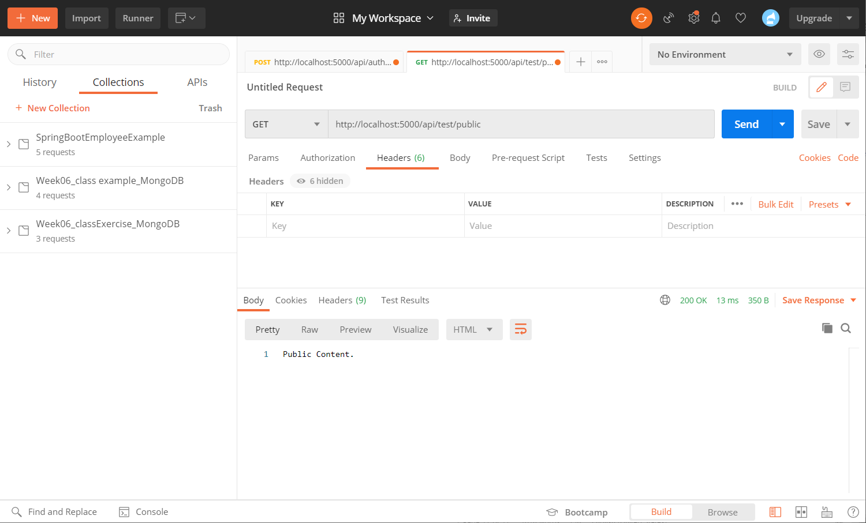

**Access protected resource:** GET: localhost:5000/api/test/user

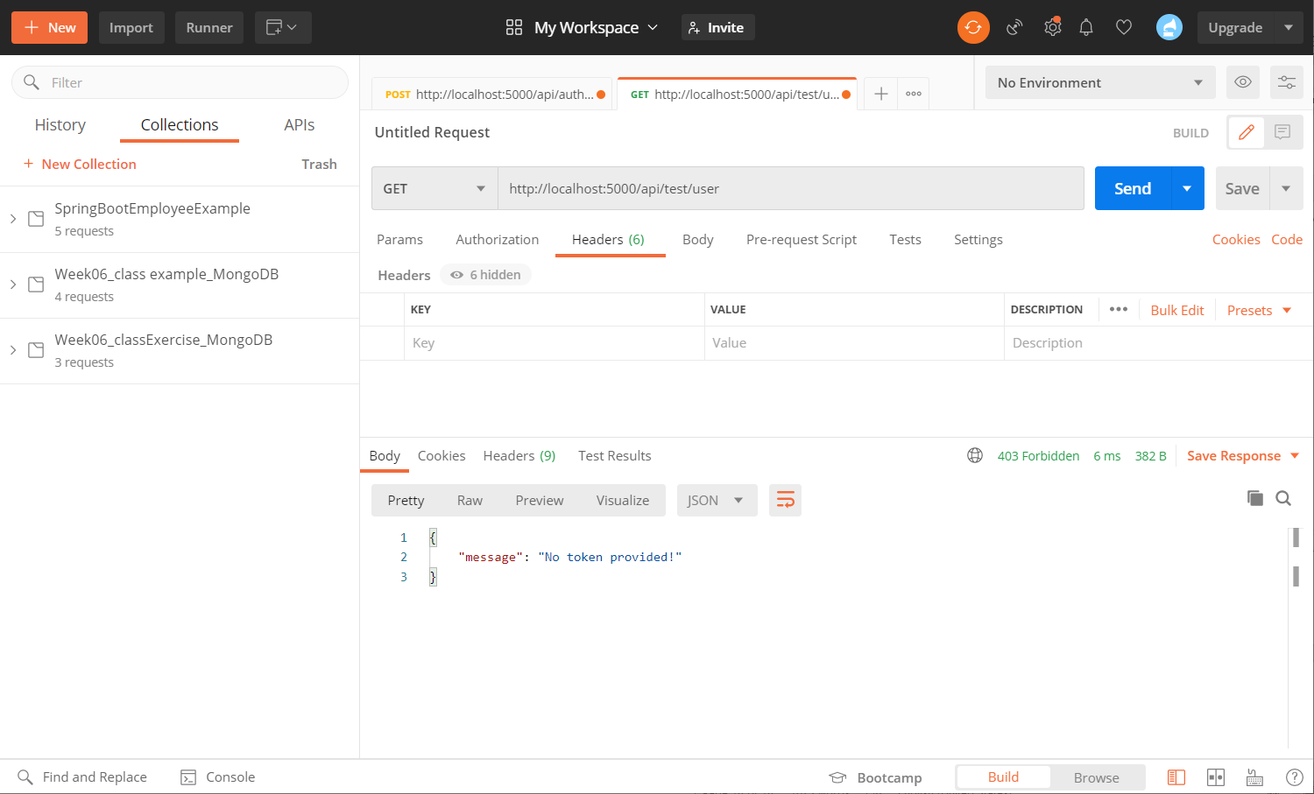

**Access protected resource(add key and value for token):** GET: localhost:5000/api/test/user

