MySQL数据定义和操作（二）
实验项目名称 | MySQL数据定义和操作（二）
实验评分 |  |  |  | 实验学时 | 2学时
实验目的：
- 掌握MySQL数据库中创建数据库和表的方法；
- 掌握基本查询语句的应用。
实验重点 |  | Select语句的基本语法
实验难点
实验类型 |  | 实训 | 实验学时 |  |  | 2
实验原理及知识点：
（1）掌握MySQL数据库中创建数据库和表的方法；
（2）掌握基本查询语句的应用。
实验环境要求 |  | 软件：My SQL ,Navicate  硬件：无
实验原理、内容及实验步骤：
- 实验原理
一、SQL查询的基本语法
select 语句是SQL语言从数据库中获取信息的一个基本语句。该语句可以实现从一个或多个数据库中的一个或多个表中查询信息，并将结果显示为另外一个二维表的形式，称之为结果集（result set）。
SQL语句的语法：
【语句格式】
SELECT [ ALL | DISTINCT ] select_list
FROM table_source
[ WHERE search_condition ]
[ GROUP BY group_by_expression ]
[ HAVING search_condition]
[ ORDER BY order_expression [ASC | DESC] ]
[limit count]

二、实验内容及步骤
1、在navicate中完成以下表的创建和数据的插入操作。

CREATE DATABASE test_4 default character set utf8 collate utf8_general_ci;
use test_4;
/*学生表*/
CREATE table student(
studentNo char(12) comment '学号',
sname char(8) comment '姓名',
sex char(2) comment '性别',
birthdate date comment '出生日期',
entrance int comment '入学成绩',
phone char(11) comment '电话号码',
email VARCHAR(20) comment '邮件号码',
departmentname varchar(20) comment '所在系名'
);

/*课程表*/
CREATE table course(
courseno char(6) comment '课程号',
cname varchar(20) comment '课程名',
type char(8) not null comment '课程类型',
cpno char(6) comment '先行课程',
period int(2) not null comment '总学时',
exp int(2) not null comment '实验学时',
term int(2) not null comment '开课学期',
primary key(courseno)
);

/*成绩表*/
CREATE table score(
studentno char(12) comment '学号',
courseno char(6) comment '课程号',
daily float(3,1) default 0 comment '平时成绩',
final float(3,1) default 0 comment '期末成绩',
primary key(studentno,courseno)
)

/*教师表*/
CREATE TABLE teacher(
teacherno char(6) not null comment'教师号',
tname char(8) not null comment '教师姓名',
major char(10) comment '专业',
prof char(10) comment '职称',
department char(16) comment '部门',
primary key(teacherno)
);

/*teach_course表*/
CREATE TABLE teach_course
(teacherno char(6) not null,
courseno char(6) not null,
teachtime datetime,
primary key(teacherno,courseno,teachtime)
);

/*学生表数据插入*/
INSERT into student values
('18122221324','何白露','女','2001/12/4',879,'13786112345','heyy@sina.com','机电院'),
('18125111109','敬横江','男','2000/3/1',789,'15678945623','jing@sina.com','计数院'),
('19125121107','王伟','男','1999/9/12',790,'13786188347','3267888@QQ.com','计数院'),
('19137156732','吴英','女','2000/10/19',888,'13055568618','17865@QQ.com','经管院');

/*课程表数据插入*/
insert into course VALUES
('c05103','电子技术','选修',null,48,16,2),
('c05107','程序设计基础','必修',null,48,16,4),
('c05109','C语言','必修','c05108',48,16,4),
('c05127','Java语言','必修','c05109',64,16,4),
('c05138','软件工程','必修','c05109',48,8,5),
('c05124','经济学','必修',null,64,16,4),
('c05108','数据库原理','必修','c05107',48,16,3),
('c05222','会计实务','必修',null,48,8,2),
('c05223','UML_SOFT','选修','c05224',48,8,2),
('c05224','UML设计','选修','c05138',64,8,2);

/*成绩表数据插入*/
insert into score VALUES
('18122221324','c05103',87.0,92.0),
('18122221324','c05109',85.0,90.0),
('18122221324','c05127',95.0,93.0),
('18125111109','c05127',91.0,88.0),
('18125111109','c05138',80.0,80.0),
('18125111109','c05108',76.0,78.0),
('19125121107','c05108',88.0,72.0),
('19125121107','c05127',81.0,76.0),
('19125121107','c05138',75.0,74.0),
('19137156732','c05124',89.0,88.0),
('19137156732','c05222',81.0,79.0);

/*教师表数据插入*/
insert into teacher values
('t05001','苏超然','软件工程','教授','计数院'),
('t05002','常斌','会计学','助教','经管院'),
('t05003','孙石安','网络安全','教授','计数院'),
('t05011','卢先','软件工程','副教授','计数院'),
('t05013','李明','机械制造','讲师','机电院'),
('t05014','王石','软件工程',NULL,'计数院');

/*教师授课表数据插入*/
insert into teach_course values
('t05001','c05109','2021-02-08 10:00:00'),
('t05001','c05127','2021-03-09 8:00:00'),
('t05001','c05109','2021-03-10 14:00:00'),
('t05003','c05124','2021-03-11 16:00:00'),
('t05011','c05127','2021-03-13 16:00:00'),
('t05011','c05127','2021-03-15 10:00:00');

SELECT * FROM student;
SELECT * FROM course;
SELECT * FROM score;
SELECT * FROM teacher;
SELECT * FROM teach_course;

二、按要求完成以下1-17题的查询，在每道题目的下面粘贴好SQL语句及运行效果截图。完成其中的8道题及格，12道题良好，17道题优秀。
/*1、查询选修课程号为c05103的学生的学号、姓名和期末成绩*/
select t1.studentNo 学号, t1.sname 姓名, t2.final 期末成绩
from student t1,
score t2
where t1.studentNo = t2.studentno
and t2.courseno = 'c05103';
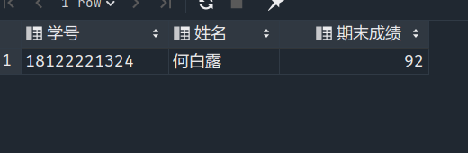

/*2、统计选课门数超过两门的学生的学号及姓名*/
select studentNo 学号, sname 姓名
from student
where studentNo in (select studentno from score t group by t.studentno having count(t.studentno) > 2);
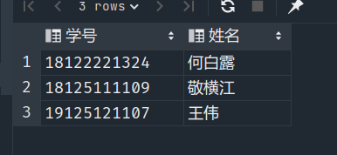

/*3、查询选修了姓“苏”的老师的课程的学生的学号。*/
select distinct studentno 学号
from score
where courseno in (select distinct courseno
from teach_course t
where t.teacherno in (select teacherno from teacher t where t.tname like '苏%'));
-- 或
select distinct t1.studentno 学号
from score t1,
teach_course t2,
teacher t3
where t1.courseno = t2.courseno
and t3.teacherno = t2.teacherno
and t3.tname like '苏%';
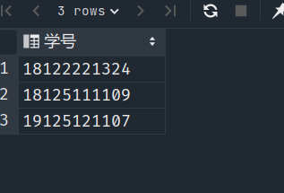

/*4、求每个学生所选修课程的期末平均分，要求显示学生的学号，姓名，及所选修课程的期末平均成绩，并按期末平均成绩从高到低排序。*/
select t1.studentNo 学号, t1.sname 姓名, t2.courseno 选修课程, (t2.final + t2.daily) / 2 平均成绩
from student t1,
score t2
where t1.studentNo = t2.studentno
order by 平均成绩 desc;

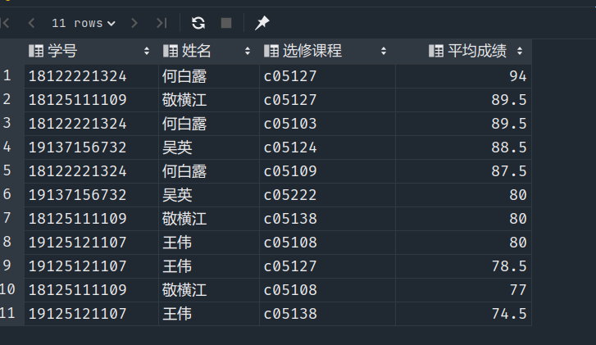

/*5、查询19级学生的学号、姓名、课程名、期末成绩及学分。注意学号前两位代表年级*/
select t1.studentNo 学号, t1.sname 姓名, t2.courseno 课程名, t2.final 期末成绩, t3.period + t3.exp 学时
from student t1,
score t2,
course t3
where t2.studentno in (select studentNo from student where studentNo like '19%')
and t2.studentno = t1.studentNo
and t2.courseno = t3.courseno;
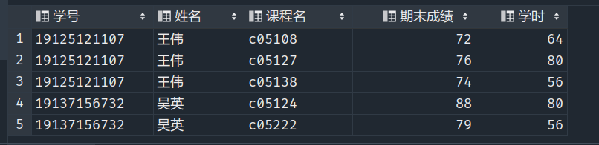
/*6、查询与“王伟”在同一个系学习的学生的基本信息*/
select *
from student
where student.departmentname in (select departmentname
from student
where sname = '王伟');
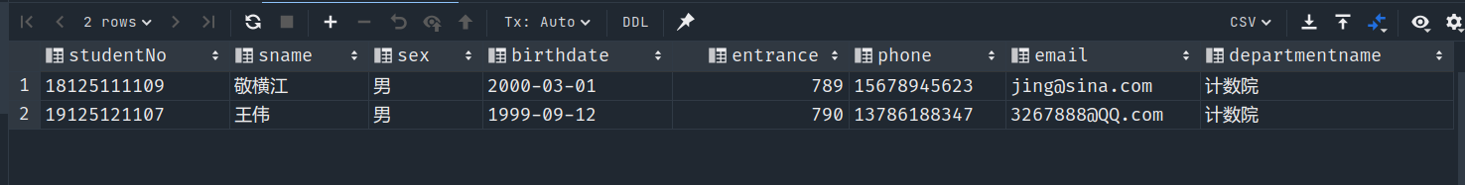
/*7、查询选修了课程名为“数据库原理"课程的学生的学号和姓名（要求使用exists子查询实现）*/
select studentNo, sname
from student
where exists(
select *
from score t1,
course t2
where t1.courseno = t2.courseno
and t2.cname = '数据库原理'
and student.studentNo = t1.studentno
);
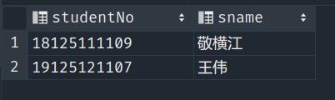

/*8、查询期末成绩大于等于90分、总评成绩高于85分的学生的学号、课程号和总评成绩*/
select studentno, courseno, 0.8 * score.final + score.daily * 0.2 总评成绩
from score
where final > 90
and final * 0.8 + score.daily * 0.2 > 85;
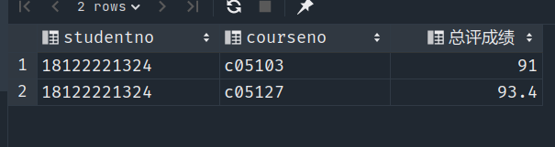

/*9、查询期末成绩比选修课程平均期末成绩低的学生的姓名、课程号和期末成绩*/
select t2.sname, courseno, t1.final 期末成绩
from score t1,
student t2
where final < (t1.final + t1.daily) / 2
and t1.studentno = t2.studentNo;
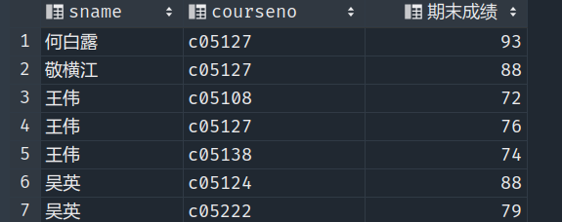

/*10、查询期末成绩中含有高于90分的学生的学号、姓名、电话及课程名*/
select t1.studentNo, sname, phone, cname
from student t1,
score t2,
course t3
where t2.final > 90
and t1.studentNo = t2.studentno
and t2.courseno = t3.courseno;
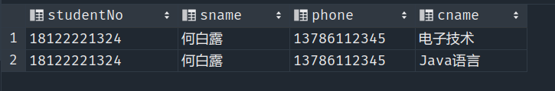

/*11、查找score表中所有比c05103课程期末成绩都高的学生的学号、姓名和期末成绩*/
select t1.studentNo, t1.sname, t2.final
from student t1,
score t2
where t2.final > all (select final from score where score.courseno = 'c05103')
and t1.studentNo = t2.studentno;
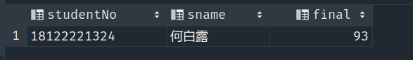

/*12、查询每一课程的间接先行课(即先行课的先行课)。*/
select t1.courseno, t1.cname, t2.cpno
from course t1
left join course t2
on t1.cpno = t2.courseno;
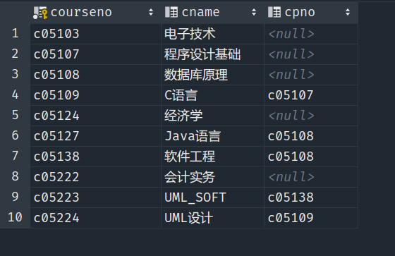

/*13、找出每个学生期末成绩超过他选修课程期末平均成绩的学生的学号及课程号*/
select studentno, courseno
from score
where final > (score.final + score.daily) / 2;
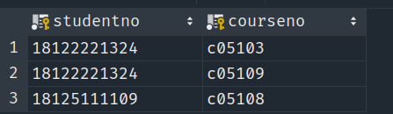

/*14、查询年龄低于所有计数院学生的学生姓名、所在系、年龄。*/
select sname, departmentname, year(now()) - year(birthdate) age
from student
where year(now()) - year(birthdate) < all
(select year(now()) - year(birthdate) from student where departmentname = '计数院');
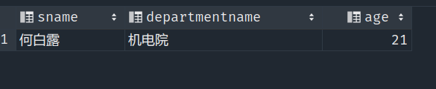

/*15、查询选修了全部课程的学生姓名。*/
-- 没有一门课是他不选的
select sname
from student t1
where not exists(
select *
from score t2
where not exists(
select *
from score t3
where t3.studentno = t1.studentNo
and t3.courseno = t2.courseno
)
);
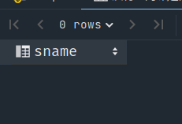

/*16、查询至少选修了学生18125111109选修的全部课程的学生学号,注意查询结果中不应该含有18125111109学生*/
select distinct studentno
from score t1
where not exists(
select *
from score t2
where t2.studentno = '18125111109'
and not exists(
select *
from score t3
where t3.courseno = t2.courseno
and t3.studentno = t1.studentno
)
)
and studentno != '18125111109';
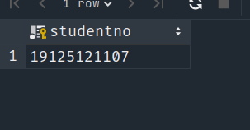

/*17、查询今年3月份苏姓老师的授课信息，包括教工号，教师姓名，课程名，授课时间。*/
select t1.teacherno, tname, cname, teachtime
from teacher t1,
teach_course t2,
course t3
where t1.teacherno = t2.teacherno
and t2.courseno = t3.courseno
and tname like '苏%'
and date_format(teachtime, '%Y-%m') = '2021-03';
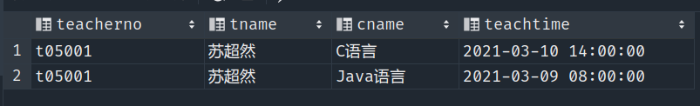
/*18、查询没有人选修的课程的信息，要求显示课程的编号，课程的名称。*/
select courseno, cname
from course
where courseno not in (select courseno from score);
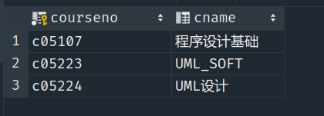

实验总结：
- 查询某个月的数据(查询21年3月份数据)
select * from table where date_format(start_time,'%Y-%m') = '2021-03'
- sql中没有全称量词，所以当遇到全部问题时，可以转化为否定再否定（两层exists）
- 多表查询要注意理清各表之间的联系，防止出现无用数据和重复数据

