Week 3 Dataset Assessment and Pre DE Quality Control
GSE146853 and GSE87487 workflow before differential expression
Student: Lei Jiali (雷嘉莉) | Checked: 12 September 2026
Dataset triage means a short suitability check before full analysis. It asks whether the official files exist, whether counts and metadata can be aligned, whether the study design can answer the question, and whether the available data layer supports the intended claim.
Scope For both datasets, this submission validates integer counts, aligns metadata, filters low-expression genes, constructs a DESeq2 object, runs blind VST, and creates a PCA panel. It stops before DESeq() and differential-expression testing.

1 Dataset suitability screening
Field | Assessment
Data-driven question | Across CRC, IBD, and IBS cases and controls, which colonic mucosal microbe-host gene or pathway associations are shared across diseases, and which are disease-specific?
Primary GEO series | GSE146853 (Homo sapiens; host colonic-mucosal RNA-seq).
Study design | GEO contains 68 biopsies from 42 subjects: 26 subjects have two visits and 16 have one. For an independent cross-sectional QC comparison, use 39 first-visit samples: IBS n=26 and healthy n=13.
Data layer | Official host gene-count matrix. The Nature Microbiology study also uses matched 16S rRNA profiles; the GEO matrix alone is not the complete multi-omic dataset.
Focused contrast | First-visit IBS versus healthy host-transcriptome comparison. One sample with missing cohort information is excluded from this focused analysis.
Decision | PROCEED for host-transcriptome preprocessing and QC; REJECT as a stand-alone basis for the full cross-disease host-microbiome claim.

Six criterion assessment
Criterion | Score | Rationale
Biological relevance | 1/2 | Directly relevant to IBS host response, but not all CRC/IBD multi-omic cohorts.
Authoritative provenance | 2/2 | Official NCBI GEO/SRA records linked to the paper.
Count-data suitability | 2/2 | Official non-negative integer gene counts are available.
Metadata completeness | 1/2 | Repeated visits require care and one GEO sample lacks cohort information.
Design reconstructability | 2/2 | Subject, visit, cohort, and sample identifiers can be aligned.
One-hour feasibility | 2/2 | The count matrix supports focused filtering, VST, and PCA without FASTQ processing.
Total | 10/12 | Proceed within the stated, narrower scope.

2 Retrieval record
The submitted week3_homework.R script downloaded or reused the following official files and recorded the inspection date, accession, type, and byte size.
Accession | Date | File | Type | Size
GSE146853 | 2026-09-12 | GSE146853_family.soft.gz | GEO SOFT gzip | 5.5 KiB
GSE146853 | 2026-09-12 | GSE146853_GeneCount_raw.txt.gz | raw gene-count TSV gzip | 5.0 MiB
SRX7899639 | 2026-09-12 | SRX7899639_runinfo.csv | SRA RunInfo CSV | 1.0 KiB
GSE87487 | 2026-09-12 | GSE87487_family.soft.gz | GEO SOFT gzip | 3.1 KiB
GSE87487 | 2026-09-12 | GSE87487_counts.20samples.txt.gz | raw gene-count TSV gzip | 3.7 MiB
SRX2199841 | 2026-09-12 | SRX2199841_runinfo.csv | SRA RunInfo CSV | 2.3 KiB
SRP090633 | 2026-09-12 | SRP090633_runinfo.csv | SRA RunInfo CSV | 34.1 KiB

- GSE146853 → GSM4407890 → SRX7899639 → SRR11294080; BioProject PRJNA612180; SRA Study SRP252532.
- GSE87487 → GSM2332515 → SRX2199841 → SRR4305577; BioProject PRJNA344898; SRA Study SRP090633.
- The GSE87487 study query returned 20 SRX experiments, 76 SRR runs, and 20 GSM samples with raw-read download paths. The submitted analysis uses the official count matrix rather than reprocessing FASTQ files.

3 Integrity and cleaning summary
Dataset | Raw dimensions | Alignment | Missing / duplicate checks | Filter and retained features
GSE146853 | 64253 genes × 68 samples; 6 annotation columns | Matched: TRUE | Missing key fields: 1; duplicates: GSM 0; subject-stage 0 | count >= 10 in at least 13 first-visit samples → 25161 genes
GSE87487 | 60498 genes × 20 samples; 6 annotation columns | Matched: TRUE | Missing key fields: 0; duplicates: GSM 0; subject-stage 0 | count >= 10 in at least 10 samples → 12960 genes

Count integrity: both expression matrices contain only finite, non-negative, integer-valued counts. Sample alignment was verified as a one-to-one match after explicit case-insensitive identifier normalization; this resolves the HBBx/HBBX capitalization difference in GSE87487 without changing biological labels.
GSE146853 cleaning: 64,253 raw genes and 68 samples were inspected. The focused first-visit analysis uses 39 samples; the filter count >= 10 in at least 13 samples retained 25,161 genes. The one missing cohort value is reported, not silently imputed.
GSE87487 cleaning: 60,498 raw genes, six annotation columns, and 20 count columns were inspected. The filter count >= 10 in at least 10 samples retained 12,960 genes. All 20 samples have complete subject, stage, and IRI-status fields.
DESeq2 objects: GSE146853 contains 25,161 genes and 39 samples with design ~ analysis_group. GSE87487 contains 12,960 genes and 20 samples with paired design ~ subject + stage. Blind VST completed for both objects.

4 Pre differential expression workflow and QC figure
For each dataset integer counts → low-count filter → DESeqDataSet → blind VST → PCA
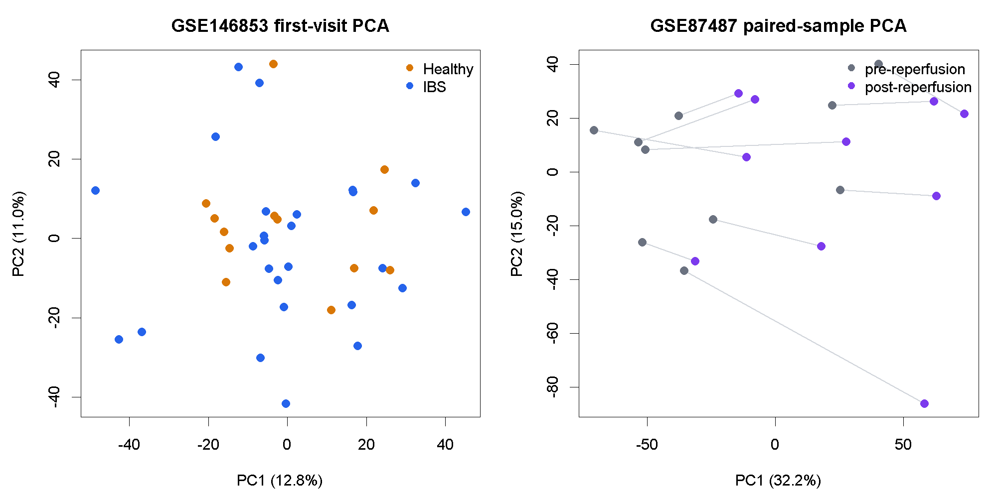
Figure 1. VST-based PCA for GSE146853 and the paired GSE87487 samples.
After filtering and VST, PC1 and PC2 explain 12.8% and 11.0% of variance in GSE146853 and 32.2% and 15.0% in GSE87487.
The first two PCs show limited IBS-versus-healthy separation in GSE146853 and visible pre-versus-post separation in GSE87487; the gray lines identify paired biopsies, and neither panel is a differential-expression test.
Boundary: No differential-expression model was fitted and no p-values, fold changes, or gene lists were produced.

5 Required GSE87487 assessment
Question | Code-derived answer | Decision
Does GEO provide a count matrix? | Yes: GSE87487_counts.20samples.txt.gz, 60,498 genes × 20 samples plus six annotation columns; 3.7 MiB compressed. | Proceed
Are all 20 samples independent? | No. They are paired pre- and post-reperfusion biopsies from 10 liver-allograft subjects. | Do not treat as independent
Can all samples be compared directly? | Use a within-subject post-versus-pre contrast and block on subject. Four subjects are IRI-positive and six are IRI-negative. | Paired design required
Could full raw-read reprocessing be done? | Yes. The discovered SRP090633 record provides raw-read paths for every sample; this submission deliberately uses official counts. | Feasible, not performed

Metadata-derived description: Homo sapiens, GEO type “Expression profiling by high throughput sequencing,” SRA library strategy RNA-Seq, liver tissue, and liver-allograft biopsy material. Because the RNA was extracted from tissue rather than isolated single cells, “bulk RNA-seq” is a documented inference from the sample material and library metadata.
After filtering, the script constructs the GSE87487 DESeq2 object with 12,960 genes and 20 samples using design ~ subject + stage, then runs blind VST and PCA. The paired subject term is already present for the later post-versus-pre comparison, but DESeq() is not called.
A stage × IRI-status interaction would be a reasonable later model for IRI-specific changes, but it is not presented here as a completed differential-expression result.

6 AI use and verification
AI was used to organize the assignment, revise the retrieval and QC logic, construct DESeq2 objects and VST transformations for both datasets, and polish the English. Every quantitative statement in this document was checked against the output of the submitted script.. The complete prompt, decision, source, and test record is in ai_verification_log.txt.

7 Reflection
The largest limitation is that GSE146853 contains the IBS host-transcriptome layer, whereas the Nature Microbiology question requires matched microbiome data and comparable CRC and IBD cohorts. This dataset supports the narrower claim that a first-visit IBS-versus-healthy host-expression comparison is technically feasible after metadata alignment, count validation, and low-expression filtering. It does not establish shared or disease-specific host-microbiome associations. The next step is to integrate matched 16S profiles and the CRC/IBD cohorts, model relevant covariates and repeated measures, and then perform differential-expression, pathway, and host-microbe association analyses with independent validation.

8 Sources
- Priya S et al. Identification of shared and disease-specific host gene-microbiome associations across human diseases using multi-omic integration. Nature Microbiology (2022). DOI: 10.1038/s41564-022-01121-z.
- NCBI GEO: GSE146853 and GSE87487 family SOFT metadata and official supplementary count matrices; checked 12 September 2026.
- NCBI SRA RunInfo: SRX7899639, SRX2199841, and the discovered study SRP090633; checked 12 September 2026.
- Love MI, Huber W, Anders S. Moderated estimation of fold change and dispersion for RNA-seq data with DESeq2. Genome Biology (2014) 15:550.

