Facility Manager 2
App Manager Main Window 2
Facility Module 3
Facility List 4
Facility Detail Dialog 5
Unit List 6
Unit Detail Dialog 7
Fixture List 8
Fixture Detail Dialog 9
Equipment List 10
Equipment Detail Dialog 12
Person Module 14
Person List 15
Person Detail Dialog 16
Relation List 18
Relation Detail Dialog 19
Person Address List 20
Address List 21
Address Detail Dialog 22
Person Unit List 23
Person Unit Detail Dialog 24
Account List 25
Account Detail Dialog 27
Business Module 29
Business List 29
Business Detail Dialog 30
Business Contact List 32
Contact List 33
Contact Detail Dialog 34
Business Address List 36
Address List 37
Address Detail Dialog 38
Code Type Module 39
Code Type List 40
Code Type Detail Dialog 41
Region Manager 42
Region Module 43
Province List 43
Province Detail Dialog 44
City List 45
City Detail Dialog 46
Barangay List 47
Barangay Detail Dialog 47

Facility Manager

The Facility Manager is a program designed to manage information about buildings that can be divided into units. It is designed as a plug-in so that its modules can be hosted in the App Manager program.
It contains five modules that work together to manage the facility information.

Facility
Person
Business
Province/State
Code Type

App Manager Main Window

The App Manager main window consists of two window panes separated by a moveable splitter bar.

The left windowpane is the Program Menu Tree that displays the authorized programs and program modules for the signed in user.

The right windowpane is the Tab Display pane.
When a program module is selected from the menu tree, the associated module tabs are displayed in this area.

Facility Module

A Facility is usually a building that contains multiple rooms or units. This can be a Hotel/Motel, School, Business or other similar entity.

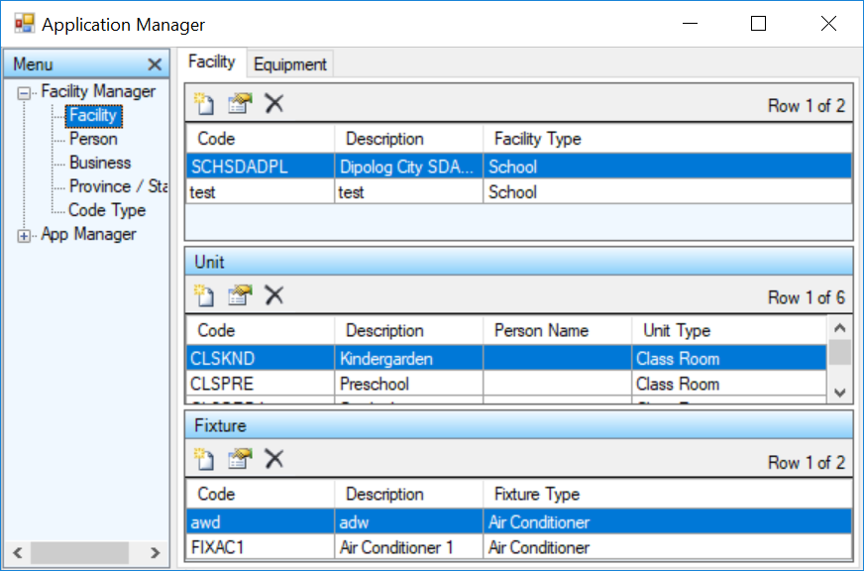

Information can be managed for entities related to the facility such as the contained units, the fixtures in those units and the equipment used to repair, maintain or temporarily enhance those units.

Unit

A Unit is usually a room in a facility. It could however represent bins or other storage units.

Fixture

A Fixture is an item that is usually not removed from the unit. Examples of fixtures can be Air Conditioners, Refrigerators, Microwave ovens, Desks, lamps and other furniture.

Equipment

Equipment usually represents something that is not permanently assigned to the unit. This can be audiovisual equipment or repair and maintenance equipment that is currently being used in that unit.

Facility List

The Facility list contains the defined facilities. Facilities can be added, edited and deleted from this list.

Context Menu

New

The 'New' menu item displays the Facility Detail dialog to allow for the creation of a new facility entry.

Edit

The 'Edit' menu item displays the Facility Detail dialog to allow for editing the selected list item.

Delete

The 'Delete' menu item deletes the selected list item.

Refresh

The 'Refresh' menu item reloads the list items from the database.

Export Text

The 'Export Text' menu item creates a tab delimited text file with the file name 'ExportFacility.doc'. It attempts to display the data with the application that is associated with the '.doc' extension.

Export CSV

The 'Export CSV' menu item creates a comma delimited text file with the file name 'ExportFacility.csv'. It attempts to display the data with the application that is associated with the '.csv' extension.

Close

The 'Close' menu item removes the module tab from the Tab Display windowpane.

Facility Detail Dialog

The Facility Detail dialog allows the user to create and edit facility entries.

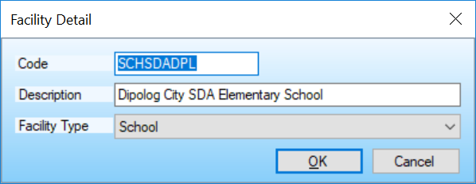

Form Controls

Code

This is the user-defined code for this facility. A code is an abbreviation that is easier to use than the long item description.
So if you define a facility code type for School facilities with the code FACSCH and you have a main school and two branches, you might give the schools the codes: SCHMAIN, SCHBR1 and SCHBR2. For these schools you would select the Facility Type of FACSCH.

Description

This is the facility description.

Facility Type

This is the facility type selection.
Only code types that belong to the Facility code type class will appear in this list.

OK Button

Saves the entered data and exits the dialog.

Cancel Button

Exits the dialog without saving the entered data.

Unit List

The Unit list contains the defined units for the selected facility. Units can be added, edited and deleted from this list.

Context Menu

New

The 'New' menu item displays the Unit Detail dialog to allow for the creation of a new unit entry.

Edit

The 'Edit' menu item displays the Unit Detail dialog to allow for editing the selected list item.

Delete

The 'Delete' menu item deletes the selected list item.

Refresh

The 'Refresh' menu item reloads the list items from the database.

Export Text

The 'Export Text' menu item creates a tab delimited text file with the file name 'ExportUnit.doc'. It attempts to display the data with the application that is associated with the '.doc' extension.

Export CSV

The 'Export CSV' menu item creates a comma delimited text file with the file name 'ExportUnit.csv'. It attempts to display the data with the application that is associated with the '.csv' extension.

Close

The 'Close' menu item removes the module tab from the Tab Display windowpane.

Unit Detail Dialog

The Unit Detail dialog allows the user to create and edit unit entries.

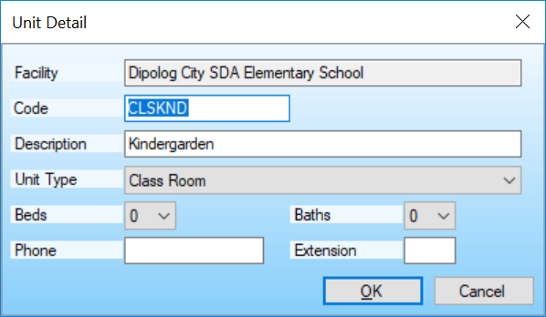

Form Controls

Code

This is the user-defined code for this unit. A code is an abbreviation that is easier to use than the long item description.
So if you define a code type for Classrooms with the code UNITCLS and you have three Classrooms, you might give the classrooms the codes: CSLA, CLSB and CLSC. For these units you would select the Unit Type of UNITCLS.

Description

This is the unit description.

Unit Type

This is the unit type selection.
Only code types that belong to the Unit code type class will appear in this list.

Beds

This is the number of beds in this unit. This may not apply for some facility units.

Baths

This is the number of baths in this unit. This may not apply for some facility units.
Phone

This is the unit phone number.

Extension

This is the unit extension.

OK Button

Saves the entered data and exits the dialog.

Cancel Button

Exits the dialog without saving the entered data.

Fixture List

The Fixture list contains the defined fixtures for the selected unit. Fixtures can be added, edited and deleted from this list.

Context Menu

New

The 'New' menu item displays the Fixture Detail dialog to allow for the creation of a new fixture entry.

Edit

The 'Edit' menu item displays the Fixture Detail dialog to allow for editing the selected list item.

Delete

The 'Delete' menu item deletes the selected list item.

Refresh

The 'Refresh' menu item reloads the list items from the database.

Export Text

The 'Export Text' menu item creates a tab delimited text file with the file name 'ExportFixture.doc'. It attempts to display the data with the application that is associated with the '.doc' extension.

Export CSV

The 'Export CSV' menu item creates a comma delimited text file with the file name 'ExportFixture.csv'. It attempts to display the data with the application that is associated with the '.csv' extension.

Close

The 'Close' menu item removes the module tab from the Tab Display windowpane.

Fixture Detail Dialog

The Fixture Detail dialog allows the user to create and edit fixture entries.

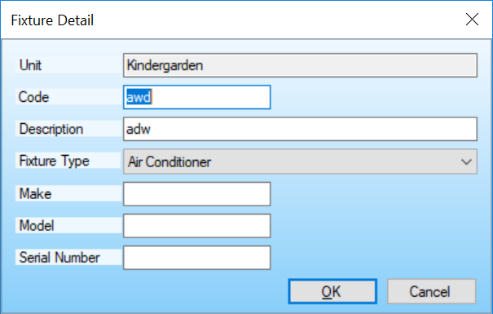

Form Controls

Code

This is the user-defined code for this fixture. A code is an abbreviation that is easier to use than the long item description.
So if you define a fixture code for Air Conditioners with the code FIXAC and you have two Air Conditioner units, you might give them the codes: AC1 and AC2. For these fixtures you would select the Fixture Type of FIXAC.

Description

This is the fixture description.

Fixture Type

This is the fixture type selection.
Only fixture types that belong to the Fixture code type class will appear in this list.

Make

This is the make of the fixture.

Model

This is the model of the fixture.

Serial Number

This is the fixture serial number.

OK Button

Saves the entered data and exits the dialog.

Cancel Button

Exits the dialog without saving the entered data.

Equipment List

The Equipment list contains the defined equipment. Equipment can be added, edited and deleted from this list.

Context Menu

New

The 'New' menu item displays the Equipment Detail dialog to allow for the creation of a new equipment entry.

Edit

The 'Edit' menu item displays the Equipment Detail dialog to allow for editing the selected list item.

Delete

The 'Delete' menu item deletes the selected list item.

Refresh

The 'Refresh' menu item reloads the list items from the database.

Export Text

The 'Export Text' menu item creates a tab delimited text file with the file name 'ExportEquipment.doc'. It attempts to display the data with the application that is associated with the '.doc' extension.

Export CSV

The 'Export CSV' menu item creates a comma delimited text file with the file name 'ExportEquipment.csv'. It attempts to display the data with the application that is associated with the '.csv' extension.

Close

The 'Close' menu item removes the module tab from the Tab Display windowpane.

Equipment Detail Dialog

The Equipment Detail dialog allows the user to create and edit equipment entries.

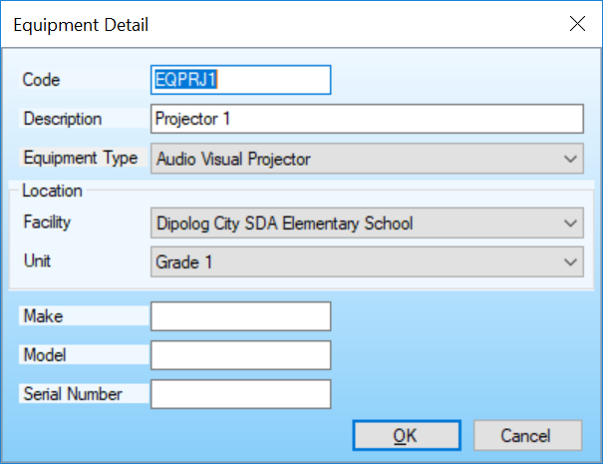

Form Controls

Code

This is the user-defined code for this equipment. A code is an abbreviation that is easier to use than the long item description.
So if you define a code type for Audiovisual equipment with the code EQAV and you have three AV units, you might give the AV units the codes: AV1, AV2 and AV3. For these AV units you would select the Equipment Type of EQAV.

Description

This is the code type description.

Equipment Type

This is the equipment type selection.
Only code types that belong to the Equipment code type class will appear in this list.

Facility

This is the Facility where the equipment is currently located.

Unit

This is the Unit where the equipment is currently located.

Make

This is the make of the equipment.

Model

This is the model of the equipment.

Serial Number

This is the equipment serial number.

OK Button

Saves the entered data and exits the dialog.

Cancel Button

Exits the dialog without saving the entered data.

Person Module

A Person is an individual associated with the facility or unit. It can be the current occupant of a hotel room, students in a classroom, employees or other associated individuals.

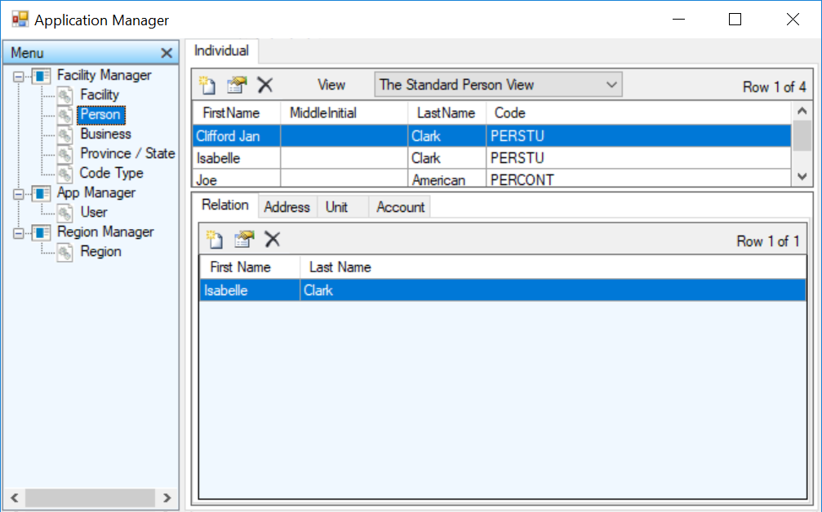

Information can be managed for entities related to the individual such as relationships, addresses, units to which the individual is assigned and accounts owned by the individual.

Relation

This related item allows relationships to be defined between the defined individuals.

Address

This related item records the addresses for the defined individual.

Unit

This item records the units occupied or assigned to an individual.
Account

This item records accounts owned by the individual.

Person List

The Person list contains the defined individuals. Individuals can be added, edited and deleted from this list.

Context Menu

New

The 'New' menu item displays the Person Detail dialog to allow for the creation of a new individual entry.

Edit

The 'Edit' menu item displays the Person Detail dialog to allow for editing the selected list item.

Delete

The 'Delete' menu item deletes the selected list item.

Refresh

The 'Refresh' menu item reloads the list items from the database.

Export Text

The 'Export Text' menu item creates a tab delimited text file with the file name 'ExportPerson.doc'. It attempts to display the data with the application that is associated with the '.doc' extension.

Export CSV

The 'Export CSV' menu item creates a comma delimited text file with the file name 'ExportPerson.csv'. It attempts to display the data with the application that is associated with the '.csv' extension.

Close

The 'Close' menu item removes the module tabs from the Tab Display windowpane.

Person Detail Dialog

The Person Detail dialog allows the user to create and edit individual entries.

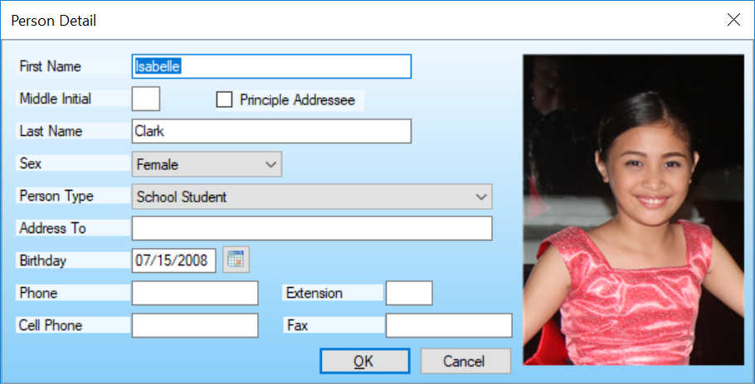

Form Controls

Name

This is the person's full name.

First Name

This is the person's first name.

Middle Initial

This is the person's middle initial.

Principle Addressee

This indicates that correspondence should be addressed to this person.

Last Name

This is the person's last name.

Sex

This is the person's sex selection.
Person Type

This is the person type selection.
Only code types that belong to the Person code type class will appear in this list.

Address To

This is the address salutation.

Birthday

This is the person's birthday. You can type the date into the date mask field or select the button to the right of the field to display the date selection dialog.

Phone

This is the person's phone number.

Extension

This is the phone extension

Cell Phone

This is the person's cell phone number.

Fax

This is the person's fax number.

OK Button

Saves the entered data and exits the dialog.

Cancel Button

Exits the dialog without saving the entered data.

Relation List

The Relation list contains the defined relationships. Relationships can be added, edited and deleted from this list.

Context Menu

New

The 'New' menu item displays the Relation Detail dialog to allow for the creation of a new relation entry.

Edit

The 'Edit' menu item displays the Relation Detail dialog to allow for editing the selected list item.

Delete

The 'Delete' menu item deletes the selected list item.

Refresh

The 'Refresh' menu item reloads the list items from the database.

Export Text

The 'Export Text' menu item creates a tab delimited text file with the file name 'ExportRelation.doc'. It attempts to display the data with the application that is associated with the '.doc' extension.

Export CSV

The 'Export CSV' menu item creates a comma delimited text file with the file name 'ExportRelation.csv'. It attempts to display the data with the application that is associated with the '.csv' extension.

Relation Detail Dialog

The Relation Detail dialog allows the user to create and edit relation entries.

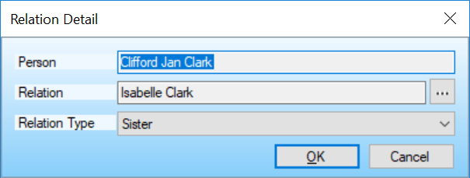

Form Controls

Person

This is a read-only field that shows the person for whom the relationship is defined.

Relation

This is the selected related person. The person selection list is displayed by selecting the button with the ellipses to the right of the read-only text field.

Relation

This is selected relationship type.
Only code types that belong to the Relation code type class will appear in this list.

OK Button

Saves the entered data and exits the dialog.

Cancel Button

Exits the dialog without saving the entered data.

Person Address List

The person address list contains the assigned addresses for the selected person.

Context Menu

Add

The 'Add' menu item displays the Address List window to allow for selecting a new address entry.

Edit

The 'Edit' menu item displays the Address Detail dialog to allow for editing the selected list item.

Remove

The 'Remove' menu item removes the selected address from the list.
Note that the address definition is not removed from the database. This can be done from the Address List window.

Refresh

The 'Refresh' menu item reloads the list items from the database.

Export Text

The 'Export Text' menu item creates a tab delimited text file with the file name 'ExportPersonAddress.doc'. It attempts to display the data with the application that is associated with the '.doc' extension.

Export CSV

The 'Export CSV' menu item creates a comma delimited text file with the file name 'ExportPersonAddress.csv'. It attempts to display the data with the application that is associated with the '.csv' extension.

Address List

The address list contains the defined addresses. Addresses can be added, edited and deleted from this list.

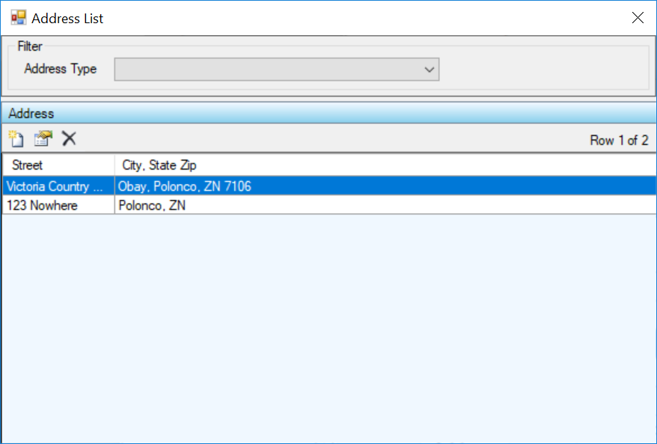

Context Menu

New

The 'New' menu item displays the Address Detail dialog to allow for the creation of a new address entry.

Edit

The 'Edit' menu item displays the Address Detail dialog to allow for editing the selected list item.

Delete

The 'Delete' menu item deletes the selected list item.

Refresh

The 'Refresh' menu item reloads the list items from the database.

Select

The 'Select' menu item returns the selected item to the associated parent list.

Close

The 'Close' menu item closes the list window without returning the selected item.

Address Detail Dialog

The Address Detail dialog allows the user to create and edit address entries.

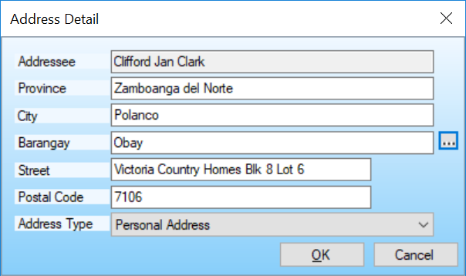

Form Controls

Addressee

This is a read-only field that shows the parent item name.

Province

This is the Province/State selection.

City

This is the city selection.

Barangay

This is the Barangay selection.

Street

This is the address number and street name.

Postal Code

This is the Zip/Postal Code.

Address Type

This is the address type selection.
Only code types that belong to the Address code type class will appear in this list.

Region Selection Button

The Region Selection button displays the Region List from Region Maintenance. This allows for the selection of Province, City/Municipality and Barangay.

OK Button

Saves the entered data and exits the dialog.

Cancel Button

Exits the dialog without saving the entered data.

Person Unit List

The Person Unit list contains the units associated with an individual. Units can be added, edited and deleted from this list.

Context Menu

New

The 'New' menu item displays the Person Unit Detail dialog to allow for the creation of a new person unit entry.

Edit

The 'Edit' menu item displays the Person Unit Detail dialog to allow for editing the selected list item.

Delete

The 'Delete' menu item deletes the selected list item.

Refresh

The 'Refresh' menu item reloads the list items from the database.

Export Text

The 'Export Text' menu item creates a tab delimited text file with the file name 'ExportPersonUnit.doc'. It attempts to display the data with the application that is associated with the '.doc' extension.

Export CSV

The 'Export CSV' menu item creates a comma delimited text file with the file name 'ExportPersonUnit.csv'. It attempts to display the data with the application that is associated with the '.csv' extension.

Person Unit Detail Dialog

The Person Unit Detail dialog allows the user to create and edit person unit entries.

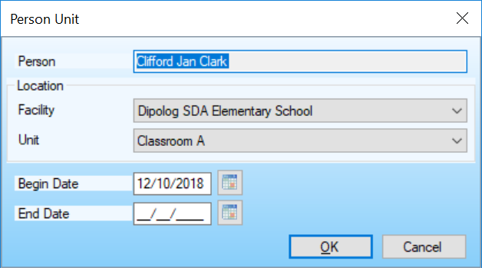

Form Controls

Person

This is a read-only field that shows the person assigned to this unit.

Facility

This is the Facility where the person is currently assigned.

Unit

This is the Unit where the person is currently assigned.

Begin Date

This is the date that the person is assigned to this unit. You can type the date into the date mask field or select the button to the right of the field to display the date selection dialog.

End Date

This is the date after which the person is no longer assigned to this unit. You can type the date into the date mask field or select the button to the right of the field to display the date selection dialog.

OK Button

Saves the entered data and exits the dialog.

Cancel Button

Exits the dialog without saving the entered data.

Account List

The Account list contains the defined accounts. Accounts can be added, edited and deleted from this list.

Context Menu

New

The 'New' menu item displays the Account Detail dialog to allow for the creation of a new account entry.

Edit

The 'Edit' menu item displays the Account Detail dialog to allow for editing the selected list item.

Delete

The 'Delete' menu item deletes the selected list item.

Refresh

The 'Refresh' menu item reloads the list items from the database.

Export Text

The 'Export Text' menu item creates a tab delimited text file with the file name 'ExportPersonAccount.doc'. It attempts to display the data with the application that is associated with the '.doc' extension.

Export CSV

The 'Export CSV' menu item creates a comma delimited text file with the file name 'ExportPersonAccount.csv'. It attempts to display the data with the application that is associated with the '.csv' extension.

Account Detail Dialog

The Account Detail dialog allows the user to create and edit account entries.

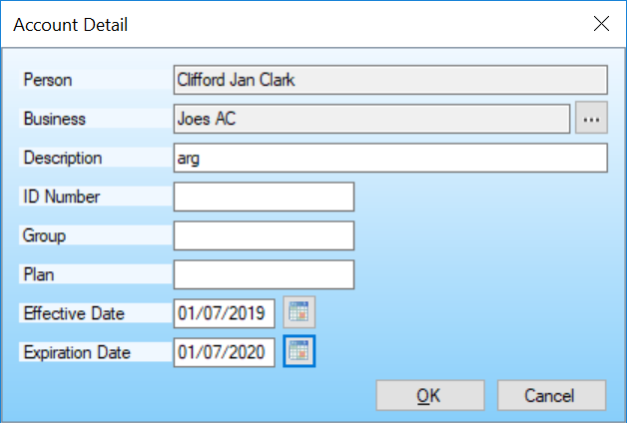

Form Controls

Person

This is a read-only field that shows the person who owns this account.

Business

This is the selected account business. The business selection list is displayed by selecting the button with the ellipses to the right of the read-only text field.

Description

This is the account description.

ID Number

This is the account ID number.

Group Number

This is the account group number.

Plan Number

This is the account plan number.

Effective Date

This is the date that the account became active. You can type the date into the date mask field or select the button to the right of the field to display the date selection dialog.

Expiration Date

This is the date after which the account is no longer active. You can type the date into the date mask field or select the button to the right of the field to display the date selection dialog.

OK Button

Saves the entered data and exits the dialog.

Cancel Button

Exits the dialog without saving the entered data.

Business Module

A Business can be a business that owns the facility, units or fixtures. It could also be a business that is contracted for repairs or maintenance.

Information can be managed for entities related to the business such as contacts and addresses.

Contact

This related item allows business contacts to be defined for the business.

Address

This related item records the addresses for the defined business.

Business List

The business list contains the defined businesses. Businesses can be added, edited and deleted from this list.

Context Menu

New

The 'New' menu item displays the Business Detail dialog to allow for the creation of a new business entry. \

Edit

The 'Edit' menu item displays the Business Detail dialog to allow for editing the selected list item.

Delete

The 'Delete' menu item deletes the selected list item.

Refresh

The 'Refresh' menu item reloads the list items from the database.

Export Text

The 'Export Text' menu item creates a tab delimited text file with the file name 'ExportBusiness.doc'. It attempts to display the data with the application that is associated with the '.doc' extension.

Export CSV

The 'Export CSV' menu item creates a comma delimited text file with the file name 'ExportBusiness.csv'. It attempts to display the data with the application that is associated with the '.csv' extension.

Close

The 'Close' menu item removes the module tabs from the Tab Display windowpane.

Business Detail Dialog

The Business Detail dialog allows the user to create and edit business entries.

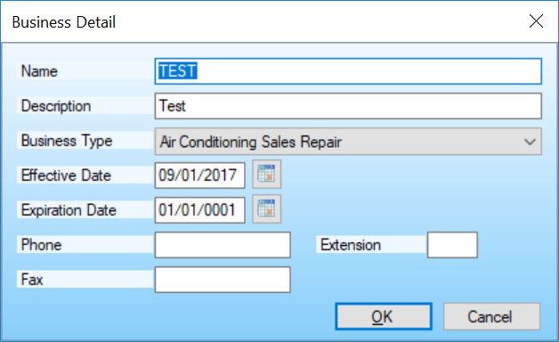

Form Controls

Name

This is the business name.

Description

This is the business description.
Business Type

This is the selected business type.
Only code types that belong to the Business code type class will appear in this list.

Effective Date

This is the date that the business is available for use. You can type the date into the date mask field or select the button to the right of the field to display the date selection dialog.

Expiration Date

This is the date after which the business is no longer available for use. You can type the date into the date mask field or select the button to the right of the field to display the date selection dialog.

Phone

This is the business phone number.

Extension

This is the phone extension.

Fax

This is the business fax number.

OK Button

Saves the entered data and exits the dialog.

Cancel Button

Exits the dialog without saving the entered data.

Business Contact List

The business contact list contains the assigned contacts for the selected business.

Context Menu

Add

The 'Add' menu item displays the Person List window to allow for selecting a new contact entry.

Edit

The 'Edit' menu item displays the Person Detail dialog to allow for editing the selected list item.

Remove

The 'Remove' menu item removes the selected contact from the list.
Note that the individual definition is not removed from the database. This can be done from the Person List window.

Refresh

The 'Refresh' menu item reloads the list items from the database.

Export Text

The 'Export Text' menu item creates a tab delimited text file with the file name 'ExportContact.doc'. It attempts to display the data with the application that is associated with the '.doc' extension.

Export CSV

The 'Export CSV' menu item creates a comma delimited text file with the file name 'ExportContact.csv'. It attempts to display the data with the application that is associated with the '.csv' extension.

Contact List

The Contact list contains the defined individuals. Individuals can be added, edited and deleted from this list.

Context Menu

New

The 'New' menu item displays the Person Detail dialog to allow for the creation of a new individual entry.

Edit

The 'Edit' menu item displays the Person Detail dialog to allow for editing the selected list item.

Delete

The 'Delete' menu item deletes the selected list item.

Refresh

The 'Refresh' menu item reloads the list items from the database.

Select

The 'Select' menu item returns the selected item to the associated parent list.

Close

The 'Close' menu item closes the list window without returning the selected item.

Contact Detail Dialog

The Person Detail dialog allows the user to create and edit individual entries.

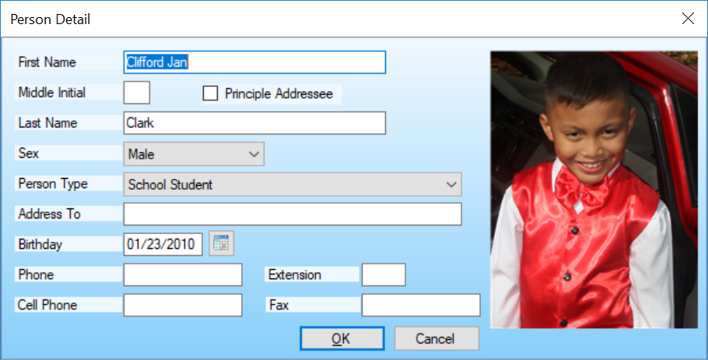

Form Controls

Name

This is the person's full name.

First Name

This is the person's first name.

Middle Initial

This is the person's middle initial.

Principle Addressee

This indicates that correspondence should be addressed to this person.

Last Name

This is the person's last name.
Sex

This is the person's sex selection.

Person Type

This is the person type selection.
Only code types that belong to the Person code type class will appear in this list.

Address To

This is the address salutation.

Birthday

This is the person's birthday. You can type the date into the date mask field or select the button to the right of the field to display the date selection dialog.

Phone

This is the person's phone number.

Extension

This is the phone extension

Cell Phone

This is the person's cell phone number.

Fax

This is the person's fax number.

OK Button

Saves the entered data and exits the dialog.

Cancel Button

Exits the dialog without saving the entered data.

Business Address List

The business address list contains the assigned addresses for the selected business.

Context Menu

Add

The 'Add' menu item displays the Address List window to allow for selecting a new address entry.

Edit

The 'Edit' menu item displays the Address Detail dialog to allow for editing the selected list item.

Remove

The 'Remove' menu item removes the selected address from the list.
Note that the address definition is not removed from the database. This can be done from the Address List window.

Refresh

The 'Refresh' menu item reloads the list items from the database.

Export Text

The 'Export Text' menu item creates a tab delimited text file with the file name 'ExportBusinessAddress.doc'. It attempts to display the data with the application that is associated with the '.doc' extension.

Export CSV

The 'Export CSV' menu item creates a comma delimited text file with the file name 'ExportBusinessAddress.csv'. It attempts to display the data with the application that is associated with the '.csv' extension.

Address List

The address list contains the defined addresses. Addresses can be added, edited and deleted from this list.

Context Menu

New

The 'New' menu item displays the Address Detail dialog to allow for the creation of a new address entry.

Edit

The 'Edit' menu item displays the Address Detail dialog to allow for editing the selected list item.

Delete

The 'Delete' menu item deletes the selected list item.

Refresh

The 'Refresh' menu item reloads the list items from the database.

Select

The 'Select' menu item returns the selected item to the associated parent list.

Close

The 'Close' menu item closes the list window without returning the selected item.

Address Detail Dialog

The Address Detail dialog allows the user to create and edit address entries.

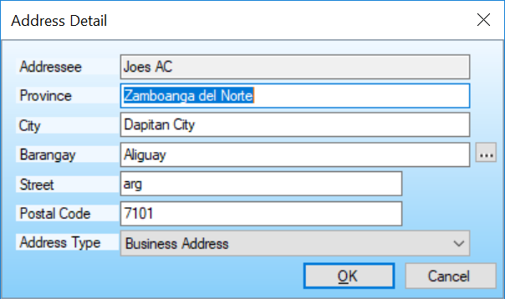

Form Controls

Addressee

This is a read-only field that shows the item to which this address is assigned.

Province

This is the Province/State selection.

City

This is the city selection.

Barangay

This is the Barangay selection.

Street

This is the address number and street name.

Postal Code

This is the Zip/Postal Code.

Address Type

This is the address type selection.
Only code types that belong to the Address code type class will appear in this list.

Region Selection Button

The Region Selection button displays the Region List from Region Maintenance. This allows for the selection of Province, City/Municipality and Barangay.

OK Button

Saves the entered data and exits the dialog.

Cancel Button

Exits the dialog without saving the entered data.

Code Type Module

A Code Type is used to group user defined codes.

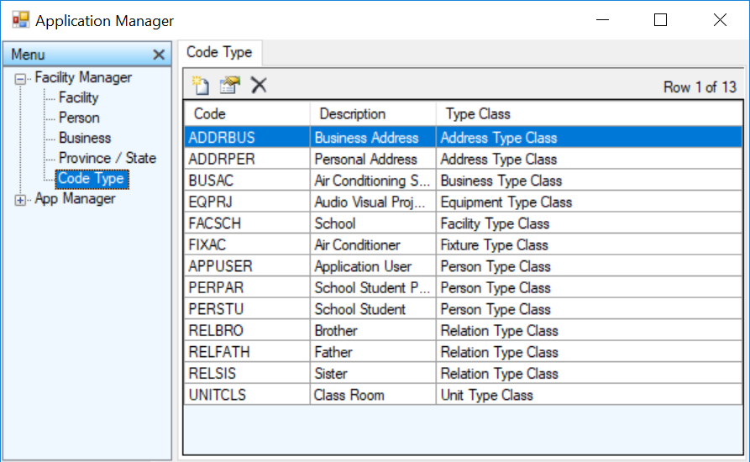

Code Type List

The Code Type list contains the defined code types. Code types can be added, edited and deleted from this list.

Context Menu

New

The 'New' menu item displays the Code Type Detail dialog to allow for the creation of a new code type entry.

Edit

The 'Edit' menu item displays the Code Type Detail dialog to allow for editing the selected list item.

Delete

The 'Delete' menu item deletes the selected list item.
Refresh

The 'Refresh' menu item reloads the list items from the database.
Export Text

The 'Export Text' menu item creates a tab delimited text file with the file name 'ExportCodeType.doc'. It attempts to display the data with the application that is associated with the '.doc' extension.

Export CSV

The 'Export CSV' menu item creates a comma delimited text file with the file name 'ExportCodeType.csv'. It attempts to display the data with the application that is associated with the '.csv' extension.

Close

The 'Close' menu item removes the module tabs from the Tab Display windowpane.

Code Type Detail Dialog

The Code Type Detail dialog allows the user to create and edit code type entries.

Form Controls

Code

This is the code value. A code is a user-defined abbreviation that is easier to use than the long item description.

One possible format for creating a code type value is to use the type class abbreviation followed by an abbreviation that makes it unique.

So if we are creating Person code types they might follow this pattern.
PERPAR - A person who is a parent.
PERSTU - A person who is a student.
PERCUST - A person who is a customer.

Description

This is the code type description.

Code Type Class

This is the selected code type class.
A code type class controls the code types can be selected for specific items.
E.G. A person can only be assigned a code type that belongs to the person type class.

A code type can be defined as belonging to one of 8 code type classes. A suggested abbreviation is included for each type class.
Facility Type Class - FAC
Unit Type Class - UNIT
Fixture Type Class - FIX
Equipment Type Class - EQ
Person Type Class - PER
Business Type Class - BUS
Address Type Class - ADDR
Relation Type Class - REL

OK Button

Saves the entered data and exits the dialog.

Cancel Button

Exits the dialog without saving the entered data.

Region Manager

A region Province, City and Barangay are used when defining addresses.

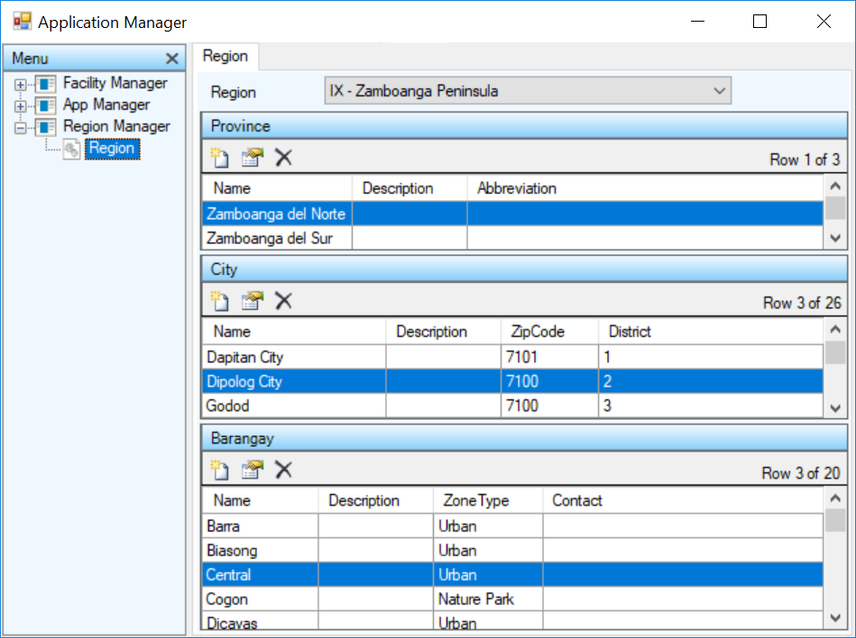

Region Module

This window is displayed when selecting the Province, City and Barangay from an Address Detail Dialog.

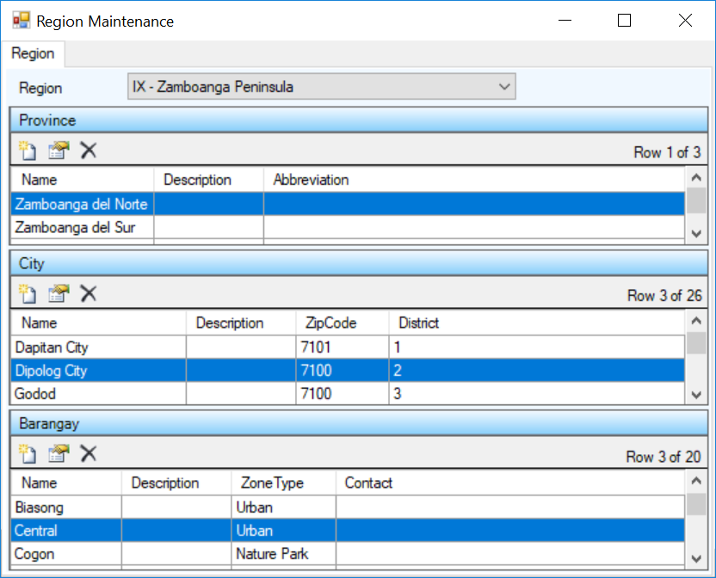

Province List

The Province list contains the defined states/provinces. Provinces can be added, edited and deleted from this list.

Context Menu

New

The 'New' menu item displays the Province Detail dialog to allow for the creation of a new province entry.

Edit

The 'Edit' menu item displays the Province Detail dialog to allow for editing the selected list item.

Delete

The 'Delete' menu item deletes the selected list item.

Refresh

The 'Refresh' menu item reloads the list items from the database.

Close

The 'Close' menu item removes the module tabs from the Tab Display windowpane.

Province Detail Dialog

The Province Detail dialog allows the user to create and edit Province/State entries.

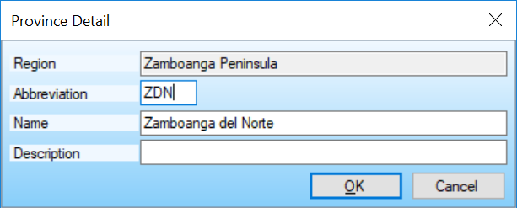

Form Controls

Region

This is a read-only field that shows the item to which this province is assigned.

Abbreviation

This is the abbreviation for this province.

Name

This is the province name.

Description

This is the province description.

OK Button

Saves the entered data and exits the dialog.

Cancel Button

Exits the dialog without saving the entered data.

City List

The City list contains the defined cities/municipalities. Cities can be added, edited and deleted from this list.

Context Menu

New

The 'New' menu item displays the City Detail dialog to allow for the creation of a new city entry.

Edit

The 'Edit' menu item displays the City Detail dialog to allow for editing the selected list item.

Delete

The 'Delete' menu item deletes the selected list item.

Refresh

The 'Refresh' menu item reloads the list items from the database.

City Detail Dialog

The City Detail dialog allows the user to create and edit City/Municipality entries.

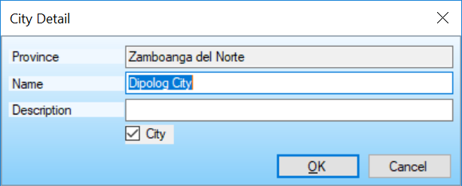

Form Controls

Province

This is a read-only field that shows the item to which this city is assigned.

Name

This is the city or municipality name.

Description

This is the city description.

OK Button

Saves the entered data and exits the dialog.

Cancel Button

Exits the dialog without saving the entered data.

Barangay List

The Barangay list contains the defined barangays. Barangays can be added, edited and deleted from this list.

Context Menu

New

The 'New' menu item displays the Barangay Detail dialog to allow for the creation of a new barangay entry.

Edit

The 'Edit' menu item displays the Barangay Detail dialog to allow for editing the selected list item.

Delete

The 'Delete' menu item deletes the selected list item.

Refresh

The 'Refresh' menu item reloads the list items from the database.

Barangay Detail Dialog

The Barangay Detail dialog allows the user to create and edit Barangay entries.

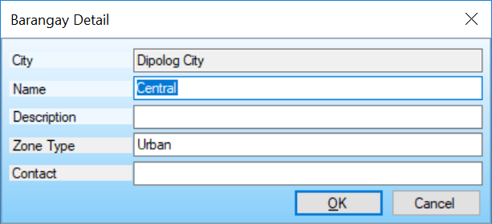

Form Controls

City

This is a read-only field that shows the item to which this barangay is assigned.

Name

This is the barangay name.

Description

This is the barangay description.

OK Button

Saves the entered data and exits the dialog.

Cancel Button

Exits the dialog without saving the entered data.

