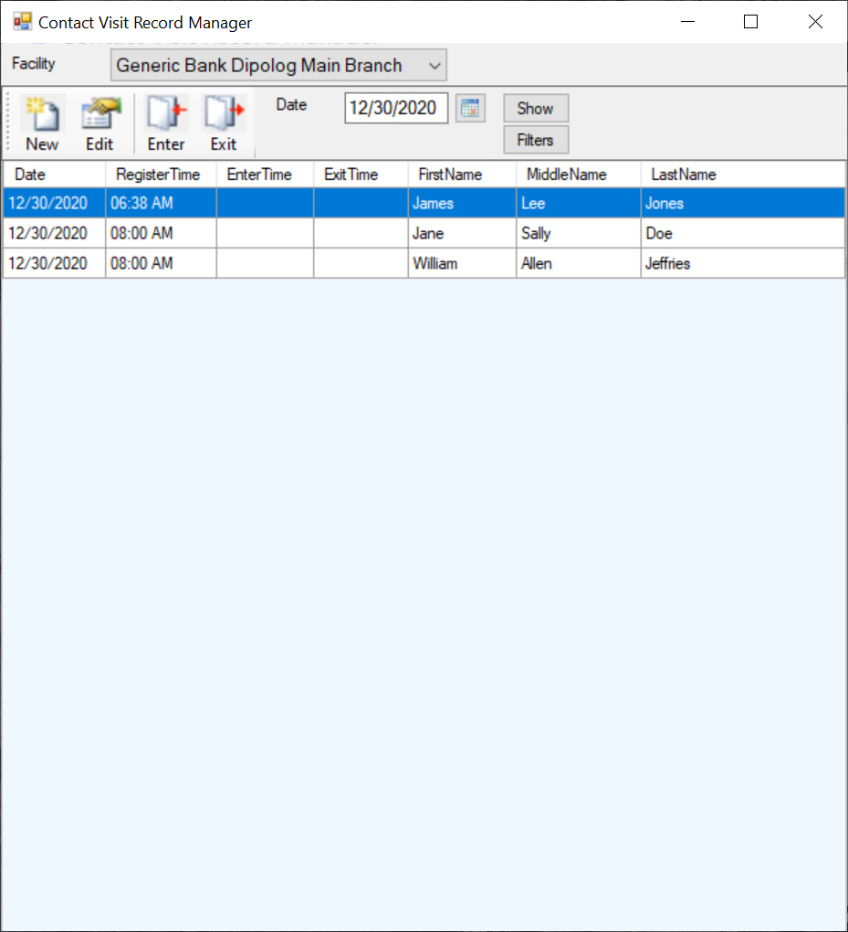

Contact Visit Record Manager

The CVR Manager is a computer application that tracks contact visits to a facility.

* Contact registration is quick and easy, with simple, reduced data entry design.

* Full Contact recall by Index number.

* Saves a permanent record of visits to one or more facilities.

* Provides for quick and easy visit tracing by Date Range, Contact or both.

* Enables easy to read reporting capabilities through simple export functions.

* Enhanced for use with Touch Laptop and Tablet computers.

* Can be used to register contacts before they enter a facility.

Search YouTube.com on “Contact Visit Record Manager” for a basic online demonstration.

Contact:
Lester J. Clark
Victoria Country Homes Block 8 Lot 6
7106 Obay, Polanco ZDN
0912-630-4661

